Meeting Date | 14 May 2026 |  | Agenda Item |  |  | 2.2
Name of Meeting | Charitable Funds Committee
Report Title | Top Slicing of Charitable Funds to cover Swansea Bay Health Charity costs
Report Authors | Richard Thomas, Director of Insight, Communication and Engagement  Claire Osmundsen-Little, Interim Executive Director of Finance
Report Sponsors | Richard Thomas, Director of Insight,  Claire Osmundsen-Little, Interim Executive Director of Finance
Presented by | Richard Thomas, Director of Insight, Communication and Engagement
Freedom of Information | Open
Purpose of the Report | To brief the Committee on discussions around the top slicing of charitable funds and to agree a way forward.
Key Issues | Swansea Bay Health Charity has 259 separate charitable funds under its umbrella.  These funds vary in size and activity - there are 86 which have been dormant for 12 months and 10 are restricted while 249 are unrestricted.  Legally, these charitable funds are not independent funds – they are all part of Swansea Bay Health Charity.  The administration and running costs of the Charity need to be covered – these include financial, audit, governance, administrative and promotional costs.  Previously, the Charity’s costs were recharged to a general fund that was unrestricted. However, the value of the general fund has decreased over time and an alternative funding method needed to be formulated.  Last year, the Charitable Funds Committee was asked to approve the top slice of every charitable fund to pay for the Charity’s running costs – this was agreed but its implementation was delayed until the end of March this year in order to cover the Charity’s costs for 2026-27 (rather than 2025-26).  Following formal notification, a large number of fund managers contacted the Charity and Health Board execs to say that they were unhappy with the 10% top slice.  Discussions with a number of key fundholders have been held since then and this paper outlines a way forward in relation to the top slice for 2026-27 costs as well as the way in which the Charity’s costs could be covered from 2027-28 onwards.
Specific Action Required  (please choose one only) | Information | Discussion |  | Assurance | Approval
Specific Action Required  (please choose one only) | ☐ | ☐ |  | ☐ | ☒
Recommendations | Members are asked to:  - APPROVE the scaling back of the agreed top slice of individual charitable funds to match the actual costs of provision (currently 6%) for 2026-27rather than the original 10%, based on actual 2025-26 costs rather than planned costs.  - APPROVE the use of general funds and/or the £55k per quarter draw down from the investment portfolio to meet any shortfalls if required.  - ACCEPT further clarity on the exceptions to the recharges (whether a very limited number of legacies focused on funding recurrent activities were subject to the recharges) is required – exceptions to be clarified at the next Charitable Funds Committee (CFC).  - Approve engagement with fund managers regarding the approach to recovering 2027-28 costs to be undertaken over the next few months as part of a wider engagement process, taking on board lessons learned and culminating in a proposal to the CFC in the Autumn/Spring 2026/27.  - APPROVE engagement with charitable fund managers and others across the Health Board regarding a rationalisation of funds in the longer-term, aimed at reducing the number of dormant funds and creating fewer, bigger funds with more strategic impact – subsequent proposal to be brought back to the CFC in due course.

Top Slicing of Charitable Funds to cover Swansea Bay Health Charity costs

- INTRODUCTION

Swansea Bay Health Charity is made up of 259 different charitable funds. These funds vary in size

Each of the charitable funds has its own fund manager who looks after the fund.

Swansea Bay Health Charity, like all charities, has administration and running costs it needs to cover. These costs relate to financial, audit, governance, administrative and promotional activities.

This paper relates to how those costs could be paid for and provides the CFC with feedback from fund managers around the originally proposed 10% top slice approach. It also proposes a new way forward.

- BACKGROUND & Opportunity

The Top Slice

The Charity has a clear strategy (summary in Appendix One) and five-year business plan covering income and expenditure from 2024-25 through to the end of 2028-29. The cost element can be found in Appendix Two.

The CFC agreed to cover the Charity’s costs via a 10% top slice of all charitable funds because the general fund (an unrestricted fund) had diminished over time.

Originally, the plan was that the top slice was to be enacted during year two of the plan – 2025-26 when the cost of running the charity was due to be £381k.

Subsequently it was agreed following the CFC meeting to notify the fund managers formally of a 10% top slice of the closing position for 2025-26 to cover 2026-27 costs.

Feedback

When the letter was distributed to fund managers, there were a number of strong negative reactions. Issues raised included:

- A lack of awareness that their charitable fund was part of a wider charity with costs that needed to be covered and the lack awareness on the makeup and drivers of the costs.
- Opposition to the imposition of the top slice without any prior engagement and general lack of engagement.
- Concerns that the Health Board might be using the top slice to help it deliver its year-end financial position (the Health Board’s, not the Charity’s).
- Questions regarding the nature of the Charity’s costs and how they benefited individual funds i.e. the value derived from them.
- Opposition to the scale of the top slice and the blanket approach being adopted – some fund holders felt that due to the scale of their fund, they would pay an inordinate amount towards the costs while smaller funds would pay far less while some fund managers in charge of smaller funds felt that the 10% would have a bigger impact on them than on larger funds.
- Questions regarding the legality of the top slice and whether the CFC had the authority to levy it.
- Concerns from some legacy funds designed to fund regular activities on an annual basis that their fund would be depleted, and the annual funding process would be unsustainable.
- Concerns that donors did not know that some of their donations would be used to cover the Charity’s costs.
- Questions as to why the Charity’s costs could not be covered by the investment portfolio.

Listening and engaging

In light of the feedback, an email providing more information regarding the Charity and its activities was circulated to fund managers and meetings were held with some in order to talk through the issues (the issue was also raised at an Ask Abi session – the monthly all staff teams meeting with the Chief Executive and other executives).

The discussions with fund managers were fronted by Richard Thomas and Claire Osmundsen-Little who conveyed the following messages:

- Every one of the individual charitable funds is part of Swansea Bay Health Charity and exists within the Charity’s eco-system – they are not independent funds nor charities in their own right.
- Accountability to the Charity Commission and all of the obligations that entails is via Swansea Bay Health Charity.
- The Health Board cannot subsidise the Charity – the Charity has to cover all of its own costs and therefore the money to cover the costs has to come from the Charity itself.
- The top slice was not being used in any way to bolster the Health Board’s financial position – the top slice was solely intended to cover the Charity’s costs.
- The costs are normal costs incurred by any Charity and at 10%, the overhead charge was very low compared with most.
- Acknowledgement that the top slice had not been communicated in a timely or helpful way and that it should have been handled better – an apology was offered for that.
- Transparency around the nature of the Charity’s costs, including the finance charges and the funding of the very small Charity team (see Appendix Two for more detail).
- A reminder of the Charity’s core strategy to grow income over time and to support that through incremental investment in the team – importantly though, the investment follows the growth.
- Confirmation that the Charity and the CFC were entitled to impose a top slice and that the decision had been properly made.
- Acknowledgement that there might be a need to recognise that funds designed to purely provide an annual income for repeated activities needed to be considered as a potential exception given that a regular top slice would undermine the fund’s raison d’etre.
- Previously, the Charity’s general fund (an unrestricted fund) had been used to cover the Charity’s costs but this had become depleted over the last few years and was not being replenished (the vast majority of income generated was being generated for restricted funds). There were now insufficient funds in the general fund to cover the Charity’s costs.
- The Charity’s investment portfolio had been used to cover some costs over the last couple of years with £55k drawn down on a quarterly basis but the CFC had come to the view that that was unsustainable in the long run given the ebbs and flows of the investment market.
- Some of the funds related to staff legacies funding recurrent activities and although relatively small in nature, given the circumstances, there was a need to understand the exceptions to the charges and where and when they would be applicable.

A new way forward

Notwithstanding the above and in the interests of finding a way forward, Richard Thomas and Claire Osmundsen-Little (RT and COL) focused on the difference between the Charity’s planned costs (again, as seen in Appendix Two) and the actual costs.

While the Charity had exceeded its income target in 2025-26 (see Appendix Three), raising £1.58m as opposed to the planned figure of £755k, in doing so it had also spent far less money than planned.

The expenditure during 2025-26 was £274k vs a planned expenditure of £381k. At the same time, the Charity (via its individual funds) spent more on its good causes than it had originally planned (a good thing - £882k actual vs £801k planned).

Taking all of this into account, RT and COL pointed to a compromise position:

- The principle that the top slice would cover actual costs not budget and no gains would be made on the administration and running costs of the charity. This equates to a reduction to 6% in light of the 2025-26 actual costs. To proceed with this approach.
- To utilise the general fund and/or draw down £55k per quarter from the investment portfolio to offset any deficit if required.
- Engagement with fund managers over the next few months regarding the approach to covering the costs in 2027-28 – top slice to be discussed as well as other approaches that fund managers raise
- Re-statement of the fact that the Charity’s costs have to be covered by the Charity itself and that the overhead costs being incurred are proportionate and reasonable, particularly when compared with other Charities.
- Clarity would be provided via the Charity’s website regarding overheads incurred, making it clear that 90p out of every £1 is spent on good causes (see Appendix Three).

Longer term issues

A number of issues have become clear over the last few weeks as a result of discussions around the top slice:

- More engagement is needed between fund managers and the Charity to ensure a better mutual understanding of the relationship between the two.
- This would enable fund managers to better exploit the Swansea Bay Health Charity brand and promotional capabilities and influence its decision-making around major appeals.
- It would also help develop a better understanding of the obligations the Charity has in terms of accountability to the Charity Commission and the legal, financial, auditing and governance work this entails.
- In terms of individual charitable funds, the Charity has 259, 86 are dormant whilst others have minimal amounts of money in them – this is not conducive to making best use of income received from donors nor does it enable the Charity to make a big impact.
- That is reinforced by the fact that the vast majority of the funds are ‘restricted funds’ where the money can only be used for very specific purposes – that’s particularly the case with the smaller funds.
- Some fund managers are more engaged in administering their fund than others.

In light of the above and previous CFC discussions, it is proposed that engagement with fund managers over the next few months include discussions around the longer-term rationalisation of funds with the aim of radically reducing their number.

A reduction in number would result in:

- Fewer, bigger funds with the potential to make a bigger impact for good causes.
- More engaged fund managers supporting that effort due to the scale of the funds available to deploy and the broader relevance of the fundraising proposition.
- Less likelihood of having dormant funds (they would be merged with other funds if they remained dormant for too long).

Engagement with fund managers and the new Care Groups being formed within the Health Board will explore all the above and more detailed proposals will be presented to the CFC and Corporate Trustee in due course.

- FINANCIAL IMPLICATIONS

There are no financial implications for the Health Board as it is entirely separate to the Swansea Bay Health Charity. In terms of the Charity, the financial implications of this paper are self-contained i.e. no additional financial implications are being entered into given that all the Charity’s planned costs have already been approved as part of the five-year Business Plan.

- RISKS

The main risks are as follows:

- Some fund managers continue to oppose the top slice as a matter of principle. Mitigation – we already know that some have responded positively to the way forward. Mitigation with others will include an emphasis on engagement regarding the approach for the 2027-28 costs and an offer to work with them to increase income into their fund to offset the impact of any top slice.
- Charity costs will increase during 2026-27 because of recruitment to the Charity Director role – therefore basing the top slice on 2025-26 costs will result in a deficit. Mitigation – the Charity Director role will not be filled until part way through the 2026-27 financial year therefore reducing its cost
- Fund managers won’t engage with us regarding the approach for 2027-28. Mitigation – provided they are given sufficient opportunity to engage in discussions regarding 2027-28, non-participation will be down to them and will result in them being unable to influence the future direction.
- No consensus amongst fund managers regarding the best way for the Charity to cover its costs from 2027-28. Mitigation – if there is no consensus, the different views will need to be considered by the CFC as it makes a decision. Depending on how contested the approach is, the CFC might want to make a recommendation to the Corporate Trustee.
- Fund managers will oppose the rationalisation of funds in the longer term. Mitigation – we will differentiate between fund managers who actively manage their funds, bringing in income and spending the money on good causes, from those who manage dormant funds or those who manage funds with very small balances.
- Fund managers feel no buy in to the Charity’s long-term strategy and business plan. Mitigation – the Charity will engage fund managers in the next iteration of its long-term Strategy and Business Plan. This is likely to be during 2027-28.

- RECOMMENDATION

The Charitable Funds Committee is asked to:

- APPROVE the scaling back of the agreed top slice of individual charitable funds to reflect actual costs of 6% rather than the original 10%, on the basis of actual 2025-26 costs rather than planned costs.
- APPROVE the use of general funds and / or the £55k per quarter draw down from the investment portfolio to plug any shortfall if required
- APPROVE engagement with fund managers regarding options for cost recovery for 2027-28 onwards with a proposal returning to the CFC in the Autumn
- APPROVE engagement with charitable fund managers and others across the Health Board regarding a rationalisation of funds in the longer-term, aimed at reducing the number of dormant funds and creating fewer, bigger funds with more strategic impact – subsequent proposal to be brought back to the CFC in due course.

Appendix One – A summary of the Charity’s Strategy
- A growth strategy – grow the income and reinforce the charity’s capacity as that income grows
- Less rattling of tins and more high impact appeals and activities, including:
  - One or two major appeals a year
  - Major events such as Jiffy’s Bike Ride and Touched by Cancer
  - Corporate partnerships
  - Legacies
  - Bids for funding
- Development and maintenance of a strong brand identity out and about and on-line as well as a strong brand presence across our sites
- Effective digital marketing via an effective website, strong social media activity and database led e-marketing as well as PR with cut-through
- Squaring the circle – more effective promotion of impact alongside fundraising appeals
- Mobilisation of staff, patients, friends and family

Appendix Two – Planned running costs 2024-25 to 2028-29

Appendix Three – website content re overhead
How we spend money
- When you donate to us, 90p out of every £1 goes directly to your chosen cause.
- We reinvest 10p out of every £1 to cover essential costs as well as fundraising activities so that we can continue supporting patients, staff and services across Swansea Bay.

Appendix Four – Income Analysis 2025-26
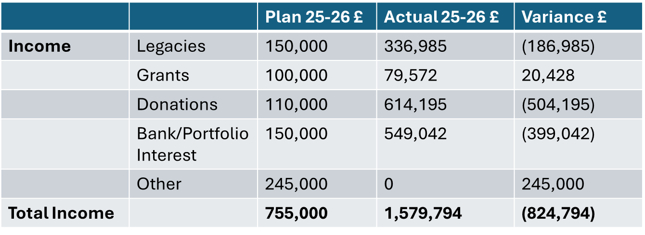

Appendix Five – Actual costs v planned costs 2025-26
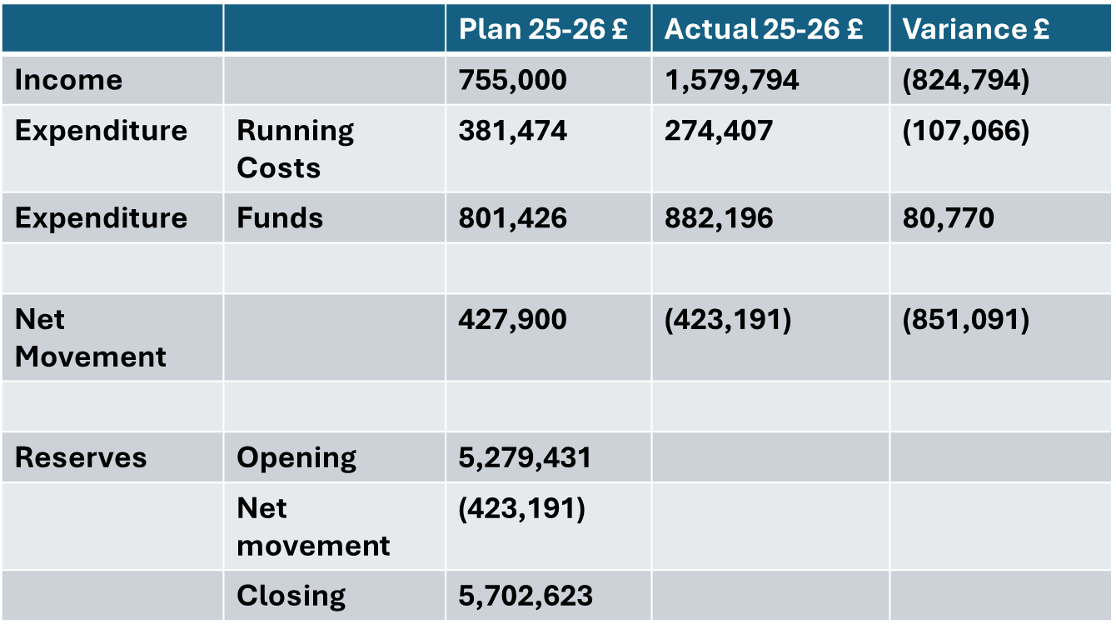
Governance and Assurance
Link to Enabling Objectives  (please choose) | Supporting better health and wellbeing by actively promoting and empowering people to live well in resilient communities
Link to Enabling Objectives  (please choose) | Partnerships for Improving Health and Wellbeing |  | ☒
Link to Enabling Objectives  (please choose) | Co-Production and Health Literacy |  | ☒
Link to Enabling Objectives  (please choose) | Digitally Enabled Health and Wellbeing |  | ☒
Link to Enabling Objectives  (please choose) | Deliver better care through excellent health and care services achieving the outcomes that matter most to people
Link to Enabling Objectives  (please choose) | Best Value Outcomes and High Quality Care |  | ☒
Link to Enabling Objectives  (please choose) | Partnerships for Care |  | ☒
Link to Enabling Objectives  (please choose) | Excellent Staff |  | ☒
Link to Enabling Objectives  (please choose) | Digitally Enabled Care |  | ☒
Link to Enabling Objectives  (please choose) | Outstanding Research, Innovation, Education and Learning |  | ☒
Health and Care Standards
(please choose) | Staying Healthy |  | ☒
(please choose) | Safe Care |  | ☒
(please choose) | Effective Care |  | ☒
(please choose) | Dignified Care |  | ☒
(please choose) | Timely Care |  | ☒
(please choose) | Individual Care |  | ☒
(please choose) | Staff and Resources |  | ☒
Quality, Safety and Patient Experience
Financial Implications
Legal Implications (including equality and diversity assessment)
Staffing Implications
Long Term Implications (including the impact of the Well-being of Future Generations (Wales) Act 2015)
In delivering against its public purposes the Charity undertakes its activities in a way that supports the Future Generations Act.
Report History |  | N/A
Appendices |  | Appendix One – Business Case

