


Charitable Funds Bids Panel
Application for Non Recurrent Funding

Under Which Evaluation Criteria is this bid being submitted?

Promoting health and wellbeing
Outline the scheme for which you are requesting funding (Maximum 250 words)
( NB. Medical equipment bids will only be Accepted for consideration if it is new equipment or if the equipment provides a new and innovative way of treating patients which improves the patient experience- please demonstrate how the bid will achieve this).
Our Corporate People Recognition Programme has been well established since 2017 and delivered by the Culture, OD and Staff Experience team. Its primary aim is to recognise and celebrate staff and volunteers, reinforce organisational values, and support morale and engagement. It is well documented that engaged, motivated and healthy healthcare staff results in better patient experience and outcomes.

The two main components of the programme are Long Service Recognition events and the Patient Choice Awards. This funding request seeks support from the Health Board Charity to enable the continued delivery of our Staff Recognition Programme, and in a meaningful way that provides a quality, timely experience.

The Patient Choice Awards recognise staff, volunteers and teams who deliver outstanding care, as identified by patients, relatives and carers. The programme not only celebrates excellent care through the eyes of the patient, service user or family, but supports meet our strategic objective to be an anchor organisation in the community we serve.

Long Service recognition celebrates the dedicated and loyal cumulative NHS Service of Health Board staff and volunteers both at 25+ and 40+ years. In comparing with Long Service recognition offered other Health Boards, we offer one of the most cost-effective options in NHS Wales with our qualifying staff celebrated over afternoon tea and a presentation of certificates and pin badges or commemorative coin (40+ years).

Describe the current service provision and detail how funding of this project will enhance the service provision (maximum 250 words)

Whilst our Staff Recognition Programme is a core priority under Strategic Objective 4; ‘The Health Board is a great place to work where all staff feel valued and work together towards a common goal’, the current financial climate puts delivery at risk.

This year, records indicate there are 350 qualifying Long Serving staff that will be offered the opportunity to attend our celebratory event.

In 2026, 19 Patient Choice ceremonies were delivered across three sites, recognising 156 individuals and 28 teams, with 276 staff and 68 patients attending. This was over double the number of events ran in 2024.

At the most recent Patient Choice events, staff and patients were offered a complimentary hot drink prepared by SBU catering team. In line with the Health Board-wide restrictions on printing and associated cost-saving measures, staff were presented with a prop certificate for photographs during the event and subsequently received a digital certificate via email, diminishing the impact and we would aim to address this.
A paper evaluating the current recognition programme was presented to the Executive Board in June 2026. The outcome was a request to submit a charitable funds bid to sustain and enhance our current programme. Given the Health Board's current financial position and the sensitivity surrounding expenditure, Charitable Funds is a more appropriate funding option.

In return, we aim to enhance the profile of the Health Board Charity through a variety of promotional opportunities as part of our Staff Recognition Programme.
How will this scheme meet the evaluation criteria selected above? (maximum 150 words)
Recognition is a key contributor to organisational culture with research consistently demonstrating that when staff feel valued and appreciated this, in turn, contributes to a better experience for patients and supports improved patient outcomes.

We will evaluate the success of the programme through feedback and testimonials from both staff and patients (where appropriate). We aim to continually improve and enhance the programme through digitising low-value tasks to enhance efficiencies, engaging with staff around what recognition means to them and enhancing spread and scale through development of more localised recognition that reaches more staff.

Working in partnership with the DICE team, we will continue to share recognition nominations / stories through internal bulletins, external press releases, and social media channels to further enhance staff engagement. A recent example from the most recent awards programme can be found here: MND Team with ‘outstanding empathy’ pick up Swansea Bay Patient Choice award
How many patients will benefit from this scheme and in what ways will they benefit? (maximum 150 words)
In line with the link between a positive staff experience leading to a positive patient experience, all those involved with the Staff Recognition Programme will benefit.

All 350 qualifying Long Serving staff will be offered the opportunity to attend the annual celebratory event.

All patients who submit a nomination will receive an invite to a celebration event. This would mean that around 200 patients and almost 300 staff (based on this years’ figures) could benefit annually from the improved programme and having their personal story told. It would also contribute to the Health Board’s activities as an anchor organisation in the community.

The promotion of the Swansea Bay Health Charity working in partnership with the Staff Recognition Programme will mean that the charity will be promoted to a wider audience, therefore raising awareness and donations. Increased donations would in turn benefit numerous more patients and staff in the future.
What are the expected outcomes from this scheme? Maximum (150 words)
Our Staff Recognition work plan is a core priority under Strategic Aim 1 – Engaged, Motivated and Healthy under the Health Board’s People Strategy. As set out in our overarching plan, the aim/outcome is to deliver a meaningful corporate staff recognition programme within resources available, that enables every person to feel valued. It contributes towards the improvement of our overarching engagement score made up from the responses of 7 key questions of the National Staff Survey, which was 70% for 2025:

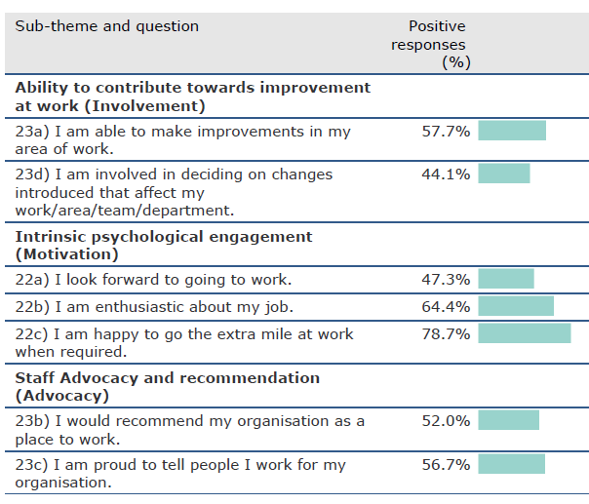

In addition, there will be increased awareness of and engagement with the Swansea Bay Health Charity.
How will you determine if the scheme has been successful and how will success be measured? Maximum 150 words)

The driver metrics for the workplan enabling success to be measured are:

Baseline:
Up-take, access, attendance and experience for 2025/6’s programme as set out in our end of year evaluation report.

Success Measures:
- Reduce time from nomination to receipt of patient choice award by 50% (Currently 18 months)
- Delivery of a cost and resource-effective corporate staff recognition programme that is successfully evaluated and impactful to staff.
What is the value of funding sought? (Please provide a detailed breakdown of the funding required to include VAT costs and confirm the basis on which the amount of funding required has been identified) (Maximum 100 words)

The value of the total funding requested is £8,313.07 based on the cost of 3 ipads and 300 nominees. A breakdown of costs per quantity of 100 is detailed in the table below.

Product | Supplier | Cost | per 100
A4 Snap Frame Silver 25mm Frame | UK POINT OF SALE GROUP LTD | £5.66 | £566.00
Card A4 | LYRECO | £9.99 | £29.97  250 sheets x 3
Pack lunches (Patient Choice) | CATERING DEPT | £6.00 | £450.00
Tea and Coffee (Patient Choice) | CATERING DEPT | £1.50 | £150.00
Ipads x 3* | CDW – through Digital | £1,248.95
Afternoon Tea (Long Service Recognition) | Village Hotel (most cost effective following Multi-quote tender) | £4,709.25 | Based on 350 attendees. Includes venue hire and 15% discount
Pin Badges (Long Service Recognition) | Promotional Focus | £1.65 | £577.50 based on 350 qualifying staff
Commemorative Coins and display boxes (40+ years Long Service Recognition) | Wheelers | £5.61 | £561 + £20.40 delivery

Dual Purpose Snap Frame with Foot | A6, A5 and A4 Snap Frames
Clairefontaine White Card Clairalfa A4 160gsm -... | Lyreco
*IPads one off purchase to support future Staff Recognition Programme and wider Staff Experience/Engagement events
Detail any other revenue costs associated with this project and how these will be funded? (Maximum 50 words)
N/A
Detail all other avenues of funding which have been explored and why these this has been unsuccessful (maximum 100 words)
(NB Details are required of other Charitable Funds that have been approached for funding and why these cannot be used)

As previously detailed, our allocated re-occurring budget for Staff Reward and Recognition has reduced by over half during the last 2 years due to the Health Board’s financial position. Whilst we do have some allocated funds, Staff and Public perception remain the highest risk around public spending by the Health Board. Charitable Funds money would help mitigate against this risk.

We have not explored other avenues of funding and are not aware of any that would be suitable.

When is the scheme proposed to start?
The relaunch of Patient Choice and Long Service recognition following revision and enhancement of co-ordination processes to improve efficiencies and timeliness of receipt commenced during September 2026.

Delivery of celebration events and timeframes are dependent on Charitable Funds monies being approved.
When will the funding be required and who will be responsible for managing the funding?
We hoped to have had sign off of funding by September 2026 in order to ensure appropriate timeliness aligned with the success measures set out in our workplans and co-ordinate aspects in line with team capacity and ahead of Winter pressures.

The Director of Workforce & OD is ultimately responsible for this workplan, however day to day monitoring and management of the funding will be overseen by the Head of Culture, OD & Staff Experience.
When will the scheme be complete?
We aim for the current work plan to be delivered by Quarter 4, 2026/7, however, as previously mentioned this is dependent on timely access to funds. Our Staff Recognition Programme is an ongoing programme of work and will require an annual application for Charitable Funds.
Declaration

I confirm that any funding awarded will only be utilised in line with this bid for funding.

Name: Julie Lloyd Role: Head of Culture, OD & Staff Experience

Signature 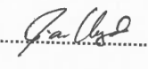 Date 22/07/2026

I confirm that this bid is supported by the Delivery Unit Management Team

Name: Tina Ricketts Role: Director of Workforce & OD

Signature 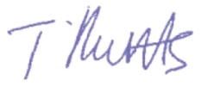 Date 22.07.2026

FINANCE DEPARTMENT USE ONLY

Date Bid Received

Date Discussed by Bids Panel

DECISION OF BIDS PANEL

APPROVED/REJECTED

REASON FOR REJECTION

DATE

Forms to be submitted electronically by e mail to Swanseabay.healthcharity@wales.nhs.uk & abm.endowments@wales.nhs.uk

