Meeting Date | 22 January 2026 |  | Agenda Item |  |  | 3.1
 | Digital, Data, Research and Innovation Committee
Report Title | Research and Development Clinical Trial Activity
Report Author | Jayne Caparros, Research Delivery Manager  Jemma Rogers, Research and Development Manager  Liz Wonnacott, Head of Service – Medical Director
Report Sponsor | Professor Richard Evans, Executive Medical Director
Presented by | Jayne Caparros, Research Delivery Manager  Jemma Rogers, Research and Development Manager
Freedom of Information | Open
Purpose of the Report | The purpose of the report is to provide an update on research and development activity during the current financial year.
Key Issues | - The health board supports research across most clinical areas and spans all research types, from randomised clinical trials of new drugs and technologies to qualitative methodologies and use of routine data, demonstrating a commitment and recognition of the vital role research and development in achieving a high-quality organisation;  - At the end of 2024-25, the health board had undertaken 372 studies, which saw 3,332 patients participating and income generated of £2.4m.  - The report provides a snapshot of the clinical research activity currently ongoing within the research and development teams.
Specific Action Required  (please choose one only) | Information | Discussion |  | Assurance | Approval
Specific Action Required  (please choose one only) | ☐ | ☐ |  | ☒ | ☐
Recommendations | Members are asked to:  - TAKE ASSURANCE from the level of clinical trial activity undertaken in 2024-25;  - TAKE ASSURANCE from the performance figures to date in 2025-26;  - TAKE ASSURANCE that the health board is a significant recruiter to UK and Wales-wide clinical trials and studies.

RESEARCH AND DEVELOPMENT CLINICAL TRIAL ACTIVITY

- INTRODUCTION
The purpose of the report is to provide an update on research and development ongoing clinical trial activity.

- BACKGROUND
Research has long been supported and recognised by clinicians for its importance in healthcare and is one of the main drivers in providing evidence-based improved treatment and care options for patients, as there is a growing body of evidence that research-active hospitals have better patient outcomes, even for patients who are not directly involved in clinical trials. In addition, the opportunity to participate in research improves recruitment and attracts high-calibre candidates; and presents opportunities for cost reduction and income generation.

The health board supports research across most clinical areas and spans all research types, from randomised clinical trials of new drugs and technologies to qualitative methodologies and use of routine data, demonstrating a commitment and recognition of the vital role research and development in achieving a high-quality organisation.

It has a research and development team, under the remit of the Executive Medical Director, which is funded by Health and Care Research Wales (HCRW). Commercial income also supports the service financially.

The team comprises three delivery components (cancer, non-cancer and Joint Clinical Research Facility (JCRF)) which are supported by a management and governance function. The teams include specialist research nurses, officers and facilitator staff who work to support research active clinicians deliver research studies, which may be externally led by a commercial or non-commercial sponsor or an in-house study, sponsored by the health board.

- GOVERNANCE AND RISK ISSUES
At the end of 2024-25, the health board had undertaken 372 studies, which saw 3,332 patients participating and income generated of £2.4m.

Based on figures to date, this year is progressing well:
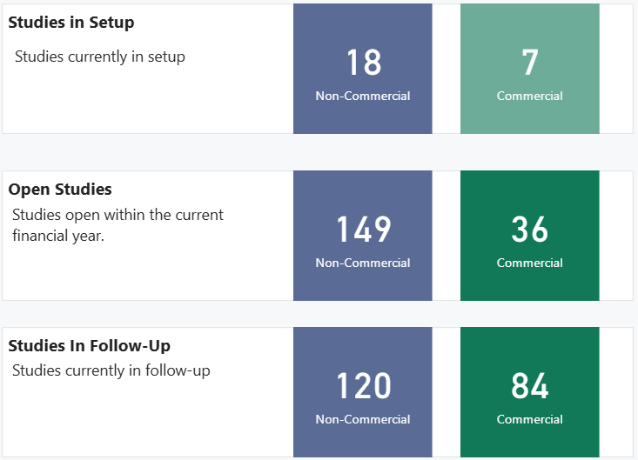

Performance for non-commercial studies is monitored by HCRW, with a requirement that 80% of studies close on time and have met the target number of participants. Regular finance and performance meetings take place with HCRW take place, during which this target is discussed, as if the health board was consistently below the 80% target, discussions would be held regarding oversight of the budget.

It is important to note that for all trials, the study sponsor running them will set a target number of patients to be entered, so it is not always a case of everyone eligible will be able to take part. The numbers below represent the numbers of studies which have recruited at least one patient this year and the total number of people recruited in 2025-26:

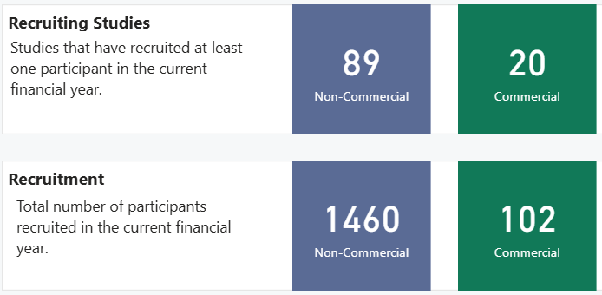

Studies and trials can be split across the categories – commercial, portfolio (which are ones recognised in the National Institute for Health and Care Research Clinical Research Network Portfolio and non-portfolio. The above figures represent portfolio and commercial studies only and there are currently 92 non-portfolio studies open.

Some of the non-portfolio studies are research undertaken locally by health board staff who focus on their own areas of expertise to enhance practice for their patients. They go on to present their findings to colleagues at conferenced and/or publish their work to help inform the work of others. For these studies, the health board is the sponsor and examples are:
- Dr Sing Yu Moorcraft, consultant medical oncologist, undertook the SALUTE study to assess the unmet psychological and emotional needs of family members. The finding of this study were presented to the ESMO Congress, a global oncology event;
- CATCH study – this is a health board study open across Wales and the team recruited more than the target within the first month. It aims to develop and evaluate a new competency assessment tool to help therapists assess and improve the skills needed to provide high-quality care for patients with chest injuries.

Usually for commercial or portfolio studies, there are multiple sites involved, normally across the UK. Each one will have a lead researcher, known as the Chief Investigator (CI), who will oversee the study across all sites. There are several ongoing trials for which a health board clinician is the Chief Investigator.

Dr Owen Pearson, Consultant Neurologist, is the CI for a number of multiple sclerosis trials:

- CARINA – evaluating if a new under-the-skin version of ocrelizumab is safe, easy to tolerate, and how it works in the body when given in different single doses;
  - FREVIVA – checking if Frexalimab, given by IV every 4 weeks, works and is safe compared to a placebo for slowing down disability in adults with a type of MS called non-relapsing secondary progressive MS (nrSPMS) over a period of up to 4 years;
  - PERSEUS - compares an oral medication with a placebo to see if the drug reduces 6-month confirmed disability progression participants with primary progressive multiple sclerosis (PPMS).
  - MOONSTONE - aims to evaluate the efficacy and safety of weekly under-the skin administration of Obexelimab compared with placebo in patients with relapsing multiple sclerosis.

Professor Steve Bain, Associate Medical Director for Research and Diabetes/Diabetes Consultant is the lead for TRIUMPH which is looking at whether a weekly injection of Retatrutide, along with usual care, can lower the risk of serious heart problems and/or slow down kidney damage in adults who are overweight and have heart disease or chronic kidney disease, compared to a placebo.

And finally, Dr Manju Krishnan, Stroke Consultant and HCRW speciality lead for stroke, was the winner of BIASP Local Researcher award 2025, which recognises non-academic clinicians who have substantially contributed to local stroke research. Dr Krishnan is currently working on a new stroke scale for stroke survivors.

Of the UK-wide trials, the health board has been the top recruiter in several:
- MATRIX-2 - an international trial for people with atrial fibrillation (AF) who need to take blood-thinning medication long-term and have had a successful procedure to open blocked heart arteries (PCI)
- SCC-After – the health board was nationally the top recruiter and the second highest in the UK, missing the top spot by a couple of days. The study is looking at radiation treatment given after surgery to people with a high-risk type of skin cancer called cutaneous squamous cell carcinoma. This is the first non-melanoma skin radiotherapy trial for a number of years and has highlighted areas to review on the standard of care pathway.
- LOXO BTK 20030 – a phase three (compares a drug and a placebo) study for patients with chronic lymphocytic leukaemia. Not only was the health board the highest in the U recruiter for part one (part two has just opened), Dr Unmesh Mohite, Consultant Haematologist is the CI.
- SNAP3 – the midwifery team recognised as ‘outstanding recruiters’ in this trial which looked at the effectiveness of nicotine replacement therapy in pregnancy;
- PETNECK2- - comparing two different ways to check for cancer coming back after treatment for head and neck cancer, one is patient initiated, and the other is a clinical follow-up. 35 patients took part in the study, and the health board was in the top six of recruiters and collaborated with the clinical nurse specialist to deliver education sessions. The work highlighted a better way of following-up head and neck cancer patients and one of the research nurses presented a poster at three national conferences.

There are also examples of the health board being the first in the UK to recruit to a trial, such as EPIC34, which looks at how well blood flows through the heart when using two different types of replacement valves in patients who need a valve-in-valve procedure because their previous surgical aortic valve has worn out.

On a Wales-wide basis, the team is fully participating in proton beam studies and was the first in Wales to recruit several trials. These studies are expensive to run and need extra treatment costs from Welsh Government to support the proton beam treatment which is carried out in England. Recruitment numbers into these trials is limited and monitored closely by HCRW due to cost.

Also, Singleton Hospital was the highest recruiting neonatal unit to recruit into a nasogastric feeding intervention study and a randomised controlled trial for prostate surgery to clarify if lymph nodes need to be removed) were the highest recruiters in Wales.

The research delivery team is in the process of setting up the first Swansea Bay cancer-led ‘One Site Wales’ study for GRACE (gynae radiotherapy consent enhancement). This approach enhances study set-up when more than one site in Wales wants to set up the same study. One site takes on the responsibility to ensure the process is co-ordinated across all sites in Wales. They become the single point of contact for the sponsor ensuring a single agreed contract and costing scheme. This collaborative working helps to overcome challenges and shares learning.

Also, the team is screening for eligible patients for the Biontech studies open in Velindre Cancer Centre. This is a new collaborative venture with the three cancer centres and Biontech whereby the study is open in only one centre and the others screen and refer to the open site. Swansea Bay is already hosting an endometrial study which is accepting referrals from west and east Wales.

Other examples of partnership working on clinical trials include:
- PICCOS - the study is testing a treatment called PIPAC (pressurised chemotherapy sprayed inside the abdomen) to see how well it works for people with cancer that has spread to the lining of the abdomen (peritoneal metastases) from the colon, ovary, or stomach. It’s a phase 2 trial, meaning researchers are checking its effectiveness and safety compared to standard care. Dr Sarah Gwynne, Consultant Clinical Oncologist, is the UK Stomach Oncology lead for this trial. The health board’s team works closely with colleagues in the University Hospital of Wales, Cardiff for the delivery of PIPAC treatment.
- 999 R.E.S.P.O.N.D – collaboration with the Welsh Ambulance Services NHS University Trust which aims to examine how ambulance control-room teams decide to dispatch specialist critical-care responders, including how this process changed during COVID-19, to improve the speed, accuracy, and effectiveness of sending advanced care to the sickest patients.
- AVENUE-PDR – lead by Swansea Bay in collaboration with Swansea University investigating whether it is possible to train experienced people (eye care practitioners (ECPs)), who are not doctors, to deliver laser treatment safely and acceptably for advanced diabetic eye disease.

Trials and study set up is continuous to consistently provide patients with the opportunity to participate where appropriate. A snapshot of the upcoming work is:
- Evaluating whether a vaccine targeting Epstein-Barr virus can safely reduce new disease activity in people recently diagnosed with multiple sclerosis.
- Looking to improve the assessment and management of patients with mild traumatic brain injury in the emergency department, by seeing if a blood test can help predict who has a brain injury and who may need a CT (computerised tomography) scan or further support. It also tests whether using these biomarkers as part of decision-making improves patient care;
- Assess whether Remibrutinib is as safe and effective as continuous Ocrelizumab over two years in people with relapsing multiple sclerosis who switch from Ocrelizumab.

In addition to the work carried out by the health board’s research and development teams, patients also have the opportunity to participate in trials managed by the Joint Clinical Research Facility (JCRF).

JCRF is a standalone clinical trials entity which is joint between the health board and university. It was previously hosted by the health board however upon receiving European funding prior to the pandemic, it transferred to Swansea University and the staff have honorary contracts with Swansea Bay. A regular JCRF board takes place with representatives from the health board, university and JCRF as an opportunity to discuss the performance and finance position of JCRF as well as update on any issues, challenges or opportunities which affect the three entities.

Below sets out the number of ongoing trials within JCRF:

Current Recruiting Studies by Disease Areas | Current Studies in Follow-Up by Disease Area
  Disease area | Total Number
  Cardiovascular | 10
  MS/Neurology | 6
  Renal | <5
  Diabetes | <5
  GI/Liver | <5
  Respiratory | <5
  Total | 22
  Disease area | Number
  Cardiovascular | 8
  MS/Neurology | 9
  Renal | <5
  Diabetes | 5
  GI | <5
  Respiratory | 0
  Total | 27
Studies in Final Set Up | Studies in Discussion Awaiting Site Selection  Key: MS – Multiple Sclerosis  GI – Gastrointestinal
  Disease area | Number
  MS/ Neurology | 5
  Cardiovascular | 5
  Diabetes | 5
  Renal | <5
  GI | 0
  Respiratory | 0
  Ophthalmology | <5
  Total | 17
  Disease area | Number
  Diabetes | <5
  MS/ Neurology | <5
  Total | 7

The application of successful for trials is not always in the gift of the health board as often the sponsors are external, and the majority require an application to the National Institute of Clinical Excellence to change guidance. However, local studies can and are published to inform the practice of others, with several publications already this year:

- SOUL – Published in The New England Journal of Medicine (March 2025) - Oral Semaglutide and Cardiovascular Outcomes in High-Risk Type 2 Diabetes | New England Journal of Medicine;
- VESAILUS – Published in The New England Journal of Medicine (November 2025) - Evolocumab in Patients without a Previous Myocardial Infarction or Stroke | New England Journal of Medicine;
- Redefine 2 - Prof Steve Bain (PI) – Published in The New England Journal of Medicine (June 2025) - Cagrilintide–Semaglutide in Adults with Overweight or Obesity and Type 2 Diabetes | New England Journal of Medicine.

In summary, the health board continues to be continues to be one of the more research active organisations in NHS Wales.

- FINANCIAL IMPLICATIONS
There are no financial implications associated with this report.

- RECOMMENDATION
Members are asked to:
- TAKE ASSURANCE from the level of clinical trial activity undertaken in 2024-25;
- TAKE ASSURANCE from the performance figures to date in 2025-26;
- TAKE ASSURANCE that the health board is a significant recruiter to UK and Wales-wide clinical trials and studies.
Governance and Assurance

Link to Enabling Objectives  (please choose) | Supporting better health and wellbeing by actively promoting and empowering people to live well in resilient communities
Link to Enabling Objectives  (please choose) | Partnerships for Improving Health and Wellbeing |  | ☒
Link to Enabling Objectives  (please choose) | Co-Production and Health Literacy |  | ☐
Link to Enabling Objectives  (please choose) | Digitally Enabled Health and Wellbeing |  | ☐
Link to Enabling Objectives  (please choose) | Deliver better care through excellent health and care services achieving the outcomes that matter most to people
Link to Enabling Objectives  (please choose) | Best Value Outcomes and High Quality Care |  | ☐
Link to Enabling Objectives  (please choose) | Partnerships for Care |  | ☐
Link to Enabling Objectives  (please choose) | Excellent Staff |  | ☐
Link to Enabling Objectives  (please choose) | Digitally Enabled Care |  | ☐
Link to Enabling Objectives  (please choose) | Outstanding Research, Innovation, Education and Learning |  | ☒
Health and Care Standards
(please choose) | Staying Healthy |  | ☐
(please choose) | Safe Care |  | ☐
(please choose) | Effective Care |  | ☐
(please choose) | Dignified Care |  | ☐
(please choose) | Timely Care |  | ☐
(please choose) | Individual Care |  | ☒
(please choose) | Staff and Resources |  | ☐
Quality, Safety and Patient Experience
Research and development is an enabler to the health board’s 10-year vision to be a high quality organisation as there is a growing body of evidence showing that research-active hospitals have better patient outcomes, even for patients who are not directly involved in clinical trials.
Financial Implications
Not applicable
Legal Implications (including equality and diversity assessment)
Not applicable
Staffing Implications
Not applicable
Long Term Implications (including the impact of the Well-being of Future Generations (Wales) Act 2015)
Research and development supports innovation and opportunities for new medications and treatments within a number of specialities providing potential for people to live longer and healthier.
Report History |  | First report to the committee
Appendices |  | No appendices

