Appendix A
Fig 1 - Fig 2.
Quality and Safety Dashboard

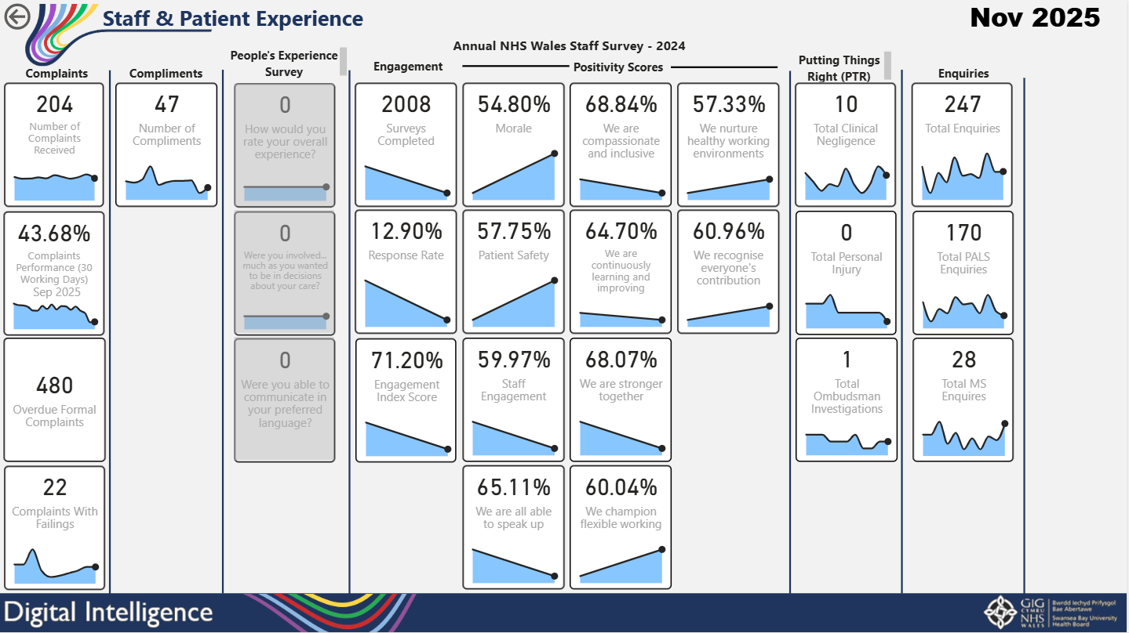

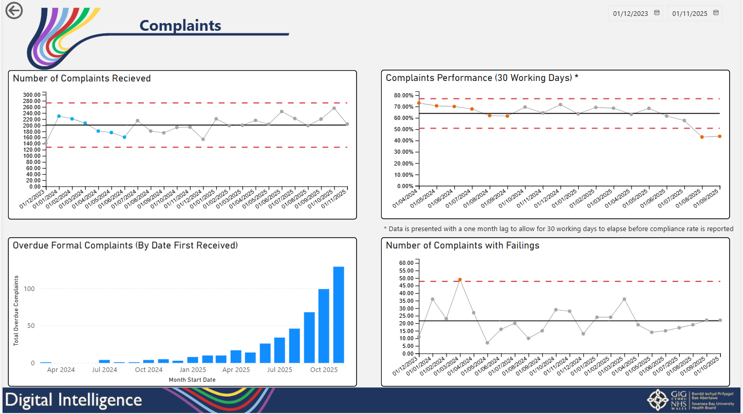
Staff and Patient experience quadrant added to Quality and Safety Dashboard containing drill-down pages showing agreed measures for area.

Fig 3 – Fig 4.
Neonatal Dashboard

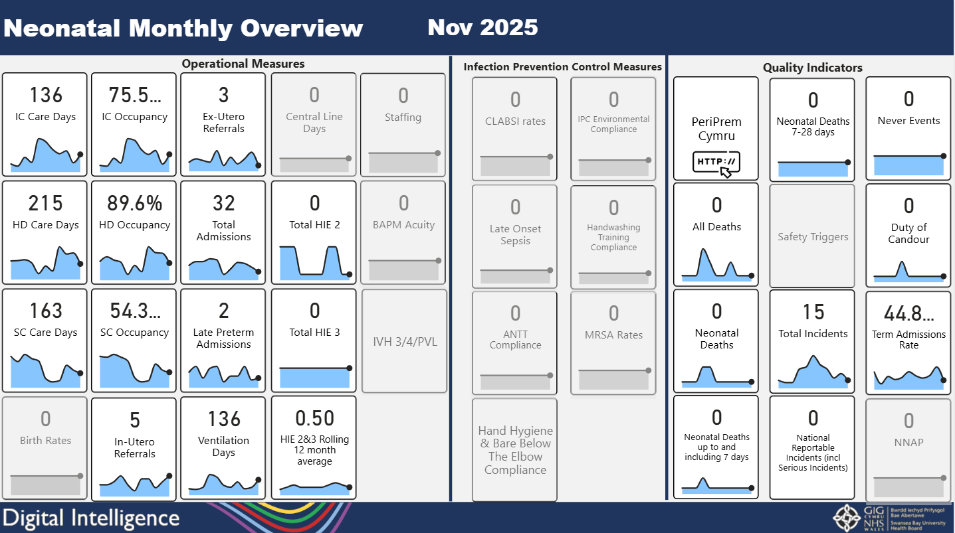

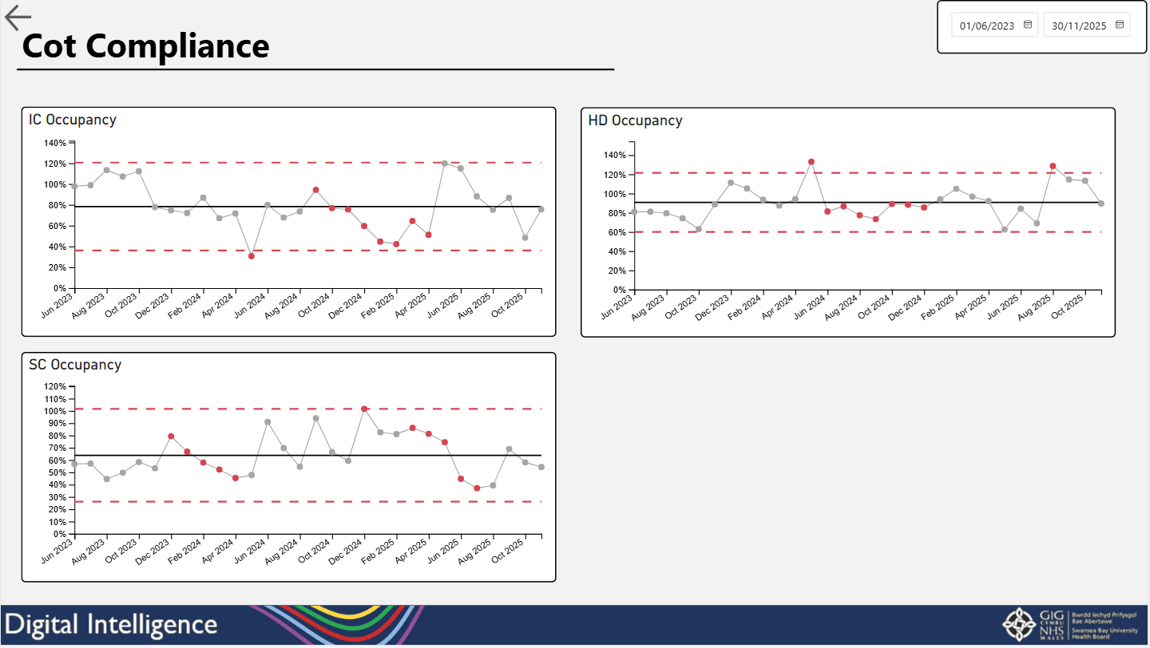
Neonatal dashboard added to the Neonatal and Maternity App containing drill-down pages for each measure showing further data.

Fig 5.
GP Out of Hours Dashboard

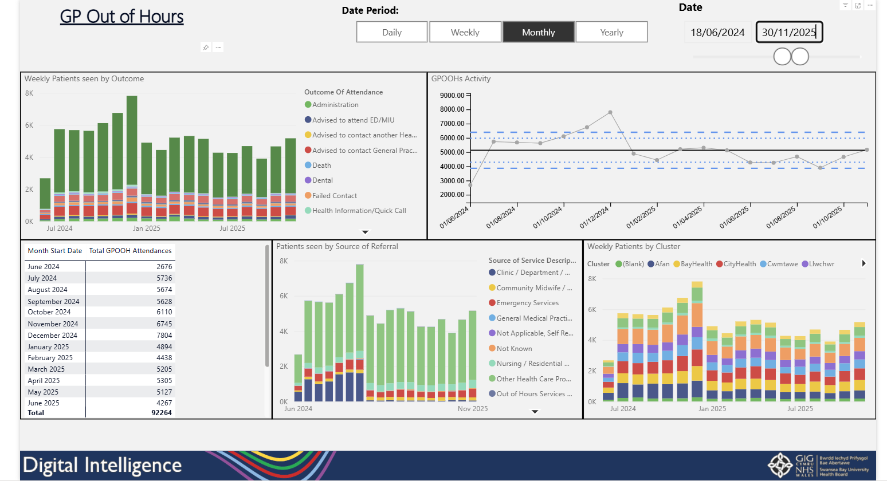
Report added to the Urgent and Emergency Care App showing activity into the service which can be split by outcome and source of referral.

Fig 6.
Psychological Therapies Reports

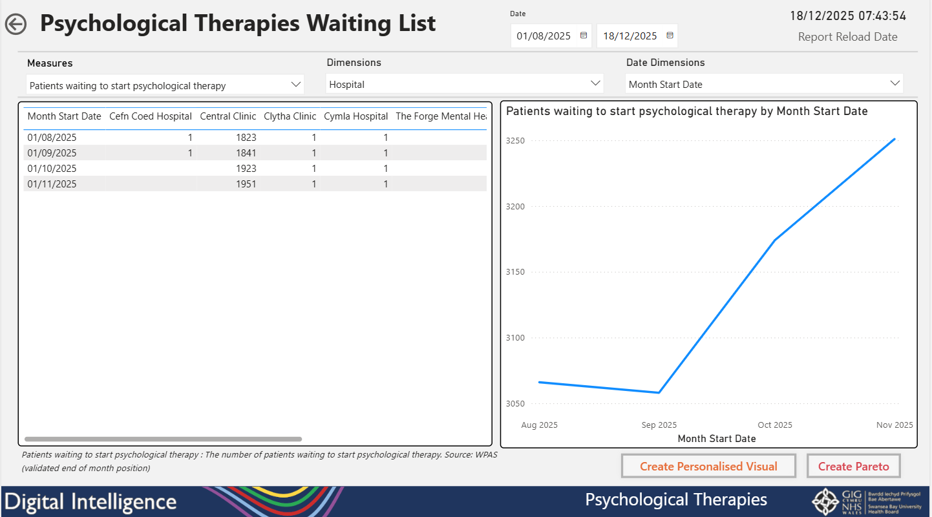
Report added to the Mental Health and Learning Disabilities App showing referrals and waiting lists over time.
Fig 7 – Fig 8.
Understanding Health Inequalities in Urgent and Emergency Care
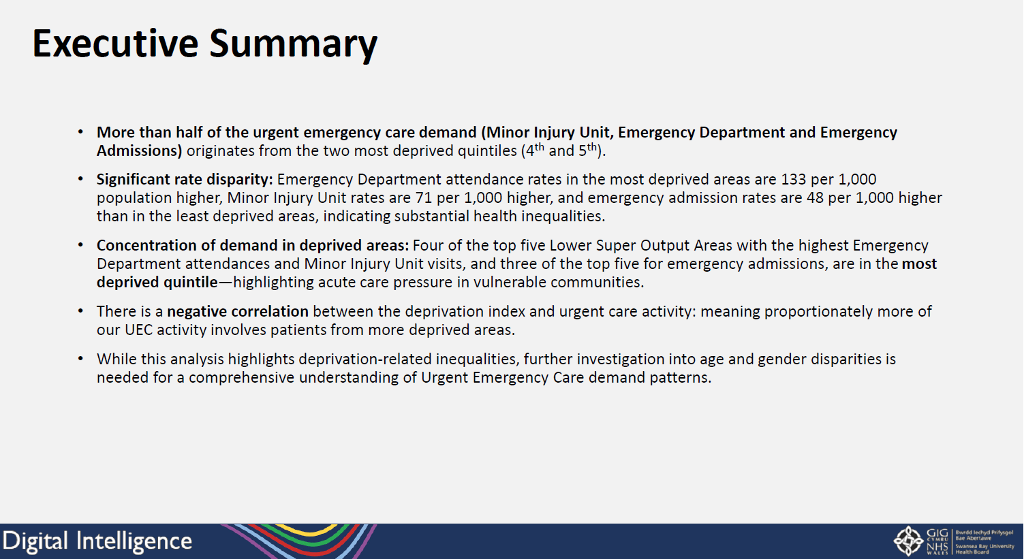

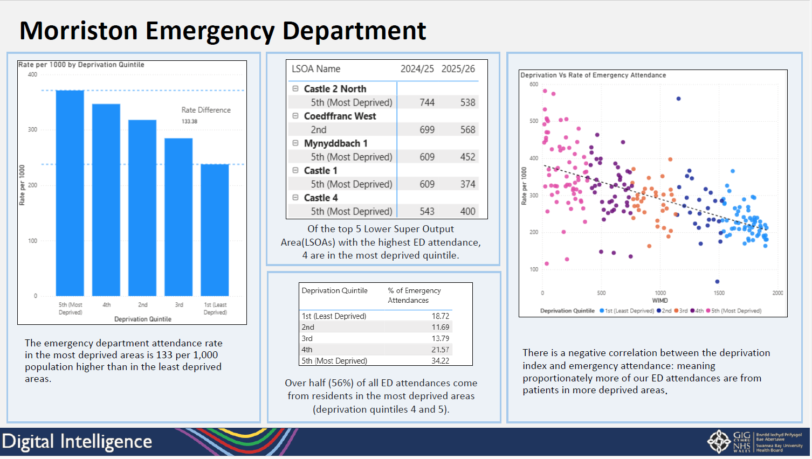
Bespoke analysis pack on Health Inequalities in Urgent and Emergency Care analysing Emergency Department demand by deprivation areas.

