Meeting Date | 22 January 2026 |  | Agenda Item |  |  | 4.3
Name of Meeting | Digital Data Research and Innovation Committee
Report Title | Clinical Coding Update Paper
Report Author | Lee Morgan, Assistant Director of Digital Intelligence
Report Sponsor | Matthew John, Director of Digital
Presented by | Lee Morgan, Assistant Director of Digital Intelligence
Freedom of Information | Open
Purpose of the Report | The purpose of this report is to provide an update on Clinical Coding within the Health Board.
Key Issues | Sickness absence and vacancies across department impacting performance against coding compliance rates.
Specific Action Required  (please choose one only) | Information | Discussion |  | Assurance | Approval
Specific Action Required  (please choose one only) | ☐ | ☐ |  | ☒ | ☐
Recommendations | Members are asked to;  - RECEIVE the report for assurance.

Clinical Coding Update Paper

- INTRODUCTION
This report provides an update on Clinical Coding since the previous report of July 10th 2025.

- BACKGROUND
Since the previous update report of July 10th 2025 the Organisational Change Policy (OCP) process has been completed to incorporate an audit function within the qualified coder role. The re-banding took place in September 2025. This re-banding is essential for the delivery of the three-year modernisation plan enabling greater staff retention and the implementation of an auto-coding tool. A machine learning model for the auto-coding of short-stay elective neurology episodes has been developed and integrated into the Clinical Coding App. The app and auto-coding model is currently in production for neurology episodes with a limited number of qualified coders before wider rollout across the department. The model will then be expanded across additional specialties with Rheumatology and Cataracts identified as high-volume areas to be targeted in the future.

High staff sickness levels and further staff leavers before the re-banding took place have meant the short-term rates initially outlined in the coding modernisation plan were no longer achievable. To improve completion rates the coding of primary diagnosis and procedure only was approved by the executive board in August 2025. An exception criteria list was created for episodes where full coding would continue to take place based on the importance of collecting this data. The paper that was taken to executive board outlining the exception criteria and the justification for primary diagnosis and procedure coding has been attached as an appendix to this paper.

Since primary diagnosis and procedure coding has been implemented in September 2025 the average rate of episodes coded has increased by over one per hour with the percentage of electronic coding increasing allowing a higher degree of working from home. The below chart shows the increase in the number of episodes coded per month since September 2025. It is important to note that this increase in coding levels has occurred without overtime taking place which did take place in the previous months.
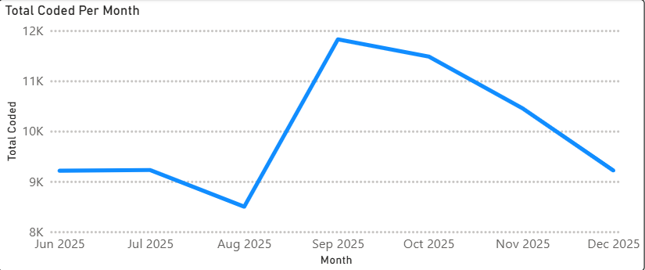
Since the original primary procedure coding projections were compiled in August 2025 there has been further unprecedented sickness absence across the department. Due to vacancy restrictions, there have also been delays in recruiting to vacant posts. A coding supervisor has also left the department in recent months. Sickness absence and staff leaving were factored into the original projections but not at their current levels. Since June there has also been an increase of circa 800 per month in the number of episodes needing to be coded compared to equivalent months in previous years. This increase is due the outsourcing of cataract procedures, older persons activity now being recorded as admissions instead of attendances, and additional activity in Neath and Singleton day-surgery units.
Despite these unforeseen challenges the increase in coding rate following the implementation of primary procedure coding has been within 10% of the original trajectory set for October and 14% for November. Amended trajectories have been created for the remaining financial year anticipating the return of staff from sickness and higher discharges per month. These projections indicate a 25/26 year-end position of circa 88% by June 2026 up from the 79% achieved in 24/25:
Discharge month | % Coded within one reported month post discharge | Current % Coded | August 2025 Trajectory | New Trajectory
Oct 2025 | 63.4% | 66% | 73% | 58%
Nov2025 | 61.3% | 62.3% | 75% | 55%
Dec 2025 |  |  | 83% | 80%
Jan 2026 |  |  | 92% | 84%
Feb 2026 |  |  | 100% | 88%
Mar 2026 |  |  | 100% | 88%

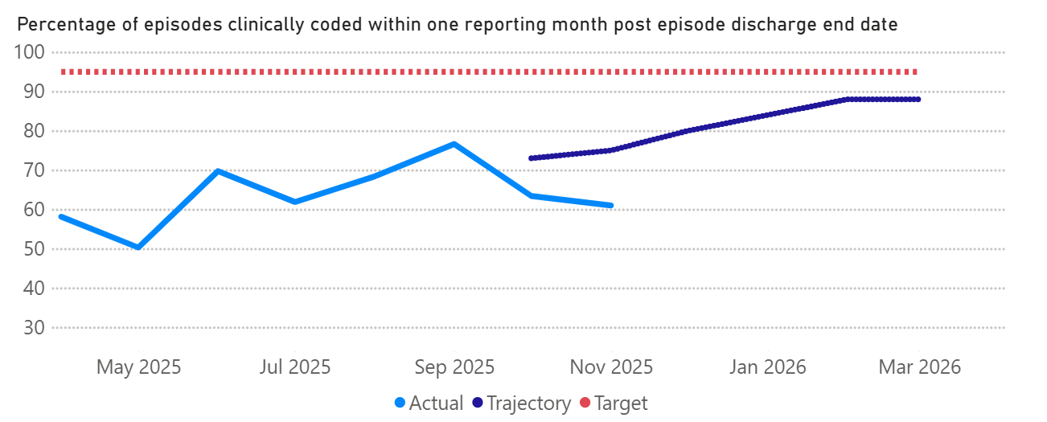

- GOVERNANCE AND RISK ISSUES
The Clinical Coding department is currently holding two vacant posts one of which has already gone out for recruitment unsuccessfully. There is also a high level of staff absence through sickness.

The Clinical Coding risk around coding completeness rates has been escalated onto the Health Board risk register with a score of 20.

- FINANCIAL IMPLICATIONS
Implementation of re-banding and implementation of auto-coding tool is within existing budgets.

- RECOMMENDATION
The Committee is asked to consider the contents of this report for assurance.

Governance and Assurance

Link to Enabling Objectives  (please choose) | Supporting better health and wellbeing by actively promoting and empowering people to live well in resilient communities
Link to Enabling Objectives  (please choose) | Partnerships for Improving Health and Wellbeing |  | ☐
Link to Enabling Objectives  (please choose) | Co-Production and Health Literacy |  | ☐
Link to Enabling Objectives  (please choose) | Digitally Enabled Health and Wellbeing |  | ☐
Link to Enabling Objectives  (please choose) | Deliver better care through excellent health and care services achieving the outcomes that matter most to people
Link to Enabling Objectives  (please choose) | Best Value Outcomes and High Quality Care |  | ☒
Link to Enabling Objectives  (please choose) | Partnerships for Care |  | ☐
Link to Enabling Objectives  (please choose) | Excellent Staff |  | ☐
Link to Enabling Objectives  (please choose) | Digitally Enabled Care |  | ☐
Link to Enabling Objectives  (please choose) | Outstanding Research, Innovation, Education and Learning |  | ☐
Health and Care Standards
(please choose) | Staying Healthy |  | ☐
(please choose) | Safe Care |  | ☐
(please choose) | Effective Care |  | ☐
(please choose) | Dignified Care |  | ☐
(please choose) | Timely Care |  | ☐
(please choose) | Individual Care |  | ☐
(please choose) | Staff and Resources |  | ☐
Quality, Safety and Patient Experience
Clinical Coding is used from a quality perspective to inform the Health Board Welsh Costing Returns (WCRs), completion of freedom of Information Requests (FOIAs) where clinical data is requested, and also population health requests when planning for future services. These services can also have a direct impact on patient experience.

Financial Implications
Cost-neutral plan within existing budgets has been approved for the recruitment of additional trainee coders, re-banding of department and implementation of auto-coding solution.

Legal Implications (including equality and diversity assessment)
Staffing Implications
Non-recruitment of staff will continue to have a detrimental effect on achieving the Tier 1 Target.

Long Term Implications (including the impact of the Well-being of Future Generations (Wales) Act 2015)
Report History |  | July 10th 2025
Appendices |  | Coding Paper – Exec Board Aug 2025(02)

