Meeting Date | Wednesday 20th August 2025 |  | Agenda Item
Name of Meeting | Formal Executive Team Meeting
Report Title | Primary Condition and Procedure Clinical Coding
Report Author | Lee Morgan, Assistant Director of Digital Intelligence
Report Sponsor | Matthew John, Director of Digital
Presented by | Matthew John, Director of Digital Intelligence
Freedom of Information | Open
Purpose of the Report | The purpose of this report is to outline the proposal to code primary condition and primary procedure only to increase completion rates and attain Tier 1 Welsh Government Coding Targets.
Key Issues | Clinical Coding only the Primary Condition and Primary Procedure codes to increase Coding Completion Rates and mitigating the risk of missing key data in doing so.
Specific Action Required  (please choose one only) | Information | Discussion |  | Assurance | Approval
Specific Action Required  (please choose one only) | ☐ | ☐ |  | ☐ | ☒
Recommendations | Members are asked to receive the report for approval.

Primary Condition and Procedure Clinical Coding

- INTRODUCTION
This report provides background on Clinical Coding Completeness rates within the Health Board and recommends coding only the primary condition and primary procedure going forward to increase coding completeness.

- BACKGROUND
In recent years the Health Board has been failing to attain the National Tier One Coding targets of 95% episodes coded within 30 days of discharge and 98% of the previous financial year coded by June 30th. This has mainly been caused by difficulties in retaining and recruiting staff with other Health Boards and NHS England paying a higher band for qualified clinical coders. Approximately 8WTE qualified coders have been lost in recent years to other health organisations. Coding completeness for the 24/25 financial year currently sits at 79%, well below the Tier One Target of 98%.

Following a limited assurance audit report into clinical coding in August 2024, a Coding Modernisation plan was formed to increase coding completeness to meet Tier One targets over the next three years. Achieving this would require implementing an auto-coding solution and re-banding the coding department to reflect a shift toward more audit-based roles and putting qualified coders at the same banding as NHS England improving staff retention and recruitment. The Modernisation plan was approved by the executive board in February 2025 and the Organisational Change Policy process for re-banding concluded in August 2025.

The original plan anticipated that Tier One Coding targets would be reached in year three. However, since the original plan was produced, it is now expected that additional staff will leave the coding department reducing capacity until new staff can be recruited and trained as qualified coders. There is also an expectation that multiple members of staff will be on sick leave over the next six months reducing the rates further than anticipated in the short-term. Low coding completeness rates impacts the ability to invoice activity against other Health Boards with circa £70million per annum claimed by the Health Board from coded activity. It also negatively impacts service planning for population health needs and inadequate levels of data being available for mortality review/quality and safety purposes. This could result in failures at spotting patterns of variance that are negatively impacting levels of patient care and potentially causing avoidable deaths. Clinically coded activity is also used to understand how resources are being allocated and used at Health Board and National level (programme budgeting), and therefore a reduction in coding completeness will affect the accuracy of this analysis. Coding data is also frequently used for freedom of information requests and a lack of coding data will impact the ability to answer these effectively. There is also the reputational damage failing to attain Tier 1 Welsh Government targets brings to the Health Board.

Low coding completeness rates are an issue across the majority of Health Boards in NHS Wales and Digital Health and Care Wales have been working on recommendations to improve completion rates termed ‘Project Zero’. Whilst originally designed to improve the backlog of uncoded activity, it listed a range of options that could be adopted to increase productivity going forward. These recommendations include increasing the use of only digital sources for coding due to using the paper record increasing the amount of time taken to code, and to only code the primary condition and procedure. The coding department are already only coding from electronic sources where possible and efforts are continuing to increase the proportion of episodes where this occurs. However, they are not currently only coding the primary codes and it is expected that only coding primary condition and procedures would significantly increase the number of episodes clinical coders can code an hour – increasing the average from 3.98 per hour to 6 per hour.

The impact of this rate increase is shown in the below chart which outlines that due to staff leaving and absentees through sickness over the next six months coding completeness will fall below 60% without any changes to the current coding rate.

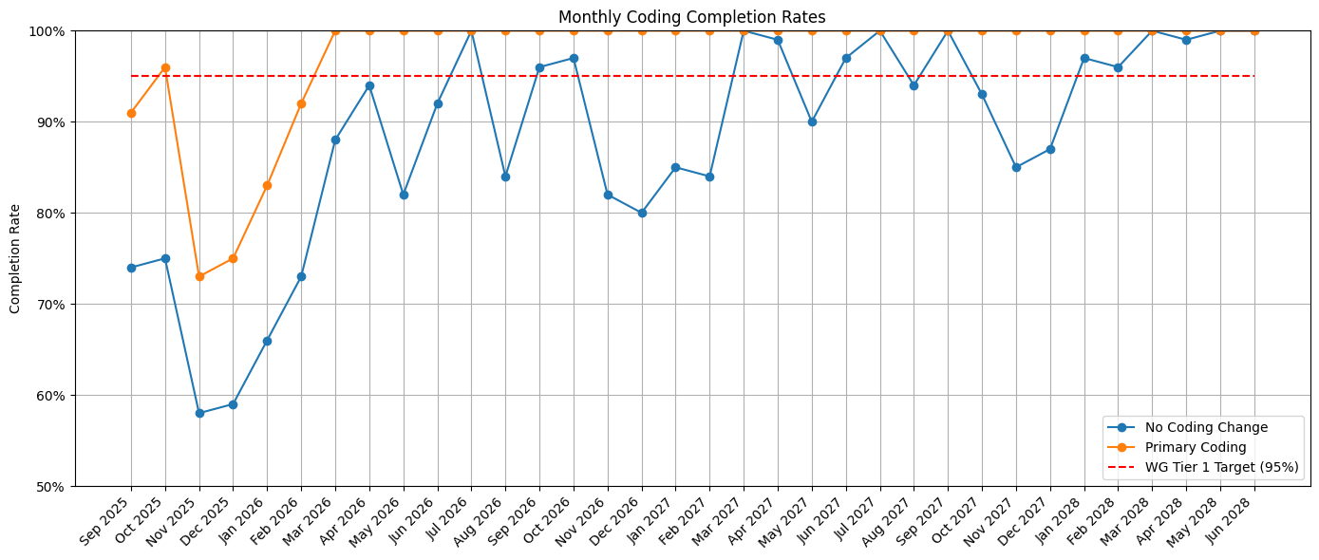

Whilst the depth (number of codes coded per episode) would decrease through only coding Primary condition and procedures many of the key areas where coding data is used only rely on primary codes and the central data items used in analysis of inpatient activity at national level in Wales are the primary diagnosis and the primary procedure. Taken together these data items indicate the main condition treated and the main procedure carried out due to that condition. Though codes are also assigned to capture co-morbid conditions, these are used less frequently as the main informational source for local and national projects and programs. This is also true of secondary procedures such as scans, central line introduction, electrocardiograms, etc.

Nonetheless it is true that through coding only primary codes there is a risk important data could be missed. Discussions have been held with both national and our own Health Board clinical coding colleagues to create criteria around when to code in addition to primary condition and procedure to help mitigate this risk. The additional coding criteria are as follows:
- Patients with a length of stay of eight days or more will be coded in the usual way due to the higher risk of them having co-morbidities and having had complications during their stay.
- Deceased patients would also continue to be coded in the usual way.
- Any post-operative complications will be coded for patients in addition to the primary condition and procedure codes. This data would include hospital acquired infections such as pneumonia which is regularly requested data through Freedom of Information Requests.
- All pair and cause codes will continue to be coded in adherence with the coding standards. These are codes that must also be coded when another code has been coded. An example of this would be in obstetrics where the primary condition could be O80.0 - Spontaneous Vertex Delivery and the Z code outlined in the standards would be Z37.0 Single Live Birth.
- Diabetes, Cancer and Heart Failure co-morbidities will continue to be coded due to this data being used by National Value in Health dashboards.

A plan has been created (Appendix A) demonstrating a projected breakdown of coding completeness from September 2025 until July 2028 with the two different coding options. The plan demonstrates that to attain Welsh Government tier one coding targets at pace over the next three years, the adoption of coding only the primary condition and diagnoses should be implemented, along with our Coding Supervisors being asked to contribute to the overall coding levels.

It is recommended that going forward only primary condition and procedure are coded, except for episodes that meet the earlier presented criteria for coding additional codes. It is anticipated that this will attain the tier one target by year two and at this point reducing the Supervisor’s coding levels or widening the additional coding criteria would be assessed. Clinical Coding Trainees would continue to code as they have due to them not being qualified and required to learn how to code according to the clinical coding standards to pass the Accredited Clinical Coder exam.

- GOVERNANCE AND RISK ISSUES
There is a balancing act between increasing the rate of coding performance and not be at a detriment to the depth of coding. It is also essential that any risks of not coding key clinical information is mitigated.
As detailed earlier Project Zero are a collection of principles for coding backlog that have been put together Nationally. The aim of these principles is to reduce the time taken to assign codes to episodes whilst maintaining useful, accurate information for critical use cases. The National team have also drafted coding standards when coding primary condition and procedure to reduce the risk of not coding important data. These principles and standards are the foundation of our additional coding criteria and coding episodes with a length of stay of 8 days or more has been taken from these standards. This decision is based on these episodes being more likely to have had hospital complications and co-morbidities. Diabetes, cancer and heart failure co-morbidities will also continue to be coded due to this data being important for National Value in Health Data.
After internal discussions with the coding department at Swansea Bay University Health Board (SBUHB) some concerns were raised around:
- Missing post-operative complications. This data is regularly used within Freedom of Information Requests. The coding of these complications has also been added to the additional coding criteria that staff will work to. It has also been recognised that any deaths should continue to be coded as normal and coding standards will continue to be adhered to in the event a pair/cause code is required with a primary code.
- Obstetric complications detailed through secondary procedures not being coded, therefore this activity will also continue to be coded in addition to the primary procedure.
The additional coding criteria aims to mitigate the risk of missing critical data whilst also increasing coding completeness through only coding primary condition and procedure for those episodes not meeting the criteria. The criteria will continue to be reviewed against the overall performance by the Clinical Coding Management Team and discussions will continue to be held with coding staff and information departments around whether additional criteria need to be put in place. As completion rates increase additional areas will be targeted where increased depth of coding is deemed most valuable.
Projections over the next six months currently show that if we continue to code episodes in the usual way, only 60% of hospital episodes on average will be coded during certain months. This position means 40% of SBUHB activity would not have any clinical coding data for these months.
It is also important to note that there is a Health Board Clinical Coding risk for coding completeness and the non-attainment of the Health Board Tier 1 Target, that has been escalated onto the Health Board risk register.
The coding of only primary condition and procedures with the exception of the additional coding criteria was taken to Information Governance and Cyber Assurance Group on the 7th August and approved. It was agreed that regular coding updates on the completion rates and any issues from coding primary condition and procedures would be given to this group and the additional coding criteria will be under continuous review.

- FINANCIAL IMPLICATIONS
Implementation of re-banding and auto-coding tool contained within the three-year coding modernisation plan will be within existing budgets. Coding Primary Procedure and Diagnosis only will have no impact on existing budgets. Costing data uses primary codes and through the increase in completion rates that only coding primary condition and procedure will bring costing data will be more comprehensive.

- RECOMMENDATION
The group is asked to approve the recommendation to only code primary condition and procedure going forward with the exception of those episodes that meet the additional coding criteria to increase Coding Completeness rates.

Governance and Assurance

Link to Enabling Objectives  (please choose) | Supporting better health and wellbeing by actively promoting and empowering people to live well in resilient communities
Link to Enabling Objectives  (please choose) | Partnerships for Improving Health and Wellbeing |  | ☐
Link to Enabling Objectives  (please choose) | Co-Production and Health Literacy |  | ☐
Link to Enabling Objectives  (please choose) | Digitally Enabled Health and Wellbeing |  | ☐
Link to Enabling Objectives  (please choose) | Deliver better care through excellent health and care services achieving the outcomes that matter most to people
Link to Enabling Objectives  (please choose) | Best Value Outcomes and High Quality Care |  | ☒
Link to Enabling Objectives  (please choose) | Partnerships for Care |  | ☐
Link to Enabling Objectives  (please choose) | Excellent Staff |  | ☐
Link to Enabling Objectives  (please choose) | Digitally Enabled Care |  | ☐
Link to Enabling Objectives  (please choose) | Outstanding Research, Innovation, Education and Learning |  | ☐
Health and Care Standards
(please choose) | Staying Healthy |  | ☐
(please choose) | Safe Care |  | ☐
(please choose) | Effective Care |  | ☐
(please choose) | Dignified Care |  | ☐
(please choose) | Timely Care |  | ☐
(please choose) | Individual Care |  | ☐
(please choose) | Staff and Resources |  | ☐
Quality, Safety and Patient Experience
Clinical Coding is used from a quality perspective to inform the Health Board Welsh Costing Returns (WCRs), completion of freedom of Information Requests (FOIAs) where clinical data is requested, and also population health requests when planning for future services. These services can also have a direct impact on patient experience.

Financial Implications
Cost-neutral plan within existing budgets has been approved for the recruitment of additional trainee coders, re-banding of department and implementation of auto-coding solution. The coding of only primary condition and procedure would have no financial impact on existing budgets.

Legal Implications (including equality and diversity assessment)
Staffing Implications
Non-recruitment of staff will continue to have a detrimental effect on achieving the Tier 1 Target.

Long Term Implications (including the impact of the Well-being of Future Generations (Wales) Act 2015)
Report History |  | August 7th 2025
Appendices |  | Appendix A – Coding Plan

