Appendix 1

Digital delivery:
3 Year Plan on a Page including a 2025/2026 1 Year Plan

A high level 3-year plan has been developed and assured by DDRI in July 2025 which demonstrates the alignment between the digital strategic plan, the IMTP and the organisational strategy. Figure 1 presents the 3 year “Plan on a Page” which has been updated to show progress in Year 1 to date.

Whilst the 3-year plan provides a high-level overview of delivery from 2025-2028, it is recognised that a more granular timeline is required, demonstrating alignment to the Health Board’s on-year Integrated Medium Term Plan (IMTP). Figure 2 shows the 2025/2026 timeline including key milestones to the digital strategic plan.

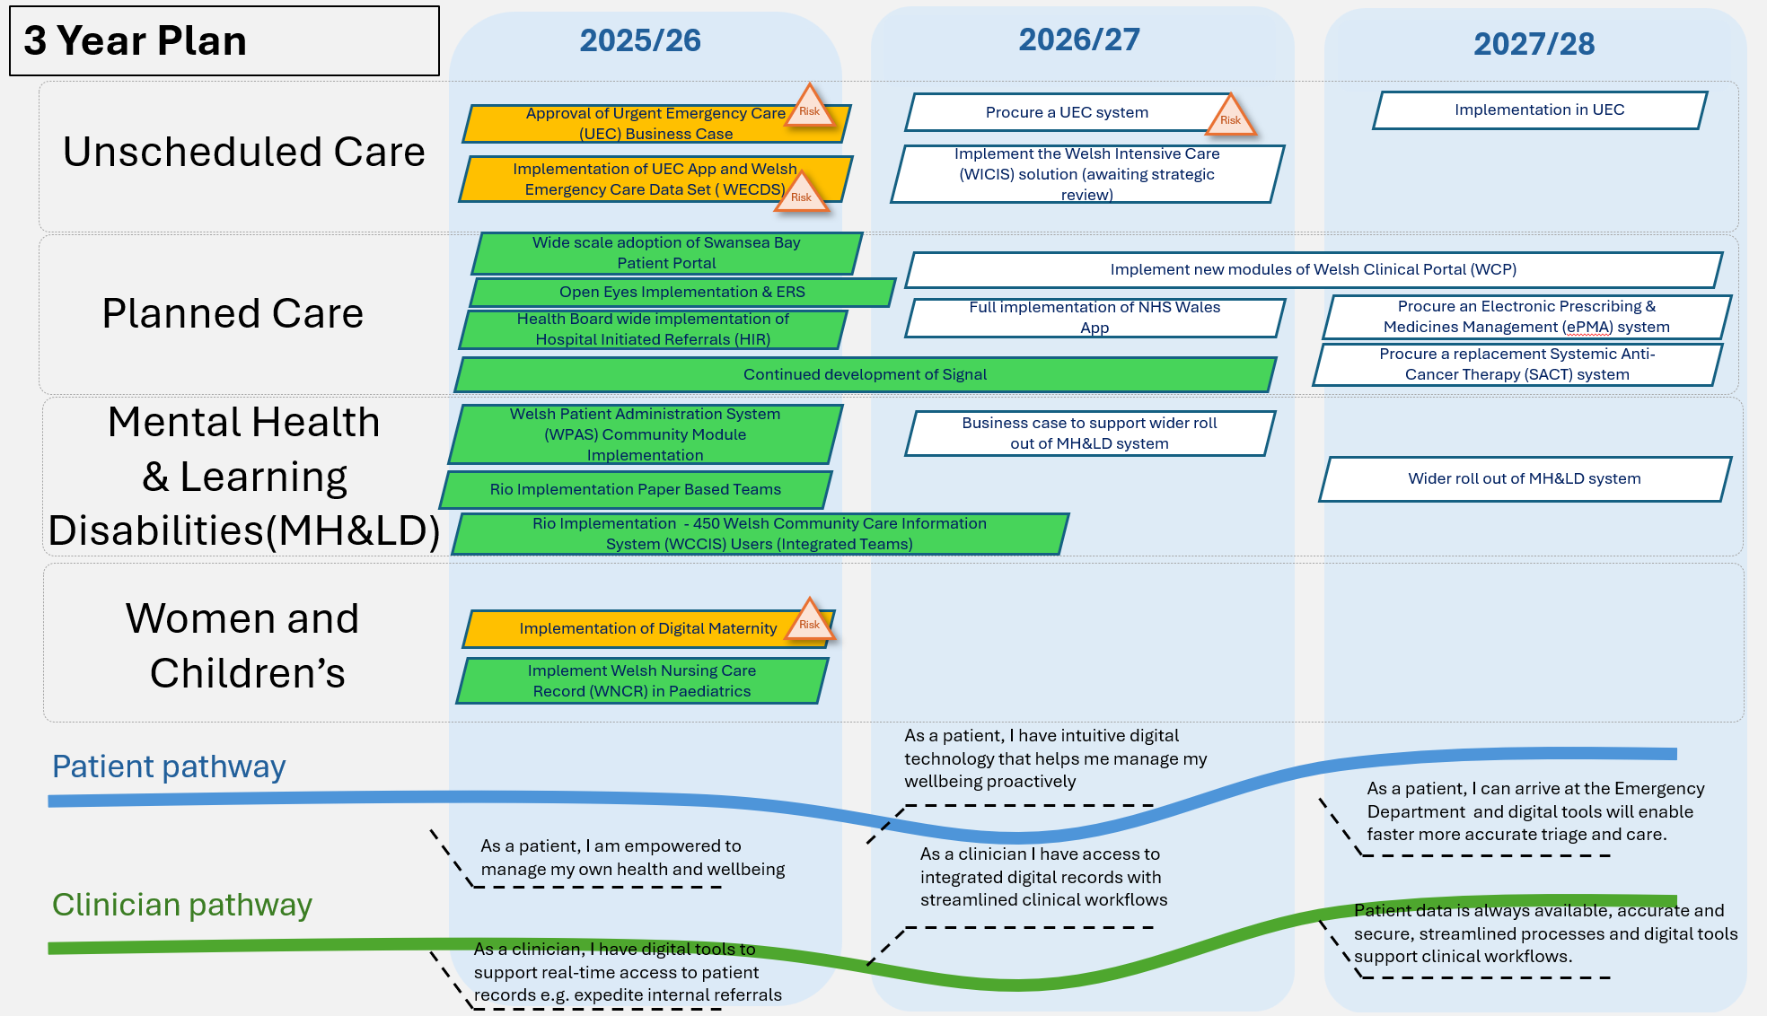

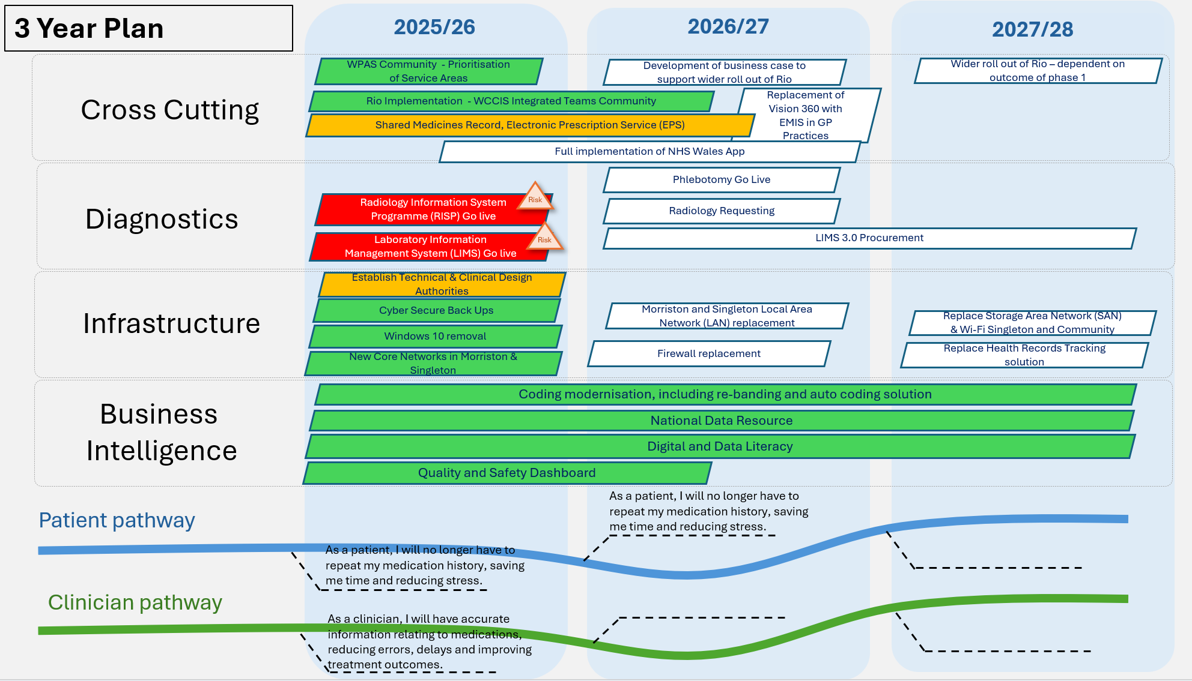
Figure 2
