

HEALTH BOARD RISK REGISTER
May 2025

DIGITAL, DATA, RESEARCH & INNOVATION COMMITTEE

Datix ID Number: 1035  Health & Care Standard: |  |  | HBR Ref Number: 27  Risk Target Date: 31/03/2026 |  | Current Risk Rating  4 x 4 = 16
Objective: The delivery of care is supported by innovative digital solutions |  | BAF Ref: 4 | Director Lead: Matt John, Director of Digital  Assuring Committee: Digital, Data, Research & Innovation Committee
Risk: Digital Transformation  Inability to deliver sustainable clinical services due to lack of resources to deliver sustainable Digital Transformation and services. There are insufficient resources to:  - Invest in the delivery of the SBU Digital strategy  - Support the growth in utilisation of existing and new digital solutions  - Replace existing technology infrastructure or software at the end of its useful life. |  |  | Date last reviewed: May 2025
Risk Rating  (consequence x likelihood):  Initial: 4 x 4 = 16  Current: 4 x 4 = 16  Target: 5 x 2 = 10 | 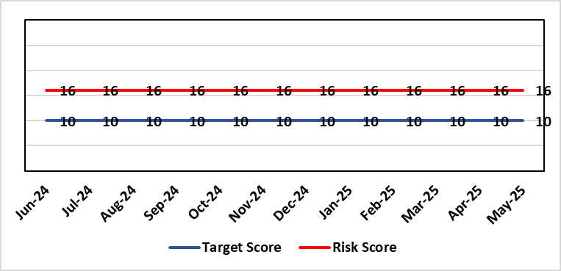 |  | Rationale for current score:  C – Reliance on digital ways of working has increased. Loss of IT service has a greater impact on ability to provide clinical care. Lack of investment in new digital solutions to make services more effective will mean clinical service provision will become unsustainable.  L- Reduction in capital funding in 2022/23/24 has increased the likelihood of HB not being able to replace aging infrastructure such as the network equipment. There is a £15m capital requirement over the next 3 years. Acceleration of the CTM SLA disaggregation has been proposed and there are further pressures on revenue funding. The shift to cloud and software as a service contracting models will increase the requirement for revenue funding to deliver digital transformation and ongoing services.
Rationale for target score:
C – Of failure will increase as the reliance and proliferation of the use of digital solutions increases.
L – Investment will mean the support mechanisms, rate of failure and ability to deliver solutions that meet the needs of users will improve sustainable digital services. There will however always be an inherent risk of failure of IT solutions.
Level of Control
= 50%
Date added to the HB risk register
2012
Controls (What are we currently doing about the risk?) |  |  | Mitigating actions (What more should we do?)
- Digital Strategy has been approved by the Health Board and outlines requirements  - HB Capital priority group considers digital risks for replacement technology which is fed into the annual discretionary capital plan  - Digital Services prioritisation process is in place Digital Leadership Group provides the overarching governance to the delivery of the Digital Strategic Plan including financial considerations.  - Digital Services Management Group assesses current service provision and flags risks and issues  - Digital Services revenue requirements are included in 2025/26 annual plan |  |  | Action | Lead |  | Deadline
 |  |  | Review 10-year financial plan for Digital Strategy and prioritise key costs for the next 3 years. Share plan with Director of Finance for consideration and alignment to 2026/27/28/29 IMTP process | Assistant Director of Digital: Business Management and Information Governance |  | 31/07/2025
Assurances (How do we know if the things we are doing are having an impact?)  - Internal Audit Program assesses Digital in 4 areas annually |  |  | Gaps in assurance (What additional assurances should we seek?)  - Lack of certainty over future capital and revenue funding streams makes planning and implementation difficult/less effective.
Additional Comments / Progress Notes
08/05/2025: Action complete: Refresh the Digital Strategy including a high-level investment plan to set out vision for the Health Board
16/06/2026: Risk to be adapted and transferred to the Strategic Risk Register

Datix ID Number: 1043  Health & Care Standard: |  |  | HBR Ref Number: 36  Risk Target Date: 31/07/2025 | Current Risk Rating  4 x 4 = 16
Objective: The delivery of care is supported by innovative digital solutions |  | BAF Ref: 4 | Director Lead: Matt John, Director of Digital  Assuring Committee: Digital, Research & Innovation Committee  For information: Quality & Safety Committee
Risk: Paper Record Storage  Lack of a single electronic record means there is greater reliance on the provision of the paper record. If we fail to provide adequate storage facilities for paper records, then this will impact on the availability of patient records at the point of care. Quality of the paper record may also be reduced if there is poor records management in some wards. There is an increased fire risk where medical records are stored outside of the medical record libraries. |  |  | Date last reviewed: May 2025
Risk Rating  (consequence x likelihood):  Initial: 4 x 5 = 20  Current: 4 x 4 = 16  Target: 3 x 3 =9 | 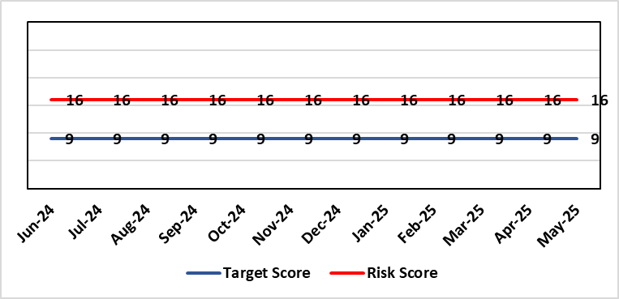 |  | Rationale for current score:  C - Inability to find records for patients could delay care/increase length of stay over 15 days. Could also mean patients receive incorrect treatment. Increased risk of fire where records are stored outside of the medical record libraries.  L - we know this happens from incidents raised
Level of Control  = 70% |  |  | Rationale for target score:  C - The increased development and adoption of the digital record will reduce the need for the paper health record being available at the point of care.  L - The increased development and adoption of the digital record, the introduction of RFID and the approach to management of the paper record identified in the Business case process should reduce the amount of paper required to be stored and managed.
Date added to the HB risk register
June 2016
Controls (What are we currently doing about the risk?) |  |  | Mitigating actions (What more should we do?)
- There is a plan in place to increase the functionality of the electronic record to document patient care. The delivery of the plan is overseen by the Digital Leadership Group and progress provided to Management Board. (Supported by individual project boards as appropriate).  - Records managed by the Medical Records libraries are RFID-tagged (Radio Frequency Identification) and location tracked.  - Medical Record libraries are regularly risk assessed for fire by health and safety.  - Alternative offsite storage arrangements have been identified.  - All records must be documented on the Information Asset Register (IAR). |  |  | Action |  | Lead | Deadline
 |  |  | Allow for new process to stabilise and evaluate benefits of new centralised unit. |  | Head of Health Records & Clinical Coding | 01/08/2025
Assurances (How do we know if the things we are doing are having an impact?)  - RFID has been implemented for the acute record improving the management and storage of records  - Health Records performance reports developed in line with RFID technology  - Attainment of the Tier 1 Health Board target for clinical coding completeness which relies on the timely availability and quality of the Paper record and electronic sources  - Monitoring complaints and incident reporting.  - Electronic record is being implemented in accordance with the plan eg implementation of WNCR (Welsh Nursing Care Record), ETR (Electronic Test Requesting), HEPMA (Hospital Electronic Prescribing and Medicines Administration) |  |  | Gaps in assurance (What additional assurances should we seek?)  Investment required supporting the delivery and operational costs of the Digital strategy.  Reliance on DHCW (Digital Health & Care Wales) for delivery of the solution for a fully electronic patient record.  Impact of the Infected Blood Enquiry on the Health Boards ability to destroy notes.  Process for ensuring clinical adoption of electronic ways of working and cessation of adding information to the paper record that is already available electronically needs to be agreed and enforced by the Health Board.  Impact of the infected Blood Inquiry on the health board’s ability to destroy notes and the change in the records code of practice is being reviewed by the Director of Digital.
Additional Notes
11/03/2025: Movement of staff and records continue but coming to an end – on target for completion by current deadline.
07/04/2025: All relevant records and all staff now moved across to Ty Samlet. Action 1 therefore completed.
08/05/2025 - Reviewed with ADI – some progress being made with wider non-acute records, therefore will be waiting for updates on the wider records workstream before considering a re-wording of this risk or whether to close it down (reference whether this risk is relating to the paper storage issue, or the wider digital record workstream).
12/06/2025 – Reviewed – no notable progress to report

Datix ID Number: 1217  Health & Care Standard: |  |  | HBR Ref Number: 37  Risk Target Date: 30/06/2026 |  | Current Risk Rating  4 x 3 = 12
Objective: The delivery of care is supported by innovative digital solutions |  | BAF Ref: 4 | Director Lead: Matt John, Director of Digital  Assuring Committee: Digital, Data, Research & Innovation Committee
Risk: Operational and strategic decisions are not data informed:  - Significant gaps in information collection due to lack of digital clinical systems especially within Primary, Community and Mental Health services (Connecting Care System) resulting in inability to deliver statutory reporting requirements.  - Users are unable to access the information they require to make decisions at the right time  - Business intelligence and information already available is not always utilised effectively |  |  | Date last reviewed: May 2025
Risk Rating  (consequence x likelihood):  Initial: 4 x 3 = 12  Current: 4 x 3 = 12  Target: 4 x 2 = 8 | 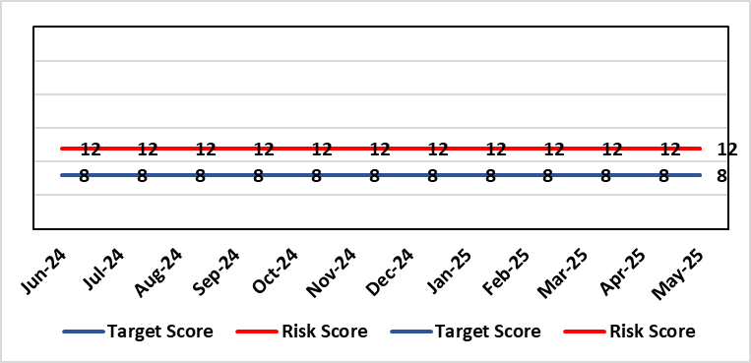 |  | Rationale for current score:  C – Opportunity cost of not acting on data could mean opportunities for improvement are missed, failures are not identified in a timely manner resulting in adverse national publicity and/or delays in care/increased length of stay.  L - Following appointments Business intelligence partners and introduction of data literacy course of Dashboard utilisation has significantly increased. However, there are significant data gaps with community and mental health areas due to the lack of digital systems.
Level of Control  = 70% |  |  | Rationale for target score:  C- Will remain the same or increase due to increased reliance in information  L- Investment in BI will lead to more information be available and used. The higher the use of information at operational level will lead to better quality data.
Date added to the HB risk register: July 2016
Controls (What are we currently doing about the risk?) |  |  | Mitigating actions (What more should we do?)
- Four BI partner roles have been appointed and are working with SDGs to help drive data literacy and data driven decision making with services.  - Ad-hoc Data literacy module training is given, and a formal Manager’s Pathway Course has been developed which circa 100 manager’s a year attend.  - Self-service dashboards in areas such as UEC and Mental Health have been developed to allow service users to derive the data and insights they require.  - Over 100 dashboards in place including Cancer, Patient Flow, Outpatients, Mortality, Clinical Variation, Primary & Community Care Delivery Unit Dashboard and Ward Dashboard and Apps created for all key areas.  - Safety Huddle implemented in Morriston has improved data quality and improved operational working.  - Quality and Safety Dashboard continues to be developed delivering key insights around agreed measures.  - New technologies being reviewed for advanced analytics and integration into a new Health Board analytics platform.  - Health Board has representation on national groups such as the Advanced Analytics Group (AAG), all Wales Business Intelligence and Data Warehousing Group and Welsh Modelling Collaborative.  - Digital Intelligence representatives involved within Digital SDG meetings to emphasise importance of the implementation of digital solutions for data capture. |  |  | Action | Lead |  | Deadline
 |  |  | Digital Intelligence 2025-2028 Strategic Plan approved (Business Intelligence Collaborative) | Assistant Director of Digital Intelligence |  | Complete
 |  |  | Digital Intelligence 2025-2028 Strategic Plan approved (Management Board) | Assistant Director of Digital Intelligence |  | 30/09/2025
Assurances (How do we know if the things we are doing are having an impact?)  More evidence based and proactive decisions being made.  Dashboard technology; assist in developing indicators / triangulating information to identify issues  Number of unique users and unique dashboards used increases  Dashboard usage increases within areas where current digital maturity is low due to inadequate systems for data collection.  Number of people attending Data Literacy Training courses continues to grow  An internal audit of the Digital Intelligence Strategy implementation was completed in May 2023 and received a substantial grade. |  |  | Gaps in assurance (What additional assurances should we seek?)  Significant gaps in data still remain within certain areas primarily due lack of digital clinical systems. Culture of the organisation continues to change to focus on information and Business intelligence for operational rather than just reporting purposes. With the capability of operational staff to utilise the tools and capacity to act on the intelligence provided increasing through training and awareness.
Additional Comments / Progress Notes
07/04/2025: Actions complete: Digital Strategy approved through Health Board. Draft of Digital Intelligence Strategic Plan has been to Business Intelligence Collaborative for approval and signed off. It will now go to Management Board.
12/05/2025 - Strategic Plan to be taken to Exec Management Committee – date to be confirmed.

Datix ID Number: 2796  Health Care Standards: |  |  | HBR Ref Number: 90  Target Risk Date: 30/04/2025 |  | Current Risk Rating  4 x 5 = 20
Objective: The delivery of care is supported by innovative digital solutions |  | BAF Ref: 4 | Director Lead: Matt John, Director of Digital  Assuring Committee: Digital, Research & Innovation Committee
Risk: Non-compliance with UK-GDPR Article 15 regarding Subject Access Requests (SARs), along with other health records requests for disclosure of personal data  If the Health Board is non-compliant with the UK-GDPR, then there is a risk of ICO enforcement action being taken against SBUHB, reputational damage and the potential for claims.  The Health Board does not have adequate/identified resources to deal with the sustained increase in volume and complexity of subject access/access to health records requests received from requestors and is seeing a large number of SARs exceeding the required legal timeframe for response, which poses the risk of ICO involvement if backlogs continue to grow.  There are significant challenges across the Health Board pertaining to the timely redaction and clinical review of records prior to disclosure. Individual services/departments do not have adequate health professional resources and/or knowledge on undertaking redaction. Currently, a high number of records are released without adequate redaction and review in order to meet the legal timeframe. The lack of review/adequate redaction increases the risk of personal data breaches occurring.  Complex requests received can include both corporate and medical records. Information can be located across multiple services/departments which can be paper based or held within numerous systems, databases and applications or non-corporate communication channels. They can include particularly sensitive and contentious information relating to safeguarding, ongoing complaints claims or legal aspects.  There is a risk of personal data breaches occurring without higher scrutiny of the amount of misfiling happening at a service level resulting in SARs needing to be double checked by Health Records Team to ensure don’t include other individual’s personal data.  There will also be a knock-on effect/impact on staff who are already working on other priority work when they are required to have input in the SAR process. |  |  | Date last reviewed: May 2025
Rationale for current score:
C – The Health Board has a statutory requirement to comply with UK GDPR and Data Protection Act 2018. This includes compliance with an individual’s Right to Access their personal data. The Information Commissioner has the power to take enforcement action, including substantial monetary penalties, for non-compliance (up to 4% of annual worldwide turnover), for serious breaches of data protection principles. Historically, a number of complaints regarding the handling of SARs within SBUHB have been highlighted previously in both the mainstream media and on social media, leading to a loss of trust in the Health Board with damage to staff and Health Board reputation and a breach of data subjects’ fundamental right.
L- The Health Board does not have adequate/identified resources to deal with the sustained increase in volume and complexity of SARs received from both patients and staff as a result of changes to the SAR landscape since the introduction of UK-GDPR and advancements in technology and data availability. There are inconsistent processes across the Health Board, with varying levels of robustness regarding legal compliance. The increased use of various digital applications has impacted the volume and complexity of content and the ability to retrieve the personal data required to comply with SARs. Since Covid, there have been rapid changes in ways of working such as the use of non-corporate communication channels (e.g. WhatsApp) and increased e-mails with clinical relevance - with no or limited recording back to the clinical and corporate records. The process for ensuring information is appropriately reviewed and redacted by health professional within services has become far more complex and resource intensive increasing the likelihood of personal data breaches and/or non-compliance with legal timescales for disclosure. The ICO have previously been involved with a number of complaints in this area and there is an increased potential for future enforcement action if significant improvements are not made. SBUHB is already seeing an increase in complaints and ICO input relating to the handling of SARs to the extent that further complaints are expected to materialise with a very high level of frequency and probability. Solicitors’ correspondence on behalf of individuals is becoming increasingly difficult with threats of legal action. The ICO has this year issued a reprimand to an NHS Trust in England in connection with their poor compliance with the statutory timescales to respond to SARs and the ICO have indicated an intention to more closely monitor organisations who develop significant backlogs when responding to SARs.
Risk Rating  (consequence x likelihood):  Initial: 4 x 4 = 16  Current: 4 x 5 = 20  Target: 4 x 3 = 12 | 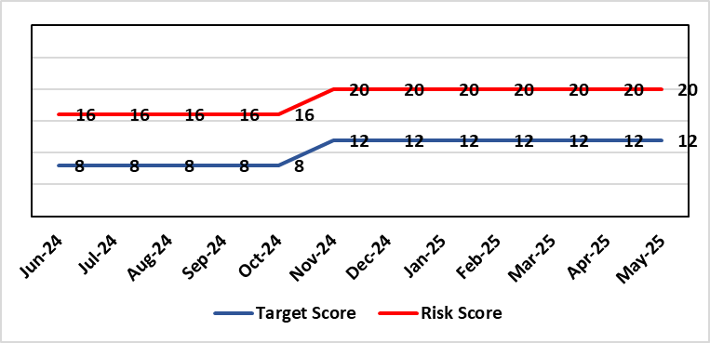
Level of Control  = 50% |  |  | Rationale for target score:  C – As above  L – Additional resources would allow the organisation to make significant improvements to the process by which SARs are managed. Being able to adequately comply with legal requirements reduces the likelihood of enforcement action and fines from the ICO, as well as minimising the risk of reputational damage.
Date added to the risk register
Jan 2023
Controls (What are we currently doing about the risk?) |  |  | Mitigating actions (What more should we do?)
- New SAR (Subject Access Request) Working Group established in February 2024  - Prioritisation of workload  - Revised SAR policy in place (to be reviewed & updated in line with Working Group actions)  - Advice sought from Legal and Risk on complex cases  - Escalating areas of concern to IGCAG (Information Governance & Cyber Assurance Group) |  |  | Action | Lead |  | Deadline
 |  |  | Develop Action Plan | Data Protection Officer/Head of Health Records |  | Complete
 |  |  | Implement detailed Action Plan in line with the timescales outlined within the Plan | Data Protection Officer/Head of Health Records |  | 31/03/2026
Assurances (How do we know if the things we are doing are having an impact?)  - Bi-monthly IGCAG chaired by SIRO (Senior Information Risk Owner) and attended by Deputy Caldicott Guardian and Data Protection Officer  - Bimonthly reporting to DDRI with progress reports  - Escalation reports from IGCAG to Management Board & Digital, Data, Research and Innovation Committee as required  - IG governance structures in place with key roles and responsibilities established e.g. SIRO, Caldicott Guardian, DPO (Data Protection Officer) |  |  | Gaps in assurance (What additional assurances should we seek?)  Recent internal audit identified the requirement to invest in resources to address gap in assurance.
Additional Comments / Progress Notes
12/5/2025 - Action plan has been presented to IGCAG on 10/4 and was ratified at that meeting. Action plan is now in the process of going to DDRI meeting on 13/5 and is intended to go to Management Board on 21/5.
9/6/2025 - Confirmation received that SAR Action Plan has been formally approved at DDRI meeting. New actions added to implement action plan and to provide updates on progress of actions on a quarterly basis. Next meeting of SAR Working Group to be arranged to discuss progress.

Datix ID Number: 443 New Risk  Health & Care Standard: Effective Care 3.1 Clinically Effective Care |  |  | HBR Ref Number: 104  Risk Target Date: 31/03/2027 |  | Current Risk Rating  4 x 5 = 20
Objective: Care is delivered in safe and appropriate settings supported by innovative digital solutions |  | BAF ref: | Director Lead: Matt John, Director of Digital  Assuring Committee: Digital Data & Innovation Committee  For information: Quality & Safety Committee
Risk: Failure to meet Tier 1 targets in Clinical Coding Completeness  Because: The volume of new inpatient episodes exceeds the available clinical coding staff capacity; There are difficulties recruiting and retaining a sufficient number of trained clinical coding staff to address the gap, and; Clinical information is not always of sufficient quality or completeness electronically (such as DALs) to support swift coding.  There is a risk that: Clinical notes for inpatient episodes will not be coded in a timely way.  Resulting in: The non-achievement of the Tier 1 Welsh Government target (which is that 95% of inpatient activity should be coded within 30-days of discharge); Insufficient coded data to support effective service planning for population health needs; Inadequate data being available for mortality review/quality and safety purposes, with increased risk of failure to spot variance that are negatively impacting levels of patient care and potentially causing avoidable deaths; Negative impact on accuracy of analysis to understand how resources are being allocated and used at Health Board level and national level (programme budgeting); Delays in claiming casemix sensitive contract lines with JCC, Hywel Da and Cwm Taff (circa 70m per annum value in total) due to lack of coding data. |  |  | Date last reviewed: May 2025
Risk Rating  (consequence x likelihood):  Initial: 3 x 4 = 12  Current: 4 x 5 = 20  Target: 4 x 3 =12 | 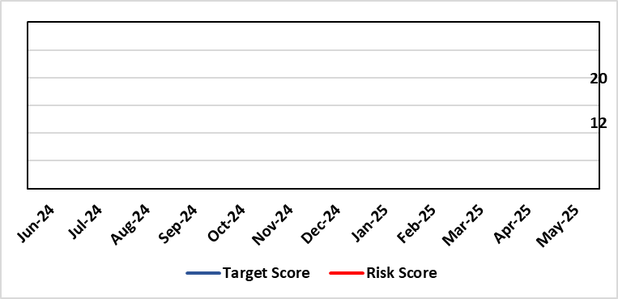 |  | Rationale for current score:  C - Insufficient coding data will negatively impact service planning for population health needs and inadequate data being available for mortality review/quality and safety purposes. This could result in failures at spotting patterns of variance that are negatively impacting levels of patient care and potentially causing avoidable deaths.  Clinically coded activity is also used to understand how resources are being allocated and used at Health Board level and national level (programme budgeting), and therefore a reduction in coding completeness will impact on the accuracy of this analysis. It is also used to claim casemix sensitive contract lines with JCC, Hywel Da and Cwm Taff of circa 70m per annum with lack of coding data impacting on the timeliness in making these claims.  L - Tier 1 target is currently not being met on a regular basis.
Level of Control  = |  |  | Rationale for target score:  C - Insufficient coding data will negatively impact service planning for population health needs and inadequate data being available for mortality review/quality and safety purposes. This could result in failures at spotting patterns of variance that are negatively impacting levels of patient care and potentially causing avoidable deaths.  Clinically coded activity is also used to understand how resources are being allocated and used at Health Board level and national level (programme budgeting), and therefore a reduction in coding completeness will impact on the accuracy of this analysis. It is also used to claim casemix sensitive contract lines with JCC, Hywel Da and Cwm Taff of circa 70m per annum with lack of coding data impacting on the timeliness in making these claims.  L – Increase in what can be coded electronically, unit centralisation, greater staff retention and the development of an auto-coding model will lead to increased capacity and a reduction in likelihood for targets not being met.
Date added to the HB risk register

Controls (What are we currently doing about the risk?) |  |  | Mitigating actions (What more should we do?)
- A three-year coding modernisation plan has been approved by executive board on 26th February 2025. This plan will see the implementation of an auto-coding solution and a re-banding of the clinical coding department within existing budgets to attain Tier 1 targets by 27/28.  - The coding management team assess the staffing complement on a daily basis to ensure resources are deployed in the most efficient and effective manner, in line with demand and clinical coding priorities.  - There is a comprehensive training programme in place for new Trainee Coders.  - The Clinical Coding Departments raise incidents when clinical information is missing from the patient’s health records and prevents the activity being coded in a timely manner. These incidents are highlighted at the Directorate Business Meetings held on a monthly basis as part of the Clinical Coding Key Performance Indicators.  - Clinical coding staff performance continues to be monitored and discussed during the monthly Clinical Coding Managers Meetings, which are chaired by the Head of Health Records & Clinical Coding and an update is also reported and presented on the Health Board Performance Scorecard.  - An App has been developed by Digital Intelligence that shows any relevant data relating to a patient episode from different systems including Signal, TOMs, EPOA and DAL in one place. This will reduce the number of systems a clinical coder needs to log into. |  |  | Action | Lead |  | Deadline
 |  |  | Electronic coding increased by circa 20% increasing Home Working | Coding Manager |  | Complete
 |  |  | Completion of all Actions on Audit Action Plan | Head of Digital Intelligence Programmes |  | 30/06/2025
 |  |  | Auto-coding model in production for two specialties | Head of Digital Intelligence Programmes |  | 30/09/2025
 |  |  | Organisational Change Process for re-banding of clinical coding department completed | Head of Health Records & Clinical Coding |  | 30/09/2025
 |  |  | Centralising of coding department leading to efficiencies | Head of Health Records & Clinical Coding |  | 31/10/2025
Assurances (How do we know if the things we are doing are having an impact?)  - Attainment of the Tier 1 Health Board target for clinical coding completeness which relies on the timely availability and quality of the paper record and electronic sources. Coding 95% of in-patient activity within 30 days of discharge is a tier 1 Welsh Government target that is currently not being achieved regularly within SBU – with an average of circa 74% for 24/25. Performance is reported to Digital Business Meeting every 3 months, and to Digital, Data, Research & Innovations Committee via a Coding Paper.  - Episodes are coded from paper and electronic sources; the ability to code from electronic sources improves the timeliness & accuracy; approximately 52,000 episodes of 150,000 episodes are coded from electronic sources currently. This is reported to Digital Business Meeting every 3 months, and to Digital, Data, Research & Innovations Committee via a Coding Paper.  - An Audit has been carried out by NHS Wales Assurance and Audit Services of the Coding Department was completed in June 2024 with a result of limited assurance. In response a twelve-point action plan was developed of which one action remains which is the escalation of the coding risk to the Health Board Risk register. |  |  | Gaps in assurance (What additional assurances should we seek?)  Investment required supporting the delivery and operational costs of the Digital strategy.  Replacing qualified coders who have left the department with trainees reduces productivity - the only mitigation against this is an auto-coding product to increase productivity and re-banding across coding department to put staff at same bandings as NHS England and help staff retention – the investment required for this is yet to be funded.  The Quality of Discharge Summary provision and standard of clinical information available at the point of coding requires improvement to assist with prompt and accurate coding.  There continues to be missing clinical information at the point of coding, preventing accurate and timely coding.
Additional Comments / Progress Notes
Supplementary Notes:
- Coding 95% of in-patient activity within 30 days of discharge is a tier 1 Welsh Government target that is currently not being achieved regularly within SBU – with an average of circa 74% for 24/25.
- Contract coders and overtime have been used to achieve that 75% average which has stopped due to the current financial situation of the Health Board.
- Retaining and recruiting qualified coding staff is a big challenge due to higher bandings in England and the availability of digitised record to allow home working.
- 6 WTE qualified coders have been lost to English Health Boards or DHCW in the last 3 years due to higher bandings with a further 2WTE retiring. This has resulted in circa 44% of the current coding WTE being trainees/unqualified. Currently, there are 5 qualified coder vacancies (June 2025).

Datix ID Number: 3114 New Risk  Health & Care Standard: 3.4 Information Governance and Communications Technology |  |  | HBR Ref Number: 105  Target Date: TBC |  | Current Risk Rating:  5 x 4 = 20
Objective: Care is delivered in safe and appropriate settings supported by innovative digital solutions |  | BAF Ref: | Director Lead: Chris Morrell, EDAHPHS  Supporting Director: Matt John, Director of Digital  Assuring Committee: Quality & Safety  For information: Digital, Data & Innovation
Risk: Loss of pathology services  If the new Laboratory Information Management (LIMS) system is not live before 15th December 2025 then pathology will lose access to the current LIMS system resulting in the inability of pathology to deliver diagnostic results and blood transfusion services across all Health Board services including emergency, acute, primary and community services. |  |  | Date last reviewed: May 2025
Risk Rating  (consequence x likelihood):  Initial: 5 x 5 = 25  Current: 5 x 4 = 20  Target: 5 x 1 = 5 | 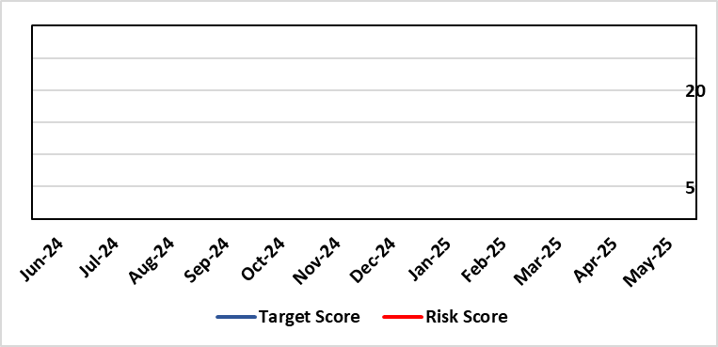 |  | Rationale for current score:  Consequence – catastrophic – due to loss of ability to support clinical services and manage blood transfusion services  Likelihood – probable (10-50% chance currently) – due to being off-track on project and lack of confirmed back-up plan.
Level of Control  = |  |  | Rationale for target score:  Consequence as above  Likelihood will be negligible if effective system / mitigations put in place in time
Date added to the HB risk register
18/06/2025
Controls (What are we currently doing about the risk?) |  |  | Mitigating actions (What more should we do?)
Working with Digital Health and Care Wales to explore how access to the current LIMS system could be extended beyond 15th December 2025  The current LIMS system is accessed through remote access software. Licenses for the remote access software end on 14th December 2025. This means from 15th December 2025 SBUHB Pathology services will not be able to access the current LIMS system. Digital Health and Care Wales are underway with a procurement exercise that could either extended licenses for, or replace, the current remote access software.  Configuring and testing the new LIMS system with the aim of go-live before 15th December 2025  The new LIMS system does not require remote access software. If the Health Board can go live on the new LIMS system before 15th December 2025 the risk will not be realised. SBUHB Pathology services are working in collaboration with other Health Boards and Trusts to share configuration and testing as part of a national programme. However, there is low confidence in achieving go-lives in September (Cellular Pathology), Blood Sciences (October) and Blood Transfusion (November) given the number of issues in the system. Testing has been already extended from two months to twelve months.  Pursuing only a ‘Minimal Viable Product’ to avoid scope-creep  SBUHB Pathology Services are only seeking to pursue a safe replacement system, known as a ‘Minimal Viable Product’. This is to eliminate the possibility of testing timescales being extended. Other Health Boards and Trusts report they are following the same approach.  Challenging the supplier and Digital Health and Care Wales for their technical delivery  The supplier is responsible for addressing any defects identified during testing. Digital Health and Care Wales (DHCW) are responsible for delivering some of the technical integrations (in addition to co-ordinating the national programme). The SBUHB Project Team, through the programme governance, challenge the supplier and DHCW to deliver on their commitments. |  |  | Action | Lead |  | Deadline
 |  |  | Blood Transfusion is the last pathology discipline to go live (November) and is consequently most at risk from access being lost from 15th December 2025. Explore how the Blood Transfusion Module of the current LIMS could potentially be accessed without the need for remote access software. | Head of Laboratory Medicine |  | TBC
Assurances (How do we know if the things we are doing are having an impact?)  National Programme Board  SBUHB, together with all Health Boards, Trusts and the supplier belong to the national LIMS Programme Board.  The Programme Board receives updates on Digital Health and Care Wales progress towards procuring extended licenses, or a replacement of, the current remote access software.  The Programme Board receives updates on testing activities, including metrics showing the number of outstanding system issues. It is chaired by the Executive Director of Allied Health Professions and Health Science for Aneurin Bevan University Health Board.  SBUHB Project Team  A Project Manager is in place to manage the SBUHB Project Team on daily basis.  Operational Delivery Network LIMS 2.0 Sub-Group  SBUHB work in regional partnership with Hywel Dda University Health Board (HDUHB) and hold a joint, monthly Operational Delivery Network LIMS 2.0 Sub-Group, which receives reports from the SBUHB and HDUHB Project Managers, along with Programme Managers from the supplier and Digital Health and Care Wales.  This group is jointly chaired by the SBUHB Clinical Lead for Laboratory Medicine and HDUHB Head of Pathology Service, who are also Senior Responsible Officers for the SBUHB and HDUHB projects.  Morriston Management Board  The SBUHB project regularly reports progress to the Morriston Management Board.  Digital, Data, Research and Innovation Committee  The SBUHB project regularly reports progress to the Digital, Data, Research and Innovation Committee. |  |  | Gaps in assurance (What additional assurances should we seek?)  The national programme team have stated that engagement on costs will initiated with Directors of Finance by the DHCW Director of Finance. SBUHB should seek assurance on minimising and meeting the costs of the proposed mitigation and backup plans:  Meeting the costs of mitigation  The SBUHB go-live date had been planned for June 2025, but a proposed ‘mitigation plan’ put forward by the national programme team seeks both to extend testing timescales and extend licensing for the current LIMS (otherwise due to expire in June 2025) while still achieving go-live before 15th December 2025. It also re-profiles non-SBUHB Blood Transfusion activities into Q1 2025/26. The national programme estimate the cost across Wales at £1.6m.  Meeting the costs of the backup plan  If a go-live before 15th December 2025 is not achieved, a backup plan has been proposed by the national programme team which would extend both access to the current LIMS system and the programme to implement the new LIMS system.  The national programme estimate the cost across Wales between £7.2m (for 3 months) and £12.3m (for 12 months).  A significant proportion of these costs are associated with the remote access software. If the procurement exercise by Digital Health and Care Wales to source an extension or replacement of the remote access software is unsuccessful, then the current supplier is only willing to extending licenses for a minimum of 3 years at a cost of around £5m.
Additional Comments / Progress Notes
User Acceptance Testing sign-off
User Acceptance Testing across Wales was originally expected to take place across the two months of September and October 2024. However, a significant number of issues in the system, coupled with partial delivery of integrations between the LIMS and national systems managed by Digital Health and Care Wales, were identified early in the process. Maintaining the availability of Pathology staff to undertake testing across an extended duration, alongside maintaining service delivery, has also been challenging.

User Acceptance Testing has been extended to, depending on the pathology discipline, around twelve months. Go-lives have not been delayed by the same amount and the decreased duration between the end of User Acceptance Testing and go-live puts additional pressure on the project:
 | Previously | Currently
Duration of User Acceptance Testing | 2 months | 12 months
Duration between User Acceptance Testing sign-off and go-live | 3 months | 1 month

Business Continuity
The Health Board’s current Business Continuity Plan to address a failure in digital pathology systems is to revert back to paper based reporting, which is unsustainable and would only be effective over a very short-term period (days).

Blood Transfusion services in other part of Wales
SBUHB Blood Transfusion are the only Blood Transfusion service in Wales that have successfully migrated onto the current LIMS system. Other Blood Transfusion services use other legacy systems and will potentially be impacted after the 15th December 2025 in other ways (e.g. by having to extend support for their existing legacy systems).

Pathology resource for testing
Testing is reliant on the knowledge and skills of Health Board staff whose availability is limited, having to manage testing alongside normal service delivery. With a national shortage of Biomedical Scientists, there is no readily available external resource to support this process.

Risk Score Calculation

For each risk identified, the LIKELIHOOD & CONSEQUENCE mechanism will be utilised. Essentially this examines each of the risks and attempts to assess the likelihood of the event occurring (PROBABILITY) and the effect it could have on the Health Board (IMPACT). This process ensures that the Health Board will be focusing on those risks which require immediate attention rather than spending time on areas which are, relatively, a lower priority.

