

HEALTH BOARD RISK REGISTER
January 2025
DIGITAL, DATA, RESEARCH & INNOVATION COMMITTEE

Datix ID Number: 1035  Health & Care Standard: |  |  | HBR Ref Number: 27  Risk Target Date: 31/03/2026 |  | Current Risk Rating  4 x 4 = 16
Objective: The delivery of care is supported by innovative digital solutions |  | BAF Ref: 4 | Director Lead: Matt John, Director of Digital  Assuring Committee: Digital, Research & Innovation Committee
Risk: Digital Transformation  Inability to deliver sustainable clinical services due to lack of resources to deliver sustainable Digital Transformation and services. There are insufficient resources to:  - Invest in the delivery of the SBU Digital strategy  - Support the growth in utilisation of existing and new digital solutions  - Replace existing technology infrastructure or software at the end of its useful life. |  |  | Date last reviewed: January 2025
Risk Rating  (consequence x likelihood):  Initial: 4 x 4 = 16  Current: 4 x 4 = 16  Target: 5 x 2 = 10 | 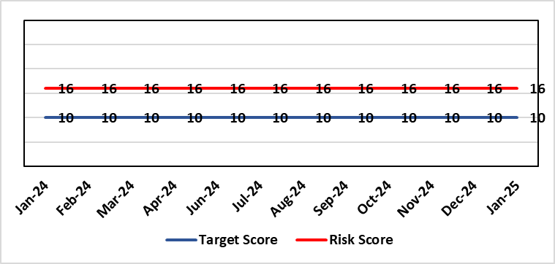 |  | Rationale for current score:  C – Reliance on digital ways of working has increased. Loss of IT service has a greater impact on ability to provide clinical care. Lack of investment in new digital solutions to make services more effective will mean clinical service provision will become unsustainable.  L- Reduction in capital funding in 2022/23/24 has increased the likelihood of HB not being able to replace aging infrastructure such as the network equipment. There is a £15m capital requirement over the next 3 years. Acceleration of the CTM SLA disaggregation has been proposed and there are further pressures on revenue funding. The shift to cloud and software as a service contracting models will increase the requirement for revenue funding to deliver digital transformation and ongoing services.
Rationale for target score:
C – Of failure will increase as the reliance and proliferation of the use of digital solutions increases.
L – Investment will mean the support mechanisms, rate of failure and ability to deliver solutions that meet the needs of users will improve sustainable digital services. There will however always be an inherent risk of failure of IT solutions.
Level of Control
= 50%
Date added to the HB risk register
2012
Controls (What are we currently doing about the risk?) |  |  | Mitigating actions (What more should we do?)
- Digital Strategy has been approved by the Health Board and outlines requirements  - HB Capital priority group considers digital risks for replacement technology which is fed into the annual discretionary capital plan  - Digital Services prioritisation process is in place Digital Leadership Group provides the overarching governance to the delivery of the Digital Strategic Plan including financial considerations.  - Digital Services Management Group assesses current service provision and flags risks and issues  - Digital Services revenue requirements are included in 2025/26 annual plan |  |  | Action | Lead |  | Deadline
 |  |  | Refresh the Digital Strategy including a high level investment plan to set out vision for the Health Board | Assistant Director of Digital: Business Management and Information Governance |  | 31/03/2025
Assurances (How do we know if the things we are doing are having an impact?)  - Internal Audit Program assesses Digital in 4 areas annually |  |  | Gaps in assurance (What additional assurances should we seek?)  - Lack of certainty over future capital and revenue funding streams makes planning and implementation difficult/less effective.
Additional Comments / Progress Notes
08/11/2025 – Action due date extended to 31/01/2025.Following discussions at the Digital, Data, Research and Innovation Committee.
10/01/2025 - The strategy was presented to the DOF and CEO on the 9th January. The paper is going to the Digital, Data, Innovation & Research Committee on the 16th January. Then it will go to the Board for approval in March 2025.

Datix ID Number: 1043  Health & Care Standard: |  |  | HBR Ref Number: 36  Risk Target Date: 31/07/2025 | Current Risk Rating  4 x 4 = 16
Objective: The delivery of care is supported by innovative digital solutions |  | BAF Ref: 4 | Director Lead: Matt John, Director of Digital  Assuring Committee: Digital, Research & Innovation Committee  For information: Quality & Safety Committee
Risk: Paper Record Storage  Lack of a single electronic record means there is greater reliance on the provision of the paper record. If we fail to provide adequate storage facilities for paper records, then this will impact on the availability of patient records at the point of care. Quality of the paper record may also be reduced if there is poor records management in some wards. There is an increased fire risk where medical records are stored outside of the medical record libraries. |  |  | Date last reviewed: January 2025
Risk Rating  (consequence x likelihood):  Initial: 4 x 5 = 20  Current: 4 x 4 = 16  Target: 3 x 3 =9 | 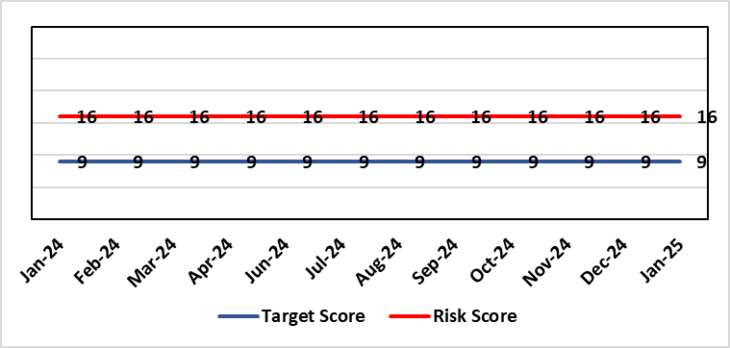 |  | Rationale for current score:  C - Inability to find records for patients could delay care/increase length of stay over 15 days. Could also mean patients receive incorrect treatment. Increased risk of fire where records are stored outside of the medical record libraries.  L - we know this happens from incidents raised
Level of Control  = 70% |  |  | Rationale for target score:  C - The increased development and adoption of the digital record will reduce the need for the paper health record being available at the point of care.  L - The increased development and adoption of the digital record, the introduction of RFID and the approach to management of the paper record identified in the Business case process should reduce the amount of paper required to be stored and managed.
Date added to the HB risk register
June 2016
Controls (What are we currently doing about the risk?) |  |  | Mitigating actions (What more should we do?)
- There is a plan in place to increase the functionality of the electronic record to document patient care. The delivery of the plan is overseen by the Digital Leadership Group and progress provided to Management Board. (Supported by individual project boards as appropriate).  - Records managed by the Medical Records libraries are RFID tagged and location tracked.  - Medical Record libraries are regularly risk assessed for fire by health and safety.  - Alternative offsite storage arrangements have been identified.  - All records must be documented on the Information Asset Register (IAR). |  |  | Action |  | Lead | Deadline
 |  |  | Movement of records and staff into new centralised unit |  | Head of Health Records & Clinical Coding | 31/03/2025
 |  |  | Allow for new process to stabilise and evaluate benefits of new centralised unit. |  | Head of Health Records & Clinical Coding | 30/05/2025
Assurances (How do we know if the things we are doing are having an impact?)  - RFID has been implemented for the acute record improving the management and storage of records  - Health Records performance reports developed in line with RFID technology  - Attainment of the Tier 1 Health Board target for clinical coding completeness which relies on the timely availability and quality of the Paper record and electronic sources  - Monitoring complaints and incident reporting.  - Electronic record is being implemented in accordance with the plan eg implementation of WNCR, ETR, HEPMA etc. |  |  | Gaps in assurance (What additional assurances should we seek?)  Investment required supporting the delivery and operational costs of the Digital strategy.  Reliance on DHCW for delivery of the solution for a fully electronic patient record.  Impact of the Infected Blood Enquiry on the Health Boards ability to destroy notes.  Process for ensuring clinical adoption of electronic ways of working and cessation of adding information to the paper record that is already available electronically needs to be agreed and enforced by the Health Board.  Impact of the infected Blood Inquiry on the health boards ability to destroy notes and the change in the records code of practice is being reviewed by the Director of Digital.
Additional Notes
11/09/2024 (Revised 27/09/2024) – Two previous actions completed: WG approval for Health Records Business Case; legal agreement with landlord.
Actions & targets revised: Two actions now included within the risk. Action 1 – All necessary work in progress and milestones agreed with contractor. Action 2 – Allowing time for new staff and processes to settle within the new unit, evaluate impact and consider further actions if required.

Datix ID Number: 1217  Health & Care Standard: |  |  | HBR Ref Number: 37  Risk Target Date: 30/06/2026 |  | Current Risk Rating  4 x 3 = 12
Objective: The delivery of care is supported by innovative digital solutions |  | BAF Ref: 4 | Director Lead: Matt John, Director of Digital  Assuring Committee: Digital, Research & Innovation Committee
Risk: Operational and strategic decisions are not data informed:  - Significant gaps in information collection due to lack of digital clinical systems especially within Primary, Community and Mental Health services (Connecting Care System) resulting in inability to deliver statutory reporting requirements.  - Users are unable to access the information they require to make decisions at the right time  - Business intelligence and information already available is not always utilised effectively |  |  | Date last reviewed: January 2025
Risk Rating  (consequence x likelihood):  Initial: 4 x 3 = 12  Current: 4 x 3 = 12  Target: 4 x 2 = 8 | 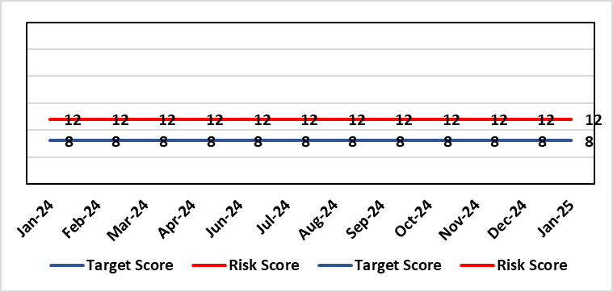 |  | Rationale for current score:  C – Opportunity cost of not acting on data could mean opportunities for improvement are missed, failures are not identified in a timely manner resulting in adverse national publicity and/or delays in care/increased length of stay.  L - Following appointments Business intelligence partners and introduction of data literacy course of Dashboard utilisation has significantly increased. However, there are significant data gaps with community and mental health areas due to the lack of digital systems.
Level of Control  = 70% |  |  | Rationale for target score:  C- Will remain the same or increase due to increased reliance in information  L- Investment in BI will lead to more information be available and used. The higher the use of information at operational level will lead to better quality data.
Date added to the HB risk register: July 2016
Controls (What are we currently doing about the risk?) |  |  | Mitigating actions (What more should we do?)
- Four BI partner roles have been appointed and are working with SDGs to help drive data literacy and data driven decision making with services.  - Ad-hoc Data literacy module training is given and a formal Manager’s Pathway Course has been developed which circa 100 manager’s a year attend.  - Self-service dashboards in areas such as UEC and Mental Health have been developed to allow service users to derive the data and insights they require.  - Over 100 dashboards in place including Cancer, Patient Flow, Outpatients, Mortality, Clinical Variation, Primary & Community Care Delivery Unit Dashboard and Ward Dashboard and Apps created for all key areas.  - Safety Huddle implemented in Morriston has improved data quality and improved operational working.  - Quality and Safety Dashboard continues to be developed delivering key insights around agreed measures.  - New technologies being reviewed for advanced analytics and integration into a new Health Board analytics platform.  - Health Board has representation on national groups such as the Advanced Analytics Group (AAG), all Wales Business Intelligence and Data Warehousing Group and Welsh Modelling Collaborative.  - Digital Intelligence representatives involved within Digital SDG meetings to emphasise importance of the implementation of digital solutions for data capture. |  |  | Action | Lead |  | Deadline
 |  |  | Digital Strategy to be approved through Health Board | Director of Digital |  | 31/03/2025
 |  |  | Initial Draft Digital Intelligence Strategy 2025-2028 | Assistant Director of Digital Intelligence |  | 31/01/2025
 |  |  | Digital Intelligence 2025-2028 Strategy approved | Assistant Director of Digital Intelligence |  | 31/03/2025
Assurances (How do we know if the things we are doing are having an impact?)  More evidence based and proactive decisions being made.  Dashboard technology; assist in developing indicators / triangulating information to identify issues  Number of unique users and unique dashboards used increases  Dashboard usage increases within areas where current digital maturity is low due to inadequate systems for data collection.  Number of people attending Data Literacy Training courses continues to grow  An internal audit of the Digital Intelligence Strategy implementation was completed in May 2023 and received a substantial grade. |  |  | Gaps in assurance (What additional assurances should we seek?)  Significant gaps in data still remain within certain areas primarily due lack of digital clinical systems. Culture of the organisation continues to change to focus on information and Business intelligence for operational rather than just reporting purposes. With the capability of operational staff to utilise the tools and capacity to act on the intelligence provided increasing through training and awareness.
Additional Comments / Progress Notes
05/12/2024: Actions updated.
10/01/2025: Action targets refreshed

Datix ID Number: 2796  Health Care Standards: |  |  | HBR Ref Number: 90  Target Risk Date: 30/04/2025 |  | Current Risk Rating  4 x 5 = 20
Objective: The delivery of care is supported by innovative digital solutions |  | BAF Ref: 4 | Director Lead: Matt John, Director of Digital  Assuring Committee: Digital, Research & Innovation Committee
Risk: Non-compliance with UK-GDPR Article 15 regarding Subject Access Requests (SARs), along with other health records requests for disclosure of personal data  If the Health Board is non-compliant with the UK-GDPR, then there is a risk of ICO enforcement action being taken against SBUHB, reputational damage and the potential for claims.  The Health Board does not have adequate/identified resources to deal with the sustained increase in volume and complexity of subject access/access to health records requests received from requestors and is seeing a large number of SARs exceeding the required legal timeframe for response, which poses the risk of ICO involvement if backlogs continue to grow.  There are significant challenges across the Health Board pertaining to the timely redaction and clinical review of records prior to disclosure. Individual services/departments do not have adequate health professional resources and/or knowledge on undertaking redaction. Currently, a high number of records are released without adequate redaction and review in order to meet the legal timeframe. The lack of review/adequate redaction increases the risk of personal data breaches occurring.  Complex requests received can include both corporate and medical records. Information can be located across multiple services/departments which can be paper based or held within numerous systems, databases and applications or non-corporate communication channels. They can include particularly sensitive and contentious information relating to safeguarding, ongoing complaints claims or legal aspects.  There is a risk of personal data breaches occurring without higher scrutiny of the amount of misfiling happening at a service level resulting in SARs needing to be double checked by Health Records Team to ensure don’t include other individual’s personal data.  There will also be a knock-on effect/impact on staff who are already working on other priority work when they are required to have input in the SAR process. |  |  | Date last reviewed: January 2025
Rationale for current score:
C – The Health Board has a statutory requirement to comply with UK GDPR and Data Protection Act 2018. This includes compliance with an individual’s Right to Access their personal data. The Information Commissioner has the power to take enforcement action, including substantial monetary penalties, for non-compliance (up to 4% of annual worldwide turnover), for serious breaches of data protection principles. Historically, a number of complaints regarding the handling of SARs within SBUHB have been highlighted previously in both the mainstream media and on social media, leading to a loss of trust in the Health Board with damage to staff and Health Board reputation and a breach of data subjects’ fundamental right.
L- The Health Board does not have adequate/identified resources to deal with the sustained increase in volume and complexity of SARs received from both patients and staff as a result of changes to the SAR landscape since the introduction of UK-GDPR and advancements in technology and data availability. There are inconsistent processes across the Health Board, with varying levels of robustness regarding legal compliance. The increased use of various digital applications has impacted the volume and complexity of content and the ability to retrieve the personal data required to comply with SARs. Since Covid, there have been rapid changes in ways of working such as the use of non-corporate communication channels (e.g. WhatsApp) and increased e-mails with clinical relevance - with no or limited recording back to the clinical and corporate records. The process for ensuring information is appropriately reviewed and redacted by health professional within services has become far more complex and resource intensive increasing the likelihood of personal data breaches and/or non-compliance with legal timescales for disclosure. The ICO have previously been involved with a number of complaints in this area and there is an increased potential for future enforcement action if significant improvements are not made. SBUHB is already seeing an increase in complaints and ICO input relating to the handling of SARs to the extent that further complaints are expected to materialise with a very high level of frequency and probability. Solicitors’ correspondence on behalf of individuals is becoming increasingly difficult with threats of legal action. The ICO has this year issued a reprimand to an NHS Trust in England in connection with their poor compliance with the statutory timescales to respond to SARs and the ICO have indicated an intention to more closely monitor organisations who develop significant backlogs when responding to SARs.
Risk Rating  (consequence x likelihood):  Initial: 4 x 4 = 16  Current: 4 x 5 = 20  Target: 4 x 3 = 12 | 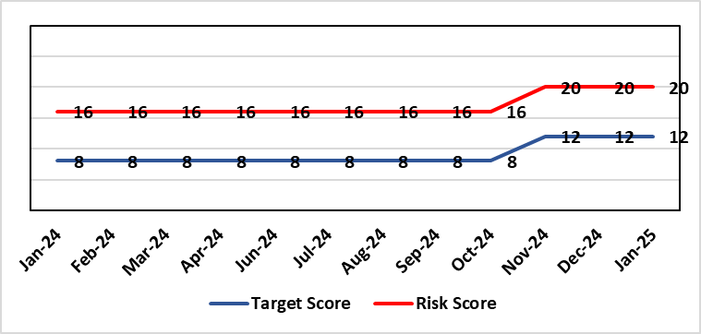
Level of Control  = 50% |  |  | Rationale for target score:  C – As above  L – Additional resources would allow the organisation to make significant improvements to the process by which SARs are managed. Being able to adequately comply with legal requirements reduces the likelihood of enforcement action and fines from the ICO, as well as minimising the risk of reputational damage.
Date added to the risk register
Jan 2023
Controls (What are we currently doing about the risk?) |  |  | Mitigating actions (What more should we do?)
- New SAR (Subject Access Request) Working Group established in February 2024  - Prioritisation of workload  - Revised SAR policy in place (to be reviewed & updated in line with Working Group actions)  - Advice sought from Legal and Risk on complex cases  - Escalating areas of concern to IGCAG (Information Governance & Cyber Assurance Group) |  |  | Action | Lead |  | Deadline
 |  |  | Undertake benchmarking exercise to establish extent of issues compared to other Health Boards | Head of Health Records |  | 31/12/2024
 |  |  | Develop Action Plan | Data Protection Officer/Head of Health Records |  | 30/04/2025
Assurances (How do we know if the things we are doing are having an impact?)  - Bi-monthly IGCAG chaired by SIRO (Senior Information Risk Owner) and attended by Deputy Caldicott Guardian and Data Protection Officer  - Escalation reports from IGCAG to Management Board & Digital, Data, Research and Innovation Committee as required  - IG governance structures in place with key roles and responsibilities established e.g. SIRO, Caldicott Guardian, DPO (Data Protection Officer) |  |  | Gaps in assurance (What additional assurances should we seek?)  Recent internal audit identified the requirement to invest in resources to address gap in assurance.
Additional Comments / Progress Notes
27/09/2024 – Action targets refreshed.
14/10/2024 – Risk rearticulated to better reflect the current challenges faced by the Health Board and to provide context underpinning those challenges. Actions replaced.

Risk Score Calculation

For each risk identified, the LIKELIHOOD & CONSEQUENCE mechanism will be utilised. Essentially this examines each of the risks and attempts to assess the likelihood of the event occurring (PROBABILITY) and the effect it could have on the Health Board (IMPACT). This process ensures that the Health Board will be focusing on those risks which require immediate attention rather than spending time on areas which are, relatively, a lower priority.

