Appendix A
Fig 1.
Population Health – Intelligence Portal
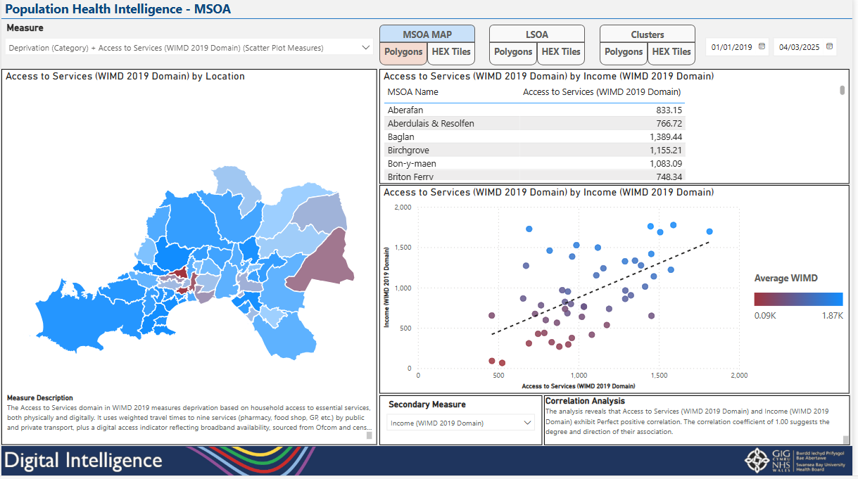
Dashboard allowing users to select deprivation measures such as employment and education to compare, analyse and view correlations between health measures such as Mortality and DNA rates.

Fig 2.
Population Health – Activity Dashboard
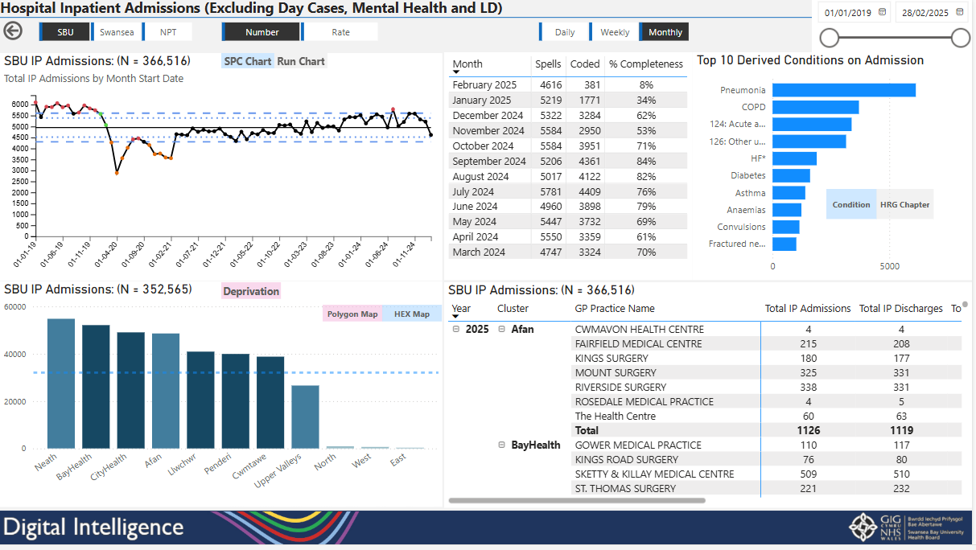
This page demonstrates hospital inpatient admissions via GP cluster and practice and the common conditions patients have been admitted with.
Fig 3.
Cellular Pathology Episodes
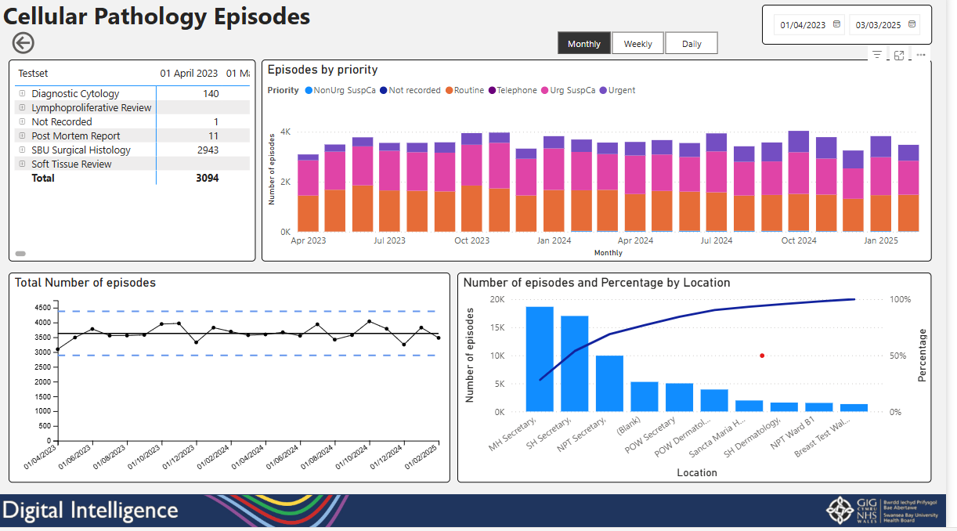
This view demonstrates the number of cellular pathology requests over time by locations and type of request.
Fig 4.
Cellular Pathology Turnaround Times
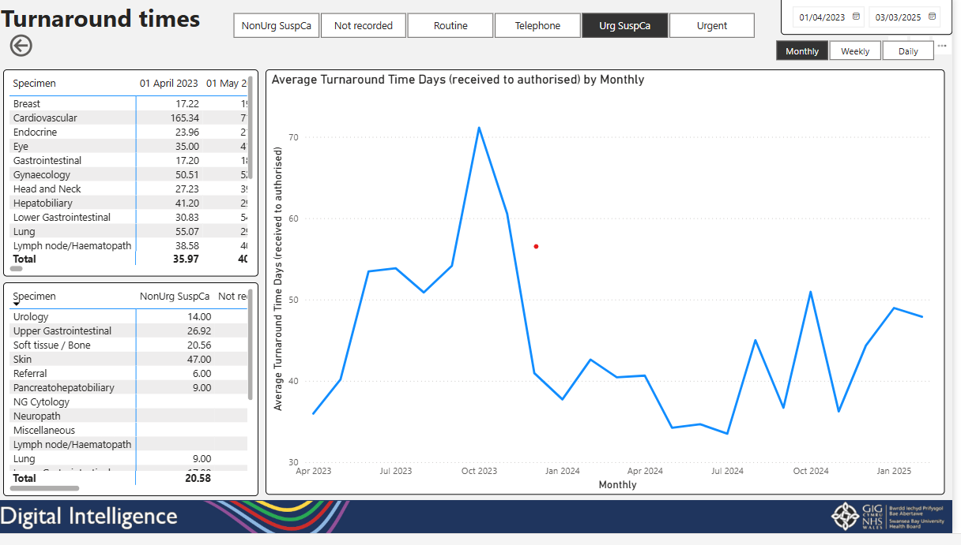
Dashboard page demonstrating the average turnaround times of requests which can filtered by request type and split into a monthly, weekly or daily view.
Fig 5.
Minor Injury Unit Simulation Model
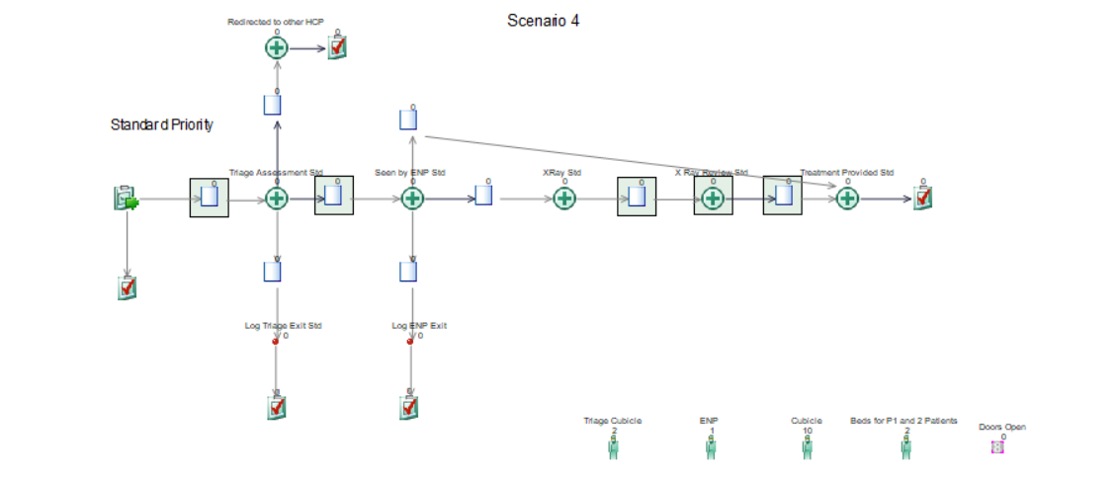
Simulation model showcasing the different processes within a patient journey at the Minor Injury Unit that allows variables to be changed to view different outcomes.

Fig 6.
Pathways of Care Delays Report
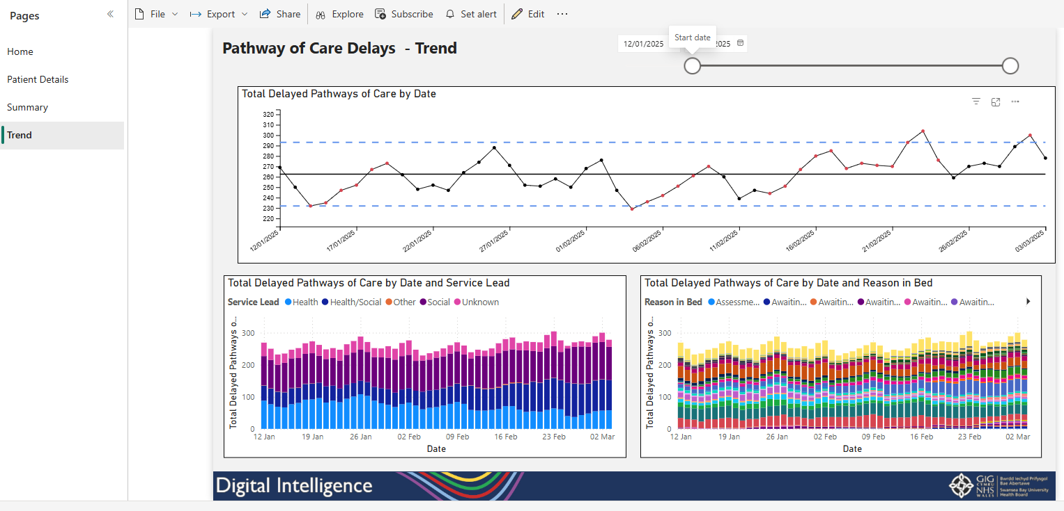
Dashboard showing total number of pathway care delays over time which can be viewed by reasons and services.

Fig 7.
Weekly Executive Summary
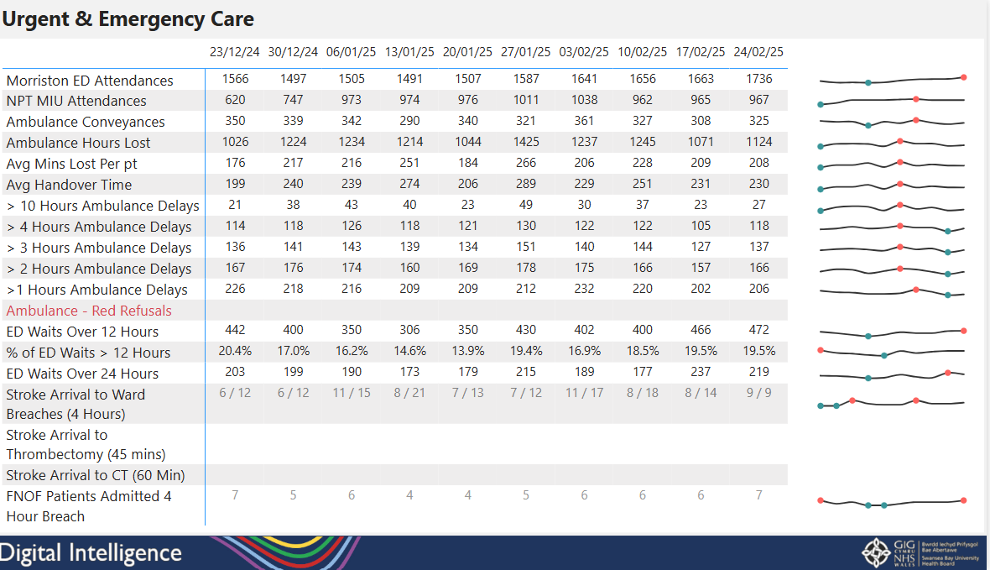
Summary report showing weekly trends of urgent and emergency care measures such at ED attendances, ambulance conveyances and ED waits that once approved will be emailed to executives weekly.

Fig 8.
Urgent and Emergency Care Summary Prototype
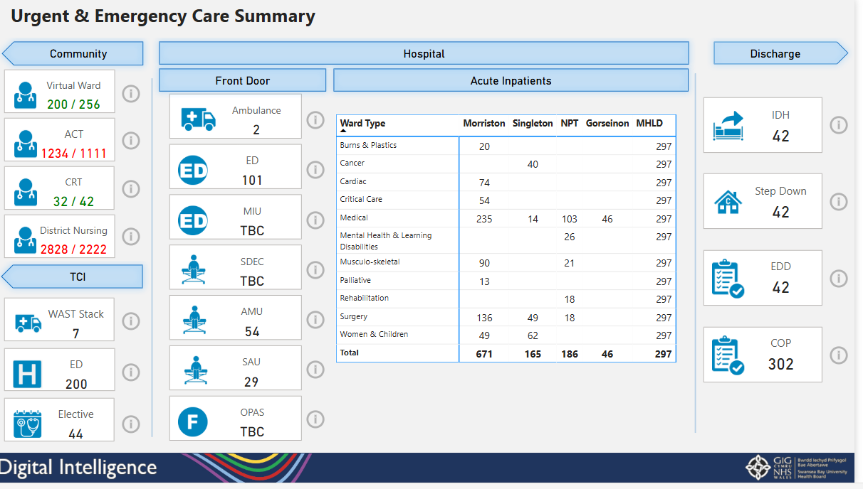
Prototype dashboard showing a collation of key front-door, community discharge and inpatient service measures throughout the urgent and emergency care system. Once approved this will be added to the Urgent and Emergency Care App.

