Appendix A
Fig 1.
Weekly Executive Summary
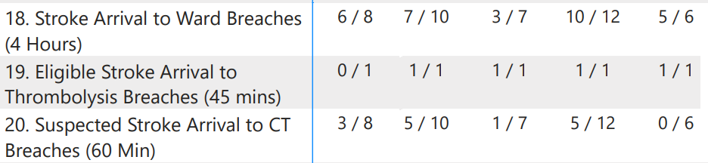
Stroke Key Performance Indicators added into the weekly Executive Summary email which is sent on a Monday morning.

Fig 2.
Emergency Preparedness, Resilience and Response Dashboard
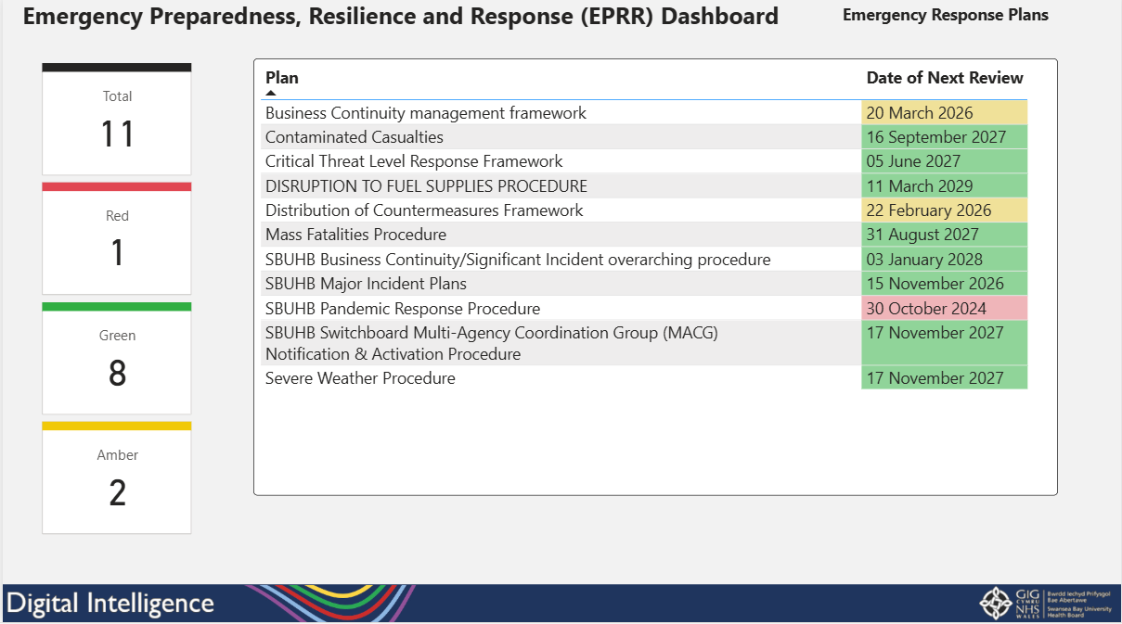
Emergency response plans page added into the EPRR dashboard showing the rag status plans and the next review date.

Fig 3.
Planned Care App
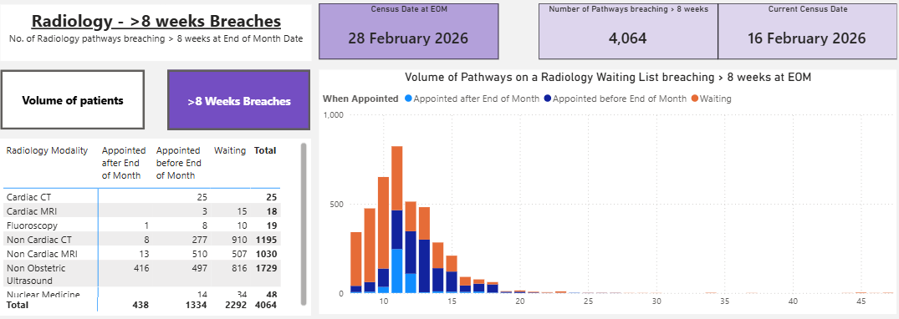
Radiology waiting list pages showing current eight-week breaches and projected eight-week breaches at the end of current census months within the Planned Care App. Users can drill down into the detail of the patients.

Fig 4 – 6.
Integrated Performance Assurance Dashboard
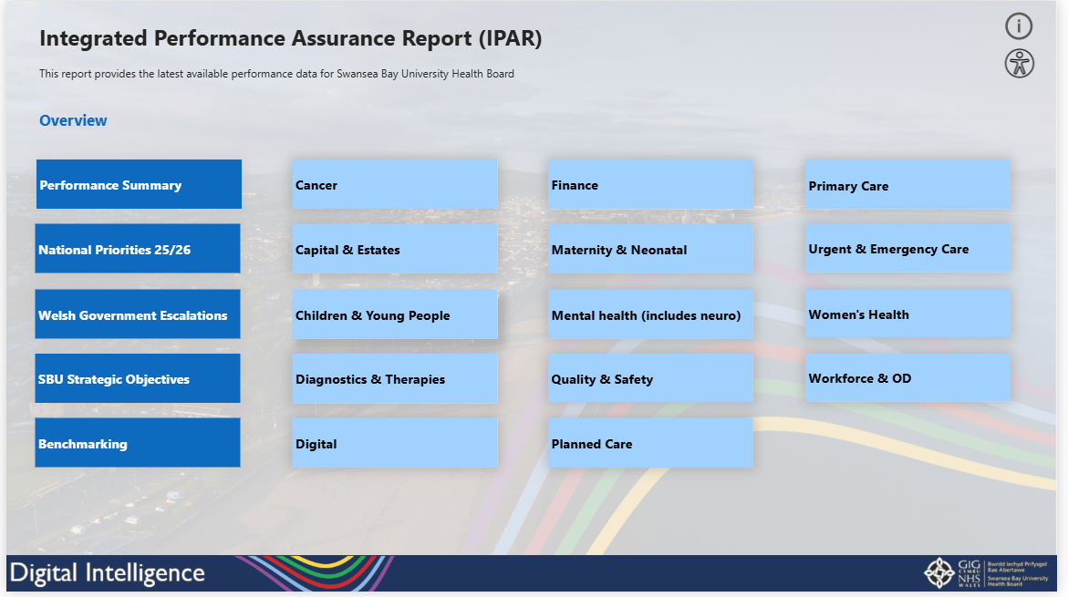

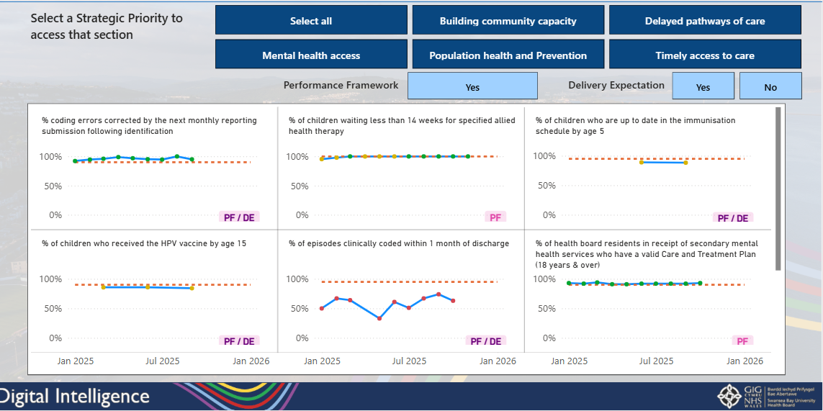

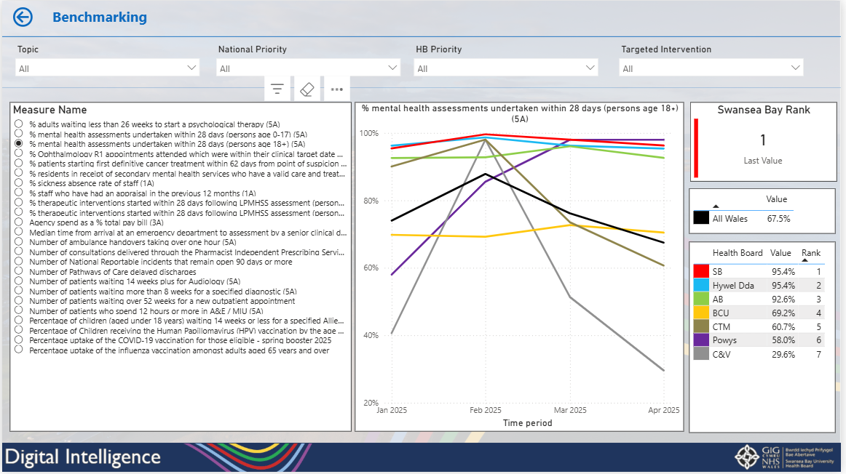
Integrated Performance Assurance Dashboard that is currently in development containing a suite of performance metrics across different areas and benchmarking visuals which the user can use to compare measures across Health Boards.

