Meeting Date | 05 March 2026 |  | Agenda Item |  |  | 5.1
Name of Meeting | Digital, Data, Research and Innovation Committee
Report Title | Digital Strategy and Plan Update  Focus on Quarter 4 delivery and associated risks
Report Author | Tracey Bell, Head of Digital Planning, Unscheduled and Community Care  Gareth O’Gorman, Head of Digital Planning, Diagnostics and Patient Flow
Report Sponsor | Matthew John, Director of Digital
Presented by | Deirdre Roberts, Assistant Director of Digital Transformation
Freedom of Information | Open
Purpose of the Report | The paper provides a summary of digital transformation progress for delivery of milestones in Q4 of Financial Year (FY) 2025/2026, with a focus on key risks and mitigations. Delivery milestones are spread across eight programmes of work, aligned to the digital strategic plan, the Integrated Medium-Term Plan (IMTP) and the organisational strategy.
Key Issues | - The Health Board’s digital plan is aligned to the approved Digital Strategic Plan, and the three priority components that contribute to the delivery of a health and social care record.  - A significant number of projects are scheduled to go live in Quarter 4 of 2025/26, with some deadlines mandated by Welsh Government. This concentration of national requirements, combined with local priorities, results in an ambitious delivery period for Q4.  - Go live of some projects scheduled for Q4 FY25/26 will be deferred to FY26/27; Signal v4, Digital Maternity (phase 2), Shared Medicines Record and a solution for Unscheduled Care. Where appropriate these delays have been escalated locally and / or nationally.
Specific Action Required  (please choose one only) | Information | Discussion |  | Assurance | Approval
Specific Action Required  (please choose one only) | ☐ | ☐ |  | ☒ | ☐
thematic | Members are asked to:  RECEIVE: the update on the FY2025/2026 Q4 scheduled digital delivery, noting the progress made and the number of parallel implementations.  RECEIVE: the update that some projects will not be delivered in Q4 and delivery will be carried forward to FY26/27.

Quarter 4 Delivery Plan and associated risks

- INTRODUCTION
The Swansea Bay University Health Board’s Digital strategic plan is aligned with the organisation’s Integrated Medium-Term Plan (IMTP) including the 2025/2026 digital work programme.

A significant number of projects are scheduled to go live by the end of Quarter 4 Financial Year (FY) 25/26. Delivery in Quarter 4 has been imposed for several reasons, including funding availability for FY 25/26 and delivery deadlines mandated by Welsh Government. This concentration of national requirements, combined with local priorities, results in an ambitious delivery period. The need to balance national directives with operational realities is challenging for the Health Board to deliver against these deadlines, requiring agile resource allocation, robust risk management, and clear communication to ensure successful delivery and sustainable transformation.

This paper sets out the progress made against the FY 2025/2026 Digital Delivery Plan including the key milestones scheduled for delivery in Quarter 4 of FY 25/26. The Quarter 4 plan reflects the high volume of concurrent system go-lives scheduled within a compressed timeframe, highlighting key risks and mitigations to deliver against the ambitious timescales, recognising some projects will need to be carried forward to FY26/27.

BACKGROUND
The Digital 3-year plan was developed and assured by DDRI in July 2025. This plan demonstrated alignment between the digital strategic plan, the IMTP and the organisational strategy. This was supported by a more detailed 1-year plan that provided an overview of digital transformation projects for delivery in the Financial Year (FY) 2025/2026.

Good progress has been made across the digital delivery plan during this financial year (FY25/26), with several projects generating meaningful operational efficiencies and service improvements such as Hybrid Mail and the Swansea Bay Patient Portal. Hospital Electronic Prescribing and Medicines Administration (HEPMA) alerts in Signal were released, prompting timely review of prescriptions and supporting targeted intervention. Cellular Pathology went live with LIMS 2.0; the first users in Wales. The Welsh Patient Administration System (WPAS) disaggregation has also successfully completed. The Open Eyes Electronic Patient Record was successfully implemented and well received by the Ophthalmology service; work continues to map national Wales General Ophthalmic Services (WGOS) pathways in readiness for the national e-referral solution go live at the end of March. However, as previously reported, the Welsh Government ministerial priorities, associated delivery deadlines in addition to supplier and DHCW delays has resulted in delayed go live for some key projects.

These include Signal v4, the Unscheduled Care app, LIMS 2 (Blood Sciences and Blood Transfusion) and the Shared Medicines Record. In addition, the joint digital and maternity team are exploring a phased implementation of Badgernet (Digital Maternity) with a view phase 1 goes live in March, followed by a phase 2 implementation in FY 26/27.

A detailed Project Delivery Dashboard for active Digital projects in FY 25/26 can be found in Appendix 1.

- Quarter 4 Delivery Schedule
Figure 1 outlines the Quarter 4 Digital Transformation Programme plan. It reflects the high volume of concurrent system go-lives scheduled within a compressed timeframe and underscores the extensive readiness and stakeholder engagement activities that have taken place to meet the demanding timescales and ensure successful deployment. It highlights that some key milestones have been delayed, creating a risk to the overall delivery of certain projects. These risks are outlined in Section 4, where further detail is provided on the cause, impact and proposed mitigations.

Figure 1 Legend
Milestone completed as planned
Original milestone delayed
Milestone scheduled for completion

Figure 1 - Progress made against Q4 Milestones

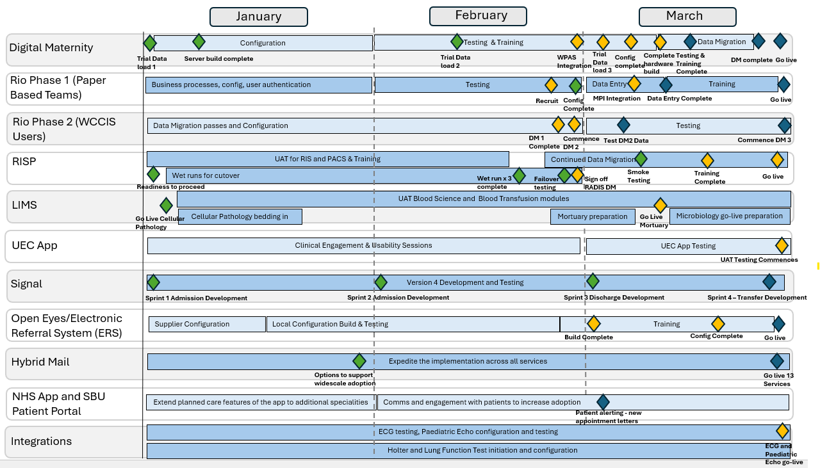

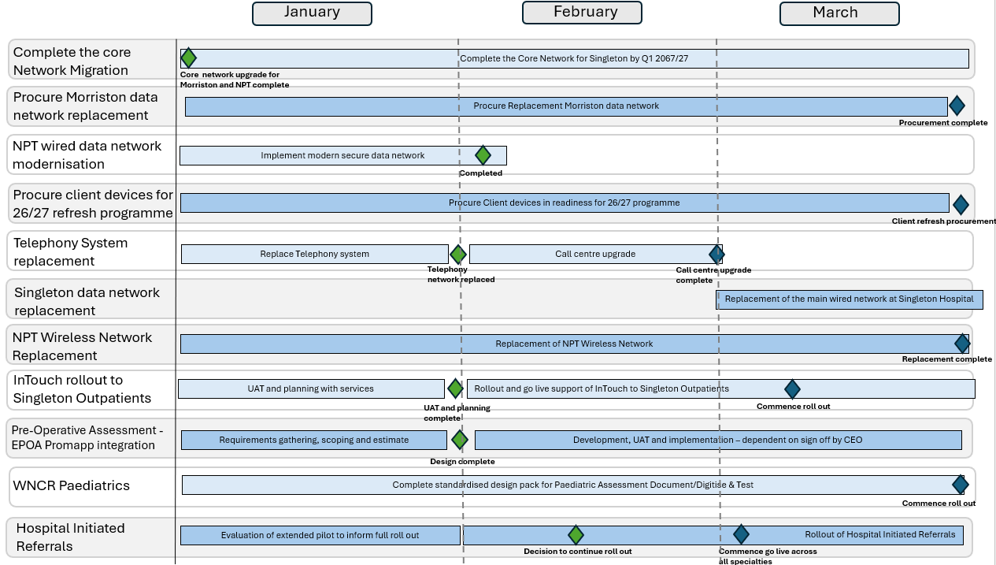

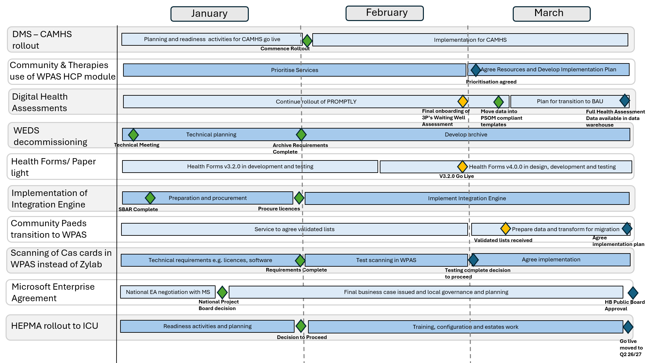

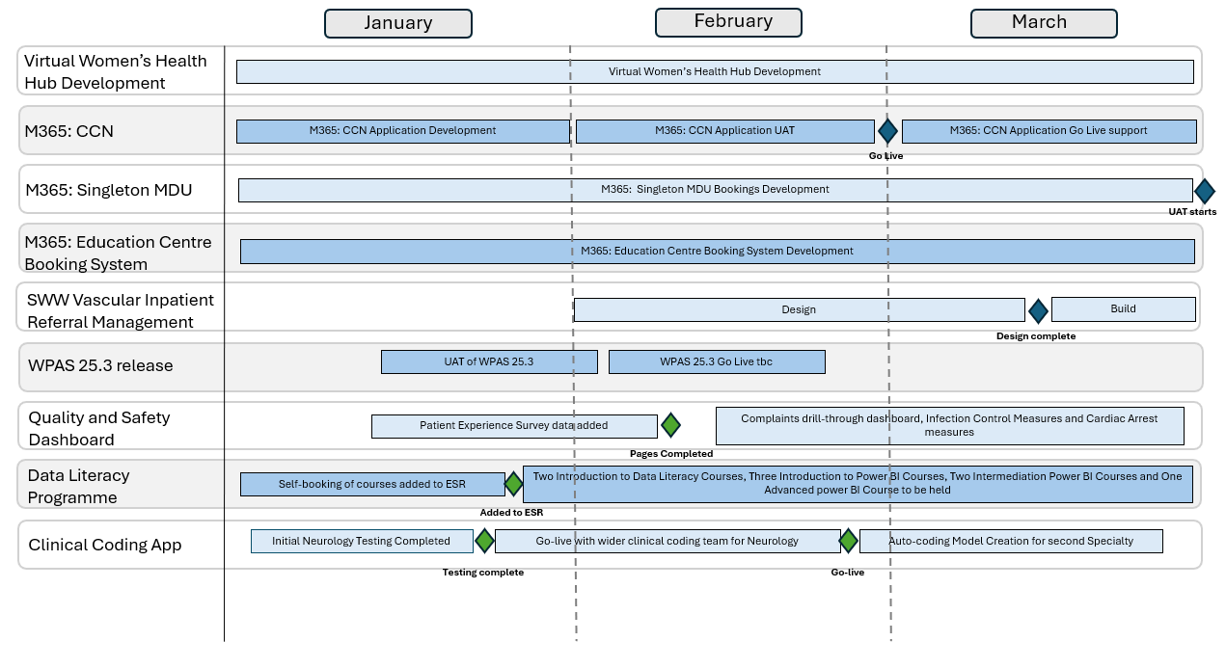

- GOVERNANCE AND RISK ISSUES

Governance
Digital delivery for Quarter 4 continues to be governed by dedicated digital programme boards, which include representation from clinical and operational teams. These boards provide regular progress updates and escalate risks, where necessary, to the relevant Health Board Programme Board (e.g., Unscheduled Care, Mental Health, and Planned Care). Reporting to the appropriate Health Board Programme Board is critical to ensure delivery timelines are understood, resources are aligned to support implementation and service transformation, and that risks, coupled with mitigation strategies, are actively monitored and addressed.
Risks pertaining to live operational services continue to be managed via the Digital Service Management Group (DSMG).
Throughout the year, the digital team have worked closely with service leads to identify emerging risks early, assessing potential impact, and agreeing mitigation strategies to safeguard delivery and maintain patient safety. In addition to the governance framework in place, key risks have been described in project specific updates for Management Board and where necessary individual risks have been added to the relevant Service Delivery Group register and / or escalated to the Health Board risk register.
Risk
Key risks specific to Quarter 4 delivery are set out below:

Laboratory Information Management System 2 (LIMS):
- SBUHB Cellular Pathology successfully went live - the first in Wales - showcasing commitment to transitioning to LIMS 2.0.
- In the national plan, SBUHB Blood Sciences are scheduled to go live in July 2026. There are 218 critical defects that must be resolved before go-live. These are expected to be resolved by the end of March (previously reported end February) 2026 for testing by Health Boards.
  - Biochemistry has the largest volume of defects still requiring testing alongside key configuration items.
  - Pathology considered a suggestion from the national team of external Biochemistry testing resource. Significant training would be required, particularly for end-to-end testing involving local requesting processes, specialist interfacing and sample management, potentially extending timelines.
  - From a Biochemistry perspective, additional hours or overtime for current staff is viewed as a more practical and beneficial option.
- Public Health Wales Microbiology will go live in May 2026. This will be a “big bang” implementation across Wales.
- Blood Transfusion
  - The project team and the Blood Transfusion service remain concerned about the delivery of the Blood Transfusion module in LIMS 2.0.
  - The national plan (first published mid-January 2026) indicated a go-live in Q2 of 2026/2027 and is currently estimated to go-live in September 2026. The plan continues to be developed in consultation with Health Boards to assure the ambitious dates being proposed are realistic and that resources can be made available to meet the Q2 go-live. Paramount to the go-live will be assurance that the system configuration supports clinical workflow and importantly, regulatory requirements.
  - The supplier, Intersystems, have waived their costs until end of August but they will begin again from September onwards at £69k per month.
  - The Blood Transfusion service appreciate that the aging LIMS 1.0 infrastructure, due to become ‘end of life/support’ from August 2026 brings with it risks. Given the critical nature of Blood Transfusion services, the Health Board need to establish the level of risk being carried and what mitigations could be put in place should the service be required to remain on LIMS 1.0 for Blood Transfusion post-August 2026.
The national team have proposed extending the programme to complete delayed delivery of the Blood Sciences and Blood Transfusion modules of LIMS 2.0.

The national costs to SBUHB of extending the programme are £180k revenue and £310k capital across Q1 and Q2 2026/27.

The project continues to submit monthly updates to Management Board with progress updates and risks highlighted. Delays to the LIMS programme is included in the Health Board risk register (HBR 105, Datix ID 3114 – score 16). A paper has been submitted for consideration to a special Health Board meeting on the 26th February requesting approval of funding to absorb costs for Q1 and Q2 FY26/27 as set out above.

Radiology Information System Programme
- As previously reported the 23rd February 2026 go live date is no longer feasible. A new go live date of the 30th of March has been secured and the team are working towards this date. The Health Board awaits a Change Control Notice from Phillips to confirm the revised go live date.
- Good progress continues on data migration (3 years of Picture Archiving and Communications System (PACS) images) and testing of the RIS solution (soliton).
- The SBU current PACS contract (Fuji) has been extended to March 2027 by way of mitigation, should delivery timescales slip beyond March 2026. A delayed go-live has an associated benefit of reduced dual running costs alongside the Fuji contract.
- There is no national funding from Welsh Government for FY26/27 allocated to the RISP Implementation. If the Health Board does not go live in FY25/26 there is a risk the Health Board will need to absorb associated costs to support go-live. However, the risk of not achieving a Q4 go live has now been reduced given a go live date of the 30th of March has been secured.

Unscheduled & Emergency Care:

- The Minor Injury Unit currently use the Welsh Emergency Department System (WEDS) provided by Optum expires in May 2026, with an option to extend to September 2026 (at a cost of £60k). A replacement solution is required.
- At the request of the national 6 goals programme for unscheduled care, DHCW have developed the UEC app (including the Welsh Emergency Care Data Set (WECDS) dataset) as a Minimal Viable Product (MVP) to replace the functionality in WPAS ED.
- User Acceptance Testing (UAT) of the UEC app, was originally expected in September 2025 but has been delayed until March 31st, 2026.
- Recent usability testing with clinicians has raised concerns on the suitability of the app with the clinical leads suggesting it is a backwards step for the Emergency Department.
- To mitigate this risk, the Health Board have engaged with third party suppliers to establish how alternative solutions could support flow and safety across the UEC footprint, including the timescales for delivery.
- Given the risks associated with the contract expiry of the WEDS (Symphony) system, delivery of the UEC app and concerns regarding the suitability of its functionality to meet the requirements across the UEC footprint, a paper was presented to Formal Executives recommending the following.
  - The Health Board proceed with the procurement of the System C ED module; recognising further discussions are required to secure funding from Welsh Government prior to a contract award.
  - The Health Board no longer pursues an implementation of the national UEC system, recognising concerns raised by clinicians, operational and digital colleagues re the lack of functionality to digitally enable service transformation across the SBUHB UEC footprint.
  - The MIU will revert to the WPAS ED module as a short-term tactical solution.
- These recommendations were endorsed by Formal Executives on February 11th.
- Funding for a third party UEC solution is being factored into the UEC re-design discussions between the Health Board and Welsh Government. A meeting took place between the Director of Digital, Assistant Director of Digital Transformation and Welsh Government officials on the 23rd February. A paper setting out the proposed way forward including indicative costs is being prepared for Welsh Government.

Digital Maternity:
- SBUHB is continuing to work towards the nationally agreed go-live date of 31st March 2026. However, the ability to deliver a safe and fully assured digital solution within the current timescales remains ambitious, with low levels of confidence.
- Technical and clinical challenges are actively being managed:
  - Issues relating to the Welsh Birth Notifications (WBNS) and the WPAS integrations
  - Limited access to the Badgernet test environment following system issues encountered by System C
  - Data validation activities to support data migration, due to technical clarifications that were required by the supplier
Collectively, these challenges have resulted in substantial disruption to the planned testing schedule.
- The project team is currently without a Lead Digital Midwife due to unplanned leave, which is exacerbating the ongoing implementation challenges. This has necessitated a complete re-evaluation of the clinical assurance processes and has placed additional pressure on senior leaders within Maternity Services managing competing operational priorities, as well as digital staff undertaking configuration, business process mapping and data validation activities.
- Although SBUHB are continuing to work towards a March 31st go-live, the Health Board remain constrained by other Health Board implementations that are closely scheduled ahead of the SBUHB go-live. To mitigate this risk, SBUHB are continuing to work closely with the supplier, DHCW and regionally with Hywel Dda to share lessons learned with a focus on system configuration. The project are also exploring a phased go live implementation with a view phase 1 goes live at the end of March in line with Welsh Government deadlines.

Signal Admission Discharge and Transfer (ADT) development
- Given the contractual commitments to deliver other projects in Quarter 4, resources to deliver Admission, Discharge and Transfer developments in Signal continue to be constrained.
- The development plan has been revised, and delivery of ADTs is now expected in Q2 of FY26/27.

- FINANCIAL IMPLICATIONS
All digital projects scheduled for delivery in Quarter 4 of 2025/26 have secured funding either through direct allocations from Welsh Government, utilisation of existing resources within Digital Services, or a combination of both. This ensures that each project is financially underpinned, supporting the Health Board’s commitment to delivering its digital transformation objectives within the agreed timeframe.

Project budgets are subject to robust monitoring and are reported on in accordance with the arrangements set out in the separate finance paper previously reported to the DDRI Committee. This ensures transparency and accountability, with regular updates provided to both the Committee and the Health Board’s management structures.

It is important to note that any slippage in the delivery of key projects beyond Quarter 4 of 2025/26 will have financial implications that the Health Board will need to manage. As outlined above there are two projects that have specific external financial implications from slippage:

Radiology Information System Programme (RISP): The Health Board has committed £1.4 million for the initial go-live payment to Philips. Should delivery slip beyond the current financial year, the impact is likely to be significantly lower, in the region of £176,000. The contract for the current Picture Archiving and Communications System (PACS) has been extended to March 2027 as a mitigation. A delay in go-live would reduce dual running costs. However, the likelihood of slipping into next financial year is currently considered to be low.

Laboratory Information Management System (LIMS): As outlined above, the implementation is now slipping into 2026/27 with Blood Sciences scheduled for July 2026 and Blood Transfusion proposed for September 2026. The national costs to SBUHB of extending the programme are £180k revenue and £310k capital. In addition, the Health Board will have to extend the allocation of existing internal resources to support the implementation into 2026/27. Should the Blood Transfusion implementation slip beyond September 2026 then SBUHB will be required to pay the supplier £69k per month for the continued use of LIMS 1.0.

Any other delays in projects after 2025/26, such as Digital Maternity or Digital Eyecare, will require the reallocation of resources from 2026/27 IMTP objectives to finish implementation.

These financial implications are being actively managed through close collaboration between Digital Services, Capital Finance, and are escalated to the Executive Team as appropriate. This ensures that risks are identified early, mitigation strategies are developed, and any required decisions are taken at the appropriate level to safeguard both service delivery and financial sustainability.

The introduction of new Health Board financial controls may also impact the ability to deliver digital projects, particularly where restrictions on variable spend and procurement are in place. These controls, while necessary for overall financial governance, have the potential to introduce delays if not managed proactively. It is therefore essential that Digital Services work closely with the Executive Team, Finance and Procurement colleagues to ensure that any constraints are identified and addressed early, ensuring that the Health Board continues to meet its strategic objectives.

- RECOMMENDATION
Members are asked to:
RECEIVE: the update on the FY2025/2026 Q4 scheduled digital delivery, noting the progress made and the number of parallel implementations.
RECEIVE: the update that some projects will not be delivered in Q4 and delivery will be carried forward to FY26/27.

Governance and Assurance

Link to Enabling Objectives  (please choose) | Supporting better health and wellbeing by actively promoting and empowering people to live well in resilient communities
 | Partnerships for Improving Health and Wellbeing |  | ☒
 | Co-Production and Health Literacy |  | ☒
 | Digitally Enabled Health and Wellbeing |  | ☒
 | Deliver better care through excellent health and care services achieving the outcomes that matter most to people
 | Best Value Outcomes and High-Quality Care |  | ☒
 | Partnerships for Care |  | ☒
 | Excellent Staff |  | ☒
 | Digitally Enabled Care |  | ☒
 | Outstanding Research, Innovation, Education and Learning |  | ☐
Health and Care Standards
(please choose) | Staying Healthy |  | ☒
(please choose) | Safe Care |  | ☒
(please choose) | Effective Care |  | ☒
(please choose) | Dignified Care |  | ☒
 | Timely Care |  | ☒
 | Individual Care |  | ☒
 | Staff and Resources |  | ☒
Quality, Safety and Patient Experience
Implementation of digital systems in healthcare can have a significant positive impact on quality, safety, and patient experience. Critical to success is the wide scale adoption of an effective business change model, digital service team capacity and capability, workforce digital skills and clinical leadership.
Financial Implications
Please reference agenda: Digital Financial Management
Legal Implications (including equality and diversity assessment)
None.
Staffing Implications
Increasing numbers of staff will be required to deliver the digital change programme in SBUHB. This will be detailed in future workforce plans, individual business cases and digital priorities and plans.
Long Term Implications (including the impact of the Well-being of Future Generations (Wales) Act 2015)
- Long Term – Health and Social Care “A Healthier Wales” (2018) sets out a long-term future vision of a ‘whole system approach to health and social care’, which is focussed on health and wellbeing, and on preventing illness
- Wellbeing of Future Generations Act (2015)
  - Focus on prevention, not service provision.
  - Prevent ill health, reduce impact of illness or injury and delay onset of frailty.
  - Provide services to carers that prevent, reduce, or delay them developing a need for support.
- Swansea Bay University Health Board’s Clinical Services Plan (2019-2024)
  - Adoption of digital solutions and technology.
  - Create a mobile workforce that is digitally connected to ensure staff work seamlessly to ‘Make Every Contact Count’.
  - Technology to support care closer to the patient’s home or in the community.
Report History
Appendices |  | Appendix 1

