Appendix A
Fig 1 - Fig 3.
Health Board Weekly Summary
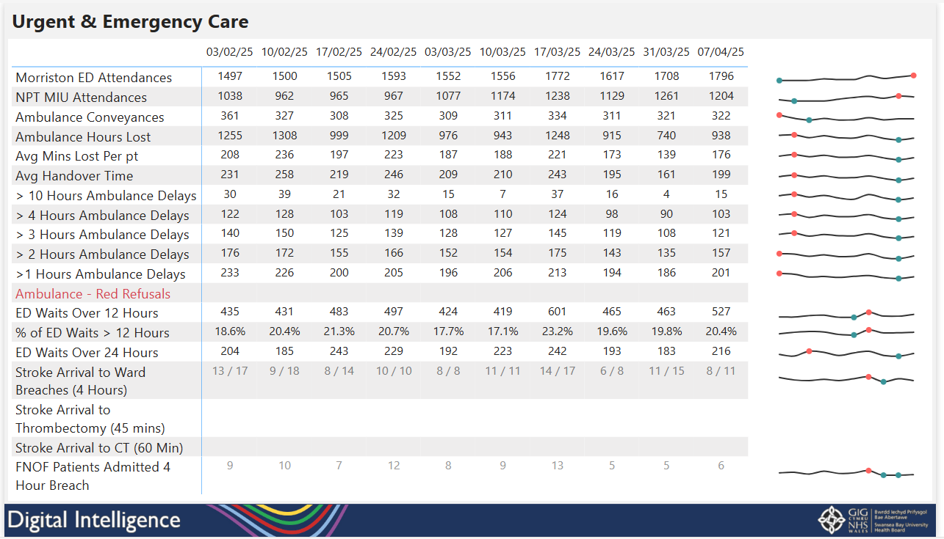

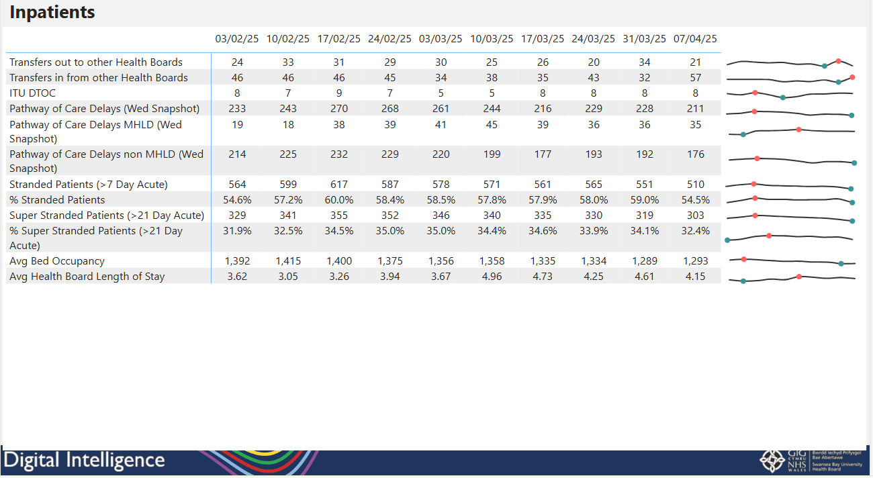
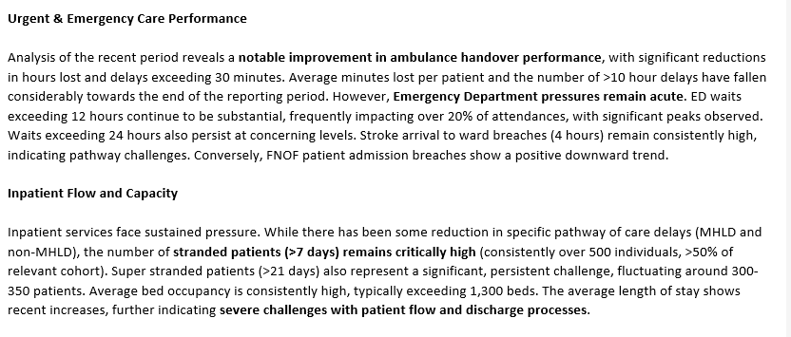

Automated weekly report showing measures across Urgent and Emergency Care, Inpatients, Mortality, Maternity and Planned care that is emailed to executives. Development has started on generating an AI generated summary of the report to accompany the email.

Fig 4.
Maternity App
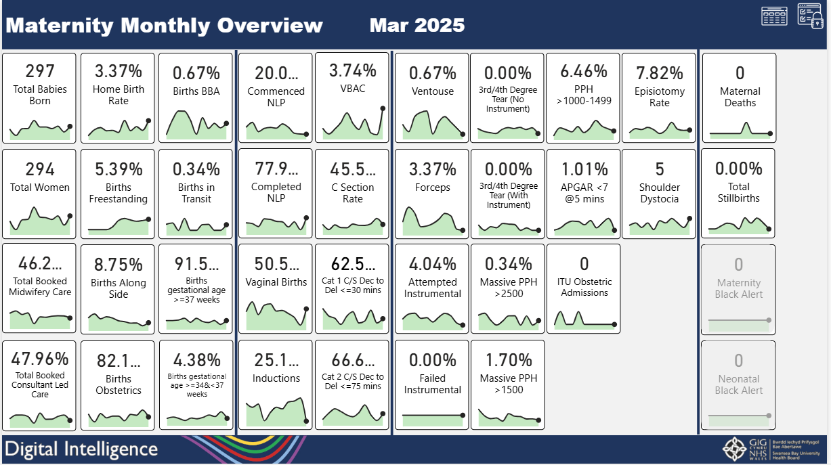

Maternity App with a suite of reports across numerous measures as shown above. The user can click on any of these measures to drill down for further information.

Fig 5.
Mental Health and Learning Disabilities App – Outpatients Reports
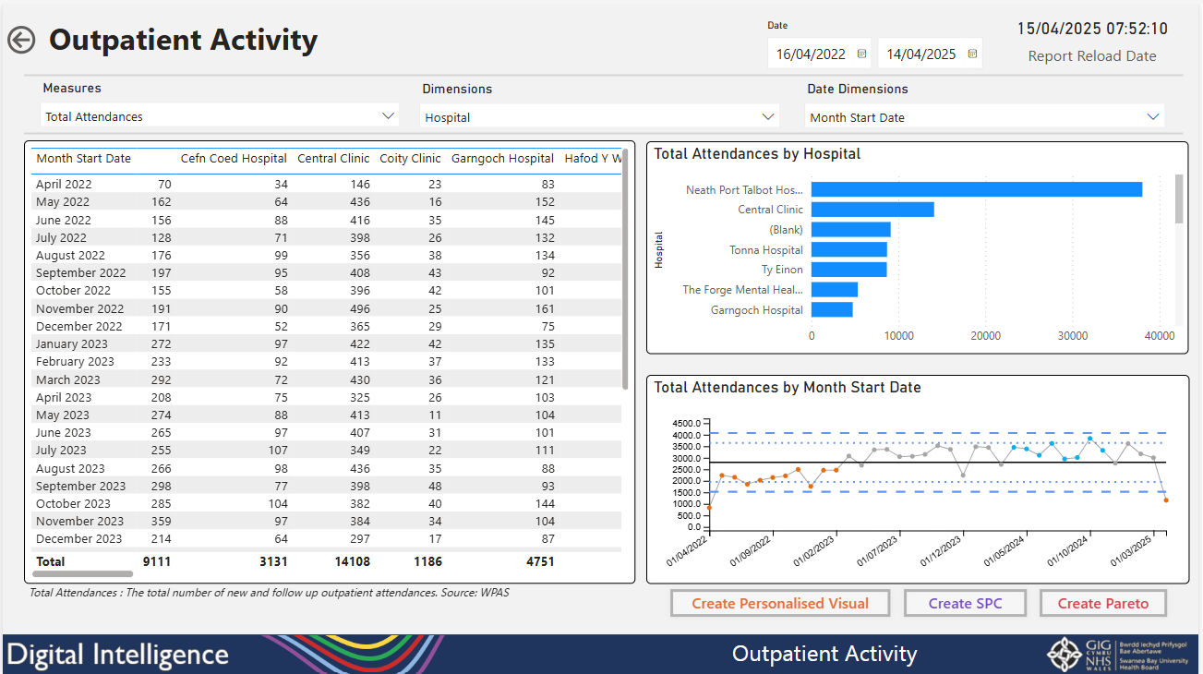

Outpatient Referrals, activity and self-service reports have been added into the Mental Health and Learning Disabilities App. The above shows how users can select numerous measures and dimensions to create their own tables and charts.

