Meeting Date | 07 May 2026 |  | Agenda Item |  |  | 4.2
Name of Meeting | Digital Data Research and Innovation Committee
Report Title | Business Intelligence and Analytics
Report Author | Lee Morgan, Assistant Director of Digital Intelligence
Report Sponsor | Matt John, Director of Digital
Presented by | Lee Morgan, Assistant Director of Digital Intelligence
Freedom of Information | Open
Purpose of the Report | To provide an update on Business Intelligence and Analytics within Swansea Bay University Health Board
Key Issues | The paper outlines updates on Business Intelligence usage metrics and key Business Intelligence deliverables against the work plan since the last committee report in March 2026. These include:  - Mental Health Situation Report  - Quality and Safety Reports  - Older Person Assessment Unit and Short Stay Dashboard  - Acute Medical Unit Dashboard  - Health and Safety Dashboard  - Data Literacy Delivery
Specific Action Required  (please choose one only) | Information | Discussion |  | Assurance | Approval
Specific Action Required  (please choose one only) | ☐ | ☐ |  | ☒ | ☐
Recommendations | Members are asked to;  - Receive the contents of the report and the current and future work plans described within it.

Business Intelligence and Analytics

- INTRODUCTION
This Business Intelligence and Analytics update report is to provide assurance to the committee on the work being carried out by the Digital Intelligence team and to provide an update on the work plan.

- BACKGROUND
Since the last update report on the 5th March 2026, the Mental Health Daily Metrics Dashboard has been developed showing key acute mental health measures to provide timely insight into flow, capacity and operational pressures across the system. Measures include bed occupancy, planned discharges and numbers waiting for a mental health admission across sites. The data is currently taken from Signal and the Welsh Patient Administration system with measures from the new mental health system RIO to also be added in the coming months. (Appendix A, Fig 1).

Development has started on the Mental Health Quality and Safety Dashboard containing a suite of quality and safety metrics to provide assurance and oversight. Measures include incidents, falls, pressure ulcers and complaints. The dashboard will go live in quarter 2 following review and sign-off from the service. (Appendix A, Fig 2-3).

The Older Person Assessment Unit and Short Stay Dashboard has been developed and is available within the Urgent and Emergency Care App. The dashboard includes measures such as admissions, length of stay, readmissions within seven days, delay reasons and demographic disaggregation for the Older Person Assessment Unit and the Older Person Short Stay inpatient wards in Morriston Hospital, helping to support clinical flow oversight. (Appendix A, Fig 4-5).

A new Acute Medical Unit Dashboard has been developed and is available within the Urgent and Emergency Care App. The dashboard includes measures around length of stay, bed occupancy, turnaround, admissions and discharges for the Acute Medical Unit Assessment and inpatient ward, helping to support oversight and performance monitoring. (Appendix A, Fig 6-7).

Phase one of the Health and Safety Dashboard has gone live. The first phase of the dashboard displays staff and contractor safety incidents broken down by type and location, and incident rates. The dashboard allows the service to track the number and severity of incidents over time to identify patterns and high-risk areas and monitor the timeliness of reporting and closure of incidents. Phase two will include measures including the reporting of injuries, diseases, and dangerous occurrences and Health and Safety training. (Appendix A, Fig 8).

Data Literacy courses have continued to be held with staff across the Health Board. Since the last update report, one ‘Introduction to Data Literacy’ course, two ‘Introduction to Power BI’ courses, one ‘Advanced Power BI’ course, and one ‘Intermediate Power BI’ course have taken place, with circa 50 staff members attending.

Approximately 400 staff have attended Data Literacy courses since their inception, supporting wider data-informed decision making across the organisation.

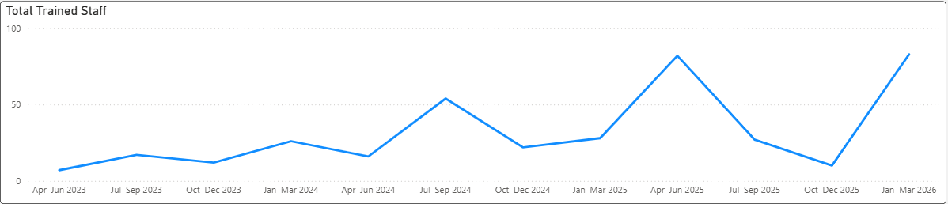

In the last four weeks, 193 Business Intelligence reports and dashboards have been used by 548 users across the Health Board.

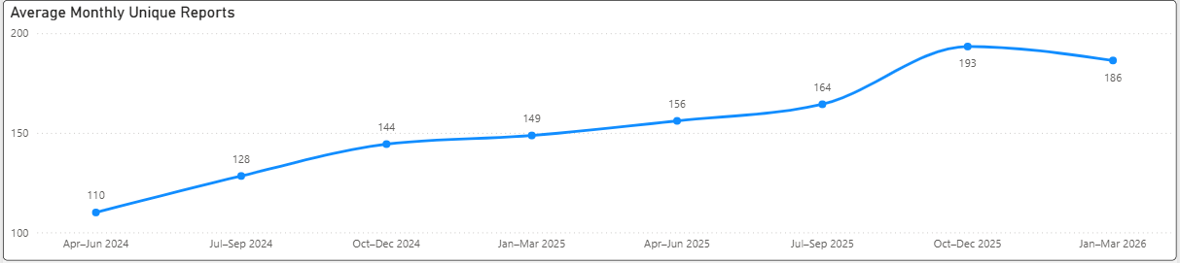

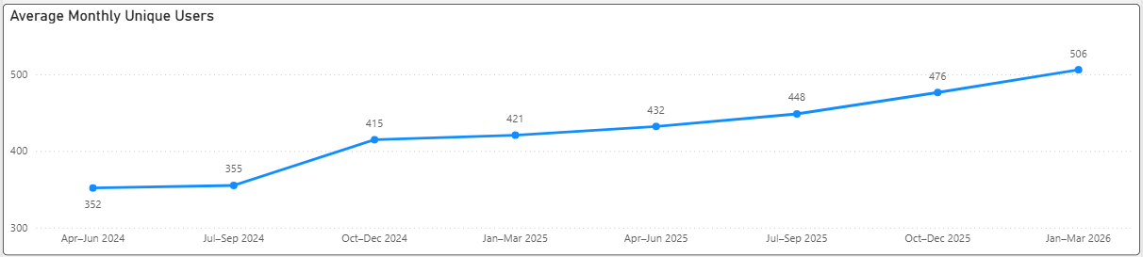

- GOVERNANCE AND RISK ISSUES
The previously recorded risk, scored at 12 and titled “Operational and strategic decisions are not data-informed”, has been removed from the Health Board Risk Register. Over the past 12 months, significant progress has been made through the delivery of the Data Literacy Programme, which has addressed key elements of this risk and supported its reduction.

Although the risk has been removed from the corporate register, it continues to be monitored at a service level and will be reassessed in line with audit recommendations as part of the All-Wales Review of Operational Governance.

In addition, following the appointment of a Director of Performance and BI, discussion will take place to establish the Performance and Business Intelligence delivery model going forward. This model will optimise the use of skill sets across corporate and care groups to improve efficiency and address resourcing capacity challenges.

- FINANCIAL IMPLICATIONS
Nothing to note.

- RECOMMENDATION
Members are asked to receive the contents of the report and the current and future work plans described within it.

Governance and Assurance
Link to Enabling Objectives  (please choose) | Supporting better health and wellbeing by actively promoting and empowering people to live well in resilient communities
Link to Enabling Objectives  (please choose) | Partnerships for Improving Health and Wellbeing |  | ☒
Link to Enabling Objectives  (please choose) | Co-Production and Health Literacy |  | ☒
Link to Enabling Objectives  (please choose) | Digitally Enabled Health and Wellbeing |  | ☒
Link to Enabling Objectives  (please choose) | Deliver better care through excellent health and care services achieving the outcomes that matter most to people
Link to Enabling Objectives  (please choose) | Best Value Outcomes and High Quality Care |  | ☒
Link to Enabling Objectives  (please choose) | Partnerships for Care |  | ☒
Link to Enabling Objectives  (please choose) | Excellent Staff |  | ☐
Link to Enabling Objectives  (please choose) | Digitally Enabled Care |  | ☒
Link to Enabling Objectives  (please choose) | Outstanding Research, Innovation, Education and Learning |  | ☒
Health and Care Standards
(please choose) | Staying Healthy |  | ☒
(please choose) | Safe Care |  | ☒
(please choose) | Effective Care |  | ☒
(please choose) | Dignified Care |  | ☒
(please choose) | Timely Care |  | ☒
(please choose) | Individual Care |  | ☒
(please choose) | Staff and Resources |  | ☒
Quality, Safety and Patient Experience
Not applicable.

Financial Implications
Not applicable.

Legal Implications (including equality and diversity assessment)
Not applicable.

Staffing Implications
Across Digital Intelligence there are currently four vacancies.
Long Term Implications (including the impact of the Well-being of Future Generations (Wales) Act 2015)
Not applicable.

Report History |  | 5th March 2026
Appendices |  | Appendix A – BI Screenshots May 26

