Appendix A
Fig 1.
Mental Health Daily Metrics Dashboard
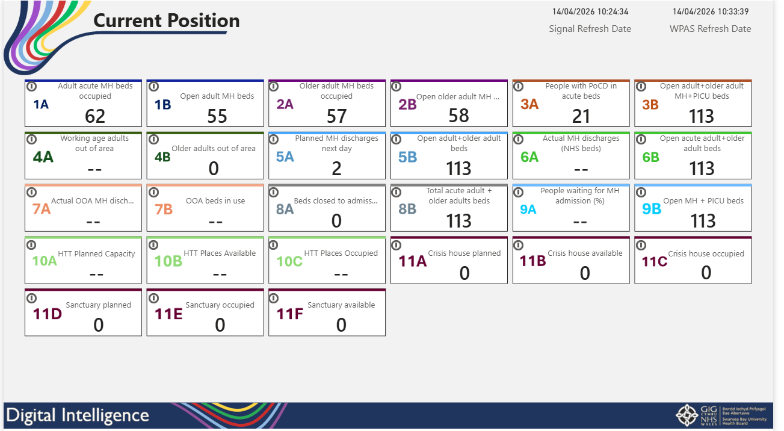
Daily measures showing the current Mental Health Position around bed occupancy, planned discharges and admissions.

Fig 2-3.
Mental Health Quality and Safety Dashboard
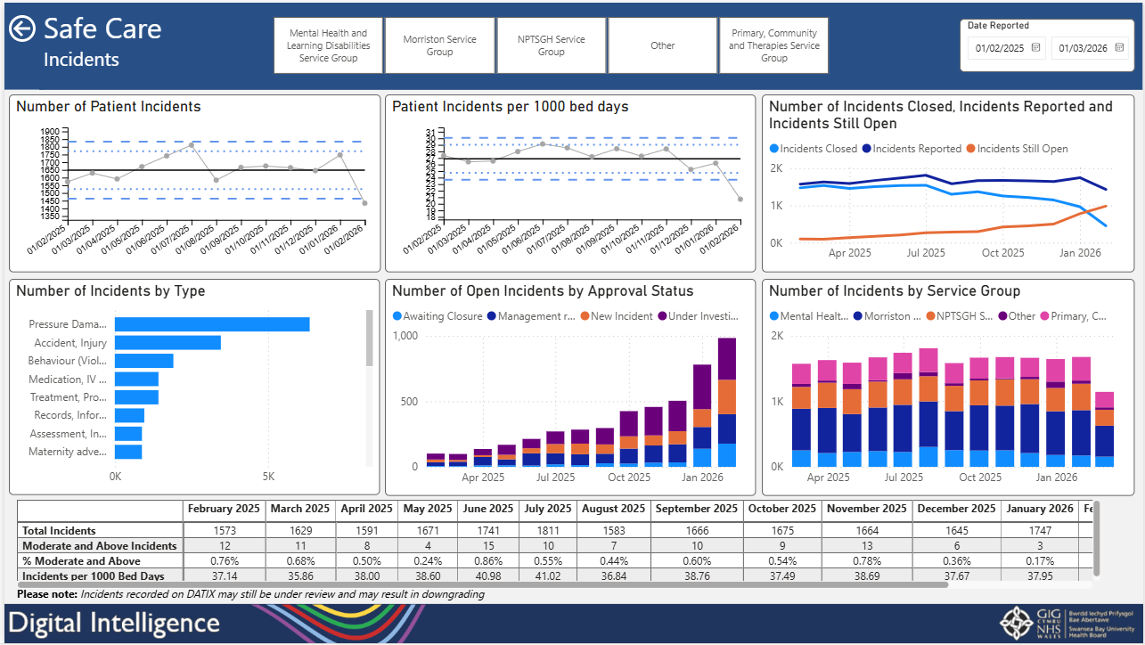

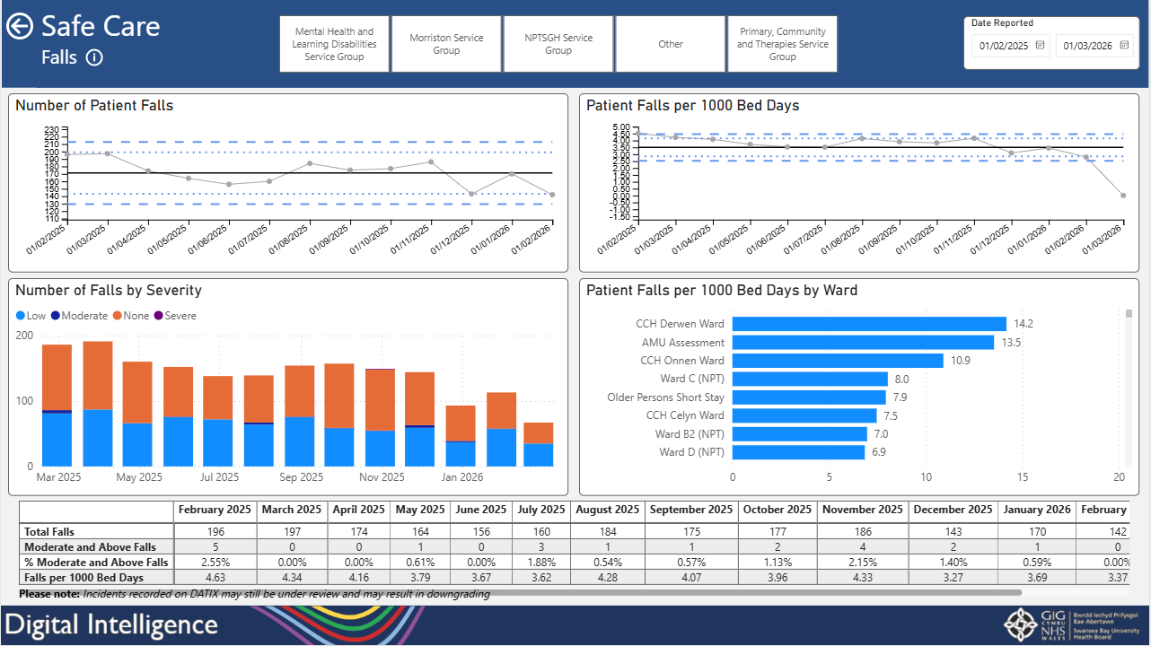
Mental Health Quality and Safety Dashboard showing a suite of measures across incidents, falls, complaints and pressure ulcers that can be filtered by service groups and date.

Fig 4-5.
Older Personal Assessment and Short Stay Dashboard
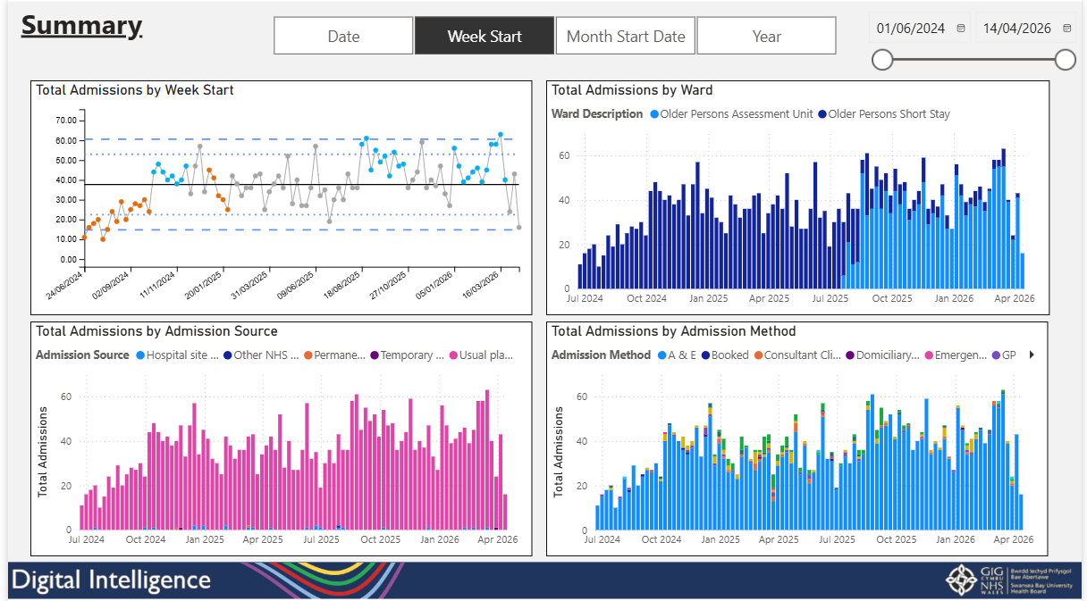

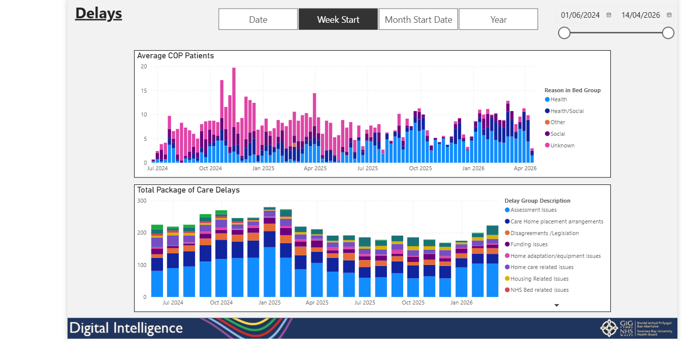
Dashboard showing discharges, admissions, delay reasons and demographic split for Older Person Assessment Unit and Older Person Short Stay Ward.

Fig 6 – 7.
Acute Medical Unit Dashboard
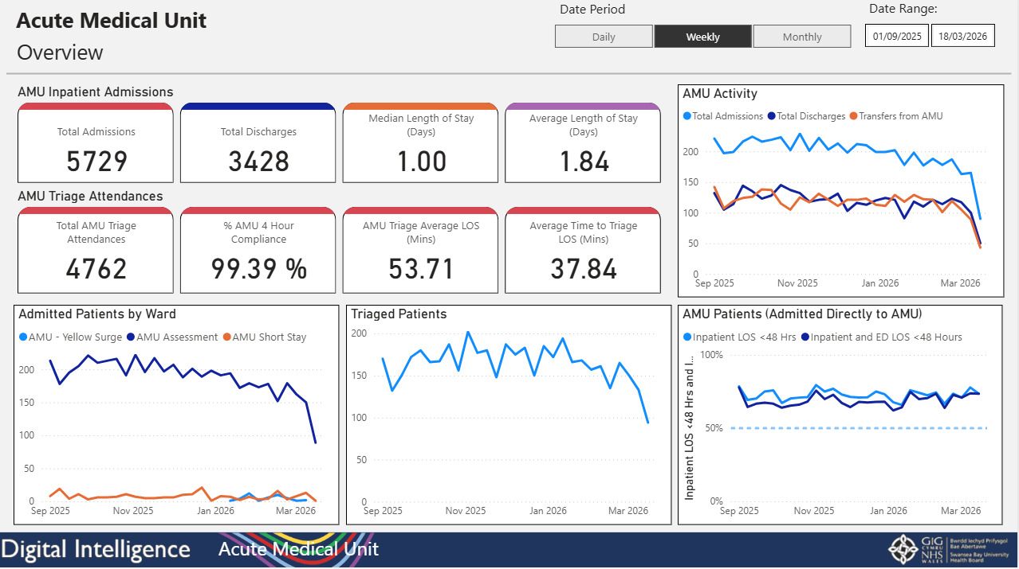
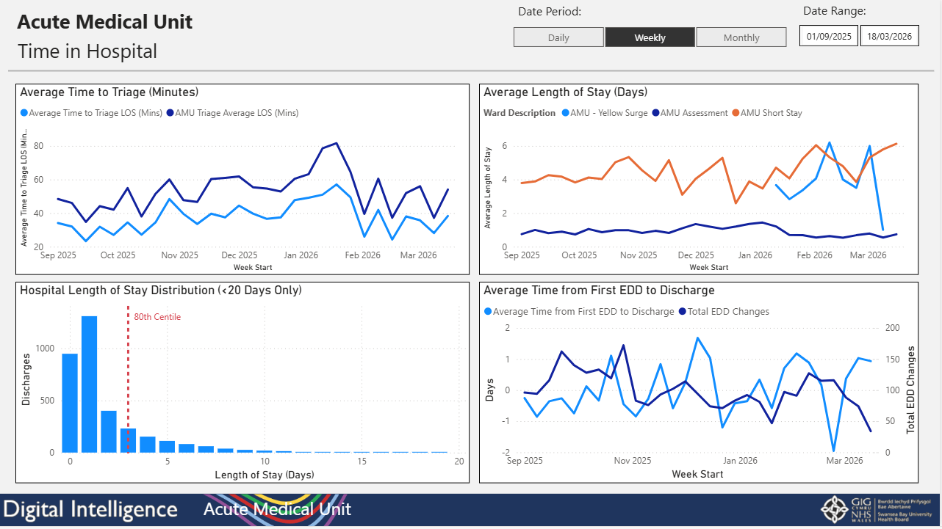
Dashboard pages showing measures included admissions, length of stay, bed occupancy, turnaround times and discharges for the Acute Medical Unit.

Fig 8.
Health and Safety Dashboard
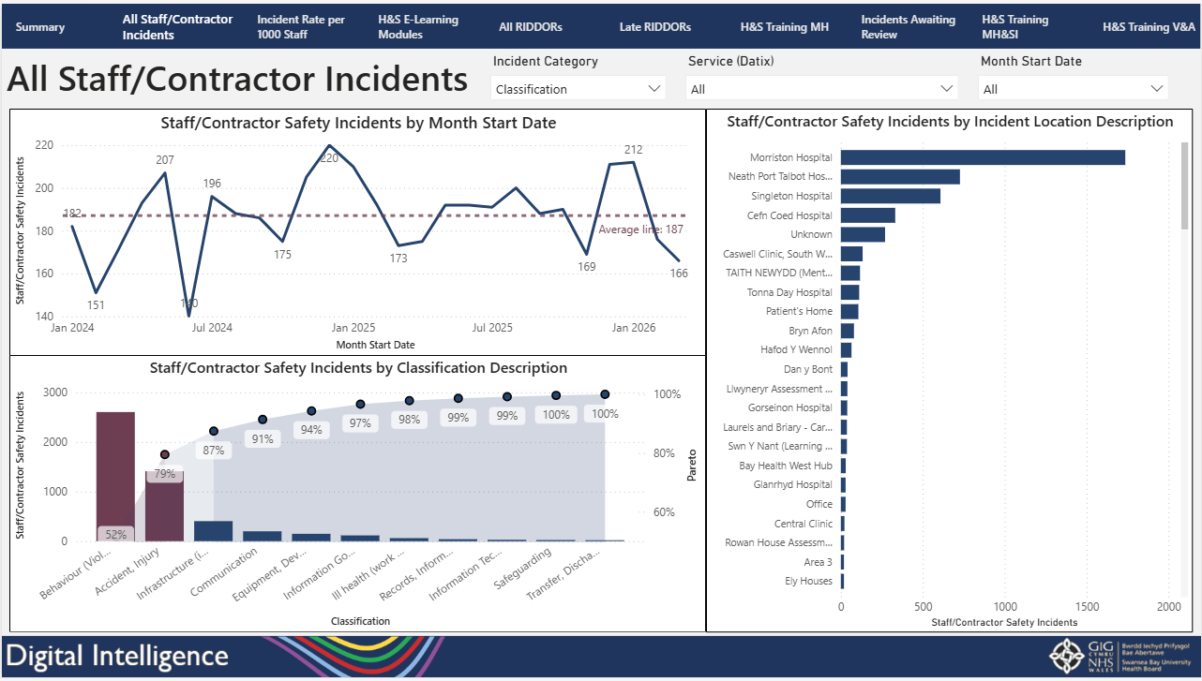
Phase one of the Health and Safety Dashboard which shows all staff contractor/incidents and incident rates over time filtered by type and location.

