Meeting Date | 10 November 2024 |  | Agenda Item |  |  | 4.3
Report Title | Integrated Medium Term Plan (IMTP) Digital Planning
Report Author | Tracey Bell, Head of Digital Planning, Planned Care and Community  Gareth O’Gorman, Head of Digital Planning, Patient Flow and Diagnostics
Report Sponsor | Matthew John, Director of Digital
Presented by | Deirdre Roberts, Assistant Director of Digital Transformation
Freedom of Information | Open
Purpose of the Report | To update the committee on the development of the digital plan for FY25/26.
Key Issues | - Development of the digital plan for FY25/26 is underway with a focus on recovery, delivery and sustainability.  - Digital is supporting the development of the Health Board plan for FY25/26, via the Integrated Planning Group and the Executive Strategy Group.  - Engagement is also underway with individual Service Delivery Groups (SDGs) planning leads to ensure the digital plan is informed by service priorities.  - The digital plan will reference agreed funding streams, whilst also noting local/ regional / national schemes that are in development and subject to funding approval.  - There may be an expectation from services that digital can absorb work required to support new projects without the agreed funding stream. This will be managed by the Integrated Planning Group and where appropriate escalated to the Executive Strategy Group.
Specific Action Required  (please choose one only) | Information | Discussion |  | Assurance | Approval
Specific Action Required  (please choose one only) | ☒ | ☐ |  | ☒ | ☐
Recommendations | Members are asked to NOTE the progress in developing the digital plan for FY 25/26 and the joint working between digital, strategy, corporate teams and SDGs to ensure the digital plan is aligned to the organisation priorities.

INTEGRATED MEDIUM-TERM PLAN (IMTP) DIGITAL PLANNING

- INTRODUCTION
This report details the role of digital services in the development of the Health Board Integrated Medium-Term Plan (IMTP) planning process, such that the digital plan aligns with the organisational priorities with a focus on recovery, delivery and sustainability.

- BACKGROUND
Digital Services work in partnership with the strategy team, Service Delivery Groups (SDGs) and corporate areas to support the IMTP planning process.

In September ‘24, planning leads, service delivery representatives and other key stakeholders from across the organisation attended a planning workshop to inform the plan for FY25/26. Further to the workshop, SDGs are expected to submit their baseline assessments that reflect demand, capacity and action plans to address identified gaps, with final submissions due in early November. Scrutiny of plans will take place until mid-December, with the Health Board aiming to submit an approved IMTP by the end of January. Appendix A shows a detailed timeline.

In conjunction with the Integrated Planning Group (IPG) the digital team will consider the SDG and corporate plans from a number of perspectives:
- What digital support is required to deliver against SDGs and corporate priorities?
- Has funding and / or resources been identified within digital to support the scheme, and if not, is there a potential funding route that could be explored?
- How do the schemes identified by the SDG and corporate teams support national and / or regional digital schemes, whilst also aligning to the principles of the digital strategy?

Digital Services have contributed to the IMTP guidance pack, which prompts service groups to consider what digital support they need – see Appendix B.

In addition to Health Board level planning, Digital Leads are also collaborating with Digital Health and Care Wales (DHCW), Welsh Government Digital Leads and other health board/trust digital leads with the aim to ensure there is alignment between health board priorities and national digital plans. In September 2024 a meeting took place between the Health Board and DHCW Executive Teams to gain a better understanding of each other’s priorities. A commitment was made to increase the level of collaboration moving forward in order to achieve a wider executive team understanding and involvement in digital priority setting with DHCW.

Furthermore, there is ongoing planning with: our local authority partners regarding the way forward for digitally enabled integrated working beyond the Welsh Community Care Information System (WCCIS); Hywel Dda on regional digital opportunities; and also with Cwm Taf Morgannwg to ensure that appropriate plans are in place for Bridgend IT disaggregation work for 25/26.

- GOVERNANCE AND RISK ISSUES
The Digital Leadership Group (DLG) oversees the submission of the digital delivery actions to the IMTP, and the Annual Planning & Oversight Group (APOG) takes a lead on coordinating progress reports and managing any changes to the IMTP across the Health Board.

Although guidance is provided and engagement is undertaken throughout the planning process, digital dependencies to support service delivery can often be overlooked. To mitigate this, Digital Services will:
- Work with IPG to scrutinise SDG and corporate plans to identify additional requirements which may not be reflected in the draft digital plan.
- Meet separately with individual SDG and corporate planning leads during the planning phase to ensure alignment between the digital and SDG plans.
- Escalate any concerns pertaining to differing approaches and / or priorities to IPG, and where necessary ESG.

- FINANCIAL IMPLICATIONS
The focus of this year’s IMTP plan is recovery, delivery and sustainability. Services have been asked to submit their Delivery Actions into three categories: Expenditure control; Short term service change/safe services, and Medium term financial recovery & sustainability.

The guidance stresses that the planning process must incorporate savings planning and any new cost for the Health Board must be consumed within the allocation for each service.

AS noted above, the digital team are working with SDGs to ensure any digital costs associated with the digital plan for FY25/26 are reflected in the Health Board plan.

- RECOMMENDATION
The Committee are asked to:

NOTE: the progress in developing the digital plan for FY 25/26
NOTE: the joint working between digital, strategy, corporate teams and SDGs to ensure the digital plan is aligned to the organisation priorities.

Appendix A – Timeline for the IMTP process
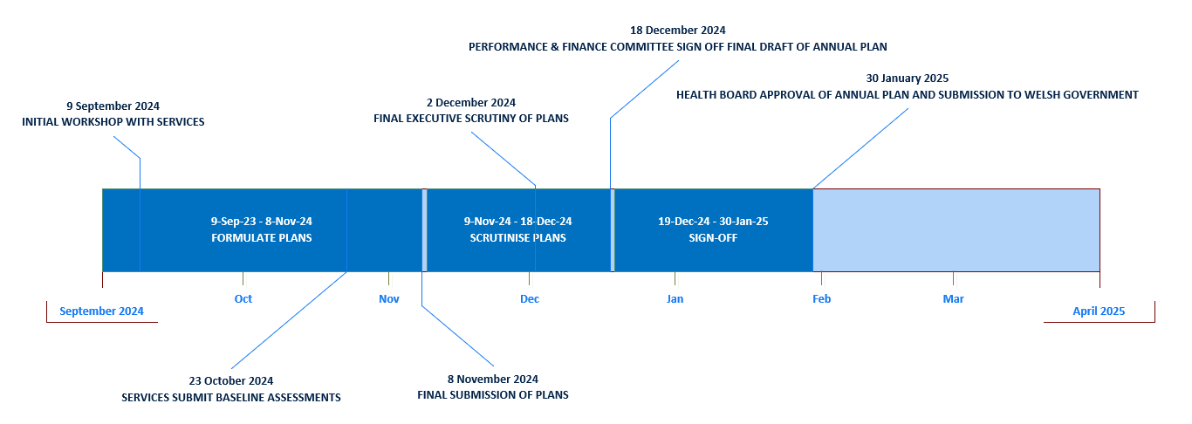

Appendix B – Guidance for service groups on what digital support to consider
When considering any digital dependencies for the achievement of Delivery Actions, what do you need from Digital?
- Does the Delivery Action involve new business processes that will require a new system or an amendment to an existing system.
- Will you require new/amended reports to support data capture from new/amended business processes.
- Are there any changes to the physical environment that will need equipment moved or purchase of new equipment. If there is a requirement for additional equipment has a Capital funding request been submitted?
- Are you moving to a new site? Are there healthcare connections already at site, an unconnected site could take up 6 months for connection to be provided. Will the site require local infrastructure installed (e.g. data points extra power etc) If the service is public facing, consider the telephony requirements. Call Centre? Call recording etc
- Are any of your existing systems due to be replaced or close to contract end, locally or nationally? What are the plans for the legacy data, data needs to be either migrated to the new system or deleted in line with retention policies. Old systems cannot remain online for the access to legacy, this provides not only support issues but also major cyber risks.
- Whilst you may not need equipment, new/amended system, do you require digital expertise in any capacity, such as IG, cyber security, storage, networking and architecture.
- Have you considered the ongoing support model? Will your need be requiring ongoing IT support; current IT support is a limited resource and is there to support the current systems and there no capacity to support new systems or locations without further investment.
- What arrangements are required from third party companies for support - is this in place ready?
- Have you considered the training of your staff? Do you require any classroom environments?
- If digital services/equipment is required, have the Capital and Revenue costs been included in the overall cost attributed to the Delivery Action?

Governance and Assurance

Link to Enabling Objectives  (please choose) | Supporting better health and wellbeing by actively promoting and empowering people to live well in resilient communities
Link to Enabling Objectives  (please choose) | Partnerships for Improving Health and Wellbeing |  | ☒
Link to Enabling Objectives  (please choose) | Co-Production and Health Literacy |  | ☐
Link to Enabling Objectives  (please choose) | Digitally Enabled Health and Wellbeing |  | ☒
Link to Enabling Objectives  (please choose) | Deliver better care through excellent health and care services achieving the outcomes that matter most to people
Link to Enabling Objectives  (please choose) | Best Value Outcomes and High Quality Care |  | ☒
Link to Enabling Objectives  (please choose) | Partnerships for Care |  | ☒
Link to Enabling Objectives  (please choose) | Excellent Staff |  | ☒
Link to Enabling Objectives  (please choose) | Digitally Enabled Care |  | ☒
Link to Enabling Objectives  (please choose) | Outstanding Research, Innovation, Education and Learning |  | ☐
Health and Care Standards
(please choose) | Staying Healthy |  | ☐
(please choose) | Safe Care |  | ☐
(please choose) | Effective Care |  | ☐
(please choose) | Dignified Care |  | ☐
(please choose) | Timely Care |  | ☐
(please choose) | Individual Care |  | ☐
(please choose) | Staff and Resources |  | ☐
Quality, Safety and Patient Experience
Implementation of digital systems in healthcare can have a significant positive impact on quality, safety and patient experience. Critical to the success of digital transformation is effective IMTP planning processes outlining digital service team capacity and demand.

Financial Implications
The corporate focus of this year’s IMTP plan is recovery, delivery and sustainability. In this context services have been asked to place their Delivery Actions into three categories: Expenditure control; Short term service change/safe services, and medium- term financial recovery & sustainability.

The planning process must incorporate savings planning and any new cost for the Health Board must be consumed within the allocation for each service. New business cases for additional funding will not be considered.

Legal Implications (including equality and diversity assessment)
None known

Staffing Implications
There is an increasing demand on the resources in Digital Services to support SDGs in the delivery of the IMPT plan. In response to the current financial challenges, a digital services prioritisation exercise is in place via the Digital Leadership Group, which provides the overarching governance to the delivery of the Digital Strategic Plan including financial considerations

Long Term Implications (including the impact of the Well-being of Future Generations (Wales) Act 2015)
- Long Term – Health and Social Care “A Healthier Wales” sets out a long term future vision of a ‘whole system approach to health and social care’, which is focussed on health and wellbeing, and on preventing illness
- Wellbeing of Future Generations Act
- Focus on prevention, not service provision.
- Prevent ill health, reduce impact of illness or injury and delay onset of frailty.
- Provide services to carers that prevent, reduce, or delay them developing a need for support.
- SBU HB’s Clinical Services Plan
- Adoption of digital solutions and technology.
- Create a mobile workforce that is digitally connected to ensure staff work seamlessly to ‘Make Every Contact Count’.
- Technology to support care closer to the patient’s home or in the community.

Report History
Appendices |  | None.

