

HEALTH BOARD RISK REGISTER
September 2025

RISKS ASSIGNED TO THE
DIGITAL, DATA, RESEARCH & INNOVATION COMMITTEE

Datix ID Number: 1035  Health & Care Standard: |  |  | HBR Ref Number: 27  Risk Target Date: 31/03/2026 |  | Current Risk Rating  4 x 4 = 16
Objective: The delivery of care is supported by innovative digital solutions |  | BAF Ref: 4 | Director Lead: Matt John, Director of Digital  Assuring Committee: Digital, Data, Research & Innovation Committee
Risk: Digital Transformation  Inability to deliver sustainable clinical services due to lack of resources to deliver sustainable Digital Transformation and services. There are insufficient resources to:  - Invest in the delivery of the SBU Digital strategy  - Support the growth in utilisation of existing and new digital solutions  - Replace existing technology infrastructure or software at the end of its useful life. |  |  | Date last reviewed: September 2025
Risk Rating  (consequence x likelihood):  Initial: 4 x 4 = 16  Current: 4 x 4 = 16  Target: 5 x 2 = 10 | 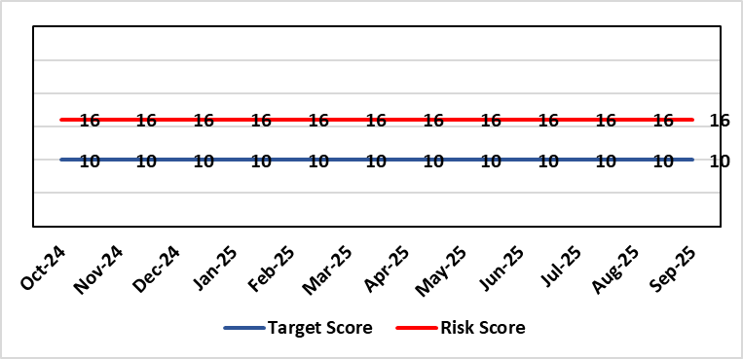 |  | Rationale for current score:  C – Reliance on digital ways of working has increased. Loss of IT service has a greater impact on ability to provide clinical care. Lack of investment in new digital solutions to make services more effective will mean clinical service provision will become unsustainable.  L- Reduction in capital funding in 2022/23/24 has increased the likelihood of HB not being able to replace aging infrastructure such as the network equipment. There is a £15m capital requirement over the next 3 years. Acceleration of the CTM SLA disaggregation has been proposed and there are further pressures on revenue funding. The shift to cloud and software as a service contracting models will increase the requirement for revenue funding to deliver digital transformation and ongoing services.
Rationale for target score:
C – Of failure will increase as the reliance and proliferation of the use of digital solutions increases.
L – Investment will mean the support mechanisms, rate of failure and ability to deliver solutions that meet the needs of users will improve sustainable digital services. There will however always be an inherent risk of failure of IT solutions.
Level of Control
= 50%
Date added to the SBU HB risk register
Apr 2019
Controls (What are we currently doing about the risk?) |  |  | Mitigating actions (What more should we do?)
- Digital Strategy has been approved by the Health Board and outlines requirements  - HB Capital priority group considers digital risks for replacement technology which is fed into the annual discretionary capital plan  - Digital Services prioritisation process is in place Digital Leadership Group provides the overarching governance to the delivery of the Digital Strategic Plan including financial considerations.  - Digital Services Management Group assesses current service provision and flags risks and issues  - Digital Services revenue requirements are included in 2025/26 annual plan |  |  | Action | Lead |  | Deadline
 |  |  | Review 10-year financial plan for Digital Strategy and prioritise key costs for the next 3 years. Share plan with Director of Finance for consideration and alignment to 2026/27/28/29 IMTP process | Assistant Director of Digital: Business Management and Information Governance |  | 31/01/2026
Assurances (How do we know if the things we are doing are having an impact?)  - Internal Audit Program assesses Digital in 4 areas annually |  |  | Gaps in assurance (What additional assurances should we seek?)  - Lack of certainty over future capital and revenue funding streams makes planning and implementation difficult/less effective.
Additional Comments / Progress Notes
07/08/2025: Forecast outturn presented to Director of Digital. Review of the 10-year financial plan has commenced.
05/09/2025 – Action “Review of 10-year financial plan” extended to 31/01/2026
10/10/2025 – £1m revenue funding received from Welsh government to support connecting care programme.

Datix ID Number: 1043  Health & Care Standard: |  |  | HBR Ref Number: 36  Risk Target Date: TBC | Current Risk Rating  4 x 4 = 16
Objective: The delivery of care is supported by innovative digital solutions |  | BAF Ref: 4 | Director Lead: Matt John, Director of Digital  Assuring Committee: Digital, Research & Innovation Committee  For information: Quality & Safety Committee
Risk: Paper Record Storage  Lack of a single electronic record means there is greater reliance on the provision of the paper record. If we fail to provide adequate storage facilities for paper records, then this will impact on the availability of patient records at the point of care. Quality of the paper record may also be reduced if there is poor records management in some wards. There is an increased fire risk where medical records are stored outside of the medical record libraries. |  |  | Date last reviewed: September 2025
Risk Rating  (consequence x likelihood):  Initial: 4 x 5 = 20  Current: 4 x 4 = 16  Target: 3 x 3 =9 | 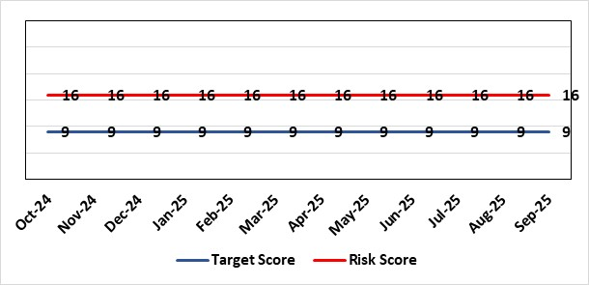 |  | Rationale for current score:  C - Inability to find records for patients could delay care/increase length of stay over 15 days. Could also mean patients receive incorrect treatment. Increased risk of fire where records are stored outside of the medical record libraries.  L - we know this happens from incidents raised
Level of Control  = 70% |  |  | Rationale for target score:  C - The increased development and adoption of the digital record will reduce the need for the paper health record being available at the point of care.  L - The increased development and adoption of the digital record, the introduction of RFID and the approach to management of the paper record identified in the Business case process should reduce the amount of paper required to be stored and managed.
Date added to the SBU HB risk register
Apr 2019
Controls (What are we currently doing about the risk?) |  |  | Mitigating actions (What more should we do?)
- There is a plan in place to increase the functionality of the electronic record to document patient care. The delivery of the plan is overseen by the Digital Leadership Group and progress provided to Management Board. (Supported by individual project boards as appropriate).  - Records managed by the Medical Records libraries are RFID-tagged (Radio Frequency Identification) and location tracked.  - Medical Record libraries are regularly risk assessed for fire by health and safety.  - Alternative offsite storage arrangements have been identified.  - All records must be documented on the Information Asset Register (IAR). |  |  | Action |  | Lead | Deadline
 |  |  | Allow for new process to stabilise and evaluate benefits of new centralised unit. |  | Head of Health Records & Clinical Coding | 31/12/2025
Assurances (How do we know if the things we are doing are having an impact?)  - RFID has been implemented for the acute record improving the management and storage of records  - Health Records performance reports developed in line with RFID technology  - Attainment of the Tier 1 Health Board target for clinical coding completeness which relies on the timely availability and quality of the Paper record and electronic sources  - Monitoring complaints and incident reporting.  - Electronic record is being implemented in accordance with the plan e.g. implementation of WNCR (Welsh Nursing Care Record), ETR (Electronic Test Requesting), HEPMA (Hospital Electronic Prescribing and Medicines Administration) |  |  | Gaps in assurance (What additional assurances should we seek?)  Investment required supporting the delivery and operational costs of the Digital strategy.  Reliance on DHCW (Digital Health & Care Wales) for delivery of the solution for a fully electronic patient record.  Impact of the Infected Blood Enquiry on the Health Boards ability to destroy notes.  Process for ensuring clinical adoption of electronic ways of working and cessation of adding information to the paper record that is already available electronically needs to be agreed and enforced by the Health Board.  Impact of the infected Blood Inquiry on the health board’s ability to destroy notes and the change in the records code of practice is being reviewed by the Director of Digital.
Additional Notes
08/09/2025 – Reviewed, no further comments or amendments required
14/10/2025 – Action date reviewed and amended.

Datix ID Number: 2796 Risk re-articulated & refreshed  Health Care Standards: |  |  | HBR Ref Number: 90  Target Risk Date: TBC |  | Current Risk Rating  4 x 5 = 20
Objective: The delivery of care is supported by innovative digital solutions |  | BAF Ref: 4 | Director Lead: Matt John, Director of Digital  Assuring Committee: Digital, Research & Innovation Committee
Risk: Subject Access Request Risk  Due to insufficient resources and inconsistent processes across Swansea Bay University Health Board, there is a risk that Subject Access Requests (SARs) will not be fulfilled in compliance with UK-GDPR Article 15, resulting in potential breaches of personal data which could cause distress and lead to a loss of public and government confidence in the Health Board’s trustworthiness and legal standing.  Additional Potential Consequences:  - Regulatory Enforcement: ICO (Information Commissioner’s Office) may impose fines up to 4% of annual turnover for serious breaches. While the ICO has not historically issued fines for SAR breaches, this may change, especially as enforcement activity increases. A recent reprimand issued by the ICO to another NHS Trust, signals heightened regulatory scrutiny.  - Operational Disruption: Staff diverted from priority tasks to manage SARs, affecting service delivery.  - Legal Exposure: Increased risk of litigation & claims from individuals with compromised data rights. |  |  | Date last reviewed: September 2025
Rationale for current score:
C – This is assessed to be Major (score 4) under the Governance & Assurance risk domain of health board policy. Given the heightened external scrutiny of Swansea Bay University Health Board’s Maternity and Mental Health services, failure to comply with SAR requirements or mis-sharing of sensitive information in these areas could result in multiple complaints, loss of public confidence, negative media coverage, and/or criticism by Welsh government.
L- The probability of one of these potential consequences occurring is currently considered to score 5 (expected – greater than 50% chance) due to the sustained and growing backlog of SARs, particularly in the Maternity and Children and Young People (CYP) services, along with 2024/25 statistics showing 65% of SARs are released without full clinical approval. These areas are experiencing a surge in requests following media coverage, with further increases expected. The complexity and sensitivity of these cases, combined with limited resources and inconsistent processes, make delays and errors expected. While the risk of an ICO fine remains low, the frequency of breaches, solicitor correspondence, complaints, ICO involvement and claims for financial compensation is already high and likely to escalate.

Risk Rating  (consequence x likelihood):  Initial: 4 x 4 = 16  Current: 4 x 5 = 20  Target: 4 x 3 = 12 | 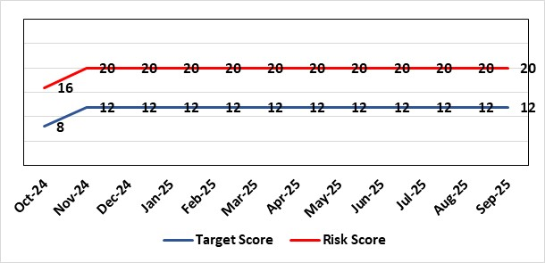
Level of Control  = 50% |  |  | Rationale for target score:  C – As above  L – Additional resources would allow the organisation to make significant improvements to the process by which SARs are managed. Being able to adequately comply with legal requirements reduces the likelihood of enforcement action and fines from the ICO, as well as minimising the risk of reputational damage.
Date added to the SBU HB risk register
Jan 2023
Controls (What are we currently doing about the risk?) |  |  | Mitigating actions (What more should we do?)
- Approved SAR Policy: Provides a formal framework for consistent SAR handling.  - Dedicated SAR Lead (Band 7 IG Manager): Ensures operational oversight and coordination.  - Defined Governance Roles: SIRO, Caldicott Guardian, and DPO roles are in place and active.  - Legal and Risk Advice: Accessed for complex SARs to ensure lawful and appropriate handling.  - Escalation to Information Governance & Cyber Assurance Group (IGCAG): Enables timely intervention and oversight of emerging issues  - SAR Working Group monitoring: Tracks delivery of actions and feeds into governance structures. |  |  | Action | Lead |  | Deadline
 |  |  | Implement detailed Action Plan in line with the timescales outlined within the Plan | Data Protection Officer/Head of Health Records |  | 31/03/2026
Assurances (How do we know if the things we are doing are having an impact?)  - Bi-monthly reporting to DDRI: Provides regular oversight and visibility at committee level.  - IGCAG oversight: Chaired by the SIRO and attended by key governance leads.  - Escalation reports to Management Board and DDRI: Ensures senior leadership awareness.  - Internal audit findings: Highlighted resource gaps and informed improvement planning. |  |  | Gaps in assurance (What additional assurances should we seek?)  Internal audit report identified the requirement to invest in resources to address gap in assurance.
Additional Comments
Background and Context:
The Health Board faces a sustained increase in both the volume and complexity of SARs, driven by technological advancements, expanded data availability, and evolving communication practices (e.g. use of WhatsApp and non-corporate email channels). This surge has outpaced existing capacity, including that of professional and expert staff, with many requests exceeding statutory response times and lacking adequate redaction or clinical review. The fragmented nature of record-keeping—spanning paper files, multiple systems, and sensitive content— and inconsistent handling procedures across departments further complicates timely and compliant disclosures.
During the 24/25 financial year, the acute SAR team processed 8,652 requests for data. This excludes other areas of SBUHB who manage their own SAR. Each SAR application may involve multiple requests for Health Care Professionals (HCPs) to approval the release of information. The 8,652 applications resulted in 9,102 requests to HCPs to approve, with an additional 4561 released without specific approval based on an ‘open consent’ given previously. Of the requests to approve, 48% (4,366) did not reply within 7 days and therefore this data was released without approval. Therefore only 35% of all SAR requests are released with full HCP oversight. The acute SAR team note that of the 8,652 requests into them, 124 were unable to be completed within the 28-day mandatory timescale. Of these 124, 104 were relating to Children and Young People (CYP) and 18 related to complex email enquiries. Whilst these figures may not appear significant in comparison to the total annual requests received, it is important to recognise that the time required to address these CYP and complex emails is considerable and places an excessive pressure on the organisation, e.g. A large email search may result in 10,000-15,000 emails, all requiring oversight and review, often taking weeks to complete for each request.
During 2024/25, SBU received 10 SAR complaints from the public, an additional 3 SAR complaints from the ICO, and reported 1 SAR breach to the ICO.
Progress Notes
03/10/2025: SAR data included within the Background and context. Risk re-articulated.
14/10/2025: Further stats added supporting score of 20.

Datix ID Number: 443  Health & Care Standard: Effective Care 3.1 Clinically Effective Care |  |  | HBR Ref Number: 104  Risk Target Date: 31/03/2027 |  | Current Risk Rating  4 x 5 = 20
Objective: Care is delivered in safe and appropriate settings supported by innovative digital solutions |  | BAF ref: | Director Lead: Matt John, Director of Digital  Assuring Committee: Digital Data & Innovation Committee  For information: Quality & Safety Committee
Risk: Failure to meet Tier 1 targets in Clinical Coding Completeness  Because: The volume of new inpatient episodes exceeds the available clinical coding staff capacity; There are difficulties recruiting and retaining a sufficient number of trained clinical coding staff to address the gap, and clinical information is not always of sufficient quality or completeness electronically (such as DALs) to support swift coding.  There is a risk that: Clinical notes for inpatient episodes will not be coded in a timely way.  Resulting in: The non-achievement of the Tier 1 Welsh Government target (which is that 95% of inpatient activity should be coded within 30-days of discharge); Insufficient coded data to support effective service planning for population health needs; Inadequate data being available for mortality review/quality and safety purposes, with increased risk of failure to spot variance that are negatively impacting levels of patient care and potentially causing avoidable deaths; Negative impact on accuracy of analysis to understand how resources are being allocated and used at Health Board level and national level (programme budgeting); Delays in claiming casemix sensitive contract lines with JCC, Hywel Da and Cwm Taff (circa 70m per annum value in total) due to lack of coding data. |  |  | Date last reviewed: September 2025
Risk Rating  (consequence x likelihood):  Initial: 3 x 4 = 12  Current: 4 x 5 = 20  Target: 4 x 3 =12 | 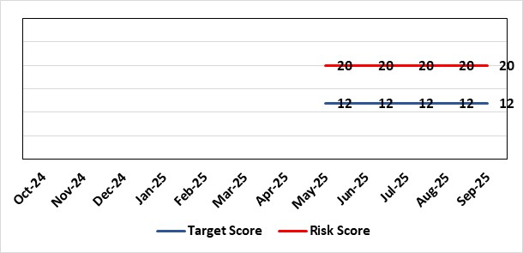 |  | Rationale for current score:  C - Insufficient coding data will negatively impact service planning for population health needs and inadequate data being available for mortality review/quality and safety purposes. This could result in failures at spotting patterns of variance that are negatively impacting levels of patient care and potentially causing avoidable deaths.  Clinically coded activity is also used to understand how resources are being allocated and used at Health Board level and national level (programme budgeting), and therefore a reduction in coding completeness will impact on the accuracy of this analysis. It is also used to claim casemix sensitive contract lines with JCC, Hywel Da and Cwm Taff of circa 70m per annum with lack of coding data impacting on the timeliness in making these claims.  L - Tier 1 target is currently not being met on a regular basis.
Level of Control  = |  |  | Rationale for target score:  C - Insufficient coding data will negatively impact service planning for population health needs and inadequate data being available for mortality review/quality and safety purposes. This could result in failures at spotting patterns of variance that are negatively impacting levels of patient care and potentially causing avoidable deaths.  Clinically coded activity is also used to understand how resources are being allocated and used at Health Board level and national level (programme budgeting), and therefore a reduction in coding completeness will impact on the accuracy of this analysis. It is also used to claim casemix sensitive contract lines with JCC, Hywel Da and Cwm Taff of circa 70m per annum with lack of coding data impacting on the timeliness in making these claims.  L – Increase in what can be coded electronically, unit centralisation, greater staff retention and the development of an auto-coding model will lead to increased capacity and a reduction in likelihood for targets not being met.
Date added to the SBU HB risk register
18/06/2025
Controls (What are we currently doing about the risk?) |  |  | Mitigating actions (What more should we do?)
- A three-year coding modernisation plan has been approved by executive board on 26th February 2025. This plan will see the implementation of an auto-coding solution and a re-banding of the clinical coding department within existing budgets to attain Tier 1 targets by 27/28.  - The coding management team assess the staffing complement on a daily basis to ensure resources are deployed in the most efficient and effective manner, in line with demand and clinical coding priorities.  - There is a comprehensive training programme in place for new Trainee Coders.  - The Clinical Coding Departments raise incidents when clinical information is missing from the patient’s health records and prevents the activity being coded in a timely manner. These incidents are highlighted at the Directorate Business Meetings held on a monthly basis as part of the Clinical Coding Key Performance Indicators.  - Clinical coding staff performance continues to be monitored and discussed during the monthly Clinical Coding Managers Meetings, which are chaired by the Head of Health Records & Clinical Coding, and an update is also reported and presented on the Health Board Performance Scorecard.  - An App has been developed by Digital Intelligence that shows any relevant data relating to a patient episode from different systems including Signal, TOMs, EPOA and DAL in one place. This will reduce the number of systems a clinical coder needs to log into. |  |  | Action | Lead |  | Deadline
 |  |  | Completion of all Actions on Audit Action Plan | Head of Digital Intelligence Programmes |  | 31/10/2025
 |  |  | Auto-coding model in production for two specialties | Head of Digital Intelligence Programmes |  | 01/11/2025
 |  |  | Centralising of coding department leading to efficiencies | Head of Health Records & Clinical Coding |  | 31/10/2025
 |  |  | Primary Procedure and Primary Condition Coding paper approved | Head of Health Records & Clinical Coding |  | Complete
Assurances (How do we know if the things we are doing are having an impact?)  - Attainment of the Tier 1 Health Board target for clinical coding completeness which relies on the timely availability and quality of the paper record and electronic sources. Coding 95% of in-patient activity within 30 days of discharge is a tier 1 Welsh Government target that is currently not being achieved regularly within SBU – with an average of circa 74% for 24/25. Performance is reported to Digital Business Meeting every 3 months, and to Digital, Data, Research & Innovations Committee via a Coding Paper.  - Episodes are coded from paper and electronic sources; the ability to code from electronic sources improves the timeliness & accuracy; approximately 52,000 episodes of 150,000 episodes are coded from electronic sources currently. This is reported to Digital Business Meeting every 3 months, and to Digital, Data, Research & Innovations Committee via a Coding Paper.  - An Audit has been carried out by NHS Wales Assurance and Audit Services of the Coding Department was completed in June 2024 with a result of limited assurance. In response a twelve-point action plan was developed of which one action remains which is the escalation of the coding risk to the Health Board Risk register. |  |  | Gaps in assurance (What additional assurances should we seek?)  Investment required supporting the delivery and operational costs of the Digital strategy.  Replacing qualified coders who have left the department with trainees reduces productivity - the only mitigation against this is an auto-coding product to increase productivity and re-banding across coding department to put staff at same bandings as NHS England and help staff retention – the investment required for this is yet to be funded.  The Quality of Discharge Summary provision and standard of clinical information available at the point of coding requires improvement to assist with prompt and accurate coding.  There continues to be missing clinical information at the point of coding, preventing accurate and timely coding.
Additional Comments / Progress Notes
Supplementary Notes:
- Coding 95% of in-patient activity within 30 days of discharge is a tier 1 Welsh Government target that is currently not being achieved regularly within SBU – with an average of circa 74% for 24/25.
- Contract coders and overtime have been used to achieve that 75% average which has stopped due to the current financial situation of the Health Board.
- Retaining and recruiting qualified coding staff is a big challenge due to higher bandings in England and the availability of digitised record to allow home working.
- 6 WTE qualified coders have been lost to English Health Boards or DHCW in the last 3 years due to higher bandings with a further 2WTE retiring. This has resulted in circa 44% of the current coding WTE being trainees/unqualified. Currently, there are 5 qualified coder vacancies (June 2025).

14/07/2025: The Service improvement role will now be advertised following the conclusion of the Clinical Coding OCP which concludes end of August 2025. New completion date for the advertising of the post of October 2025.
05/08/2025: Action complete: OCP process for qualified clinical coders now completed with re-banding now having taken place. Auto-coding dataset to be sent across to 3rd party supplier to fine tune model ahead of being available in September 2025. Paper going to IGCAG and then Management Board around coding primary procedure and condition to boost coding completeness rates.
05/09/2025 - Primary Procedure and Condition Coding has been signed off by IGCAG and Management Board and will be implemented from September 2025. Neurology Dataset for auto-coding has been sent for fine-tuning the auto-coding model with testing set to begin by the end of September 2025. Production date moved to November 2025.
13/10/2025 - OCP Process now complete and rebanding of qualified coders has taken place. Auto-coding model about to be tested for implementation with neurology episodes and Primary Procedure coding started in September with the number of episodes coded and rate of coding showing an increase on than previous months.

Datix ID Number: 3114  Health & Care Standard: 3.4 Information Governance and Communications Technology |  |  | HBR Ref Number: 105  Target Date: TBC |  | Current Risk Rating:  4 x 4 = 16
Objective: Care is delivered in safe and appropriate settings supported by innovative digital solutions |  | BAF Ref: | Director Lead: Matt John, Director of Digital  Supporting Director: Chris Morrell, EDAHPHS  Assuring Committee: Digital, Data & Innovation Committee  For information: Quality & Safety Committee
Risk: Significant increased cost for the replacement Pathology System LIMS  If the new Laboratory Information Management (LIMS) system is not live before 31st December 2025 then there will be significant more cost across NHS Wales which could impact the Health Board’s financial plans in 2025/26 and 2026/27. Costs would have to be covered to avoid pathology losing access to the current LIMS system resulting in the inability of pathology to deliver diagnostic results and blood transfusion services across all Health Board services including emergency, acute, primary and community services. |  |  | Date last reviewed: September 2025
Risk Rating  (consequence x likelihood):  Initial: 5 x 5 = 25  Current: 4 x 4 = 16  Target: 4 x 1 = 5 | 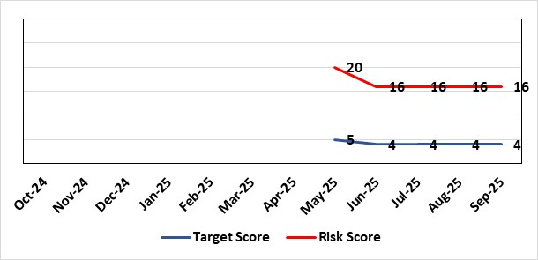 |  | Rationale for current score:  Consequence – Additional costs could be in region of approximately £1m for the Health Board depending on the length of delay  Likelihood – probable (10-50% chance currently) – due to being off-track on project and lack of confirmed back-up plan.
Level of Control  = |  |  | Rationale for target score:  Consequence as above  Likelihood will be negligible if effective system / mitigations put in place in time
Date added to the SBU HB risk register
18/06/2025
Controls (What are we currently doing about the risk?) |  |  | Mitigating actions (What more should we do?)
Configuring and testing the new LIMS system with the aim of go-live with all disciplines before 31st March 2026  SBUHB Pathology services are working in collaboration with other Health Boards and Trusts to share configuration and testing as part of a national programme. The project has agreed a go-live of Cellular Pathology in November. However, national replanning is still underway for other disciplines (Microbiology, Andrology, Blood Sciences and Blood Transfusion) to secure go-live dates before 31st March 2026 when funding for the national programme ends. The two months allocated by the national programme for User Acceptance Testing has been extended to over 12 months as the number of defects in the system remains high. There remain significant defects to be addressed by the supplier, most notably for Blood Sciences with over 400 defects – over 300 of which must either be resolved or worked around before go-live.  Pursuing only a ‘Minimal Viable Product’ to avoid scope-creep  SBUHB Pathology Services are only seeking to pursue a safe replacement system, known as a ‘Minimal Viable Product’. This is to eliminate the possibility of testing timescales being extended. Other Health Boards and Trusts report they are following the same approach.  Challenging the supplier and Digital Health and Care Wales for their technical delivery  The supplier is responsible for addressing any defects identified during testing. Digital Health and Care Wales (DHCW) are responsible for delivering some of the technical integrations (in addition to co-ordinating the national programme). The SBUHB Project Team, through the programme governance, challenge the supplier and DHCW to deliver on their commitments. |  |  | Action | Lead |  | Deadline
 |  |  | Determine what additional local costs may be attracted due to extending the project from 31st December 2025 until 31st March 2026 and how these could be funded. | SBUHB Project Team |  | 31/12/2025
 |  |  | Continue to work in collaboration with other NHS Wales organisations to challenge supplier delivery and secure go-live dates before 31st March 2026. | SBUHB Project Team |  | 31/03/2026
Assurances (How do we know if the things we are doing are having an impact?)  National Programme Board  SBUHB, together with all Health Boards, Trusts and the supplier belong to the national LIMS Programme Board.  The Programme Board receives updates on Digital Health and Care Wales progress towards procuring extended licenses, or a replacement of, the current remote access software.  The Programme Board receives updates on testing activities, including metrics showing the number of outstanding system issues. It is chaired by the Executive Director of Allied Health Professions and Health Science for Aneurin Bevan University Health Board.  SBUHB Project Team  A Project Manager is in place to manage the SBUHB Project Team on daily basis.  Operational Delivery Network LIMS 2.0 Sub-Group  SBUHB work in regional partnership with Hywel Dda University Health Board (HDUHB) and hold a joint, monthly Operational Delivery Network LIMS 2.0 Sub-Group, which receives reports from the SBUHB and HDUHB Project Managers, along with Programme Managers from the supplier and Digital Health and Care Wales.  This group is jointly chaired by the SBUHB Clinical Lead for Laboratory Medicine and HDUHB Head of Pathology Service, who are also Senior Responsible Officers for the SBUHB and HDUHB projects.  Morriston Management Board  The SBUHB project regularly reports progress to the Morriston Management Board.  Digital, Data, Research and Innovation Committee  The SBUHB project regularly reports progress to the Digital, Data, Research and Innovation Committee. |  |  | Gaps in assurance (What additional assurances should we seek?)  Meeting the costs of extending the project and access to the current LIMS  A national mitigation plan was previously proposed that would enable go-lives of all SBUHB pathology disciplines by 31st December 2025. The national programme has since reported they have extended the programme until 31st March 2026.  Welsh Government have confirmed they will cover the £1.6m cost of the mitigation plan that would fund the programme until 31st December 2025.  Digital Health and Care Wales are seeking to cover a further £0.69m of national costs not previously included in the mitigation plan, that would fund national components of the programme until 31st March 2026.  The SBUHB project needs to determine what additional local costs may be attracted due to extending the project from 31st December 2025 until 31st March 2026 and how these could be funded.  Resource Constraints  All available staff are committed to the programme, with no external resources readily available. This has contributed to the programme’s red RAG status.
Additional Comments / Progress Notes
User Acceptance Testing sign-off
User Acceptance Testing across Wales was originally expected to take place across the two months of September and October 2024. However, a significant number of issues in the system, coupled with partial delivery of integrations between the LIMS and national systems managed by Digital Health and Care Wales, were identified early in the process. Maintaining the availability of Pathology staff to undertake testing across an extended duration, alongside maintaining service delivery, has also been challenging.

User Acceptance Testing has been extended to, depending on the pathology discipline, around twelve months. Go-lives have not been delayed by the same amount and the decreased duration between the end of User Acceptance Testing and go-live puts additional pressure on the project:
 | Previously | Currently
Duration of User Acceptance Testing | 2 months | 12 months
Duration between User Acceptance Testing sign-off and go-live | 3 months | 1 month

Business Continuity
The Health Board’s current Business Continuity Plan to address a failure in digital pathology systems is to revert back to paper based reporting, which is unsustainable and would only be effective over a very short-term period (days).

Blood Transfusion services in other part of Wales
SBUHB Blood Transfusion are the only Blood Transfusion service in Wales that have successfully migrated onto the current LIMS system. Other Blood Transfusion services use other legacy systems and will potentially be impacted after the 15th December 2025 in other ways (e.g. by having to extend support for their existing legacy systems).

Pathology resource for testing
Testing is reliant on the knowledge and skills of Health Board staff whose availability is limited, having to manage testing alongside normal service delivery. With a national shortage of Biomedical Scientists, there is no readily available external resource to support this process.

Update Aug 2025: The LIMS risk is no longer framed as a “loss of system” but as a financial risk—specifically, the cost implications of ensuring continued provision of a functioning pathology system. The programme is experiencing significant delays and defect volumes, impacting deployment timelines and operational readiness.
Deployment Plan & Tranche 1 delay: The programme is structured into five tranches, with go-live dates staggered from July 2025 to March 2026. A sixth tranche (PHW/Microbiology/Cervical Screening) remains unscheduled due to unresolved middleware dependencies. Originally scheduled for mid-July, the technical go-live for Tranche 1 was deferred due to unresolved defects, including the critical trickle feed interface needed for dual running of LIMS 1.0 and 2.0. A revised dry-run is planned for late August, with go-live in early September.
Defects: Approximately 160 new severity 1 and 2 defects are raised monthly. While a third have been fixed, they require retesting. Completion of UAT is contingent on resolving these defects.
Dependencies and Risks: Blood Sciences must complete testing by end of August to meet the October deployment target. Significant sign-off activity is pending both locally and nationally.

Risk Score Calculation

For each risk identified, the LIKELIHOOD & CONSEQUENCE mechanism will be utilised. Essentially this examines each of the risks and attempts to assess the likelihood of the event occurring (PROBABILITY) and the effect it could have on the Health Board (IMPACT). This process ensures that the Health Board will be focusing on those risks which require immediate attention rather than spending time on areas which are, relatively, a lower priority.

