Appendix A
Fig 1 - Fig 2.
Quality and Safety Dashboard

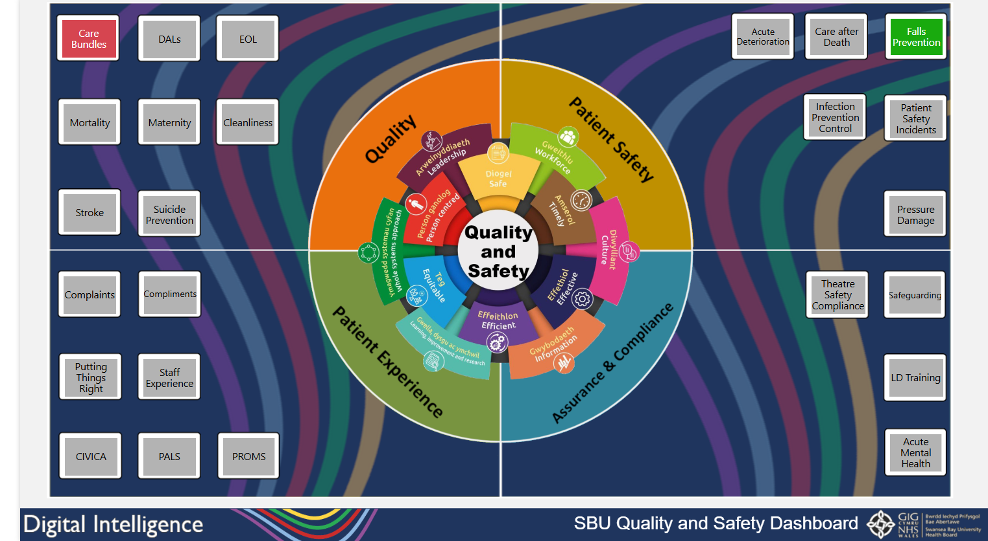

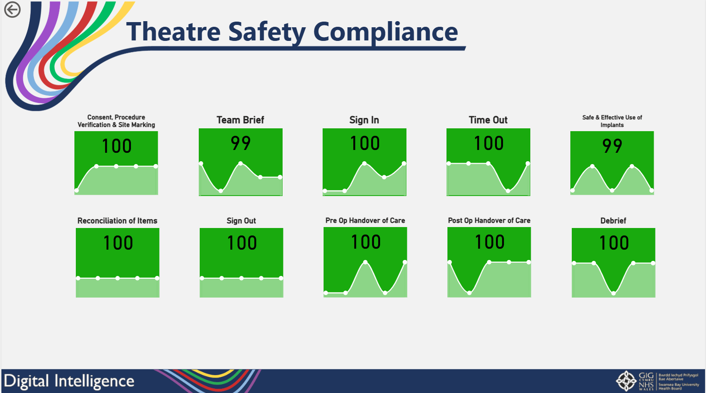
Assurance and Compliance Quadrant added to Quality and Safety Dashboard containing drill-down pages showing agreed measures for area.

Fig 3.
Weekly Health Board Summary – Mental Health and Learning Disabilities

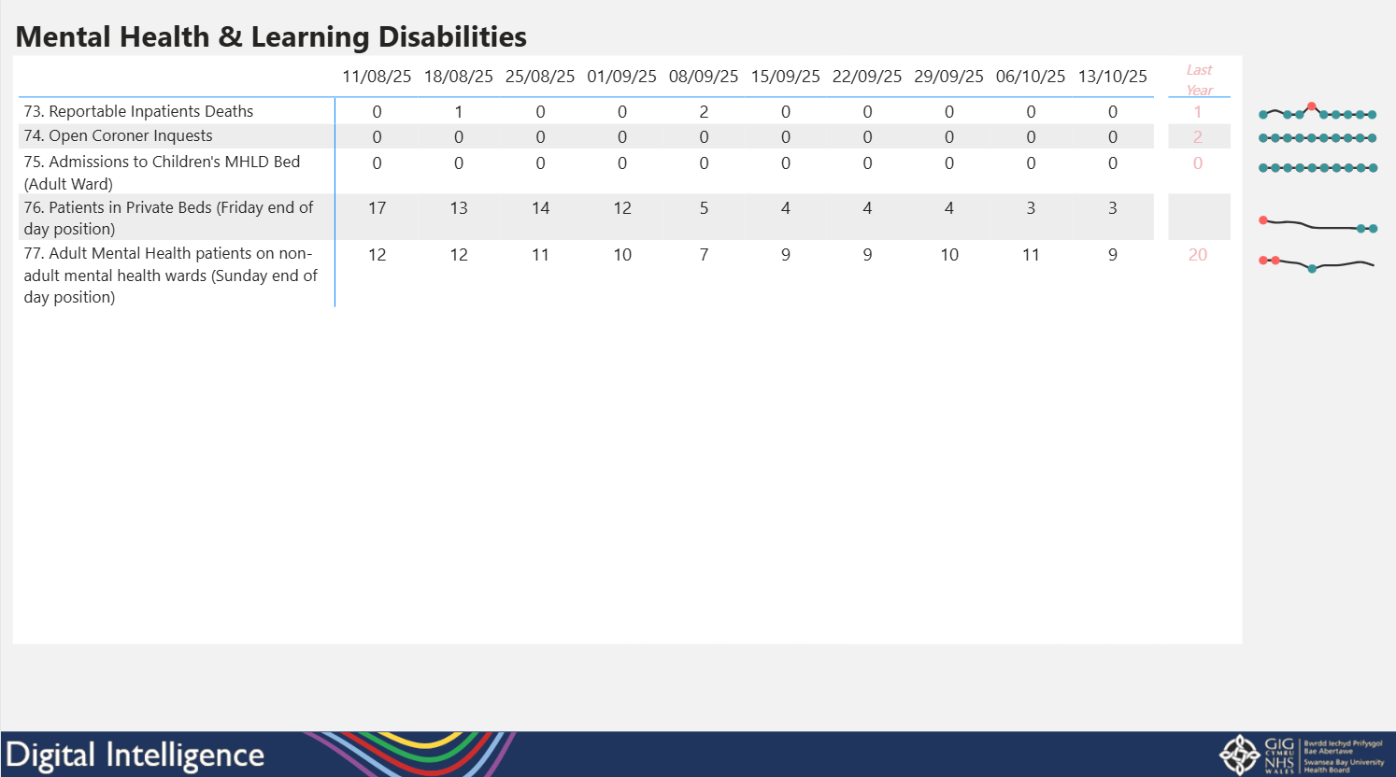
Mental Health and Learning Disabilities measures added into the daily and weekly executive summary reports

Fig 4.
Parkinson’s Admissions Report

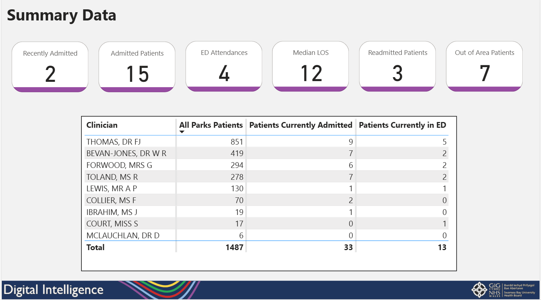
Report which shows a list of patients who have been referred at any stage to a Parkinson’s consultant that are currently admitted in a Swansea Bay hospital.
Fig 5.
Plastic Trauma Hub Dashboard

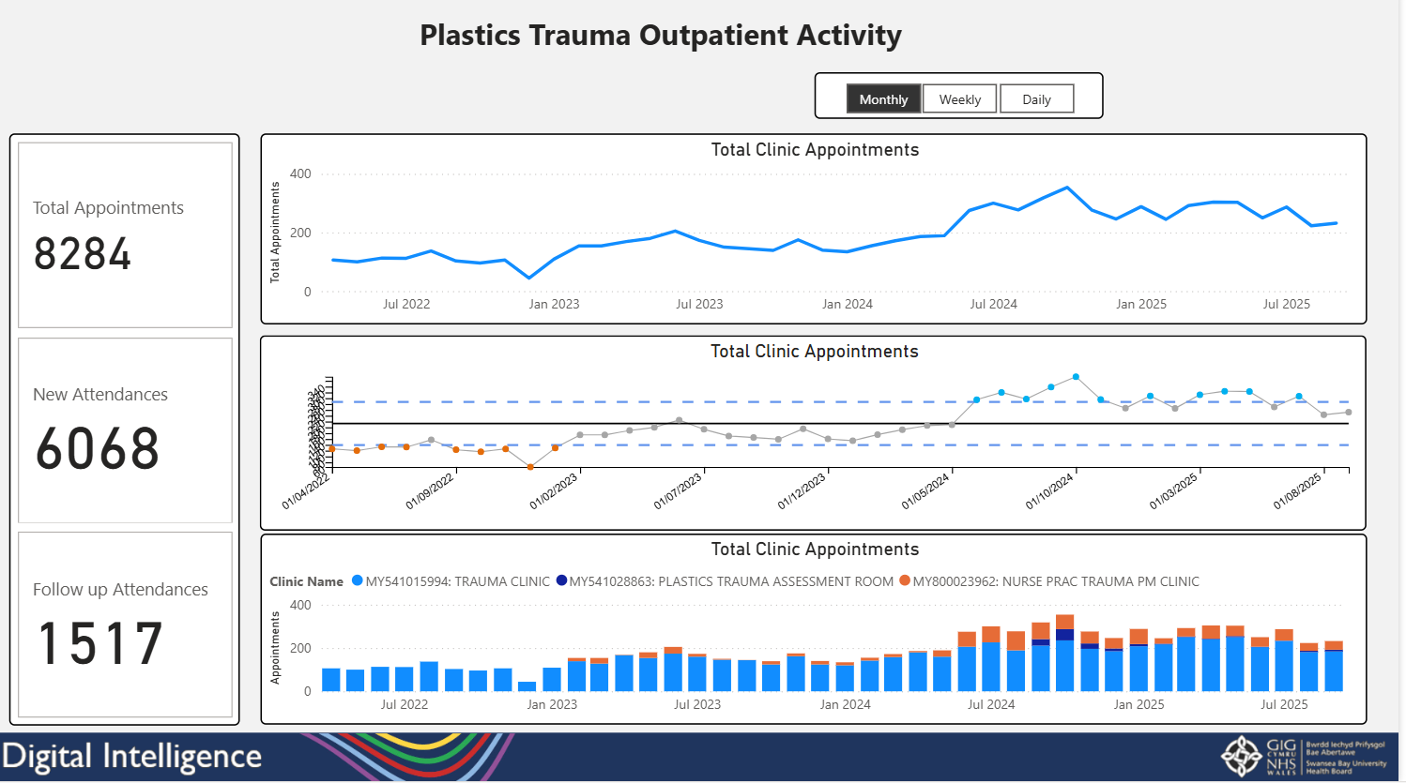
The Plastic Trauma Hub Dashboard that visualises outpatient, theatre and inpatient activity across the hub.

Fig 6.
Immunisation App - Flu Vaccinations Dashboard
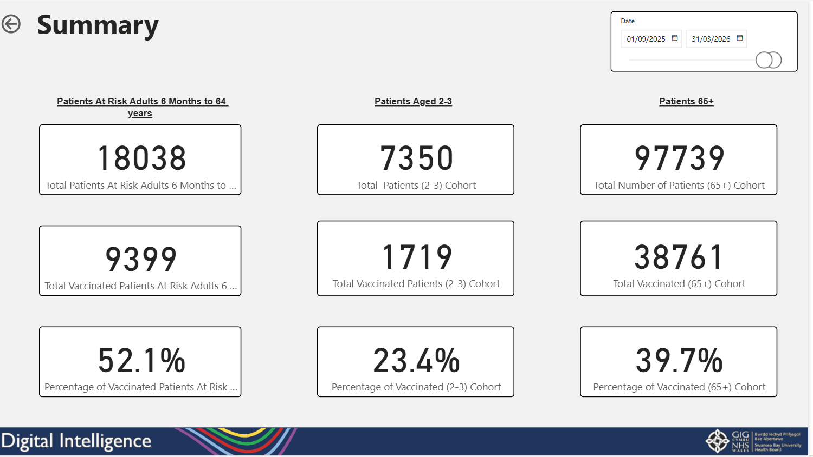
The Flu Vaccinations Dashboard showing vaccination numbers, locations and uptake rates across different cohorts

