Meeting Date | 13 November 2025 |  | Agenda Item |  |  | 5.1
Name of Meeting | Digital, Data, Research and Innovation Committee
Report Title | Delivery of the Digital Strategy and 2025/26 Plan
Report Author | Tracey Bell, Head of Digital Planning, Unscheduled and Community Care  Gareth O’ Gorman, Head of Digital Planning, Diagnostics and Patient Flow
Report Sponsor | Matthew John, Director of Digital
Presented by | Deirdre Roberts, Assistant Director of Digital Transformation
Freedom of Information | Open
Purpose of the Report | The paper provides a summary of digital transformation progress for Q2 Financial Year (FY) 2025/2026 across eight programmes of work, aligned to the digital strategic plan, the Integrated Medium-Term Plan (IMTP) and the organisational strategy
Key Issues | - The long-term sustainability of health and social care is dependent on having the right digital foundations in place.  - The Health Board’s digital plan is aligned to the recently approved Digital Strategy, and the three priority components that contribute to the delivery of a health and social care record.  - Delays pertaining to the delivery of projects have been escalated locally and/or nationally: Radiology Information Management System, Laboratory Information Management System and Digital Maternity.  - A significant number of projects are scheduled to go live in Quarter 4 of 2025/26, with many deadlines mandated by Welsh Government. This concentration of national requirements, combined with local priorities, results is an ambitious delivery period for Q3 and Q4.
Specific Action Required  (please choose one only) | Information | Discussion |  | Assurance | Approval
Specific Action Required  (please choose one only) | ☐ | ☒ |  | ☒ | ☐
Recommendations | Members are asked to:  RECEIVE: the update on Q2 FY2025/2026 progress made across the digital portfolio whilst also noting the ambitious delivery plan for Q3 and Q4.  CONSIDER: the risks related to the delivery of the digital plan for FY 2025/2026.

DELIVERY OF THE DIGITAL STRATEGY AND 2025/26 PLAN

- INTRODUCTION
The Digital Data Research and Innovation (DDRI) committee has emphasised the importance of ensuring the delivery of Swansea Bay University Health Board’s (SBUHB) Digital strategic plan is aligned with the organisation’s Integrated Medium-Term Plan (IMTP) including the 2025/2026 digital work programme. This alignment is essential, not only to maintain strategic coherence across the Health Board’s transformation agenda, but also to provide assurance that digital investments are enabling tangible improvements in patient care, operational efficiency, and organisational resilience.

The paper provides a summary of digital transformation progress for Q2 FY 2025/2026 across eight programmes of work, aligned to the digital strategic plan, the IMTP and the organisational strategy.

BACKGROUND

The Digital 3-year plan was developed and assured by DDRI in July 2025 which demonstrated alignment between the digital strategic plan, the IMTP and the organisational strategy.

The three-year “Plan on a Page” provides a high-level view of the digital transformation journey for 2025 – 2028. It demonstrates how key programmes and enabling capabilities such as infrastructure upgrades, digital front door initiatives, data platform enhancements, and workforce development are sequenced. It serves as a reference point for external and internal stakeholders, including the DDRI Committee.

Figure 1 overleaf presents the 3 year “Plan on a Page” which has been updated to show progress in year 1 of the 3-year digital transformation programme along with the current RAG status.

Figure 1 – 3 Year Plan
(Please note further detail pertaining to the risks flagged in Figure 1 is provided in section 3)
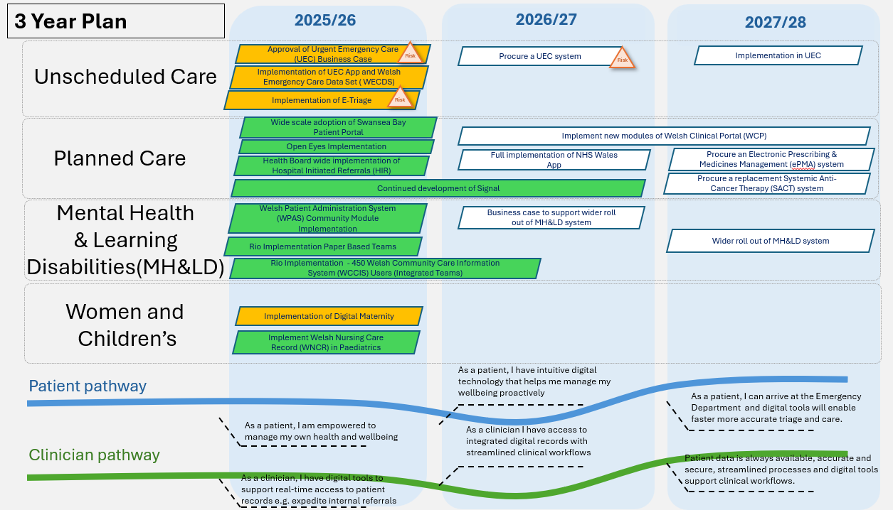
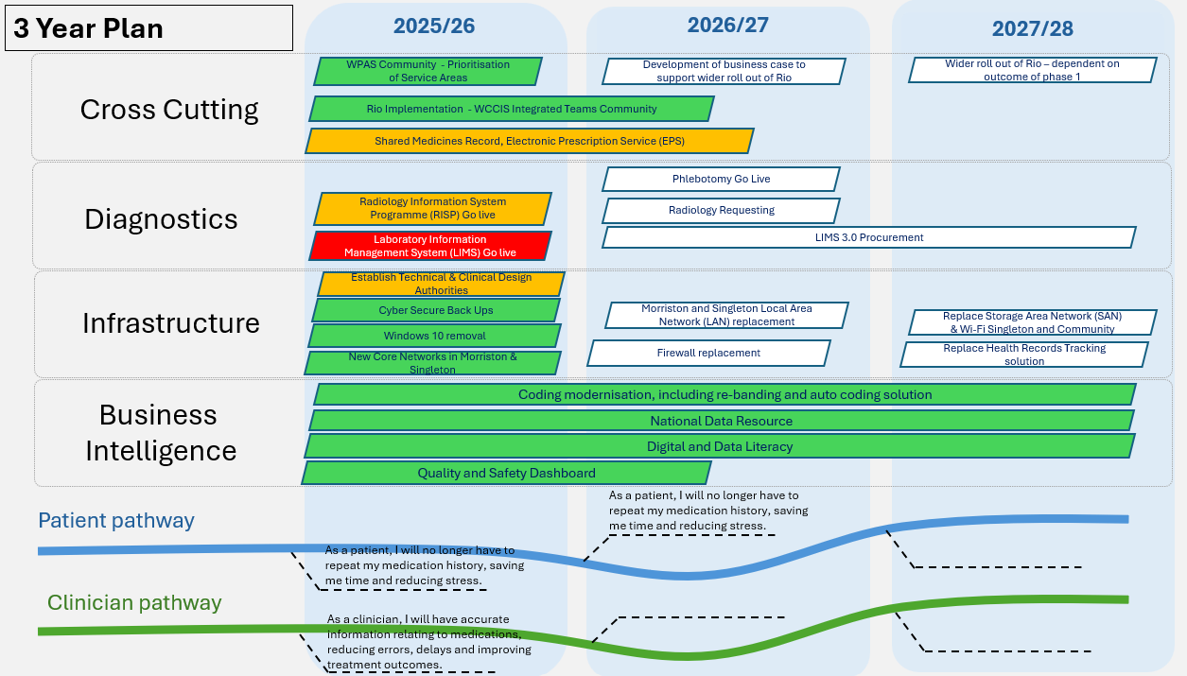
2.1 FY 2025/2026 Timeline

Whilst the 3-year plan provides a high-level overview of delivery from 2025-2028, it is recognised that a more granular timeline is required, demonstrating alignment to the Health Board’s one-year IMTP.

The 2025/2026 timeline offers an overview of when workstreams will be initiated, progressed, and / or completed. Whilst the majority of the projects to be delivered are agreed via the Health Board’s IMTP process it is recognised that additional organisational priorities will emerge outside of the agreed IMTP deliverables. These may reflect urgent operational needs, national directives, or opportunities for innovation that have arisen in-year. The 2025/26 timeline categorises deliverables to provide a transparent view of how the digital portfolio is evolving, where delivery is tracking against plan, and where flexibility has been required to respond to emerging national and / or local operational priorities. It also supports more informed decision-making around resource allocation, risk management, and benefits realisation.

Figure 2 shows the FY2025/26 timeline including key milestones to digital strategic plan.

Figure 2 highlights a number of projects are scheduled to go live in Quarter 4 of 2025/26, with many deadlines set by the Welsh Government. This puts pressure on Health Board resources to deliver within mandated timeframes. This concentration of Welsh Government driven requirements, alongside local priorities, increases the risk of resource bottlenecks and competing demands, which may impact the pace and effectiveness of organisational change. The need to balance national directives with operational realities could challenge the Health Board’s ability to maintain momentum across all programmes, requiring agile resource allocation, robust risk management, and clear communication to ensure successful delivery and sustainable transformation.

Figure 2 – FY2025/26 Timeline
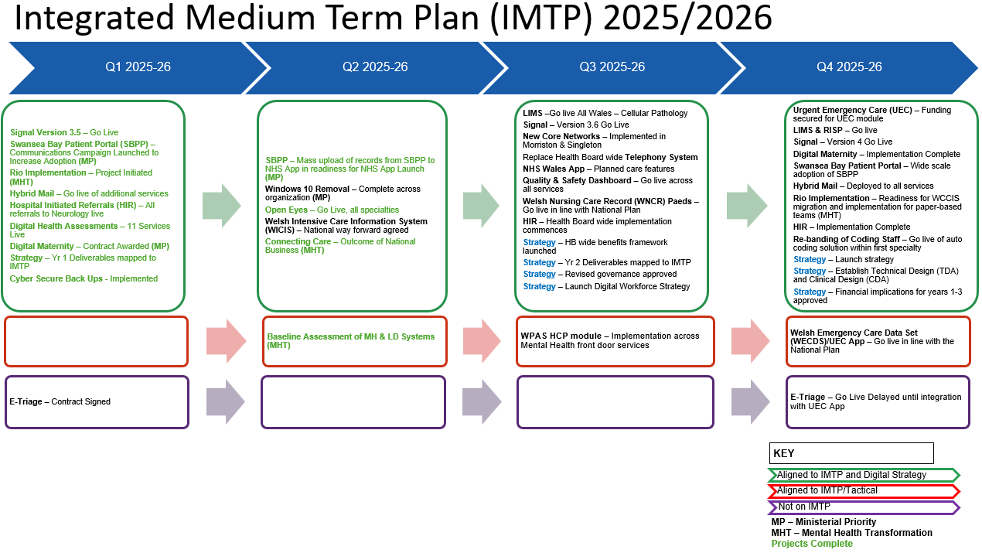

2.2 Project Delivery Dashboard
A detailed Project Delivery Dashboard for active Digital projects in FY 2025/2026 has been developed and is provided in Appendix 1, along with more detailed context to support the dashboard. At the end of quarter 2 of the 36 projects detailed in the delivery dashboard, 22 projects are green and are progressing as planned, 13 projects are amber however, mitigating actions are in place and 1 project is red and off-track (Laboratory Information Management System). Further detail relating to this risk is provided in section 3 of this report.

- GOVERNANCE AND RISK ISSUES
Governance
The digital plan is overseen by the Digital Leadership Group (DLG), which has representation from each corporate directorate and service group. The Digital Leadership Group reports to Management Board. The delivery of the digital plan continues to be managed by digital programme boards, providing updates and/or escalations (where appropriate) to the Digital Leadership Group and the relevant Health Board Programme Board e.g. Unscheduled Care and Planned Care boards.

Risk
Risks pertaining to the delivery of digital programmes are managed via the relevant programme board and escalated to the Digital Leadership Group and respective Health Board wide programme board where necessary. Risks that impact a live operational service will be recorded via the digital service management group (DSMG). Where a digital risk impacts a service or a service delivery group (SDG), digital services will work with the relevant service delivery group to ensure the risk and associated impact is reflected on the service delivery group risk register and where relevant, escalated to the Health Board risk register.

Programmes at risk to delayed delivery are set out below:

- Laboratory Information Management System (LIMS): SBUHB Cellular Pathology is scheduled to go live during November, bringing the first users in Wales onto the system. This is dependent on the preceding technical go-live going well; SBUHB are, together with other Health Boards, supporting the programme by testing the bulk data upload and trickle feed. It is also dependent on the supplier fixing defects identified during testing, so that these defects can be re-tested and closed. Concerns remain that the level of defects is not reducing quickly enough to support other discipline go lives. With full functionality for Blood Sciences not due for delivery until 16th February, and without a clear downward trajectory of open defects, determining when the system can safely pass through testing for remaining pathology disciplines is challenging. Welsh Government have agreed to fund the £1.6m Mitigation Plan, which was constructed to fund resources until 31st December 2025. However, the Programme Board in September heard that - after the £1.6m funding has been accounted for - an additional £690k overspend is expected due to resources being extended to 31st March 2026 and heard in the October meeting that this has risen to £870k. Digital Health Care Wales (DHCW) are looking to cover these costs with Digital Priorities Investment Fund (DPIF) underspend and they do not expect the overspend to increase past £870k in this financial year. Swansea Bay is the only Health Board in Wales reliant on the current LIMS for Blood Transfusion, creating an additional pressure to transition to the new LIMS. A risk was approved for escalation to the Health Board Risk Register at the June SBUHB Risk Management Group (Datix ID 3114 – score 16).

- Radiology Information System Programme: The Health Board is scheduled to go live in February ‘26. SBUHB are putting every resource and effort available into absorbing the impact of supplier delays but remain concerned of Philips’ ability to successfully manage their deliverables that would enable us to meet a 23rd February 2026 go-live. The SBU current Picture Archiving and Communications System (PACS) contract (Fuji) has been extended to March 2027 by way of mitigation should delivery timescales slip beyond March 2026. A delayed go live has an associated benefit of reduced dual running costs alongside the Fuji contract. This risk is recorded on the Morriston Service Delivery Group (SDG) risk register with regular updates being presented to Morriston senior leadership team meetings and management board. The Health Board continues to engage and be advised by the national commercial group underpinning delivery of the national programme recognising the impact supplier issues and resource constraints will have on the national implementation plan.

- Connecting care: Refer to Mental Health Transformation Programme; digital update paper. Risks relating to the delayed delivery for a service wide solution have been captured in the paper.

- Unscheduled & Emergency Care (UEC) App: The Minor Injury Unit currently use the Welsh Emergency Department System (WEDS) provided by Optum. The contract expires in September 2026. A replacement solution is required. At the request of the national 6 goals programme for unscheduled care, DHCW have developed the UEC app (including the Welsh Emergency Care Data Set (WECDS) dataset) which is being proposed as a data capture solution across unscheduled care settings in Wales. Swansea Bay will look to implement the UEC app in the Minor Injury Unit in the first instance given the impending WEDS contract end date. Concerns relating to delayed delivery of the solution coupled with requirements for local integration have been escalated to the Health Board UEC board and 6 goals programme. Digital leads are also assessing other alternative ways forward to provide further mitigation.

- Digital Maternity: There is a risk that the integration of national systems required for Badgernet—specifically the Welsh Birth Notification Service and Admissions, Discharge and Transfer (ADT) feeds—will not be delivered in 2025/26, as these integrations are not currently included in DHCW’s national delivery plan. The absence of these integrations would prevent the Health Board from proceeding to go-live with Badgernet before the end of March 2026, impacting the delivery timeline for the Digital Maternity project and potentially affecting compliance with national and local strategic objectives. The Health Board has escalated the issue to DHCW through formal governance channels and a national task force has been established to determine the delivery plan for these integrations. DHCW have re-prioritised resources to ensure the required integrations are complete for phase 1.

- Strategy mobilisation: additional capacity is required to mobilise the Digital Strategy. Options are currently being explored to create the capacity and capability required to support this work within existing budgets. Alignment to the national approach and Ministerial priorities is also a key component in mobilising the Digital Strategy, the impact of the recommendations from the recent report from the Ministerial Advisory Group are currently being considered.

- FINANCIAL IMPLICATIONS
As outlined in previous reports the Digital Strategy will require significant investment to achieve the desired service-led, digitally enabled transformation. Digital experts suggest allocating 5-10% of total Health Board income to digital and data to reach digital maturity. The current annual spend on data and digital at SBUHB is just over 2%, and the strategy sets out the indicative requirement to increase this allocation to 4.6% over the next 10 years.

The assessment of investment required has been further validated by a recent benchmarking exercise conducted as part of the Recovery and Sustainability Programme. The results of the exercise are shown in the graph below. Whilst it is recognised that all benchmarking needs to be treated with some caution, e.g. SBUHB digital costs will have included the costs of the Health Board’s Health Records department but excluded other costs held outside Digital Services budgets, the outcome does substantiate the investment required to deliver the digital strategy and sustainable digital solutions/services.

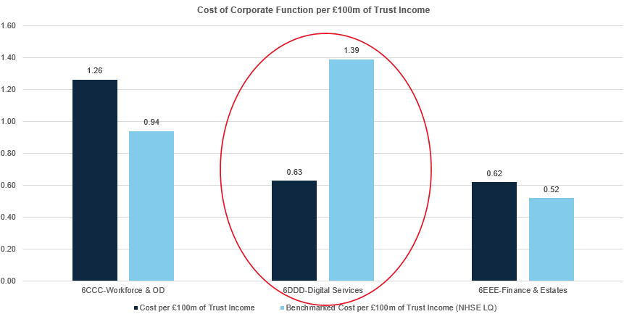

As previously reported progress has been made in terms of securing funding for delivery of solutions in 2025/26 including funding for the interim solution for integrated teams and to support the implementation of Open Eyes and the Maternity Electronic Patient Record (EPR). Since the last update to DDRI funding has also been confirmed by Welsh Government, via DHCW, for 2025/26 for the Connecting Care Programme. This constitutes of £1.010m revenue and £726k Capital. No commitment has been given for Connecting Care funding requirements for future years. A local business case has been developed setting out how best to utilise this funding effectively.

A detailed update on the financial management of Digital Services for 2025/26 is contained within a separate paper to DDRI.

As reported previously to DDRI, further work will be required to ensure that the financial investment required is prioritised as part of the ongoing IMTP process for 2026/27 and beyond. Following discussions with the Director of Finance, the three-year investment plan outlined within the Digital Strategy has been reviewed and refined. A detailed review of the projected financial outturn for the Digital Services Directorate in 2026/27 to determine scope of non-recurrent reallocation of existing budget to support delivery of the Digital Strategy has also been completed. The Director of Digital and Director of Finance will make a joint presentation to the Chief Executive Officer (CEO) on the investment required in Digital for the next 3 years and its inclusion in the IMTP process.

- RECOMMENDATION
Members are asked to:
- RECEIVE: the update on Q2 FY2025/2026 progress made across the digital portfolio whilst also noting the ambitious delivery plan for Q3 and Q4.
- CONSIDER: the risks related to the delivery of the digital plan for FY 2025/2026.

Governance and Assurance

Link to Enabling Objectives  (please choose) | Supporting better health and wellbeing by actively promoting and empowering people to live well in resilient communities
 | Partnerships for Improving Health and Wellbeing |  | ☒
 | Co-Production and Health Literacy |  | ☒
 | Digitally Enabled Health and Wellbeing |  | ☒
 | Deliver better care through excellent health and care services achieving the outcomes that matter most to people
 | Best Value Outcomes and High-Quality Care |  | ☒
 | Partnerships for Care |  | ☒
 | Excellent Staff |  | ☒
 | Digitally Enabled Care |  | ☒
 | Outstanding Research, Innovation, Education and Learning |  | ☐
Health and Care Standards
(please choose) | Staying Healthy |  | ☒
(please choose) | Safe Care |  | ☒
(please choose) | Effective Care |  | ☒
(please choose) | Dignified Care |  | ☒
 | Timely Care |  | ☒
 | Individual Care |  | ☒
 | Staff and Resources |  | ☒
Quality, Safety and Patient Experience
Implementation of digital systems in healthcare can have a significant positive impact on quality, safety, and patient experience. Critical to success is the wide scale adoption of an effective business change model, digital service team capacity and capability, workforce digital skills and clinical leadership.
Financial Implications
Please reference agenda: Digital Financial Management
Legal Implications (including equality and diversity assessment)
None.
Staffing Implications
Increasing numbers of staff will be required to deliver the digital change programme in SBUHB. This will be detailed in future workforce plans, individual business cases and digital priorities and plans.
Long Term Implications (including the impact of the Well-being of Future Generations (Wales) Act 2015)
- Long Term – Health and Social Care “A Healthier Wales” (2018) sets out a long-term future vision of a ‘whole system approach to health and social care’, which is focussed on health and wellbeing, and on preventing illness
- Wellbeing of Future Generations Act (2015)
  - Focus on prevention, not service provision.
  - Prevent ill health, reduce impact of illness or injury and delay onset of frailty.
  - Provide services to carers that prevent, reduce, or delay them developing a need for support.
- Swansea Bay University Health Board’s Clinical Services Plan (2019-2024)
  - Adoption of digital solutions and technology.
  - Create a mobile workforce that is digitally connected to ensure staff work seamlessly to ‘Make Every Contact Count’.
  - Technology to support care closer to the patient’s home or in the community.
Report History
Appendices |  | Appendix 1

