

Chief Executives and Chairs
NHS Health Boards and Trusts Wales
Via Email

18 November 2025

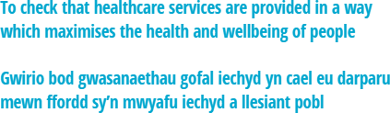
EMBARGOED: Healthcare Inspectorate Wales (HIW)
Mental Health, Learning Disability Services and Mental Health Act Monitoring Annual Report 2024-2025
Dear Chief Executive and Chair

I would like to inform you that HIW will be publishing its 2024-2025 Mental Health, Learning Disability Services and Mental Health Act Monitoring Annual Report at 00:01 on Thursday 20 November 2025. Please find a copy of our report attached.

The report sets out our assurance activity and findings during the period from April 2024 to March 2025 and explores the standards of care being delivered by mental health and learning disability healthcare services across Wales during this time.
Should you wish to follow up on anything contained within the report then please get in touch with me directly.

Yours sincerely

Alun Jones Chief Executive

Healthcare Inspectorate Wales

Llywodraeth Cymru / Welsh Government Parc Busnes Rhydycar / Rhydycar Business Park
Merthyr Tudful / Merthyr Tydfil
CF48 1UZ
Tel / Ffôn 0300 062 8163
Fax / Ffacs 0300 062 8387
www.hiw.org.uk / www.agic.org.uk

