Meeting Date | 23 April 2024 |  | Agenda Item |  |  | 4.2
Report Title | Fractured Neck of Femur Frailty Strategy
Report Author | Rhodri Davies, Associate Service Group Director - Surgery  Charlotte Le Brocq, Directorate Manager, T&O and Spinal
Report Sponsor | Deb Lewis, COO
Presented by | Ceri Gimblett, Service Group Director NPTSSG  Rhodri Davies
Freedom of Information | Open
Purpose of the Report | This paper has been developed to provide an update on the Fractured Neck of Femur (NOF) challenges in SBUHB and to set out how the proposed Frailty Strategy within Morriston Hospital will improve patients outcomes.
Key Issues | Performance Metrics for two of the eight National Hip Fracture KPI’s reporting as below national average therefore this paper will describe the key constraints and plans to improve quality of care and performance for this cohort of patients.
Specific Action Required  (please choose one only) | Information | Discussion |  | Assurance | Approval
Specific Action Required  (please choose one only) | ☐ | ☐ |  | ☒ | ☐
Recommendations | Members are asked to:  - Note the Performance for the National NOF KPI’s.  - Further approve the plan for the ring-fenced bed area for #NOF patients to improve the KPI’s for access to a specialist bed and timely access to surgery.

NECK OF FEMUR FRAILTY STRATEGY

- INTRODUCTION

A fractured neck of femur is a very common orthopaedic presentation. Over 70,000 hip fractures each year are recorded in the UK, and they are becoming increasingly frequent due to the aging population. There have been significant improvements in the service provided for this cohort of patients largely due to investment in the Consultant Orthogeriatric Team at Morriston Hospital however delays to surgery and access to ring fenced Orthopaedic beds remains a constraint.

- BACKGROUND

During 2023 Morriston Hospital admitted 720 patients with a fractured neck of femur.

This cohort of patients are monitored via a national audit tool, National Hip Fracture Database which was established in 2007. The key performance indicators are illustrated below with national figures (NHFD overall) and Morriston Hospital figures.

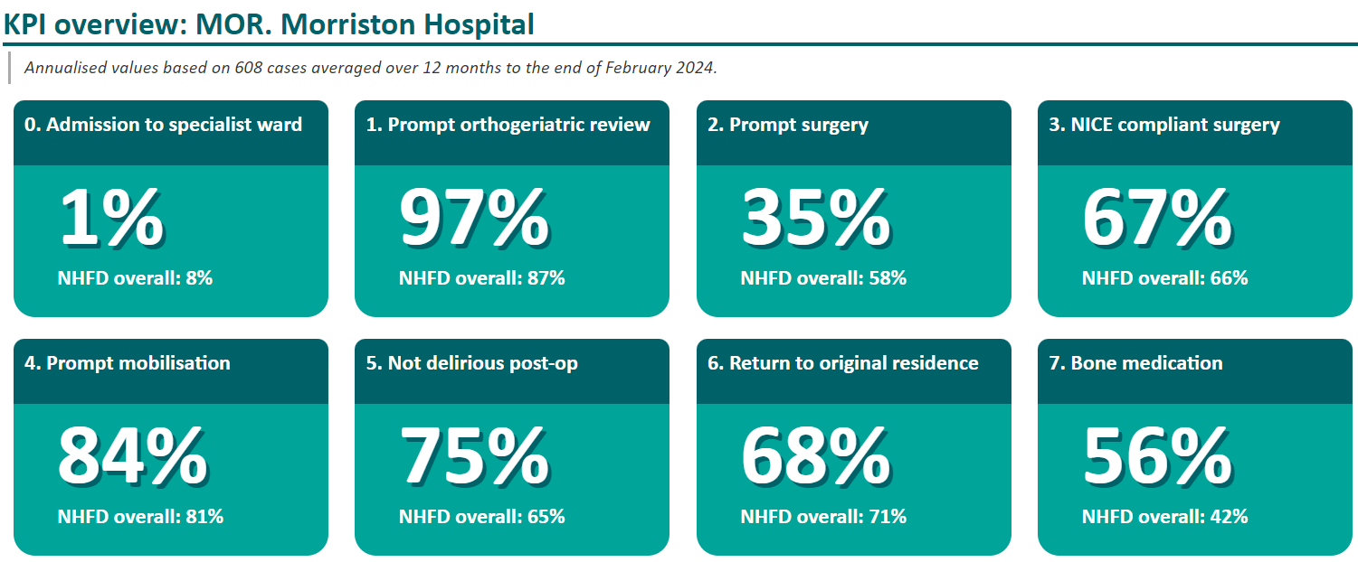

The timeframe for the two most poorly performing KPI’s are 4 hours to a specialist bed and 36 hours for surgery. Current performance can be seen below.

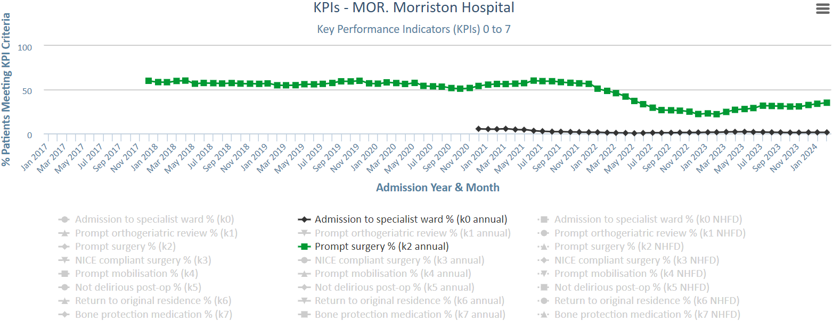

The above shows the current percentage is 1% for admission to a specialist ward/bed versus a national average of 8% and 35% for prompt surgery versus the national average of 58%. This KPI has seen a marginal improvement 31% in August 2023, 32% in December 2023 to 35% in February 2024. The main factor preventing prompt surgery is access to a specialist bed. Any delay within these two KPI’s also impacts on the patients length of stay. The average acute length of stay within SB is 22 days.

Fracture of Neck of Femur in the elderly has a mortality rate of 10% for one month and 30% at one year. This injury also prevents return to the original residence a fifth of these patients consequently require nursing or residential care. On average Morriston Hospital receives two fractured NOF patients every 24 hours.

- Frailty strategy

There have been considerable improvements in the service offered to patients presenting with hip fractures related to frailty in recent years, mainly driven by the recruitment of a Morriston based consultant orthogeriatric team.

The service has considerable strength in measurement of key metrics through its participation in national audit work-streams (The National Hip Database and the Fracture Liaison Service Database.) Access to prompt surgery for hip fracture patients is well below the Welsh average and as such deconditioning and a longer length of stay is more likely despite excellent access to early Orthogeriatrician review and avoidance of delirium.

Average time from presentation at ED to Ortho bed in 2023 (Jan-Dec) is 16 hours 25 minutes. Theatre delays are common with 63% of patients not meeting the 36-hour target for access to surgery. These delays are related to theatre space in 81% of cases and are largely outside of the scope of the orthogeriatric service to influence.

The key strategic aims to note include:
- Reducing LOS for frail patients with hip fracture (National GIRFT (Getting it Right First Time) average 19 days, at Swansea Bay UHB, 53% of patients stay more than 14 days; 34% more than 30 days)
- Improving the proportion of patients rapidly admitted to a specialist unit and offered effective analgesia as per NHF audit standards.
- Improving access to prompt surgery.

Patients with a confirmed fractured neck of femur should be directed into the proposed frailty unit co located to the emergency department. There will need to be 4-6 beds ring fenced for the orthogeriatric service to provide care in the first 48 hours of admission to their caseload of 720 patients a year in the new unit (the current wait for surgery in Swansea Bay averages 55 hours, the longest wait was 305 hrs in 2023). The frailty unit will need daily speciality in-reach from Orthogeriatrics and orthopaedics, it is not anticipated [other than nursing costs for the 6 beds] that this will attract an additional cost as these arrangements are currently in place for patients in ED.

Within the frailty unit there will be six ring-fenced beds to enable immediate admission and stabilisation pre-operatively.

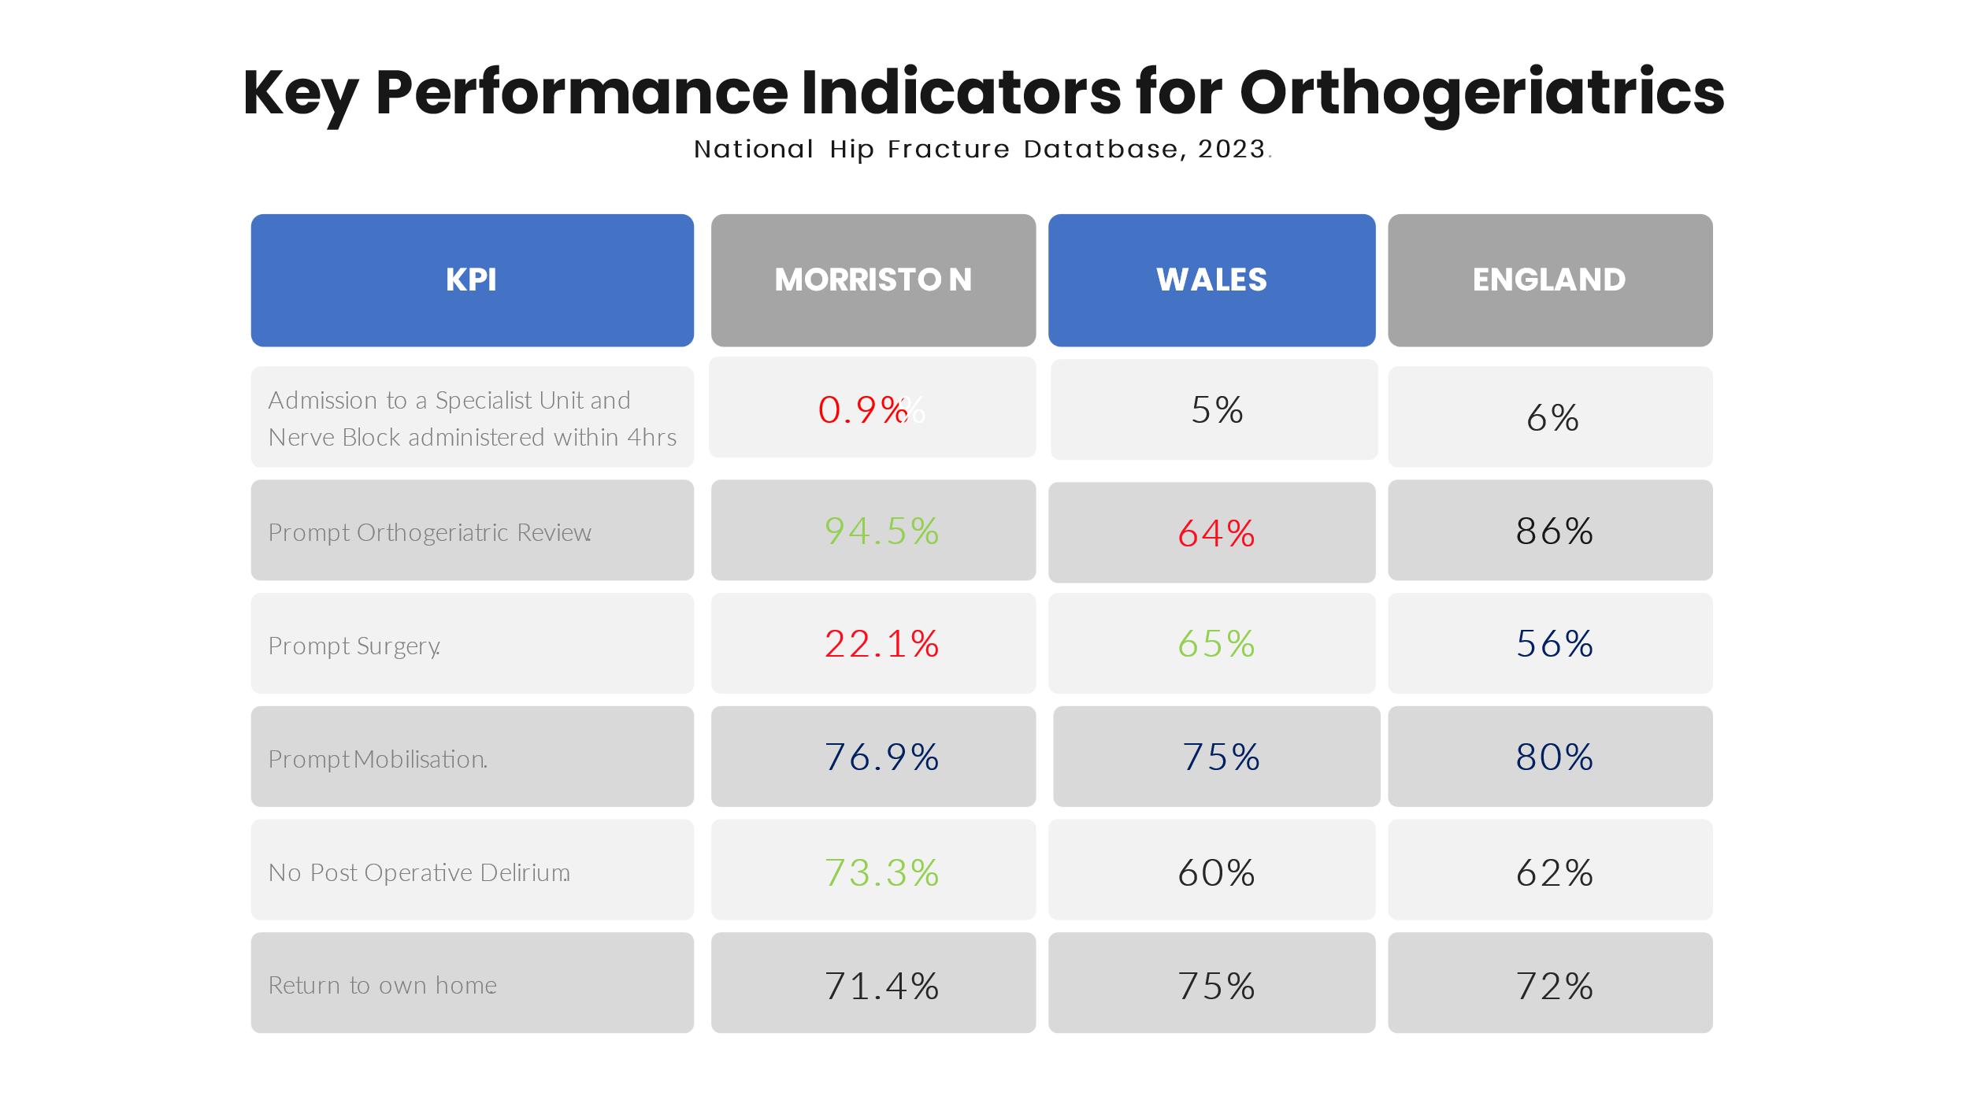
We can do this by maximising and co-ordinating the current teams that already exist within the health board within a single line management structure. This should sit within the Morriston Service Group, acknowledging that much of the care can, and will be out of hospital but noting the current consequences of a disconnected frailty strategy currently manifest as emergency department presentations.

- GOVERNANCE AND RISK ISSUES

The long waiting times for fractured neck of femur patients results in risks to both patient experience and outcomes and the reputation of the Health Board.

The plan for patients to have access to ring fenced beds within the Frailty Unit next to the ED department within Morriston will reduce the risk for these patients as they will be admitted more timely allowing them access to the most appropriate resource and surgery within the required time frame.

- FINANCIAL IMPLICATIONS

The 21 bedded Acute Frailty Unit (includes the 6 bedded area for #NOF patients) has already sought funding (Further Faster Fund) via another paper submitted to Management Board and has been approved.

- RECOMMENDATIONS

- Note the Performance for the National NOF KPI’s.
- Further approve the plan for the ring fenced bed area for #NOF patients to improve the KPI’s for access to a specialist bed and timely access to surgery.

Governance and Assurance

Link to Enabling Objectives  (please choose) | Supporting better health and wellbeing by actively promoting and empowering people to live well in resilient communities
Link to Enabling Objectives  (please choose) | Partnerships for Improving Health and Wellbeing |  | ☐
Link to Enabling Objectives  (please choose) | Co-Production and Health Literacy |  | ☐
Link to Enabling Objectives  (please choose) | Digitally Enabled Health and Wellbeing |  | ☐
Link to Enabling Objectives  (please choose) | Deliver better care through excellent health and care services achieving the outcomes that matter most to people
Link to Enabling Objectives  (please choose) | Best Value Outcomes and High Quality Care |  | ☒
Link to Enabling Objectives  (please choose) | Partnerships for Care |  | ☒
Link to Enabling Objectives  (please choose) | Excellent Staff |  | ☐
Link to Enabling Objectives  (please choose) | Digitally Enabled Care |  | ☐
Link to Enabling Objectives  (please choose) | Outstanding Research, Innovation, Education and Learning |  | ☐
Health and Care Standards
(please choose) | Staying Healthy |  | ☐
(please choose) | Safe Care |  | ☒
(please choose) | Effective Care |  | ☒
(please choose) | Dignified Care |  | ☐
(please choose) | Timely Care |  | ☒
(please choose) | Individual Care |  | ☐
(please choose) | Staff and Resources |  | ☐
Quality, Safety and Patient Experience
The ongoing work to address excessive waits for access to a specialist bed and timely surgery for fracture neck of femur patients in SBUHB will have a positive impact on patient experience.

Financial Implications
The expansion of the Orthogeriatric Team is already in place and additional funding is also available for an additional Band 7 and Band 3 within the Fracture Liaison Services until March 2025. There will however be additional nursing costs for the 6 beds. Morriston Hospital Service Group are leading on the frailty strategy.

Legal Implications (including equality and diversity assessment)
N/A

Staffing Implications
The Plan for the ring fenced bed area within the Frailty Unit is to maximise and co-ordinate the current teams that already exist within the health board.

Long Term Implications (including the impact of the Well-being of Future Generations (Wales) Act 2015)
Report History
Appendices |  | None.

