Meeting Date | 26 August 2025 |  | Agenda Item |  |  | 3.2
Name of Meeting | Performance & Finance Committee
Report Title | Continuing NHS Healthcare (CHC)  Quarter 1 Report: April- June 2025
Report Author | Amanda Davies, Deputy Head of Nursing for Long  Term Care  Richard Mugford, Finance Business Partner PCTSG  Colin Jones, CHC & Commissioning Manager MHLD  Janet Millward, Deputy Head of Nursing for  Children’s Services  Hannah Roan, Acting Assistant Director of Planning & Partnerships (Commissioning & Sustainability)
Report Sponsor | Marie Davies, Executive Director of Planning & Partnerships  Liz Rix, Executive Director of Nursing & Patient Experience
Presented by | Marie Davies, Executive Director of Planning & Partnerships
Freedom of Information | Open
Purpose of the Report | This report provides an update on the quarter 1 2025/26 activity and highlight areas of relevance to the Finance and Performance Management Committee relating to Continuing Health Care (CHC) which includes complex care and continuing care for children and young people.
Key Issues | Demand for CHC continues to grow. The Health Board (HB) has a transformation programme in place with the aim of creating a centralised commissioning function for CHC. One of the outputs from the programme is the development of a performance dashboard that will give a complete HB view of CHC activity and performance. Appendix 1 of this report provides a first cut of the performance dashboard which has been utilised for the new charts contained in this report. The dashboard will continue to be developed and refined over the coming months.  Key risks and issues identified in this quarter 1 report for CHC include:  - Sustainability of the care home sector  - Care homes in escalation  - Introduction of Direct Payments for CHC  - Increasing cost pressures associated with CHC
Specific Action Required  (please choose one only) | Information | Discussion |  | Assurance | Approval
Specific Action Required  (please choose one only) | ☐ | ☐ |  | ☒ | ☐
Recommendations | Members are asked to:  - Consider the content of this report  - Provide feedback on the dashboard and advise on any additional measures the committee would like to see featured in future reports.

Continuing NHS Healthcare (CHC) Quarter 1 Report: April- June 2025

- INTRODUCTION
This report provides an update on the Quarter 1 2025/26 activity and highlight areas of relevance to the Health Board (HB) relating to CHC funded care.

- BACKGROUND
The revised National Framework for CHC was implemented on 1st April
2022.

As part of the CHC Performance Framework required by Welsh Government, HBs are required to receive a quarterly report on CHC, and this paper fulfils that requirement. Its intention is to inform the Committee of developments and current issues relevant to CHC, both nationally and locally.

Commissioning of CHC including complex care and continuing care, sits across three Service Groups in the HB:
- Mental Health and Learning Disabilities (MH&LD)
- Long Term Care (LTC)
- Childrens and Young People (CYP)

  - CHC Performance Dashboard
Swansea Bay University Health Board (SBUHB) has a transformation programme in place to strengthen the commissioning arrangements for CHC and Complex Care. A key deliverable of the programme is the creation of a central commissioning function for CHC within the Corporate Commissioning Team that would aid in providing a HB view of CHC commissioning across the organisation.

As part of the programme, a new CHC performance dashboard has been created which aims to pull together data held at an operational level across the Service Groups into one central repository. The HB summary of the dashboard can be found in Appendix 1 and it provides a 13 month view of key measures. Funded Nursing Care (FNC) activity is included in Appendix 1 however, for the purpose of this report only CHC performance will be analysed.

The dashboard will continue to grow and be refined over the coming months to ensure that it not only provides the intel to inform the quarterly performance reports, but can also be utilised by the HBs to look at trends, hot spots and possible areas of concern/ opportunity. The data in this quarter 1 report should be regarded as draft as the dashboard is work in progress.

  - Quarter 1 2025/26 Performance
As at June 2025, there were a total of 999 CHC packages of care being commissioned for individuals across the HB footprint. Chart 1 provides an overview of the active cases by Service Group.

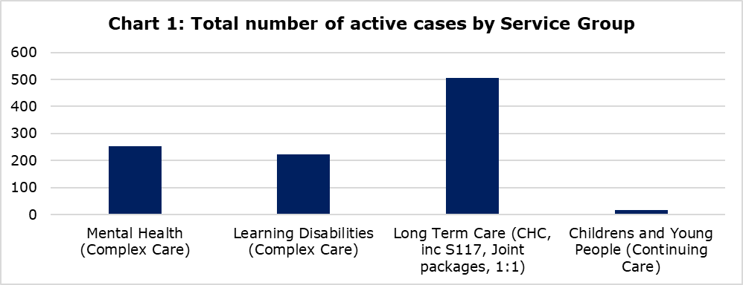

Chart 2 shows the monthly trend for active cases by Service Group. LTC account for the highest proportion of cases and whilst packages managed by the LTC Team saw a dip in cases between December 2024 and January 2025, the average number of cases is around 476 per month.

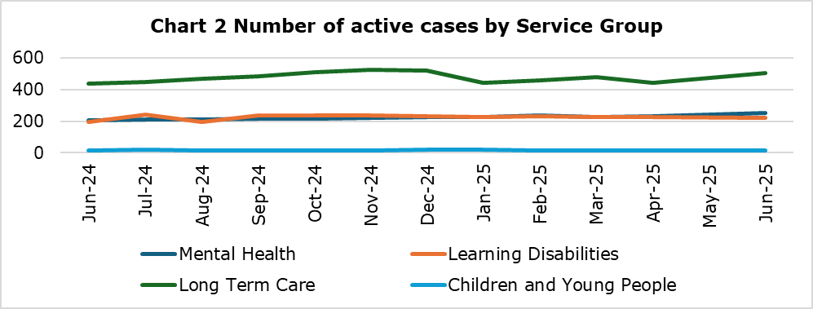

Table 1 provides a breakdown of the number of new referrals received in June 2025. Fast track accounts for the highest number of referrals and would have been for individuals requiring palliative care services or discharge from hospital as part of the Discharge to Recover and Assess (D2RA) pathway.
Table 1: Number of new referrals received in June 2025
 | Number of referrals received
Fast Track | 64
Mental Health | 30
Learning Disabilities | 27
Number of CHC & FNC with CHC Triggers referrals inc. EMI | 16
Section 117 | 1
CYP | 0

Several drivers contribute to the level of demand within the period, primarily a general increase in pressure within adult mental health services and unscheduled care which appears to be overflowing into complex care commissioning as well as a continuing increase in Elderly Mental Illness (EMI) cases. Chart 3 shows the trend in the types of packages being commissioned.

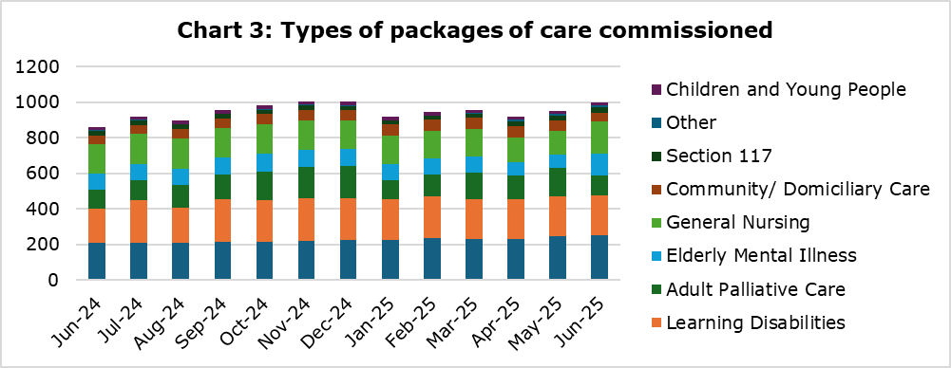

Chart 4 shows where the packages of care across all Service Groups were delivered in June 2025. The vast majority are in nursing or residential homes. An in-depth analysis is currently underway in conjunction with the Regional Partnership Board (RPB) mapping out all the packages of care across Health and Social Care by need and location in order to create a regional demand and capacity plan. The output will be brought to a future committee meeting.
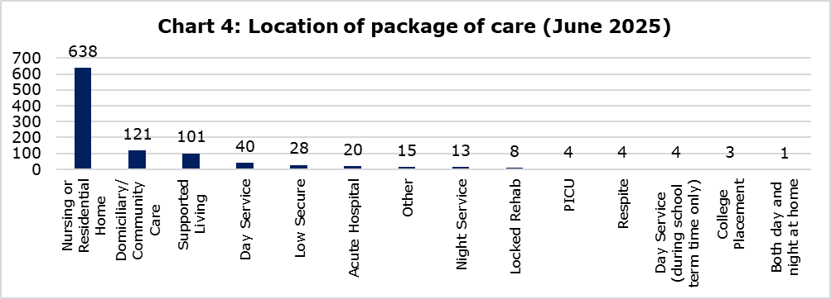
In line with the Welsh Government Framework for Continuing NHS Healthcare, individual’s eligibility is subject to review. The initial review is undertaken 3 months after the recommended outcome and thereafter on an annual basis. However, should there be a change in need identified by the individual, family, professionals or provider of care the review will be undertaken earlier.

Routine reviews of the packages of care are crucial in ensuring that the patient is not only receiving the right level of care but also quality of care. An initial review is

As at the end of Q1 25/26, a total of 233 reviews were due with 131 being completed. For LTC the outstanding reviews are due to hospital admissions and care homes in incident status. The LTC Team are working at a staffing deficit of 2.6 WTE Band 6. Recruitment has been completed with start dates planned for July and August 2025.

For MH & LD, the increasing number of routine reviews have identified a significant number of recipients of NHS Continuing Healthcare (CHC) requiring review of their CHC status – where this applies DSTs are being booked in conjunction with the applicable Local Authority. However, this process is protracted as a result of resource issues within the Local Authorities whereby they do not have enough Social Workers to support in a timely manner. This matter has been escalated to the MH & LD Service Group Director and can be discussed via the weekly Health and Social Care Interface meetings between the HB and the Local Authorities attended by the Executive Director of Planning & Partnerships and the Chief Operating Officer.

It is hoped that the charts/ tables above plus the summary in Appendix 1 has given committee members a flavour for the data that can be reported on a regular basis. The following measures are planned to be included in the next report however, members are asked to highlight any additional measures that would be of interest.
- High cost cases approved
- Location of placements- in or out of area
- Unresolved disputes with Local Authority

- GOVERNANCE AND RISK ISSUES
  - Retrospective Claims
The retrospective claims process for the organisation is managed through the LTC Team. The role of the Retrospective Team is to consider claims from individuals or their family/representative where they feel that they should have been eligible for CHC funding for past care needs.
All retrospective claims received within this quarter have been completed within the 6-month timescale and no Ombudsman enquiries relating to retrospective claims were received.

  - Escalating Concerns
One Care Home in the Port Talbot area remains in escalating concerns during the Q1 period. Concerns raised:
- Governance Process
- Management & Leadership
- Safeguarding Concerns
- Infection Prevention & Control

Recent Joint Interagency Monitoring Panel (JIMP) on 2nd July 2025 identified some improvements and suspension of placements lifted during Q1. Due to inconsistency in improvements to action plan, panel agreed to continue with escalating concerns status due to sustainability and risks. New Management Team in place. Panel agreed that continued monitoring required for assurances on sustainability of the management of the home. Next JIMP meeting 30th July 2025. Risk score reduced to 9 (significant) 5th June 2025 as home no longer in suspension of placements. Risk remains significant but controls and assurances remain in place to mitigate risks.

One Neath Port Talbot Care Home remains in Performance Management, Ty Nant Nursing Home, following concerns raised by NPT and Bridgend Local Authority regarding the management of the financial processes within the home. Improvement has been noted and Performance Management position to be reviewed in July 2025. No concerns related to patient safety or care noted.

  - Sustainability in the Care Home Sector
Recruitment and retention of staff remains a challenge across social care and is severely impacting both domiciliary and residential care. Care Home providers may need to consider a different approach regarding on-site availability of registered nurses. NHS pay awards will also affect the independent sector as providers compete with the NHS for nurses on higher wages and better terms and conditions.

Occupancy levels within the Independent Care Home Sector across the Swansea Bay footprint continues to grow and is now at the pre pandemic levels. The overall occupancy as at June 2025 within the independent sector for 94.64% Neath Port Talbot and 91.7% for Swansea.

CIW registered Nursing and Residential Care beds across Swansea Bay totals 2,359 beds (this includes the registered beds in Swansea and Neath Port Talbot). Table 2 provides a summary of the capacity and usage across the SBU footprint.

Table 2: Bed capacity for Independent Sector
 | Capacity Registered | Current Residents | Nursing | Residential
Neath Port Talbot | 803 | 760 | 321 | 438
Swansea | 1556 | 1427 | 1,020 | 407

  - Cost pressures in the Care Home Sector
The Health Board is an active partner with Swansea Local Authority in the process of considering the costs of providing care and accommodation for care home providers. Care home fees have significantly increased since 1st October 2021 in recognition of the increased costs of food, fuel and inflation. Recent concerns have been raised from Care Home Providers on the increase in employers’ contribution to National Insurance (NI) and Real Living Wage for 2025/26.

A Finance Sub Group Meeting has been undertaken with Health, LA, Care Forum Wales and providers to discuss 2025/26 rates. All partners have approved 6.1% uplift for 2025/26 however, Swansea care home providers are challenging this rate. Swansea LA received a legal challenge on 7th May 2025 relating to the fees set for 2025/26. The HB will remain in close dialogue with the LA regarding the outcome of the challenge as any change in uplift agreed will have a significant financial implication for the HB.

  - Direct Payments
Health and Social Care (Wales) Act (2025) mandates the introduction of Direct Payments (DP) for CHC, however, further legislative steps are required to develop regulations which will pass these Directed Functions on to HBs. Work is now underway in Welsh Government and includes a formal consultation process that commenced on the 16th July 2025 for 12 weeks.

Following this, policy guidance will be developed for issue in April 2026.
Until recently, the requirement had been for DPs for CHC to be implemented in Wales by the end of 2026; the implementation timeline has now changed with HBs informed of a requirement to implement the model in early 2026, prior to the pre-election cut off of end March 2026 and in readiness for the May 2026 Senedd elections.

This reduces the implementation time by nine months and will be extremely challenging given there is no previous experience or expertise on any form of personal health budget in Wales and the policy guidance will not be available until April 2026. Implementation will therefore take place without access to published policy guidance, posing a significant risk to all HBs.

The HB is actively involved in the all-Wales work looking at options for implementation and a further paper will be brought back to committee with an update once the options have been developed and worked through with Welsh Government.

- FINANCIAL IMPLICATIONS

  - Long Term Care
    - Interim FNC rate
Confirmation of the new interim 2025/26 FNC rate was received 12th May 2025. The position agreed by CEOs for the NHS component is £224.26 which is a 2.82% uplift. This is made up of £208.75 for the NHS component of the RN time (there is an additional component paid by LAs) and £15.51 for continence products. There may need to be an adjustment to this rate when the NHS pay award is confirmed and when certain NI issues have been fully resolved, but CEOs have agreed this position as the interim rate. This new rate has been approved by board and letters disseminated to providers.

The FNC rate is set nationally using an agreed methodology which references A4C pay awards and CPI to calculate the % increase to be applied to the previous year’s rate. The current year rate is described as interim due to it using an estimate of the A4C pay award as it was unknown at April 1st. Any difference between the interim rate and final rate is backdated to April 1st.

Table 3: FNC rate for 2025/26 compared with 2024/25
Year | RN | Continence | FNC Health rate | RN Social care | FNC Full Rate
2024/25 | £203.06 | £15.06 | £218.12 | £8.83 | £226.95
2025/26 | £213.66 | £15.51 | £224.26 | £9.08 | £233.34

The HB is an active partner with Swansea Local Authority in the process of considering the costs of providing care and accommodation for providers.

Swansea Local Authority residential rates are used for the regional fee setting process as they are higher than the NPT residential rates and provider engagement is more extensive given the respective sizes of the markets in those areas.

The HB CHC base rate fee setting methodology is determined by a 3-yearly cycle of extensive engagement with providers and a lighter touch annual review, where in year and unexpected costs (e.g., utilities and living wage increases) are considered.

The HB CHC base rate therefore is an amalgamation of the agreed care and accommodation costs plus a sum added to reflect nursing care requirements, together with any inflationary uplift and cost of living rises.

Continuing this methodology results in the rate outlined in Table 4 for 2025-26.

Table 4: 2025/26 CHC base rates
Category | LA 24/25 | Uplift | LA 25/26 | FNC | HB CHC rate
Residential Care | £848 | 6.1% | £900 | 224.26 | N/A
General Care | £888 | 6.1% | £942 | 224.26 | £1166.26
EMI Care | £937 | 6.1% | £994 | 224.26 | £1218.26

Table 5 shows the CHC expenditure for the HB since 23-24, through to the current quarter.

Table 5: CHC Expenditure

Expenditure has plateaued over the last 12 months. Changes in expenditure is linked to:
- NHS led pay inflation and general inflation linked to CPI
- Changes in availability base rate packages versus higher rate packages
- Changes in demand and capacity

Q1 has seen a drop in expenditure versus all quarters in 24-25. Reduction in the number of packages in existence is the main driver. The number and cost per package of non-base rate placements has grown year on year since covid. Last year saw an increase of 7%. The impact on this year is expected to be circa 8% as homes pass on increases in employers NI and pay legislation.

4.2 Mental Health and Learning Disabilities
The in-month CHC financial position was reported as an overspend against budget of £865k which is an increase of £331k compared to the previous month (£534k).

Table 6: Mental Health & LD financial overview (June 2025)

A breakdown of the overspend to budget is reported in Table 7.

Table 7: Breakdown of overspend (June 2025)

The in-month budget is greater than the baseline expenditure following the successful repatriation and right-sizing of some packages last year which has reduced the level of expenditure in year.

The primary driver for the Month 3 position is the continuation of high levels of privately commissioned Inpatient and PICU beds. As at the end of June, 24 beds were being utilised in the private sector. The in-month cost of these additional beds was £794k which was £140k more than the previous month (£654k). Whilst the number of patients placed in privately commissioned placements remained static, several retrospective invoices were recognised in respect of enhanced observation costs. Work continues within the Adult directorate to improve flow within Inpatient areas and repatriate patients back into HB Services.

The cost of new cases increased in month compared to the previous month following the recognition of new high-cost cases within Mental Health and a one-off charge recognised in Mental Health for a retrospective case.

A step up in a Learning Disability placement was recognised in Month 3 following the move of a former disputed placement with the Local Authority to a 100% Health funded placement.

Additional observation costs continue to be significant due to a deterioration in some patient’s presentation primarily in Mental Health. The cost of has increased in Month 3 to recognise additional observation costs for an additional two patients. We continue to manage this issue closely as a Service Group via Scrutiny Panel and Complex Case Panel.

Within the “All other reductions” section, the deterioration in performance is attributable to one-off benefits being recognised in month two in relation to retrospective recovery of income for two Section 117 service users and a one-off refund for an overpayment of services in 2024/25.

Work has taken place to create a new Patient Care & Financial Sustainability Review pro-forma which will provide greater focus on the financial sustainability of commissioned care packages whilst at the same time ensuring that patient care remains a key review measure. The new pro forma was deployed to BAU in June 2025. Several amendments have been identified that are required to make the new form more user friendly and these will be actioned once all stakeholder feedback has been received. Discussions will take via the CHC Programme Board as to whether the pro-forma can be implemented across all Service Groups.

Furthermore, discussions are ongoing with NPT to look at the existing Brokerage process to see where changes can be made to streamline the process in order to increase efficiencies going forward and provide education and resources to the Care Co-ordinator population. Several Brokerage Process Guidance sessions have been arranged (provided by the Regional Brokerage Team) and these have been well attended by the Care Coordinator community.

The Service Group achieved Savings of £(52)k during the month which was in line with the Service group’s current savings plan and an improvement of £(9)k compared to the previous month. Divisions are continuing to work collaboratively with the Commissioning team to ensure patients are commissioned to receive the appropriate levels of care are placed appropriately based on their level of need.

As part of the HB’s annual plan, the Service Group has received additional funding to offset the cost of inflationary uplifts to packages. Inflationary uplifts for providers were formally approved by the Management Board in May 2025. Documentation is now being updated to process these uplifts for non-CCAPS packages. The HB has received notification of uplifts for all CCAPS commissioned Hospital placements but are still awaiting details in relation to uplifts for residential placements.

Further funding in respect of growth was not issued as part of the annual plan and as such, any further growth in demand must be managed within the current budget. Unfunded net growth in the month totalled £143k which was £64k worse than the prior month at £79k.

CHC Expenditure trend
The budget and actual position has moved in month primarily due to the number of days in the month (From 31 to 30 days). The spike in budget in P12-25 recognises several provisions and accruals identified as part of the year end accounts process for which the Service group were funded for.

Chart 5: Mental Health and Learning Disabilities Expenditure

The step up in total actual expenditure during the last 12 months is reflective of the additional Private packages being commissioned to support pressures in Adult Inpatient and recognises a recent increase in additional observations costs. The step up in Private Inpatient expenditure occurred from P12-25 (March 2025) following the de-commissioning of surge beds in Tawe clinic.

Savings Plans
The Service group has been set a savings target for this financial year of £5.696m. As at the end of April, £0.687m in year has been identified of which, all relate to savings within CHC.

Table 8: MH&LD Service Group Savings Plan 2026/26

Directorates continue to consider repatriation and right-size reviews for Mental Health, Secure Services & Recovery and Learning Disability service users. Service users continue to have their commissioned packages reviewed and where a change is recommended, Care Co-Ordinators and Case Managers engage with relevant stakeholders to either amend the package of care or transfer these clients to a more appropriate placement to meet their current level of need.

Work is ongoing in relation to the proposed repatriation lists that require progression as a matter of urgency. This is being taken forward with the Divisional Triumvirate following the recent changes in service managerial structures, with the inclusion of the Commissioning Team.

4.3 Children and Young People
Table 1 provides an overview of expenditure against budget for Children and Young People’s Continuing Care packages. Although the quarterly spends remain within budget, expenditure for Q1 25/26 was higher than the same quarter in 2024/25.

Table 9: Expenditure for Children and Young People Continuing Care
 | Actual Spend | Budget | Variance
Q1 24/25 | £501,066 | £566,965 | -£65,899
Q2 24/25 | £525,091 | £562,445 | -£37,354
Q3 24/25 | £576,780 | £635,866 | -£59,086
Q4 24/25 | £543,029 | £591,826 | -£48,797
Q1 25/26 | £574,119 | £643,024 | -£68,905

Matters Relating to CYP Packages of Care
- Overall, for this quarter 17 episodes of missed care for both day and night packages. In these instances, care reverted to parent (CYPCC Guidance Wales 2020):
- All episodes of missed care, DATIX’s raised and reviewed.
- Missed care continues to be supported by management to exhaust all available options including, staff swaps, additional hours offered, putting out to bank.
- 1 incident of bank staff cancelling shift due to sickness
- Missed care continues to relate to staff sickness/recruitment.
- Staff sickness is monitored and actively addressed through policy.
- 1 appeal case. No actions to continue with appeal has been reported to leads. For Panel discussion
- Panel cancelled – July date due to lack of Quorate from Local authorities
- Risks:
- Workforce risk is currently recorded on the Health Board Risk Register at a score of 20 with a target score of 15. This relates to the fragility of the team including vacancies and sickness/absence in the non-registered workforce.
- All CYP with Packages of care are RAG (in line with intensity of need) to manage and support requirements
- Commissioning of external care agency to potentially fulfil identified packages of care. Full scoping undertaken however the external Agency providers were unable to fulfil POC requirements.
- Mitigation includes the backfill with bank/overtime. Recruitments and retention continue to be challenging. Despite successful recruitment over the last quarter, there have been staff resignation and staff unavailability within the service due to special leave, bereavement, short-term and long-term sickness that have been managed in accordance with policy. At present the approximate fulfilment of the roster with bank only staff is 198 hours per week.
- The vacancies and recruitment requirements include:
- 2.4 WTE Band 4 HCSW recruited into post. Start of employment 4th August.
- 4 WTE Band 3 HCSW Awaiting sign off for recruitment process.
- 3 WTE CCN reduction in team due to 2 successful promotions within the CCN team. 1 successful at interview for post outside of team within SBUHB
- CCN Manager successful at interview employed July 2025
- Children’s Complex Care Practice Facilitator successful at interview employed July 2025
- Roster Co-ordinator post awaiting employment checks. (Candidate successful at interview internal to team)

- RECOMMENDATION
Members are asked to:
- Consider the content of this report
- Provide feedback on the dashboard and advise on any additional measures the committee would like to see featured in future reports.

Governance and Assurance

Link to Enabling Objectives  (please choose) | Supporting better health and wellbeing by actively promoting and empowering people to live well in resilient communities
Link to Enabling Objectives  (please choose) | Partnerships for Improving Health and Wellbeing |  | ☐
Link to Enabling Objectives  (please choose) | Co-Production and Health Literacy |  | ☐
Link to Enabling Objectives  (please choose) | Digitally Enabled Health and Wellbeing |  | ☐
Link to Enabling Objectives  (please choose) | Deliver better care through excellent health and care services achieving the outcomes that matter most to people
Link to Enabling Objectives  (please choose) | Best Value Outcomes and High Quality Care |  | ☐
Link to Enabling Objectives  (please choose) | Partnerships for Care |  | ☐
Link to Enabling Objectives  (please choose) | Excellent Staff |  | ☐
Link to Enabling Objectives  (please choose) | Digitally Enabled Care |  | ☐
Link to Enabling Objectives  (please choose) | Outstanding Research, Innovation, Education and Learning |  | ☐
Health and Care Standards
(please choose) | Staying Healthy |  | ☐
(please choose) | Safe Care |  | ☐
(please choose) | Effective Care |  | ☐
(please choose) | Dignified Care |  | ☐
(please choose) | Timely Care |  | ☐
(please choose) | Individual Care |  | ☐
(please choose) | Staff and Resources |  | ☐
Quality, Safety and Patient Experience
The Health Board has a responsibility to ensure that its duty of care extends to NHS provision.
Standardisation of policies and strengthening commissioning processes are centred around quality of care.
Financial Implications
MH&LD and PCS Service Groups have identified financial risks and have
implemented improvement plans.
Strengthening of the commissioning arrangements will create efficiencies.
Delivery of financial savings is being managed by the CHC programme board.
Legal Implications (including equality and diversity assessment)
The Health Board is required to provide NHS funded care in line with
agreed procedures. The sustainability of the independent sector, quality
and governance concerns and the pre–Judicial Review from the Caron
Group challenging the methodology of setting the CHC rates for the
Health Board have been identified as potential risk. This has now been
resolved.
Staffing Implications
There are staffing issues in the private care sector which require a
revised approach to ensure the sector remains positive and suitable for
continued commissioning of NHS funded care.
Long Term Implications (including the impact of the Well-being of Future Generations (Wales) Act 2015)
- Long Term – centralised commissioning function ensures a balance of short-term needs with the need to safeguard the ability to meet the longer-term commissioning needs.
- Prevention – strengthening the commissioning function is acting to prevent further problems occurring and current problems getting worse to help the Health Board meet our objectives
Report History |  | Last CHC Quarterly Report to Performance and Finance Committee was in May 2025
Appendices |  | Appendix 1- CHC Dashboard

