Meeting Date | 26 August 2025 |  | Agenda Item |  |  | 3.3
Name of Meeting | Performance and Finance Committee
Report Title | Delivery of the Vaccination Equity Plan V4a
Report Author | Llyr Lloyd, Senior Principal Public Health Practitioner.  James Ruggiero, Deputy Head of Immunisation Service
Report Sponsor | Gillian Richardson, Interim Executive Director of Public Health.
Presented by | TBC
Freedom of Information | Open
Purpose of the Report | To provide the Committee with an update on the delivery of the Swansea Bay University Health Board (SBUHB) Vaccination Equity Plan.
Key Issues | Ongoing work to develop the overarching and detailed analysis of challenges and barriers associated with engagement, acceptance and uptake across all immunisation programmes and the need to provide tailored and appropriate interventions to ensure an equitable offering.
Specific Action Required  (please choose one only) | Information | Discussion |  | Assurance | Approval
Specific Action Required  (please choose one only) | ☐ | ☐ |  | ☒ | ☐
Recommendations | Members are asked to CONSIDER their assurance on the implementation of the Vaccine equity strategy in SBUHB and to support the ongoing work.

Delivery of the Vaccination Equity Plan

- INTRODUCTION

The Swansea Bay University Health Board Immunisation Team are committed to the promotion of vaccination delivery in order to achieve population equity in the prevention of vaccine preventable diseases.

This paper outlines the input and impact of the Immunisation Team in their delivery of the priorities and objectives set in the Vaccine Equity Strategy and planned, monitored and recorded through the Vaccine Equity Plan for the 2024-2025 financial year. The paper includes information highlighting the engagement and support provided to primary care partners in developing and delivering vaccination activities through an equity lens.

Future planning and monitoring priorities, objectives and outcomes are included to demonstrate progression and the aim of increasing and sustaining an equitable vaccination service.

- BACKGROUND

During the roll out of COVID-19 vaccination programme a Vaccine Equity Strategy for Wales was published, together with an Action Plan. This led to the formation of a Vaccine Equity Network and Health Board specific plans.

In 2024, the Swansea Bay University Health Board Vaccine Equity Strategy (VES) (Appendix 1) was developed to ensure that local planning activity focuses and delivers vaccination services and interventions in accordance with the priorities set within the Welsh Government’s National Immunisation Framework (NIF). The strategy guides and supports the Immunisation Team’s priorities and actions enabling tracking and accountability.

Within the strategy there are 4 agreed priorities each representing a different focus, with key objectives included under each priority. The objectives focus our efforts to improve and sustain vaccine equity (Appendix 2). The priorities are: Data and Intelligence (tracking progress in increasing vaccine coverage, monitoring equity); Improving Accessibility to Vaccines for underserved population groups; Communication; and, Engagement and Evaluation of actions and interventions.

Embedding the strategy within our daily work, developing and reviewing our planning and interventions has been essential in facilitating adaptability in our delivery and strengthening stakeholder engagement and support through multiple networks. A key development was the creation in October 2024 of a Vaccine Equity Group, with the purpose of developing an equity focus, sharing and progress. The Immunisation Team have highlighted to partners who deliver vaccination programmes the importance of adhering to the Health Board’s Vaccine Equity Strategy, and informed and advised on the objectives and priorities.

Since the previous vaccine equity update to Board in November 2024 the Immunisation Team have continued to develop and strengthen the work on creating an equitable service and supporting primary care organisations in developing and sharing of resources, providing interventions and evaluation.

The Vaccine Equity Implementation Plan 2024-2025 was created to support reporting and auditing of planning interventions in adhering and delivering on the four priorities and objectives. Input from all partners on the implementation plan was received through various group meetings. The Immunisation Team encourage key delivery partners to use the following approach. (fig.1)

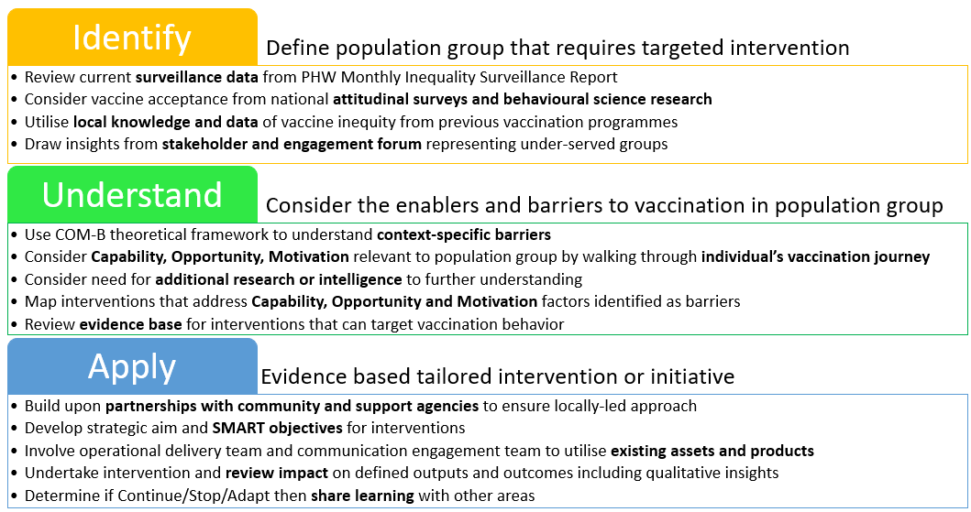
Figure 1- Vaccine Equity Approach

By identifying the population that we are delivering to, this enables the design of a service that is fit for purpose through the use of existing statistical and other data (both quantitative and qualitative). We are then able to develop further engagement, working with partners organisations and individual/communities that are trusted voices in providing us with insight and intelligence.

By understanding what is required, we can adapt and tailor our collective efforts, focusing on people’s reported barriers and challenges with vaccinations. We use the World Health Organisation COM-B model to consider factors that affect this including the 3C’s of vaccine hesitancy; Convenience, Complacency and Confidence. This provides us with the opportunity to develop our delivery based upon individuals and communities’ needs by increasing Capability, Opportunity and Motivation and in turn creating behaviour change (COM-B Model, fig.2).

Then we apply, based on the identified needs and best practice, an assets-based approach through partnership collaboration and co-production.

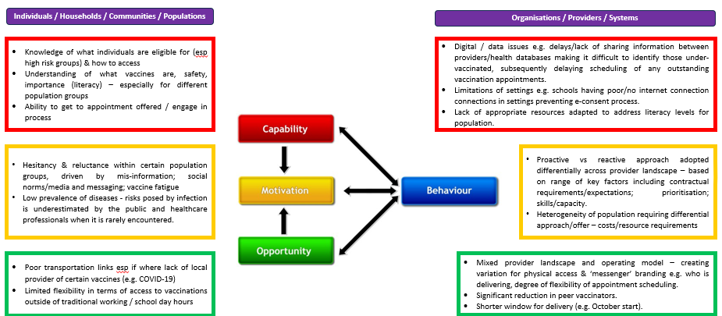
Figure 2 – COM-B Model

To support identification of those vulnerable groups and delivering on our objectives, there is a requirement to understand the data and use our surveillance work to gather intelligence and insight (fig.3). The model supports our ability to develop and update our aims and outputs in a timely manner and that is reflected on our findings, increasing our focus in delivering a service that is adapted and tailored based on individual and community needs.

Figure 3 – Surveillance and insight
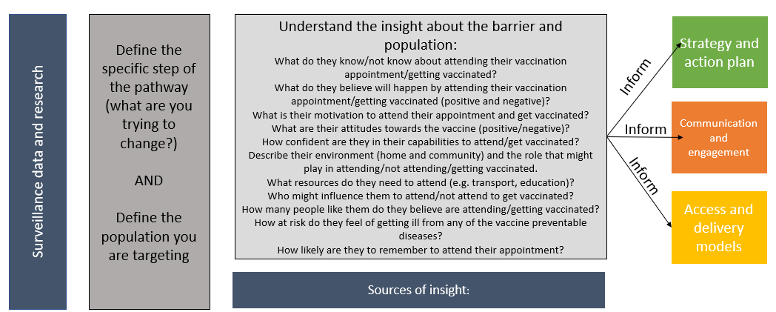

Over the last two quarters of the 2024/25 financial year the Immunisation Team have further developed actions that address the priorities, examples are:

Data and Intelligence

- Regular discussions with Child Health and Primary Care Teams to ensure the data is accurate and updated. This will enable the Immunisation Team to focus on areas of development to progress with the most recent data available and tailor service according to accurate uptake rate figures.
- Conversations with the public using an insight gathering survey, conducted through telephone calls. This gathers intelligence on perception, attitudes and knowledge of eligible people for both the new Respiratory Syncytial Virus (RSV) Vaccine and COVID-19, enabling the Immunisation Team to have alternative delivery methods and improve our communication with the public through tailored resources. (Text, letter, e-mail – included within these methods are Videos, Easy-read and link to Public Health Wales material).
- Insight and intelligence gathered through the Vaccine Equity Group to support delivery or engagement with home educated children. Primary Care also provide insight where possible on the children that regularly do not attend (DNA) appointments and if GP are aware, provide the Immunisation Team with details of home educated children.
- Work in partnership with colleagues from the Health Boards’ Digital Team to develop a local dashboard for all vaccinations, to support with breakdown of local data that capture greater local level intelligence.
- Immunisation Team membership on the Swansea Bay University Health Board Health Inclusion Health Forum to ensure that information on vaccination programmes is highlighted and focused on. Increasing communication with key partners on the group that represent the more vulnerable and at risk within our communities’ population
- Questions focused on equity included in the school Fluenz (influenza) e-consent that provides further insight into challenges and barriers for parents/children to receive FLUENZ vaccine. This has enabled us to collaborate with the school nursing team to support them in addressing some of the concerns.
- Liaised with Community Voluntary Sector Development Outreach Officers for both Swansea and Neath Port Talbot to gain insight into the most commonly spoken languages across communities and schools, developing resources based on our needs analysis.

Improving Accessibility

- Regularly discuss with primary care practices with poor uptake to explore reasons, what they have previously done to address this and scope of accessibility options.
- Utilised multiple locations/delivery methods to increase vaccine accessibility through the mobile provision of the Immbulance (vaccination vehicle), clinics in Aberafan (Local Vaccination Centre based in the middle of a town shopping centre) and the use of clinical rooms in locations that have either completed their vaccination delivery or who have not engaged from the start of the campaign.
- Delivered COVID-19 spring pop-up clinics and childhood immunisation pop-up clinics during half term holidays, focusing on delivering in areas of low uptake, predominantly located in more deprived areas from our intelligence mapping.
- Regular conversations with the Practice Managers / Practice Nurses to encourage exploring alternative offers with their vaccination delivery, based on the insight received from stakeholders and the public.
- Development of posters and flyers to support with increasing confidence and awareness of vaccinations, including a QR code to access further information via multiple methods (video, easy read) on the Public Health Wales website. This was also shared with Flying Start settings and Community Centres, improving access to factual information.
- Attending multiple community and partner events across the health board area, ranging from pre-school to older adults. Supporting partner organisations by engaging and communicating on vaccination and opportunistically providing vaccinations when appropriate.

Communication and engagement

- Developed a SharePoint page to provide a single point of access and information both with local and national information and resources with access for anyone with a health board e-mail.
- Regular engagement with DICE and Llais to increase our awareness and understanding of reported concerns and challenges the public have with vaccinations.
- Developed links and continuous engagement with home educated groups to raise awareness and education on vaccinations. Ensuring that they do not miss out due to their home-schooled status.
- Developed training and education on immunisation and vaccination through face to face and online presentations for Midwives, School Nurses, Health Visitors and Practice Nurses, with a focus on vaccine equity. Highlighting the importance of Making Every Contact Count (MECC) in conversations.
- Audited use of both local and national resources on vaccinations against vaccine literacy standards set by PHW.
- Immunisation Team Project Support Managers regularly have one to one conversations with their designated practices and with GP Cluster Leads, highlighting the needs for equity development and discuss how best to support primary care with their delivery against the priorities set in the VES.

Evaluation of actions and interventions

- Immunisation Co-ordinators and Immunisers regularly evaluate their delivery against improving equity, assessing their impact.
- The Immunisation Team regularly use national dashboards in order to provide surveillance reports at a local level. Targeting interventions at areas with lowest uptake rate.
- Utilising the PHW Primary Care Equity Assessment Toolkit within our Immunisation Team to ensure we are targeting the right areas.
- Circulation of PHW Primary Care Equity Assessment Toolkit to primary care and other stakeholders. The toolkit has been created to support improving equity across primary care settings. Using a visual checklist and prompts to support.

For 2025-26, the Immunisation Team have agreed with partner organisations that the four priorities within our Vaccine Equity Strategy are still relevant. There is also a 3 year (2025-2028) Strategic Immunisation Plan being developed and this includes a section focusing on vaccine equity implementation. (Appendix 3).

To highlight progress against the Vaccine Equity Implementation Plan monitoring will be undertaken each quarter. A quarter 1 summary is highlighted below. This progresses the 2024/25 plan, including greater insight and a focus on targeted groups and interventions across our immunisation programmes.

Key actions from Quarter 1:

Data and Intelligence

- Review of the gelatine-free vaccine requested through the school Fluenz e-consent form. Breaking down uptake rate at schools and GP of administered Fluenz vaccine, uptake rate of gelatine-free flu vaccine by GPs and children that did not receive a flu vaccine last year.
- Research uptake rates for our spring catch-up childhood vaccination campaign through analysing COVER report from Oct to Dec 2024.
- Data breakdown on poorest uptake areas across GP practices and clusters gathered to further develop a targeted summer vaccination programme.
- Insight gathering exercise phoning all eligible patients for COVID-19 vaccine, gathering intelligence on their views, preferences and concerns, enabling us to have alternative delivery methods and improve our communication with the public.
- The Immunisation Team have liaised and visited care homes across the health board area prior to the campaign, gathering intelligence and insight that enables us to deliver a more effective and productive service, working in partnership with each home based on their needs.
- A request by the Immunisation Team for the Public Health Midwife and the Midwifery Team to provide insight into any vaccine concerns raised during discussions. Especially with those who are at a greater risk or have protected characteristics.
- Analysed uptake rates at primary care practice and cluster level for older adults on Respiratory Syncytial Virus (RSV) Vaccine, both routine and catch-up programme.
- A vaccine equity feedback MS form sent to partner organisations (distributed through primary care contact list, third sector organisation contact list and Vaccine Equity Group members) to gather insight on their thoughts and areas of development through a vaccine equity lens.
- PHW Equity Assessment Toolkits to be used in supporting the Immunisation Team in delivering an equitable service. Used in the planning stages, ensuring we are always including the most vulnerable and at risk with our programmes.

Improving Accessibility

- Immbulance located across areas that have been identified with poor uptake rates over the spring half term holidays.
- Community venues identified across the health board chosen to support with increasing access during spring vaccination.
- Delivery of vaccination catch-up sessions by Immunisation team in GP practices.
- Immbulance and community venues located across areas that have been identified with poor uptake rates over the summer holidays.
- The use of the insight work on RSV uptake rates per practice, enables the immunisation team to focus on targeted areas where GP have finished delivering or underperforming.
- Alternative offers have been used to support with increase accessibility, conveniency and engagement. We are utilising multiple locations/delivery methods to increase provision during the campaign. Using the Immbulance, Aberafan Local Vaccination Centre and clinical rooms at GP practices that are not engaging (if appropriate).
- Supporting public registered to GP practices with the highest quintile of deprivation. We are offering alternative delivery models to support these areas.

Communication and engagement

- Distribution of the PHW Equity Passement Toolkits to partner organisations (distributed through Primary Care Contact List, 3rd Sector Organisation contact list and Vaccine Equity Group members) to support with equitable planning and delivering.
- Information on key resources and links circulated to key stakeholders (accessible resources: easy read, QR codes and links to PHW (Health Information Resources). This includes primary care, local authorities and Llais.
- National information on importance of vaccinations and awareness of disease circulating sent to CVS and the Health Access Team that support BAME communities, refugees and asylum seekers who potentially will be attending pilgrimage and festivals across Middle East and Asia in May.
- Engaged with Health Board’s Drug and Substance Misuse Team. Providing links to Public Health Wales vaccine and Brand Kitt app provided to support with communicating to their service users, increasing confidence and awareness on vaccination in materials that is tailored for their needs. (Easy read, audio, videos with subtitles, digital comms for digital platforms). And providing opportunities for training of staff to become peer vaccinators.
- Presentation on importance of vaccine equity and the benefit of collaborating as key stakeholders provided to Health Visitors, Flying Start, and to the Health Board’s Mental Health and Learning Disability Service.

Evaluation of actions and interventions:

- Evaluation of the Spring Vaccination Catch-up programme to identifying effectiveness and any learning.
- Evaluation of the Midwifery training and engagement sessions
- Evaluation of current Vaccine Equity Strategy as part of a scoping review
- Communication team reviewed the reach and engagement of social media posts regularly during the COVID Spring Booster campaign.

- GOVERNANCE AND RISK ISSUES

The Swansea Bay University Health Board Equity Strategy and Implementation Plan has been supported and monitored through the Vaccination Equity Group within the current immunisation governance structure (Appendix 4). Representation within the Vaccine Equity Group is from a range of organisations, such as Primary Care (both GP and Community Pharmacy representation), Local Authority Area Co-Ordinators, Health Board Mental Health Services, ethnic minority input from Health Boards Health Access Team and Community Voluntary Sector’s Community Outreach Officers, Health Visting, and Prison Nurses.

Risk associated within this delivery is not achieving our outcomes in creating and sustaining an equitable service. The greatest risk highlighted is the lack of accurate and recent data available both nationally and locally on the volume of the public that are underserved/at risk across the population. With ethnic minority data based on 2021 Census and the deprivation data based on the Welsh Index of Multiple Deprivation from 2019.

Aiming to improve our knowledge of our communities’ demographics, the Immunisation Team are utilising Public Health Wales’s Equity Assessment Toolkits. This enables a greater assessment of our interventions, scoping and assessing if we are including and adapting delivery of vaccination programmes to the most vulnerable and at risk across the population.

This toolkit, designed primarily for primary care use has been shared via various groups and directly to primary care to support them in gathering insight and intelligence, which will support addressing the risk highlighted on poor demographic data.

- FINANCIAL IMPLICATIONS

Currently, the Immunisation Team is not staffed to its full establishment. 3 WTE Band 5 Immunisers and a Band 6 Deputy Immunisation Co-ordinator have recently been approved for internal recruitment following a delay. Recruitment to vacant data and administration support will now be progressed.

- RECOMMENDATION

The Committee is asked to note the developments to date relating to the implementation of the Swansea Bay University Health Board Vaccine Equity Strategy and the demonstration of our learning in developing our current and future vaccination programmes.

Governance and Assurance

Link to Enabling Objectives  (please choose) | Supporting better health and wellbeing by actively promoting and empowering people to live well in resilient communities
Link to Enabling Objectives  (please choose) | Partnerships for Improving Health and Wellbeing |  | ☒
Link to Enabling Objectives  (please choose) | Co-Production and Health Literacy |  | ☒
Link to Enabling Objectives  (please choose) | Digitally Enabled Health and Wellbeing |  | ☒
Link to Enabling Objectives  (please choose) | Deliver better care through excellent health and care services achieving the outcomes that matter most to people
Link to Enabling Objectives  (please choose) | Best Value Outcomes and High-Quality Care |  | ☒
Link to Enabling Objectives  (please choose) | Partnerships for Care |  | ☒
Link to Enabling Objectives  (please choose) | Excellent Staff |  | ☒
Link to Enabling Objectives  (please choose) | Digitally Enabled Care |  | ☒
Link to Enabling Objectives  (please choose) | Outstanding Research, Innovation, Education and Learning |  | ☒
Health and Care Standards
(please choose) | Staying Healthy |  | ☒
(please choose) | Safe Care |  | ☒
(please choose) | Effective Care |  | ☒
(please choose) | Dignified Care |  | ☒
(please choose) | Timely Care |  | ☒
(please choose) | Individual Care |  | ☒
(please choose) | Staff and Resources |  | ☒
Quality, Safety and Patient Experience
Vaccine safety is the cornerstone of public trust in immunisation programmes, ensuring confidence across all communities.

Delivering a high-quality service guarantees equitable access, timely delivery, and informed consent for all eligible groups.

Robust safety monitoring and transparent communication help address concerns and reduce vaccine hesitancy.

Quality assurance in delivery supports consistent standards across settings, including primary care and outreach.

Together, safety and service quality underpin the effectiveness and equity of vaccination efforts.

Financial Implications
As highlighted above, it is important to have key roles within the Immunisation Team. The lack of ability to deliver the vaccination programme due to capacity creates financial impactions across the Health Board.
Legal Implications (including equality and diversity assessment)
Staffing Implications
None
Long Term Implications (including the impact of the Well-being of Future Generations (Wales) Act 2015)
Delivering vaccine equity across health boards in Wales directly supports the Well-being of Future Generations (Wales) Act 2015, which places a legal duty on public bodies to improve the social, economic, environmental, and cultural well-being of Wales through sustainable development. Here's how vaccine equity aligns with the Act and the Five Ways of Working based on its application to vaccine equity; Long term planning and outcome measures, Prevention of diseases, Integration of equity focused delivery, collaboration between partner organisations (Primary, Secondary and 3rd sector), and involvement and engagement with diverse and underserved populations ensuring services reflect and meet the needs of the population with the greatest risk.

Report History |  | Previous Vaccine Equity paper was provided and presented to Board in November 2024.
Appendices |  | Appendix 1 – 2024-2025 Vaccine Equity Strategy  Appendix 2 – 2024-25 Vaccine Equity Strategy’s objectives and priorities  Appendix 3– 2025-2028 Strategic Immunisation Plan (Equity Section).  Appendix 4 – Vaccine Equity Group Governance Structure

