Meeting Date | 17 December 2024 |  | Agenda Item |  | 2.2
Report Title | Capital Resource Plan Month 8 Update and  Draft 2025-26 Capital Resource Plan
Report Author | Ian MacDonald, Assistant Director of Finance (Strategy & Planning)
Report Sponsor | Darren Griffiths, Executive Director of Finance & Performance
Presented by | Ian MacDonald, Assistant Director of Finance (Strategy & Planning)
Freedom of Information | Open
Purpose of the Report | To provide an update on the financial performance of the Health Board’s capital programme at month 8 and the impact of emerging risks and opportunities on the projected outturn position for 2024/25.  To present a draft 2025-26 Capital Resource Plan for discussion.
Key Issues | The Health Board approved a balanced capital financial plan for 2024/25 as part of the approved Annual Plan.  The forecast outturn position reported at Month 8 shows an overspend position of £1.624m. Additional income from the City Deal and disposals are anticipated to provide a balanced position. The national funding position remains unclear pending the outcome of the national capital prioritisation exercise. However additional in-year slippage funding has mitigated some of the short-term pressures on the programme.  A draft Capital Resource Plan for 2025-26 based on the latest allocations has been developed for discussion. Options are presented to achieve a balanced 2025-26 position, with further work required on plans from the Delivery Units and implementation of the new national Waste strategy from April 2026. Whilst awaiting the outcome of the national prioritisation exercise, the 10-year major capital business case portfolio remains as approved, with updates provided on the latest positions.  Whilst the risk of the plan shifting from balance to imbalance has reduced in-year, future years remains material and is reflected in Risk 93 on the Health Board Risk Register. The main finance paper proposes an adjustment to the risk level.
Specific Action Required  (please choose one only) | Information | Discussion | Assurance | Approval
Specific Action Required  (please choose one only) | ☐ | ☐ | ☐ | ☒
Recommendations | Members are asked to:  - NOTE the month 8 reported position of the capital plan.  - NOTE the latest additional in-year slippage allocations and the reduced risk of the plan shifting from balance to imbalance.  - NOTE the contingency sum to maintain the balanced plan is nil.  - NOTE the draft 2025-26 Capital Resource Plan with options to balance and further work required on plans from the Delivery Units.

CAPITAL PLAN MONTH 8 UPDATE & DRAFT 2025-26 CAPITAL RESOURCE PLAN

- INTRODUCTION
To provide an update on the financial performance of the Health Board’s capital programme at month 8 and the provision of a draft 2025-26 Capital Resource Plan for discussion.

- BACKGROUND
The Health Board approved a balanced capital financial plan for 2024/25 as part of the Annual Plan submitted to Welsh Government (WG) in March 2024.

The plan included a positive uplift of 50%/£1.3m against the 2022/23 reduction in discretionary capital of 24%/£2.671m (following the national £100m reduction in the core capital budget allocated to the Health and Social Care department within WG). This means the discretionary allocation has been reinstated in full, although it should be noted that this allocation has never been increased over the last 12 years to reflect the impact of rising prices.

The national funding situation continues to be challenging, with very little uncommitted capital funding remaining; this could have an impact on not just the Health Board’s discretionary capital programme, which is primarily for replacement of the existing asset base, but also larger service continuity, service recovery and service change schemes, including those contained within the approved Health Board Estates Strategy. However, the recent release of additional in-year funding from WG following the additional funding flowing from Wales via the UK Government October budget has made a material benefit to the in-year position.

The approved plan also included the repayment of existing commitments from the All- Wales Capital Programme of £3.1m, where these schemes slipped during the final 6 months of 2023/24 and the Health Board then must manage the slippage across years through its discretionary programme,

The approved plan also includes income assumptions, including the receipt of business case fees from WG and disposals proceeds.

2.1 Capital Plan Month 8 Update

Month 8 Position

The forecast outturn position reported at month 8 shows an over-commitment of £1.624m. Allocations shown below in table 1 are anticipated to provide a balanced position. There are no remaining risks on the income assumption for business case fees, as due to the national funding challenges these have been mitigated in-year through other funding opportunities. If business cases are approved in the future, there.

will be a benefit to the future years plan. The remaining income risks are due to the timing of disposal income anticipated for the Board approved disposals at Morriston and Phillips Parade.

Table 1 - Month 8 Forecast Outturn Position 2024/25
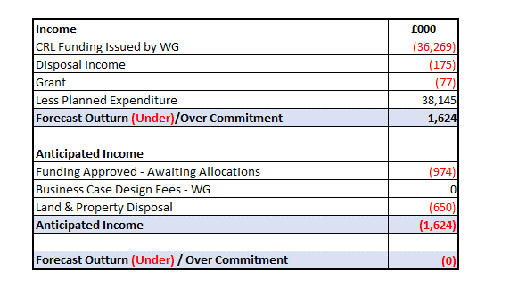
Table 2 - Anticipated Income 2024/25
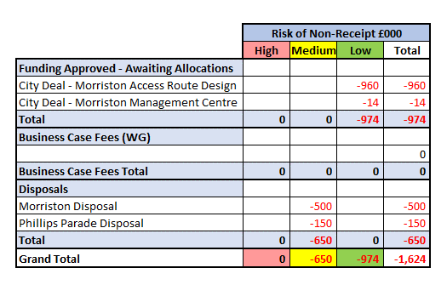
Additional Capital National Funding Allocations

Additional funding allocations of £12.034m have been received since the last report which are reflected in the month 8 plan plus a recently received allocation of £1.971m, for digital refresh which will be reflect in the month 9 plan.

Table 3 - Additional Capital Allocations 2024-25
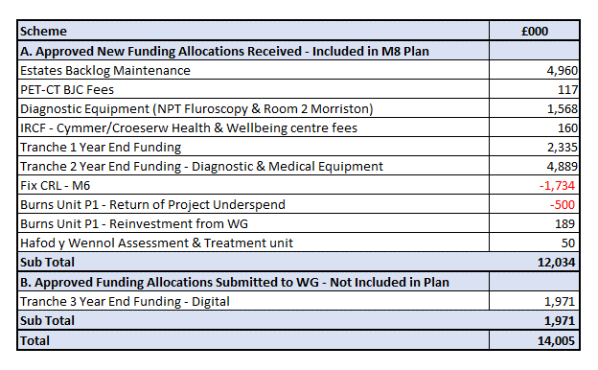
Estates
In addition to the £4.9m already received from the EFAB (Estates Funding Advisory Board) at the start of the year to carry out infrastructure, fire and decarbonisation work, an additional £4.960m was received for estates backlog maintenance in Month 3. The combination of these allocations will allow several of the high-risk backlog maintenance issues identified in the 6-facet survey to be undertaken. These include the replacement of the ward roofing felt and tiles at Morriston. Whilst underlying roof structures have been assessed in good condition, the external fabrics of the roof were identified at risk of failure of a scale which could result in an unsustainable loss of bed capacity. In addition to the two wards completed last year, four wards have already been completed this year, with another four programmed for the rest of the year. The works on the roof and other ward areas has been made possible due to the provision of a decant ward at Morriston Hospital.

Further backlog maintenance works including roof repairs will be required next year – subject to further WG funding support. The IPC works on seventeen wards have been completed with ongoing works to complete all wards made available by the end of March 2025

The ability to complete these works will only be possible with the continued provision of a decant ward. A summary of the EFAB and backlog maintenance works are shown in table 4.

Table 4 – EFAB and Backlog Maintenance Works
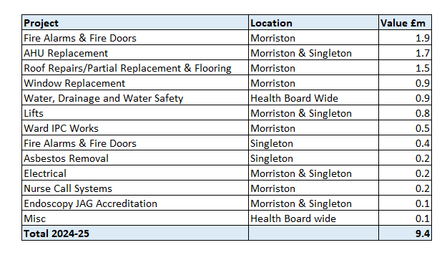
Equipment

Following a request from WG during September 2024 for the submission of bids for additional capital funding to support further backlog estates maintenance, diagnostic & medical equipment and digital equipment, 3 tranches of additional funding have been received. Tranches 1 and 2 for mostly diagnostic and medical equipment for a combined £7.224m are already included in the plan. An additional Tranche 3 of £1.971m for digital replacement was received following the closure of the M8 position. These investments will support a number of high risk equipment replacements across the Health Board, including: -

- OR1, Morriston £804k. To replace the 3 integrated theatre suite systems, as 2 have recently failed and are unusable.
- Cardiac Heart Lung Machines, Morriston, £850k
- Digital Core Networks, Morriston and Singleton £1.9m
- Endoscopy Scopes, Health Board wide, £418k
- Orthopaedic Stacks & Power Tools, Health Board wide, £284k
- Gynaecology Stacks and Scopes, £143k
- Opthalmology Laser & Optos Machibe, Singleton, £187k
- Renal Ward & Water Treatment Plant, Morriston, £755k
- Mental Health Dental Suite, £249k

Contingency

Although there are contingencies built into major projects across the capital programme, the remaining general discretionary programme contingency has now been fully utilised.

Overall Assessment

Given the recent significant in-year investment of £9.195m for the 3 tranches of equipment, the risk of the in-year plan shifting from balance to imbalance can now be lowered. Plans are in place and work is progressing at pace with colleagues in procurement and across the service to ensure this additional funding is spent before the end of this financial year.

Update on All Wales Capital Schemes

WG have indicated that the national capital funding challenges are expected to remain in the short to medium term. Feedback on the national Capital Prioritisation process for major business cases is expected following the recent WG 2025-26 Budget.

A ten-year prioritised capital programme was submitted to WG in March as part of the Health Board’s annual plan submission. The estimated capital funding requirement of £821m included some business cases that were already in production but which due to the unavailability of WG business case fee funding were placed on hold. There have been two new allocations provided by WG and several business cases have been completed and submitted to WG for approval where business case fee funding was already in place. The main sections are summarised below, and more detail is provided in Annex A.

Business Cases submitted to WG.
- Urology OR1 Theatres, NPT, September 2024 - £4.285m
- Permanent PET-CT, SWWCC (South- West Wales Cancer Centre), Singleton September 2024 - £13.931m
- 2nd CT-Sim at (SWWCC), Singleton, July 2024 - £2.630m
- Hybrid Vascular Theatre, Morriston, May 2024 - £10.135m
- Elective Modular Theatres, Singleton, November 2023 - £23m

Business Case in Production
- ED Improvements, Morriston
- Imaging Replacement Programme, CT1 Morriston
- Morriston Access Route, Hybrid Planning Application
- Seclusion Suite, Medium Secure Unit, Glanrhyd
- Dan y Deri Learning Disabilities,
- Croeserw Health and Wellbeing Centre.

Business Cases on Hold pending outcome of National Capital Prioritisation
- Thoracic Morriston, OBC on hold
- Regional Pathology, Morriston, OBC on hold
- Adult Acute Mental Health, Cefn Coed, OBC on hold
- Swansea Wellness Centre, OBC on hold.

Table 5 below provides an update on the major capital projects that have WG capital funding support and where works have commenced.

Table 5 - Major Capital Projects Build Status
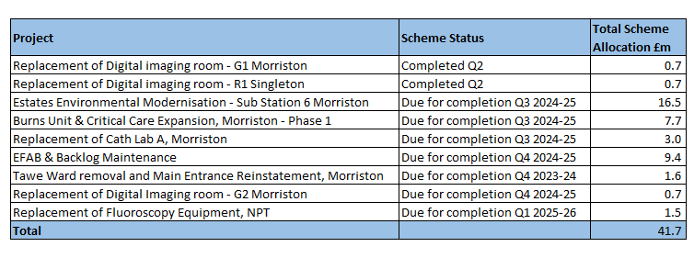

2.2 Draft Capital Resource Plan 2025-26

An initial draft of the 2025-26 Capital Resource Plan, along with indicative allocations for 2026-27 and 2027-28 is included here for discussion.

The plan has been developed from the usual sources of information, including contractual commitments, bids through the Capital Prioritisation Group (CPG), and major work programmes including digital and estates. A detailed slide pack is in included in Annex B.

Financial context:

- We are aiming for breakeven in 2024-25. The pressure to retain a balanced capital position remains fragile as there is limited remaining flexibility in the programme to manage emerging service and infrastructure risk. However recent in-year allocations of £9.1m from WG for equipment and digital replacements have significantly eased the in-year pressure and will allow the 2025-26 plan to start from a more stable base.

- The 2025-26 discretionary plan reflects initial WG advice on the NHS All Wales Capital Prioritisation and initial core funding allocations. Further work is required to finalise scheme specific proposals outside of the core allocation changes, as WG work through a number of scenarios as part of the 2025-26 WG budget planning.

- Our prioritised 10-year forecast for the All-Wales Capital Programme (AWCP) major investments remains in place, with work continuing those cases where design fee funding is available. Others remain on-hold pending the outcome of the national prioritisation work. Detail included in Annex A.

Key financial challenges:

- Significant national capital funding constraints remain. The level of discretionary funding has continued to be eroded against inflation and continued growth in the fixed asset base in medical equipment and digital devices, with no national uplift to discretionary allocations since 2010. Following the 2022/23 national reduction in core capital funding 24%/£100m, the local reduction of £2.7m was fully reinstated in 2024/25 (following a 50% reinstatement in 2023/24). We have received formal notification from WG that a national uplift to discretionary allocations from £83.7m to £100m an increase of £16.2m/19.3% has been notified for 2025/26. The impact for SBUHB is an uplift of £2.7m/24%.

- Additional national funding allocations are also to be made for a) TEF (Targeted Estates Fund) £40m, b) Diagnostic Equipment Replacement Programme £15m and c) Digital Replacement Programme £10m.

- Continuing upward price inflation across the market for all aspects of capital spend, including building schemes, medical and digital equipment, albeit at a lower level than the last 2 years.

- The PFI contract for Neath Port Talbot hospital has a fixed £1.389m contribution to the lifecycle replacement programme [note: starts to reduce significantly from 2025/26 and ends in 2027/28.

Assessment

The combination of significant backlog maintenance (estates, equipment and digital) means investment from the discretionary allocation for service change/recovery projects is likely to be limited and difficult choices will be required to achieve a balanced opening 2025/26 capital resource plan.

This initial draft plan provides an outline to achieve an opening balanced plan.

Further work is required to assess:-

a) Service Group priorities following the Executive Team review.
b) Implementation of new national waste regulations from April 2026.

- GOVERNANCE AND RISK ISSUES
There is an increased possibility that new service requests, including those with a high-risk score will be unable to be receive capital funding during 2024/25 within the capital resources made available to the Health Board. These risks will continue to be assessed through the Capital Prioritisation Group and raised up through the Management Board.

A risk register entry (Risk 93) has been included in the Health Board risk register and is currently assessed as a 20-score risk. It is now suggested that this risk reduces as per the main finance report to Committee.

- FINANCIAL IMPLICATIONS
The financial implications and funding risks are as detailed within the body of the report. In summary, the approved balanced capital plan is assuming additional funding of £1.624m.

The remaining contingency in the plan is nil. Recent additional in-year allocations from WG for backlog equipment and digital replacement have eased the immediate pressure on the programme.

- RECOMMENDATIONS
Members are asked to: -
- NOTE the month 8 reported position of the capital plan.
- NOTE the latest additional in-year slippage allocations and the reduced risk of the plan shifting from balance to imbalance.
- NOTE the contingency sum to maintain the balanced plan is nil.
- NOTE the draft 2025-26 Capital Resource Plan with options to balance and further work required on plans from the Delivery Units.

Governance and Assurance

Link to Enabling Objectives  (please choose) | Supporting better health and wellbeing by actively promoting and empowering people to live well in resilient communities
Link to Enabling Objectives  (please choose) | Partnerships for Improving Health and Wellbeing |  | ☐
Link to Enabling Objectives  (please choose) | Co-Production and Health Literacy |  | ☐
Link to Enabling Objectives  (please choose) | Digitally Enabled Health and Wellbeing |  | ☐
Link to Enabling Objectives  (please choose) | Deliver better care through excellent health and care services achieving the outcomes that matter most to people
Link to Enabling Objectives  (please choose) | Best Value Outcomes and High Quality Care |  | ☒
Link to Enabling Objectives  (please choose) | Partnerships for Care |  | ☐
Link to Enabling Objectives  (please choose) | Excellent Staff |  | ☐
Link to Enabling Objectives  (please choose) | Digitally Enabled Care |  | ☐
Link to Enabling Objectives  (please choose) | Outstanding Research, Innovation, Education and Learning |  | ☐
Health and Care Standards
(please choose) | Staying Healthy |  | ☐
(please choose) | Safe Care |  | ☐
(please choose) | Effective Care |  | ☐
(please choose) | Dignified Care |  | ☐
(please choose) | Timely Care |  | ☐
(please choose) | Individual Care |  | ☐
(please choose) | Staff and Resources |  | ☒
Quality, Safety and Patient Experience
Without additional funding support from WG, further requests for capital funding will not be affordable within the allocated resources. This may impact on new service requests for additional capital funding for estates, medical equipping and digital services.

Financial Implications
The financial implications and funding risks are as detailed within the body of the report. In summary, the approved balanced capital plan is assuming additional funding of £1.624m. The remaining contingency in the plan is nil. Recent additional in-year allocations from WG for backlog equipment and digital replacement have eased the immediate pressure on the programme.

Legal Implications (including equality and diversity assessment)
None
Staffing Implications
None
Long Term Implications (including the impact of the Well-being of Future Generations (Wales) Act 2015)
n/a
Report History |  | Month 2 Capital Resource Plan Update  Approved Capital Plan Board March 2024
Appendices |  | Annex A - Major Capital Business Case Portfolio  Annex B - Draft 2025-26 Discretionary Resource Plan

