Meeting Date | 17 December 2024 |  | Agenda Item |  |  | 4.1
Report Title | Theatre Performance – Update Report
Report Author | Rhodri Davies, Associate Service Group Director, Surgery  Jonathan Gates, Head of Nursing, Surgery  Victoria Gibbs, Directorate Manager, Theatres and Anaesthetics
Report Sponsor | Ceri Gimblett, Service Group Director NPTS
Presented by | Rhodri Davies, Associate Service Group Director, Surgery
Freedom of Information | Open
Purpose of the Report | The purpose of this paper is to provide an update on Theatres performance work that is taking place for Swansea Bay University Health Board.
Key Issues | The paper presents key up-to-date theatres performance metrics and highlights issues in  - Theatre cancellations,  - Theatre staff sickness and workforce limitations across theatres nursing and anaesthetics staffing
Specific Action Required  (please choose one only) | Information | Discussion |  | Assurance | Approval
Specific Action Required  (please choose one only) | ☒ | ☐ |  | ☒ | ☐
Recommendations | Members are asked to:  - ACKNOWLEDGE the current performance and the actions being taken to improve the overall performance in a sustainable and consistent manner.

Theatre Performance Report

- INTRODUCTION

This paper provides an update to the Performance and Finance Committee on Theatre performance and follows a previous report submitted in August 2024.

- BACKGROUND

The Performance and Finance Committee (P&FC) received a paper in August 2024 setting out performance tables for key metrics in relation to Theatres. The report set out quarter 1 performance across theatre utilisation, elective cases completed, cancellations and start and finish times. The paper also highlighted the year-on-year comparison of number of cases completed across all hospital theatre complexes, using July 2024 as the comparison point.

The following sets out quarter 2 performance across the same key metrics and a year-on-year comparison of number of cases, using November 2024 as the comparison point. It also sets out the actions undertaken since the last paper in August 2024.

Number of cases completed

The following graph highlights November 2024 performance on ‘Number of cases completed’ in all theatres in SBUHB. November data shows a year-on-year steady increase in the number of elective cases completed across all theatre sites and follows a similar trend to July 2024 data.
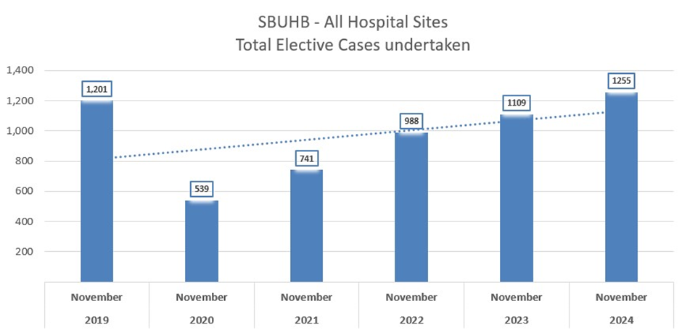

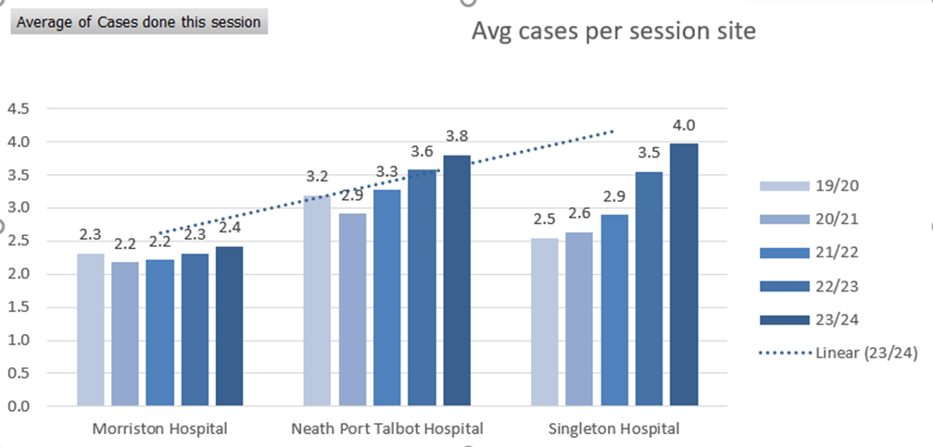

An important metric to highlight for the Committee is average number of elective cases undertaken per session. This is steadily increasing across all sites since 2019/20, with the most significant increase observed at Singleton Hospital where four cases per session on average being managed in 2023/24.

Quarter 2 performance comparison

The tables below present a comparison of quarter 2 data between 2022-23 and 2023-24 time periods.

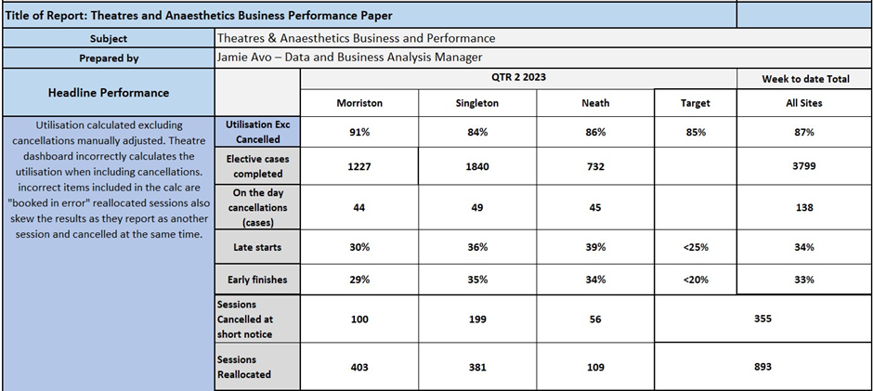

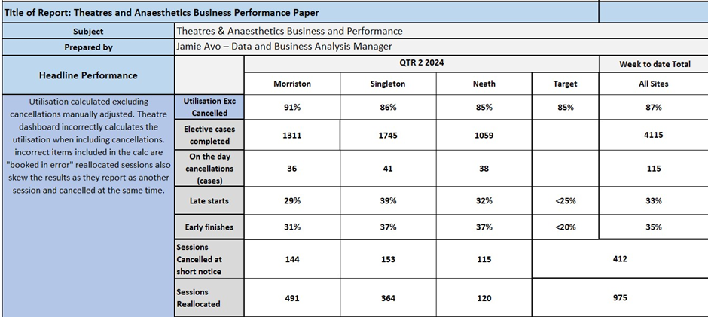

The above tables highlight a marked increase in activity on the Neath Port Talbot (NPTH) site. The increase is as a result of the third and final of the three new theatres coming on line from December 2023, as well as a steady increase in the amount of activity carried out by Orthopaedic services.

Orthopaedic services have also undertaken significant work since the last update to P&FC in relation to increasing the number of arthroplasty cases on theatre lists, in line with GIRFT standards – specific consultants have been targeted with increasing their case numbers per list, which initial findings show has been successful. The service is currently rolling this out to all surgeons operating on the NPTH site.

Also important to point out is the increasing complexity undertaken on the NPTH site, particularly from an orthopaedic service perspective – pushing the boundaries on case mix operated on seems to be resulting in an increase in activity.

The tables also highlight that Theatre utilisation levels remain static when compared to the previous year. Important to note is the utilisation at Morriston Hospital where numbers of cancellations on the day have reduced. Rates remain unacceptably high still but utilisation is maintained given theatre capacity for complex cases is pressurised and surgical specialties mobilise quickly to backfill cancelled theatre sessions. This is more difficult on the other two sites given the limitations on site compared with Morriston, e.g. access to ITU.

- GOVERNANCE AND RISK ISSUES

The quarter 2 comparison tables also highlight continued and significant issues with cancellations – both on the day and at short notice. The table below highlights the top five reasons for theatre cancellations:

 | 2023 | 2024
1 | No surgeon | No surgeon
2 | Priority list taking preference | No theatre staff
3 | Other specialty to utilise | No anaesthetist
4 | Audit Day | No patients
5 | Other | Other specialty to utilise

The table highlights a difference in the profile of cancellation reasons when comparing 2023 and 2024 theatre data. Unavailability of surgeons, theatre staff, anaesthetists and patients are common themes through this year.

Theatres Scheduling

An important element of the work programme of the new Theatres Board has been the establishment of a Theatres Scheduling Group (TSG). The group was established in quarter three of 2024 with the aim of managing elective theatre lists through a 6-4-2 planning cycle, which details actions that need to be completed, and what information needs to have been provided, at each week over a six-week cycle. At six weeks, surgical staff should have their annual leave approved. At four weeks, surgeons should have scheduled their theatre lists. Two weeks ahead of time, theatre plans should be reviewed, finalised and there should be no further changes made from this point onwards. The TSG is holding surgical specialty and anaesthetic directorates to account with adhering to the 6-4-2 theatre booking process. This process is designed to ensure maximum use of available theatre sessions and is being rolled out at pace. Weekly meetings are now taking place where all surgical specialties are expected to attend.

Baseline workforce assessments

In relation to unavailability of theatre and anaesthetics staff, a comprehensive assessment of this workforce area has taken place in quarter three. Initial baseline workforce information points to significant shortfalls in both theatres and anaesthetic staffing when trying to deliver the existing theatre schedule. The initial assessment has identified a short fall of 15 WTE theatre staff and 12 WTE consultant anaesthetists. Whilst this workforce assessment needs to be worked through with Executive colleagues, it does explain why these departments are struggling with availability. It also explains why there is significant financial overspend in these specific departments, where Additional Duty (ADH) payments for anaesthetists and theatre staff overtime are required to deliver the capacity required. If staff do not come forward for these additional hours then theatre lists are at risk of cancellation.

Given the difficulties with recruiting into some specialist theatre staffing roles and the national shortage of Anaesthetists, comprehensive workforce plans are now being pulled together by the theatres and anaesthetics directorate to describe the actions needed to address retirements, retention and recruitment requirements.

Theatres staff sickness

Theatres staff sickness is also an issue currently. The theatre staff sickness data for November 2024 is presented in the graph below:

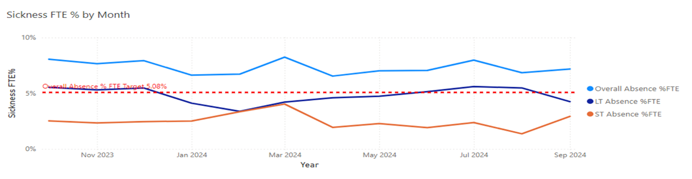

The graph highlights the staff sickness levels across all three theatre sites currently sits at 8%. This, figure is calculated with all staff associated with the running of theatres, such as admin and clerical and support staff included. When looking at nursing staff specifically, which is the largest element of the workforce, the sickness levels are significantly higher at 10%.

As a result of the sickness issue, a number of actions are being undertaken with the support of workforce Business Partners. In December 24, Sickness Absence Summits have been established with hotspot areas within Theatres. The aim of the summits is to carry out a deep dive into both long and short term sickness to understand whether line managers require any additional support to manage absences, ensuring processes are being followed rigidly and that any outstanding actions are completed.

The NPTSSG workforce Business Partners have worked with the theatres Management Team to design a Staff Experience, Wellbeing and Retention plan that will see a roll out of targeted engagement sessions with staff during quarter four 2025. This is being launched by the Associate Medical Group Director for Surgery Division, Nurse Group Director and Associate Service Group Director for Surgery Division on audit day on 20th December 2024. The engagement sessions planned are just one element of the plan – in the background the Theatre Management Team will be implementing best practice guidelines for retention of staff,
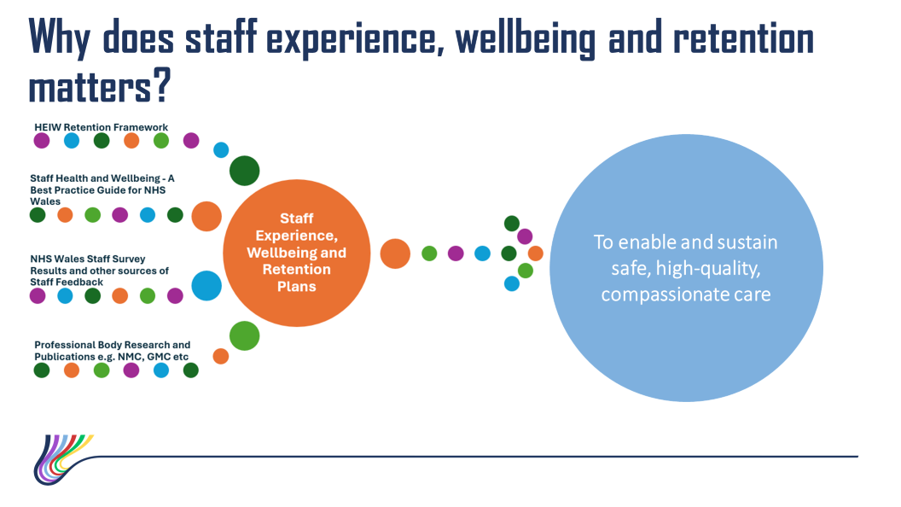

The above diagram sets out the framework for the Staff Experience, Wellbeing and Retention plan and illustrates the wide range of the work programme. It is envisaged this will have a positive outcome for the service and a more comprehensive update can be provided to the committee in the next reporting period.

Theatre Dashboard

It is important to note that the Theatre Board is aware that there are several sources for Theatres data given the number of systems and databases linked to theatre activity. A comprehensive work programme is underway by health Care Systems Engineering Team to develop a Theatres Dashboard, which will consolidate these systems and reporting methods into one system so that a clear performance framework for Theatres. Below are visual representations of the dashboard which is nearing final design stage. The prototype dashboard is being presented to Clinical leaders and service managers on 11th December 2024.

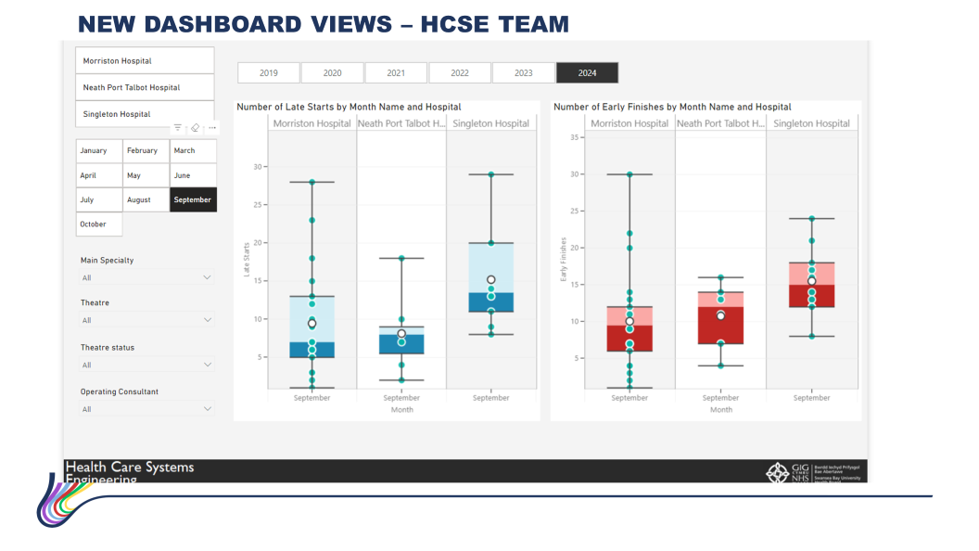
The example views above illustrate the capability of the new dashboard – for example the quarter 2 performance update presented within this paper highlights late start and early finish times as an issue. Current theatre systems do not have the capability for granular assessment/analysis of this issue, whereas the new dashboard will be able to. It is envisaged that the Theatres performance update for the next Committee reporting period will be based on the innovative ways of presenting the data.

- FINANCIAL IMPLICATIONS

There are no additional financial implications identified as part of this report. However, the initial workforce assessments carried out in theatres nursing and anaesthetics may require funding in terms of increasing workforce. It is also important to point out that the service is incurring significant overspend in these areas in order to deliver the level of activity required as a result of the theatre schedule

- RECOMMENDATION

The Performance and Finance Committee is asked to:
- ACKNOWLEDGE the Theatres performance update and the actions being taken to improve the overall performance in a sustainable and consistent manner.

Governance and Assurance

Link to Enabling Objectives  (please choose) | Supporting better health and wellbeing by actively promoting and empowering people to live well in resilient communities
Link to Enabling Objectives  (please choose) | Partnerships for Improving Health and Wellbeing |  | ☐
Link to Enabling Objectives  (please choose) | Co-Production and Health Literacy |  | ☐
Link to Enabling Objectives  (please choose) | Digitally Enabled Health and Wellbeing |  | ☐
Link to Enabling Objectives  (please choose) | Deliver better care through excellent health and care services achieving the outcomes that matter most to people
Link to Enabling Objectives  (please choose) | Best Value Outcomes and High Quality Care |  | ☒
Link to Enabling Objectives  (please choose) | Partnerships for Care |  | ☐
Link to Enabling Objectives  (please choose) | Excellent Staff |  | ☒
Link to Enabling Objectives  (please choose) | Digitally Enabled Care |  | ☐
Link to Enabling Objectives  (please choose) | Outstanding Research, Innovation, Education and Learning |  | ☐
Health and Care Standards
(please choose) | Staying Healthy |  | ☐
(please choose) | Safe Care |  | ☒
(please choose) | Effective Care |  | ☒
(please choose) | Dignified Care |  | ☐
(please choose) | Timely Care |  | ☒
(please choose) | Individual Care |  | ☐
(please choose) | Staff and Resources |  | ☐
Quality, Safety and Patient Experience
Timely and effective care: People of all ages to have timely access to admission for surgery. When arranged to have confidence in being admitted with the full knowledge of the procedure and its implications as appropriate. Establishing the workstreams aligned to the Theatre Board
- Resources
- Digital /DATA
- Finance
- Scheduling /Performance
- Q&S
- Service Improvements
- Service Developments
To achieve patient outcomes: to have outcomes comparable with the best in Europe.
Financial Implications
There are no additional financial implications identified as part of this report. However, the initial workforce assessments carried out in theatres nursing and anaesthetics may require funding in terms of increasing workforce. It is also important to point out that the service is incurring significant overspend in these areas in order to deliver the level of activity required as a result of the theatre schedule
Legal Implications (including equality and diversity assessment)
There are no legal implications to consider.

Staffing Implications
To run an effective theatre service requires access to skilled theatre staff, surgeons and anaesthetists along with other key resources along the surgical pathway including referral from primary care, through to the outpatient clinic, Pre-Assessment and admission for surgery.
Long Term Implications (including the impact of the Well-being of Future Generations (Wales) Act 2015)
Optimizing theatre capacity across the Health Board will support an improved delivery against waiting time standards, whilst ensuring the effective deployment of resources reducing variation in cost and resources.
Report History |  | Theatres Performance update report August 2024
Appendices |  | N/A

