Meeting Date | 16 December 2025 |  | Agenda Item |  |  | 2.2
Name of Meeting | Performance & Finance Committee
Report Title | Financial Report – Month 8 2025/26
Report Author | Samantha Moss, Deputy Director of Finance  Gemma Pearson, Finance Business Partner  Crystal Davies, Principal Finance Manager
Report Sponsor | Darren Griffiths, Executive Director of Finance and Performance
Presented by | Samantha Moss, Deputy Director of Finance
Freedom of Information | Open
Purpose of the Report | The report advises the Performance & Finance Committee of the Health Board on the financial position for Month 8 2025/26 (November 2025) and risks regarding the current forecast revenue year end outturn.
Key Issues | The report invites the Performance & Finance Committee to note the detailed analysis of the financial position for Month 8 2025/26 (November 2025).  The report includes a summary of the key drivers of the position either at Service level or by expenditure type (i.e. Non-Pay/Pay). It also provides information of the current position with regards to Health Board reserves to ensure transparency in the overall Health Board position.  Risk will have been considered based on the information provided within the report and the score updated where necessary.  Whilst the key messages are provided within the main body of the report, further information is provided in the Appendices.
Specific Action Required  (please choose one only) | Information | Discussion |  | Assurance | Approval
Specific Action Required  (please choose one only) | ☐ | ☐ |  | ☒ | ☐
Recommendations | Members are asked to: -  - CONSIDER the 2025/26 Financial Plan, and the Health Board’s and the Welsh Government’s inability to approve it given the planned deficit of £58.7m.  - CONSIDER the actions in place with regards to Welsh Government’s expectation that the Health Board delivers the £55.4m savings to support the delivery of the 2025/26 Financial Plan.  - Consider and comment upon the Health Board’s financial performance for Month 8 2025/26 and the Year to Date (YTD) position.  - CONSIDER the risks to the position at Month 8.  - SUPPORT the position with regards to Health Board reserves.

FINANCIAL REPORT – MONTH 8 2025/26

- INTRODUCTION
The Annual Plan submitted to the Welsh Government on 31 March 2025 included a financial assessment, as summarised in the table below:
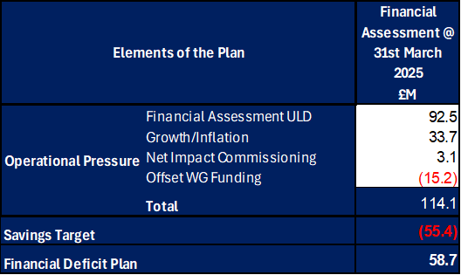

The Welsh Government issued a letter to the Health Board on 6 June 2025 indicating that the planning process has been closed to focus on delivery and improvement. The Welsh Government issued a further letter on 18 August requesting an update on the Annual Financial Plan and actions being taken by the Health Board for submission by 11 September. This document was presented at the Special Board Meeting on the 11 September which provided full details of the actions and milestones to achieve the original £55.4m savings to support the delivery of the original plan submission made in March 2025. Progress against this Plan is detailed in sections below. Therefore, at Month 8 the forecast for 2025/26 remains as per the original plan submission of £58.7m.

- FINANCIAL PERFORMANCE

KEY PERFORMANCE INDICATORS
TARGET | ACTUAL PERFORMANCE
Cash Balance Bank < £6.0m | £11.365m
In Month Performance Revenue Resource Limit ≤ 1/ 12th £58.7m | £4.201m
YTD Performance Revenue Resource Limit ≤ £ 8/12th 58.7m | £51.368m
YTD Performance Capital Resource Limit ≤ £0m | (£1.081m)
YTD Performance Public Sector Payment Policy > 95% | 96.2%

FINANCIAL REPORT REVENUE – MONTH 8

The Health Board’s assessment on performance against the £58.7m deficit has three components Operational Pressure, Savings Target, and Planned Deficit. Performance against these three elements at Month 8 is summarised in the Table below. At Month 8 there was an In-Month deficit of £4.2m, which is £0.7m below the £58.7m planned deficit, with the YTD position reporting a £51.4m deficit, which is £12.2m above £58.7m plan.

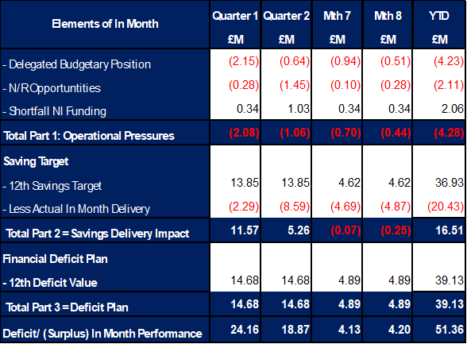

It is clear from the table above that currently the Year-to-Date issue remains the non-delivery of savings. This shortfall in delivery YTD is in part mitigated by ‘Delegated Budget’ position underspending and the central N/R opportunities as set out in the 11 September submission delivering. Whilst excluding the non-delivery of saving most areas are within the delegated operational budgets, the key exception to this is Mental Health & LD Services. Throughout the year there have been pressures linked to pay and CHC but also Temporary Adult Placements. The latter issue has resulted in an in-month pressure of £0.8m, with YTD expenditure of £4.6m. During November the service saw the highest number of patients in Temporary Adult Placements at 33, which at the time of closing the ledger was at 31. This level is significantly higher than where the service was in October 2025, with 3 patients in placements. If these numbers do not reduce the Health Board could face a further pressure of £3m, as well as continuing to mitigate the ENIC and savings delivery shortfall. An escalation meeting has been scheduled to consider options, and agree actions, to reduce this with immediate effect alongside current discussions around capital configuration and optimisation of the Mental Health services estate.

The focus in the final 4 months of the year needs to be on: -

- Reducing the Adult Temporary Placements and mitigating the financial impact on Month 1-8 = £4.5m to £8.0m
- Mitigating the ENIC funding shortfall on £3.1m
- Addressing the in-year savings gap.

On savings performance the submission made on 11 September 2025 set out the Plan to deliver the £55.4m savings in 2025/26. This was a combination of (1) Part A - budgetary releasing savings delivery supported by our external strategic partner; alongside (2) Part B - delivery of underspends in the operational budgets specifically around the corporate directorates and N/R opportunities. A summary of the assessed performance is summarised in the Table below and demonstrates that at Month 8 there is a gap of £13.0m.

Summary Performance against £55.4m
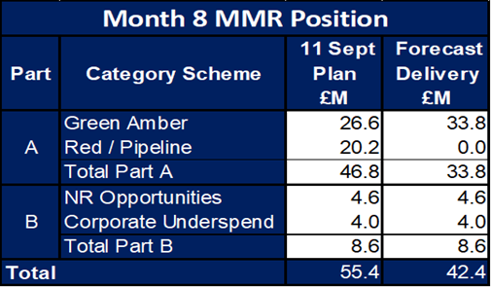

The increase in savings identified in between Month 7 and Month 8 relates to four service areas as per the table below, with the largest increase under MH&LD.

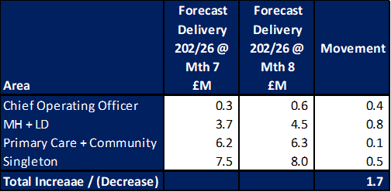

With regard to the £13m savings gap, there is an urgent requirement for further work to be undertaken to clearly set out the actions both in preparation for the Public Accountability Meeting on 18 December 2025 and provide the assurance on the delivery of the £58.7m both in year and recurrently. Further actions will be presented and considered by the Performance & Finance Committee on 16 December 2025 and to a special Board meeting on 17 December.

As well as focusing on savings, the Health Board continues to seek out all other opportunities to mitigate known risks. Whilst the delivery of the £55.4m is key to achieving the Health Board deficit plan, there are operational pressures and risks which will also need to be mitigated to enable the Health Board is to achieve the £58.7m deficit. There are several areas where work is ongoing to seek further opportunities to mitigate risks, and these are included in the Table below. At the end of Month 8 £0.9m of further opportunities have been confirmed, with £0.7m being added to saving trackers and supporting the growth in forecast and £0.2m supporting the operational delegated budgetary position.

Further Opportunities as Reported MMR @ Mth 8

With regards to the overall financial performance, Graph one below reflects the actual financial performance in each month, with the orange bars reflecting the performance required to achieve the original plan of £58.7m. Graph 2 outlines the savings delivered to date as the blue bars against the monthly target set (red line), and the orange bars reflect the level of savings required in future months to achieve the £55.4m target aligned to the £58.7m plan.
Graph 1: Performance Graph 2: Savings
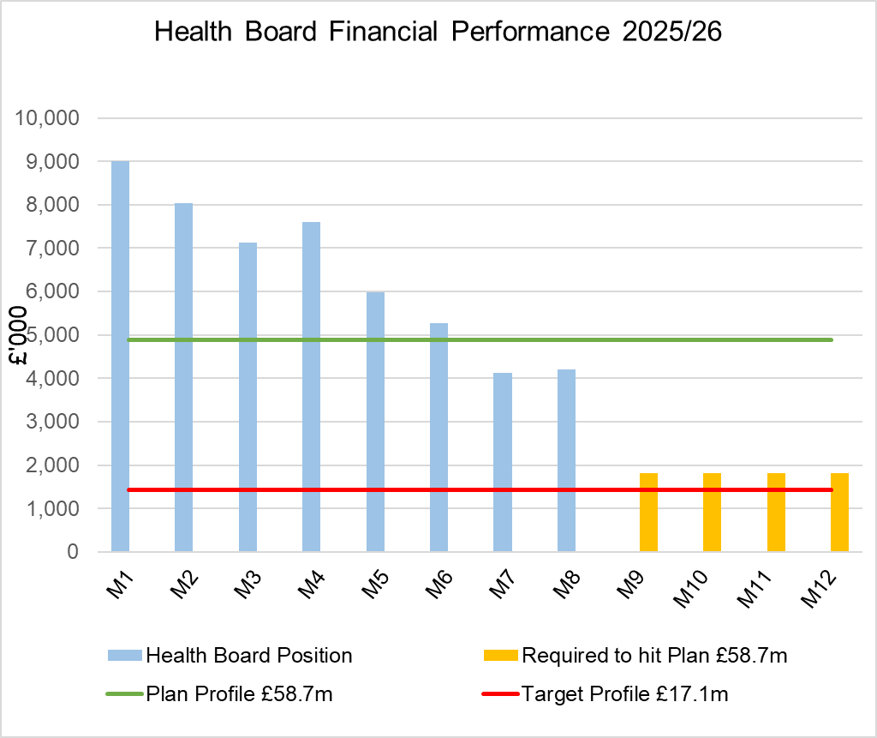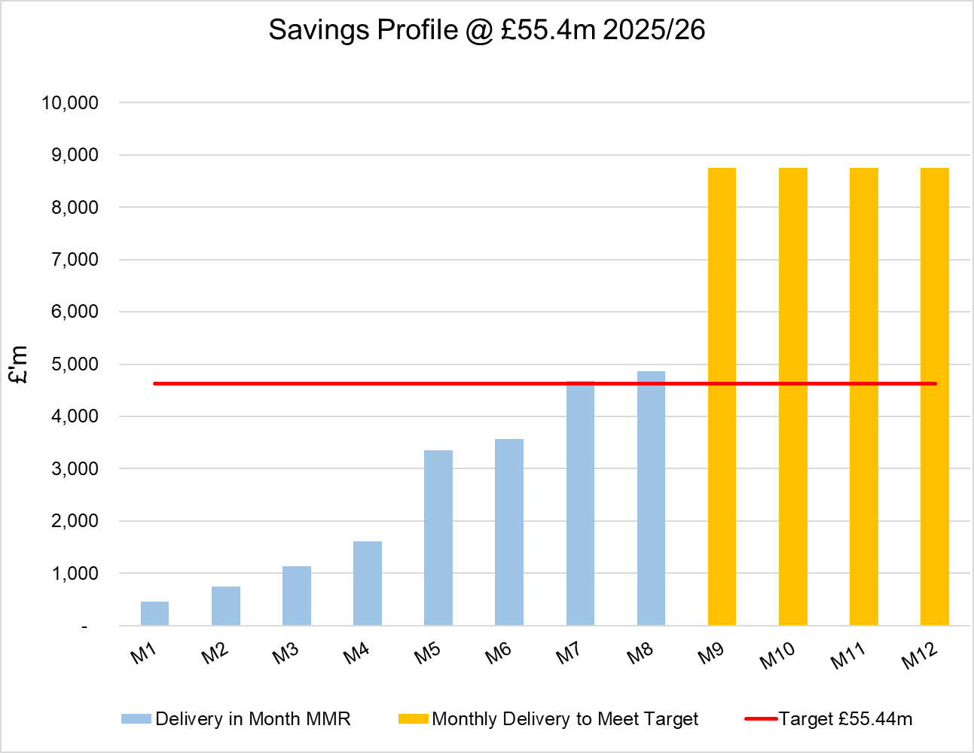

- KEY DRIVERS OF THE IN-MONTH POSITION
The key drivers of the Month 8 position are summarised in the table below. Further detail at a Health Board level of expenditure on Income, Pay and Non-Pay, is also provided in Appendix one.

  - Key Drivers by Service Area In-Month

  - Key Drivers by Service Area YTD

  - Summary By Expenditure Type

- Income
The Joint Commissioning Committee (JCC) Income as a provider over-performed by £0.3m in-month (£1.5m over-performance YTD). This has been driven by TAVI, Cardiology and Bariatric activity in Morriston. See Appendix 1 for further details on overall performance of JCC income.

- Pay
Month 8 pay is broadly in line with the prior month; the continued vacancy freeze primarily in Admin & Clerical and other Pay Controls being the driver for this. Variable pay expenditure has held at the same level as September and October (£4.7m and the lowest achieved YTD).

- Clinical Consumables
(see Appendix 1)

- Prescribing
(see Appendix 1)

- SAVINGS
Full details on savings are provided Appendix 3, but in summary the in-month delivery in Month 8, was £4.86m against a target of £4.62m; on a YTD basis the undelivered savings gap is £16.54m and remains the key driver of the Health Board overspend.
Part C Actions
- Part C1: Savings Trackers Red & Corporate Stretch @ 4 September 2025
- Part C2: Savings Trackers Pipeline @ 4 September 2025
- Part C3: In-year impact of the thematic Scheme Summaries (adjusted to avoid double count)
Further Actions
- Additional interventions to close the gap to the original savings plan
  - Exec oversight of variable pay
  - Additional capacity reduction
  - Non pay bans / restrictions

Whilst at Month 8 the Health Board is unable to turn all the planned schemes from 11 September submission to Amber/Green, of the £13.0m gap between plan and forecast delivery, 60% of the plans were not due to deliver until after Month 8. So, with the further actions supported by our strategic partner and the work of the R&S Team, progress on increasing the current level of Green/Ambers will continue.

- GOVERNANCE AND RISK ISSUES
Two Board level financial risks:

Achieving financial plan (HBR92) with the key elements as follows: -

  - Risk of delivery of savings quantum
  - Risk of operational overspend being in excess of funding available agreed via the Financial Plan
  - Risk of commitment of reserves (e.g. NICE) being above reserves available.
  - Risk of achieving the actions and options outlined in the 2025/26 Financial Recovery & Sustainability Assessment.

Based on the financial performance to Month 8 and the shortfall in the delivery of savings YTD, to deliver the deficit plan of £58.7m, it is recommended that the Health Board Corporate Risk Register continues to reflect a risk score of 25.

The assessment at the end of November of the Risks, totalling £30.99m, is summarised in the table below. For Month 8, within Part A, the table has been updated to provide greater clarity on these items which are an in-year risk to the delivery of the Plan and are within the YTD position but for which mitigating actions have yet to be identified (column labelled Within YTD) and those items which present a further risk for the remainder of the financial year (Column labelled Further Risk). Part B lists other issues which could pose a risk to the organisation, but at this point no financial value is assumed as the certainty is significantly less that Part A, but these will be reviewed each month.

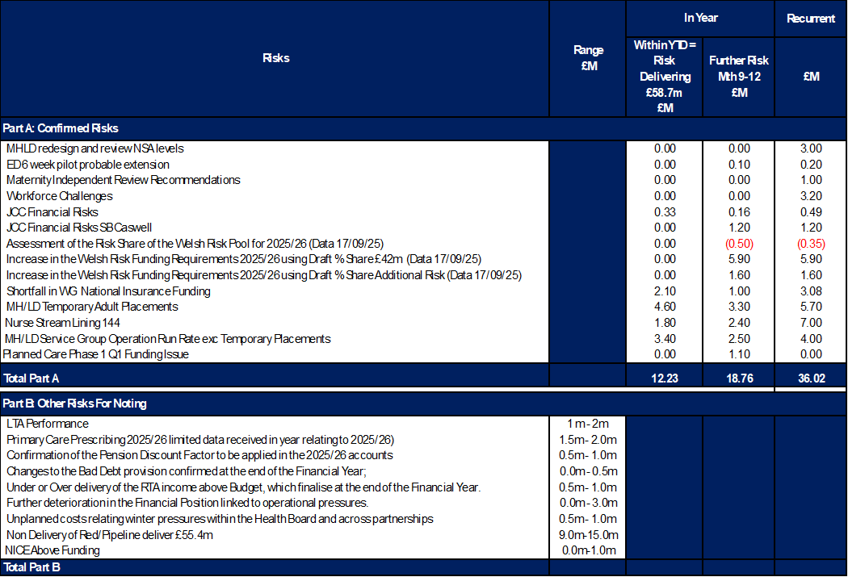

The Risk table above includes two new entries for Month 8:

- Planned Care funding – the Health Board was originally anticipating funding for Phase 1 Q1 of Planned Care funding of £2.3m. Actual delivery was £1.7m, but funding from WG is only £0.6m. It is assumed in the assessment to the 31 March 2026 that all additional Planned Care work will be funded in full but as the Health Board cannot get confirmation that a further allocation will be issued for Q1 it is now flagged a risk to the delivery of the £58.7m.
- JCC Caswell – since the closure of Cedar ward and the use of the Caswell Clinic to support some services there is a risk this may impact on the provider performance of the contract. Whilst further work and discussion are ongoing between JCC and the Health Board a risk is noted at this point based on an estimate.

Since preparing this table which directly relates to the monitoring return the Welsh Government has written to Health Boards confirming that for 2025/26, the Welsh Risk Pool (WRP) risk will be met centrally, non-recurrently.

All risks will continue to be reviewed, and the tables updated as necessary.

Availability of capital (HBR93). This risk was re-opened in 2022/23 given the reduction in discretionary capital allocation. Due to the additional capital funding provided during 2024/25 the risk score was reduced to 12. The score was increased in June 2025 to reflect risks regarding Emergency Department and Adult Acute Mental Health. The current assessment is to continue with the risk score of 20.

- RECOMMENDATIONS
Members are asked to:
- CONSIDER the 2025/26 Financial Plan, and the Health Board’s and Welsh Government’s inability to approve it given the planned deficit of £58.7m.
- CONSIDER the actions in place with regards to the Welsh Government’s expectation that the Health Board delivers the £55.4m savings to support the delivery of the 2025/26 Financial Plan.
- Consider and comment upon the Health Board’s financial performance for Month 8 2025/26 and the Year to Date (YTD) position.
- CONSIDER the risks to the position at Month 8.
- SUPPORT the position with regards to Health Board reserves.

Governance and Assurance

Link to Enabling Objectives  (please choose) | Supporting better health and wellbeing by actively promoting and empowering people to live well in resilient communities
Link to Enabling Objectives  (please choose) | Partnerships for Improving Health and Wellbeing |  | ☐
Link to Enabling Objectives  (please choose) | Co-Production and Health Literacy |  | ☐
Link to Enabling Objectives  (please choose) | Digitally Enabled Health and Wellbeing |  | ☐
Link to Enabling Objectives  (please choose) | Deliver better care through excellent health and care services achieving the outcomes that matter most to people
Link to Enabling Objectives  (please choose) | Best Value Outcomes and High Quality Care |  | ☐
Link to Enabling Objectives  (please choose) | Partnerships for Care |  | ☐
Link to Enabling Objectives  (please choose) | Excellent Staff |  | ☐
Link to Enabling Objectives  (please choose) | Digitally Enabled Care |  | ☐
Link to Enabling Objectives  (please choose) | Outstanding Research, Innovation, Education and Learning |  | ☐
Health and Care Standards
(please choose) | Staying Healthy |  | ☐
(please choose) | Safe Care |  | ☐
(please choose) | Effective Care |  | ☐
(please choose) | Dignified Care |  | ☐
(please choose) | Timely Care |  | ☐
(please choose) | Individual Care |  | ☐
(please choose) | Staff and Resources |  | ☐
Quality, Safety and Patient Experience
Financial Governance supports quality, safety, and patient experience

Financial Implications
The Board is reporting a forecast year-end deficit financial outturn.

Legal Implications (including equality and diversity assessment)
No implications

Staffing Implications
No implications

Long Term Implications (including the impact of the Well-being of Future Generations (Wales) Act 2015)
No implications

Report History |  | Updates on the financial position are provided at every meeting.
Appendices |  | Appendix 1 – Variances by Area and Type of Expenditure  Appendix 2 – Reserves and Central Budgets  Appendix 3 – Savings  Appendix 4 – Accountability Letters

APPENDIX 1 – FURTHER DETAIL ON VARIANCES BY AREA & TYPE OF EXPENDITURE
- Overview Financial Position

- Overview of Income

The table below compared the income performance in Month 8 to the average levels of 2023/24 and 2024/25.

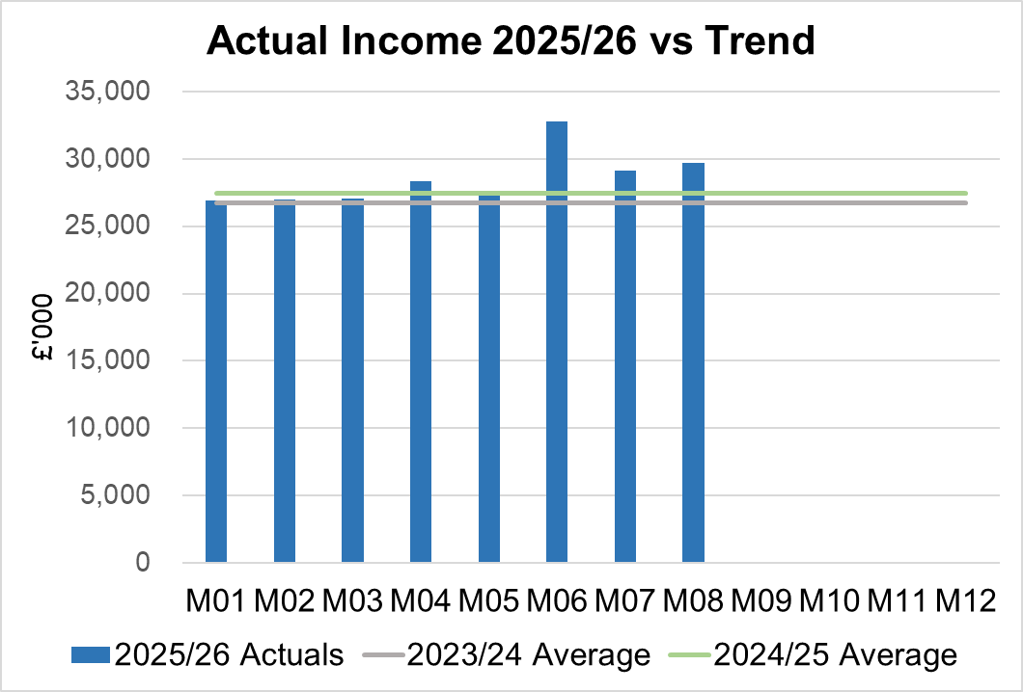

Income had increased in Month 8 due to rebates relating to the price increase in the Mounjaro drug and additional income received within the Clinical Research Unit and Non contracted income activity in month increasing due to Burns Activity and NICU. These are all non-recurrent in nature, with the exception of the drug rebate.

2.1 JCC Income

The Health Board monitors performance on a monthly basis for JCC activity, which is predominantly delivered via the Morriston Service Group. Throughout the financial year there are variance movements linked to performance. The table below provides a summary of the performance at Month 8 for each speciality area.

  - Anticipated Income
The below table highlights anticipated income the Health Board expects to receive during 2025/26. The current deficit plan of £58.7m is predicated on receipt of these Welsh Government funds at the levels anticipated.

- Pay, Agency & Other Variable Pay Expenditure

Total Pay

The Month 8 total remains higher than the prior two years average (as shown in the graph below).

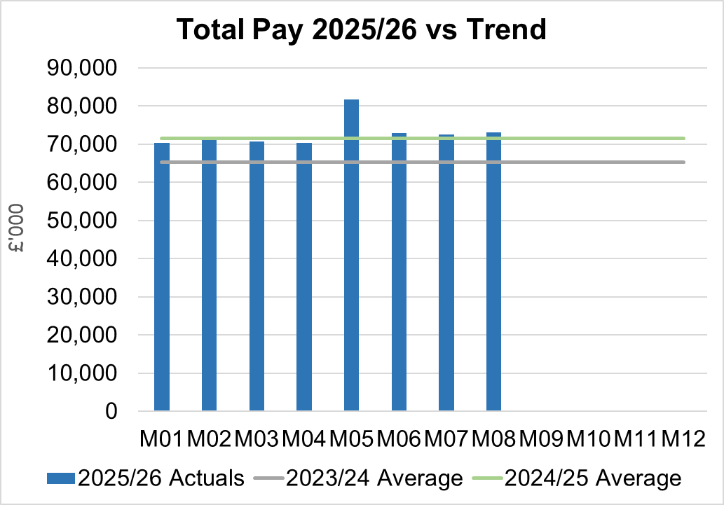
Note - 2023/24 and 2024/25 values have been notionally increased by pay award uplifts to allow for comparison to current value of 2025/26 pay value.
Variable Pay

Variable pay is £1.265m lower in Month 8 2025/26 (£4.659m vs £5.924m) when compared to the same period last year (graph below shows this year’s actual versus prior year’s average). At Month 8 it remained unchanged from that reported at Months 6 and 7 in the current year.

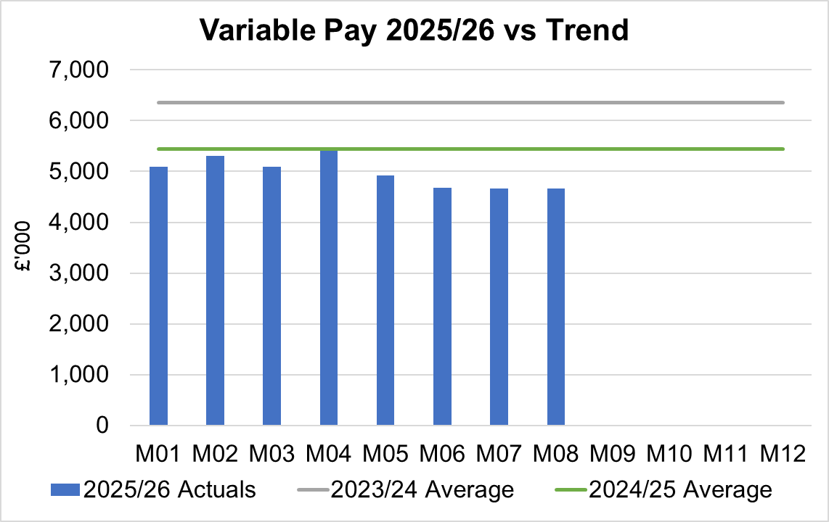

Variable Pay is classified by the Health Board into the following categories: Agency, Bank, Overtime, Waiting List Initiatives (WLI) and Irregular Sessions, a breakdown of the expenditure into these categorise is provided below.

Variable Pay by Expenditure Type

- Overview Non-Pay

Actual Non-Pay expenditure for Month 8 remains higher than the last 2 year’s average expenditure levels (as shown in the graph below):

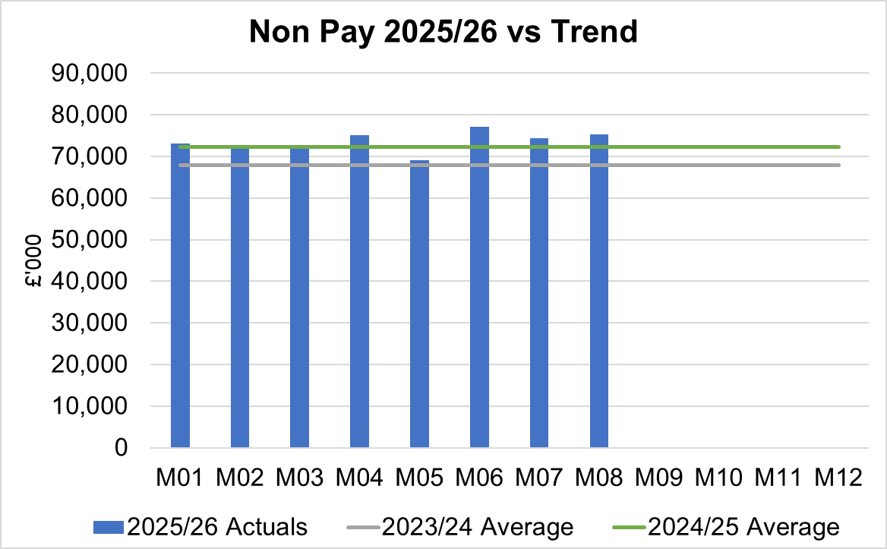

Below are further details on the key areas of non-pay:

  - Clinical Consumables
This area overall has an in-month breakeven position. Within the ledger the gross income is reflected within the income lines and not netted off against expenditure and so overall the Health Board position is not adversely affected where expenditure levels are driven by activity such as specialist services under JCC.. The main drivers within this category of clinical consumable expenditure includes heart valves & pacemakers. Excluding Secondary Care Drugs, a breakdown of the categories of Clinical Consumables is provided below:

  - Primary Care Prescribing
Prescribing was slightly overspent (£0.1m) in-month and YTD at a £0.1m overspend following receipt of the latest dataset (September 2025).

  - CHC
In Month 8 CHC was overspent by £0.9m (YTD £5.0m). Expenditure on Adult Mental Health placements increased further in-month to £0.8m. The pressure remains at £0.3m in month in addition to standard CHC growth in excess of the Plan.
An analysis of actual expenditure and patient numbers for 2025/26, along with the average values from 2024/25 is provided in table below.
CHC Analysis by Month

Please note:
- PCT Group numbers are based on bed days
- MHLD Group are based on cases
- PCT Group does not include the Singleton/NPT element. The NPTS element which covers Children and Young People CHC patients is provided internally by the Health Board and as such is part of the wider NPTS position and is not recorded in the ledger as PCT/MH/LD CHC.

  - Maternity Review
The total costs for this are allocated to a dedicated Cost Centre (6F34).

  - Z Codes (Section 1,3-4 Table Point 1 Appendix 1)
The narrative below groups together the key elements of the Z codes detailed in Point 1 of this appendix.

- Contracting: SLA /LTA performance: JCC (previously WHSSC), LTA and SLA contract income and expenditure are transacted within this area and financial performance reported. NICE approved high-cost drugs and associated LTAs are also transacted and monitored against targets set. In addition to this, non-contracted activity income in relation to English foundation trusts invoiced on a quarterly basis are reported.

- Capital: The Finance Capital Team manage a number of cost centres covering the PFI, IFRS16 and Depreciation charges for assets both owned and donated are transacted here.

- RRL and Central Reserves: The Welsh Government funding received at the start of the year is tracked within this area. Any anticipated allocations in year are also transacted through these codes. Other HB wide funding received from HEIW and SIFT is also captured in here. All central reserves remain within the Z cost centres and details of these are provided in Appendix 2.

- Corporate income and expenditure. Any income and expenditure that is not service group specific is transacted and reported through a number of corporate Z cost centres, examples include, payroll and pension costs, VAT recovery, losses and receipts in relation to funding from Welsh Risk Pool, overseas visitors’ income and Road Traffic Accident income.

  - LTA Values & Forecast performance
The table below is based on Month 5 activity undertaken by other Health Boards and Trusts for Swansea Bay residents (SBU Commissioner) and activity undertaken by Swansea Bay for residents of other Health Boards.

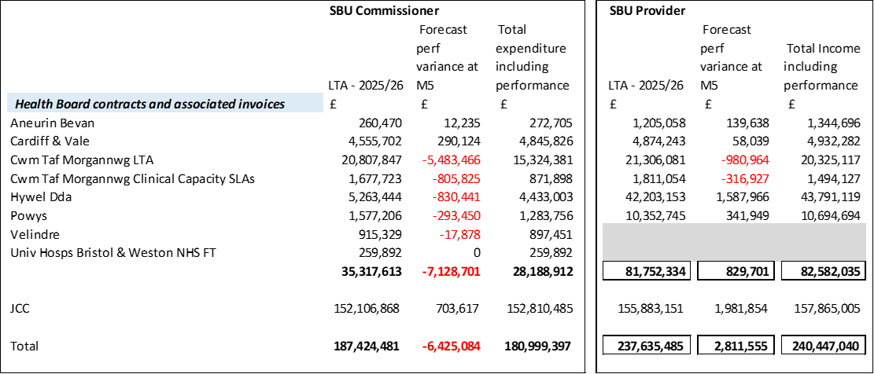

The above figures include the annual contract values plus invoices relating to patient activity. SBU Commissioner Performance variances are based on information received from each organisation. Forecast performance variances are subject to fluctuations and exclude NICE drug recharges.

APPENDIX 2 – DETAILS ON RESERVES & CENTRAL BUDGETS

- SUMMARY RESERVES
Overall management of the reserves is as per the Health Board Budget Management document.

  - Balances: Main & NICE
For 2025/26, the Health Board will hold two central reserves and the purpose of these reserves are below:
- Main – this holds funding from Welsh Government or the plan that has yet to be issued to Budget Holders. These items are not surplus but either due to timing have not been issued or is an area where funding is issued based on actual values consumed in future month.
- NICE – this holds the total Health Board funding for all NICE costs (drugs and infrastructure) and is issued to the service each month based on the actual costs consumed as reported through the Pharmacy system.

Details on the balances and movements are provided in the Table below:

- COVID RECOVERY
As part of the Financial Plan Welsh Government Funded £15.2m for Local COVID Recovery and £19.5m for Regional COVID Recovery. The funding remains in Central Reserves and is reported in Main reserves in Section 1 above. This funding is then issued to service areas based on the actual costs committed. A summary of the forecast costs against the original funding total of £34.7m is summarised in the table below:

WG are also issuing additional non-recurrent funding to support the reduction of the 52 week and 104 week target, alongside diagnostic targets. This is in addition to the original Planned Care Recovery £34.7m detailed in the table above. This non-recurrent funding for Planned Care is held in Main or Service Group local reserves until the costs are committed at which point funding is issued to the relevant budget line.
APPENDIX 3 – SAVINGS

The section below reflects performance against the original £55.4m requirement taken from the Savings Trackers.

- Summary of Savings Position as at November 2025 (Month 8)

The below graph clearly shows the gap between the YTD savings target in red and the level of actual savings delivered in green, with full details provided in the table.

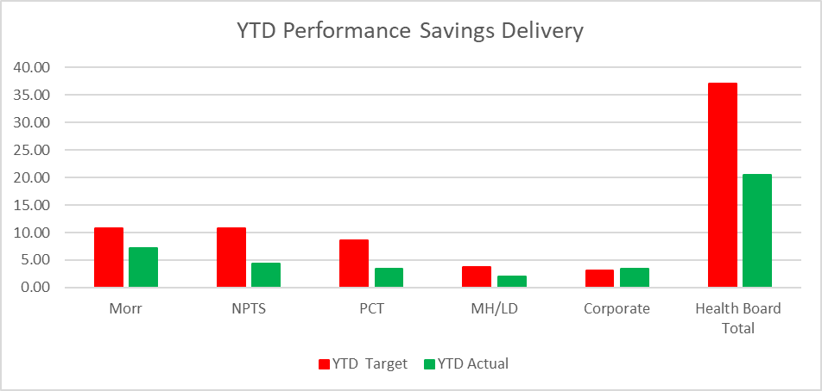

In summary the £58.7m plan required the Health Board to deliver £55.4m of savings. In Month 8 there was an overachievement of savings totalling £0.2m. YTD there remains a shortfall of £16.5m. This is the key issue in the delivery of the 2025/26 financial position.

- Planned Savings schedule as at Month 8
An element of £55.4m plan submitted on the 11 September was not going to be delivered through savings, a proportion was to be achieved via Non-Recurrent Opportunities and underspend in operational budgets, which relates to the Gap reported in the first table. This table provides a summary of the planned savings schemes, which total £46.8m, broken down by Pipeline, Red, Amber and Red. The second table provides the full reconciliation of the £55.4m. The forecast against the plan of £55.4m is noted in a table under section 2 of this report.

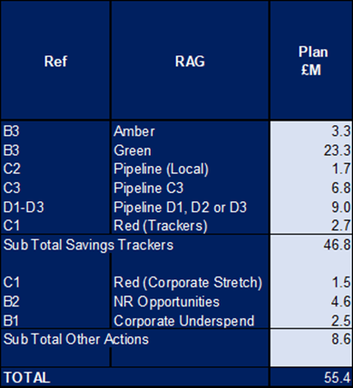

APPENDIX 4 – SUMMARY OF THE REPLIES TO THE ACCOUNTABILITY LETTERS (@11th December 2025)

No: | Name | Date Proforma Returned
 | Ceri Gimblett – NPTS | 13/05/25 – signed proforma + covering letter to CEO / DoF
 | Sue Moore – Morriston | 12/05/25 – no proforma, but a letter to CEO
 | Dermot Nolan – MH&LD | 09/05/25 – proforma signed + narrative added
 | Craige Wilson – PCTSG | Outstanding
 | Hazel Lloyd – Corporate Governance | 28/04/25
 | Deb Lewis – COO | 07/05/25
 | Richard Thomas – DICE | 01/10/25
 | Matt John – Digital | 10/06/25
 | Richard Evans – Medical | 30/04/25
 | Liz Rix – Nursing | 28/04/25
 | Gill Richardson – Public Health | 22/05/25 – no proforma, but a letter to CEO
 | Marie Davies – Planning & Partnerships | 27/06/25
 | Tina Ricketts – W&OD | 13/05/25
 | Darren Griffiths – Finance and Estates | 20/04/25
 | Christine Morrell – Allied Health Professions & Health Science | 14/05/25

