

HEALTH BOARD RISK REGISTER
Risk Assigned to the Performance & Finance Committee
January 2024



Datix ID Number: 738  Health & Care Standard: 5.1 Timely Care |  |  | HBR Ref Number: 1  Risk Target Date: 31/03/2024 |  | Current Risk Rating  5 x 5 = 25
Objective: Networked Hospitals – A Systems Approach – Urgent & Emergency Care |  | BAF Ref: 3.3 | Director Lead: Deb Lewis, Chief Operating Officer  Assuring Committee: Performance and Finance Committee  For information: Quality & Safety Committee
Risk: Access to Unscheduled Care  If we fail to provide timely access to Unscheduled Care then this will have an impact on quality & safety of patient care as well as patient and family experience and achievement of targets. There are challenges with capacity/staffing across the Health and Social care sectors. (This risk includes ED, AMU and impact in community from ability to release ambulances at both front doors.) |  |  | Date last reviewed: January 2024
Risk Rating  (consequence x likelihood):  Initial: 4 x 5 = 20  Current: 5 x 5 = 25  Target: 3 x 4 =12 | 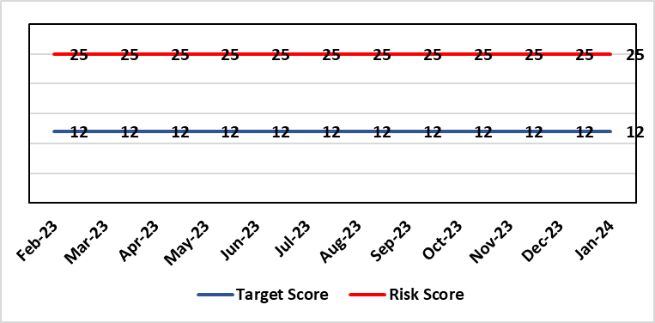 |  | Rationale for current score:  Post wave 2 of COVID 19 Morriston and Singleton have experienced a steady increase in emergency demand to pre-Covid levels. Capacity is limited due to Covid response and therefore remains a high risk. Current score raised due to increasing pressures. Recent implementation of All Wales Immediate Release Protocol puts additional pressure on already overcrowded ED dept.
Level of Control  = 50% |  |  | Rationale for target score:  Our annual plan is to implement models of care that reflect best practice. This will improve patient flow, length of stay and reduce emergency demand.
Date added to the HB risk register
26.01.16
Controls (What are we currently doing about the risk?) |  |  | Mitigating actions (What more should we do?)
- Increased reporting as a result of escalation to targeted intervention status.  - Phone First for ED model in place in conjunction with 111 to reduce demand.  - OPAS (Older People’s Assessment Service) have undertaken training with nursing homes (on management of patient falls) & set up direct contact details with nursing homes  - Frailty short-stay unit re-established  Additionally, actions to improve the discharge of clinically optimised patients (risk HBR80) expected to assist with patient flow, are anticipated to free capacity to assist to address this risk HBR1 also.  Acute Medical Unit (AMU)  - Medical patient flow within Morriston has been refined between ED, AMU and wards.  Patient flow  Roll out SAFER (Seen, Aim, Flow, Early Discharge and Recovery) continues across all hospitals, 23 wards at Morriston, Gorseinon completed and started at SGH and NPT  - WAST direct access to SDEC  - Expected medical patients conveyed by WAST go direct to AMU rather than ED, medical patients in ambulances outside ED diverted to AMU after initial assessment  - Stroke rehab pathway between MGH and NPT embedded  - Morning “golden” patients identified for early moves to discharge lounge freeing up beds earlier in the day |  |  | Action | Lead |  | Deadline
 |  |  | Increase of hours in SDEC planned. Currently increased hours from Monday to Friday (12 hours per day) | SGD (Morriston) |  | 01/03/2024
 |  |  | OPAS – exploring internal & external funding options. (Currently going through business case) | SDEC Clinical Lead |  | 31/03/2024
 |  |  | Looking to extend OPAS to non-surgical fractures. Resource requirements & options to be quantified and presented to the Chief Executive for consideration. | Head of Nursing (Service Transformation) |  | 31/03/2024
 |  |  | Monitoring of Continuous Flow Model now implemented. It will be monitored over 12 month period. | COO |  | 30/09/2024
 |  |  | Criteria led discharge roll out | Corporate patient flow team |  | Progress: Rolled out in Medicine. Other specialties to follow, timescales TBC
Assurances (How do we know if the things we are doing are having an impact?)  - New Urgent & Emergency Care Board is meeting monthly.  - Six Goals programme has been reviewed, programme leads appointed  - Update UEC (Urgent and Emergency Care) dashboard has been developed and released by digital |  |  | Gaps in assurance (What additional assurances should we seek?)  The need to deliver sustained service.
Additional Comments / Progress Notes
12/02/2024: Action Complete: (1) Surgical SDEC open; (2) Continuous Flow Model implemented (from 9th October) but will be monitored over 12 months; (3) Zero tolerance on ambulance waits has been implemented. Criteria led discharge has been rolled out in Medicine and is continuing to embed. Further work will be required across other specialities over the course of the year.

Datix ID Number: 840  Health & Care Standard: 5.1 Timely Care |  |  | HBR Ref Number: 16  Risk Target Date: 31/01/2024 | Current Risk Rating  5 x 4 = 20
Objective: Networked Hospitals – A Systems Approach – Planned Care |  | BAF Ref: 3.4 | Director Lead: Deb Lewis, Chief Operating Officer  Assuring Committee: Performance and Finance Committee  For information: Quality & Safety Committee
Risk: Access and Planned Care  There is a risk of harm to patients if we fail to diagnose and treat them in a timely way. |  |  | Date last reviewed: January 2024
Risk Rating  (consequence x likelihood):  Initial: 4 x 4 = 16  Current: 5 x 4 = 20  Target: 4 x 2 = 8 | 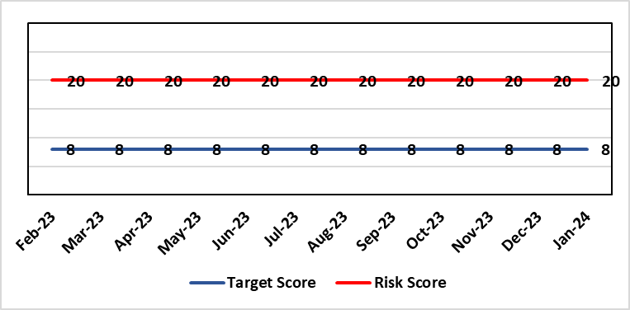 |  | Rationale for current score:  All non-urgent activity was cancelled due to response to the Covid-19 pandemic and has increased the backlog of planned care cases across the organisation. Whilst mitigating measures such as virtual clinics have been put in place new referrals are still being accepted which is adding to the outpatient backlog particularly in Ophthalmology and Orthopaedics. The significant reduction in theatre activity during the pandemic increased the number of patients now breaching 36 and 52 week thresholds.
Level of Control
= 90%
Level of Control  = 90% |  |  | Rationale for target score:  There is scope to reduce the likelihood score to reduce the overall risk to an acceptable level. The Risk target date indicates when we expect to see some reduction in waiting lists – albeit the overall risk level may remain as work continues.
Date added to the HB risk register
January 2013
Controls (What are we currently doing about the risk?) |  |  | Mitigating actions (What more should we do?)
- Post Covid 19 the focus is on minimising harm by ensuring that the patients with the high clinical priority are treatment first. The Health Board is following the Royal College of Surgeons guidance for all surgical procedures and patients on the waiting list have been categorised accordingly.  - There is a bi-weekly recovery meeting for assurance on the recovery of our elective programme.  - Specialty level capacity and demand models set out the baseline capacity and identify solutions to bridge the gap. Non-recurring pump – prime funding is available to support initial recovery measures. Fortnightly performance reviews track progress against delivery.  - A focused intervention is in train to support to the 10 specialties with the longest waits.  - Long waiting patients are being outsourced to the Independent Sector  - Additional internal activity is being delivered on weekends (via insourcing)  - Planned care trajectories developed and submitted to WG as part of IMTP.  - Governance process put in place to monitor performance against trajectories internally, and with Welsh Government.  - External & internal validation has commenced.  - A 10 bedded orthopaedic ward was created at Morriston Hospital in December to address the longest waits in the specialty that can only be operated on at Morriston.  - All long waiting patients are receiving clinical reviews to ascertain continued need for surgery. |  |  | Action |  | Lead | Deadline
 |  |  | Implement demand management initiatives |  | Deputy COO | 31/03/2024
 |  |  | Work ongoing with Finance colleagues to establish the funding allocation for elective recovery for 2023/24. |  | Deputy COO | 29/02/2024
Assurances (How do we know if the things we are doing are having an impact?)  - Weekly meetings in place to ensure patients with greatest clinical need are treated first. |  |  | Gaps in assurance (What additional assurances should we seek?)
Additional Comments / Progress Notes
09/11/2023: 52 week ministerial target was achieved at the end of Oct 2023 and will be sustained going forward. Alongside the Health Board plans we are looking at regional solutions for Orthopaedics to support SBU patients, and for SBU to support Hywel Dda in Ophthalmology.
29/01/2023: All but three of the longest waiting patients (5 years) will be treated by end January. Plans in place to treat all patients waiting over 4 years by end of March. Regional working in place for orthopaedics with SBUHB patients treated in Prince Philip Hospital and HDUHB patients treated in NPTH.

Datix ID Number: 1761  Health & Care Standard: Timely Care 5.1 Access |  |  | HBR Ref Number: 50  Risk Target Date: 31/12/2023 |  | Current Risk Rating  5 x 5 = 25
Objective: Networked Hospital – A Systems Approach – Cancer Care |  | BAF Ref: 3.5 | Director Lead: Deb Lewis, Chief Operating Officer  Assuring Committee: Performance and Finance Committee  For information: Quality & Safety Committee
Risk: Access to Cancer Services A backlog of patients now presenting with suspected cancer has accumulated during the pandemic, creating an increase in referrals into the health board which is greater than the current capacity for prompt diagnosis and treatment. Because of this there is a risk of delay in diagnosing patients with cancer, and consequent delay in commencement of treatment, which could lead to poor patient outcomes and failure to achieve targets. |  |  | Date last reviewed: January 2024
Risk Rating  (consequence x likelihood):  Initial: 4 x 5 = 20  Current: 5 x 5 = 25  Target: 4 x 3 = 12 |  |  | Rationale for current score:  Risk score based on being off trajectory for SCP.
Level of Control  = 70% |  |  | Rationale for target score:  Target score reflects the challenge this area of work present the Board and where small numbers of patients impact on the potential to breach target.
Date added to the HB risk register
April 2014
Controls (What are we currently doing about the risk?) |  |  | Mitigating actions (What more should we do?)
- Tight management processes to manage each individual case on the Urgent Suspected Cancer Pathway. Enhanced monitoring & weekly monitoring of action plans for top 6 tumour sites.  - Initiatives to protect surgical capacity to support USC pathways have been put in place  - Additional investment in MDT coordinators, with cancer trackers appointed in April 2021.  - Prioritised pathway in place to fast track USC patients.  - Ongoing comprehensive demand and capacity analysis with directorates to maximise efficiencies. This will form part of the remit of the Cancer Performance Group.  - Weekly cancer performance meetings are held for both NPTS and Morriston Service Groups by specialty.  - The top 6 tumour sites of concern have developed cancer improvement plans – weekly monitoring arrangements have been put in place.  - Additional work being undertaken as part of diagnostic recovery and theatre recovery workstreams.  - Endoscopy contract has been extended for insourcing. |  |  | Action | Lead |  | Deadline
 |  |  | Cancer Performance Group to monitor improvement trajectories for both cancer backlog and SCP performance on a monthly basis | Deputy COO |  | 31/03/2024
 |  |  | Full review of gynaecology / gynae-oncology pathway given service constraints to be done. Additional theatre capacity for gynaecological cancer to be agreed to reduce current backlog | Deputy COO |  | 29/03/2024
Assurances (How do we know if the things we are doing are having an impact?)  Backlog trajectories updated at Management Board and will be going to Performance & Finance Committee in August. Cancer Performance Group established to support execution of the services delivery plans for improvements and meeting regularly. |  |  | Gaps in assurance (What additional assurances should we seek?)  Performance and activity data monitored, but delays to treatment continue while sustainable solutions found.
Additional Comments / Progress Notes
29/01/2024 – Slight in improvement in SCP performance during November and December, 52% and 53% respectively. Improvement in Upper GI performance (73%) but further work required in other tumour site area e.g. gynaecology, urology and breast.

Datix ID Number: 1763  Health & Care Standard: Staff & Resources 7.1 Workforce |  |  | HBR Ref Number: 52  Risk Target Date: TBC |  | Current Risk Rating  4 x 3 = 12
Objective: Focus on Population Health Needs |  | BAF Ref: 4 | Director Lead: Richard Thomas, Director of Communications and Engagement  Assuring Committee: Performance and Finance Committee
Risk: Impact Assessment Requirements  The Health Board does not have sufficient skills & resource in place to undertake impact assessments in line with strategic service change and policy development. |  |  | Date last reviewed: January 2024
Risk Rating  (consequence x likelihood):  Initial: 4 x 4 = 16  Current: 4 x 3 = 12  Target: 4 x 2 = 8 | 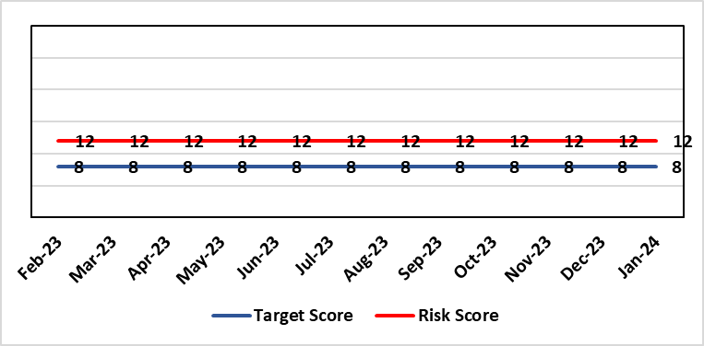 |  | Rationale for current score:  - Current lack of required skills / staff to deliver requirements.
Level of Control  = 50% |  |  | Rationale for target score:  - All of these areas need to have adequate resourcing and robust processes / policies in place for the organisation to make robust plans, engage public confidence and meet our statutory and public duties.
Date added to the HB risk register
November 2018
Controls (What are we currently doing about the risk?) |  |  | Mitigating actions (What more should we do?)
- Head of EDI to be appointed to support equality impact assessment – funding previously agreed, paper going to Management Board and then Board on 25th January 2024. Funding to be agreed to allow appointment to be made.  - Creation of DICE has led to some additional capacity within Engagement Team but alongside a significant increase in demand for activity.  - Robust policies and processes to be in place for Impact Assessment going forward.  - EIA responsibilities incorporated into wider Impact Assessments.  - Development of Strategic Equality Group across organisation to support processes. |  |  | Action | Lead |  | Deadline
 |  |  | Appoint Head of EDI  Delayed due to need to confirm budget | Assistant Director of Insight, Engagement & Fundraising - DICE |  | 31/03/2024
 |  |  | Review of the current process for developing Equality Impact Assessments around service change, engagement and consultation. | Assistant Director of Insight, Engagement & Fundraising - DICE |  | 31/03/2024  In progress
 |  |  | Robust policies and processes to be in place for Impact Assessment going forward. | Assistant Director of Insight, Engagement & Fundraising - DICE |  | 30/06/2024  In progress
 |  |  | Roll out Impact Assessment process across organisation. | Assistant Director of Insight, Engagement & Fundraising - DICE |  | 30/09/2024
Assurances (How do we know if the things we are doing are having an impact?)  Advice on Equality Impact Assessment and then wider Impact Assessments available across organisation supported by robust policies and procedures, overseen by Strategic Equality Group. |  |  | Gaps in assurance (What additional assurances should we seek?)  Participation from across organisation in Strategic Equality Group.
Additional Comments / Progress Notes
19/01/2024: Reviewed – no change currently

Datix ID Number: 2522  Health & Care Standard: 5.1 Timely Care |  |  | HBR Ref Number: 75  Risk Target Date: TBC |  | Current Risk Rating  5 x 2 = 10
Objective: Services working effectively through a systems approach |  | BAF Ref: 3 | Director Lead: Deb Lewis, Chief Operating Officer  Assuring Committee: Performance and Finance Committee
Risk: Whole-Service Closure  Risk that services or facilities may not be able to function if there is a major incident or a rising tide that renders current service models unable to operate |  |  | Date last reviewed: January 2024
Risk Rating  (consequence x likelihood):  Initial: 5 x 4 = 20  Current: 5 x 2 = 10  Target: 5 x 1 = 5 | 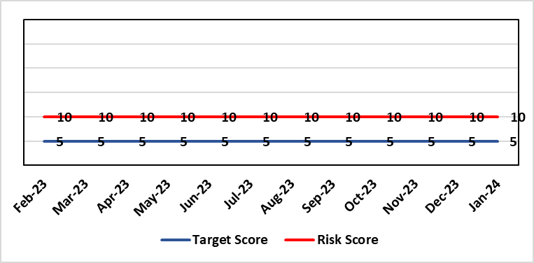 |  | Rationale for current score:  Risk reflects transition to business as usual as part of living with Covid strategy. BCP plans in place. There is still fluctuation in patient numbers and new variants continue to emerge so score maintained as watching brief.
Level of Control  = 25% |  |  | Rationale for target score:  The strategy of moving towards living with Covid will eventually lower the risk level to target.
Date added to the HB risk register
May 2021
Controls (What are we currently doing about the risk?) |  |  | Mitigating actions (What more should we do?)
- Sites have business continuity plans and the impact of one site being overwhelmed by COVID demand has been reviewed.  - Monitoring of associated risks has been being transferred to appropriate forums such as UEC Board, Elective Care Board and Nosocomial Group with overall oversight by Management Board.  - Ongoing surveillance of epidemiology data for early warning and further change to risk level via live Covid dashboard. |  |  | Action | Lead |  | Deadline
 |  |  | Periodic review of risk | COO |  | See Notes Below
Assurances (How do we know if the things we are doing are having an impact?)  Monitored via Management Board for early warning signs. |  |  | Gaps in assurance (What additional assurances should we seek?)
Additional Comments / Progress Notes
06/01/2023: Risk reviewed – no change. Health Board has received updated local choices framework from WG to aid decision-making if required.
07/02/2023: Risk score reviewed – no change
31/07/2023: Risk reviewed.
03/11/2023: Consideration currently being given to replacement of this risk with fresh entry on wider organisational business continuity arrangements

Datix ID Number: 3444  Health & Care Standard: 2.1.1 Managing Financial Risk |  |  | HBR Ref Number: 92  Risk Target Date: 31st March 2024 | Current Risk Rating  5 x 4 = 20
Objective: Maintain and Deliver Sustainable Financial Health |  | BAF Ref: 6 | Director Lead: Darren Griffiths, Director of Finance and Performance  Assuring Committee: Performance and Finance Committee
Risk: Forecast Deficit  Forecast deficit is not met due to insufficient progress on COVID cost reduction, savings identification, run rate reduction and the potential for new in-year pressures. |  |  | Date last reviewed: January 2024
Risk Rating  (consequence x likelihood):  Initial: 5 x 4 = 20  Current: 5 x 4 = 20  Target: 5 x 1 = 5 | 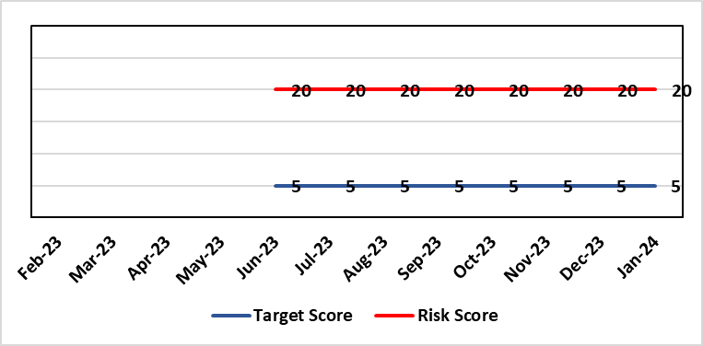 |  | Rationale for current score:  - Delivery of the deficit plan is predicated on a combination of £63.5m of savings and cost reduction which is a significant ask  - Consequence is significant as failure to deliver the plan could impact service delivery if cost reduction required later in the year  - A deficit plan is a failure to meet a statutory duty  - At the time of writing the Health Board still has to identify £31m of the risk mitigation to achieve the deficit plan leading to a high likelihood at this stage
Level of Control
= 25%
Date added to the risk register  June 2023 |  |  | Rationale for target score:  - The consequence will not change given the important of financial delivery and its relationship with the delivery of the Health Board recovery and sustainability plan  - Reducing likelihood to 1 supports a confidence that the deficit plan will be delivered.
Controls (What are we currently doing about the risk?) |  |  | Mitigating actions (What more should we do?)
The Health Board is doing the following:  - Finance Review Meetings with Units to agree cost exit plans  - Escalation plan for highest pressure areas (Morriston and Neath Port Talbot Singleton)  - Transparent exchange of position with NHS Executive & Welsh Government  - Clear financial plan in place for 2023/24  - Savings PMO in place to support savings delivery  - Additional support being targeted to key areas of pressure  - Focus on efficiency of core resource to avoid spending premium cost resource |  |  | Action | Lead | Deadline
 |  |  | Continuation of weekly escalation meetings and escalation of other areas as necessary | Director of Finance & Performance | Will run until targets met
 |  |  | Develop robust cross system service change plans which improve quality of care and reduce system cost | Director of Finance & Performance and Chief Operating Officer | Will run until target is met
Assurances (How do we know if the things we are doing are having an impact?)  The Health Board financial performance is reviewed and monitored through:  - Monthly financial recovery meetings  - Performance and Finance Committee  - Routine reporting to Board of most recent monthly position and financial forecasts  - Weekly escalation meetings with CEO and Director of Finance & Performance – temporary escalations until delivery is assured – each meeting has run rate trackers  - Weekly savings tracker reports from Savings PMO.  - Comprehensive mid-year review of trajectory to 31st March 2024 will be completed in October for discussion with WG and Board. |  |  | Gaps in assurance (What additional assurances should we seek?)
Additional Comments / Progress Notes
Update 16.08.2023 - Letter from WG dated 3rd August outlined that the Health Board had failed to meet its statutory duty to submit an IMTP and to have an IMTP approved by the Welsh Ministers. Although the deficit financial plan is not agreed with Welsh Government, the Board is working to deliver the deficit number unless advised to the contrary. Since submission of the plan the Health Board has also been required to identify options to reduce the deficit below the £86.6m which was submitted to Welsh Government on 11th August along with an Accountability Officer Letter.

Datix ID Number: 3448  Health & Care Standard: 2.1.1 Managing Financial Risk |  |  | HBR Ref Number: 93  Risk Target Date: 31st March 2024 |  | Current Risk Rating  5 x 4 = 20
Objective: Best Value Outcomes from High Quality Care |  | BAF Ref: 6 | Director Lead: Darren Griffiths, Director of Finance and Performance  Assuring Committee: Performance and Finance Committee
Risk: Reduced Capital Funds  Reduced discretionary capital funds and reduced National NHS funds requiring a restricted Capital Plan for 2023/24 |  |  | Date last reviewed: January 2024
Risk Rating  (consequence x likelihood):  Initial: 5 x 4 = 20  Current: 5 x 4 = 20  Target: 5 x 1 = 5 |  |  | Rationale for current score:  - The Health Board has been advised that its discretionary capital allocation for 2023/24 is £9.8m.  - The funding available within the Capital Resource Limit (CRL) will not meet the demands for capital investment. Discretionary capital is deployed to replace ageing medical devices & equipment; to address backlog maintenance of premises; and to support small scale, non-National service improvements with capital investments  - The current Health Board assessment of the carry forward and previously agreed commitments for inclusion in the 2023/24 capital plan currently suggests a requirement for an additional £9.8m to balance the plan and meet highest risk priorities only.  - It is likely that due to slippage on capital schemes, this over-commitment will reduce.  - There is potential for further capital requirements arising from service model changes which will need to be managed.  - Potential consequences of this risk are the inability to achieve the ambitions set out within health board plans; the potential failure of ageing equipment leading to service disruption; the exposure to potential environmental health & safety risks.
Level of Control
= 25%
Date added to the risk register  June 2023 – new for 2023/24 |  |  | Rationale for target score:  The target score expresses the aspiration of the health board for addressing this risk. The target date indicated above reflects the point which the current actions are anticipated to reduce the risk, though knowledge of the actual funding available is required to reduce it further and this is not available until some months into the financial year.
Controls (What are we currently doing about the risk?) |  |  | Mitigating actions (What more should we do?)
The Health Board is doing the following: -  - Regular dialogue with Welsh Government regarding capital requirements.  - Clear communication and reporting of the capital position, the risks and limitations.  - Close management of all schemes to ensure slippage is understood along with the impact on service.  - Clear prioritisation of any new requirements recognising the current constraints |  |  | Action | Lead |  | Deadline
 |  |  | Routine review and flexing of plan as spending is committed through the year. Routine monitoring processes will identify any potential slippage and will deploy this on risk based basis. | Director of Finance & Performance |  | Monthly through the financial year as plan is dynamic
Assurances (How do we know if the things we are doing are having an impact?)  The Health Board capital position is reviewed and monitored through:  - Monthly capital prioritisation group  - Performance and Finance Committee monthly finance report  - Monthly Monitoring Returns to Welsh Government. |  |  | Gaps in assurance (What additional assurances should we seek?)  Reporting on impact of constraints to the capital programme on service delivery.
Additional Comments
Board members will be aware that capital plans are dynamic through the year with mitigating actions taken and opportunities for slippage and further support from WG sought on a consistent basis. This process will continue in 2023/24 in efforts to de-risk the capital plan.
21/09/23: No additional information, therefore, no change.

Datix ID Number: 3516  Health Care Standards: Standard 3.1 safe and clinically effective services |  |  | HBR Ref Number: 94  Risk Target Date: TBC |  | Current Risk Rating  4 x 3 = 12
Objective: Children, Young People & Maternity Services |  | BAF Ref: 3.6 | Director Lead: Deb Lewis, Chief Operating Officer  Assuring Committee: Performance and Finance Committee  For information: Quality & Safety Committee
Risk: CAMHS failure to meet required standards of performance  The CAMHS service is unable to meet the required level of performance due to workforce deficits in the team across all staff groups including medics, psychological therapies and nursing.  This is further hindered by poor data quality which presents a risk to reporting until validation is complete.  Links to other CAMHS risk register entries: (Ref: 3410/3373/3351/3346/3349/3350) |  |  | Date last reviewed: January 2024
Risk Rating  (consequence x likelihood):  Initial: 4 x 5 = 20  Current: 4 x 3 = 12  Target: 3 x 3 = 9 | 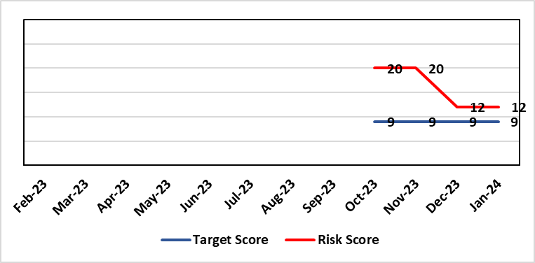 |  | Rationale for current score:  Marked improvement in the performance against the Mental health Measure for CAMHS. Data validation for new patients complete. Current risk score reduced to 12 in view of improved performance however this reflects the fragility in the workforce to deliver sustained performance.
Level of Control  = % |  |  | Rationale for target score:  The rationale for the target score is linked to successful recruitment and more timely access to services for children and young persons which will reduce risk.
Date added to the risk register
October 2023
Controls (What are we currently doing about the risk?) |  |  | Mitigating actions (What more should we do?)
-Ongoing recruitment into all staff groups  -Temporary agency workforce in nursing at premium pay rates to sustain current levels of performance  -Use of locum medical staff due to high vacancy level on medical workforce.  -Recent appointment into psychological therapies lead posts.  -Exploring fixed term appointment of Band 5 psychological therapies support staff to improve performance |  |  | Action | Lead |  | Deadline
 |  |  | Continued efforts at recruitment | Acting Associate Service Director |  | Monthly review
Assurances (How do we know if the things we are doing are having an impact?)  -Monthly CAMHS Directorate meeting in place where performance and workforce are scrutinised  -Reporting into Weekly Business Team and MH & LD management board.  -Reporting into HB Performance and Finance Committee  -Ongoing validation of the waiting list to ensure robust reporting going forward |  |  | Gaps in assurance (What additional assurances should we seek?)
Additional Comments / Progress Notes
13/12/2023: Marked improvement in the performance against the Mental health Measure for CAMHS. Data validation for new patients complete. Data validation for follow-up patients including ADHD in progress. Over recruitment into agency nursing has supported delivery of improved performance outputs however continue to struggle to recruit into substantive posts.
Current risk score reduced to 12 in view of improved performance however this reflects the fragility in the workforce to deliver sustained performance.

Datix ID Number: 3571  Health & Care Standard: Safe Care 2.1 Managing Risk & Promoting Health & Safety |  |  | HBR Ref Number: 96  Target Date: 31st March 2025 |  | Current Risk Rating  4 x 5 = 20
Objective: Demonstrating Value and Sustainability |  | . BAF Ref: 6 | Director Lead: Nerissa Vaughan, Interim Director of Strategy  Assuring Committee: Performance and Finance Committee
Risk: Failure to Develop an Approvable IMTP (statutory compliance)  Failure to have an approvable (Integrated Medium Term Plan) IMTP for 2024/5 then we will lose public confidence and breach legislation. |  |  | Date last reviewed: January 2024
Risk Rating  (consequence x likelihood):  Initial: 4 x5 = 20  Current: 4 x 5 = 20  Target: 4 x 2 = 8 | 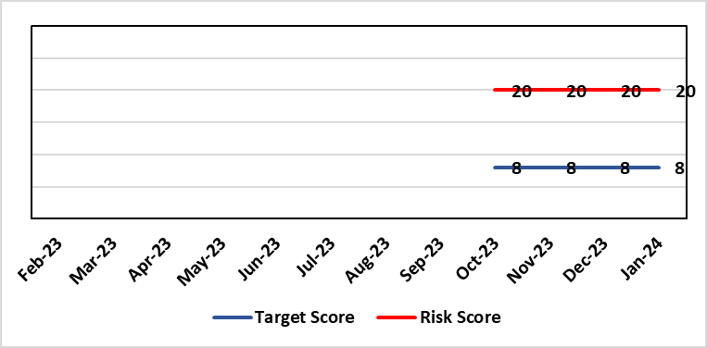 |  | Rationale for current score:  The Health Board does not have a WG approved IMTP and has been placed in enhanced monitoring for Finance and Planning following the inability of the HB to submit a balanced IMTP in March 2023. An Annual Plan was submitted for 2023/24. Given the all Wales financial context the HB is not expecting to submit an IMTP in March 2024 and will instead be developing an Annual Plan 24/25 set in a three year context.
Level of Control
= 70%
Date added to the HB risk register
October 2023
Date added to the HB risk register  October 2023 |  |  | Rationale for target score:  The target remains to develop a financially balanced IMTP so that we meet our statutory duties.
Controls (What are we currently doing about the risk?) |  |  | Mitigating actions (What more should we do?)
- An Annual Plan was submitted to WG in March 2023 with further detailed supporting information provided in July 2023.  - An integrated process is in place to develop the Annual Plan 2024/25.  - The existing IMTP Executive Steering Group will provide oversight of the R&S Plan, Performance and Finance Plans assured by P&F Committee. W&OD Committee reviews the workforce plan, Q&S Committee the Q&S elements. JET meetings with WG  - A prioritisation process will take place in Jan 2024 to establish GMOs for 24/25 along with a robust financial and workforce assessment which will determine whether an IMTP is achievable  - The outcome of the above will be submitted in an Accountability Officer Letter to WG in Feb 2024 |  |  | Action | Lead |  | Deadline
 |  |  | Development of a robust Annual Plan for 2024/25 and continued work to set out a timeline for financial recovery. | Dir of Strategy & Dir of Finance |  | 31/03/2025
Assurances (How do we know if the things we are doing are having an impact?)  Robust arrangements are in place to execute the Annual Plan and for 23/24 these arrangements have been strengthened with updated reporting and monitoring arrangements through the newly established Annual Plan Oversight Group chaired by the COO. |  |  | Gaps in assurance (What additional assurances should we seek?)
Additional Comments / Progress Notes

Risk Score Calculation

For each risk identified, the LIKELIHOOD & CONSEQUENCE mechanism will be utilised. Essentially this examines each of the risks and attempts to assess the likelihood of the event occurring (PROBABLILITY) and the effect it could have on the Health Board (IMPACT). This process ensures that the Health Board will be focusing on those risks which require immediate attention rather than spending time on areas which are, relatively, a lower priority.

