Meeting Date | 28 January 2025 |  | Agenda Item |  | 3.2
Name of Meeting | Performance and Finance Committee
Report Title | QTR 4 Delivery Plan
Report Author | Tony Clark – Head of Programme Management  Brian Owens – Director Recovery and Sustainability
Report Sponsor | Darren Griffiths – Director Finance and Performance
Presented by | Brian Owens – Director Recovery and Sustainability
Freedom of Information | Open
Purpose of the Report | To provide the Performance and Finance Committee oversight of the planned actions to support the delivery of the Health Board financial plan.  The delivery plan builds on the financial plan presented to the Special Board Meeting on December 19th 2024, and also accompanies the Financial Report M09.  The Committee is asked to approve the recommended actions as detailed.
Key Issues | The previous report to the Special Health Board meeting in December detailed work which has been undertaken to explore all options to deliver the 2024/25 outturn forecast. The gap from forecast deficit of £43.7m was identified as £14.3m following 11th December 2024 Recovery and Sustainability Board.  This paper sets out the actions required to achieve the forecast deficit, updates the previous report based on Month 9 Financial report and focusses on the key areas:  - Non recurrent Opportunities  - Productivity Efficiency including Variable Pay Scrutiny, Vacancy Control processes, and Value and Sustainability Procurement  - Support for Service Groups in Escalation  - Reducing Capacity - Savings
Specific Action Required  (please choose one only) | Information | Discussion | Assurance | Approval
Specific Action Required  (please choose one only) | ☐ | ☐ | ☐ | ☒
Recommendations | Members are asked to: -  - Support the quarter 4 tactical plan  - TAKE ASSURANCE that proactive management actions are in place to support delivery of the financial plan:  - Increased controls for use of both variable pay and vacancy management;  - A review of the Star Chamber additional savings to consider deliverability;  - A review of health board funded investment decisions;  - Further work from the Value and Sustainability Procurement workstream;  - Review of benefits realisation and stock consolidation of theatre consumables and the project to deliver the Automated Stock Management System (Omnicell).  - CONSIDER the risks of delivery against the plan  .  - SUPPORT the direction of travel regarding the actions being undertaken to support the financial outturn.

QUARTER 4 DELIVERY PLAN ALIGNED WITH THE FINANCIAL REPORT M09

- INTRODUCTION
The following paper sets out the delivery plan for quarter 4, following the presentation and discussion of the financial plan in the December Special Health Board. The paper builds on the decisions and actions agreed in Board, subsequent recovery and Sustainability Meetings and an updated financial position from Month 9.

- BACKGROUND
The QTR 4 delivery plan presented to the Special Board meeting on 19th December 2024 set out the actions required to achieve the forecast deficit, £43.7m. The gap from the forecast deficit was identified as £14.3m. The Board agreed the following recommendations: -

- The development of a plan to achieve variable pay reductions (excluding Waiting List Initiatives, WLI’s)
- Vacancy freeze for all posts to be overseen by a revised vacancy panel process which considers the overall pay bill and variable pay impacts of decisions
- No planned care money directly allocated to the Health Board be used for any purpose other than waiting times reduction
- The immediate development of plans to release the benefits of options within star chamber pools of £3.018m

This paper will focus in more detail on the tactical actions required to achieve the forecast deficit. During the special Board meeting in December 2024, it was further recommended:

- a reduction of Variable pay of £5.2m against the current average.
- £3m additional savings requirement which plans were submitted as part of the Star Chamber Sessions earlier in the year.
- Further efficiencies from the Value and Sustainability (V+S) Procurement workstream focussing on Theatre Consumables and efficiencies around stock management.

  - Enhanced Variable Pay Controls (£5.2m)

Despite direct focus and oversight, the Health Board’s variable pay bill has remained largely unchanged throughout the financial year with total variable pay spend at month 9 at £48.3m.
Enhanced additional variable pay controls remains one of the most significant financial opportunities. Previous targets for variable pay expenditure have not been achieved and a more directed approach to variable pay management has been implemented.

Figure 1 details evidence of the expenditure on agency to Month 9. Whilst the health board experienced some improvements during the summer months, this was not sustained. Agency usage has been increasing, reaching £1.9m in December, the second highest usage for the year. The pattern (see below) seems to be reflective of all Service Groups.

Figure 1. Agency Spend by Service Group M1-9
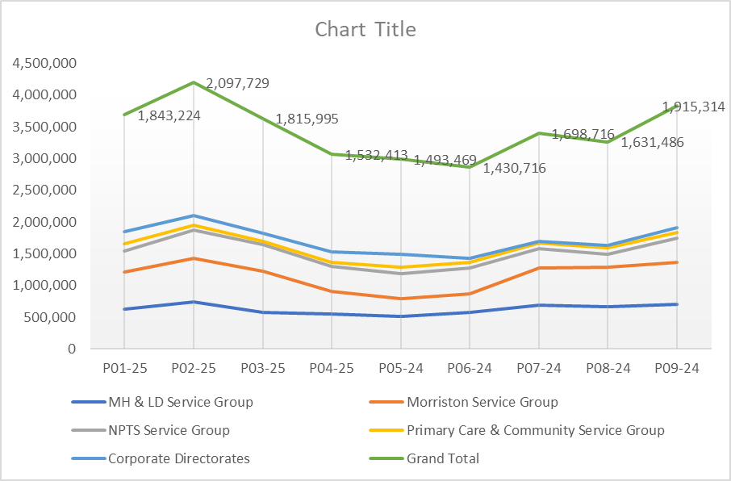

Table 1 sets out the required maximum agency expenditure for the remainder of the financial year based on the December board agreed agency expenditure controls totals.

As an example, Morriston Service Group, whose monthly average variable pay has been circa £2m to Month 9 must achieve a reduced agency expenditure to no greater than £1.530m per month.

Table 1 - Variable Pay Reduction Target by Service Group in Qtr. 4
To support the delivery of the agency control expenditure targets enhanced controls have been implemented. The oversight for agency expenditure in clinical areas is overseen by executive clinical professionals to ensure the most senior level of scrutiny and support to mitigate the need for agency staff. See appendix 1, for an overview of the current actions in progress and daily ‘battle rhythm’ for nursing. Similar arrangements are in place for medical and Allied Health Professionals / Health Scientists. Each led by the respective executive lead for the profession.
The default position is that agency is not to be used unless there are specific safety implications which are supported by the executive lead.

Service groups and Directorates are expected to implement mitigating actions prior to consideration of agency staffing. These include, not intended to be a comprehensive list, the temporary deployment of staff from areas with less risk to those with high risk, consideration of the temporary deferral of study leave to ensure gaps in the rota are safely covered etc. Internal mitigating actions are required prior to requesting consideration of agency cover.

It should be noted that this enhanced process is being developed in ‘real time’ as the new controls are tested and modified and therefore may be altered. Oversight of the effectiveness of the control processes will be via the Recovery and Sustainability Board, chaired by the CEO.

  - Vacancy Freeze (£TBC)

The Special Board in December 2024 also approved a freeze on vacancies following on from the recruitment ‘pause’ on administrative and clerical roles. As with the agency ban, there will be some limited and specific exceptions to maintain clinical safety.

The Executive Director of Workforce has implemented a clinical vacancy review panel, to ensure very senior scrutiny and oversight of all clinical vacancies going forwards. As these are clinical roles, the respective executive clinical director will adjudicate for their professional group whilst allowing wider scrutiny and oversight from the broader representation.

Vacancy requests are also being considered against the Establishment Control dashboard. The establishment control dashboards are a relatively recent development and follows extensive work to ensure that the dashboards align to the funding within the budget. Therefore, moving forwards as part of the vacancy control process there will be a requirement for all requests being considered to be visible on the dashboard to demonstrate a funded vacant position.

To support the default position of a vacancy freeze, the previously established administrative and clerical vacancy panel has been ‘stood down’. The expectation is that moving forwards there will be limited number of posts that require an exemption, these will need to be supported by a quality impact assessment and will therefore be treated on a case by case basis.

The effectiveness of the process will be monitored via the Recovery and Sustainability board. Appendix 1, provides additional detail on the current position. It should be noted that this enhanced process is being developed in ‘real time’ as the new controls are tested and modified and therefore may be altered.

  - Additional Savings from Star Chamber - Red Schemes (£3.0m)

Through the series of Star Chamber meetings which were used to formulate the recovery plan submitted at the end of September 2024, all possible options to reduce spend/deliver savings were put forward for consideration. These options set out actions that were beyond the normal tolerance the Health Board has for cost reduction with impacts on service access, capacity, recruitment and partnership featuring as potential consequences of the cost reductions. This resulted in potential delivery of £3m across MHLD and NPTS Service Groups.

Further work is now being undertaken to revisit the options in each of the pools. This work is a blend of assessments made by Services Groups on scheme deliverability and ability to release spend in 2024/25.

Table 2. Star Chamber Red Schemes

  - Investment/Funding Review

A detailed review has commenced of the funding allocated though Health Board plans in 2023/24 and 2024/25. The work will seek to provide assurance around the return on investment and benefits realisation and to make recommendations around the continuity of the financial allocation decision.

The preliminary work will report at the end of January 2025 and will be a key feature of recurrent improvements for 2025/26 and future years. It should be recognised that this is a complex and very detailed exercise and is likely to continue into 2025/26. Therefore, at this point no contribution to closing the gap to forecast has been assumed for this action for 2024/25, although detailed work will be undertaken in quarter four.

  - V+S Procurement (£0.2m)

The Value and Sustainability Procurement workstream continue to drive efficiencies across priority areas such as: -

- Price and Volume;
- Contract Negotiations and Management;
- Management of Service Contracts.
- Roll out of usage of Advise Inc, a Procurement Dashboard for Spend analytics

Cash releasing Savings to date for SBUHB is £2.9m (Nov) against a full year target of £3.464m. The majority of savings are from Medical, Surgical Equipment and Pharmaceuticals. It is anticipated that with support in these priority areas an additional £0.2m can be achieved.

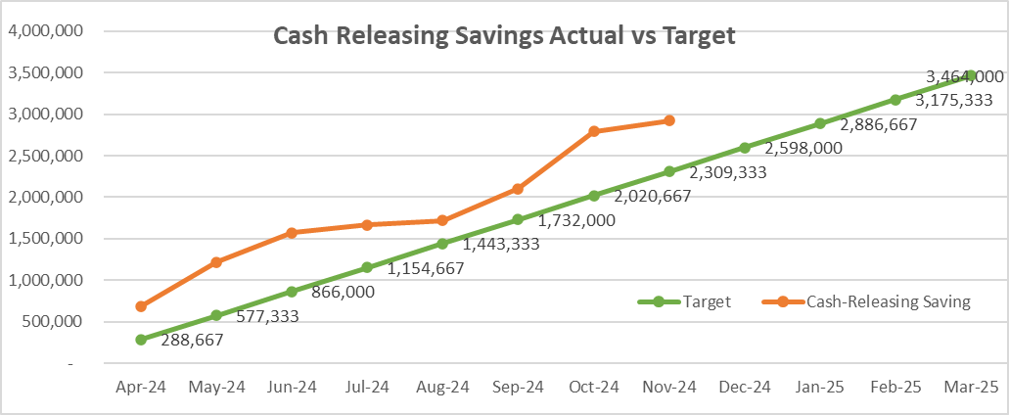

Theatre Stock Management and Omnicell Benefits (£0.5m)

The Automated Stock Management (ASM) system was introduced to Swansea Bay University Health Board (SBUHB) in 2019 for theatres and anaesthetic services across the acute hospital sites. The aim of the project was to deliver significant cash efficiencies and savings; supporting efficient financial controls and management processes; to provide managers with access to ‘live’, reliable and usable stock records; reduce the quantity of stock holding; allow compliance with best practice; maximise space utilisation; and increase user accountability.

However, the programme has been significantly delayed over the years and not all of the cabinets have been fully commissioned, predominantly the radio-frequency identification (RFID) enabled cabinets. The R&S team are proactively supporting the theatre teams to ensure the final cabinets are fully commissioned across the suites on all sites by the end of February 2025.

The R&S team are also supporting the theatre procurement group, which is the delivery vehicle being used to achieve the requirement to deliver an additional £0.5m on theatre consumables by 31st March 2025. The theatre procurement group has already been established and is actively working with procurement and clinicians to deliver this additional component of the plan, focussing on reducing waste and not stock levels which wouldn’t impact on the spend levels due to the stock take at year end.

- GOVERNANCE AND RISK ISSUES
The Health Board risk register is currently reporting the revenue risk through Risk number 92 - achieving financial plan with the key elements. Of note will be the risk of achieving the financial benefits from the actions and options outlined above.

- FINANCIAL IMPLICATIONS
The financial implications are implicit in the report and is linked to the PFC Financial Report Month 09.

- RECOMMENDATION
Members are asked to:
- Support the quarter 4 tactical plan

- TAKE ASSURANCE from the actions to ensure delivery of the financial plan to £43.7m overspend by Year End 2024/25, including:

- The increased controls for use of both variable pay and vacancy management.
- A review of the Star Chamber additional savings to consider deliverability.
- A review of health board funded investment decisions.
- Further work from the Value and Sustainability Procurement workstream.
- Review of benefits realisation and stock consolidation of theatre consumables and the project to deliver the Automated Stock Management System (Omnicell).

- CONSIDER the risks of delivery of the plan and the impact this would have on the SBUHB financial outturn for 2024-25 as highlighted in the Financial Report M09.

- SUPPORT the direction of travel regarding the actions being undertaken to support the financial outturn.

Governance and Assurance

Link to Enabling Objectives  (please choose) | Supporting better health and wellbeing by actively promoting and empowering people to live well in resilient communities
Link to Enabling Objectives  (please choose) | Partnerships for Improving Health and Wellbeing |  | ☐
Link to Enabling Objectives  (please choose) | Co-Production and Health Literacy |  | ☐
Link to Enabling Objectives  (please choose) | Digitally Enabled Health and Wellbeing |  | ☐
Link to Enabling Objectives  (please choose) | Deliver better care through excellent health and care services achieving the outcomes that matter most to people
Link to Enabling Objectives  (please choose) | Best Value Outcomes and High Quality Care |  | ☒
Link to Enabling Objectives  (please choose) | Partnerships for Care |  | ☐
Link to Enabling Objectives  (please choose) | Excellent Staff |  | ☐
Link to Enabling Objectives  (please choose) | Digitally Enabled Care |  | ☐
Link to Enabling Objectives  (please choose) | Outstanding Research, Innovation, Education and Learning |  | ☐
Health and Care Standards
(please choose) | Staying Healthy |  | ☐
(please choose) | Safe Care |  | ☐
(please choose) | Effective Care |  | ☐
(please choose) | Dignified Care |  | ☐
(please choose) | Timely Care |  | ☐
(please choose) | Individual Care |  | ☐
(please choose) | Staff and Resources |  | ☒
Quality, Safety and Patient Experience
Financial Governance supports quality, safety, and patient experience.

Financial Implications
The Report is supporting the Financial Outturn projected deficit position as reported in the Financial Report M09.
Legal Implications (including equality and diversity assessment)
No Implications
Staffing Implications
The proposed actions and successful delivery will require partnership working of the Recovery and Sustainability Team, Finance Team, and Service Group staff, although this will not require additional resource over and above current establishment.
Long Term Implications (including the impact of the Well-being of Future Generations (Wales) Act 2015)
No Implications

Report History |  | This report is linked to the QTR 4 Finance Delivery Plan presented at the Special Board Meeting on 19 December 2024 (Agenda 2.1)
Appendices |  | Appendix 1. Agency Controls and Recruitment Vacancy Processes.

Appendix 1 – Agency Controls and Vacancy Scrutiny Panel

Agency Staffing for planned / known gaps in rotas:

- An urgent re-review of all 34 long term medical locums to be completed with a corresponding exit strategy being developed for all 34 posts, complete with timeline and monitoring process for delivery of the exit strategy.
- Long term locums in other professional groups to be reviewed and exit strategies to be developed as above.
- Other planned gaps in rotas to be accompanied by a related quality impact assessment (QIA) and evidence that the gap cannot be covered by the temporary emergency redeployment of staff from other areas with lower clinical risk. The assessment must be signed off and agreed at Service Group Triumvirate level prior to submission for consideration. A refreshed QIA and assessment will be required each time agency requests for known gaps in the rota’s are requested.
- There will need to be a strict and limited exclusions list which will be developed as part of this overall approach. The Executive Director for Nursing will ensure very senior scrutiny and oversight of the exit strategy for these areas.
- The appropriate executive director for the service will scrutinise and accept / reject the request.
- New Long term agency bookings will not be approved.

Short Notice Agency Requests
Medical <72 hours
- Requests with Triumvirate support and associated assessment to be reviewed and assessed by Medical Director’s office.

Non-Medical <24 hours
- Requests with Triumvirate support and associated assessment to be reviewed by responsible Executive Director.

Out of Hours (OOH) Approval
- Emergency requests for agency staff OOH must be accompanied by a declaration from the most senior clinical person on duty covering that profession that the gap cannot be mitigated by temporarily redeploying staff from areas with lower risk.
- Gold on call will approve / reject

11am Exec Scrutiny Panel
- Each working day there is an 11am Executive Scrutiny panel to professionally review requests – the expectation is that we review approved requests by the Group Nurse Director (delegated deputies only in absence for annual leave) these will be for last resort requests for the next 24hr time period.

- Post 11am panel - for urgent requests for a night shift or early shift the following day that have been submitted after panel– the online form should only contain the information relevant to these requests and have been approved by the Group Nurse Director. There will be a designated Exec Nurse allocated to review within business hours until 5pm. All other requests will be considered at panel the following working day.

- Out of Hours - during out of hour periods up until 2200hrs or after 8am the following day – requests need to be sent to Silver on call on the on-line form and if required will escalate to Gold on call via telephone communication to discuss. Silver On call will confirm the outcome with the requester. This system will be fully automated when all Silver and Gold are trained. No requests for agency will be reviewed between the hours of 2200hrs and 0800hrs – local arrangements to mitigate requirements will need to be actioned.

Vacancy Scrutiny Process
Weekly Clinical Vacancy Control Meetings have now been set up. This will be a weekly meeting to ensure that the posts are managed in a timely manner given the clinical risks associated with approval of such posts. The aim is to ensure all clinical posts now come through this mechanism, so it will replace previous methods.

To ensure that clinical safety is maintained whilst balancing the requirement to achieve a sustainable financial position, the following control process will be implemented with immediate effect:
- All posts to be assessed using a quality impact assessment process (QIA), posts to be reviewed and considered by the service group triumvirate.
- Consideration at service group to include:
  - Temporary redeployment of staff from other lower risk areas;
  - Service redesign to ensure the most effective deployment of current staffing;
  - Assessment of the risk if the post is paused in the short / medium term and not covered elsewhere;
  - Fixed term posts for NHS staff are to be via secondment only;
  - Ceasing the back fill for posts that have been seconded;
  - Review of any staff on the Redeployment Register.
- It is acknowledged that some recruitment will need to continue to maintain safe clinical services therefore posts will need to be supported by the service group triumvirate. Each post will be discussed and considered in a modified vacancy scrutiny panel process with Executives.
- It is expected that service groups maintain a local record of all posts declined at service group level and this is shared as part of the additional scrutiny process when requesting consideration of posts for recruitment.
- Posts that are essential and where the impact cannot be mitigated elsewhere within the service group will be discussed in this panel.
  - The same process will apply for posts within corporate directorates
  - The Establishment Control Dashboard will be used to evidence that all posts being considered for recruitment are within the funded budgeted staffing establishment

