

Meeting Date | 25th July 2023 |  | Agenda Item |  |  | 2.1
Report Title | Financial Report – Period 03 2023/24
Report Author | Samantha Moss, Deputy Director of Finance  Alison McLennan, Finance Business Partner
Report Sponsor | Darren Griffiths, Director of Finance and Performance
Presented by | Darren Griffiths, Director of Finance and Performance
Freedom of Information | Open
Purpose of the Report | The report advises the Performance & Finance Committee of the Health Board on the financial position for Period 03 (June 2023) 2023/24 and sets out the current forecast revenue year end outturn.
Key Issues | The report invites the Performance & Finance Committee to note the detailed analysis of the financial position for Period 03 (June 2023) 2023/24.  The report includes a summary of the key drives of the position either at Service level or by expenditure type (i.e. Non Pay / Pay). It also provides information of the current position with regard to Health Board reserves to ensure transparency in the overall Health Board position.  Risks have been updated.
Specific Action Required  (please choose one only) | Information | Discussion |  | Assurance | Approval
Specific Action Required  (please choose one only) | ☐ | ☐ |  | ☒ | ☐
Recommendations | Members are asked to:  - NOTE the agreed 2023/24 financial plan.  - Consider and comment upon the Board’s financial performance for Period 03 2023/24.  - NOTE the actions to ensure delivery of the financial forecast with a specific focus on savings delivery: -  - Enhanced monitoring meetings in place above standard Finance & Performance Meetings to oversee and agree actions to mitigate run rates and deliver savings. Morriston / NPTS Service Group Directors  - Focused attention to ensure that 100% of the schemes are identified at the end of Q1 23/24. All Service Group Directors and Corporate Directors  - Focused attention to ensure that 100% of the schemes identified at the end of Q1 are green and amber by the end of Q2 23/24. All Service Group Directors and Corporate Directors  - Where savings delivery is not on track there will be further meetings with the Director of Finance and CEO at the end of Q1 and Q2. All Service Group Directors and Corporate Directors  - NOTE actions to ensure the operational pressures are mitigated and areas return to financial balance.  - Enhanced monitoring meetings in place above standard Finance & Performance Meetings to oversee and agree actions to mitigate run rates and deliver savings. Morriston / NPTS Service Group Directors  - External assessment of opportunities to mitigate pressures via the Grant Thornton post-AMSR assessment. All NPTS Service Group Director & COO  - Embed and deliver opportunities identified via two Independent Financial support provided to the Service Group to review run rate and savings. Morriston Service Group Directors and Corporate Directors  - NOTE the risks position at Month 3.  - NOTE the position with regard to Health Board Reserves  - NOTE all actions and updates to support the management of the 2023/24 financial position.

FINANCIAL REPORT – PERIOD 03

- SUMMARY OF REVENUE PERFORMANCE

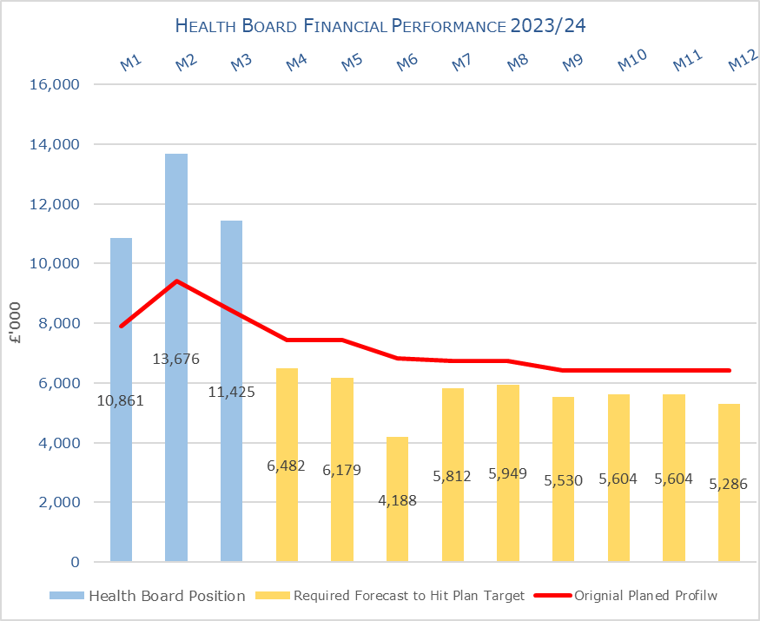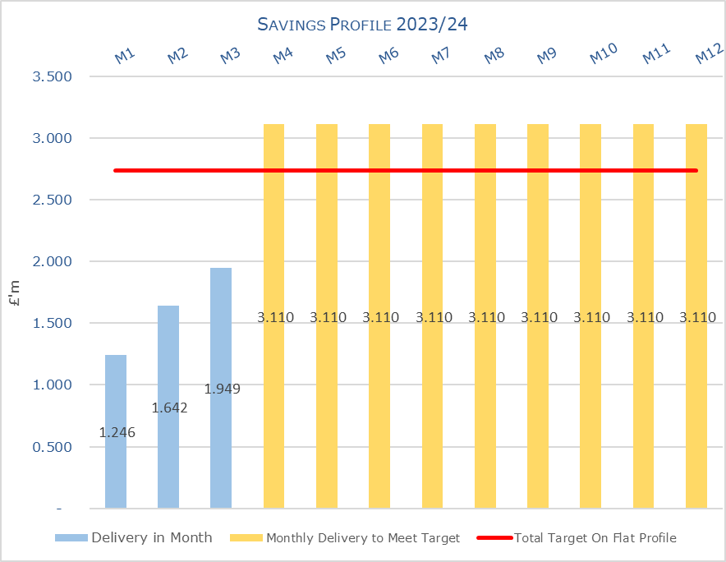

Target | In Month  £M | Year To Date (YTD)  £M
Delivery Against Revenue Resource Limit (RRL) DEFICIT / (SURPLUS) | 11.425 | 35.960
Delivery Against Financial Plan DEFICIT / (SURPLUS) | 3.00 | 10.20
Delivery Against Total Savings Target In Ledger DEFICIT / (SURPLUS) | 0.731 | 3.434

- FINANCIAL PLAN 2023/24
The Health Board (HB) developed and submitted a draft 3-year plan at the end of March 2023 showing an anticipated deficit of £69.9m. Following a further review in May 2023 the plan was updated to reflect the following changes: -

- Removal of income assumptions regarding COVID;
- Reduction in the energy assumptions by £3m;
- Reduction in cost pressure linked to disaggregation of an SLA with CTMUHB, which is delayed until 2024/25.
- Re-assessment of all risks to de-risk the plan.

The revised plan at 31st May 2023 reported a deficit of £86.6m.

Table 1: Financial Plan 2023/24
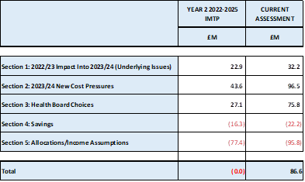

Key assumptions underpinning the plan:
- No unmet b/f savings from 2022/23 = £0m
- Run rate to remain within the envelop provided = £11m
- Savings requirement = £22.2m
- No COVID Response income = £21.2m

- KEY PERFORMANCE AREAS

Performance is summarised from two different perspectives. Section 3.1 provides the reported position by Service Group/Directors and section 3.2 onwards looks at the reported positon from the components of the ledger i.e. Income, Pay and Non Pay.

  - Summary By Service Area

Table 2 – Summary by Service Area

Key points of notes by type spent:
- Income
£0.6m under achievement of income in Month 3, in part this relates to the income from Dental and our commissioners and in particular WHSSC and the delivery of the WHSSC contract.

- Pay
The Month 3 pay was overspent by £1.2m in is part driven by the £0.6m reduction in Variable Pay between Month 2 and Month 3, linked to Overtime and WLI. There was also a reduction in WTE actuals between Month 2 and 3. This reduction relates in the main to two areas, Nursing and Additional Clinical Services (HCSW), with these 2 areas also seeing a corresponding reduction in overtime costs, which impacts on the WTE reported in the ledger.

Therefore, the Health Board clearly needs to address both the underlying run rate issue and the continued spend on variable pay, which is driving the in-month pay variance.

- Prescribing
At this point in the year, the Health Board has yet to receive any data with regard to Prescribing. However an in month overspend of £0.5m has been included to reflect the potential likely impact of recurrent impact of No Cheaper Stock Obtainable (NCSOs) and other growth pressures seen in 2022/23. However work on this will be required during Q2 once a number of months of 2023/24 data has been received.

- Non Delivery Savings
The Health Board has set an ambitious 3.5% savings target for 2023/24, after two years of achieving 4%, and in additional had a further 310m of unmet savings brought forward from 2022/23. The savings target has been profiled in equal twelfths. However, there remains a significant gap in the delivery of the total savings requirement (£32.8m) which has resulted in a £0.7m variance in Month 3 and £3.4m Year To Date. (Savings are covered in more detail later in this report)

Key points of notes by Service Area:

- Morriston
The key variances:
  - Income = Month 3 £0.5m variance and YTD £1.34m driven by WHSSC performance. Plans are being developed to recover this via the Enhanced Monitoring meetings.
  - Pay = Month 3 £1.5m variance and YTD £4.47m, with average spend of £3.7m on variable pay.
  - Non Pay (exc Savings) = Month 3 £0.8m variance and YTD £1.1m of which £0.7m relates to clinical supplies and general consumables
  - Savings = Month 3 £1.0m variance and YTD £2.7m
  - AMSR = following sign off of the budget transfer between Morriston and NPTS Service Group operational cost centre pressures and unmet CIPs have transferred to Morriston which is impacting on variance.

- Neath Port Talbot Singleton (NPTS)
The key variances:
  - Income = Month 3 £0.12m variance and YTD £0.3m driven by loss of Private Patient income
  - Pay = Month 3 £0.14m (underspend) variance and YTD £0.63m,
  - Non Pay (exc Savings) = Month 3 £0.3m variance and YTD £0.8m which relates to clinical supplies and primary care prescribing.
  - Savings = Month 3 £0.2m over achieved and YTD £0.6m under achieved.
  - AMSR = the transfer of cost centres to Morriston has had a benefit in month to NTPS.

Key Actions being undertaken:
The Month 1 and 2 reports detailed the actions being driven by the Health Board to mitigate the planned deficit and the risks. Updates or additional actions above those reported in previous months are captured below: -

- Enhanced Monitoring – both NPTS Service Group and the Morriston Service Group remain in enhanced monitoring with the weekly meetings continuing chaired by the CEO. The output of this focus is contributing to the slowing down of both the Morriston and NPTS Service Group overspend rate, which in turn contributed to the reduction in the overspend against plan in Month 3.
- Additional Support – in Month 2 it was reported that the Health Board would provide additional support from Finance Business Partner perspective into Morriston Service Group and this will now be extended to NPTS Service Group. Plus a review over the next 2 months on staffing with our Operational Finance Team (band 6 and below).

  - Summary Income

Table 3 – Income by month

  - Summary Pay

Table 4 – Pay Variance by month

Note – movement between Mth 2 and 3 budget relates to the one-off funding for the Recovery pay award and changes to the budget profiling linked to year-end accruals for Leave, Overtime and Time owing.

Table 5 – Variable Pay by month

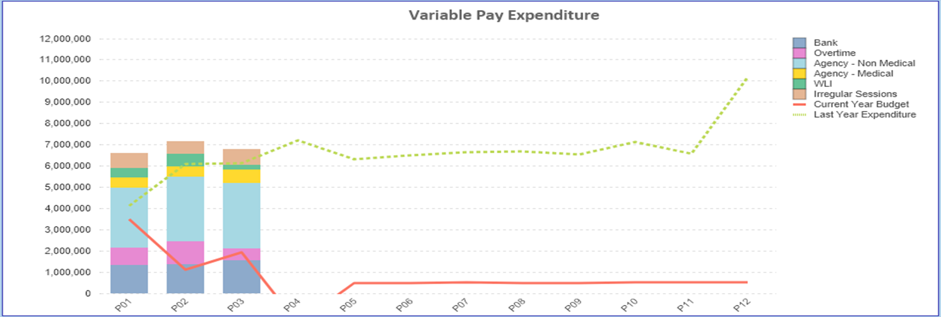

  - Summary Non Pay

Table 6 – Non Pay Variance by month

Note – movement between Mth 2 and 3 budget relates to the one-off adjustment for Losses, which is normally reflected at year end only and so had to be adjustment between months.

Below are further details on the keys areas of Non Pay (excluding savings which is addressed in Section 4):

    - Clinical Consumables
Clinical supplies and services were overspent YTD by £1.9m at the end of Month 3. Within the 80+ lines there were overspends on Laboratory Medicine General products .

    - Utilities
Currently there is a small pressures on Gas of £3k in month 3, however underspends in Electricity of £14k across the Service Groups and Corporate Directorates. Whilst an updated forecast from British Gas was shared with Health Board on the 1st June 2023. The Health Board is awaiting the Crown Commercial element of the forecast (2nd 6 months of the financial year) which we anticipate will be received by September 2023. This will then provide a robust position for the totality of the financial year and we can then update the forecast based on prices provided by British Gas and Crown Commercial Services and estimated usage, building in the benefits of the solar farm, provided by the Estates Department.

    - CHC

Table 7 – CHC Analysis By Month

(Please note: PCT Group does not include the Singleton/NPT element - which covers Children and Young People as it is provided internally).

The variance against budget for CHC is at £0.164m in month reflecting the additional funding allocated to CHC through the financial plan.

    - Prescribing
Whilst the first month of actual costs for 2023/24 is available it will not be until the end of Aug/September 2023 when a number of months of data is available before a true picture of the prescribing position can be determined for 2023/24. However at this point the forecast is to remain within the £3.2m pressure currently reflected within the in month positions.

    - LTA Performance
Full details on performance on LTA will not be available until Q2. Board to note that as part of the All Wales agreement for 2023/24 tolerances on contracts have reduced from 10% to 5%.

- SAVINGS SUMMARY
Based on the report from 10th July 2023, the schemes identified for delivery in 2023/24 by service areas are summarised below:

Table 8a In Year Performance Against 2023/24 Requirements

Table 8b Recurrent Performance Against 2023/24 Requirements

- SUMMARY RESERVES
Overall management of the reserves is as per the Health Board Budget Management document, which is aligned to the principles outlined in the Financial Plan documentation approved by Board (March 2023) and PFC (April 2023.)

  - Balances Main & NICE
For 2023/24, the Health Board will hold two central reserves and the purpose of these reserves are below: -

- Main – this holds funding from WG or the plan that has yet to be issued to Budget Holders. These items are not surplus but either due to timing have not been issued or is an area where funding is issued based on actual values consumed in future month.
- NICE – this holds the total Health Board funding for all of NICE costs (drugs and infrastructure) and is issued to the service each month based on the actual costs consumed as reported through the Pharmacy system.

Details on the balances and movements are provided in the Table below:

Table 9; Summary Main & NICE Reserves
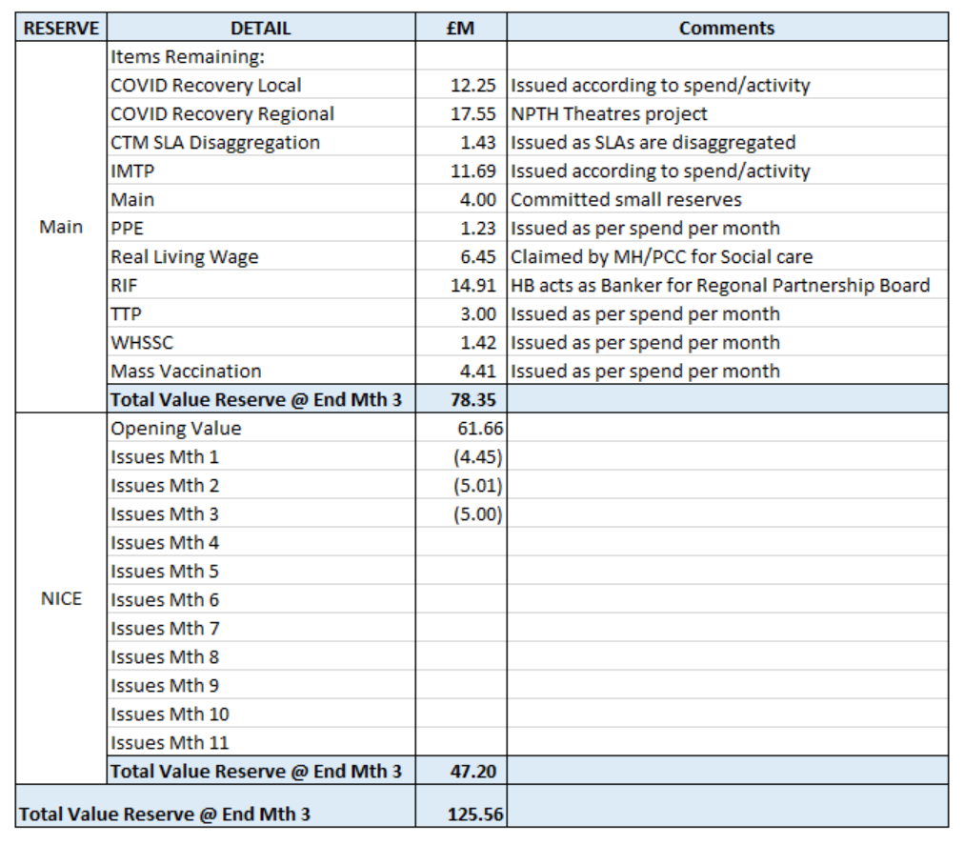

  - Changes to Deficit
The Board supported a £86.6m deficit plan. The deficit is held centrally with an element reflected each month in the reported performance against RRL (see Section 3.4 on Non-Pay) on a tapered basis, as previously agreed with the Board.

The Budgetary management process for 2023/24 stated that where the Board agreed additional investment, this could only be funded by increasing the deficit plan. Therefore, a table will be included within this paper each month showing the opening deficit plan figure and the changes made within the financial year to arrive at the current deficit held centrally. This is summarised in the below:

- RISK ASSESSMENT
Two Board level financial risks: -

- Achieving financial plan, which replaces the risks previously reported and referenced as 73, 79 and savings, with the key elements as follows: -

  - Risk of delivery of savings quantum
  - Risk of operational overspend being in excess of funding available agreed via the Financial Plan
  - Risk of commitment of reserves (e.g. NICE) being above reserves available.

A score of 20 is suggested at this stage given the financial risks the Health Board is facing the performance against RRL reported. The entries for these risks, as this was approved by the committee at its May 2023 meeting, the risks are now fully included in the Health Board Risk Register.

The individual elements of the risk behind this score are provided in detail below and reflect the information reported to WG in the month 3 MMR and is aligned to the risks recognised as part of the signed of plan at the end of May 2023:

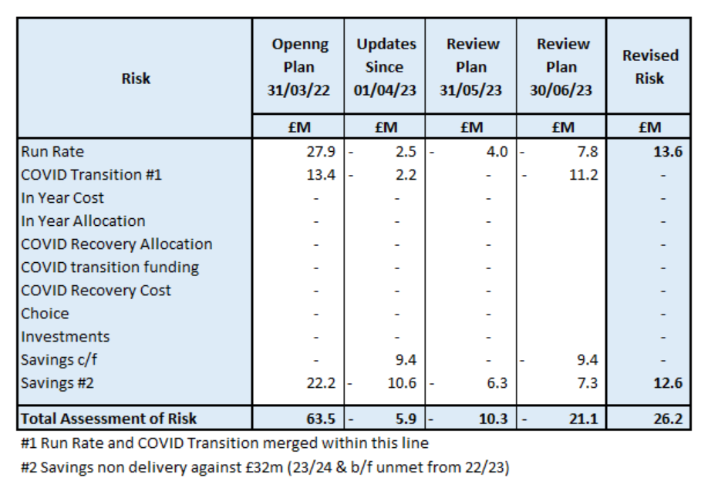

As a result of the weekly monitoring meetings (as at 16/06/23), Morriston risk has reduced from £17.8m to £16.2m and the NPTS risk has reduced from £12.1m to £10.2m. This table will be updated at month 4 to show the further impact of the risk mitigation.

- Availability of capital (risk 72). This risk was re-opened in 2022/23 given the reduction in discretionary capital allocation. Whilst work is underway to manage schemes to reduce commitments in 2023/24 and to produce a balanced plan, the risk varies during the year as more details on schemes emerge and potential slippage funding is made available by Welsh Government. A score of 20 is suggested at this stage as whilst the plan is now balanced, a number of schemes are on hold and the flexibility within the plan is extremely limited given the reduction in the allocation. A paper on the capital resource plan follows this report on today’s agenda.

- RECOMMENDATIONS
Members are asked to:
- NOTE the agreed 2023/24 financial plan.
- Consider and comment upon the Board’s financial performance for Period 03 2023/24.
- NOTE the actions to ensure delivery of the financial forecast with a specific focus on savings delivery: -
- Enhanced monitoring meetings in place above standard Finance & Performance Meetings to oversee and agree actions to mitigate run rates and deliver savings. Morriston / NPTS Service Group Directors
- Focused attention to ensure that 100% of the schemes are identified at the end of Q1 23/24. All Service Group Directors and Corporate Directors
- Focused attention to ensure that 100% of the schemes identified at the end of Q1 are green and amber by the end of Q2 23/24. All Service Group Directors and Corporate Directors
- Where savings delivery is not on track there will be further meetings with the Director of Finance and CEO at the end of Q1 and Q2. All Service Group Directors and Corporate Directors
- NOTE actions to ensure the operational pressures are mitigated and areas return to financial balance.
- Enhanced monitoring meetings in place above standard Finance & Performance Meetings to oversee and agree actions to mitigate run rates and deliver savings. Morriston / NPTS Service Group Directors
- External assessment of opportunities to mitigate pressures via the Grant Thornton post-AMSR assessment. All NPTS Service Group Director & COO
- Embed and deliver opportunities identified via two Independent Financial support provided to the Service Group to review run rate and savings. Morriston Service Group Directors and Corporate Directors
- NOTE the risks position at Month 3.
- NOTE the position with regard to Health Board Reserves
- NOTE all actions and updates to support the management of the 2023/24 financial position.

Governance and Assurance

Link to Enabling Objectives  (please choose) | Supporting better health and wellbeing by actively promoting and empowering people to live well in resilient communities
Link to Enabling Objectives  (please choose) | Partnerships for Improving Health and Wellbeing |  | ☐
Link to Enabling Objectives  (please choose) | Co-Production and Health Literacy |  | ☐
Link to Enabling Objectives  (please choose) | Digitally Enabled Health and Wellbeing |  | ☐
Link to Enabling Objectives  (please choose) | Deliver better care through excellent health and care services achieving the outcomes that matter most to people
Link to Enabling Objectives  (please choose) | Best Value Outcomes and High Quality Care |  | ☒
Link to Enabling Objectives  (please choose) | Partnerships for Care |  | ☒
Link to Enabling Objectives  (please choose) | Excellent Staff |  | ☐
Link to Enabling Objectives  (please choose) | Digitally Enabled Care |  | ☐
Link to Enabling Objectives  (please choose) | Outstanding Research, Innovation, Education and Learning |  | ☐
Health and Care Standards
(please choose) | Staying Healthy |  | ☐
(please choose) | Safe Care |  | ☐
(please choose) | Effective Care |  | ☐
(please choose) | Dignified Care |  | ☐
(please choose) | Timely Care |  | ☐
(please choose) | Individual Care |  | ☐
(please choose) | Staff and Resources |  | ☒
Quality, Safety and Patient Experience
Financial Governance supports quality, safety and patient experience.

Financial Implications
The Board is reporting a balanced forecast year-end deficit financial outturn prior to the impact of COVID-19.

Legal Implications (including equality and diversity assessment)
No implications

Staffing Implications
No implications

Long Term Implications (including the impact of the Well-being of Future Generations (Wales) Act 2015)
No implications

Report History |  | Updates on the financial position are provided at every meeting
Appendices |  | none

