
Meeting Date | 27th July 2023 |  | Agenda Item | 3.2
Report Title | NHS Wales Performance Framework Overview 2023-24
Report Author | Meghann Protheroe, Head of Health Board Performance
Report Sponsor | Darren Griffiths, Director of Finance and Performance
Presented by | Darren Griffiths, Director of Finance and Performance
Freedom of Information | Open
Purpose of the Report | The purpose of this report is to inform the Board of the changes that are required to the Health Board’s performance reporting arrangements in order to align with the 2023/24 NHS Wales Performance Framework.
Key Issues | The key issues set out in this report are: -  The updated document includes the changes to the reporting structures (removal of the COVID-19 quadrants of harm reporting), updated ministerial priority measures, along with general changes to reflect the new priorities for Healthcare in Wales going forward.  The 2023/24 Framework has also highlighted the development of the NHS Wales Assurance and Oversight Framework, along with updated accountability arrangements which will be supported by a revised escalation framework – this will be introduced later this year (2023).  A total of 68 measures are now a requirement to be reported by the Health Board for the 2023/24 Performance Framework. Of these 68 measures, 53 are Quantitative Performance measures and 15 are qualitative Policy Assurance Assessments. A total of 47 measures have been removed from the 2022/23 Performance Framework, with 21 new measures added for the 2023/24 Performance Framework. Therefore prompting a review of the Health Board current performance reporting arrangements to ensure it aligns with the updated Framework.  The reporting review has included the: -  - twice-weekly performance reports  - Monthly digital balanced score-cards  - monthly Unit level performance statements; and  - the monthly Integrated Performance Report.  This review process is a routine annual governance process carried out by the performance team to ensure that the Health Board is fully sighted on the measures set out in the Performance Framework.
Specific Action Required | Information | Discussion | Assurance | Approval
Recommendations | The Board is asked to:  - NOTE the changes to reporting arrangements set out in this report to ensure alignment of Health Board reporting process with the NHS Wales Performance Framework 2023/24  - NOTE the continued method of reporting for the rest of the 2023/24 financial year using national measures outlined in the Performance Framework  - NOTE the continued use of Ministerial priority measure trajectories for future performance management  - ACTION the confirmation of new policy assurance assessment leads for the 6 new Qualitative templates
Appendices | - Appendix 1- 2023/24 NHS Wales Performance Framework  - Appendix 2- Summary of measures removed from 2022/23 Delivery Framework  - Appendix 3 - Summary of revisions for 2023/24

FUll Review of Performance Reporting in line with 2023/24 NHS Wales performance Framework

- INTRODUCTION
The release of the 2023/24 NHS Wales Performance Framework prompted a review of the measures currently reported internally via the performance statements and externally through the Integrated Performance Report and Quality & Safety Performance Report.

This review process is a routine annual governance process carried out by the performance team to ensure that the Health Board is fully sighted on the measures set out in the Delivery Framework.

Welsh Government has made several alterations to the Performance measures within the framework which align with the recently Ministerial priorities, resulting in the need to review the Health Board’s performance reporting arrangements to ensure alignment between local reporting and nationally mandated measures.

The updated framework has moved away from reporting against the quadrants of harm set out in the NHS Wales COVID-19 Operating Framework. Therefore, reporting of the performance measures will return completely to it’s pre-COVID-19 format of reporting against the Quadruple aims.

- BACKGROUND
The performance measures in the NHS Wales Performance Framework for 2023-24 reflect the Ministerial Priority areas of focus and core support functions as outlined in the NHS Wales Planning Framework 2023-2026. These are;

Ministerial Priorities
- Access to Primary Care Services
- Cancer Recovery
- Delayed Transfers of Care
- Mental Health & CAMHS
- Planned Care Recovery, Diagnostics and Pathways of Care
- Urgent and Emergency Care

Core Support Functions
- Digital, innovation, technology and transformation
- Workforce and well-being
- Financial sustainability
- Anchor institutions

All of the performance measures and policy assurance assessments included in the NHS Performance Framework have been mapped to ‘A Healthier Wales’ quadruple aim.

The quadruple aims are:

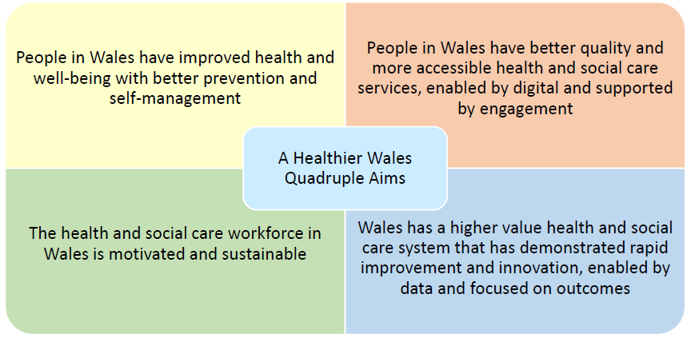
Welsh Government are currently in the process of developing the NHS Wales Assurance and Oversight framework. This will set out the mechanism and approach for gaining assurance from NHS Wales’ organisations, as well as setting out the parameters of how the Health and Social Services Group in the Welsh Government will work with the NHS.

It is envisioned that the Assurance and Oversight Framework is designed to promote a ‘no surprises’ culture, ensuring early identification of emerging issues and concerns, so that they can be addressed before they have a material impact or performance deteriorates further.

SBUHB will be expected to maintain their relationship with the NHS Executive and Welsh Government to ensure prospective changes in performance are shared in a timely manner. The new accountability arrangements, supported by a revised escalation framework will be introduced later this year.

- 2023/24 PERFORMANCE FRAMEWORK UPDATES

There are 68 measures in the 2023/24 NHS Performance Framework, of which 21 are new measures, 9 are revised measures and 47 were removed from the previous version of the NHS Delivery Framework (2022/23).

The Framework includes 48 Ministerial priority Measures, of which 12 require formal recovery trajectories which have been previously submitted to Welsh Government. A table outlining the split between qualitative and quantitative measures can be seen below, with specific reference to the number of ministerial measures in each category.

 | Qualitative Measures | Quantitative Measures
Ministerial Priorities (Require Recovery Trajectories) | 0 | 11
Ministerial Priorities (No required trajectories) | 10 | 28
Standard Performance Measures | 5 | 14
Total no. measures reported | 15 | 53

3.1 Policy Assurance Assessments (Qualitative)

Policy Assurance Assessments focus on key priority areas that cannot be monitored through traditional quantitative measures. Policy Assurance Assessments enable the NHS organisations to provide an update on the activity that has been undertaken during the operational year.

There are 15 Policy Assurance Assessments in the framework that do not have established data flows, 6 of which are new additions. As a result, self-assessment reporting templates have been developed for the following measures which will be submitted directly to Welsh Government in accordance with reporting frequency allocated to each measure. These are: -

- Implementation of Help Me Quit in Hospital smoking cessation services
- Progress to reduce smoking during pregnancy
- The Health Boards’ plan to deliver the NHS Wales Weight Management Pathway
- Assurance on GP access improvement
- Allied Health Professionals accessible and available to clusters by Health Board/Regional Partnership Board footprint
- Progress to embed the National Framework for the Delivery of Bereavement Care in Wales and the National Bereavement Pathway
- Progress to develop a whole school approach to CAMHS in reach services
- Progress made in preparation to embed and report against the Workforce Race Equality Standards (WRES) indicators
- Progress made against the organisation’s prioritised Strategic Equality Plan’s equality objectives
- Progress to improve dementia care (providing evidence of training and development in line with Good Work – Dementia and Learning Development Framework) and increasing access to timely diagnosis
- Evidence of NHS Wales advancing its understanding and role within the Foundational Economy via the delivery of the Foundational Economy in Health and Social Services Programme
- Evidence of NHS Wales embedding Value Based Health and Care within organisational strategic plans and decision-making processes
- Progress against the health boards’ plans to reduce pathways of care delays
- Progress of NHS Wales’ contribution to decarbonisation as outlined in the organisation’s plan
- Progress against the priority areas to improve the lives of people with learning disabilities

The completion of the Assurance Assessment templates will be facilitated by the Health Board performance team; however, Health Board leads will be required to complete the templates.

There have been minor revisions to four of the Assurance Assessment templates for 2023/24, all of which can be seen in the attached templates in the updated framework document.

3.2 Performance Measures (Quantitative)

Excluding the measures that require submission of a Policy Assurance Assessment template, the Health Board now has 53 quantitative national measures to report performance against, compared with 75 in 2022/23.

Within the 53 Quantitative measures, 39 of those are ministerial priority measures. Of the 39 Ministerial Priority measures, 11 require formal recovery trajectories (which have previously been submitted to Welsh Government in June 2023).

Ministerial Priority Trajectories 2023/24;

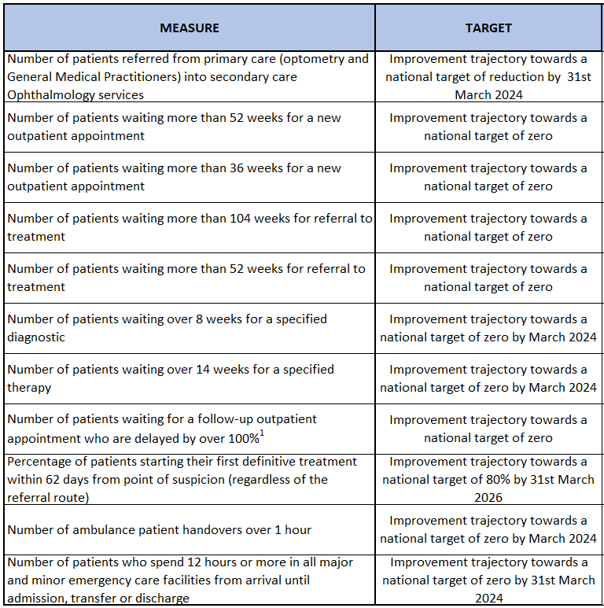

New measures for 2023/24:

21 of the 53 quantitative performance measures are new in the 2023/24 framework and can be seen below;
- Percentage of people who have been referred to health board services who have completed treatment for substance misuse (drugs or alcohol)
- Percentage of children who are up to date with the scheduled vaccinations by age 5 (‘4 in 1’ preschool booster, the Hib/MenC booster and the second MMR dose)
- Percentage of girls receiving the Human Papillomavirus (HPV) vaccination by the age of 15
- Percentage uptake of the influenza vaccination amongst adults aged 65 years and over
- Percentage uptake of the COVID-19 vaccination for those eligible
- Percentage of patients offered an index colonoscopy procedure within 4 weeks of booking their Specialist Screening Practitioner assessment appointment
- Percentage of well babies entering the new-born hearing screening programme who complete screening within 4 weeks
- Percentage of eligible new-born babies who have a conclusive bloodspot screening result by day 17 of life
- Percentage of the primary care dental services (GDS) contract value delivered (for courses of treatment for new, new urgent and historic patients)
- Number of patients referred from primary care (optometry and General Medical Practitioners) into secondary care Ophthalmology services
- Number of consultations delivered through the Pharmacist Independent Prescribing Service (PIPS)
- Median emergency response time to amber calls
- Percentage of children (aged under 18 years) waiting 14 weeks or less for a specified Allied Health Professional (Includes: Art therapy; podiatry; dietetics; occupational therapy, physiotherapy and; speech and language therapy)
- Number of patients waiting more than 36 weeks for a new outpatient appointment
- Number of patients waiting more than 52 weeks for referral to treatment
- Turnover rate for nurse and midwifery registered staff leaving NHS Wales
- Percentage of all classifications’ coding errors corrected by the next monthly reporting submission following identification
- Percentage of calls ended following WAST telephone assessment (Hear and Treat)
- Number of Pathways of Care delayed discharges
- Number of patient experience surveys completed and recorded on CIVICA
- Number of National Reportable incidents that remain open 90 days or more

In total, 47 measures have been removed from the previous version of the NHS Wales Delivery Framework (which can be found in Appendix 2). The decision to remove them from the Framework was made following advice from Welsh Government’s policy leads. The main reasons for removing these measures include: the quality of the data is not robust enough; the measure is no longer applicable due to changes in service delivery; the measure is operationalised through an alternative reporting mechanism or; an alternative measure has been identified.

Revised Measures for 2023/24

Since the publication of last year’s NHS Delivery Framework, a number of the existing delivery measures have been revised for 2023-2024. The main reasons for these revisions are to reflect changes in delivery targets to promote and encourage continuous improvement and; to capture changes in data information sources.

A full summary of these revisions can be found in Appendix 3.

- GOVERNANCE ISSUES AND RISKS
There are no direct governance risks arising from the production of this report, however appropriate updates will be made to Health Board reporting mechanisms to represent the changes within the new 2023/24 All Wales Performance Framework.

- FINANCIAL IMPLICATIONS
There are no direct financial implications arising from the production of this report.

- RECOMMENDATIONS
The Board is asked to:
  - NOTE the changes to reporting arrangements set out in this report to ensure alignment of Health Board reporting process with the NHS Wales Performance Framework 2023/24
  - NOTE the continued method of reporting for the rest of the 2023/24 financial year using national measures outlined in the Performance Framework
  - NOTE the continued use of Ministerial priority measure trajectories for future performance management
  - ACTION the confirmation of new policy assurance assessment leads for the 6 new Qualitative templates

Governance and Assurance
Link to Enabling Objectives  (please choose) | Supporting better health and wellbeing by actively promoting and empowering people to live well in resilient communities
Link to Enabling Objectives  (please choose) | Partnerships for Improving Health and Wellbeing |  | ☒
Link to Enabling Objectives  (please choose) | Co-Production and Health Literacy |  | ☒
Link to Enabling Objectives  (please choose) | Digitally Enabled Health and Wellbeing |  | ☒
Link to Enabling Objectives  (please choose) | Deliver better care through excellent health and care services achieving the outcomes that matter most to people
Link to Enabling Objectives  (please choose) | Best Value Outcomes and High Quality Care |  | ☒
Link to Enabling Objectives  (please choose) | Partnerships for Care |  | ☒
Link to Enabling Objectives  (please choose) | Excellent Staff |  | ☒
Link to Enabling Objectives  (please choose) | Digitally Enabled Care |  | ☒
Link to Enabling Objectives  (please choose) | Outstanding Research, Innovation, Education and Learning |  | ☒
Health and Care Standards
(please choose) | Staying Healthy |  | ☒
(please choose) | Safe Care |  | ☒
(please choose) | Effective Care |  | ☒
(please choose) | Dignified Care |  | ☒
(please choose) | Timely Care |  | ☒
(please choose) | Individual Care |  | ☒
(please choose) | Staff and Resources |  | ☒
Quality, Safety and Patient Experience
The NHS Wales Performance Framework summary paper outlines any appropriate updated Quality and Safety reporting measures.

There are no directly related Equality and Diversity implications as a result of this report.

Financial Implications
These are set out above

Legal Implications (including equality and diversity assessment)
n/a

Staffing Implications
n/a

Long Term Implications (including the impact of the Well-being of Future Generations (Wales) Act 2015)
The ‘5 Ways of Working’ are demonstrated in the report as follows:
- Long term – Actions within this update paper are both long and short term in order to balance the immediate service issues with long term objectives.
- Prevention – the NHS Wales Performance framework provides a measureable mechanism to evidence how the NHS is positively influencing the health and well-being of the citizens of Wales with a particular focus upon maximising people’s physical and mental well-being.
- Integration – this selected summary report brings together key performance measures across a number of care systems.
- Collaboration – in order to manage performance, the Corporate Functions within the Health Board liaise with leads from the Service Groups as well as key individuals from partner organisations including the Local Authorities, Welsh Ambulance Services Trust, Public Health Wales and external Health Boards.
- Involvement – Corporate and Service Group leads are key in identifying performance issues and identifying actions to take forward.
Report History |  | A Summary report of changes to the NHS Wales Performance Framework is brought to the Board annually
Appendices |  | - Appendix 1- 2023/24 NHS Wales Performance Framework  - Appendix 2- Summary of measures removed from 2022/23 Delivery Framework  - Appendix 3 - Summary of revisions for 2023/24

Appendix 1 – NHS Wales Performance Framework 2023/24

Appendix 2 – Summary of measures removed from 2022/23 Delivery Framework

NHS Delivery Measure (reference number & description taken from the 2022-23 NHS Delivery Framework)
1 | Percentage of adults losing clinically significant weight loss (5% or 10% of their body weight) through the All Wales Weight Management Pathway
3 | Percentage of babies who are exclusively breastfed at 10 days old
4 | Percentage of adults (aged 16+) reporting that they currently smoke either daily or occasionally
7 | Percentage of patients (aged 12 years and over) with diabetes who received all eight NICE recommended care processes
8 | Percentage of patients (aged 12 years and over) with diabetes achieving all three treatment targets in the preceding 15 months:  • Blood pressure reading is 140/80 mmHg or less  • Cholesterol values is less than 5 mmol/l (<5)  • HbA1c equal or less than 58 mmol/mol or less
9 | European age standardised rate of alcohol attributed hospital admissions for individuals resident in Wales (episode based)
10 | Percentage of people who have been referred to health board services who have completed treatment for alcohol misuse
11 | Percentage of children who received 3 doses of the hexavalent '6 in 1' vaccine by age 1
12 | Percentage of children who received 2 doses of the MMR vaccine by age 5
13 | Percentage uptake of autumn 2022 booster dose of the COVID-19 vaccination in all eligible Wales residents
14 | Percentage uptake of 2022-23 influenza vaccination in all eligible Wales residents
15 | Cancer screening coverage for:  • Percentage of eligible people aged 25-49 will have participated in the cervical screening programme within the last 3.5 years and eligible people aged 50-64 within the last 5.5 years  • Percentage of eligible people will have participated in the bowel screening programme within the last 2.5 years  • Percentage of women resident and eligible for breast screening at a particular point in time will have been screened in the previous three years
17 | Number of Urgent Primary Care Centres (UPCC) established in each Health Board footprint (i.e. both UPPC models)
18 | Number of new patients (children aged under 18 years) accessing NHS dental services
19 | Number of new patients (adults aged 18 years and over) accessing NHS dental services
20 | Number of existing patients accessing NHS dental services
21 | Percentage of 111 patients prioritised as P1CHC that started their definitive clinical assessment within 1 hour of their initial call being completed
22 | Percentage of total conveyances taken to a service other than a Type One Emergency Department
23 | Qualitative report detailing progress against the Health Boards’ plans to deliver a Same Day Emergency Day Care Service (12 hours a day, 7 days a week) across all acute sites
24 | Percentage of patients who are diagnosed with a stroke who have a direct admission to a stroke unit within 4 hours of the patient’s clock start time
29 | Percentage of patients (aged 60 years and over) who presented with a hip fracture that received an orthogeriatrician assessment within 72 hours
30 | Percentage of stroke patients who receive mechanical thrombectomy
33 | Number of people admitted as an emergency who remain in an acute or community hospital over 21 days since admission
34 | Percentage of total emergency bed days accrued by people with a length of stay over 21 days
35 | Percentage of people assigned a D2RA pathway within 48 hours of admission
36 | Percentage of people leaving hospital on a D2RA pathway
37 | Percentage of stroke patients that receive at least 45 minutes of speech and language therapy input in 5 out of 7 days
39 | Number of pathways waiting over 8 weeks for a diagnostic endoscopy
46 | Number of patients waiting more than 36 weeks for referral to treatment
47 | Percentage of patients waiting less than 26 weeks for referral to treatment
48 | Rate of hospital admissions with any mention of intentional self-harm for children and young people (aged 10-24 years) per 1,000 population
50 | Percentage of mental health assessments undertaken within (up to and including) 28 days from the date of receipt of referral for people aged under 18 years
55 | Percentage of service users (adults aged 18 years and over) admitted to a psychiatric hospital between 9:00 and 21:00 hours that have received a gate keeping assessment by the CRHT service prior to admission
56 | Percentage of service users (adults aged 18 years and over) admitted to a psychiatric hospital who have not received a gate keeping assessment by CRHTS that have received a follow up assessment by the CRHTS within 24 hours of admission
57 | Percentage of mental health assessments undertaken within (up to and including) 28 days from the date of receipt of referral for adults aged 18 years and over
66 | Percentage of confirmed COVID-19 cases within hospital which had a probable hospital onset of COVID-19
69 | Percentage of staff who have recorded their Welsh language skills on ESR who have Welsh language listening/speaking skills level 2 (foundational level) and above
70 | Percentage compliance for all completed level 1 competencies of the Core Skills and Training Framework by organisation
72 | Overall staff engagement score
73 | Percentage of staff who report that their line manager takes a positive interest in their health and well-being
74 | Emissions reported in line with the Welsh Public Sector Net Zero Carbon Reporting Approach
78 | Number of risk assessments completed on the Welsh Nursing Clinical Record by Health Board/Trust
79 | Number of wards using the Welsh Nursing Clinical Record by Health Board/Trust
81 | Total antibacterial items per 1,000 specific therapeutic group age-sex related prescribing units (STAR-PUs)
82 | Percentage of secondary care antibiotic usage within the WHO Access category
83 | Number of patients aged 65 years or over prescribed an antipsychotic
84 | Opioid average daily quantities per 1,000 patients

Appendix 3 – NHS Wales Performance Framework Revised measures 2023/24

Performance Measure | Detail of Revision
22 | Percentage of patients who spend less than 4 hours in all major and minor emergency care (i.e. A&E) facilities from arrival until admission, transfer or discharge | Previous Target: 95%.
23 | Number of patients who spend 12 hours or more in all hospital major and minor emergency care facilities from arrival until admission, transfer, or discharge | Previous Target: 0.
25 | Number of patients waiting more than 8 weeks for a specified diagnostic | Previous Target: 12 month reduction trend towards zero by Spring 2024.
27 | Number of patients (all ages) waiting more than 14 weeks for a specified therapy (including audiology) | Previous Target: 12 month reduction trend towards zero by Spring 2024.
28 | Number of patients waiting more than 52 weeks for a new outpatient appointment | Previous Target: Improvement trajectory towards eliminating 52 week waits by 31 December 2022.
30 | Number of patients waiting for a follow-up outpatient appointment who are delayed by over 100% | Previous Target: Improvement trajectory towards a reduction of 30% by March 2023 against a baseline of March 2021.  Previous Reporting Frequency: Monthly.
31 | Number of patients waiting more than 104 weeks for referral to treatment | Previous Target: Improvement trajectory towards a national target of zero by 2024.
50 | Percentage of confirmed COVID-19 cases within hospital which had a definite hospital onset (>14 days after admission) | Previous Target: Reduction against the same month in 2021-22.
52 | Number of ambulance patient handovers over one hour | Previous Target: 0.

