

Meeting Date | 25 July 2022 |  | Agenda Item |  |  | 4.2
Report Title | Cancer Performance Update
Report Author | Craige Wilson, Deputy Chief Operating Officer
Report Sponsor | Deb Lewis, Chief Operating Officer
Presented by | Deb Lewis, Chief Operating Officer
Freedom of Information | Open
Purpose of the Report | The following report provides an update on the delivery of the Single Cancer Pathway for Swansea Bay UHB patients. It focusses on recovery plans in place for the top tumour sites:  - Lower Gastrointestinal  - Breast  - Upper Gastrointestinal  - Gynaecological  - Urological  - Lung
Key Issues | This report will highlight areas where there are significant service delivery challenges.  .
Specific Action Required  (please choose one only) | Information | Discussion |  | Assurance | Approval
Specific Action Required  (please choose one only) | ☐ | ☐ |  | ☒ | ☒
Recommendations | Members are asked to:  - NOTE the performance and backlog volumes in the main tumour sites.  - NOTE the additional work required to improve both performance and backlog.

Cancer Performance Update
- INTRODUCTION
In October 2022 Welsh Government initiated the enhanced monitoring (EM) intervention process for the Health Board (HB) due to quality issues relating poor performance and long waiting times. This process was applied to the HB performance against the Single Cancer Pathway (SCP). The areas of greatest focus both locally and nationally for improvement, resulting in improvement workshop being established, have been identified as:
- Lower Gastrointestinal
- Gynaecological
- Urological
In response to the EM, further work undertaken in these areas have resulted in a change of approach with the Chief Executive meeting with tumour site leads and directorate managers to agree specific courses of action.

- BACKGROUND

The HB monitors two main metrics for the single cancer pathway:
- % Performance within the 62-day target
- Backlog volumes (patients waiting over 62 days)

Performance 2022/23

Graph 1 – SCP Performance 22-23
The graph above shows the HB’s year to date SCP performance. It represents the patients receiving first definitive treatment (FDT) within the 62-day target against the target of 75% and the internal forecast trajectory. Whilst the performance improved in April 23 to 57% disappointingly there has been another dip in May; the impact of the number of Bank Holidays in month is probably a contributory factor in this.

As can be seen below the performance in Lower GI, Gynaecology, Breast and Urology were major factors in this drop in performance, but there was also in Haematology only 12% of the patients were treated in the required timescale.

Tumour Site | Total No. of patients treated | No. of patients treated within target | % | Tumour Site | Total No. of patients treated | No. of patients treated within target | %
Head and neck | 17 | 9 | 53% | Breast | 26 | 8 | 31%
Upper GI | 18 | 10 | 56% | Gynaecological | 16 | 4 | 25%
Lower GI | 18 | 4 | 22% | Urological | 37 | 13 | 35%
Lung | 27 | 18 | 67% | Haematological | 17 | 2 | 12%
Sarcoma | 2 | 1 | 50% | Acute Leuk | 0 | 0 | N/A
Skin(c) | 50 | 37 | 74% | Children's | 1 | 0 | 0%
Brain/CNS | 0 | 0 | N/A | Other | 5 | 3 | 60%

Although performance is falling far short of the HB plan and aspiration, it is acknowledged that this is partially as a result of the removal of the backlog volumes.
The backlog removal trajectory set in April 2022 was hugely challenging and unfortunately due to continued demand and capacity constraints proved to be unachievable. However, as can be seen below significant improvement has been made over the recent months and the Health Board are just above the trajectory agreed.

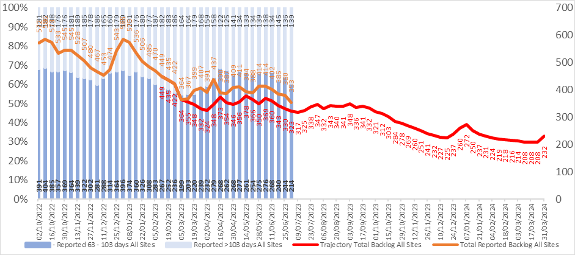

The HB now meets with the WG EM team on a monthly basis. Recent discussions on the submission of the improvement trajectory encouraged a more realistic improvement profile is set for 23/24, to support the continued improvement against the target but also in recognition of the demand and capacity issues being experienced across the system.

The table below shows the current backlog, which has now reduced to 325 patients, the greatest percentage of these patient are in gynaecology, followed by lower GI and urology.

Within the current backlog:

- 25% of all patients in backlog do not have dates confirmed for next step
- 53% of backlog is at diagnostic stage
  - 14% endoscopy,
  - 34% cellular pathology.
- 27 patients do not yet have a date from treatment, shown below.

The trajectories were developed based on the anticipated improvement for individualised tumour site basis and built into the over trajectory. Some tumour groups were set at zero for backlog throughout the year Children’s Cancer, Acute Leukaemia and Brain/CNS, the reason for this is that are in backlog infrequently and volumes do not impact on the overall position.

The analysis has considered what happened last year around bank holidays and over key periods such as Summer and Christmas when reduced capacity is observed and are also impacted from a tracking perspective due to annual leave.

Diagnostic reporting, both within radiology and in particular pathology will impact all pathways. In regard to the larger volume tumour groups such as Gynaecology and Lower GI, addressing capacity in key areas such as the one stop PMB clinic or hysteroscopy within Gynaecology; or Endoscopy for LGI will have the biggest impact overall. The lead time to observe improvement following mitigating measures is several months.

Alongside the improvement in the overall numbers of patients waiting over 62 days, an improvement in the actual percentage performance against the target is also required. There is no direct correlation between the two and therefore difficult to gauge this with a high degree of accuracy. This is due to the backlog consisting of patients with a cancer diagnosis and those who do not yet have a clear diagnosis. However, with the recovery plans that have been developed, the following trajectory has been mapped.

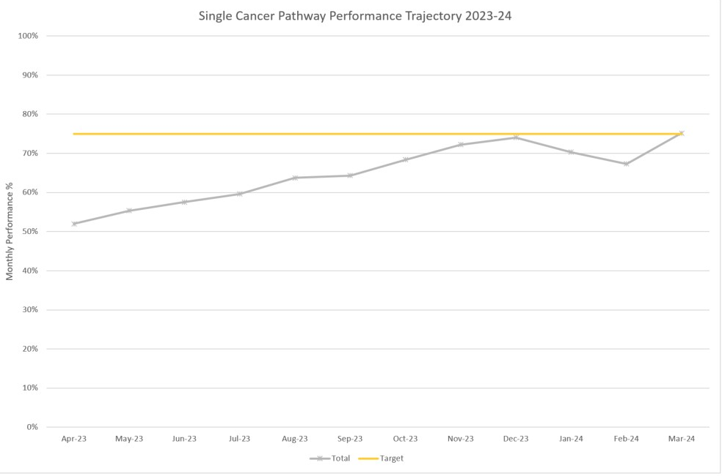

- RECOVERY PLANS

As described in the introduction to this paper, the recovery plans are currently focussing on the top 6 tumour sites and the detailed actions are outlined below. In addition to overall improvements against the 62-day target, tumour site leads, and service managers are tasked with addressing the longest waits and eradicating unnecessary waits over 100 days (for reasons noted above it may not be necessary to reduce this to zero).

Cellular Pathology
- The cellular pathology service remains under extreme pressure consequently we continue to outsource specimens for processing and reporting and this is likely to remain in place for the remainder of 23/24.
- The department have advertised a post for a cancer tracker so that these patients can more easily be identified and prioritise for processing and reporting.
- Turnaround times in Cellular Pathology for prostate biopsies are causing particular delays in diagnosis and agreeing treatment plans. The HB has agreed additional
PET
The waiting times for a PET scan has been in the region of 4 weeks during May/June 2023 with issues primarily due to scanner breakdown, and supply issues in relation to the radiopharmaceuticals across the UK. To improve waits:
- Up to 15 patients per week are being outsourced to Cardiff, reducing turnaround times, but there has been a reluctance from patients to travel.
- The mobile PET/CT scanning provider will had 5+ additional scanning days to July’s roster
- During Q2, we are moving towards a three-day per week scanning model, from the current two-day per week.

Breast
The position in Breast is currently slightly over trajectory. Some waits have been impacted by periods of patient unavailability and ability to consent. In terms of action:
- Treatment (surgical) capacity is a theme of those in backlog. Therefore, work is ongoing to identify two additional theatre sessions per week. In the short term, a Monday theatre list not able to be utilised by another service is backfilled by the breast team that will continue through July.
- Disaggregation of the SLA with CTM from September with the caveat that they will continue to support until end of March 2023. A paper is due to be presented to Management Board, in order to secure the workforce plan to enable us to take on the 35% increase in workload and ensure we are able to recruit accordingly.
- As a consequence of the resignation of the lead consultant surgeon, leaving towards the end of September, it is the intention to advertise and appoint two surgeons; job plans to be approved with the aim to be out to advert this month.

Date | PTL Volume | Backlog Volume / %
Oct-22 | 161 | 29 (18%)
Mar-23 | 138 | 11 (8%)
Jun-23 | 212 | 13 (4%)

Gynaecology
Gynaecology continues to the area of greatest challenge for the Health Board
- We are continuing with additional lists for the PMB/endometrial pathway and discussions with our insourcing partners are taking place in order to increase capacity further.
- An audit is underway to review referrals and outcomes of patients referred to the service and on HRT, potentially a proportion of this group could be managed outside of the USC pathway, as is practice elsewhere/at Hywel Dda.
- Additional theatre capacity on Saturdays continues.
- Preliminary discussions have taken place with a former gynae-oncology surgeon in relation to locum work, the formalities of which are being worked through.
- Booking of PMB clinics in NPTH is managed by CTM staff, agreement to fund the post locally, this will now be progressed. The benefits of which means there will be control over the process and the ability to book and fill slots at short notice. It would also enable the service to contact patients prior to clinic to ensure their attendance, improving DNA rates and slot utilisation.
- Discussion of repatriation of CTM activity is progressing.

Date | PTL Volume | Backlog Volume / %
Oct-22 | 435 | 91 (21%)
Mar-23 | 484 | 160 (33%)
Jun-23 | 426 | 93 (29%)

Urology
The in urology the waits for robotic treatment (RALP) remain exceptionally long. We continue to utilise any additional capacity C&V are able to offer where and whenever possible.
- Constraints within the diagnostic phase for a group of patients with poor comorbidity, requiring admission to Morriston and the constraints on site for theatre and available beds.
- Additional outpatient clinics have been arranged to reduce waits as required.

Date | PTL Volume | Backlog Volume / %
Oct-22 | 289 | 127 (44%)
Mar-23 | 237 | 64 (27%)
Jun-23 | 222 | 45 (14%)

Lower GI
There has been significant progress to reduce the backlog volumes in lower GI as can be seen below, however at present this has not improved performance. It is envisaged that the impact of improved endoscopy waiting times and additional theatre sessions will begin to shown improvement in this area through June and July. In addition:
- The first meeting took on the 28th June 2023, to advance progress with the accelerated imaging project/pilot. This does require the recruitment of an additional CNS which has been agreed by the CEO.
- Tracking vacancy within gastroenterology has been filled and training commenced.

Date | PTL Volume | Backlog Volume / %
Oct-22 | 890 | 258 (29%)
Mar-23 | 493 | 102 (21%)
Jun-23 | 336 | 36 (11%)

Lung
There are still a number of key delays in the pathway for lung cancer patient in particular diagnostic delays around PET are affecting this group of patients which will hopefully be address with the actions described above. In addition:.
- Radiology are progressing developments for dedicated radiology rooms to accommodate patients requiring CT guided biopsy currently requiring admission to hospital for post procedure monitoring.
- Dr Mughal has recently been appointed as MDT lead and is looking at the process of referral from primary care to ensure no change in terms of referral patterns.

Date | PTL Volume | Backlog Volume / %
Oct-22 | 97 | 42 (43%)
Mar-23 | 112 | 34 (30%)
Jun-23 | 74 | 26 (8%)

- RECOMMENDATION

The Committee is asked to:

- NOTE the performance and backlog volumes in the main tumour sites.
- NOTE the additional work required to improve both performance and backlog.

Governance and Assurance

Link to Enabling Objectives  (please choose) | Supporting better health and wellbeing by actively promoting and empowering people to live well in resilient communities
Link to Enabling Objectives  (please choose) | Partnerships for Improving Health and Wellbeing |  |  | ☒
Link to Enabling Objectives  (please choose) | Co-Production and Health Literacy |  |  | ☐
Link to Enabling Objectives  (please choose) | Digitally Enabled Health and Wellbeing |  |  | ☒
Link to Enabling Objectives  (please choose) | Deliver better care through excellent health and care services achieving the outcomes that matter most to people
Link to Enabling Objectives  (please choose) | Best Value Outcomes and High Quality Care |  |  | ☒
Link to Enabling Objectives  (please choose) | Partnerships for Care |  |  | ☒
Link to Enabling Objectives  (please choose) | Excellent Staff |  |  | ☒
Link to Enabling Objectives  (please choose) | Digitally Enabled Care |  |  | ☒
Link to Enabling Objectives  (please choose) | Outstanding Research, Innovation, Education and Learning |  |  | ☐
Health and Care Standards
(please choose) | Staying Healthy |  |  | ☐
(please choose) | Safe Care |  |  | ☒
(please choose) | Effective Care |  |  | ☒
(please choose) | Dignified Care |  |  | ☐
(please choose) | Timely Care |  |  | ☒
(please choose) | Individual Care |  |  | ☐
(please choose) | Staff and Resources |  |  | ☒
Quality, Safety and Patient Experience
Accurate, comprehensive demand and capacity plans can increase safety and quality whilst reducing risk and can lead to efficiency gains within clinical services. They will also facilitate more timely treatment of patients and enhance patient experience.

Financial Implications
There are no direct financial implications associated with this paper. Inputs (additional activity) into the demand and capacity models are funded via Recovery Money. However, the outputs from the modelling will inform the development of the Health Board’s IMTP and financial plans for sustainable services.

Legal Implications (including equality and diversity assessment)
There are no legal implications to consider.

Staffing Implications
There are no immediate staffing implications as a result of this paper but there is a need to be mindful that this is a very specialist area and we need to build robust and sustainable capacity in this area.

Long Term Implications (including the impact of the Well-being of Future Generations (Wales) Act 2015)
Report History |  | Previous reports have been presented to Management Board in November 2021 and February / August 2022.
Appendices

