

Meeting Date | 23rd July 2024 |  | Agenda Item |  | 2.2
Report Title | Financial Report – Period 03 2024/25
Report Author | Samantha Moss, Deputy Director of Finance  Gemma Pearson, Finance Business Partner
Report Sponsor | Darren Griffiths, Executive Director of Finance and Performance, Acting Deputy Chief Executive
Presented by | Samantha Moss, Deputy Director of Finance
Freedom of Information | Open
Purpose of the Report | The report advises the Performance & Finance Committee of the Health Board on the financial position for Month 03 2024/25 (June 2024) and risks regarding the current forecast revenue year end outturn.
Key Issues | The report invites the Performance & Finance Committee to note the detailed analysis of the financial position for Month 03 2024/25 (June 2024).  The report includes a summary of the key drivers of the position either at Service level or by expenditure type (i.e. Non Pay/Pay). It also provides information of the current position with regards to Health Board reserves to ensure transparency in the overall Health Board position.  Risk will have been considered on the basis of the information provided within the report and the score updated where necessary.  Whilst the key messages are provided within the main body of the report, further information is provided in the Appendices.
Specific Action Required | Information | Discussion | Assurance | Approval
Specific Action Required | ☐ | ☐ | ☒ | ☐
Recommendations | Members are asked to:  - To NOTE the agreed 2024/25 financial plan.  - Consider and comment upon the Board’s financial performance for Month 03 2024/25.  - TO NOTE the actions to ensure delivery of a balanced financial position for all service areas as per the accountability letters issued in May 2024, which now require:  - Re-submission of Financial Strategy by each Service Area on 28th June 2024. (Service Group Directors/ Corporate Directors)  - First step post re-submission is ‘Star Chamber’ meeting chaired by the CEO to assess the options.  - Following re-submission a summary of options to support financial balance to presented to Board.  - TO NOTE the ‘saving’ reduction target set are per the accountability letters and ensure actions are logged on the savings trackers.  - All savings were to be identified and on trackers by 31st May 2024 (Service Group Directors/ Corporate Directors)  - NOTE the risks to the position at Month 03.  - NOTE the position with regards to Health Board Reserves.  - NOTE all actions and updates to support the management of the 2024/25 financial position.

FINANCIAL REPORT – MONTH 03

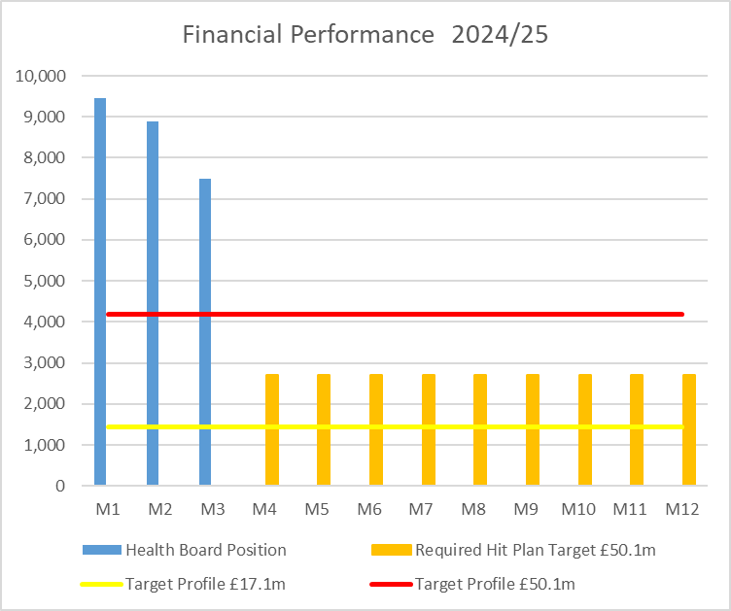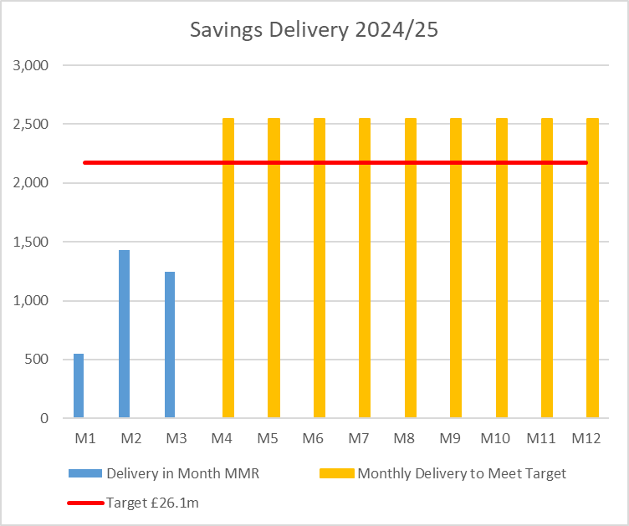

SUMMARY OF REVENUE PERFORMANCE

Target | In Month  £’m | Year To Date (YTD)  £’m
Delivery Against Revenue Resource Limit (RRL) DEFICIT / (SURPLUS) | 7.483 | 25.824
Delivery Against Total Run Rate/Savings Target In Ledger DEFICIT / (SURPLUS) | 1.242 | 3.220

In summary the Month 3 financial position was £7.5m overspent, this was £3.3m higher than the forecast deficit for the month.

The Annual Plan submitted on 28th March 2024 reported a deficit of £50.1m after the delivery of £26.1m of savings. The expectation was that the in-month position would reflect a 12th of the £50.1m deficit. For Month 3 the Health Board (HB) has reported a deficit of £7.5m against a 12th of the deficit plan of £4.2m and is £25.8m overspent against cumulative deficit plan of £12.5m. Clearly this position is unacceptable and immediate actions are being taken.

The three component and the respective impact on the £7.5m are visualised in the chart below:

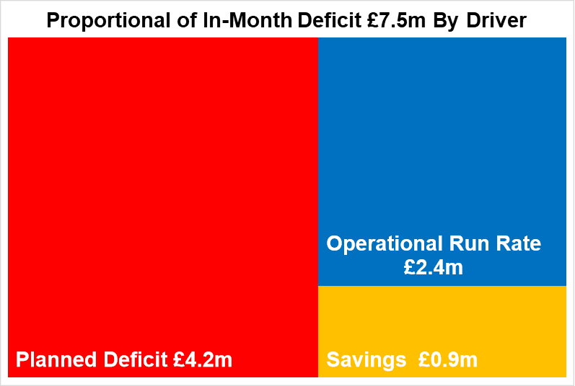

- FINANCIAL PLAN 2024/25
The Health Board submitted an Annual Plan on 28th March 2024 which reported a deficit of £50.1m. This has not been approved by Welsh Government (WG) with the request that as a minimum the Health Board reduces its deficit to £17.1m or better; work and discussions are ongoing. In order to meet the £50.1m deficit plan operational savings totalling £26.1m are required and all service areas are required to breakeven to their delegated budgets. This will require the need for a significant reduction to the Health Board’s run rate of expenditure.

A further review of the deficit in light of the Month 1 position was undertaken to be considered alongside the thematic work programme to reduce the deficit. The Board was advised in May 2024 that whilst the thematic review work had identified some technical changes that could be made and some variable benefits which could be realised, in light of the emerging Month 1 position there were not sufficient granular plans to reduce the forecast deficit as actions would first be required to de-risk the run rate. Therefore, the plan remains at £50.1m deficit.

- KEY DRIVERS OF THE IN MONTH POSITION
The key drivers of the Month 3 and YTD position are summarised in the tables below. Further detail at a Health Board level of expenditure on Income, Pay and Non-Pay, is also provided in Appendix 1.

  - Key Drivers by Service Area In Month

  - Key Drivers by Service Area YTD

  - Summary By Expenditure Type

- Income
The Joint Commissioning Committee (JCC) Income as a provider deteriorated in-month, with an in-month underachievement of £0.5m, largely due to activity levels in Burns & Plastics, Bariatric and TAVI/Cardiology procedures. The YTD underachievement is £0.8m. With Dental Contract Income continuing to underachieve by £0.1m in-month, with an YTD underachievement of £0.4m.

- Pay
The Month 3 pay overspend was £2.8m (Month 2, £2.3m), largely driven by Medical & Dental and Nursing across the acute sites and MH&LD in addition to Hotel Services within COO. The pay pressures are driven by a number of factors including the continuation of staffing surge bed capacity, pressures on services across the organisation and high levels acuity, coupled with high levels of sickness.

- Prescribing
At Month 3 the YTD position reflected in the ledger on Prescribing is an underspend of £0.2m following the issuing of both growth and price inflationary investments within the Annual Plan, and in-month delivery of savings. However, at this point in the year the Health Board has only received one month’s data for 2024/25.

- Non Delivery Savings
The Health Board has set a 2.5% savings target for 2024/25 which has been issued to Service Areas. There is currently a gap in the identification, and therefore delivery, of savings to meet the target sets has resulted in a £0.9m (Month 2, £0.7m) variance in Month 3.

  - Action being Taken to Mitigate Position
The Chief Executive Office (CEO) set out a number of actions to address the run rate pressures and during May 2024 the CEO also established clear actions for each Executive Team member, which are in addition to the Thematic Programmes.

The additional actions above the Thematic Programmes, and associated Lead Executive, focus on:
- Medical Staffing Variable Pay – Acting Medical Director
- Nursing (Registered and Unregisters) Variable Pay – Director of Nursing
- Review Bank – Acting Director of Workforce
- Review Non Pay Outsourcing – COO
- Maximising Value & Sustainability opportunities – Director of Finance & Performance

As part of an Independent Members’ Financial Briefing post the Month 2 position, held on 11th June 2024 a series of further and immediate next steps were discussed and with actions underway. The full specific updates on the actions are noted below:

- Compliance review on variable pay commitment following CEO instructions – UPDATE @ Month 3 Further clarity provided by CEO in Management Board on 19th June.
- Corporate positions to not commit further spend beyond Business As Usual (BAU) – UPDATE @ Month 3 All Corporate Directorates continue to maintain underspending positions to support operational pressures in the Service Groups
- Urgent review of all cost pressures and inflation assumptions funded in this year’s plan in addition to ‘choices’ part of the Recovery & Sustainability Portfolio– UPDATE @ Month 3 this review will be completed part of the Recovery & Sustainability Portfolio.
- Assess and then roll out options to engage and support budget holders - UPDATE @ Month 3 New training video commenced.
- Establishment of the internal run rate reduction team – UPDATE @ Month 3 Director of Recovery & Sustainability appointed and in post on 8th July. Further work underway on the External Advisor support and the establishment of a wider Support Team for next 24 months.
- Review of individual Service Area financial strategies and identification of options for the Board to consider. UPDATE @ Month 3 detailed in paragraph below.
- Implementation of weekly reporting to monitor drivers of financial expenditure during the month and taking corrective action earlier in the month. UPDATE @ Month 3 is that the data (with one exception) is now provided on regular basis and the resources to produce the report identified, with go live proposed for end July.
- Briefing Independent Members (IM) - to ensure all members are briefed as early as possible the DOF will attend the next available weekly IM briefing post Day 5 close on a monthly basis.

With regards to the Financial Strategies, the ongoing work linked to the requirements of the Accountability Letters required the four service areas to provide the Health Board will options to support the reduction of the run rate and the delivery of the financial plan. Submissions were received on 28th June 2024. The initial assessment of all options, regardless of risk on deliverability or service impact totalled £55m. The next step in the process is for each of Service Groups to attend a ‘Star Chamber’ event chaired by the CEO to identify those options that can be actioned without the need for Board approval. These meetings commenced on 11th July 2024. Following these meetings a summary of the position will be presented for discussion with Independent Members.

As of 8th July 2024 a Director of Recovery and Sustainability has been put in to place. This is a result of internal reconfiguration of roles. The Director will work directly to the Director of Finance and Performance and SRO. A three programme approach has been adopted and a team is being formed to support the delivery of this programme.

- SAVINGS
Based on the run rate reduction/savings position reported by the Savings Project Management Office (PMO) at Reporting Day 5, the schemes identified for delivery in 2024/25 by service areas are summarised below. For clarity the first call on savings will be to address the £26.1m target by area, any opportunities above this will be allocated to management of Run Rates.

Savings Table 1
Table 1 – reflects all opportunities including those identified as red along with pipeline ideas, which total £24.3m. Of this total £7.2m will mitigate run rate pressures outside of the £26.1m target set in the plan, which leave £17.1m to meet £26.1m 24/25 target. Overall, this leaves a gap of £9.1m. Recurrently, £19.4m of opportunities have been identified, with £3.6m to mitigate run rate pressures, leaving £15.8m of schemes identified recurrently, and a recurrent shortfall of £10.3m.

Savings Table 2

Table 2 – reflects only those opportunities which are deemed Green and Amber schemes. As a result, the overall total reduces to £18.1m at end of June. £4.9m of this is a reduction to run rate pressures outside of the £26.1m target set in the plan, which leaves £13.2m to meet the £26.1m 2024/25 target. Overall, this leaves a gap of £12.9m. Recurrently, £15.0m of opportunities have been identified, with £2.9m to mitigate run rate pressures, leaving £12.1m of schemes identified recurrently, and a recurrent shortfall of £14.0m.

Overall, there is a material shortfall in the identification of opportunities to address the £26.1m target set in the 2024/25 Financial Plan, and this will form part of the focus of the monthly Financial Performance meetings.

- GOVERNANCE AND RISK
Two Board level financial risks:

- Achieving financial plan (HBR92) with the key elements as follows: -

  - Risk of delivery of savings quantum
  - Risk of operational overspend being in excess of funding available agreed via the Financial Plan
  - Risk of commitment of reserves (e.g. NICE) being above reserves available.
  - Risk of achieving the actions outlined in the 2023/24 Landing Plan.

Based on the financial performance at Month 3, it is proposed that the Health Board Corporate Risk Register retain the existing risk score to 25 given the unacceptability of the current financial plan and the variance from plan in quarter 1.

- Availability of capital (HBR93). This risk was re-opened in 2022/23 given the reduction in discretionary capital allocation. Whilst work is underway to manage schemes to reduce commitments in 2024/25 and to produce a balanced plan, the risk varies during the year as more details on schemes emerge and potential slippage funding is made available by Welsh Government.

A score of 20 is suggested at this stage as whilst the plan is now balanced, a number of schemes are on hold and the flexibility within the plan is extremely limited given the reduction in the allocation.

For noting only at this point. The Financial System is based on Oracle Ledger, but to help support both budget holders and finance staff in managing and reporting the financial position the Health Board uses a dashboard called Qlikview, which extracts data from Oracle. This makes the data user friendly and able to be extracted into other products such as Excel. An all Wales decision will see the use of this dashboard phased out over the next 3-4 months and replaced by Qliksense. The Finance Team are ‘utilising’ the Qliksense system before it is released to Budget Holders. Whilst this is not risk for the financial position or integrity of the ledger it will be a new system for Budget Holders to adapt to. Further updates will be provided as the system is embedded.

- RECOMMENDATIONS
Members are asked to:
- To NOTE the agreed 2024/25 financial plan.
- Consider and comment upon the Board’s financial performance for Period 02 2024/25.
- TO NOTE the actions to ensure delivery of a balanced financial position for all service areas as per the accountability letters issued in May 2024, which now require:
  - Re-submission of Financial Strategy by each Service Area on 28th June 2024. (Service Group Directors/ Corporate Directors)
  - First step post re-submission is ‘Star Chamber’ meeting chaired by the CEO to assess the options.
  - Following resubmission a summary of options to support financial balance to presented to Board.
- TO NOTE the ‘saving’ reduction target set are per the accountability letters and ensure actions are logged on the savings trackers.
  - All savings were to be identified and on trackers by 31st May 2024 (Service Group Directors/ Corporate Directors)
- NOTE the risks to the position at Month 03.
- NOTE the position with regards to Health Board Reserves.
- NOTE all actions and updates to support the management of the 2024/25 financial position.

Governance and Assurance

Link to Enabling Objectives  (please choose) | Supporting better health and wellbeing by actively promoting and empowering people to live well in resilient communities
Link to Enabling Objectives  (please choose) | Partnerships for Improving Health and Wellbeing |  | ☐
Link to Enabling Objectives  (please choose) | Co-Production and Health Literacy |  | ☐
Link to Enabling Objectives  (please choose) | Digitally Enabled Health and Wellbeing |  | ☐
Link to Enabling Objectives  (please choose) | Deliver better care through excellent health and care services achieving the outcomes that matter most to people
Link to Enabling Objectives  (please choose) | Best Value Outcomes and High Quality Care |  | ☒
Link to Enabling Objectives  (please choose) | Partnerships for Care |  | ☒
Link to Enabling Objectives  (please choose) | Excellent Staff |  | ☐
Link to Enabling Objectives  (please choose) | Digitally Enabled Care |  | ☐
Link to Enabling Objectives  (please choose) | Outstanding Research, Innovation, Education and Learning |  | ☐
Health and Care Standards
(please choose) | Staying Healthy |  | ☐
(please choose) | Safe Care |  | ☐
(please choose) | Effective Care |  | ☐
(please choose) | Dignified Care |  | ☐
(please choose) | Timely Care |  | ☐
(please choose) | Individual Care |  | ☐
(please choose) | Staff and Resources |  | ☒
Quality, Safety and Patient Experience
Financial Governance supports quality, safety and patient experience.

Financial Implications
The Board is reporting a forecast year-end deficit financial outturn.

Legal Implications (including equality and diversity assessment)
No implications

Staffing Implications
No implications

Long Term Implications (including the impact of the Well-being of Future Generations (Wales) Act 2015)
No implications

Report History |  | Updates on the financial position are provided at every meeting
Appendices |  | Appendix 1 – Variances by Type of Spend  Appendix 2 – Reserves and Central Budgets  Appendix 3 – Savings

APPENDIX 1 – FURTHER DETAIL ON VARIANCES BY TYPE OF SPEND

- Overview Financial Position

- Overview of Income
A correction was made in Month 2 to reflect the subjective being used in R&D between Income & Non Pay totalling £3.9m

- Overview of Pay Variances

Overall Variance by month

Actual Variable Pay by month and type

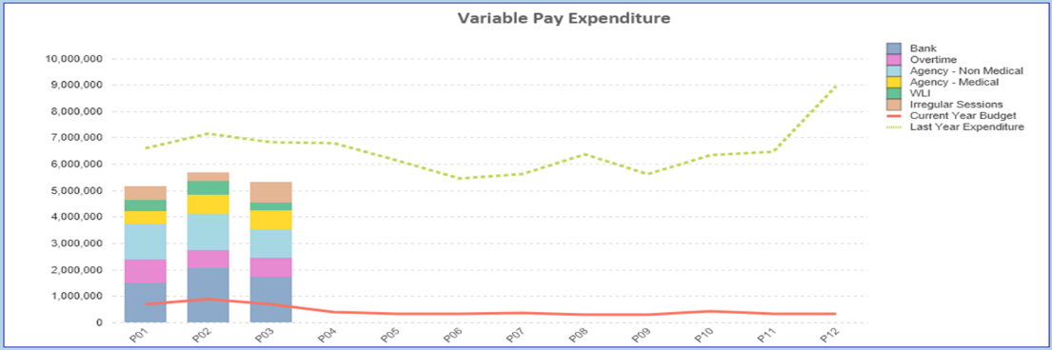

- Overview Non-Pay
A correction was made in Month 2 to reflect the subjective being used in R&D between Income & Non Pay totalling £3.9m

Below are further details on the key areas of Non-Pay (excluding savings that is addressed in main body):

  - Clinical Consumables
This area continues to be a significant pressure with an in-month position of £1.2m (Month 2, £1.4m). There are 80+ subjective lines within this category including secondary care drugs but areas seeing most pressures YTD continue to be general consumables (M&SE), laboratory products and implants (which in part will be driven by activity).

  - Energy
An update was received on 10th June 2024 from NWSSP regarding the forecast which has been validated and included in Month 3 reported position.

  - CHC
The variance against budget for CHC is £0.6m overspent in-month. An analysis of actual expenditure and patient numbers for 2024/25, along with the average values from 2024/25 is provided in table below.

CHC Analysis by Month

Please note:
- The above numbers include Domiciliary care cases.
- PCT Group does not include the Singleton/NPT element. The NPTS element which covers Children and Young People CHC patients is provided internally by the Health Board and as such is part of the wider NPTS position and is not recorded in the ledger as PCT/MH/LD CHC is recorded.

  - Prescribing
See commentary in section 2.3 in the main body of the report.

  - LTA Performance
For noting LTA contracts were finalised and approved at the end of June but the initial assessment of performance against these contracts will not be known for a number of months. Therefore updates on LTA performance will be provided once data in available during Q2.

APPENDIX 2 – DETAILS ON RESERVES & CENTRAL BUDGETS

- SUMMARY RESERVES
Overall management of the reserves is as per the Health Board Budget Management document.

  - Balances Main & NICE
For 2024/25, the Health Board will hold two central reserves and the purpose of these reserves are below:
- Main – this holds funding from WG or the plan that has yet to be issued to Budget Holders. These items are not surplus but either due to timing have not been issued or is an area where funding is issued based on actual values consumed in future month.
- NICE – this holds the total Health Board funding for all of NICE costs (drugs and infrastructure) and is issued to the service each month based on the actual costs consumed as reported through the Pharmacy system.

Details on the balances and movements are provided in the Table below:

- COVID RECOVERY
As part of the Financial Plan WG Funded £15.2m for Local COVID Recovery and £19.5m for Regional COVID Recovery. The funding remains in Central Reserves, and reported in Main reserves in Section 1 above. This funding is then issued to service areas based on the actual costs committed. A summary of the actuals to date and forecast costs against the funding total of £34.7m is summarised in the table below. This currently demonstrates an over-commitment of £0.073m, with further discussions on the deployment of this resource to support TI ongoing.

APPENDIX 3 – SAVINGS

1. Summary
Section 3 above showed a planned deliver of £24.3m of savings, however as noted this includes schemes to manage run rate pressures not solely to address the £26.1m target.

The table below shows that, at Month 3, of the £24.3m of opportunities 45% of these schemes are rated Green with a high chance of delivery. Morriston has the lowest % of Green CIP’s, therefore have the highest risk of delivering on their Savings Target this financial year. MHLD and Corporate have the highest confidence of delivery in-year. £6.2m or 25% are red schemes and are still being developed.

In Year Savings By RAG

The graph below relates to all schemes, including those that are RAG-rated Red. It shows that Morriston, NPTS and Corporate still have £9m cumulative shortfall to find this financial year. MHLD and PCTG have identified sufficient schemes this year, however, over identification will be used to reduce run rate overspends currently forecast by the Service Groups.

2. Savings & Financial Strategy Submissions 28th June

As per the actions detailed in section 2.4 a list of the total value of opportunities submitted by the Service Group on the 28th June is provided below. At the time of completing this paper work was ongoing to:
- Assess deliverability of all schemes via the Star Chamber meetings;
- Challenge the requirement for more options where the quantum will not deliver a balanced position for a Service Group
- Cross reference the schemes to those already on the savings trackers.

Of this £55m of opportunities there is a mix of Green, Amber and Red options which again is summarised in the charge below:

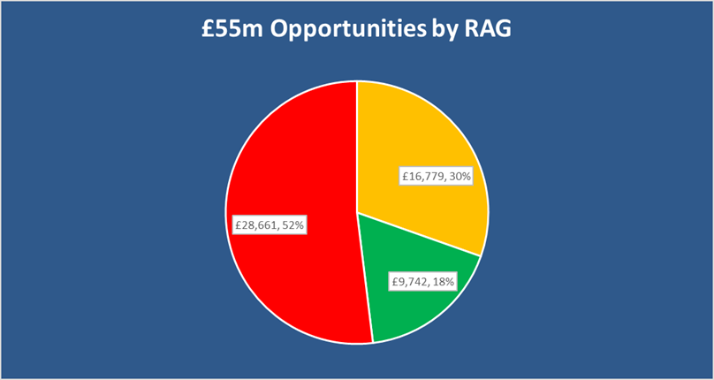

3. Repository

To continually support the identification of opportunities for the Recovery & Sustainability programmes in 2024/25 and in future years, as well as ensuring all opportunities from the National Value & Sustainability are captured and shared within the Health Board, the Repository of Opportunities introduced as part of the Planning process is being re-developed to ensure ease of navigation of the data.

The Repository will then be available via a SharePoint site for both Senior Service Managers as well as Finance to access and interrogate, similar to the approach on the NHS Wale Vault. This new approach will be launched by the Director of Finance at the end of July.

