DATE: | 20th March 2024
TITLE OF REPORT: | SBUHB frailty strategy development & roll-out
REPORT AUTHORS: | Dr Elizabeth Davies/Neil Cooper/Sue Moore
REPORT SPONSORS: | Dr Anjula Mehta /Deb Lewis

Purpose of the Report
For Decision | For Discussion | For Information
X | X

SBAR REPORT
Situation:

Wales has an ageing demographic. Ageing is associated with multi-morbidity and an increased risk of frailty. The term frailty describes a clinically recognisable syndrome of reduced resilience which results from decline in reserve and function across multiple physiological systems. Frailty is associated with advancing age but is not inevitable, many older people remain fit in later life.

People who live with frailty are less able to overcome illness or psychosocial stressors. There are several clinical indicators that suggest the presence of frailty; namely the frailty syndromes or ‘Geriatric Giants’ – falls, incontinence, confusion and immobility. There are evidenced based clinical tools that allow healthcare professionals to recognise and grade frailty, (e.g. the Rockwood Clinical Frailty Scale – Appendix 1) whilst frailty can also be identified from administrative data, in the hospital context by the Hospital Frailty Risk Score (HFRS) and in the community by the Electronic Frailty Index.

Within SBUHB it is recognised that frailty is associated with increased ill health, mortality, healthcare use, care dependency and reduced quality of life]. Guidelines on the management of frailty recommend its identification and targeted clinical management utilising the evidence-based intervention of Comprehensive Geriatric Assessment.

Severe frailty is associated with higher healthcare usage and costs, often with poor experience and health related outcomes for the person concerned. Robust strategies for frailty prevention and preventing progression are key to health in later life and will reduce the burden on the health and social care system in turn.

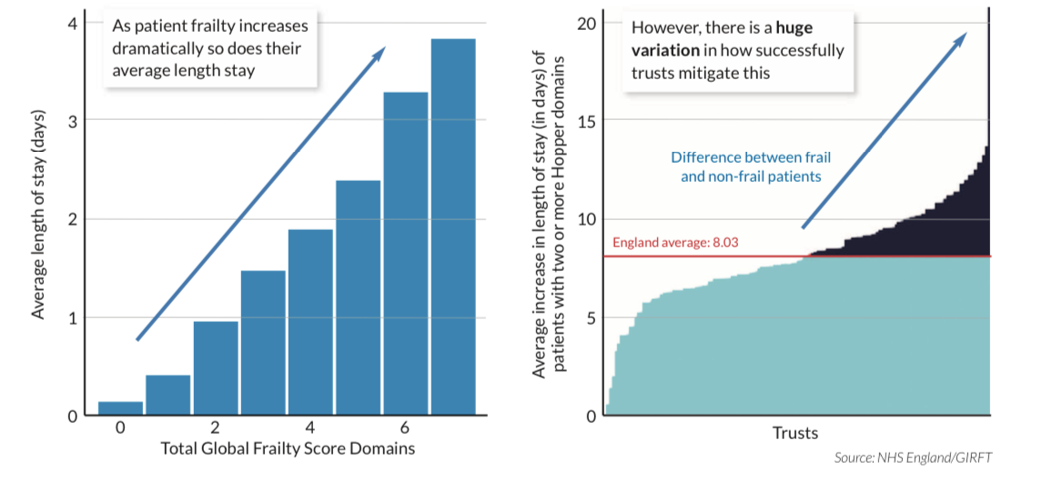
Traditionally, medical care has been designed for people with single organ disease, this has created a system that is good at providing specialist care but a lack of integration leaves gaps in which people living with comorbidity and frailty (who often present with non-specific symptoms) to fall through. Patients with undifferentiated illness represent a sizeable proportion of the work of unscheduled care.

Additionally, there will be increasing numbers of people living with frailty presenting to hospital with acute surgical emergencies, many more will present to the surgical intake with undifferentiated illness which can be difficult to manage in the absence of frailty specialist support. This latter group is a major factor in system dysfunction in surgical services at Morriston General Hospital.

In patients undergoing surgery it is evidenced that frailty is a better predictor of outcomes independent of age. With frailer patients more likely to suffer higher levels of complications, longer lengths of stay and higher rates of mortality. This in turn will place an increasing burden not only on acute medical beds as patients return with medical complications and frailty syndromes but also demand for support services. The NELA (National Emergency Laparotomy Audit) has set best standards of practice which includes all patients over 65 with a CFS of greater than 4 or aged over 80 who undergo surgery should have early geriatrician led MDT input. In England adhering to this guidance now carries a best practice tariff.

Identification of frailty can allow optimisation of the syndrome to improve postoperative outcomes, but it can also be used to inform discussions regarding options for treatment and likely outcomes.

We propose to phase the surgical development of frailty support, for the purposes of this paper we have not included costs, and these will be presented later.

Background:
Acute assessment in hospital of frailty
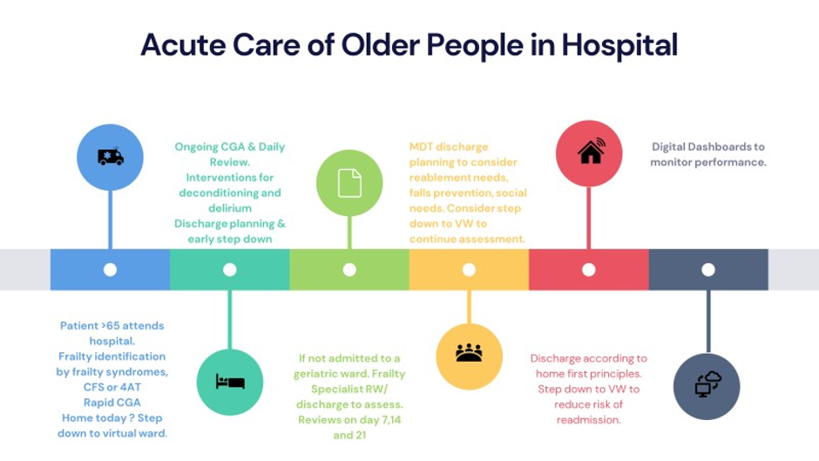

People with frailty often experience long waits in overcrowded admission areas. The time spent in an environment which is challenging to the senses and obligates immobility leads to deconditioning and delirium. In ED there is a requirement to meet process targets that can lead to older people being admitted before they receive frailty assessment. As people with frailty are at greater risk of hospital acquired harms, it is important that their frailty is assessed and identified early and managed through their hospital journey either through a CFS assessment, identification via HFRS or the clinical identification of a frailty syndrome. This should occur within 30 minutes of arrival at hospital.

This compounded by the poor flow through the Same Day Emergency Care Unit and Acute Medical Unit and onwards to the specialist wards. This leads to inappropriate patient moves and prolonged waiting times that contribute to overall deconditioning.

Currently in Morriston the assessment and admission pathway can result in a patient waiting up to 10 days to reach an elderly care ward by which time the deconditioning for the individual so great, the discharge becomes complex and this further compounds the problem.

Approximately 40% of acute medical admissions are frail. The current frailty service does not offer care to all suitable patients at the time of admission and is inequitable. The lack of early access to Comprehensive Geriatric Assessment results in avoidable admissions, deconditioning, delirium, long lengths of stay and readmissions.

Current front door demand and capacity situation:

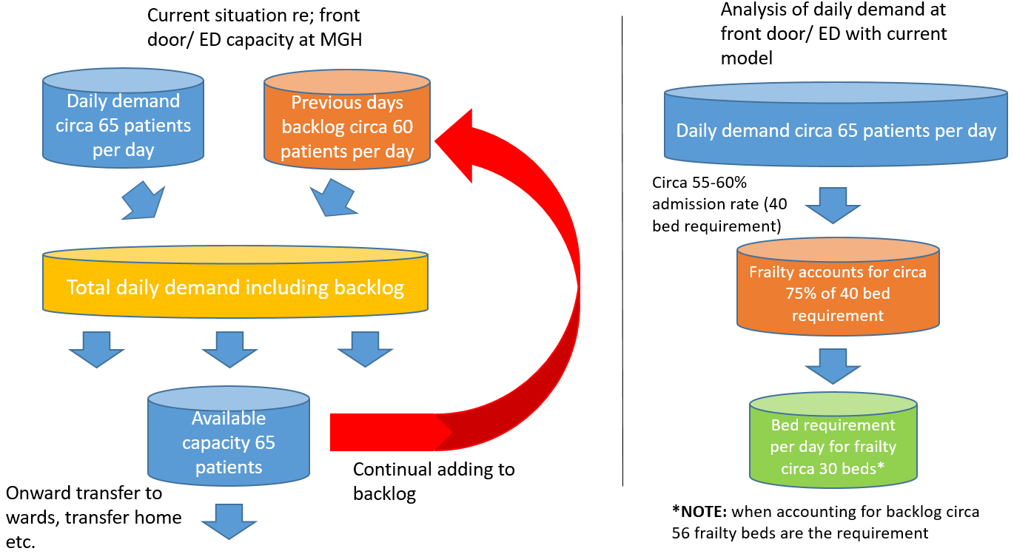

By changing the pathway to have senior clinical decision makers at the front door the aims are to increase short stay, decrease patient moves, reduce pre-admission LOS for COTE wards, reduce deconditioning, reduce ambulance conveyance to hospital and increase care to right place right time.

Patients who are identified as living with frailty should receive comprehensive geriatric assessment rapidly, in a frailty specific area that can mitigate some of the environmental triggers of deconditioning and delirium and offer multidisciplinary specialist care. Frail patients present to ED and are often referred onwards to other specialities other than medicine. It is important that comprehensive geriatric assessment is offered to all patients and not just those who would traditionally have been referred to medicine.

Hospital Admission
For patients who are admitted to hospital, it must be recognised that older people with frailty are more vulnerable to inpatient harms including those caused by falls, medication errors, poor nutrition, pressure ulcers and nosocomial infections. Best practice notes people living with frailty should be tracked through the system post-admission by a frailty liaison team, checking for these risks and taking proactive steps to prevent them. This team can follow up patients who are allocated beds on non-frailty specific wards and can facilitate frailty specific review at 7, 14 and 21 days as suggested by the SAFER bundle. This team could be formed by reconfiguring our current workforce in its first iteration.

Inpatient Wards
Older people with frailty account for a growing proportion of hospital bed days. Across England, people with frailty aged over 75 occupy about 20% of bed days, although the data show considerable variation between trusts. Patients with frailty aged over 70 years account for a third of bed days in some trusts and less than 10% in others. Swansea Bay UHB has higher bed occupancy by frail older people than these national figures would suggest, and this variation can’t be explained by demographics alone. The specialist geriatric wards and reablement areas in Swansea Bay UHB have high median length of stay. Higher length of stay is associated with a risk of increasing immobility, declining function and reduced life span and is a key area of required improvement.

Presentations such as falls, infections and delirium are often associated with frailty, which can be made worse through hospitalisation if the person’s frailty and risk of deterioration is not recognised and well managed through the system. This is the area of geriatric medicine where older people face the greatest risk of avoidable harm, where variation is at its highest and where there is considerable scope for improvement. It is imperative that inpatient wards who specialise in frailty management are adequately staffed to provide comprehensive geriatric assessment, provide robust intervention for deconditioning throughout the week and out of hours along with daily consultant review. Job planning and the working routine on inpatient wards should be in line with SAFER.

Currently, assessments within SBUHB occur in various settings and do not build upon previous work that has been undertaken in other services to care for the patient concerned. There is no reliable output to contribute to ongoing Comprehensive Geriatric Assessment in other settings e.g. on step down from hospital to the community or vice versa. There is no robust overall assessment output that aids communication between services and professionals.

Creating a dedicated space and team to manage this cohort of patients is central coupled with job planning to enable specialty in reach and continuity of care across admitting areas and wards.

The aim being to achieve this across the whole inpatient pathway with the key principles outlined below.

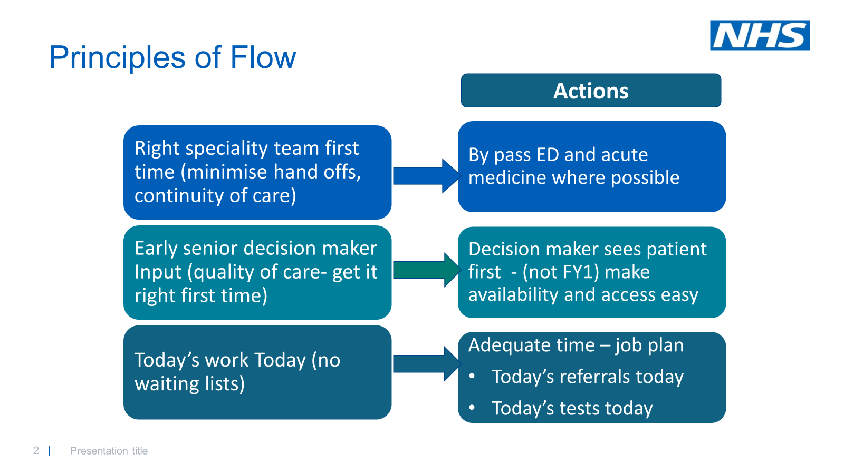

Outpatient Services
Outpatient resources are being managed in a traditional way that doesn’t fit the requirements of service users. Patients often experience a high burden of outpatient appointments, with duplication and poor overall coordination of care.

Frontline employees at SBUHB are not currently routinely offered basic frailty training, this affects the ability of the system to identify frailty and take mitigating action to reduce delirium, deconditioning or other healthcare related harms.

The high demand seen in planned and unscheduled care has made it imperative that we create a robust and integrated service for older people. If we get it right for people living with frailty in Swansea Bay, all our patients will benefit. If we fail to close the gap between what is required and what is provided, systemic collapse may result.

Management of people with frailty outside Geriatrician led areas.
Older people with frailty are treated in many specialties other than geriatric medicine or in the medical emergency pathway. Average length of stay is high in some of these departments. For example, more than 30% of people with frailty over 75 in orthopaedics stay longer than 21 days.

Specialist older people’s liaison support into these departments using Comprehensive Geriatric Assessment can help ensure that frailty is understood and recognised, reducing the risks of deconditioning and extended length of stay.

End of Life Care
Providing better end of life care older people who are approaching the end of their lives should be recognised by the health system so that appropriate care decisions can be taken, in line with NICE guidance and the quality standards on end-of-life care. As much as possible, patients should be able to die in their preferred place of care and have more choice in how this happens. They should be included, along with their families and carers, in shared decision making about end-of-life care, including preferred thresholds for interventions and treatments. Almost a third (30%) of older people who die in hospital experience three or more hospital admissions in the last 90 days of life, often causing unnecessary stress and suffering.

The local strategic position.

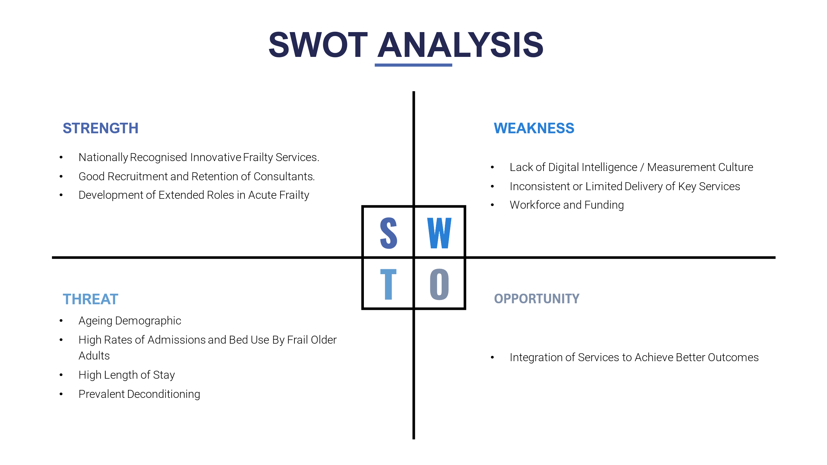

Swansea Bay UHB has considerable strength in its services for older people living with frailty, several services have been recognised both locally and at national level as being innovative and effective models of care.

Over recent years, Swansea Bay has been able to recruit and retain consultant geriatricians. Several services have been able to train and provide roles for other healthcare professionals in non-traditional roles, many of these individuals have excelled and have become key in the delivery of patient care, especially in acute frailty services in the hospital and community.

There remain challenges in scaling up services to operate 7 days a week, to offer a service to all eligible patients and not only those who present at a certain time and when there is capacity to receive them. There is a paucity of frailty specific cover out of hours and at weekends, which impacts not only service delivery but patient flow through the healthcare system too. There are very high rates of bed occupancy by older frail patients.

In SBHUB length of stay across the elderly care wards is exacerbated due the protracted admission process which arises due to poor flow and bed availability on the main acute site; Morriston. For example:

Median Length of Stay on Frailty Specific Wards SBUHB taken from SAFER Dashboard (GIRFT NHS England Average = 8 days)

WARD E | WARD D | GOWER WARD
26 Days | 20 Days | 16 Days

Due to the long stays deconditioning in frail patients is prevalent and can further negatively impact on the ability to discharge due to worsening symptoms (and in some cases loss of existing packages of care).

This will be addressed by adopting the flow principles outlined earlier in the paper.

Orthogeriatrics
There have been considerable improvements in the service offered to patients presenting with hip fractures related to frailty in recent years, mainly driven by the recruitment of a Morriston based consultant orthogeriatric team. Morriston is a high-volume centre, receiving 720 patients with hip fracture in 2023.

The service has considerable strength in measurement of key metrics through its participation in national audit work-streams (The National Hip Database and the Fracture Liaison Service Database.) Access to prompt surgery for hip fracture patients is well below the Welsh average and as such deconditioning and a longer length of stay is more likely despite excellent access to early Orthogeriatrician review and avoidance of delirium.

Theatre delays are common with 63% of patients not meeting the 36-hour target for access to surgery. These delays are related to theatre space in 81% of cases and are largely outside of the scope of the orthogeriatric service to influence.
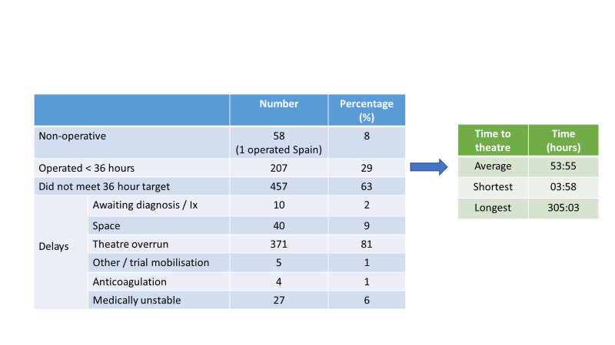

The key strategic aims to note include:
- Reducing LOS for frail patients with hip fracture (National GIRFT average 19 days, at SBUHB 53% of patients stay more than 14 days; 34% more than 30 days)
- Improving the proportion of patients rapidly admitted to a specialist unit and offered effective analgesia as per NHF audit standards.
- Improving access to prompt surgery.

Patients with a confirmed fractured neck of femur should be directed into the proposed frailty unit co located to the emergency department. There will need to be 4-6 beds ring fenced for the orthogeriatric service to provide care in the first 48 hours of admission to their caseload of 720 patients a year in the new unit (the current wait for surgery in Swansea Bay averages 55 hours, the longest wait was 305 hrs in 2023). The frailty unit will need daily speciality in-reach from Orthogeriatrics and orthopaedics, it is not anticipated [other than nursing costs for the 6 beds] that this will attract an additional cost as these arrangements are currently in place for patients in ED.

Within the frailty unit there will be six ringfenced beds to enable immediate admission and stabilisation pre-operatively
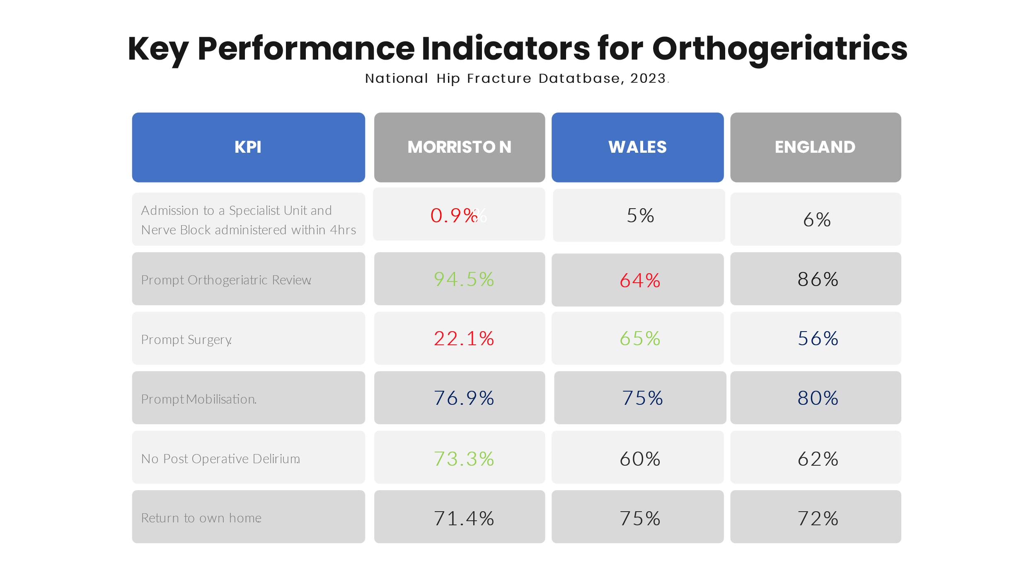
Broader strategic position

The Welsh Government’s Six Goals for Urgent Care Programme, the GIRFT report on geriatrics, and the NHS England Right Care guidance concerning frailty, all clearly describe the requirement to provide an integrated system that includes secondary care, primary care, care homes, community services, ambulance services, local authorities and the voluntary sector and is centred on the needs of individual patients and focused on preventing inappropriate hospitalisation and progression of frailty. These guidelines also mandate robust, accountable senior leadership for frailty at an organisation level.

Assessment:

Key components of SBUHB strategic frailty response
The aim of any frailty response will be to optimise the total pathway with consistent senior clinical leadership taking an overview and directing care.

We can do this by maximising and co-ordinating the current teams that already exist within the health board within a single line management structure. This should sit within the Morriston Service Group, acknowledging that much of the care can, and will be out of hospital but noting the current consequences of a disconnected frailty strategy currently manifest as emergency department presentations.

The Virtual Wards:
People living with frailty could often have their needs met best in settings outside of acute hospital care. In the primary care setting, frailty can be identified using the electronic frailty index utilising administrative data as well as by clinical assessment. Assessment in a person’s own home is potentially less disruptive and more effective than acute admission to hospital. The virtual ward should offer comprehensive geriatric assessment to people who are identified as living with moderate frailty (potentially amenable to intervention) or moderate to severe frailty who experience a functional change (most commonly presenting with falls or delirium).

The virtual ward team should be able to offer effective home and community based reablement services, including direct access to inpatient reablement for patients who require it. This facilitates 'step-up' care to avoid admissions, and 'step down' care to support post hospital care.

The Acute Community Teams (ACT):
Recent changes have catalysed several potential opportunities with medical leadership and integration of the team becoming a real possibility.

The advantage of this is to enable the alignment alongside the virtual wards and consultant ownership of the caseload of both teams could then sit under one consultant cluster lead. Realignment of the consultant sessions currently available for acute community work (2 WTE) should be utilised to achieve an integrated cluster-based Hospital at Home team with rapid access to hot clinics based at Afan Nedd and a suitable similar set up in Swansea as required.

Older Persons Assessment Service (OPAS):
Currently, the Older Person’s Assessment Service operates in the Emergency Department, links to the main Same Day Emergency Care (SDEC) department and looks after short stay beds in the AMAU. The service is limited to 8am to 5pm, Monday to Friday within traditional working hours, assessments are not carried out outside these hours. In addition, the service is often unable to accept referrals from WAST as per Welsh Government SDEC guidance due to lack of capacity.

OPAS is operates in a designated space within ED with four bed spaces and access to a waiting area. The service assesses 40-60 patients a week with a 70-80% same day discharge rate. The Frailty SDEC function of this area is not protected and is usually bedded with medical outliers.

There are 17 geriatrician led beds on the Assessment Unit providing short stay medical care. This area aims to provide care for patients during the first 72 hours of admission. The AMU struggles with poor flow, overcrowding and a short stay unit length of stay of a median of 5 days. The pressures of patient flow management hinder the ability of OPAS to achieve functional integration with the older persons short stay unit and the main SDEC department.

There are opportunities to further build on OPAS’s work to date and integrate closer with both ACT and Virtual Wards

The beds will be integrated on the frailty assessment unit with total of 21 beds identified.

This will then balance the medical take bed requirements within the Acute Medical Unit, so we have 65 acute short stay beds with defined assessment areas to manage the patient pathway

Prehospital Triage & Interface Services:
Swansea Bay University Health Board has several services for older people living with frailty that operate at the interface between community and acute services: the Virtual Ward network, the Acute Community Teams, and the Older Person’s Assessment Service. There are challenges in upscaling these services to provide 7-day services at a suitable scale to provide consistency and equality of access the above proposal could support the changes and again will give a seamless clinical model within a single consultant led team.

There were approximately 13,000 admissions in the over 80’s through ED and AMAU and 23,000 aged over 70yrs in the last year. Not all these patients will be frail but these numbers are considerably higher than the activity of our current acute frailty services and indicate a likely mismatch of service provision to demand (approximately 4000 patients being assessed by OPAS and the Older Person’s Short Stay Unit over last year); an improvement in service provision and integration with community services may offer considerable benefit to the wider system by admission avoidance and reducing the risk of deconditioning and hospital acquired harm.

6.17% of the attendances in ED are flagged as potentially frail or aged over 80 by the Hospital Frailty Risk Score digital intelligence flag. Since the beginning of November 2023, the daily proportion of patients in the Emergency Department who are flagged by the HFRS is 38% (mean average). To manage this, we need:
- Timely assessment
- Onward movement through the system for this group of patients within the department.
- Rapid offload within the national target of a maximum of 15 minutes
- Reduce bed occupancy.

There are very high rates of bed occupancy by older frail patients. 67.55% of the medical beds occupied at Morriston are occupied by patients aged over 70yrs and 41.4% occupied by the over 80s. The high demand seen in planned and unscheduled care has made it imperative that we create a robust and integrated service for older people. An integrated system requires the creation of a single point of access which has the capability to signpost a patient, according to their individual needs to the most capable provider within the network of aligned frailty services.

The current managerial structure around these services will need to be reformed to ensure maximum integrative function. The Virtual Wards, Older Person’s Assessment Service and the Acute Community Teams need to be brought into one operational structure, with robust frailty specific and workforce specific leadership (i.e. Nurse Consultants for a large ACP workforce).

This team will be integral to the frailty assessment service.

Recommendation(s):
Headline recommendation is to:

- Approve the overall SBUHB strategic direction for frailty service provision.

SBUHB frailty strategy – direction of travel:

The frailty strategy includes a proposed service change to implement an Integrated Frailty Service with overarching strategic aims:

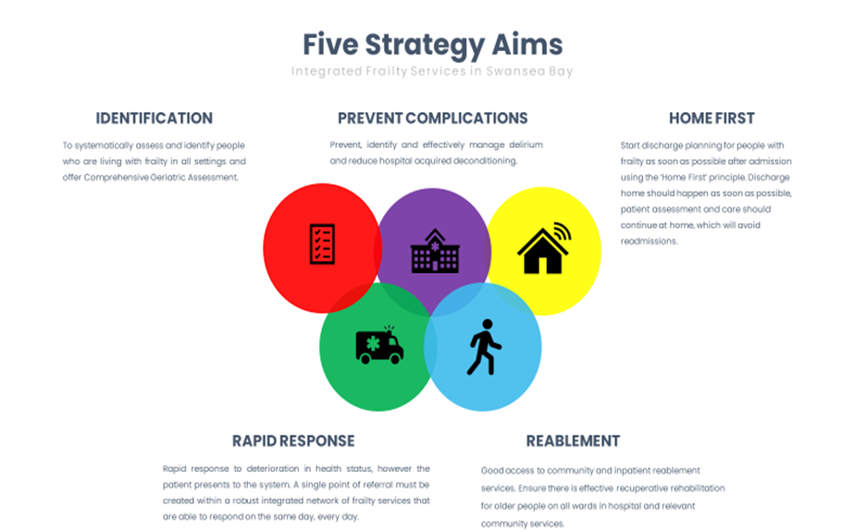

In addition to the above the implementation of the proposal is expected to support:
- Reduced LoS
- Increased short stay interventions less than 48 hours
- Reduced No of patients over 10-day LoS

The Integrated Frailty Service will include creation of Integrated Frailty Services Co-ordination Hub:

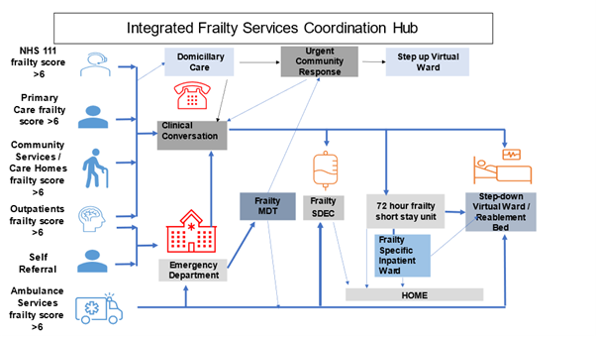

- A patient identified as frail and requiring urgent care (Clinical Frailty Score 6 or above) should be referred to a single point of referral at MGH within operating hours (which will be extended to cover 7 days a week, 12 hours a day).
- It is imperative that this referral process is rapid, reliable, consistent, and high-quality response.
- Referrers should have an experience that is superior to using traditional methods of referral ensuring that the hub represents ‘the path of least resistance’.
- Out of hours, referrals will be accepted by the Acute GP service to be discussed at a multidisciplinary team meeting at 8am the following morning. Patients who have been admitted to medicine overnight or have attended ED should be flagged up at board rounds.
- The needs of the individual patient referred will be considered by a team with frailty specific competency and knowledge of local services through a virtual and physically available hybrid MDT. An individualised, interdisciplinary plan will be made for the patient with a ‘home first’ ethos that will address medical and social needs but will reduce deconditioning and the risks of admission to a minimum. A shift from traditional admit, assess and step down to community services is required, with more activity being focussed on assessment in the home and using community services.
- Short term domiciliary care will be available to support patients through acute illness (three care calls a day should be available for up to 3 people). The hub will hold a case for up to 48hrs to give time for planned care services (i.e. District nursing) to respond.

Mobilisation of this type of service in Nottingham has seen a reduction in ED/ AMU conveyances of circa 50% - as such the realistic impact of this proposed service change is expected to yield a reduction in conveyance to hospital of 30-50%. At this the impact of the hub has not been factored into the over requirement for the service.

But this could have the potential to reduce ED conveyance /GP expected by 75 patients per day.

Funding for this is requested via the Further Faster fund.

As part of the Integrated Frailty Service a recommendation is the creation of an Acute Frailty Unit and Frailty Specific Admission Stream.

A frailty specific unit should be created near the Emergency Department and the Integrated Coordination Hub. Wards A and B (at MGH) have been earmarked as a viable location for this service.

This will be a 21 bedded unit with a 6 bed ringfenced area for patient presenting with fractured neck of femur.
A second phase will include 10 surgical post operative beds but is not included in this proposal.

This unit will build on work currently driven by the Older Persons Assessment Service (OPAS) with a pathway integrated across into specialty medicine specifically COTE

The creation of a frailty unit that offers care based on frailty identification outside of clinical diagnosis or referral stream should be created at Morriston Hospital. This can be practically implemented if co-located to the Emergency Department.

There are clear opportunities for improvement that need to be applied in the design of a new unit. The proposed Acute Frailty Unit will run on the following principles:
- Patients who are identified as having a CFS greater or equal to 6 should be directed to frailty specialist care in a unit structure that can provide an environment and staff skill set that is appropriate to their needs.
- An acute frailty intake is required to run in parallel to the Internal Medicine intake with similar consultant cover arrangements and working patterns.
- Continuity of Consultant cover is required for at least 2 consecutive days and a senior decision maker is expected to be present for medical admissions (including SDEC) throughout 12 hours of the day, including cover into the later evening. GIRFT reports a national picture of a significant admissions workload until 24.00h in most centres that informed their dataset.
- Pharmacy services need to be provided 7 days a week throughout the working day to facilitate medicine reconciliation and discharges.
- The medical admission process has several steps that involved duplication of tasks by members of the clinical team. A unified clerking document or electronic solution would release time that could be used to improve efficiency in the medical admission process.
- Availability of diagnostics should be based on clinical need; but areas such as the Frailty Unit, AMU, SDEC and Emergency Department (ED) must have the same level of access in terms of priority and reporting times. Phlebotomy, ECG and portering services should be freely available at the time of need.

The acute frailty service, in addition to service metrics regarding waiting times and explicit Welsh Government mandated targets, the system must be able to report the following key performance indicators reliably:
- Weekly admissions and length of stay in a run chart for acute medicine and acute frailty admissions.
- Monitor 7-day and 28-day readmissions.
- Review readmissions and re-attendance rates and identify large variations in, or higher than average, readmission rates.

As part of the above recommendation the Acute Frailty Unit must have a built environment that can provide sufficient space.

Recommendations re; built environment include:
- The Acute Medical Assessment Unit (AMAU) and Frailty Unit need to be the right size for the admissions they receive, and the amount of short stay care they are expected to provide.
- A physical space that will house the Integrated Coordination Hub and provide space for unit-based board rounds and MDT meetings.
- An Ambulance entrance, reception and waiting area.
- A general assessment area and an area suitable for SDEC activity – space should be configured for beds and not trollies.
- Clinical space for procedures and dealing with minor injuries.
- Acute Medical Units are traditionally supposed to have the bed base the size of the 24hr ‘intake’ + 10% (approximately 65 beds for Swansea Bay for medical admissions).

The creation of an Acute Frailty Unit and subsequent frailty specific intake will divert approximately 40% of the intake away from AMAU and ED while producing benefits for whole system in terms of avoiding admissions, deconditioning, delirium, and dependence on social services.

Proposed Acute Frailty Unit model/ patient flow:

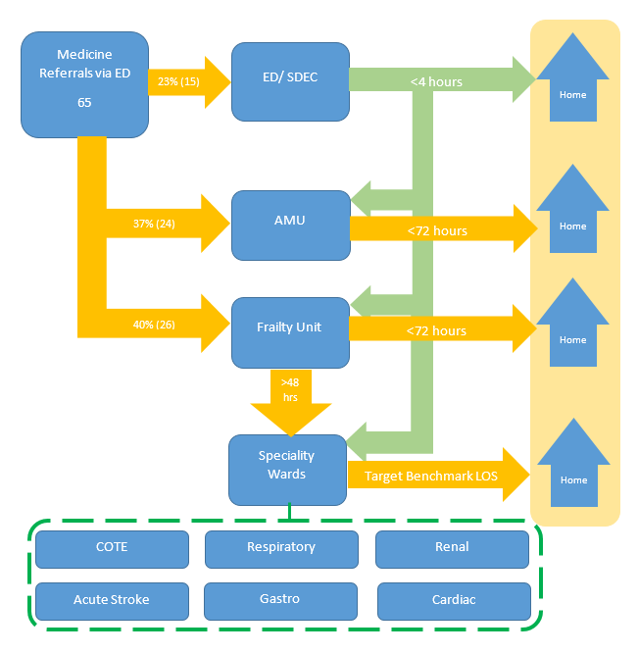
The space needs to be adapted to be dementia and delirium friendly and explicitly designed to allow continuous nursing observation (central nurses’ station). Monitoring provision will be required with links to a central console.

Orthogeriatrics – change of service proposal
There has been a recent proposal which secured funding for extra clinic capacity and support staff to improve the care of inpatient non femoral fractures and the fracture liaison service. As such, these elements are not considered by this paper.

Orthogeriatrics must be offered a bed base within a unit co-located to the Emergency Department where patients presenting with fractures neck of femur can be offered specialist input in a suitable environment with staff available with relevant skills to offer effective analgesia including fascia iliac block prior to surgery. There have been previous attempts at ring fencing capacity on orthopaedic wards, but these have failed due to patient flow pressures which are currently a daily reality on the Morriston Hospital site.

Specialist frailty skills and the ability to offer fascia iliac block are prevalent in the current Older Person’s Assessment Service (OPAS) based in the Emergency Department. There are opportunities for closer collaborative working to provide these patients with an improved service. The current service configuration of OPAS is to provide predominantly same day emergency care, the service operates in daytime and only on weekdays.

The creation of a frailty unit co-located to the Emergency Department will allow patients with a fractured neck of femur to be directed to a specialist service with the relevant skills to offer gold standard care from the point of admission.

Workforce
We need to review the workforce but broadly speaking we will be covering:
- Advanced clinical practice for specialist work - the need for specialist geriatric services has risen dramatically both in hospital care within medicine and surgery but increasingly in the community, in nursing homes and in an extended range of services. There are shortages of key staff and not enough trainees in the pipeline to meet likely future demand. The use of professionals qualified in Advanced Clinical Practice for specialist work has been actively pursued in the Health Board already. Retaining and further developing this workforce is key. Providing genuine personal development and career progression is key to retention in this area.
- Consultant shift patterns and continuity of care - continuity of the care given to patients is beneficial because it limits unnecessary transitions of care that are associated with increased length of stay. There is also evidence that consultant-led or consultant-delivered care improves patient outcomes, and senior clinical input into acute take referrals can reduce the demand on the acute take by up to 30%. This is achieved by consultants on the acute take providing clinical advice to referrers and potentially diverting patients to an alternative pathway e.g. SDEC. Likewise, delays in consultant review have a detrimental impact on the care of the patient and patient flow.

As such the intention is to create a 3-year medical workforce plan to ensure we have the appropriate staff to deal with demand. Workforce analysis has noted a gap of 8 COTE and 13 acute physicians. However, it is recognised that new job plans, and the principles of flow need to embed. We will also need to phase recruitment due to availability of qualified consultants.

Outpatient Services – Consultant support to community clusters
The traditional geriatrics outpatient offering should be realigned to provide consultant support to the community clusters who will coordinate the comprehensive geriatric assessment process.

Outpatient services in geriatric medicine should invariably offer multidisciplinary comprehensive geriatric assessment, with a focus on shared decision making to reduce the need for multiple appointments, and use the established community based multidisciplinary workforce most effectively.

Appropriate assessment and care planning for patients living in specialist settings e.g. care homes or supported housing should be coordinated by the Hospital at Home team. A system-based approach is required to support care homes with a focus on specific interventions such as management of delirium, falls or advance care planning can reduce inappropriate admissions. There have been examples of good practice in this area already at Swansea Bay but these need to be scaled up.

The function of Afan Nedd should be supported and enhanced to provide consultant led comprehensive geriatric assessment for every referral within a maximum of 72hrs. A similar service will need to be created in Swansea. The costs of this realignment is uncertain as current outpatient activity would be redirected to provide this resource.

Frailty awareness training
Frailty specific training should be available to all levels of staff. A greater awareness of frailty and how to prevent its progression would be valuable in mitigating the risks of deconditioning and delirium.

Key metrics/ rationale for service change:
To monitor progress several KPIs will be put in place – this covering the whole frailty pathway from reduction in outpatient contacts outside of cluster provided services and ED admissions through to reducing bed days by End-of-Life patients.

The overall aim to reduce unnecessary demand on our acute hospital system.

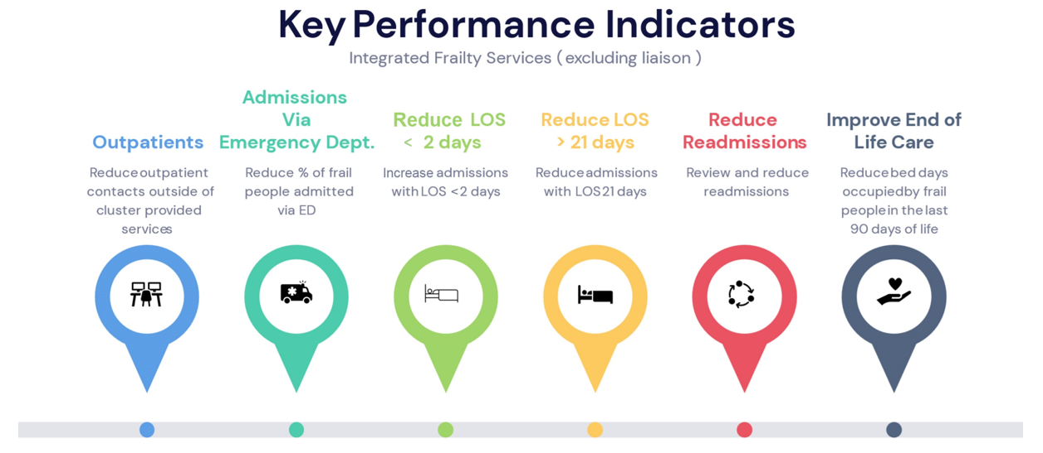

The mobilisation of the proposed model will impact the overall specialist bed requirement across specialty, in this case the care of the elderly wards have a long length of stay when compared to GIRFT benchmark and mentioned earlier in the paper.

Implementing a service model in September 2024 specifically to tackle our frail population cohort could by January 2025 potentially free up circa 9-14 beds for use in the remainder winter surge period.

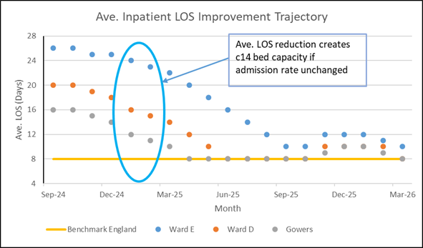

The unit will be pump primed following closure of two wards on the Morriston site and working with the team at Singleton to enable the reduction on the recently opened clinically optimised beds on ward 8 and 3. This is coincident with the planned IPC decants to enable deep cleaning and roof repairs. It could be a risk if the beds do not close but there are strong plans re the timeline and actions to achieve this.
We have agreed with Singleton a 25% share of the Ward H costs on closure of the beds, and this has been top sliced so not included in the overall business modelling. This is a health board benefit
The high-level modelling to date has indicated that between 9-14 beds could be saved following the implementation of a frailty specific service model, while if the introduction of the hub reduced frail admissions there may be opportunity to release further beds.
Financial analysis – work undertaken to date and next steps:

To date a staff model for the Integrated Frailty Services Co-ordination Hub has been provided and costed as part of the Further Faster Funding Bid. This cost totals £1.071m.

An outline staffing model for the Acute Frailty Unit has been developed at pace with input from the Head of Nursing (Medicine), Lead Consultants in COTE and Pharmacy. This model needs further testing to ensure it is robust and incorporates all required resource. At this stage it assumes no uplifts for indirect services (portering/ catering/ digital etc as patient numbers are not increasing and whilst staff numbers increase, other reductions should offset.

There are important co dependencies with acute medical admissions, surgical and orthopaedic services and as such is part of a large organisational change process outside the scope of this document. Some costs will be offset by the funding already being received by predecessor services and the funding secured for the integrated coordination hub, but significant costs will remain.

We have assumed that all infrastructure and therapy support to the two closed wards [Anglesey and Ward H Respiratory] at Morriston are realigned to the Frailty Unit.

The table below summarises new annual investment required based on initial assessment. OPAS is included in full (current service plus investment) as there will be an increased service and there is a risk to note on the funding for the existing provision post 24/25.

Morriston Hospital will have closed two existing wards ahead of the unit opening which could be used to fund the majority of the investment – however agreement from the Health Board would need to be in place that the savings generated by the closure of said wards be re-invested into the frailty strategy identified within this paper.

Despite the funding source identified, there is a shortfall on the annualised costing, which will need addressing. It is anticipated that the future LoS and admission reductions will close this gap and provide additional revenue to support future phases. The impact of the Hub, and specialist wards LoS reduction to benchmark with GIRFT metrics are not included and this provides a high level of opportunity. The use of flexible work force at premium costs will reduce as we have a cohesive service offer that is attractive to clinicians seeking to work in a fast paced and forward-thinking service.

Note - All costing at 23/24 pay rates, mid point of scale including enhancements where applicable. Full cover is note included for pharmacy, AHP’s or Social Work, further scoping work required.

Detail of staffing included in appendix 2.

Work to date notes:
- Ward capacity has been identified on the Morriston site.
- Capital investment -we have engaged with capital to establish any capital costs but this is not foreseen as significant at this stage.
- The closure of Anglesey and Ward H will release circa £3.1m of revenue funding and the Health Board are asked to approve the reinvestment.
- This is a net reduction in specialty beds but an increase in the assessment function to match the current daily take [65]
  - 44 plus SDEC for Acute Medicine
  - 20 plus Referral Hub for frailty
  - 6 beds to manage the fractured NOF pathway.
- A further £1.1m has been sought from the further faster fund to reduce the overall conveyances by 30%
  - We have not included this in the overall activity model
- The LOS reductions in COTE will generate between 9 and 14 beds to support winter surge in January 2025.
- Further LOS reductions could lead to 21 beds being released and generate sufficient savings to support the full cost of the proposal and contribution to future plans.

Therefore, the recommendation is that further financial investigation and evaluation take place to confirm the full costs with an implementation timescale to implement the entire model and fully understand the savings from the closure of wards at Morriston General Hospital.

Appendices:

Appendix 1: Clinical Frailty Scale

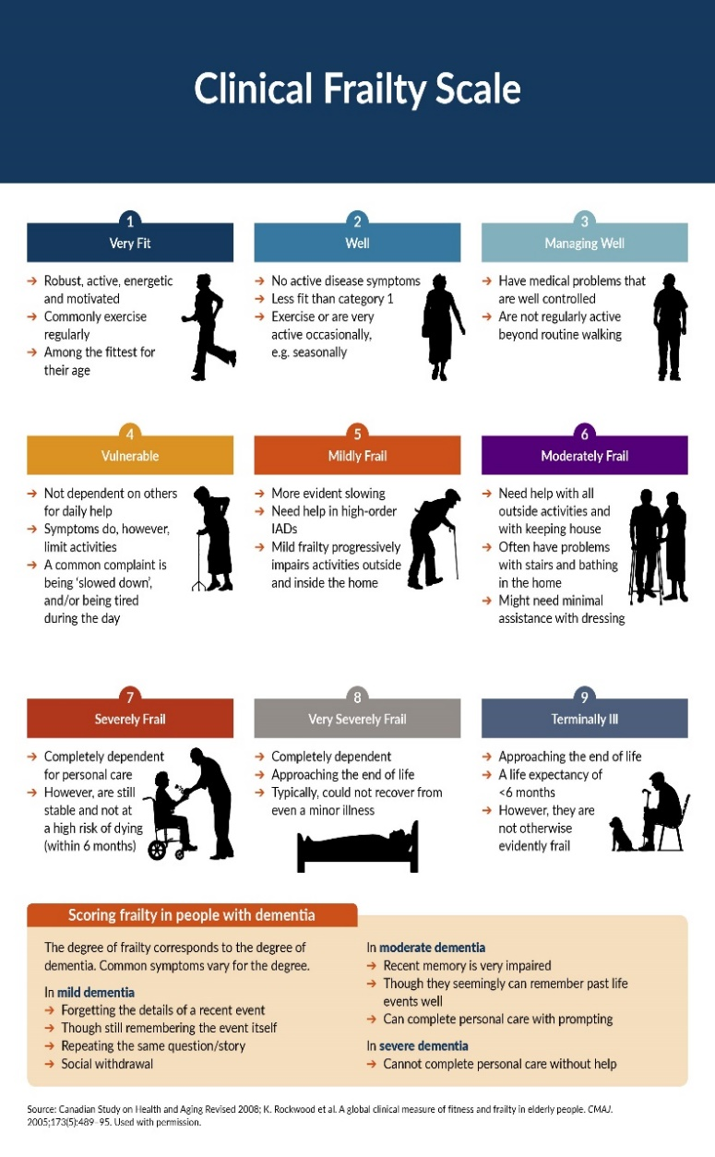

Appendix 2 Finance Details

