Meeting Date | 23rd July 2024 |  | Agenda Item |  | 4.2
Report Title | Industrial Action – Impact on Operational Delivery
Report Author | Deb Lewis, Chief Operating Officer and SRO for Targeted Intervention
Report Sponsor | Deb Lewis, Chief Operating Officer and SRO for Targeted Intervention
Presented by | Deb Lewis, Chief Operating Officer and SRO for Targeted Intervention
Freedom of Information | Open
Purpose of the Report | To provide the Committee with a summary breakdown of the impact of the junior doctors’ industrial impact on operational delivery
Key Issues | Due to an ongoing pay dispute, junior doctors in NHS Wales took industrial action during January and February 2024. This resulted in significant disruption to routine, elective operational service delivery. This report provides a summary breakdown of the impact.
Specific Action Required  (Please choose one only) | Information | Discussion | Assurance | Approval
Specific Action Required  (Please choose one only) | ☒ | ☐ | ☐ | ☐
Recommendations | Members are asked to:  - NOTE the impact junior doctors’ industrial action had on the delivery or routine, elective operational service delivery.

- INTRODUCTION

Due to an ongoing pay dispute, junior doctors in NHS Wales, via the BMA, took industrial action during January and February 2024. There were three separate periods of industrial action:
- 07.00 15th to 07.00 18th January
- 07.00 21st to 07.00 24th Feb
- 07.00 25th to 07.00 29th March

This resulted in significant disruption to routine, elective operational service delivery. This report provides a summary breakdown of the impact.

- BACKGROUND

The nature of the impact of industrial action of junior doctors across all Health Boards in NHS Wales, resulted in more senior medical staff (ie consultants and SAS doctors) having to cover emergency rotas on a 24/7 basis. Inevitably this impacted the delivery of elective services in all areas. To ensure senior clinicians would be available to cover the emergency work, Health Boards took the decision to cancel in advance planned routine activities. A retrospective review of availability of medical staff highlighted that some activity could have been delivered as planned but due to the risk of insufficient senior medical staff at key points during the industrial action (especially given the proximity to scheduled school holidays), it was deemed too big a risk to take for the January period but as you can see from the table below, this was reviewed for the February and March periods..

The main services affected were consultant delivered outpatient appointments and planned elective surgical procedures. Diagnostic procedures and nurse-led or therapist delivered services were largely unaffected. following gives a view of the scheduled activity cancelled over each period of industrial action. It should be noted that as the February IA coincided with school half-term holidays, fewer appointments were actually scheduled due to higher levels of planned annual leave, hence lower levels of cancellations.

 |  | New Outpatient  Appointments | F/up Outpatient  Appointments | Surgical Procedures
January | 15th | 251 | 543 | 100
 | 16th | 182 | 556 | 114
 | 17th | 201 | 426 | 108
 | Total | 634 | 1525 | 322
February | 21st | 213 | Not noted | 45
 | 22nd | 293 | Not noted | 57
 | 23rd | 107 | Not noted | 63
 | 24th | 0 | Not noted | 0
 | Total | 613 | 0 | 165
March | 25th | 250 | Not noted  Not noted | 75
 | 26th | 256 | Not noted  Not noted | 90
 | 27th | 142 | Not noted  Not noted | 78
 | 28th | 178 | Not noted  Not noted | 55
 | Total | 826 | Not noted  Not noted | 298
Total Losses for IA |  | 2,073 | Partial reporting | 785

As the dates of the industrial action were known in advance, there maybe a reduction in activity booked and therefore the lost activity may not be everything that was cancelled as fewer appointments were actually booked. Therefore, the table below shows some context on the same dates/days for 2023:

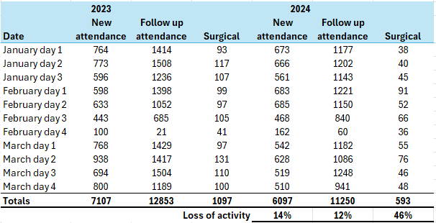

You can see from the table above that the most significant loss of activity is within surgical procedures, with a 46% reduction in activity undertaken.

Recommendation
Members are asked to:
- NOTE the impact junior doctors’ industrial action had on the delivery or routine, elective operational service delivery.

Governance and Assurance

Link to Enabling Objectives  (please choose) | Supporting better health and wellbeing by actively promoting and empowering people to live well in resilient communities
Link to Enabling Objectives  (please choose) | Partnerships for Improving Health and Wellbeing | ☐
Link to Enabling Objectives  (please choose) | Co-Production and Health Literacy | ☐
Link to Enabling Objectives  (please choose) | Digitally Enabled Health and Wellbeing | ☒
Link to Enabling Objectives  (please choose) | Deliver better care through excellent health and care services achieving the outcomes that matter most to people
Link to Enabling Objectives  (please choose) | Best Value Outcomes and High Quality Care | ☒
Link to Enabling Objectives  (please choose) | Partnerships for Care | ☒
Link to Enabling Objectives  (please choose) | Excellent Staff | ☐
Link to Enabling Objectives  (please choose) | Digitally Enabled Care | ☐
Link to Enabling Objectives  (please choose) | Outstanding Research, Innovation, Education and Learning | ☐
Health and Care Standards
(please choose) | Staying Healthy | ☐
(please choose) | Safe Care | ☒
(please choose) | Effective Care | ☒
(please choose) | Dignified Care | ☐
(please choose) | Timely Care | ☒
(please choose) | Individual Care | ☐
(please choose) | Staff and Resources | ☒
Quality, Safety and Patient Experience
Outlined within the body of the paper but in summary considerable backlog of patients awaiting a diagnostic and treatment services across a range of services. Issues of harm in relation to high levels of HCAIs noted.
Financial Implications
Funding not yet agreed for 24/25
Legal Implications (including equality and diversity assessment)
Delay to diagnosis and treatment potential.in service delivery
Staffing Implications
Additional support staffing required to deliver the programme
Long Term Implications (including the impact of the Well-being of Future Generations (Wales) Act 2015)
Report History | First comprehensive update presented.
Appendices

