1.0 EXECUTIVE SUMMARY
The Health Board’s Estate Plan (2022-2023) outlines the required reconfiguration and transformation of the estate to facilitate delivery of the required new models of care for the Swansea Bay UHB population, working alongside the infrastructure to support the developments. Execution of the strategy will result in the development and expansion of specialist hospital services
A priority for the Plan is to increase estate utilisation and efficiency by decreasing some of the estate and its backlog maintenance costs, whilst still managing to improve the environment.
The provision of a second permanent CT-Simulation (CT-Sim) in the SWWCC at Singleton Hospital aims to provide more resilient cancer planning infrastructure. CT-Sim is an integral part of Radiotherapy to Treatment (RT) pathway used for treatment planning. It supports the following national drivers:

This investment complements the Health Board’s Clinical Services’ Plan the estate priorities for Singleton Hospital have been identified as follows:
- Three Main Modular theatres
- Ward Refurbishment Programme
- Development of Outpatients
- Development of a 5th Linear Accelerator (and 6th Bunker)
- Development of a static PET-CT facility

2.0 ESTATES SPEND OBJECTIVES
This project supports delivery of the Health Board’s Strategic Estates Plan’s estates objectives as follows:
Strategic Estates Plan estate objectives | How this project supports delivery of the Health Board’s Estates Objectives
To support the delivery of the Health Board’s clinical strategy by developing a property portfolio, that meets the needs of the regional SWWCC and the Health Board’s service development plans and represents efficient use of resources. | Project aligns with NHS Infrastructure Investment Guidance objectives and criteria. In particular it aligns with the Health Board’s strategic response to access pressures is set out in “Changing for the Future” which references Singleton Hospital’s role as a centre of excellence for planned care, cancer care, maternity and diagnostics; Improves access to cancer treatment planning services’ capacity that will meet regional demand in a timely way and support delivery of care in an appropriate environment; Provides essential resilience over current levels and improves RT and pathways.
Play a strong supporting role in development of Tertiary, Acute and Primary Care facilities to deliver healthcare with healthier outcomes | Provides a more sustainable CT-Sim service with essential AI software at Singleton Hospital, which improves access to high-quality cancer services for our regional population and improves health outcomes; Supports improved clinical effectiveness by providing safer and more sustainable services to patients.
Maintain or improve compliance levels to ensure the Health Board’s physical environment is delivered to the highest affordable standards | Provides functionally modern and fully compliant facilities with state of the art AI capability within the SWWCC at Singleton Hospital.
Supports operational services and business development to capitalise on the Health Board’s estate to bring a greater range of healthcare services. | Provides additional theatre capacity for local surgical specialties to meet demand and reducing waiting times.
Support the development of agile working initiatives, through intelligent use of properties and technology | Supports Health Board wide recruitment to medical and nursing posts across the Health Board’s three Centres of Excellence model by providing cancer services that are equipped with modern and state of the art AI software / technology in support the Health Board’s Urgent & Planned Care Service Models.
Deliver a low carbon, sustainable estate that minimises its carbon footprint | The facility supports achievement of NHS Net Zero Carbon targets and SBUHB's Decarbonisation Delivery Plan 2022-24 and aligns with the Principles for Building Health Places by: Standardising the construction approach to minimise construction waste and transportation of construction materials to site, thereby minimising construction-related carbon emissions; Incorporating more efficient low carbon energy solutions – this facility will provide a fully electric ‘green energy’ engineering solution with no fossil fuel being utilised; Purchasing items of equipment from a framework supplier that supports carbon reduction and sustainability legislation, and; Maximising green / embodied carbon reduction – evidencing ‘exit plans’ for disposal and recycling of decommissioned equipment.

3.0 EXISTING SITE PLAN
INTRODUCTION
SBUHB covers a population of around 390,000 in the Neath Port Talbot and Swansea areas. It has three major hospitals providing a range of general and specialist services: Morriston and Singleton in Swansea and Neath Port Talbot Hospital in Baglan, Port Talbot.
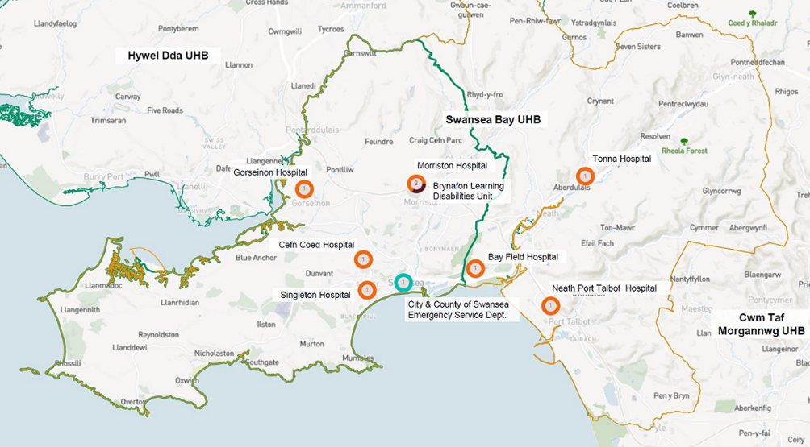
SINGLETON HOSPITAL
Singleton Hospital, overlooking Swansea Bay, will be undergoing significant change over the next few years. The ultimate vision is Singleton playing a key part as an innovative health campus offering 21st century services, care, and values.
The strategic objective for Singleton is to replace and refurbish the existing estate and optimise currently underutilised areas.

4.0 CURRENT ESTATES PERFORMANCE
INTRODUCTION
The Health Board estate has grown in size over many years, responding to service and population requirements, and specialist requirements. The buildings owned are of various size and age, some developed before 1900s, and others after 2015. The buildings and facilities are set within a complex infrastructure of engineering systems for the provision of critical services to wards, theatres, departments, and laboratories, enabling service delivery which is appropriate and timely for patients.
The aged estate is generally more complicated to reconfigure and often changes do not enable the best and efficient delivery of modern-day services. This includes developing layouts in ward environments, which do not allow adequate segregation of patients for infection prevention and control purposes, including isolation and large open wards that cannot be converted easily to meet the required standards for privacy and dignity. The configuration of a lot of the older facilities of the accommodation is also not suitable for the increasing number of people with dementia or cognitive impairments.
FUTURE VISION
The Health Board’s Estate Strategy supports our Strategic Direction by delivering our Clinical Services Plan’s vision for centres of excellence (see below):
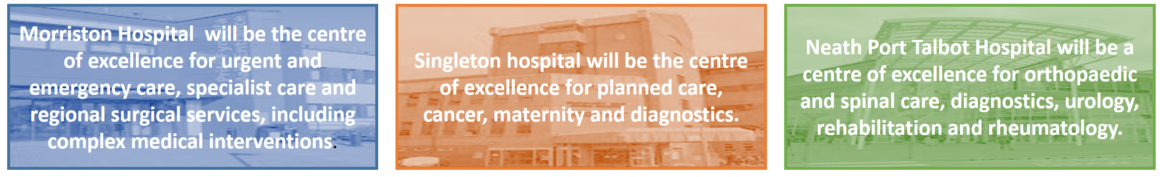
Singleton is developing as the centre of excellence for planned care, cancer care, maternity and diagnostics. In the short term the plan is as follows:
This is now enabling the development of the new Singleton Hospital - Regional Centre of Excellence for Planned Care, Diagnostic Testing, Elective Surgery, Woman’s Health, Cancer Care, and a Strategic Hospital Partner to Swansea University Medical School to establish a Healthcare technology Centre.
Singleton Hospital will also be supported to establish its role as a centre of excellence for rapid access and ambulatory (same day) care, cutting edge diagnostics, outpatients, rehabilitation, and community-based care, alongside the educational facilities.
This investment supports development of a high-quality static PET CT facility and support accommodation in situ with the SWWCC.
SINGLETON HOSPITAL - BACKGROUND
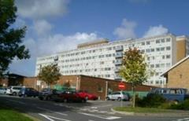 | The first stage of the hospital, which included outpatients' facilities, was completed in 1957. Work recommenced in 1963, and the second stage, which allowed the closure of the aging Swansea Hospital in St. Helen's Road, was completed in 1968. The area is currently 63,925m2.  The hospital adjoins the Singleton Park Campus of Swansea University.
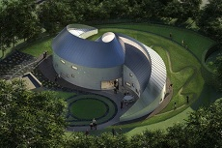 | The South West Wales Cancer Centre (SWWCC) and a separate chemotherapy day unit are also at Singleton and the iconic Maggie's Cancer Care Centre for South West Wales, is located in the grounds; bone marrow transplants are carried out by the haematology service.  There is also a GP-led Minor Injuries Unit. The hospital has 439 available beds, and comprises 63,283m2 of gross internal floor area.
The Facilitates include acute general medical services, care of the elderly, surgical, ophthalmology, ENT and radiotherapy services. It also offers a High Dependency Unit and obstetric and gynaecological departments. A number of these departments provide sub-regional services as well as secondary care services, the services include ophthalmology, ear nose and throat, and Genito-urinary services.
These services are supported by an intensive care and high dependency beds, and a range of high quality therapeutic and diagnostic services. The hospital currently has a regional, consultant-led maternity unit and neonatal intensive care.
- Singleton offers a consultant-led maternity unit and a neonatal intensive care unit for very sick babies (recognised as a sub-regional Centre). In the future, the maternity and NICU services are expected to move to Morriston Hospital.
- The site accommodates a GP acute unit, the first to open in Wales, allowing GPs quicker and easier access to hospital consultants and services so that patients have faster access to the care they need. It has an urgent care service which combines the GP acute unit with a number of other services which assess patients who are referred by GPs and other healthcare professionals.
- Genetic counselling clinics are held weekly and there is a major Genito-urinary medicine unit that provides a service for South West Wales as does the Department of Medical Physics and Radiotherapy.
This is now enabling the development of the new Singleton Hospital - Regional Centre of Excellence for Planned Care, Diagnostic Testing, Elective Surgery, Woman’s Health, Cancer Care, and a Strategic Hospital Partner to Swansea University Medical School to establish a Healthcare technology Centre.
Singleton Hospital will also be supported to establish its role as a centre of excellence for rapid access and ambulatory (same day) care, cutting edge diagnostics, outpatients, rehabilitation, and community-based care, alongside the educational facilities.
SINGLETON HOSPITAL - BACKLOG MAINTENANCE
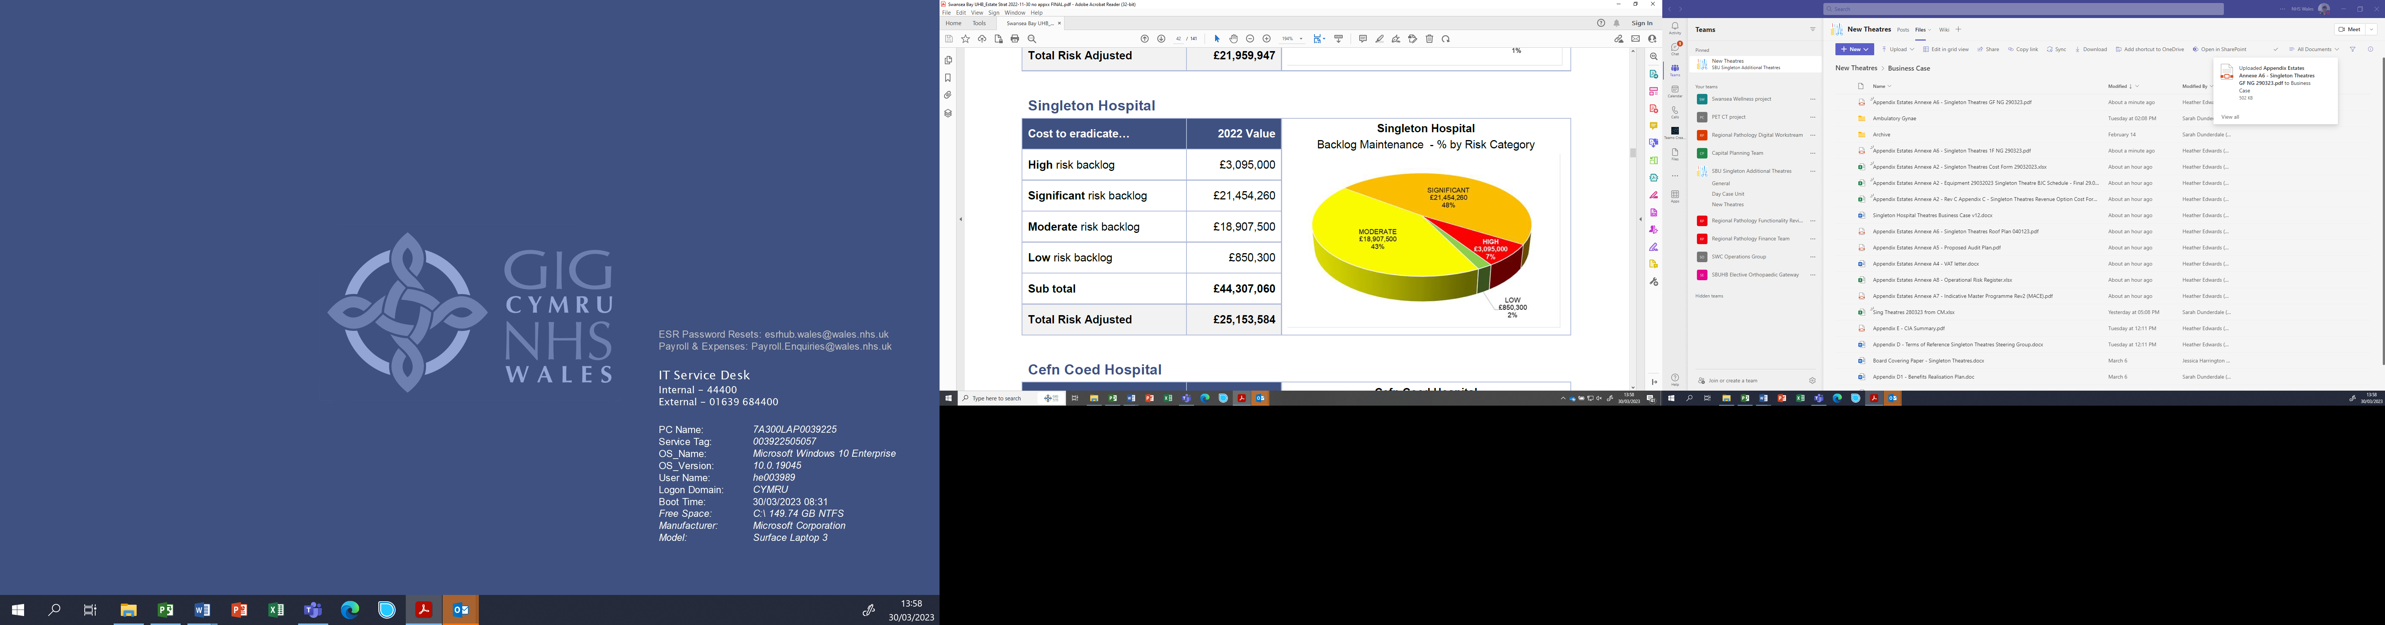
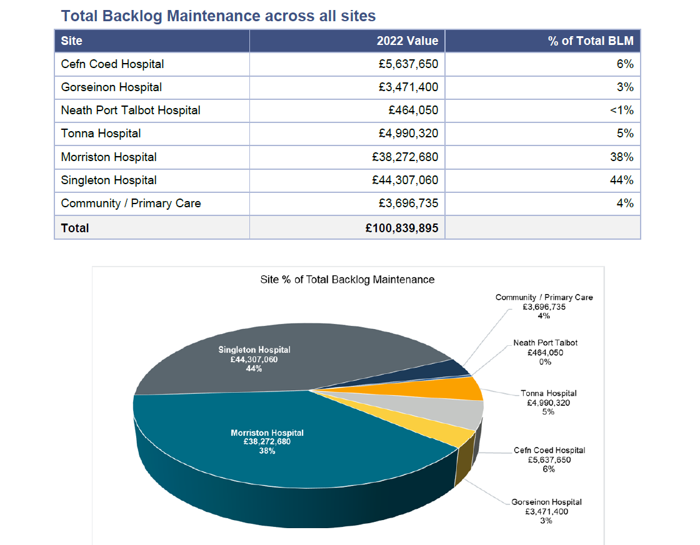
The Health Board’s liability for their Estate totals £100,839,895 which equates to approximately £391 per sqm which is in line with national averages for backlog maintenance. The highest proportion of backlog liability is with Morriston Hospital and Singleton Hospital with 82% of the overall backlog total.
Singleton Hospital with 44% of the total backlog amount and £44,307,060 equates to £700.14 per sqm which is high and well above the national average. The risk adjusted figure of £25,153,584 reduces the rate down to £397 per sqm which is much more in line with national average benchmarks.

SINGLETON HOSPITAL - BACKLOG MAINTENANCE
The Health Board’s liability for their Estate totals £100,839,895 which equates to approximately £391 per sqm which is in line with national averages for backlog maintenance. The highest proportion of backlog liability is with Morriston Hospital and Singleton Hospital with 82% of the overall backlog total.
Singleton Hospital with 44% of the total backlog amount and £44,307,060 equates to £700.14 per sqm which is high and well above the national average. The risk adjusted figure of £25,153,584 reduces the rate down to £397 per sqm which is much more in line with national average benchmarks.
6 FACET SURVEYS
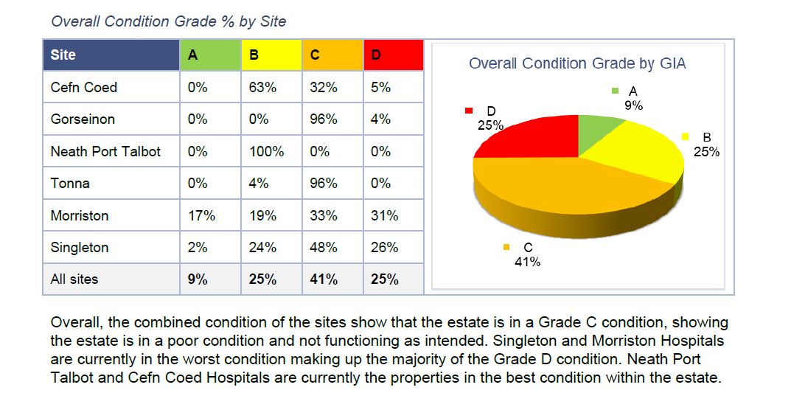
Overall, the combined condition of the sites show that the estate is in a Grade C condition, showing the estate is in a poor condition and not functioning as intended. Singleton and Morriston Hospitals are currently in the worst condition making up the majority of the Grade D condition.
The full 6 Facet Survey of the estate, carried out in 2022 by Oakleaf has found the following results for Singleton Hospital (profiled against the wider estate):

Facet 1 – Condition
A | Good. Performing as intended and performing efficiently.
B | Satisfactory. Performing as intended but exhibiting minor deterioration.
C | Poor. Exhibiting major defects and/or not operating as intended.
D | Bad. Life expired and/or serious risk of imminent failure.

Overall Condition Grade % by Site
Site | A | B | C | D | 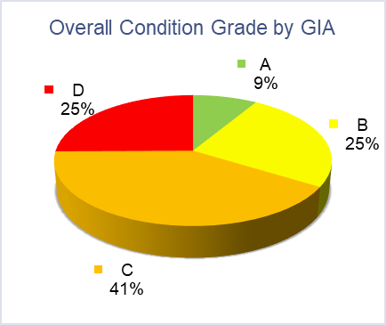
Cefn Coed | 0% | 63% | 32% | 5%
Gorseinon | 0% | 0% | 96% | 4%
Neath Port Talbot | 0% | 100% | 0% | 0%
Tonna | 0% | 4% | 96% | 0%
Morriston | 17% | 19% | 33% | 31%
Singleton | 2% | 24% | 48% | 26%
All sites | 9% | 25% | 41% | 25%

Overall, the combined condition of the sites show that the estate is in a Grade C condition, showing the estate is in a poor condition and not functioning as intended. Singleton and Morriston Hospitals are currently in the worst condition making up the majority of the Grade D condition. Neath Port Talbot and Cefn Coed Hospitals are currently the properties in the best condition within the estate.

Facet 2 – Functional Suitability
A | Very Satisfactory
B | Satisfactory
C | Not Satisfactory
D | Unacceptable

Overall Function Grade % by Site
Site | A | B | C | D | 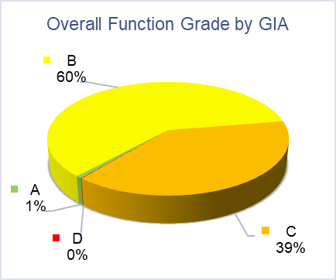
Cefn Coed | 0% | 62% | 38% | 0%
Gorseinon | 0% | 96% | 0% | 4%
Neath Port Talbot | 0% | 100% | 0% | 0%
Tonna | 0% | 100% | 0% | 0%
Morriston | 0% | 49% | 51% | 0%
Singleton | 1% | 66% | 32% | 0%
All sites | 1% | 60% | 39% | 0%

Overall, the combined Functional Suitability Grade across the sites are graded as satisfactory, however nearly 40% of the combined grading is graded as not satisfactory.

Facet 3 – Space Utilisation
Overall Space Utilisation Grade % by Site
Site | Empty | Fully Used | N/A | Overcrowded | Under-used
Cefn Coed | 5% | 60% | 3% | 32% | 0%
Gorseinon | 5% | 0% | 0% | 95% | 0%
Neath Port Talbot | 0% | 99% | 1% | 0% | 0%
Tonna | 1% | 0% | 1% | 0% | 98%
Morriston | 0% | 44% | 1% | 52% | 3%
Singleton | 0% | 91% | 0% | 8% | 1%
All sites | 0% | 62% | 1% | 28% | 9%

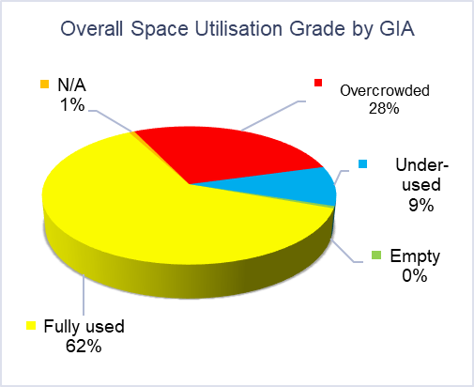 | Overall, the combined Space Utilisation rating shows that the majority of the estate is fully used, however this does not portray the scale of overcrowding within the estate.

acet 4 – Quality Audit
A | Excellent | C | Capital Investment Required
B | Maintenance Required | D | Very Poor

Overall Quality Grade % by Site
Site | A | B | C | D | 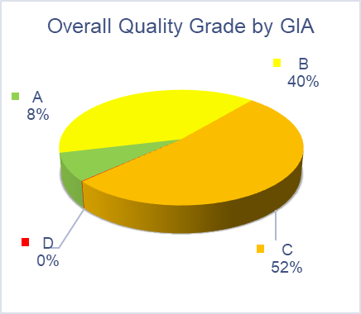
Cefn Coed | 0% | 62% | 38% | 0%
Gorseinon | 0% | 96% | 0% | 4%
Neath Port Talbot | 0% | 100% | 0% | 0%
Tonna | 0% | 6% | 94% | 0%
Morriston | 17% | 41% | 42% | 0%
Singleton | 0% | 29% | 71% | 0%
All sites | 8% | 40% | 52% | 0%

Overall, the combined Quality Grade shows that the majority of the estate requires capital investment and 40% of the rest of the estate requires maintenance. Morriston is the only site that has a small proportion of the site being in an excellent condition and Tonna / Singleton Hospitals have the highest amount of their estate requiring maintenance.

Facet 5 – Statutory Compliance
A | Very satisfactory, no change needed | C | Not satisfactory, change needed
B | Satisfactory, no change needed | D | Unacceptable

Overall Statutory Compliance Grade % by Site
Site | A | B | C | D | 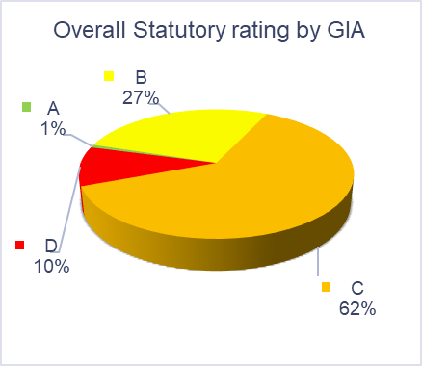
Cefn Coed | 0% | 62% | 38% | 0%
Gorseinon | 0% | 11% | 85% | 4%
Neath Port Talbot | 0% | 100% | 0% | 0%
Tonna | 0% | 7% | 93% | 0%
Morriston | 0% | 32% | 68% | 0%
Singleton | 2% | 12% | 60% | 26%
All sites | 1% | 27% | 62% | 10%

Overall, the combined Statutory Compliance Grade shows that the estate is within the not satisfactory grade and a tenth of the estate is within the not acceptable category. A quarter of the Singleton Hospital site is within an unacceptable condition and Tonna / Gorseinon Hospital’s are over 80% within the not satisfactory grading.

Facet 6 – Environmental
Energy Efficiency Survey Methodology:
The buildings will be ranked on the following usage per unit volume:
GJ per 100 cubic metres m3
⚫ Condition A 35-55
⚫ Condition B 56-65
⚫ Condition C 66-75
⚫ Condition D 76-100
The following will be assessed based on Oakleaf Q and A at technical audits:
⚫ B - Water Consumption
⚫ C - Waste Management
⚫ D - Transport Management
⚫ E - Procurement

