Meeting Date | 25 June 2024 |  | Agenda Item |  | 2.3
Report Title | Capital Resource Plan Month 2 Update
Report Author | Ian MacDonald, Assistant Director of Finance (Strategy & Planning)
Report Sponsor | Darren Griffiths, Director of Finance & Performance
Presented by | Ian MacDonald, Assistant Director of Finance (Strategy & Planning)
Freedom of Information | Open
Purpose of the Report | To provide an update on the financial performance of the Health Board’s capital programme at month 2 and the impact of emerging risks and opportunities on the projected outturn position for 2024/25.
Key Issues | The Health Board approved a balanced capital financial plan for 2024/25 as part of the approved Annual Plan.  The forecast outturn position reported at Month 2 shows an overspend position of £3.224m. Additional income from WG (Welsh Government) and disposals are anticipated to provide a balanced position.  The national funding position remains unclear pending the outcome of the national capital prioritisation exercise. A small programme contingency is under pressure, as requests for additional capital funding continue to emerge from the service.  The risk of the plan shifting from balance to imbalance remains material and is reflected in Risk 93 on the Health Board Risk Register
Specific Action Required  (please choose one only) | Information | Discussion | Assurance | Approval
Specific Action Required  (please choose one only) | ☐ | ☐ | ☐ | ☒
Recommendations | Members are asked to:  - NOTE the month 2 reported position of the capital plan.  - NOTE the emerging funding risks and the material risk of the plan shifting from balance to imbalance.  - NOTE the mitigating actions that will require further exploration.  - NOTE the temporary hold on £500k for estates.  - NOTE the contingency sum to maintain the balanced plan is £80k.

CAPITAL PLAN – MONTH 2 UPDATE

- INTRODUCTION
To provide an update on the financial performance of the Health Board’s capital programme at month 2.

- BACKGROUND
The Health Board approved a balanced capital financial plan for 2024/25 as part of the Annual Plan submitted to Welsh Government (WG) in March 2024.

The plan included a positive uplift of 50%/£1.3m against the 2022/23 reduction in discretionary capital of 24%/£2.671m (following the national £100m reduction in the core capital budget allocated to the Health and Social Care department within WG). This means the discretionary allocation has been reinstated in full, although it should be noted that this allocation has never been increased over the last 12 years to reflect the impact of rising prices.

The national funding situation continues to be challenging, with very little uncommitted capital funding remaining; this could have an impact on not just the Health Board’s discretionary capital programme, which is primarily for replacement of the existing asset base, but also larger service continuity, service recovery and service change schemes, including those contained within the approved Health Board Estates Strategy.

As in 2022/23, the additional national slippage funding provided during Q4 in 2023/24 was much lower than in previous years, meaning little headway was made with high-risk backlog equipment replacement as would normally have been expected – which is starting to have a material impact this year.

The approved plan also included the repayment of existing commitments from the All- Wales Capital Programme of £3.1m, where these schemes slipped during the final 6 months of 2023/24 and the Health Board then must manage the slippage across years through its discretionary programme,

The approved plan also includes income assumptions, including the receipt of business case fees from WG and disposals proceeds.

Month 2 Position

The forecast outturn position reported at month 2 shows an over-commitment of £3.224m. Allocations shown below in table 1 are anticipated to provide a balanced position. There are risks on the income assumption due to the national funding challenges and timing of planned disposals.

Whilst funding national funding streams are emerging for backlog estates maintenance and targeted funding for large diagnostics imaging modalities, there is very limited flexibility remaining within the approved plan locally and nationally at this stage, for the backlog replacement programme for medical equipment and IT Infrastructure. The ability to retain a balanced capital position as last year will remain challenging as there is very little remaining flexibility in the programme to manage emerging service and infrastructure risks.

Table 1 Month 2 Forecast Outturn Position 2024/25
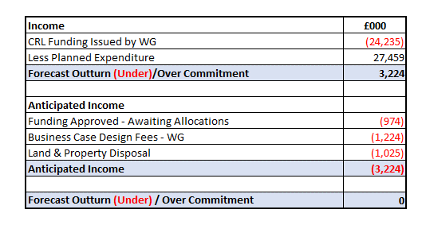
Funding Risks

The approved plan contained an assumption of additional income to offset planned in-year spend or the repayment of business case fees incurred in prior-years. A risk assessment on these income streams is shown below in table 2. Although the level of assumed income on business case fees from WG is around what would be expected at this early stage of the year, the additional risk this year is related to the on-going national capital prioritisation work. As an example, the business case for the provision of new Modular Theatres at Singleton was submitted to WG in November 2023. The usual WG scrutiny of the case has been delayed pending the outcome of the national prioritisation work. There is no certainty that the case will be approved, thus putting at risk the repayment of the £477k business case design fees. To mitigate some of the estimated £892k high risks, it is proposed that £500k of the approved £1.1m allocation for estates maintenance is held back at this stage. This is deeded to be a reasonable proposal at this stage in the year, particularly as there is already a substantial investment of £5m being made this year into estates from the national EFAB (Estates
Funding Advisory Board) which includes, phase 2 of the fire alarm replacement,

roofing works, ward nurse call systems and window replacements at Morriston. Air handling unit upgrades and calorifier replacement at Singleton and water safety improvements and asbestos removal across the Health Board Estate. A bid for an additional £4.4m to support estate backlog maintenance has been submitted this month as part of a national £30m backlog maintenance fund (see table 3). The bid is currently with the WG Cabinet Secretary for approval and an announcement is expected shortly.

Table 2 Anticipated Income 2024/25
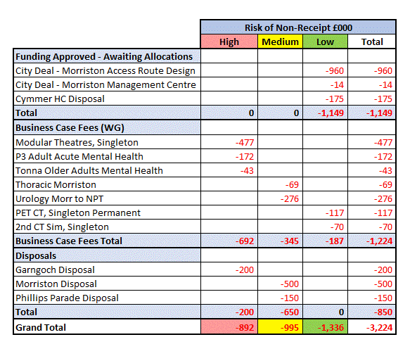

Additional Capital National Funding Allocations

Funding of £1.587m was received in May from WG for the reinstatement of the open plan main entrance at Morriston. This includes work that has already been completed on the removal of the front end of the Tawe ward and creation of the new discharge lounge. This funding will now allow the remaining work to commence, which includes provision of furniture for the front-end open plan patient/visitor waiting area which can then be opened in around 6 weeks. Work will also now commence on creating a dedicated/protected staff welfare area (internal and outside seating areas) and the creation of an enhanced service including the provision of Phlebotomy and outpatient Lung Function Suite.

Additional funding bids have been submitted for Estates Backlog Maintenance of £9.528 in total or which we are anticipating an early indication of approval for tranche 1 £4.460m this month. If successful, one of the main areas of work will be to continue with the roofing replacement and other infrastructure works in another 3 wards in Morriston, as well as works across the Health Board estate on fire doors, air handling unit replacements and lift replacements.

Although not included in the month 2 plan, approval was received last week for an additional £2.187m over the next 2 years to undertake the replacement of the Fluoroscopy room at NPT and general x-ray room 2 at Morriston.

Table 3 Additional Capital Allocations Received
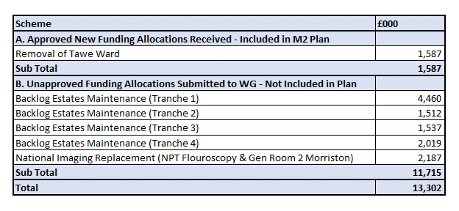
Contingency

Although there are contingencies built into major projects across the capital programme, the remaining general discretionary programme contingency is only £80k. Given the allocations for medical equipment and digital services replacements are mostly fully committed, this does not leave much flexibility in the programme.

Overall Assessment

The relatively small allocations for the medical equipping £707k and digital £740k replacement programmes are mostly fully committed. This includes an allocation made in May for £644k by the Capital Prioritisation Group for the highest priority risks identified by the SDUs for medical equipment replacement. However, the CPG (Capital Prioritisation Group) is assessing capital bids of £5m for replacement items with a risk score of 16 and above. These will continue to be risk assessed through the CPG. However, given the current national funding constraints and the limited ability to cease spending on schemes due to most already being contractually committed or for high service risks, the risk of the plan shifting from balance to imbalance is material.

To mitigate some of the estimated £892k high risks business case fee income risks, it is proposed that £500k of the approved £1.1m allocation for estates maintenance is held back at this stage.

As it looks unlikely that any additional national funding will be released in the next few months for medical equipment replacement, if the plan is to remain balanced within the resources provided, it would be prudent to explore further mitigations: -

- Charitable funds
- Slipping schemes
- Revenue solutions, in particular leases where value for money can be demonstrated. These would need the agreement of WG to provide technical capital funding, as all new leases are treated on-balance sheet following the introduction of IFRS 16 in the UK public sector in 2022/23. There will of course then be an additional annual revenue impact.

National Capital Funding Outlook

WG has indicated that the national capital funding challenges are expected to remain in the short to medium term. In November a new NHS All Wales Capital Prioritisation process was issued, and the Health Board submitted its response by way of a 10-year prioritised programme for major capital investment in March as part of the annual plan submission. WG are expecting to provide feedback later in quarter 2. In the meantime, several business cases are on hold - these include cases in production waiting the next stage of business case fees e.g. Thoracics, Adult Acute Mental Health and Regional Pathology and cases submitted to WG being held in scrutiny – Modular Theatres Singleton and Hybrid Theatres. We are however having positive discussions with WG about the release of funding to progress our highest priority - the Morriston ED improvements.

- GOVERNANCE AND RISK ISSUES
There is an increased possibility that new service requests, including those with a high-risk score will be unable to be receive capital funding during 2024/25 within the capital resources made available to the Health Board. These risks will continue to be assessed through the Capital Prioritisation Group and raised up through the Management Board.

A risk register entry (Risk 93) has been included in the Health Board risk register and is currently assessed as a 20 score risk.

- FINANCIAL IMPLICATIONS
The financial implications and funding risks are as detailed within the body of the report. In summary, the approved balanced capital plan is assuming additional funding of £3.224m.

The remaining contingency in the plan is £80k. Without additional funding support from WG and/or additional internal mitigations, further requests for capital funding may not be affordable with the allocated resources.

It is proposed that £500k is held aside for now from the Estates allocation to mitigate the risk associated with the high-risk business case fee income.

- RECOMMENDATION

Members are asked to:
- NOTE the month 2 reported position of the capital plan.
- NOTE the emerging funding risks and the material risk of the plan shifting from balance to imbalance.
- NOTE the temporary hold on £500k for estates
- NOTE the mitigating actions that will require further exploration.
- NOTE the contingency sum to maintain the balanced plan is £80k.

Governance and Assurance

Link to Enabling Objectives  (please choose) | Supporting better health and wellbeing by actively promoting and empowering people to live well in resilient communities
Link to Enabling Objectives  (please choose) | Partnerships for Improving Health and Wellbeing |  | ☐
Link to Enabling Objectives  (please choose) | Co-Production and Health Literacy |  | ☐
Link to Enabling Objectives  (please choose) | Digitally Enabled Health and Wellbeing |  | ☐
Link to Enabling Objectives  (please choose) | Deliver better care through excellent health and care services achieving the outcomes that matter most to people
Link to Enabling Objectives  (please choose) | Best Value Outcomes and High Quality Care |  | ☒
Link to Enabling Objectives  (please choose) | Partnerships for Care |  | ☐
Link to Enabling Objectives  (please choose) | Excellent Staff |  | ☐
Link to Enabling Objectives  (please choose) | Digitally Enabled Care |  | ☐
Link to Enabling Objectives  (please choose) | Outstanding Research, Innovation, Education and Learning |  | ☐
Health and Care Standards
(please choose) | Staying Healthy |  | ☐
(please choose) | Safe Care |  | ☐
(please choose) | Effective Care |  | ☐
(please choose) | Dignified Care |  | ☐
(please choose) | Timely Care |  | ☐
(please choose) | Individual Care |  | ☐
(please choose) | Staff and Resources |  | ☒
Quality, Safety and Patient Experience
Without additional funding support from WG, further requests for capital funding will not be affordable within the allocated resources. This may impact on new service requests for additional capital funding for estates, medical equipping and digital services.

Financial Implications
The financial implications and funding risks are as detailed within the body of the report. In summary, the approved balanced capital plan is assuming additional funding of £3.224m. Without additional funding support from WG and/or additional internal mitigations, further requests for capital funding may not be affordable within the allocated resources.

Legal Implications (including equality and diversity assessment)
None
Staffing Implications
None
Long Term Implications (including the impact of the Well-being of Future Generations (Wales) Act 2015)
n/a
Report History |  | Approved Capital Plan Board March 2024
Appendices |  | None

