

Meeting Date | 25th March 2025 |  | Agenda Item |  | 2.2
Name of Meeting | Performance and Finance Committee
Report Title | Financial Report – Month 11 2024/25
Report Author | Samantha Moss, Deputy Director of Finance  Gemma Pearson, Finance Business Partner
Report Sponsor | Darren Griffiths, Executive Director of Finance and Performance
Presented by | Samantha Moss, Deputy Director of Finance
Freedom of Information | Open
Purpose of the Report | The report advises the Performance & Finance Committee of the Health Board on the financial position for Month 11 2024/25 (February 2025) and risks regarding the current forecast revenue year end outturn.
Key Issues | The report invites the Performance & Finance Committee to note the detailed analysis of the financial position for Month 11 2024/25 (February 2025).  The report includes a summary of the key drivers of the position either at Service level or by expenditure type (i.e. Non-Pay/Pay). It also provides information of the current position with regards to Health Board reserves to ensure transparency in the overall Health Board position.  Risk will have been considered on the basis of the information provided within the report and the score updated where necessary.  Whilst the key messages are provided within the main body of the report, further information is provided in the Appendices.
Specific Action Required | Information | Discussion | Assurance | Approval
Specific Action Required | ☐ | ☐ | ☒ | ☐
Recommendations | Members are asked to:  - Consider and comment upon the Health Board’s financial performance for Month 11 2024/25.  - TAKE ASSURANCE from the actions to ensure delivery of the financial assessment submitted on 26th September 2024, with a line of sight to what was £50.8m in the submission but has since been restated to £43.7m following receipt of in-year funding from WG of £6.4m and the control total set, which now includes: -  - Continued focus on the actions presented at the Special Public Board Meeting on 19th December 2024 to deliver the Control Total of £43.7m, with an assessment of the current gap and options available for mitigation.  - Delivery via the oversight of the Recovery & Sustainability (R&S) Board in the reduction of the 2024/25 financial gap from £14.3m reported at December 2024.  - Progress of the R&S Board, with updates provided via a separate report to the PFC and further briefing session, aligned to the agreed governance route.  - Continual review by Service Areas of schemes to identify further opportunities to support savings gaps reported in the Section 3 of the paper.  - Ongoing focus on Variable Pay performance supported by an enhanced approval and oversight route which commenced w/c 6th January 2025.  - Publication of control targets aligned to the Health Board’s Financial Assessment.  - Continued work to refine ‘Year End Delivery Plan’ for 2024/25 and identification of non-recurrent opportunities.  - Oversight of the formal responses from the Accountability Letters provided in Appendix 4.  - CONSIDER the risks to the position at Month 11.  - SUPPORT the position with regards to Health Board Reserves.  - CONSIDER all actions and updates to support the management of the 2024/25 financial position.

FINANCIAL REPORT – MONTH 11

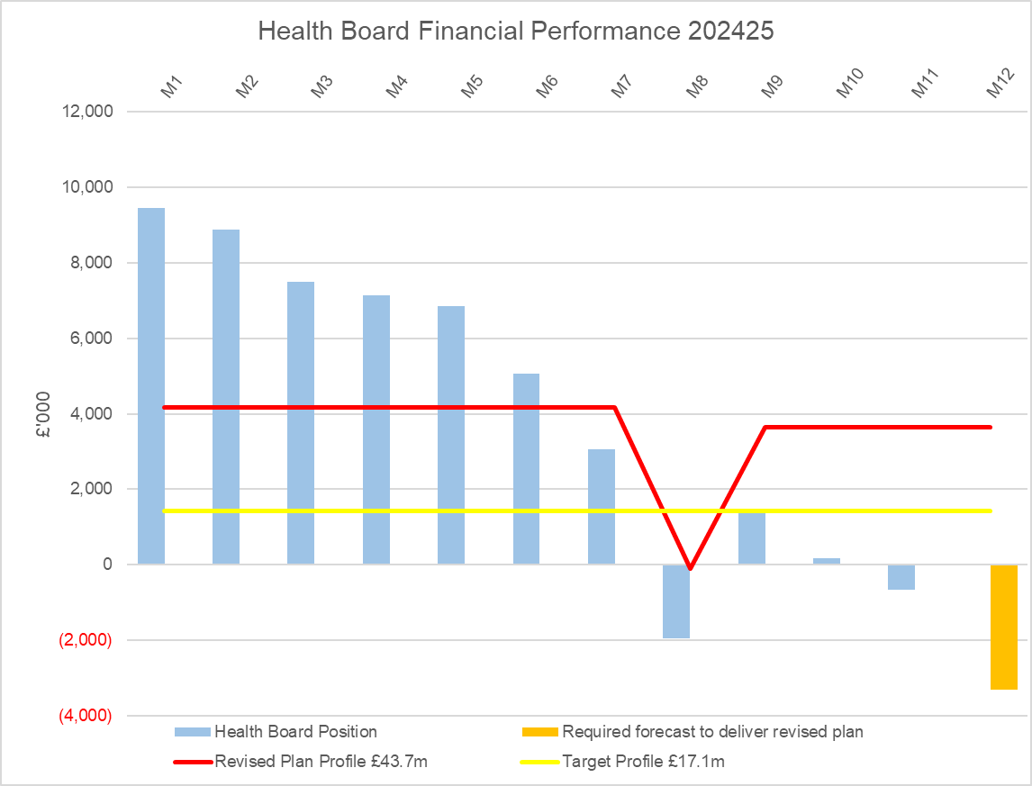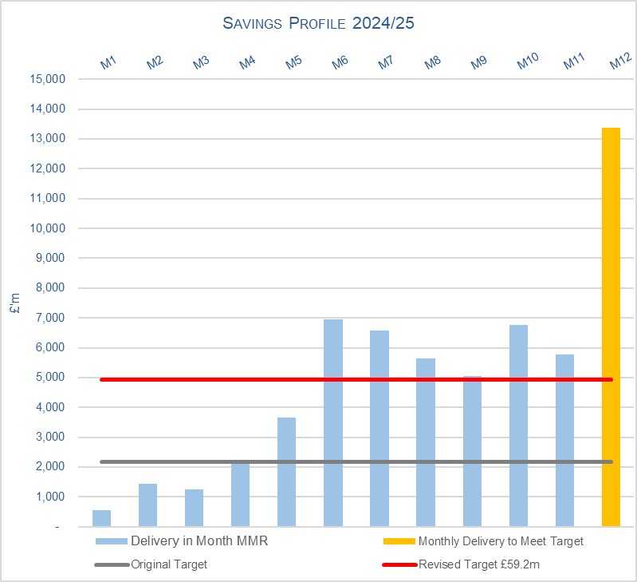

SUMMARY OF REVENUE PERFORMANCE

On the 2nd December 2024 the Health Board received a letter from WG on the 2024/25 In-year financial allocations & revised Target Control Total. The letter outlined that an additional £6.4m of recurrent funding has been allocated to the Health Board, with an expectation that the year-end assessed position reduces from the £50.1m noted since Month 1 to £43.7m.

At Month 11 the Health Board (HB) is £47.0m overspent against cumulative deficit plan of £40.1m YTD. The In-Month financial position was an underspend of £0.7m, which is an improvement of £0.9m compared to Month 10, however this is due to a combination of the release of central non-recurrent opportunities (part of the £25m) earlier than originally phased and Service Group non-recurrent fortuitous benefits and does not reflect the operational improvements needed within services to address the financial challenges on a recurrent basis.

- FINANCIAL PLAN 2024/25
On the 26th September 2024 the Health Board submitted a revised Financial Assessment for 2024/25. The assessment and accompanying letter summarised a high degree of confidence in the delivery of £64.1m deficit position by the 31st March 2025, with further opportunities of £13.3m giving the Health Board line of sight to £50.8m. Recognising the risks around the delivery of the £50.8m but with a line of sight to £50.8m the forecast remained at £50.1m. In early December 2024 Welsh Government (WG) issued an additional £6.4m of recurrent funding to the Health Board, which has reduced the deficit plan to £43.7m.

On the 19th December 2024 a Special Board meeting was provided with an assessment of the position based on the information available following Month 8 closedown. In summary the financial assessment showed a possible outturn to end March 2025 of £57.9m, with a gap to the deficit plan figure of £14.3m. Full details of the work underway to mitigate the £14.3m were presented to the Board.

Since the meeting on the 19th December 2024 there have been five Recovery & Sustainability Board meetings, which have focused primarily on driving down the in-year overspend to support the delivery of the deficit plan of £43.7m. Further details on the Recovery & Sustainability Board meetings are presented to Performance & Finance Committee in a separate paper, and the updated forecasts from these meetings are used to support the financial assessment summarised in the table below referred to as the ‘Performance Against £43.7m: Bottom-Up Assessment’

The assessment of the Month 11 position identified a number of opportunities which supported the position achieving £0.652m underspent in month. Some of these opportunities were known and were simply a change in the phasing from Month 12 to Month 11, whilst others were further non-recurrent fortuitous benefits within Service Groups. A summary of this is provided in the table below:
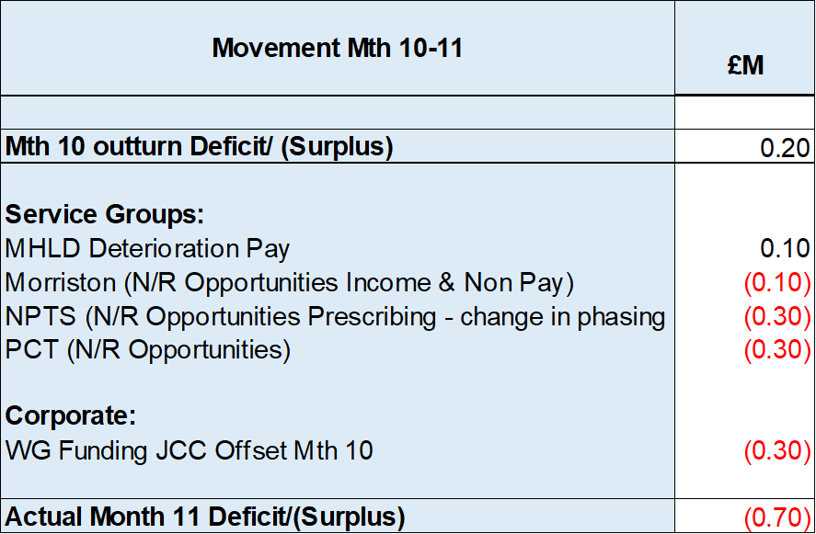
[JCC – 10/12th of the JCC pressure was reflected in the Month 10 position but post Month 10 closedown WG provided £0.290m of funding which will be reflected in the Month 11 position].

An assessment immediately following the Month 11 closedown was undertaken and was presented to Independent Members on working day 7 (4th March 2025) and builds in some of the data from the Recovery & Sustainability Board meeting held at the end of February. A summary of this assessment is provided below:

Performance Against £43.7m: Bottom-Up Assessment @ Mth 11
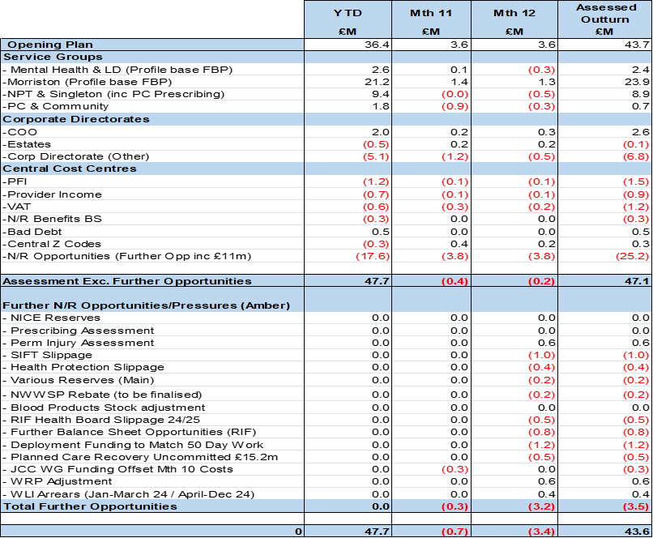

One of the key differences between the Month 10 version and the table above is the removal of the requirement to deliver £1.9m of variable pay reductions. But whilst this is not explicit within the table, the message to the organisation is that a reduction in spend remains critical for two reasons:

- Some of the N/R Opportunities are an assessment and if you applied a RAG rating most would be Amber as opposed to Green; as the value is not confirmed and there are risks in the delivery.
- Run rate reductions in 2024/25 will flow into 2025/26, when the N/R Opportunities from this financial year will no longer be available.

There remains a considerable amount of risk in the delivery of the £43.6m detailed in the table above, these risks include:

- 2024/25 Pay Award settlement – whilst majority has been received there remains £1.371m of funding for Medical & Dental Pay Award made in January which WG has not confirmed funding for. Details have been submitted to the NHS Executive and will be reported in the Month 11 MMR. The £1.371m is assumed within the position reported on slide 7.

- Service Group Positions – the tables in Part 1 of the previous slide assumes a level of spend that presents a risk, and below ae some examples:

  - MH/LD = expectation that this area underspends in Mth 12 to achieve the £2.4m target
  - NPTS = with the original £25m there was £1.4m of opportunities against PC Prescribing. Based on the December PAR, this has been transferred to the £8.9m forecast for NPTS. However further assessment will align to the January PAR data published later in March.
  - Corporate Directorate = COO/Estates to remain at current level of spend and remaining areas continue with underspend.

- N/R opportunities – the lower half of the table ‘Performance Against £43.7m: Bottom-Up Assessment’ provides an assessment following Working Day 5 Month 11 closedown. However, none of the £3.2m in Month 12 are currently 100% confirmed and these numbers will flex as we close the financial position.

These risks are considered in the assessment of the overall risk in achieving financial plan summarised in section 4 of this paper.

- KEY DRIVERS OF THE IN-MONTH POSITION
The key drivers of the Month 11 and YTD position are summarised in the tables below. Further detail at a Health Board level of expenditure on Income, Pay and Non-Pay, is also provided in Appendix 1.

  - Key Drivers by Service Area In-Month

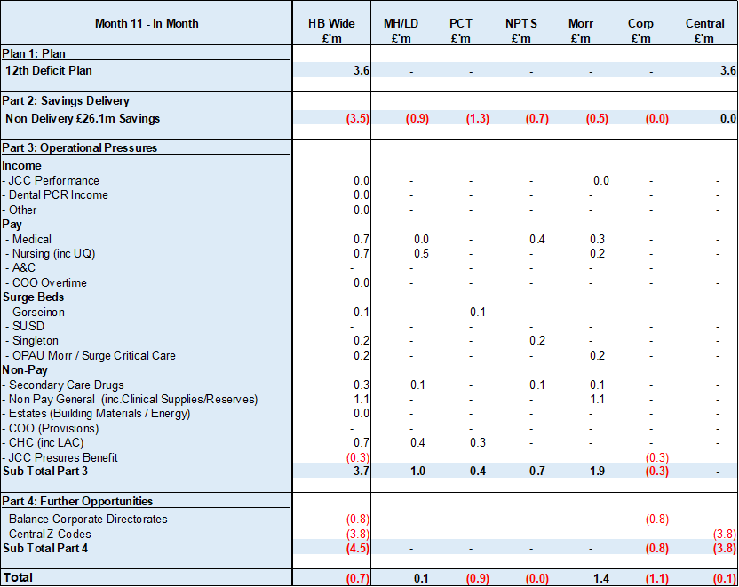

  - Key Drivers by Service Area YTD

  - Summary By Expenditure Type

- Income
The Joint Commissioning Committee (JCC) Income as a provider underperformed in-month with increased activity in Cardiology services offset by decreased activity in Burns services; the in-month underachievement was £0.1m. The YTD underachievement is £0.3m.

Dental Contract Income underperformed in-month by £0.1m, with an YTD underachievement of £1.1m.

- Pay
The Month 11 pay overspend was £2.1m (Month 10, £0.8m), this was again largely due to a continuation of surge bed capacity required, staff sickness absence and acuity in Critical Care. The YTD pay pressures are driven by a number of factors including the continuation of staffing surge bed capacity, pressures on services across the organisation and high levels acuity, coupled with high levels of sickness.

- Clinical Consumables
(see Appendix 1)

- Prescribing
(see Appendix 1)

- SAVINGS

The position reported in the Monthly Monitoring Return (MMR) only allows the reporting of Green and Amber schemes and this is provided in the table below:

Savings Table 1
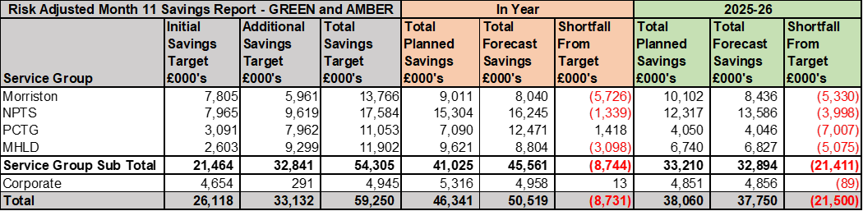

A summary of the total opportunities, including Red Schemes, at 7th March 2025 is provided in the table below:

Savings Table 2
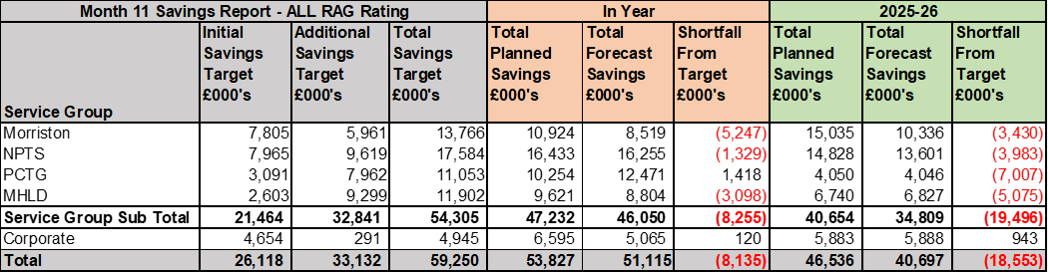
The total level of opportunities forecast in year is £51.1m.

Further details on savings are provided in Appendix 3.

- GOVERNANCE AND RISK

Two Board level financial risks:

- Achieving financial plan (HBR92) with the key elements as follows: -

  - Risk of delivery of savings quantum
  - Risk of operational overspend being in excess of funding available agreed via the Financial Plan
  - Risk of commitment of reserves (e.g. NICE) being above reserves available.
  - Risk of achieving the actions and options outlined in the 2024/25 Financial Recovery & Sustainability Assessment.

- 2024/25: Based on the financial performance at Month 11, it is proposed that the Health Board Corporate Risk Register retain the existing risk score to 25 given YTD variance from the revised deficit plan of £43.7m. Details on some of the specific risks aligned to the financial assessment to 31st March 2025 have been provided in Section 1 of this paper.

- 2025/26: An action from the January 2025 PFC was to add a supplementary note under HBRR 92 to reflect the challenges of the new financial year. At this point in the planning process the risk score would be 25 for a number of reasons:
  - Within 2024/25 a significant amount of Non recurrent opportunities have been deployed, these will not be available in 2025/26.
  - There is currently limited traction on the change in run rate spend in 2024/25, which will be needed in 2025/26 to address the deficit and allow the Health Board to achieve the WG Target Control Total of £17m.
  - Current plan requires a significant level of recurrent savings for which the Health Board does not yet have a clear plan on how this will be met in full, although there has been progress since the Month 10 report was completed.

- Availability of capital (HBR93). This risk was re-opened in 2022/23 given the reduction in discretionary capital allocation. Whilst work is underway to manage schemes to reduce commitments in 2024/25 and to produce a balanced plan, the risk varies during the year as more details on schemes emerge and potential slippage funding is made available by Welsh Government. A paper was received by PFC in December 2024 to consider the current capital position. This paper described a balanced position. Whilst the delivery of the balanced position is reliant on a large number of actions being delivered, the plan has evolved to have less risk in it given the success of bids made for substantial sums of capital being received in year.

There is no change to this assessment at the end of Month 11 and it is therefore proposed that the score remains at 12 to reflect major consequence and possible likelihood at this time.

- RECOMMENDATIONS
Members are asked to:
  - Consider and comment upon the Health Board’s financial performance for Month 11 2024/25.
  - TAKE ASSURANCE from the actions to ensure delivery of the financial assessment submitted on 26th September 2024, with a line of sight to what was £50.8m in the submission but has since been restated to £43.7m following receipt of in-year funding from WG of £6.4m and the control total set, which now includes: -
    - Continued focus on the actions presented at the Special Public Board Meeting on 19th December to focus to deliver the Control Total of £43.7m, with an assessment of the current gap and options available for mitigation.
    - Delivery via the oversight of the Recovery & Sustainability (R&S) Board in the reduction of the 2024/25 financial gap from £14.3m reported at December 2024.
    - Progress of the R&S Board, with updates provided via a separate report to the PFC and further briefing session, aligned to the agreed governance route.
    - Continual review by Service Areas of schemes to identify further opportunities to support savings gaps reported in the Section 3 of the paper.
    - Ongoing focus on Variable Pay performance supported by an enhanced approval and oversight route which commenced w/c 6th January 2025.
    - Publication of control targets aligned to the Health Board’s Financial Assessment.
    - Continued work to refine ‘Year End Delivery Plan’ for 2024/25 and identification of non-recurrent opportunities.
    - Oversight of the formal responses from the Accountability Letters provided in Appendix 4.
  - CONSIDER the risks to the position at Month 11.
  - SUPPORT the position with regards to Health Board Reserves.
  - CONSIDER all actions and updates to support the management of the 2024/25 financial position.

Governance and Assurance

Link to Enabling Objectives  (please choose) | Supporting better health and wellbeing by actively promoting and empowering people to live well in resilient communities
Link to Enabling Objectives  (please choose) | Partnerships for Improving Health and Wellbeing |  | ☐
Link to Enabling Objectives  (please choose) | Co-Production and Health Literacy |  | ☐
Link to Enabling Objectives  (please choose) | Digitally Enabled Health and Wellbeing |  | ☐
Link to Enabling Objectives  (please choose) | Deliver better care through excellent health and care services achieving the outcomes that matter most to people
Link to Enabling Objectives  (please choose) | Best Value Outcomes and High-Quality Care |  | ☒
Link to Enabling Objectives  (please choose) | Partnerships for Care |  | ☒
Link to Enabling Objectives  (please choose) | Excellent Staff |  | ☐
Link to Enabling Objectives  (please choose) | Digitally Enabled Care |  | ☐
Link to Enabling Objectives  (please choose) | Outstanding Research, Innovation, Education and Learning |  | ☐
Health and Care Standards
(please choose) | Staying Healthy |  | ☐
(please choose) | Safe Care |  | ☐
(please choose) | Effective Care |  | ☐
(please choose) | Dignified Care |  | ☐
(please choose) | Timely Care |  | ☐
(please choose) | Individual Care |  | ☐
(please choose) | Staff and Resources |  | ☒
Quality, Safety and Patient Experience
Financial Governance supports quality, safety, and patient experience.

Financial Implications
The Board is reporting a forecast year-end deficit financial outturn.

Legal Implications (including equality and diversity assessment)
No implications

Staffing Implications
No implications

Long Term Implications (including the impact of the Well-being of Future Generations (Wales) Act 2015)
No implications
Report History |  | Updates on the financial position are provided at every meeting.
Appendices |  | Appendix 1 – Variances by Area and Type of Spend  Appendix 2 – Reserves and Central Budgets  Appendix 3 – Savings  Appendix 4 – Accountability Letters

APPENDIX 1 – FURTHER DETAIL ON VARIANCES BY AREA & TYPE OF SPEND

- Overview Financial Position

- Overview of Income
A correction was made in Month 2 to reflect the subjective being used in R&D between Income & Non-Pay totalling £3.9m.

- Overview of Pay Variances

Month 8 included the year-to-date impact of the 2024/25 Pay Awards for both Agenda for Change (A4C) and Medical & Dental staff members. This has been fully funded by WG, with the exception of uplifts for Overtime as this is a type of variable pay.

Month 10 includes the year-to-date impact of the A4C Band 8a-9 increment 2024/25 Pay Award increase (which has been funded by WG), along with uplifts to the remaining Medical & Dental staff members not included in the Month 8 uplifts above (WG funding has not yet been confirmed in relation to the Month 10 Medical & Dental uplift).

Variable Pay by Quarter and type and Target

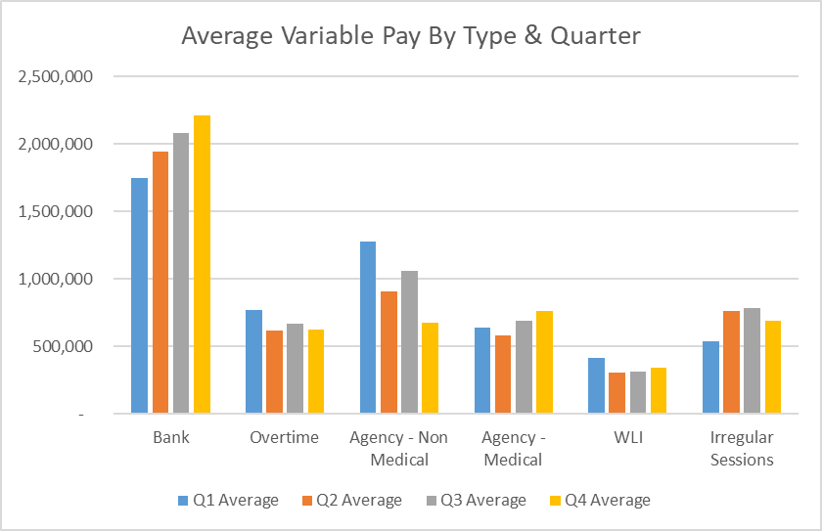

Note that within the Month 8 figure of £5.9m is a total of £0.61m relating to Bank and Overtime arrears.
Note that the M10 figure does not include the WLI arrears that were originally due to be paid of circa £0.27m.

Variable Pay Spend

- Overview Non-Pay

A correction was made in Month 2 to reflect the subjective being used in R&D between Income & Non-Pay totalling £3.9m

Below are further details on the key areas of non-pay:

  - Clinical Consumables
This area continues to be a pressure with an in-month position of £1.8m (Month 10, £1.1m). There are 80+ subjective lines within this category including secondary care drugs but areas seeing most pressures YTD continue to be general consumables (M&SE), laboratory products and implants (which in part will be driven by activity).

  - Energy Forecast
Energy costs are procured via an All-Wales contract, with NWSSP centrally co-ordinating forecast associated with this contract. An update was received on 10th June 2024 from NWSSP regarding the 2024/25 forecast which has been validated and included from Month 3. There have been no national changes to the forecast since Month 3 and the local team continues to work with Finance colleagues to assess the position.

  - Primary Care Prescribing
Prescribing is providing a £0.7m underspend in-month following receipt of the latest datasets and there is a YTD underspend of £1.4m. We have at this point received 9 months of PAR data. The YTD data is below the anticipated levels at this point in the year and therefore a larger element of this anticipated benefit has been recognised in-month. The Pharmacy team are expecting potential further reductions linked to Cat M later in the year; there is the possibility of further opportunities. The position will remain under close review pending further PAR data in the final month of the year.

  - CHC
The overall variance against budget for CHC is an £0.2m underspend in-month. An analysis of actual expenditure and patient numbers for 2024/25, along with the average values from 2023/24 is provided in table below.

CHC Analysis by Month

Please note:
- The above numbers include Domiciliary care cases.
- PCT Group does not include the Singleton/NPT element. The NPTS element which covers Children and Young People CHC patients is provided internally by the Health Board and as such is part of the wider NPTS position and is not recorded in the ledger as PCT/MH/LD CHC is recorded.

  - COVID Public Enquiry
The total costs for this are allocated to a dedicated Cost Centre (6F25).

The total YTD spend is £0.027.

  - Maternity Review
In the 2024/25 Financial Plan £0.7m was set aside to support the Maternity Review. In August to improve the oversight of this area a dedicated Cost Centre was established (6F34).

The total YTD spend is £0.914m.

  - Z Codes (Section 1,3-4 Table Point 1 Appendix 1)
The narrative below groups together the key elements of the Z codes detailed in Point 1 of this appendix.

- Contracting: SLA /LTA performance: JCC (previously WHSSC), LTA and SLA contract income and expenditure are transacted within this area and financial performance reported. NICE approved high-cost drugs and associated LTAs are also transacted and monitored against targets set. In addition to this, non-contracted activity income in relation to English foundation trusts invoiced on a quarterly basis are reported.

- Capital: The Finance Capital Team manage a number of cost centres covering the PFI, IFRS16 and Depreciation charges for assets both owned and donated are transacted here.

- RRL and Central Reserves: The WG funding received at the start of the year is tracked within this area along with the revised £43.7m deficit. Any anticipated allocations in year are also transaction through these codes. Other HB wide funding received from HEIW and SIFT is also captured in here. All central reserves remain within the Z cost centres and details of these are provided in Appendix 2.

- Corporate income and expenditure. Any income and expenditure that is not service group specific is transacted and reported through a number of corporate Z cost centres, examples include, payroll and pension costs, VAT recovery, losses and receipts in relation to funding from Welsh Risk Pool, overseas visitors’ income and Road Traffic Accident income.

  - LTA Values & Forecast performance as at M08
The table below is based on Month 8 activity undertaken by other Health Boards and Trusts for Swansea Bay residents (SBU Commissioner) and activity undertaken by Swansea Bay for residents of other Health Boards. The final impact of this will not be known until Month 12 at which point a final update will be provided as part of the Month 12 reporting.

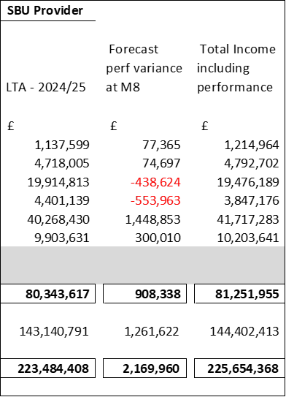

APPENDIX 2 – DETAILS ON RESERVES & CENTRAL BUDGETS

- SUMMARY RESERVES
Overall management of the reserves is as per the Health Board Budget Management document.

  - Balances Main & NICE
For 2024/25, the Health Board will hold two central reserves and the purpose of these reserves are below:
- Main – this holds funding from WG or the plan that has yet to be issued to Budget Holders. These items are not surplus but either due to timing have not been issued or is an area where funding is issued based on actual values consumed in future month.
- NICE – this holds the total Health Board funding for all NICE costs (drugs and infrastructure) and is issued to the service each month based on the actual costs consumed as reported through the Pharmacy system.

Details on the balances and movements are provided in the Table below:

- COVID RECOVERY
As part of the Financial Plan WG Funded £15.2m for Local COVID Recovery and £19.5m for Regional COVID Recovery. The funding remains in Central Reserves and is reported in Main reserves in Section 1 above. This funding is then issued to service areas based on the actual costs committed. A summary of the actuals to date and forecast costs against the funding total of £34.7m is summarised in the table below.

APPENDIX 3 – SAVINGS

1. Summary, as at February 2025 (Month 11)

With focus on those savings attributed to the original £26.1m target, including required savings to the run rate pressures across the health board, a revised total savings target of £59.2m was set. The tables below reflect the detail held within the monthly savings trackers, measurable against this target.

In summary, the table below illustrates a forecast savings delivery of £51.1m for 2024/25 (an increase of £0.5m from Month 10), £40.7m recurrently (decrease of £0.6m from Month 10), including red schemes and those schemes in progress of being developed. In 2024/25, against a target of £59.2m, a shortfall of £8.1m is anticipated (increased by £0.5m from Month 10).
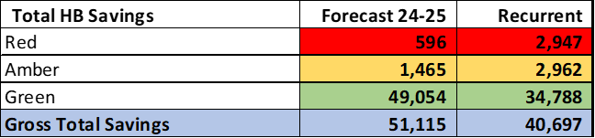
Of the forecast in 2024/25, £50.5m is considered deliverable (Green/Amber risk rating), whilst £0.59m (1.2%) are considered Red/high risk of delivery (£2.9m, 7.2% recurrently). An increase of 1.2% from the previous month, decrease of 1.6% recurrently.

In relation to Green/Amber schemes, Morriston Service Group has the lowest % of Green/Amber schemes, holding the highest risk of delivering their Savings Target in 2024/25. Some high value red schemes include CPAP Activity, remaining within funded levels for specified tertiary services, VAT recovery, limiting pump prescribing. Singleton/Neath Service Group, and Primary Care group have the highest confidence of delivery in-year with no red schemes (as shown below).

Overall percentage of delivery of Green/Amber schemes against target in 2025/26 = 85%
Savings V Target 2024-25

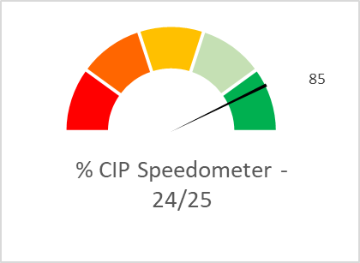

Recurrently, Morriston and Corporate Directorates have the highest risk of delivery (due to red schemes). Singleton/Neath illustrates the highest value of delivery of green schemes (only slight savings classified as Red). Corporate are the only service area forecasting to exceed their savings target (noting their target is over 50% lower than other service areas).

Overall percentage of delivery of Green/Amber schemes against recurrent target = 64%

Savings V Target Recurrent

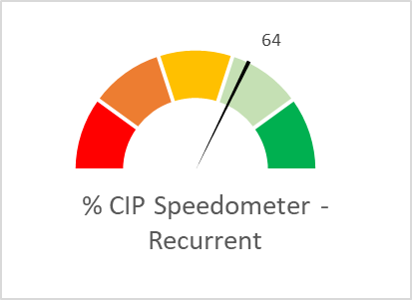

The savings profile below illustrates the timeline of the forecast savings of £51.1m in 2024/25 (all schemes).

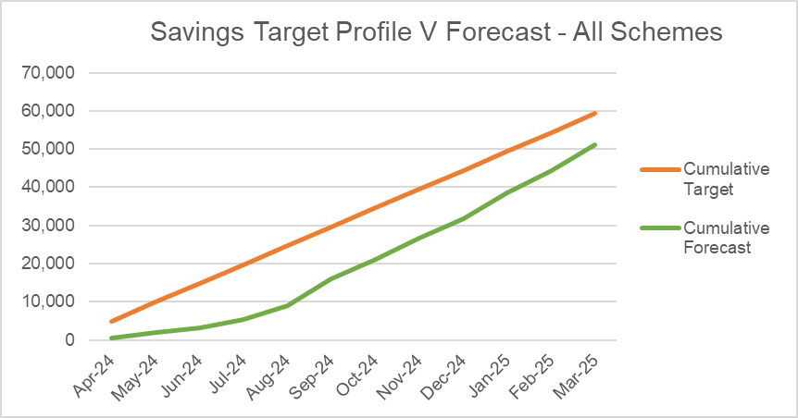
September saw the highest level of
forecasted savings however most recent
months followed a similar trend. As we
approach the final months of the
financial year, further efficiencies have
been identified, in addition to
implementing recommendations from
the Star Chambers.
Progress/Focus has continued, closing
the in-year savings gap of £8.1m.

- Type of Savings Forecast at Month 11

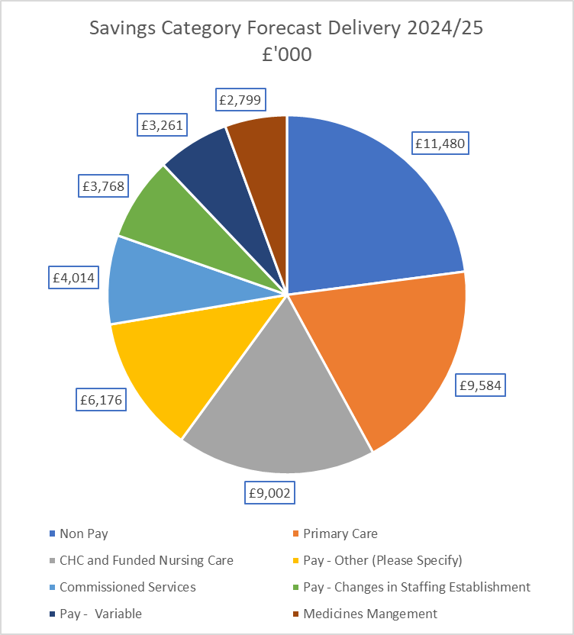

Forecast Delivery - the largest category of savings to Month 11 lies in Non-Pay / Procurement at £11.4m (22.6%). Included are savings identified by local and All Wales procurement teams, that is savings on energy-usage, managing SLA’s, procurement, capped investments and the management of maintenance contracts. Next is Primary Care savings at £9.5m (18.9%) which includes management of Optometry and Pharmacy contracts, managing levels of investments, dental clawback and in year slippage. Then, Funded Nursing Care at £9m (17.8%) which include managing CHC growth and inflation, reviewing support, decommissioning and planned step downs and repatriations.

Work is currently underway in terms of identifying sources of cost/efficiency savings for 2025/26.

- SBUHB Savings Repository

To continually support the identification of opportunities for the Recovery & Sustainability programmes in 2024/25 and in future years, as well as ensuring all opportunities from the National Value & Sustainability are captured and shared within the Health Board, the Repository of Opportunities introduced as part of the Planning process, is available to view and updated regularly.

The Repository can be accessed via the link below:
https://sbushare.cymru.nhs.uk/sites/Finance/Corp/Resources/savresp

The Repository is split into the following sections:

- National Efficiency Reports - this will include details of the NHSE FP+D Vault, NHS Wide Value and Sustainability Board Updates including Medicines, and the Carter Report
- National Benchmarking – this will include the latest CHKS Benchmarks, NHSBN reports and analysis, and summary of the NHS Wide Savings schemes for comparisons.
- Local Reports and Benchmarking to include SBUHB Procurement dashboard, Medical Staffing, and some Pay and non-Pay potential opportunities. In addition, this includes a Weekly reporting dashboard which provides data to allow us to capture, track and measure key performance indicators (KPIs) for the health board.

- Value and Sustainability Update

In 2023/24 Welsh Government and the NHS Executive established a Value and Sustainability Board to continue to focus and principles of the previous Utilisation of Resources Group but to also drive a systematic approach to strengthen cross system working, to deliver actions for financial improvement and the delivery of more sustainable health care on a consistent basis.

The V&S Board’s aim is to strengthen the national approach to support and compliment local planning and delivery arrangements to progress identification, development, and implementation of opportunities for both in year and recurrent financial improvement across NHS Wales. The V&S Board’s focus is on the areas of activity with the biggest expenditure areas for NHS Wales namely:

- Workforce
- Medicines/Prescribing
- Continuing Healthcare (CHC)/ Funded Nursing Care (FNC)
- Non-pay & Procurement
- Clinical Variation/Service Configuration

Workforce
The group is led by Liz Rogers (WG) focusses on the following priorities: monitoring reduction in agency costs, development of an international recruitment plan, nurse staffing levels and roster management and benchmarking.

SBUHB update: The Health Board’s variable pay bill has remained largely unchanged throughout the financial year with total variable pay spend at Month 11 at £54.7m. Enhanced additional variable pay controls remains one of the most significant financial opportunities. To support the delivery of the agency control expenditure targets enhanced controls have been implemented. The oversight for agency expenditure in clinical areas is overseen by executive clinical professionals to ensure the most senior level of scrutiny and support to mitigate the need for agency staff.

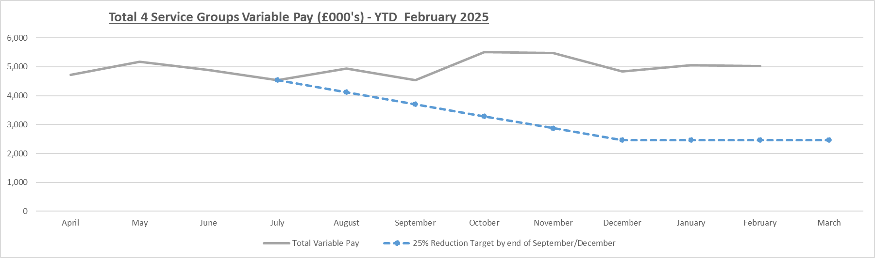

Medicines Value and Sustainability
The group is led by Alex Slade and Andrew Evans (WG) and focusses on the following priorities: Reducing spend through lower cost biosimilar, exclusive use of generic medicines, ending outsourcing of particular medicines, reviewing off contract procurement, reducing spend on low priority drugs.

SBUHB Update - Out of the 10 recommended priority actions, SBUHB have 7 actions RAG rated as green, with 3 Amber schemes with action plans against these schemes to ensure full compliance.

V+S medicine Report – Dec 2024 | SBUHB | Wales
Composite Percentage biosimilar purchased | 85.45% | 93.60%
2nd Care % Generic Purchased | 98.94% | 99.66%
Primary Care generics - % Reduction in Items issued | 8.40% | 18.45%
Source: Careflow and NWSSP

CHC
The group is led by Jeremy Griffith (WG) focussing on: High-cost cases, private provider model, data on commissioned care, invest to save. Key actions for 2024/25 include, a national management information system, upskilling of assessors, review of inflationary and cost pressures, high-cost patients, and potential benchmarking across Wales. To date, MH/LD Service Group has identified budget releasing savings of £1.845m and £4.755m of run rate achievement, followed by Primary Care with cost avoidance of £2.3m and run rate reduction of £0.3m. This illustrates the high value within CHC.

SBUHB Update – The monthly SBHB CHC Board confirmed SBU’s support for all seven recommendations in the V&S group on 10/10/24. The Board had undertaken a very comprehensive review to consider each option. The recommendation associated with an all-Wales IT system was the top ranked albeit concerns with IT implementation. The Joint Commissioning Committee are in the process of submitting a business case to Welsh Government to obtain funding on behalf of all HBs to develop an NHS Wales Continuing Healthcare Cooperation Programme (March 2025). This will involve some of the following headings;

- CHC Digital System
- CHC Assessors Training & Competency
- Value through consistent pricing
- Health & Social Care Collaboration
- Direct Payments
- Reporting

Work has taken place over the last 18 months to identify opportunities to strengthen the commissioning arrangements and to understand the workforce structure needed for an optimum model for SBUHB. A new commissioning approach is to be implemented, to be operational in 2025/26 (A proposal for the establishment of a centralised approval panel and the workforce structure required to support a centralised commissioning function is currently being considered).

Procurement and Non-Pay
Focus is placed on the following priorities; Price and Volume, Contract Negotiations and Management, Management of Service Contracts.

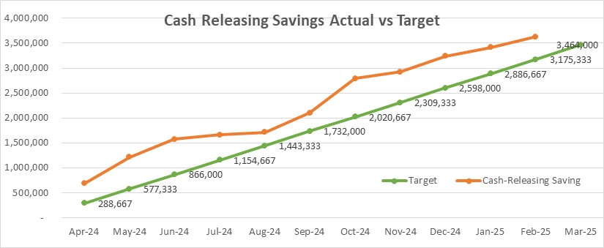
The NWSSP has set an annual target of cash releasing savings of £37m across NHS Wales. The SBUHB savings plan target has been updated to £3.464m. Currently SBUHB are reporting a cash releasing saving of £3.624m to February 2025, against a profile target of £3.175m.

Clinical Variation Summary
The group focusses on; Planned Care and elective services, Innovation and Value, estate rationalisation, pathways of care delays and assessment of service resilience. SBUHB update: Review of Estates completed by HB's and trusts, updated guidance on low value interventions, clinical effectiveness group established, 6 optimum pathways developed, Theatre productivity opportunities issued to HB's. SBUHB Executive Lead to be agreed.

APPENDIX 4 – SUMMARY OF THE REPLIES TO THE ACCOUNTABILITY LETTERS

No: | Name | Date Pro Forma Returned
 | Ceri Gimblett – SNTP | Formal reply letter received 31/05/24 but not the set pro forma
 | Sue Moore – Morriston | 31st May 2024
 | Janet Williams & Dermot Nolan – MH&LD | 30th May 2024
 | Brian Owens – PCTSG | 6th Sept 2024
 | Hazel Lloyd – Corporate Governance | 16th May 2024
 | Deb Lewis – COO | 12th June 2024
 | Richard Thomas – DICE | 3rd June 2024
 | Matt John – Digital | 22nd May 2024
 | Anjula Mehta – Medical  Raj Krishnan - Medical | 22nd May 2024
 | Anjula Mehta – Medical  Raj Krishnan - Medical | 14th May 2024
 | Gareth Howells/Hazel Powell – Nursing | Pro forma from HP signed 13th May 2024
 | Vacant – Public Health
 | Nerissa Vaughan – Strategy | 31st May 2024
 | Sarah Jenkins – W&OD | 30th May 2024
 | Darren Griffiths – Finance and Estates | 13th May 2024
 | Christine Morrell – Therapies | 23rd May 2024

