Meeting Date | 21st May 2024 |  | Agenda Item |  | 2.1
Report Title | Financial Report – Period 01 2024/25
Report Author | Samantha Moss, Deputy Director of Finance  Gemma Pearson, Finance Business Partner
Report Sponsor | Darren Griffiths, Executive Director of Finance and Performance, Acting Deputy Chief Executive
Presented by | Samantha Moss, Deputy Director of Finance
Freedom of Information | Open
Purpose of the Report | The report advises the Performance & Finance Committee of the Health Board on the financial position for Month 01 2024/25 (April 2025) and risks regarding current forecast revenue year end outturn.
Key Issues | The report invites the Performance & Finance Committee to note the detailed analysis of the financial position for Month 01 2024/25 (April 2024).  The report includes a summary of the key drivers of the position either at Service level or by expenditure type (i.e. Non Pay/Pay). It also provides information of the current position with regards to Health Board reserves to ensure transparency in the overall Health Board position.  Risk will have been considered on the basis of the information provided within the report and the score updated where necessary.  Whilst the key messages are provided within the main body of the report, further information is provided in the Appendices.
Specific Action Required | Information | Discussion | Assurance | Approval
Specific Action Required | ☐ | ☐ | ☒ | ☐
Recommendations | Members are asked to:  - To NOTE the agreed 2024/25 financial plan.  - Consider and comment upon the Board’s financial performance for Period 01 2024/25.  - TO NOTE the actions to ensure delivery of a balanced financial position per all service areas as per the accountability letters issued in May 2024. Need to include:  - Submission of Financial Strategy by each Service Area on 31st May 2024. (Service Group Directors/ Corporate Directors)  - Full breakdown of the actions to be taken for next Financial Performance meeting in May to address pressures seen in Mth 1 for which there is no budget. (Service Group Directors)  - TO NOTE the ‘saving’ reduction target set are per the accountability letters and ensure actions are logged on the savings trackers.  - All savings to be identified and on trackers by 31st May 2024 (Service Group Directors/ Corporate Directors)  - NOTE the risks to the position at Month 01.  - NOTE the position with regards to Health Board Reserves.  - NOTE all actions and updates to support the management of the 2024/25 financial position.

FINANCIAL REPORT – MONTH 01

SUMMARY OF REVENUE PERFORMANCE
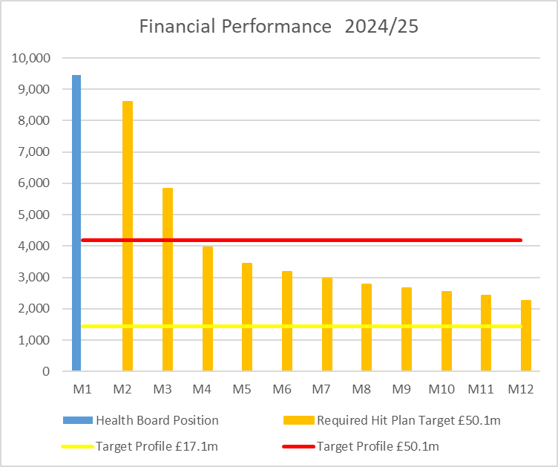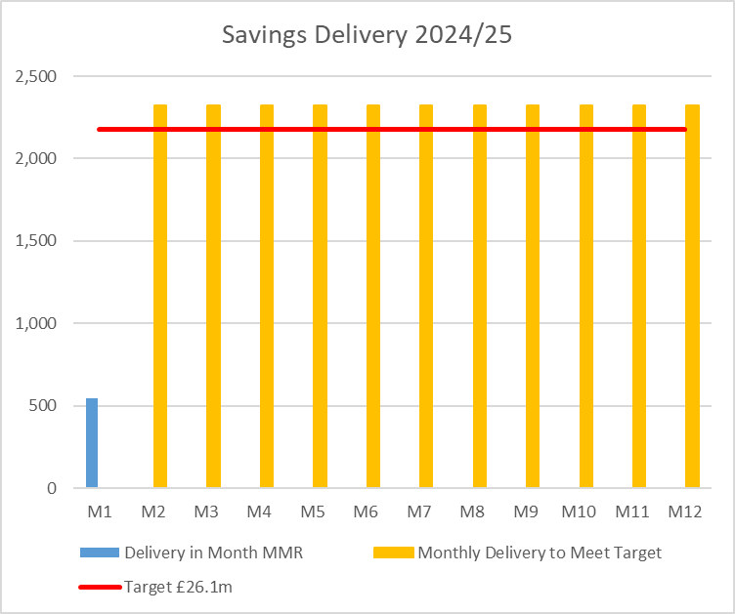

Target | In Month  £’m | Year To Date (YTD)  £’m
Delivery Against Revenue Resource Limit (RRL) DEFICIT / (SURPLUS) | 9.457 | 9.457
Delivery Against Total Run Rate/Savings Target In Ledger DEFICIT / (SURPLUS) | 0.547 | 0.547

In Summary the Month 1 financial position was £9.5m overspent, this was £5.3mm higher than the forecast deficit for the month.

The Annual Plan submitted on 28th March 2024 reported a deficit of £50.1m after the delivery of £26.1m of savings. The expectation was that the in-month position would reflect a 12th of the £50.1m deficit. For Month 1 the Health Board (HB) has reported a deficit of £9.5m against a 12th of the deficit plan of £4.2m. Clearly this position is unacceptable and immediate actions are being taken. In response to the in-month financial position, the interim CEO has written to senior leaders across the HB to instruct urgent actions to address the run rate. Discussions were also held at the Management Board on 15th May 2024 to agree immediate and lasting actions to materially reduce run rate immediately, whilst further actions are required to improve upon the deficit forecast of £50.1m. The interim CEO also issued a very clear message to all Health Board staff via the Mid Week CEO Message on 15th May 2024. Details on the actions being undertaken are summarised in section 2.3 of this report.

The three component and the respect impact on the £9.5m are visualised in the chart

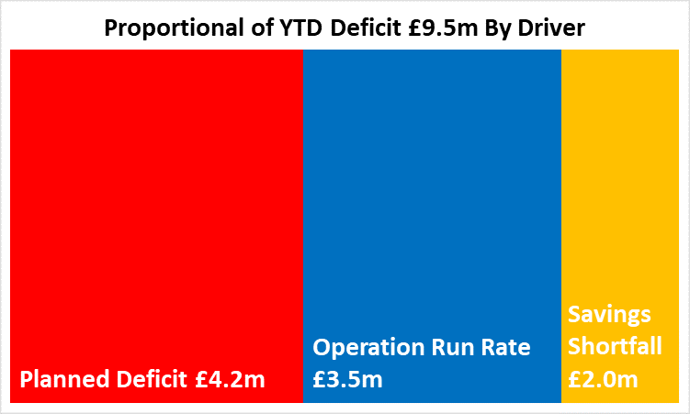

- FINANCIAL PLAN 2024/25
The Health Board submitted an Annual Plan on 28th March 2024 which reported a deficit of £50.1m. This has not been approved by Welsh Government (WG) with the request that as a minimum the Health Board reduces its deficit to £17m or better; work and discussions are underway. In order to meet the £50.1m deficit plan operational savings totalling £26.1m are required and all service areas are required to breakeven to their delegated budgets. This will require the need for a significant reduction to the Health Board’s run rate of expenditure.

- KEY DRIVERS OF THE IN MONTH POSITION
The key drivers of the month 1 position are summarised in the table below. Further detail at a Health Board level of expenditure on Income, Pay and Non-Pay, is provided in Appendix 1.

  - Key Drivers By Service Area

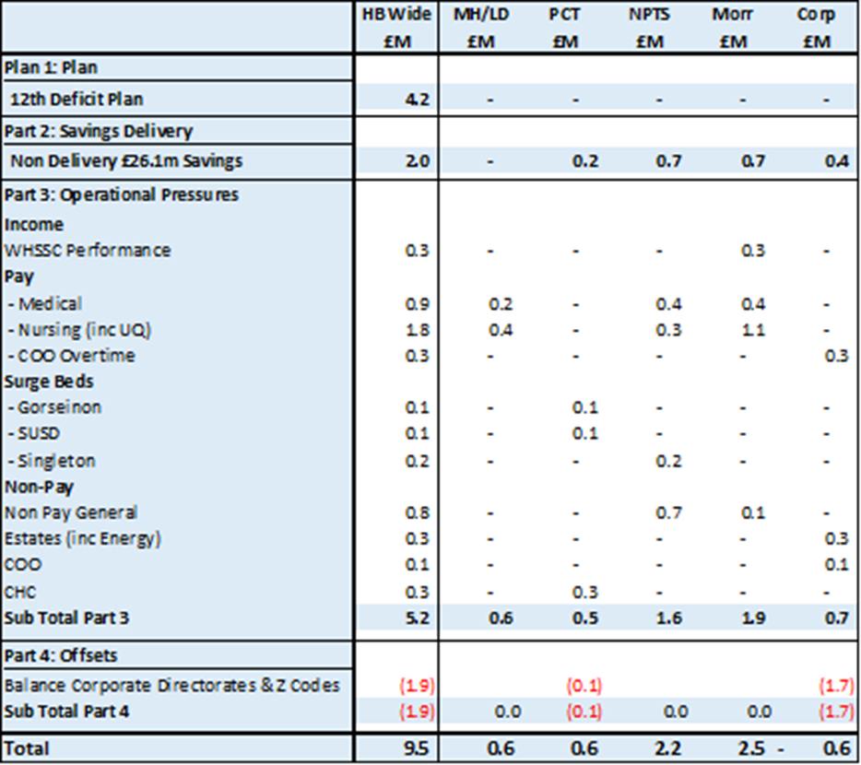

  - Summary By Expenditure Type

Income
The Welsh Health Specialised Services (WHSSC) Income as a provider continues to impact on the performance against plan, with an in-month underachievement of £0.3m. This relates to a continuation of the reduced activity trends reported in 2023/24.
Dental Contract Income has been accrued to breakeven in-month as a holding position until the impact of the new pricing tariff is understood and in recognition of the likely (but as yet unquantified) clawback from contractors in relation to underperformance in 2023/24.
- Pay
The Month 1 pay overspend was £2.8m, largely driven by Medical & Dental and Nursing across the acute sites and MH&LD in addition to Hotel Services within COO. The pay pressures are driven by a number of factors including the continuation of staffing surge bed capacity, pressures on services across the organisation and high levels acuity, coupled with high levels of sickness at 6.67% for the month of March 2024. This is a key area of immediate and direct focus.
- Non Pay:
Clinical Consumables
This area continues to be a significant pressure with an in-month position of £1.7m. There are 80+ subjective lines within this category including secondary care drugs but areas seeing most pressures YTD continue to be general consumables (M&SE), laboratory products and implants (which in part will be driven by activity).
Prescribing
At Month 1 the in-month position reflected in the ledger on Prescribing is breakeven following the issuing of both growth and price inflationary investments within the Annual Plan.

- Non Delivery Savings
The Health Board has set a 2.5% savings target for 2024/25 which has been issued to Service Areas. There is currently a gap in the identification, and therefore delivery, of savings to meet the target sets has resulted in a £2.0m variance in Month 1.

  - Action being Taken to Mitigate Position

In response to the in-month financial position, the interim CEO has written to senior leaders across the HB to request urgent actions to address the run rate.
Key areas of focus outlined in the communication for the interim CEO included:
- Variable pay with a specific focus on agency costs (£78m opportunity against variable pay based on 2023/24 levels of expenditure);
- Assurance on CHC controls and robust assessments;
- Granular and deliverable savings to target levels;
- Identification of the most cost-effective way to support surge capacity with a plan to reduce surge requirements to Nil as quickly as possible; and
- Enact all actions to reduce run rate balanced with TI recovery requirements.

Discussions were also held at the Management Board on 15th May to agree immediate and lasting actions to materially reduce run rate immediately. The outcomes of these discussions were also articulated in the Mid-Week CEO message issued to all staff on 15th May. One immediate area of focus will be on variable staff costs, particularly agency spend. As a Health Board, despite the success in recruiting to vacancies including recruiting 450 registered nursing staff over the last year, the Health Board spent over £78m on variable pay in 2023/24. So the investment made in recruiting permanent staff, has not been translated into less reliance on agency and locum staffing. Therefore immediate actions have been agreed to reduce variable pay, with Agency being the first area of focus. These include:
- Nursing - no agency to be permitted to any area with full establishment
- Nursing - approval of any agency will need to come through Director of Nursing
- Medical - all posts occupied by agency locums have an open advert on NHS jobs and an alternative plan to fill
- Medical - review of all agency locums employed for shift work
- All Areas – improvement in scrutiny and enhanced grip and control
There are other actions open to the Health Board that has the potential to reduce the planned deficit of £50.1m and these are focused on the thematic programmes, with each programme allocated a dedicated SRO. So in addition to the in-month challenges further actions and focus continue to be required to improve upon the deficit forecast plan of £50.1m, which will be presented in a separate paper.

- SAVINGS

Based on the latest Run rate reduction/savings position reported by the Savings Project Management Office (PMO), the schemes identified for delivery in 2024/25 by service areas are summarised below.

 | Target  2024/25 £000's | Actual Identified 2024/25  £000's | In Year Shortfall  £000's | Actual Recurrently Identified £000's | Recurrent Shortfall  £000's
Morriston | 7,805 | 0 | 7,805 | 0 | 7,805
NPTS | 7,965 | 0 | 7,965 | 0 | 7,965
MHLD | 2,603 | 3,208 | -605 | 1,981 | 622
PCC | 3,091 | 0 | 3,091 | 0 | 3,091
Corporate | 4,654 | 1,270 | 3,384 | 763 | 3,891
 | 26,118 | 4,478 | 21,640 | 2,744 | 23,374

The level of unidentified savings, along with the need for run rate reductions, has been escalated to Service Leads through the communication from the Interim Chief Executive. Further escalation thresholds have been set to ensure that Service Areas receive robust scrutiny and challenge. The accountability letters published at the end of April 2024 require each Service Area to submit a detailed Financial Strategy by the 31st May 2024, which will include savings delivery, management of budgets and overarching governance. Therefore, further details on savings will be submitted aligned to this and so will appear in the Month 2 MMR submission.

- RISK
Two Board level financial risks:

- Achieving financial plan (HBR92) with the key elements as follows: -

  - Risk of delivery of savings quantum
  - Risk of operational overspend being in excess of funding available agreed via the Financial Plan
  - Risk of commitment of reserves (e.g. NICE) being above reserves available.
  - Risk of achieving the actions outlined in the 2023/24 Landing Plan.

Based on the financial performance at Month 1, it is proposed that the Health Board Corporate Risk Register increased the risk to 25 given the unacceptability of the current financial plan and the variance from plan in month 1.

- Availability of capital (HBR93). This risk was re-opened in 2022/23 given the reduction in discretionary capital allocation. Whilst work is underway to manage schemes to reduce commitments in 2024/25 and to produce a balanced plan, the risk varies during the year as more details on schemes emerge and potential slippage funding is made available by Welsh Government.

A score of 20 is suggested at this stage as whilst the plan is now balanced, a number of schemes are on hold and the flexibility within the plan is extremely limited given the reduction in the allocation.

- RECOMMENDATIONS
Members are asked to:
- To NOTE the agreed 2024/25 financial plan.
- Consider and comment upon the Board’s financial performance for Period 01 2024/25.
- TO NOTE the actions to ensure delivery of a balanced financial position per all service areas as per the accountability letters issued in May 2024. Need to include:
  - Submission of Financial Strategy by each Service Area on 31st May 2024. (Service Group Directors/ Corporate Directors)
  - Full breakdown of the actions to be taken for next Financial Performance meeting in May to address pressures seen in Mth 1 for which there is no budget. (Service Group Directors)
- TO NOTE the ‘saving’ reduction target set are per the accountability letters and ensure actions are logged on the savings trackers.
  - All savings to be identified and on trackers by 31st May 2024 (Service Group Directors/ Corporate Directors)
- NOTE the risks to the position at Month 01.
- NOTE the position with regards to Health Board Reserves.
- NOTE all actions and updates to support the management of the 2024/25 financial position.

Governance and Assurance

Link to Enabling Objectives  (please choose) | Supporting better health and wellbeing by actively promoting and empowering people to live well in resilient communities
Link to Enabling Objectives  (please choose) | Partnerships for Improving Health and Wellbeing |  | ☐
Link to Enabling Objectives  (please choose) | Co-Production and Health Literacy |  | ☐
Link to Enabling Objectives  (please choose) | Digitally Enabled Health and Wellbeing |  | ☐
Link to Enabling Objectives  (please choose) | Deliver better care through excellent health and care services achieving the outcomes that matter most to people
Link to Enabling Objectives  (please choose) | Best Value Outcomes and High Quality Care |  | ☒
Link to Enabling Objectives  (please choose) | Partnerships for Care |  | ☒
Link to Enabling Objectives  (please choose) | Excellent Staff |  | ☐
Link to Enabling Objectives  (please choose) | Digitally Enabled Care |  | ☐
Link to Enabling Objectives  (please choose) | Outstanding Research, Innovation, Education and Learning |  | ☐
Health and Care Standards
(please choose) | Staying Healthy |  | ☐
(please choose) | Safe Care |  | ☐
(please choose) | Effective Care |  | ☐
(please choose) | Dignified Care |  | ☐
(please choose) | Timely Care |  | ☐
(please choose) | Individual Care |  | ☐
(please choose) | Staff and Resources |  | ☒
Quality, Safety and Patient Experience
Financial Governance supports quality, safety and patient experience.

Financial Implications
The Board is reporting a forecast year-end deficit financial outturn.

Legal Implications (including equality and diversity assessment)
No implications

Staffing Implications
No implications

Long Term Implications (including the impact of the Well-being of Future Generations (Wales) Act 2015)
No implications

Report History |  | Updates on the financial position are provided at every meeting
Appendices |  | Appendices provide further detail

APPENDIX 1 – FURTHER DETAIL ON VARIANCES BY TYPE OF SPEND

- Overview of Income
Income | Budget | Actual | Variance
Income | £'000 | £'000 | £'000
Mth 1 | (25,048) | (20,504) | 4,544
YTD | (25,048) | (20,504) | 4,544

- Overview of Pay Variances

Overall Variance by month
Pay | Budget | Actual | Variance Variable Pay | Variance Fixed Costs | Total Variance
Pay | £'000 | £'000 | £'000 | £'000 | £'000
Mth 1 | 61,151 | 63,931 | 5,087 | (2,307) | 2,780
YTD | 61,151 | 63,931 | 75,672 | (2,307) | 73,365

Actual Variable Pay by month and type

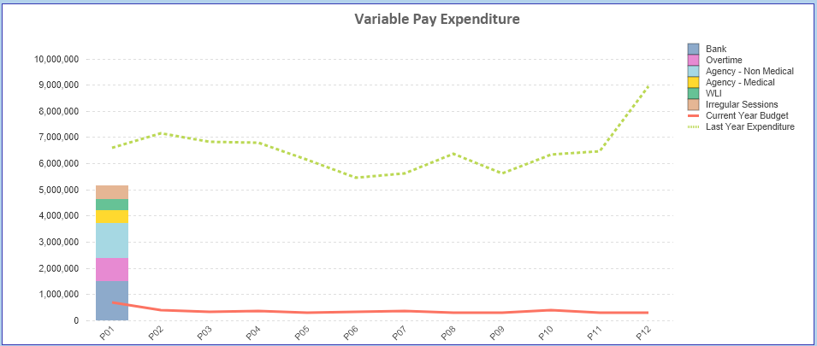

- Overview Non-Pay

Non Pay | Budget | Actual | Variance Linked Deficit | Variance Non Pay Pressure | Total Variance
Non Pay | £'000 | £'000 | £'000 | £'000 | £'000
Mth 1 | 62,208 | 64,341 | 4,175 | (2,042) | 2,133
YTD | 62,208 | 64,341 | 4,175 | (2,042) | 2,133

Below are further details on the key areas of Non-Pay (excluding savings that is addressed in main body):

  - Clinical Consumables
This area continues to be a significant pressure with an in-month position of £1.7m. There are 80+ subjective lines within this category including secondary care drugs but areas seeing most pressures YTD continue to be general consumables (M&SE), laboratory products and implants (which in part will be driven by activity).

  - Energy
There has been no updated NWSSP forecast since year end and therefore the forecast has not been amended for the Month 1 submission. We will review this for the Month 2 submission.

  - CHC
The variance against budget for CHC is £0.550m overspent in-month. An analysis of actual expenditure and patient numbers for 2024/25, along with the average values from 2024/25 is provided in table below.

CHC Analysis by Month

Please note:
- The above numbers include Domiciliary care cases.
- PCT Group does not include the Singleton/NPT element. The NPTS element which covers Children and Young People CHC patients is provided internally by the Health Board and as such is part of the wider NPTS position and is not recorded in the ledger as PCT/MH/LD CHC is recorded.

  - Prescribing
See commentary in section 2.2 in the main body of the report.

  - LTA Performance
The LTA contracts will not be finalised and approved until the end of June and the initial assessment of performance against these contracts will not be known for a number of months. Therefore updates on LTA performance will be provided one data in available for Q2.

APPENDIX 2 – DETAILS ON RESERVES & CENTRAL BUDGETS

- SUMMARY RESERVES
Overall management of the reserves is as per the Health Board Budget Management document.

  - Balances Main & NICE
For 2024/25, the Health Board will hold two central reserves and the purpose of these reserves are below:
- Main – this holds funding from WG or the plan that has yet to be issued to Budget Holders. These items are not surplus but either due to timing have not been issued or is an area where funding is issued based on actual values consumed in future month.
- NICE – this holds the total Health Board funding for all of NICE costs (drugs and infrastructure) and is issued to the service each month based on the actual costs consumed as reported through the Pharmacy system.

Details on the balances and movements are provided in the Table below:

- COVID RECOVERY
As part of the Financial Plan WG Funded £15.2m for Local COVID Recovery and £19.5m for Regional COVID Recovery. The funding remains in Central Reserves, and reported in Main reserves in Section 1 above. This funding is then issued to service areas based on the actual costs committed. A summary of the actuals to date and forecast costs against the funding total COVID Recovery funding of £34.7m is summarised in the table below. This currently demonstrates an over-commitment of £4.75m, with further discussions on the deployment of this resource to support TI ongoing.

APPENDIX 3 – SAVINGS

Following receipt of the Service Groups Financial Strategy Returns for 204/25, which are due for submission to the CEO and DOF on 31st May, further details above that provided in Section 3 will be provided in future reports.

