Meeting Date | 21 May 2024 |  | Agenda Item |  | 5.1
Report Title | Planned Care Performance Update
Report Author | Craige Wilson, Deputy COO
Report Sponsor | Deb Lewis Chief Operating Officer
Presented by | Deb Lewis Chief Operating Officer
Freedom of Information | Open
Purpose of the Report | In May 2022, Welsh Government set out its ambitious intention for planned care recovery. The output of that ambition was a requirement for Health Boards to submit recovery trajectories against two specific priority areas:  - No patient will wait more than 52 weeks for a first outpatient appointment by end of 2022.  - Patients will wait less than 104 weeks for treatment within most specialties by the end of 2022/23  These targets were subsequently revised to October 2023 for 52 weeks outpatient waiting times and March 2024 for 99% of 104 week waiting times at all stages.  This paper provides an update on improvement plans to deliver against these targets.
Key Issues | SBUHB achieved the delivery of the 52-week target and has maintained this position since October 2023. The HB Achieved a 97.8% compliance against the required 99% of patients waiting less than 104-weeks by the end of March 2024.  There is a concerted focus is on achieving zero 156 week waits by the end of Q1 as part of the response to targeted intervention.  The target for 104 week waits is 100% to be achieved by December 2024. This represents a considerable challenge and risk for delivery, balanced against a very challenging financial position.
Specific Action Required  (please choose one only) | Information | Discussion | Assurance | Approval
Specific Action Required  (please choose one only) | ☒ | ☒ | ☐ | ☐
Recommendations | Members are asked to:  - NOTE the progress made to date to achieved against the 2023/24 planned care Ministerial Targets and the risks associated with the new waiting times’ targets for 2024/25.

Planned Care Performance Update

- INTRODUCTION
In May 2022, Welsh Government set out its ambitious intention for planned care recovery. The output of that ambition was a requirement for Health Boards to submit recovery trajectories against two specific priority areas:
- No patient will wait more than 52 weeks for a first outpatient appointment by end of 2022.
- No patients will wait less than 104 weeks for treatment within most specialties by the end of 2022/23
No Health Boards achieved these targets and they were subsequently revised to October 2023 for 52 weeks outpatient waiting times and March 2024 for 99% of 104 week waiting times at all stages.

- BACKGROUND

The Recovery and Sustainability (R&S) Plan 2022-25 was endorsed by Management Board on March 2022, approved by Board, and subsequently submitted to Welsh Government for consideration.

One of the core components of the R&S Plan was the recovery of planned care, which had been impacted significantly by the pandemic. The WG recovery plan ask assumed that planned care activity levels have resumed to pre-pandemic levels (19/20) and will be exceeded as a result of the additional recovery funded provided.

The Health Board submitted initial trajectories but highlighted that further work would be undertaken to refine the modelling and strengthen the plan in the following areas:

- Strengthening GP led services to prevent referral to secondary care and diagnose and/or treat at source.
- Developing demand management solutions across our systems of care.
- Considering the application of referral management criteria to be applied to existing lists and new referrals.
- Increasing core capacity for open pathways by diverting capacity previously assigned to follow up pathways as a result of:
  - modernisation of follow up system,
  - better use of clinic slots through partial bookings,
  - individual consultant productivity and
  - rigorous enforcement of DNA protocols
- The opening of further planned capacity in our system at Neath and Port Talbot

The Health Board achieved the delivery of the 52-week target by the end of October 2023, as required. This has been maintained on a monthly basis since October 2023. The HB Achieved a 97.8% compliance against the required 99% of patients waiting less than 104-weeks by the end of March 2024.
WG announced in January 2024 that SBUHB had triggered the next escalation level as part of the performance framework, which means performance in planned care delivery is now a focus of targeted intervention. Aligned to this escalation and as already noted in the annual plan for 2024/24, the focus for Quarter 2 of 2024/25 is to ensure that there is no deterioration in the position delivered at the end of March 2024 and that a month-on-month improvement with a focus is on achieving zero 156 week waits by the end of June 2024.

- CURRENT POSITION

Stage 1
At the end of October 2023 zero-breach position for 52 weeks for a first outpatient appointment was achieved and this has been maintained for the past 7 months as demonstrated in the below:

All Stages
The provisional positions all stages for 156 weeks and 104 -weeks at the end of April 2024 is as follows:

Specialty | 156 | 104
Gynaecology | 181 | 521
T&O | 0 | 631
Plastics | 20 | 206
Spinal | 1 | 70
ENT | 0 | 128
General Surgery | 0 | 124
Urology | 0 | 29
Oral/Maxillo facial Surgery | 0 | 11
Total | 202 | 1720

The improvement in the 104-week position is a reduction from 1831 (March 24):

  - Scrutiny and Assurance Process

The dynamic nature of the recovery necessitates scrutiny and monitoring, both internal and external to the organisation. The following outlines the monitoring and reporting structure that is in place and the mechanism for directorates to be held to account for delivery.

As already noted, planned care delivery is now the focus of increased escalation to targeted intervention by WG. As a result, the internal and external scrutiny is increased, the detail of which is outlined below.

External Monitoring
Monthly targeted intervention meetings are now in place with WG officials. This is accompanied by a quarterly meeting with the CEO of NHS Wales. The HB is represented at the monthly meetings by the Executive Team.

In addition there is also a monthly meeting with NHS Executive colleagues to focus solely on the planned care agenda. The HB is represented by the COO and Deputy COO.

The monthly meetings focus on:
- Validation
- Treat in turn
- Plans for longest waits
- Detailed speciality discussions / issues / areas of concerns
- Progress on HB transformation measures
- Progress on developing patient support and communication

Internal Monitoring
The COO is the nominated SRO for targeted intervention and is also the named lead for planned care delivery. Weekly targeted intervention meetings are now in place, alongside bi-weekly reviews of planned care performance solely.
The Service Group Directors now take the lead for planned care deliver within their own service areas and chair fortnightly meetings where service leads are held to account for delivery of the trajectories. Escalation for the non-delivery against the submitted levels will be to the Chief Operating Officer in the first instance.

- Operational monitoring - the current performance management meetings:
  - monitor delivery of the trajectories and the areas of efficiency noted above
  - ensure core capacity is at or above 2019/20 levels
  - ensure robust housekeeping is in place for RTT pathways
  - further develop recovery plans as required for approval via Planned Care Board

- Formal monitoring / assurance
  - Service Group Performance Reviews
  - Planned Care Board
  - Management Board via the Performance Report
  - Performance & Finance Committee

To help support directorates a Planned Care Dashboard has been developed with specialty level performance information.

Risks
The Health Board has achieved the 52-week target and services are expected to maintain this position. An improvement trajectory for 156 weeks has been set for the end of June 2024 and it is anticipated that this will achieved in spinal surgery and plastic surgery by that date; there is a plan to achieve this position in gynaecology by the end of July.

The Health Board has been working on the assumption that the target for achieving zero patients waiting over 104 weeks would be March 2025. However, a letter from the Chief Executive of NHS Wales this week has outlined this target to be December 2024; this represents a considerable challenge for all health boards. The current cohort of patient to be treated by the end of March 2025 is 10,997 and the table below outlines the treatments required to deliver:

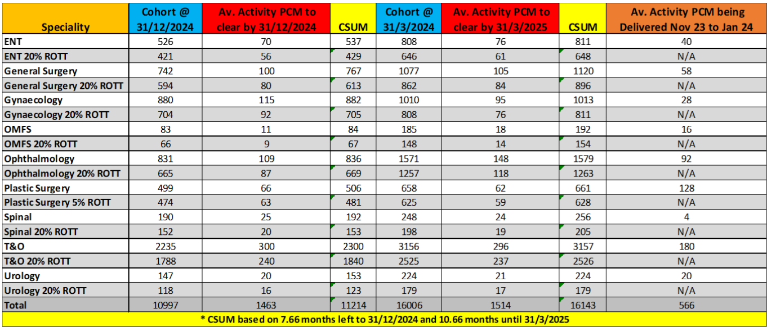
As can be seen from the table, ENT, General Surgery, Gynaecology and Orthopaedics have significant monthly deficits that need to be addressed. Services are working through the delivery plans for sign-off at the end of May.

- FINANCIAL IMPLICATIONS
In 2023/24 the Health Board planned to commit an extra £7.7m on top of its allocated £15.2m to meet planned care targets (total £22.9m).

Part way through the year the Health Board successfully secured an additional £15.5m in year (recurrent £19.5m) of which £14m for the ramping up of the orthopaedic unit and £1.5m was for endoscopy. Both allocations required delivery of the models on a regional footprint.

As a result of the significant financial challenge that the Health Board is facing in 2024/25, the Director of Finance and Performance has request that a risk assessment is undertaken to test what the impact would be on target delivery if half of the £15.2m recovery allocation was held back and £2m of the orthopaedic funding were held back in year. An assessment has also been requested as to whether the full funding of £15.2m and £19.5m; if deployed as effectively as possible would allow the Health Board to achieve Ministerial Targets

These assessments have been undertaken and are reported separately to the Committee through the presentation to be received in committee in May 2024to inform the choices available to the Board around deficit reduction and delivery impact.

- RECOMMENDATION

Members are asked to:
- NOTE the progress made to date to achieved against the 2023/24 planned care Ministerial Targets and the risks associated with the new waiting times’ targets for 2024/25.

Governance and Assurance

Link to Enabling Objectives  (please choose) | Supporting better health and wellbeing by actively promoting and empowering people to live well in resilient communities
Link to Enabling Objectives  (please choose) | Partnerships for Improving Health and Wellbeing |  | ☐
Link to Enabling Objectives  (please choose) | Co-Production and Health Literacy |  | ☐
Link to Enabling Objectives  (please choose) | Digitally Enabled Health and Wellbeing |  | ☐
Link to Enabling Objectives  (please choose) | Deliver better care through excellent health and care services achieving the outcomes that matter most to people
Link to Enabling Objectives  (please choose) | Best Value Outcomes and High Quality Care |  | ☐
Link to Enabling Objectives  (please choose) | Partnerships for Care |  | ☐
Link to Enabling Objectives  (please choose) | Excellent Staff |  | ☐
Link to Enabling Objectives  (please choose) | Digitally Enabled Care |  | ☐
Link to Enabling Objectives  (please choose) | Outstanding Research, Innovation, Education and Learning |  | ☐
Health and Care Standards
(please choose) | Staying Healthy |  | ☐
(please choose) | Safe Care |  | ☐
(please choose) | Effective Care |  | ☐
(please choose) | Dignified Care |  | ☐
(please choose) | Timely Care |  | ☐
(please choose) | Individual Care |  | ☐
(please choose) | Staff and Resources |  | ☐
Quality, Safety and Patient Experience
The successful implementation of the plans outlined have the ability to improve the quality and safety of services and in turn patient experience. However, the report has outlined a number of risks, which have the potential to delay benefit realisation.

Financial Implications
There is a significant risk that the financial allocation in 2023/24 for the Planned Care Recovery Programme will limit the progress that the Health Board is able to make in reducing waiting times further.

Legal Implications (including equality and diversity assessment)
There are no legal implications to consider as a direct result of this report.

Staffing Implications
A number of the improvement plans are facing challenges with recruitment and the availability of re-current funding.

Long Term Implications (including the impact of the Well-being of Future Generations (Wales) Act 2015)
This paper outlines how service areas within the Planned Care Programme are working in collaboration not only to look at the short term, but also to develop services across Swansea Bay in the long-term including the new theatres and the plans to enhance innovation and new ways of working.

Report History |  | May 23 – Planned Care Update
Appendices |  | Nil

