

Meeting Date | 28th November 2023 |  | Agenda Item |  |  | 2.1
Report Title | Financial Report – Period 07 2023/24
Report Author | Samantha Moss, Deputy Director of Finance  Crystal Davies, Principal Finance Manager
Report Sponsor | Darren Griffiths, Executive Director of Finance and Performance, Acting Deputy Chief Executive
Presented by | Darren Griffiths, Executive Director of Finance and Performance, Acting Deputy Chief Executive
Freedom of Information | Open
Purpose of the Report | The report advises the Performance & Finance Committee of the Health Board on the financial position for Period 07 (October 2023) 2023/24 and risks regarding current forecast revenue year end outturn.
Key Issues | The report invites the Performance & Finance Committee to note the detailed analysis of the financial position for Period 07 (October 2023) 2023/24. The position reflects the part year impact of the application of additional £60.8m allocation received as part of the redistribution of Welsh Government budgets.  The report includes a summary of the key drivers of the position either at Service level or by expenditure type (i.e. Non Pay / Pay). It also provides information of the current position with regard to Health Board reserves to ensure transparency in the overall Health Board position.  The report sets out key issues and alerts the Committee to the increased level of risk of delivery of the financial plan. The risk score will be revised once discussions have been held Welsh Government and the Board on options to delivery control total set.  The report does not consider the options for achieving the control total but provides the Committee with the standard information on the Month 7 position. Options regarding the control total will be provided to the Committee in a separate report.  Whilst the key messages are provided within the main body of the report, further information is provided in the Appendices.
Specific Action Required  (please choose one only) | Information | Discussion |  | Assurance | Approval
Specific Action Required  (please choose one only) | ☐ | ☐ |  | ☒ | ☐
Recommendations | Members are asked to:  - NOTE the agreed 2023/24 financial plan.  - Consider and comment upon the Board’s financial performance for Period 07 2023/24.  - NOTE the actions to ensure delivery of the financial forecast with a specific focus on savings delivery: -  - Enhanced monitoring meetings in place above standard Finance & Performance Meetings to oversee and agree actions to mitigate run rates and deliver savings. Morriston / NPTS Service Group Directors  - Focused attention to ensure that 100% of the schemes are identified at the end of Q1 23/24. All Service Group Directors and Corporate Directors  - Focused attention to ensure that 100% of the schemes identified at the end of Q1 are green and amber by the end of Q2 23/24. All Service Group Directors and Corporate Directors  - Where savings delivery is not on track there will be further meetings with the Director of Finance and CEO. All Service Group Directors and Corporate Directors  - NOTE actions to ensure the operational pressures are mitigated and areas return to financial balance.  - Enhanced monitoring meetings in place above standard Finance & Performance Meetings to oversee and agree actions to mitigate run rates and deliver savings. Morriston / NPTS Service Group Directors  - Embed and deliver opportunities identified via the Independent Financial support provided to the Service Group to review run rate and savings. Morriston Service Group Directors  - NOTE the risks position at Month 7.  - NOTE the position with regard to Health Board Reserves  - NOTE all actions and updates to support the management of the 2023/24 financial position.

FINANCIAL REPORT – PERIOD 07

- SUMMARY OF REVENUE PERFORMANCE

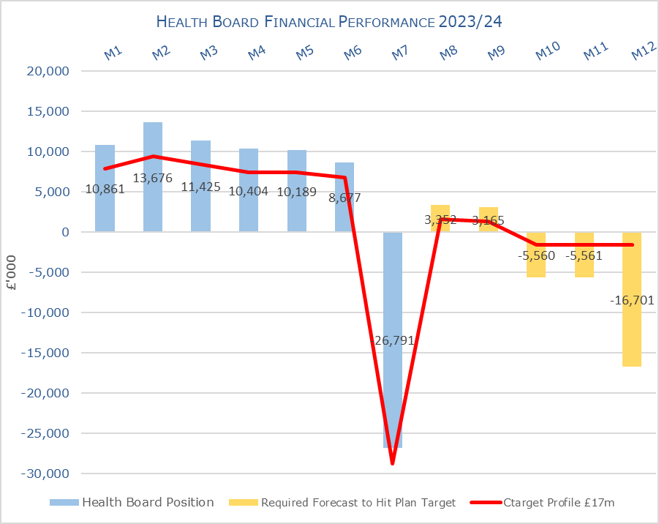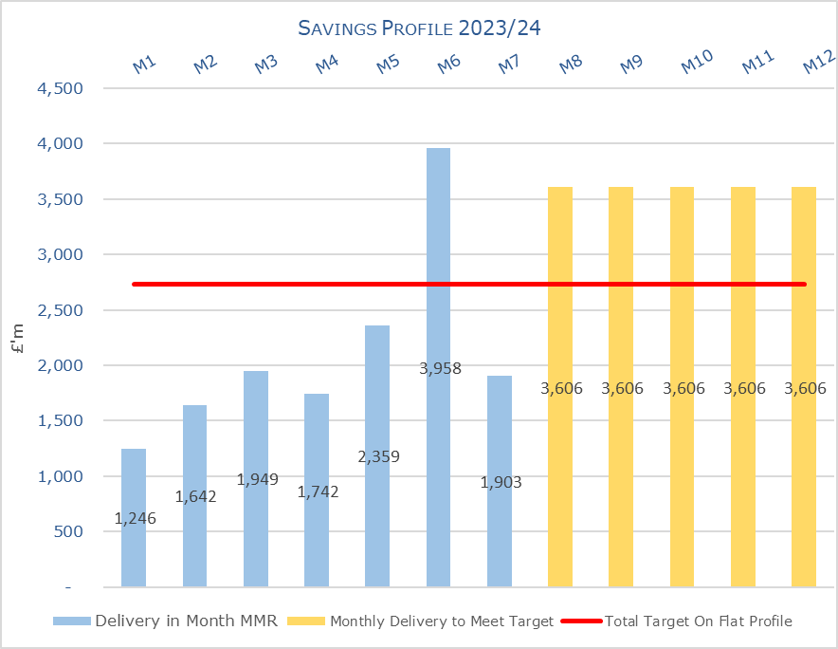

Target | In Month  £M | Year To Date (YTD)  £M
Delivery Against Revenue Resource Limit (RRL) DEFICIT / (SURPLUS) | (26.791) | 38.438
Delivery Against Financial Plan DEFICIT / (SURPLUS) | 1.949 | 18.701
Delivery Against Total Savings Target In Ledger DEFICIT / (SURPLUS) | 0.711 | 5.874

- FINANCIAL PLAN 2023/24

The Health Board (HB) submitted a revised plan at 31st May 2023 that reported a deficit of £86.6m. Following the hard work undertaken within Welsh Government NHS Wales has received £460m of additional funding of which Swansea Bay received £60.8m for 2023/24, of which £43.3m is recurrent. For 2023/24 there is then a requirement for the HB to deliver a 10% reduction based on the original deficit plan value of £86.6m, to achieve a control total of £17m.The profile on £17m control total following the receipt of the £60.8m is provided below:

Table 1: Financial Plan 2023/24
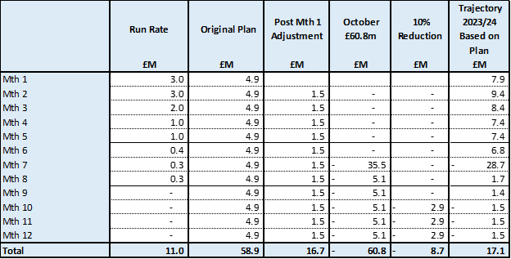

The plan was developed on a tapering basis to allow the Health Board time to work on reducing the run rates, reduce COVD spend and identify savings. Performance against the plan and the agreed tapered values is summarised below:

Table 2: Plan & Performance 2023/24

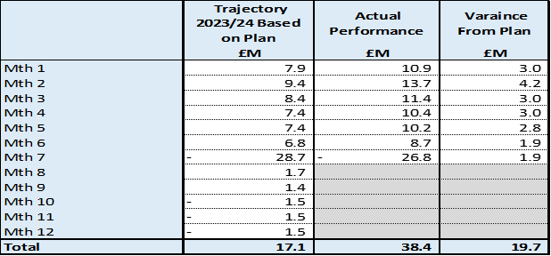

- KEY PERFORMANCE AREAS
Performance is summarised from two different perspectives. Section 3.1 provides the reported position by Service Group/Directors and Section 3.2 onwards looks at the reported positon from the components of the ledger i.e. Income, Pay and Non Pay, with further details provided in Appendix 1.

  - Summary By Service Area

Table 3: Summary

Key points of notes by Service Area:

- Morriston
The key variances:
  - Income = Month 7 was £0.177m over achieved but Year To Date (YTD) remains under achieved by £1.257m. This is driven by WHSSC performance. Plans are being developed to recover this via the Enhanced Monitoring meetings.
  - Pay = Month 7 £1.540m overspent, which was a £0.09m increase from Month 6 and remains £10.928m overspent YTD. Spend on variable pay was £2.8m in month this increased by £0.2m from Month 6.
  - Non-Pay (exc Savings) = Month 7 £1.4m overspent and YTD £6.5m. Of the £6.5m, YTD £5.2m relates to clinical services and supplies (including Drugs).
  - Savings = Month 7 £0.659m variance as there remains a shortfall in the delivery of the savings target and this takes the YTD position to £5.534m

- Neath Port Talbot Singleton (NPTS)
The key variances:
  - Income = Month 7 £0.032m over achievement and YTD £0.3m underachievement. This is primarily driven by the loss of Private Patient income.
  - Pay = Month 7 £0.230m overspent this is a deterioration of £0.193m compared to Month 6. The YTD position is £1.908m overspent. Spend on variable pay was £1.049m in month this decreased by £0.271m from Month 6.
  - Non Pay (exc Savings) = Month 7 £1.218m variance and YTD £4.068m which relates to clinical supplies and primary care prescribing.
  - Savings = Month 7 £0.027m under achieved in month but YTD shows £0.233m underachievement.

  - Summary By Type Expenditure

- Income
The WHSCC Income as a provider continues to impact on the performance against plan, with YTD underachievement of £1.0m. However, this has stabilised in the last 2 months but performance has not recovered the reduced activity on WHSSC services seen in Quarter 1 of 2023/24.

As reported for the previous 6 months of 2023/24 the pressure as a result in the loss of Dental Contract Income continues, with the YTD shortfall increasing to £1.1m.

- Pay
The Month 7 pay overspend has deteriorated slightly and stood at £1.4m (an increase from Month 6 overspend of £0.5m) taking the YTD overspend to £10.99m. Whilst overall there has only been a 5 WTE increase in actuals between months, there has been reductions in Unqualified Nursing and increases in Qualified linked to the ongoing on-boarding of our Overseas Nurses along with new student streamlining. On Variable Pay overall spend increase by £0.1m, with movements across type and service area.
Therefore, the Health Board clearly needs to address both the underlying run rate issue and the continued spend on variable pay, which is driving the in-month pay variance.

- Prescribing
At Month 7, the year to date position reflected in the ledger on Prescribing is £4m overspent. The June PAR reflected a significant increase linked to the volume of items, which was pushing the forecast to £6.7. However, July PAR saw the costs reduce only for an increase in volume in August PAR to increase the forecast again. This will continue to be a risk in the delivery of the control total for 2023/24.

- Non Delivery Savings
The Health Board has set a 3.5% savings target for 2023/24, after two years of achieving 4%. In additional there is a further £10.6m of unmet recurrent savings b/f from 2022/23. However, there remains a gap in the delivery of savings to meet the target sets, which has resulted in a £0.7m variance in Month 7, with a £5.9m YTD.

  - Action being Taken to Mitigate Position

The previous reports detailed the actions being driven by the Health Board to mitigate the planned deficit and the risks. Updates or additional actions above those reported in previous months are captured below: -

- Check & Challenge Independent Members – a bottom-up forecast was always planned to be completed post Month 6 to establish the HB’s ability to deliver the £86.6m plan and identify possible actions the Board may need to consider to address the delivery of the plan. The output of the work was being taken to an In-Committee meeting on 24th October 2023 of the Performance & Finance Committee with the invite extended to all Independent Members, the Chair and CEO. Between the completion of this work and the 24th October 2023 the HB received the positive update on the additional funding and as part of this session with the Independent Members we were able to overlay the impact of this funding and the additional requirement of the 10%. Therefore, since the 24th October 2023 the Board has been fully briefed and is working to identify opportunities to address the control total.

- SAVINGS
Based on the report from 7th November 2023, the schemes identified for delivery in 2023/24 by service areas are summarised below:

Table 4a In Year Performance Against 2023/24 Requirements

Table 4b Recurrent Performance Against 2023/24 Requirements

- RISK
Two Board level financial risks: -

- Achieving financial plan (HBR92) with the key elements as follows: -

  - Risk of delivery of savings quantum
  - Risk of operational overspend being in excess of funding available agreed via the Financial Plan
  - Risk of commitment of reserves (e.g. NICE) being above reserves available.

Whilst there has been improvement in the assessment of the delivery of the savings, the ongoing assessment of the Morriston Service Group, which continues to significantly over spend, has resulted in a revised assessment of the Morriston Service Group risk in Month 7. As noted in Month 5, this does not reflect the Health Board’s acceptance of the position but is a balanced assessment of the risk of delivering the plan, which is now a set control total of £17m. The Health Board Corporate Risk Register is currently reporting this risk as a 20 score and as previously discussed this may need to change depending full assessment of the deliverability of the plan, which now requires the HB to achieve a control total set by WG. The assessment of the HB ability to deliver will be included as part of a supplementary paper following discussions with WG on 20th November. An assessment of the risk score will then be considered following this and the assessment by the Board at the end of November 2023.

The individual elements of the risk behind this score are provided in detail below and reflect the information reported to WG in the month 7.

- A plan is being developed to assess options to achieve the set control total for the Health Board in year. This plan will need to mitigate the risks set out in the table above along with addressing the current forecast shortfall from the control total. This is work in progress and will be developed over the next 14 days – updates will be provided to the Management Board.

- Availability of capital (HBR93). This risk was re-opened in 2022/23 given the reduction in discretionary capital allocation. Whilst work is underway to manage schemes to reduce commitments in 2023/24 and to produce a balanced plan, the risk varies during the year as more details on schemes emerge and potential slippage funding is made available by Welsh Government. A score of 20 is suggested at this stage as whilst the plan is now balanced, a number of schemes are on hold and the flexibility within the plan is extremely limited given the reduction in the allocation.

- RECOMMENDATIONS

Members are asked to: -
- NOTE the agreed 2023/24 financial plan.
- Consider and comment upon the Board’s financial performance for Period 07 2023/24.
- NOTE the actions to ensure delivery of the financial forecast with a specific focus on savings delivery: -
  - Enhanced monitoring meetings in place above standard Finance & Performance Meetings to oversee and agree actions to mitigate run rates and deliver savings. Morriston / NPTS Service Group Directors
  - Focused attention to ensure that 100% of the schemes are identified at the end of Q1 23/24. All Service Group Directors and Corporate Directors
  - Focused attention to ensure that 100% of the schemes identified at the end of Q1 are green and amber by the end of Q2 23/24. All Service Group Directors and Corporate Directors
  - Where savings delivery is not on track there will be further meetings with the Director of Finance and CEO. All Service Group Directors and Corporate Directors
- NOTE actions to ensure the operational pressures are mitigated and areas return to financial balance.
  - Enhanced monitoring meetings in place above standard Finance & Performance Meetings to oversee and agree actions to mitigate run rates and deliver savings. Morriston / NPTS Service Group Directors
  - Embed and deliver opportunities identified via the Independent Financial support provided to the Service Group to review run rate and savings. Morriston Service Group Directors
- NOTE the risks position at Month 7.
- NOTE the position with regard to Health Board Reserves
- NOTE all actions and updates to support the management of the 2023/24 financial position.

Governance and Assurance

Link to Enabling Objectives  (please choose) | Supporting better health and wellbeing by actively promoting and empowering people to live well in resilient communities
Link to Enabling Objectives  (please choose) | Partnerships for Improving Health and Wellbeing |  | ☐
Link to Enabling Objectives  (please choose) | Co-Production and Health Literacy |  | ☐
Link to Enabling Objectives  (please choose) | Digitally Enabled Health and Wellbeing |  | ☐
Link to Enabling Objectives  (please choose) | Deliver better care through excellent health and care services achieving the outcomes that matter most to people
Link to Enabling Objectives  (please choose) | Best Value Outcomes and High Quality Care |  | ☒
Link to Enabling Objectives  (please choose) | Partnerships for Care |  | ☒
Link to Enabling Objectives  (please choose) | Excellent Staff |  | ☐
Link to Enabling Objectives  (please choose) | Digitally Enabled Care |  | ☐
Link to Enabling Objectives  (please choose) | Outstanding Research, Innovation, Education and Learning |  | ☐
Health and Care Standards
(please choose) | Staying Healthy |  | ☐
(please choose) | Safe Care |  | ☐
(please choose) | Effective Care |  | ☐
(please choose) | Dignified Care |  | ☐
(please choose) | Timely Care |  | ☐
(please choose) | Individual Care |  | ☐
(please choose) | Staff and Resources |  | ☒
Quality, Safety and Patient Experience
Financial Governance supports quality, safety and patient experience.

Financial Implications
The Board is reporting a forecast year-end deficit financial outturn.

Legal Implications (including equality and diversity assessment)
No implications

Staffing Implications
No implications

Long Term Implications (including the impact of the Well-being of Future Generations (Wales) Act 2015)
No implications

Report History |  | Updates on the financial position are provided at every meeting
Appendices |  | App 1-2 providing further detail

APPENDIX 1 – FURTHER DETAIL ON VARIANCES BY TYPE OF SPEND

- Overview of Income

- Overview of Pay Variances

Overall Variance by month
Note – movement between Month 2 and 3 and Month 4 and 5 budget relates to the one-off funding for the Recovery pay award and changes to the budget profiling linked to year-end accruals for Leave, Overtime and Time owing. Mth 7 budget includes Medical & Dental Pay Award for 2023/24.

Actual Variable Pay by month and type
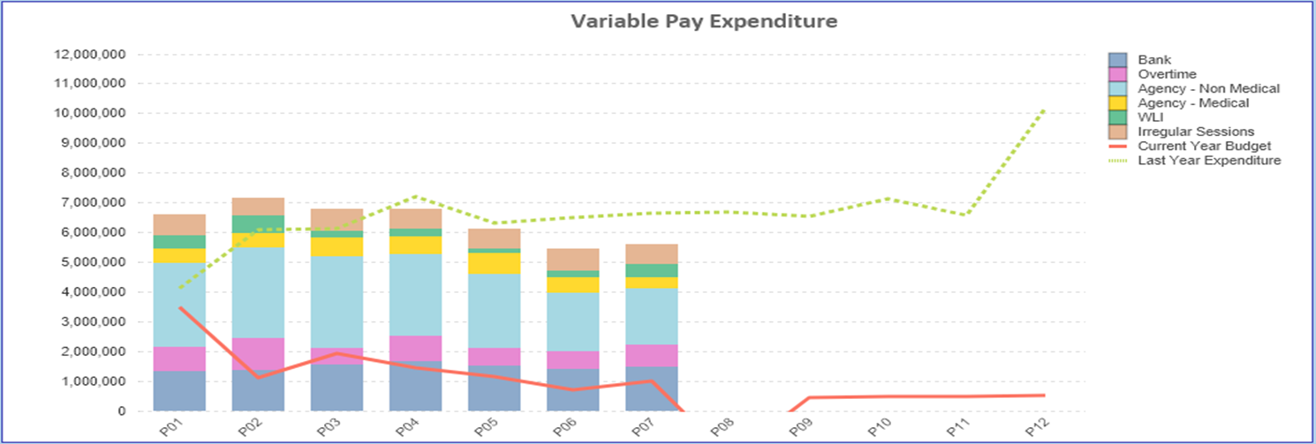

- Overview Non Pay
Note – movement between Month 2 and 3 budget relates to the one-off adjustment for Losses, which is normally reflected at year-end only and so had to be adjustment between months. Mth 7 reflects 7/12th of budget linked to the additional funding of £60.8m

Below are further details on the keys areas of Non Pay (excluding savings that is addressed in main body):

  - Clinical Consumables
This area continues to be a significant pressure with a YTD variance of £5.9m. With the in month position deteriorating from Month 6 by £1.2m. There are 80+ subjective lines within this category including secondary care drugs but areas seeing most pressures YTD continue to be general consumables (M&SE), laboratory products and implants (which in part will be driven by activity).

  - Utilities
The most recent update on the forecast via British Gas/CCS ranges from £14.2m to £13.2m based on the email from NWSSP dated 2nd October 2023. It is important to note that this forecast is not based on actual or predicted volume usage but industry averages. This becomes important given the Moriston site acquires a significant amount of its power from the Solar Farm, which if using industry averages would not be built into the forecast

Therefore, alongside this the Health Board has under an assessment of its predicted usage costed at the CCS rate. In addition, the estimated costs for 2022/23 provided by British Gas and used to support the Year End accruals have resulted in a non-recurrent benefit.

The forecast at this point is based on:

Area | £M
HB Assessment | 12.60
Funded by:
N/R opportunities | (1.6)
Less Original Funding | (3.3)
Less Additional Funding WG | (7.8)
Deficit / (Surplus) | 0

As the £12.6m is between £0.6m-£1.6m below the CCS forecast, £1m has been included as a risk. However, we will monitor the HB assessment position and review the forecast monthly as the actual costs/invoices are processed.

For noting, the above excludes the PFI NPT Hospital site, which is managed separately. The costs recharged as part of the PFI contract are estimated to be £2m but there is a delay in the receipt of the actual costs for 2023/24.

  - CHC
The variance against budget for CHC is £0.444m overspent in month, however remains underspent by £0.347m YTD which reflects both the additional funding allocated to CHC through the financial plan and the non-recurrent benefit from the release of some accruals from 2022/23. An analysis of actual spend and patient numbers for 2023/24, along with the average values from 2023/24 is provided in table below.

CHC Analysis By Month
(Please note: PCT Group does not include the Singleton/NPT element. The NPTS element which covers Children and Young People CHC patients it a provided internally by the Health Board and as such is part of the wider NPTS positon and is not recorded in the ledger as PCT/MH/LD CHC is recorded)

  - Prescribing
See commentary in section 3.2 in the main body of the report.

  - LTA Performance
Historically LTA contracts have been based on a Cost and Volume approach, which reflects adjustments for under and over performance. From the start of the COVID pandemic in April 2020 all LTA agreements in both England and Wales transferred to a block arrangement, whereby commissioners funded providers on 2019/20 levels uplifted by nationally agreed rates with no adjustment for performance. From 1st April 2022 the previous block arrangements have ceased and a hybrid model adopted where under or over performance adjustments will become applicable above a tolerance level. This became relevant to both services we commission from other Health Boards and services commissioned from SBU HB. In 2022/23 the tolerance level was 10% but in 2023/24 the tolerance level has reduced to 5%.

The Month 5 report provided an update on the LTA performance and further updates will be provided once the Quarter 2 data has been receive and analysed. Therefore the data below reflects that reported in the previous month.

Table below is the performance of Swansea Bay HB at the end of Month 4 as a provider, for services commissioned by other Health Boards. Under the previous Long Term Agreements the full year forecast for underperformance would be £1.889m, under the interim arrangements that risk has reduced and delivers a benefit of £0.995m.

The Table below is the performance of contracts provided by other Health Boards in Wales but commissioned by Swansea Bay. Here under the previous LTA arrangements we would have seen a benefit of £5.2m but under the interim arrangement that has reduced to £3.5m.

Of the net impact of £4.5m, some is already accounted for in the YTD position however at this point there is £2.4m that is not yet assumed in full. However it is still early in the financial year for some of the benefits to be assumed. Updates will be provided as we progress through the year.
APPENDIX 2 – DETAILS ON RESERVES & CENTRAL BUDGETS

- SUMMARY RESERVES
Overall management of the reserves is as per the Health Board Budget Management document.

  - Balances Main & NICE
For 2023/24, the Health Board will hold two central reserves and the purpose of these reserves are below: -
- Main – this holds funding from WG or the plan that has yet to be issued to Budget Holders. These items are not surplus but either due to timing have not been issued or is an area where funding is issued based on actual values consumed in future month.
- NICE – this holds the total Health Board funding for all of NICE costs (drugs and infrastructure) and is issued to the service each month based on the actual costs consumed as reported through the Pharmacy system.

Details on the balances and movements are provided in the Table below:

- COVID
As part of the Financial Plan £22.9m was set aside to support COVID Recovery (excluding Regional Investments). The £22.9m was funded through £15.2m from WG Annual Allocation letter issued in December 2023, and an additional £7.7m of Health Board discretionary revenue funding. The funding remains in Central Reserves, as recorded in section 1 above. This funding is then issued to service areas based on the actuals costs committed. A summary of the actuals to date and forecast costs against the £22.9m is summarised in the table below:

- Changes to Deficit
The Board supported the original £86.6m deficit plan. The deficit was held centrally with an element reflected each month in the reported performance against RRL (see Section 3.4 on Non-Pay) on a tapered basis, as previously agreed with the Board. Following the announcement by WG the HB received £60.8m, which has been allocated against the opening deficit. This leaves the planned deficit at £25.7m. However this does not include the additional 10% required to meet the control total.

