Meeting Date | 28 April 2026 |  | Agenda Item |  |  | 2.2
Name of Meeting | Performance & Finance Committee
Report Title | Draft Financial Report – Period 12 2025/26
Report Author | Gemma Pearson, Finance Business Partner  Rebecca Hayes, Assistant Director of Finance  Samantha Moss, Deputy Director of Finance
Report Sponsor | Claire Osmundsen-Little, Interim Director of Finance
Presented by | Samantha Moss, Deputy Director of Finance
Freedom of Information | Open
Purpose of the Report | The report advises the Performance and Finance Committee of the Health Board on the interim draft outturn financial position for 2025/26, on 20 April 2026.  The position reported in this paper will remain an interim draft position until the audit process has been completed and final accounts submitted at the end of June 2026.
Key Issues | The report invites the Performance and Finance Committee to note the interim draft financial position for 2025/26 on 20 April 2026.The figures in the report only provide the interim draft statement pending both receipt of the final Welsh Government Allocations and the completion of the Draft Annual Accounts and the full audit programme.  Key messages: -  - Delivery of the Welsh Government best practice balance of Cash position control, subject to audit sign off.  - Delivery of Revenue Deficit Plan maximum total, pending final allocation adjustments and subject to audit sign off  - Delivery of Capital Resource Limit (CRL), subject to audit sign off.  - Delivery of Public Sector Payment Policy (PSPP), subject to audit sign off.  The Performance and Finance Committee is asked to note the next steps and timetable for the finalisation of the 2025/26 Annual Accounts, as shared with Audit Committee.
Specific Action Required  (please choose one only) | Information | Discussion |  | Assurance | Approval
Specific Action Required  (please choose one only) | ☐ | ☐ |  | ☐ | ☐
Recommendations | Members are asked to:  - RECEIVE the Heath Board’s interim draft outturn financial performance for Financial Year 2025/26 for:  - the cash balance at 31/03/26.  - the revenue draft outturn position.  - the capital draft outturn position; and  - Public Sector Payment Policy outturn position.  - RECEIVE the Annual Accounts Timetable and the next steps in finalising the 2025/26 Financial Position.

Financial Report – Period 12 2025/26

1. INTRODUCTION
The report provides the Performance and Finance Committee with an interim draft statement on the values to be reflected in the Annual Accounts for 2025/26.

The report remains interim pending (1) final Welsh Government Allocations for 2025/26 and (2) the completion of the draft Annual Accounts and full audit process during May and June 2026, with the final 2025/26 Annual Accounts submitted to Welsh Government on 30 June 2026. In the meantime, this report provides a summary of the information available as at the 20 April 2026.

2. SUMMARY TARGETS

TARGET | ACTUAL PERFORMANCE
Cash Balance Bank < £6.0m | £2.555m
Revenue Resource Limit < £58.7m | £53.2m
Capital Resource Limit < £0m | (£0.045m) Under
Public Sector Payment Policy > 95% | 96.46%

Cash Balance @ 31 March 2025
Whilst there is no formal target, best practice is for a Health Board to hold no more that £6m in cash at the 31 March 2026 in any financial year. At the 31 March 2026 the Health Board’s cash balance was £2.555m.

Revenue Resource Limit (RRL) 2024/25
The Health Board was not forecasting a balanced plan for 2025/26 and one of the key issues throughout 2025/26, had been the identification and delivery of savings. In July 2025, the Health Board commissioned an external strategic partner to support the Health Board in its in year and recurrent identification and delivery of savings. The draft interim position against the Revenue Resource Limit on 20 April 2026 was £53.2m overspent, which is £5.5m under the deficit plan of £58.7m, £5.5m reflects 0.3% of the Health Board gross expenditure.

Capital Resource Limit (CRL) 2025/26
The approved Capital Resource Limit (CRL) value, on 31 March 2026, was £0.045m under. The approved CRL value includes Discretionary Capital and the schemes under the All-Wales Capital Programme.

Public Sector Payment Policy (PSPP) @ 31 March 2026
The Health Board is expected to deliver a target of 95% against the total number of Non-NHS Invoices Paid Within 30 Days. At the 31 March 2026 the interim performance for the year was 96.46% against the 95% target.

3. FURTHER DETAILS REVENUE POSITION
Details on the key areas of the Health Board Revenue position are summarised in the tables below:

Overall Variance
Table below reflects the draft variance by Service Area for 2025/26. Further work in terms of an analytic review will be undertaken following the completion of the Draft Annual Accounts and will be included as part of the May Performance and Finance Committee papers for information.

Work has also commenced on assessing the opportunities delivered in 2025/26 position and whether any could be recurrent.

Table 1: 2025/26 Summary Variance

Savings Performance
The table below reflects the savings position based on two assessments. Part A is how the HB performed based on the plan submitted on 11 September. Part B reflects further underspends in Corporate Directorates and further N/R Opportunities which allows HB to achieve £55.4m.

Of importance in the righthand column, which reflects the recurrent impact of savings and aligns to the position reported in the 2026/27 Annual Plan, which provides an underlying pressure of £32m, against 2025/26 recurrent savings target of £55.4m

Table 2: 2024/25 Summary Savings Performance

Variable Pay
The variable pay position for Month 12 increased above Month 11; this aligns to the core data extracted each week from the Allocate system and reflected on the blue line in the graph below.

Graph 1: 2025/26 FTE Bank & Agency Trend Data
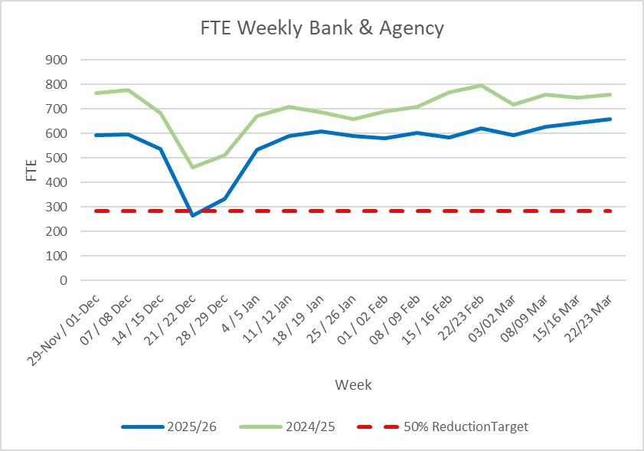

Whilst there was an increase, the graph also demonstrates overall there has been a reduction when comparing the Allocate extracted data each week from 2024/25 and 2025/26. On average from December 2025 through to March 2026 there was a weekly 136 FTE reduction on the use of Bank and Agency, compared to the 2024/25 average.

Table 3: Draft Variable Pay Position 2025/26

Overall Month 12 was £0.5m higher than the average for the 2025/26. There were three areas of movement. Overtime and Bank, which will be part of the stepped change seen in the graph above and an increase in ADH costs specifically driven by Theatres and Anaesthetics. On the later where these are related to Planned Care, funding would be issued which would not be reflected in the table above as this capture’s actual costs only and the combined Month 12 and Month 11 expenditure is consistent with expenditure in Month 9 and Month 10

LTA Performance
The table below provides an overview of the LTA performance for 2025/26, both as a provider and a commissioner of services. The most noticeable impact is the CTM LTA performance.

Table 4: 2024/25 LTA Performance

4. ACTIONS AND NEXT STEPS 2025/26 ANNUAL ACCOUNTS

Receipt Final Welsh Government Allocation Letters | 24 April 2026
Closure of Ledger to support Draft Accounts | 24 April 2026
Submission of Draft Accounts (Welsh Government Deadline) | 1 May 2026
Commencement of External Audit Programme | 5 May 2026
Submission of Audited Accounts (Welsh Government Deadline) | 30 June 2026

5. RECOMMENDATIONS
Members are asked to:
- RECEIVE the Heath Board’s interim draft outturn financial performance for Financial Year 2025/26 for:
  - the cash balance at 31/03/26.
  - the revenue draft outturn position.
  - the capital draft outturn position; and
  - Public Sector Payment Policy outturn position.
- RECEIVE the Annual Accounts Timetable and the next steps in finalising the 2025/26 Financial Position.

Governance and Assurance
Link to Enabling Objectives  please choose) | Supporting better health and wellbeing by actively promoting and empowering people to live well in resilient communities
Link to Enabling Objectives  please choose) | Partnerships for Improving Health and Wellbeing |  | ☐
Link to Enabling Objectives  please choose) | Co-Production and Health Literacy |  | ☐
Link to Enabling Objectives  please choose) | Digitally Enabled Health and Wellbeing |  | ☐
Link to Enabling Objectives  please choose) | Deliver better care through excellent health and care services achieving the outcomes that matter most to people
Link to Enabling Objectives  please choose) | Best Value Outcomes and High-Quality Care |  | ☐
Link to Enabling Objectives  please choose) | Partnerships for Care |  | ☐
Link to Enabling Objectives  please choose) | Excellent Staff |  | ☐
Link to Enabling Objectives  please choose) | Digitally Enabled Care |  | ☐
Link to Enabling Objectives  please choose) | Outstanding Research, Innovation, Education and Learning |  | ☐
Health and Care Standards
(please choose) | Staying Healthy |  | ☐
(please choose) | Safe Care |  | ☐
(please choose) | Effective Care |  | ☐
(please choose) | Dignified Care |  | ☐
(please choose) | Timely Care |  | ☐
(please choose) | Individual Care |  | ☐
(please choose) | Staff and Resources |  | ☐
Quality, Safety and Patient Experience
Financial Governance supports quality, safety and patient experience.
Financial Implications
Report provides the performance against Cash, RRL, CRL and PSPP
Legal Implications (including equality and diversity assessment)
No implications
Staffing Implications
No implications
Long Term Implications (including the impact of the Well-being of Future Generations (Wales) Act 2015)
No implications
Report History |  | Updates on the financial performance is reported monthly to Board and Performance & Finance Committee.
Appendices |  | None

