Meeting Date | 28 April 2026 |  | Agenda Item |  | 4.2
Name of Meeting | Performance & Finance Committee
Report Title | Regional Integration Fund (RIF)– Review and Evaluation 2025/26
Report Author | Michelle Davies, Head of Strategic Planning & Partnerships  Heledd Bingham, Strategic Planning Manager
Report Sponsor | Marie Davies, Director of Planning and Partnerships
Presented by | Marie Davies, Director of Planning and Partnerships
Freedom of Information | Open
Purpose of the Report | The Report sets out the funding decisions for regional schemes for 2025-26 following the evaluation and review of projects funded under the Regional Integration Fund (RIF). The funding for the RIF is allocated to and managed through the West Glamorgan RPB (WGRPB) governance structures.  As an action from the Health Board’s Health and Social Care RIF Internal Audit Report (February 2024), there is a requirement to take the 2025/26 evaluation of the RIF through Health Board governance to ensure oversight and assurance.  This function was previously provided through the Population Health and Partnerships Committee (PHPC) As the remit of this committee has now changed, it was agreed for the evaluation to be taken to Performance & Finance Committee (P&FC).  The report provides P&FC with oversight and assurance on:  - the process and outcomes of the RIF review and evaluation process for 2025/26;  - the RIF allocations for 2026/27;  - the financial / service risks to the Health Board in 2026/27.
Key Issues | The RPB is responsible for agreeing and managing the overall strategic direction and ensuring effective governance of the use of the RIF. All investment is aligned to the Population Programme Boards and regular updates are provided to the Steering Advisory Boards and RPB.  The projects funded via the RIF have both direct and indirect impact of the delivery of core health board functions.  There are also potential funding implications for the Health Board from the RIF evaluation and review process which are outlined within the body of the report and require consideration.
Specific Action Required  (please choose one only) | Information | Discussion | Assurance | Approval
Specific Action Required  (please choose one only) | ☐ | ☐ | ☒ | ☐
Recommendations | Members are asked to:  - RECEIVE the WGRPB report and be assured of the governance arrangements in place to review projects funded though the RIF.  - BE ASSURED that internal governance arrangements are place with senior health board leadership embedded across the WGRPB governance and a RIF standing agenda item on the internal Strategic Partnerships Group;  - CONSIDER the financial risks outlined in section 4 of the report and continued discussions /pending decisions.

Regional Integration Fund (RIF)– Review and Evaluation 2025/26

- Purpose

To provide members with an overview of the arrangements that are in place through the West Glamorgan Regional Partnership Board (RPB) to process, manage and evaluate the Regional Integration Fund.
As required from Internal Audit’s Health and Social Care RIF Audit, the report provides oversight and assurance on:
- the process and outcomes of the RIF review and evaluation process for 2025/26;
- the RIF allocations for 2026/27;
- the financial / service risks to the Health Board in 2026/27.

- BACKGROUND

In February 2024 an Internal audit of Health and Social Care RIF was undertaken and one of the recommendations was that:

An annual RIF assurance report on Health Board schemes will be provided

In addition, the Wales Audit Office published a series of recommendations in 2019 to be delivered by the Welsh Government in relation to the Integrated Care Fund (ICF) (replaced by the the Regional Integration Fund (RIF) in 2022). In March 2026, the Wales Audit Office published the outcome of a review to assess how well the Welsh Government had implemented the recommendations. The full report is attached as appendix 1.

The Regional Integrated Fund (RIF) is a 5-year regional the Welsh Government funded programme (April 2022 to March 2027). The RIF is a flat rate fund with year-on-year financial pressures and risks managed through the established RPB governance structures.

Funding to support the delivery of the Regional Partnership’s Board’s Area Plan 2023-2027 is provided by the Welsh Government through the Regional Integration Fund (RIF). Funding allocation for the region is flat rated with an annual allocation.

A summary of the RIF and other national funds managed by the RPB is included in table 1 below:
Table 1
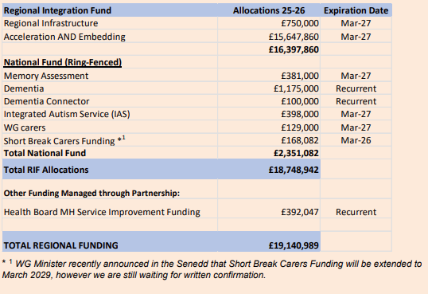
Attached as appendix 2 is a breakdown of the SBUHB schemes operating in 2025/26.
2.1 WGRPB RIF Review and Evaluation Approach 2025/26
All projects in year 2 acceleration are subject to formal evaluation and all projects in year 1, 3, 4, 5 are subject to light touch reviews. At the SBUHB Strategic Partnerships Group (SPG) meeting in October, colleagues were updated on the Review and Evaluation process scheduled to start, and the Health Board schemes scheduled to be evaluated – the SPG slide deck is attached as appendix 3. Please note the following in relation to process from a WGRPB perspective:
- Prior to consideration by the Population Programme Boards, the West Glamorgan Team RAG rate the schemes based on the performance and finance data, milestone update and the story of change.
- In 2025/26, 12 projects were subject to full evaluation, and all schemes were aligned to Mental Health & Learning Disabilities. Light touch reviews were conducted for the other 116 projects. Please see table below, further details are included in the RIF Evaluation report attached as appendix 4
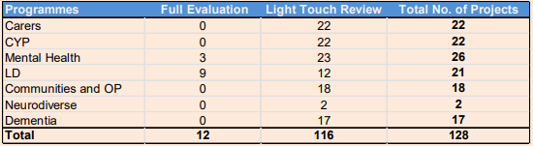
- All RIF evaluations and reviews were approved through the approved governance and went through to the relevant Population Programme Boards.
- All evaluations and reviews of the RIF funded projects were completed before Christmas in order to ensure organisations had sufficient notice of future funding and especially funding for the 2026/27 financial year. The final evaluation report was presented to SAB 3 on the 9 December 2025 and to RPB partners at the RPB meeting on the 11 December 2025.
2.2 Evaluation and Review outcomes
The attached report (appendix 4) provides full detail on the outcomes for all the projects and the funding levels for 2026/27.
All schemes across all population groups evaluated were approved. Some differences in funding were identified due to a few different reasons including some schemes coming to an end.
In addition to the RIF, other regional funding streams are managed via the RPB including Dementia and Neurodivergence and there have been changes to these funding streams, please note the following:
- The dementia funding is now included in the Health Board’s baseline funding;
- Funding for Neurodivergence was reallocated across Wales with only £193,200 allocated to SBUHB to prioritise children and young people on the neurodivergence waiting list. This resulted in a couple of ND projects which had commenced in April 2025 to incur unfunded costs. The only Health Board project affected was the IAS project with £24,887 unfunded costs. The RPB ND Board have agreed to cover these costs with funding set aside to support future ND strategy priorities.
2.3 Lessons Learned and Key areas for Action through the WGRPB
There were several issues and lessons learned from last year’s RIF review, with most of them being addressed via the process in 26/27. Other lessons learned this year are as follows:

- Lack of a strategic approach to project review
An exercise was undertaken to assess cost per beneficiary, comparing the number of people supported with the percentage of investment for projects, utilising the same intervention levels. However, this analysis could not be applied in the RIF review because the funding allocated to each project does not reflect its actual cost. Most projects receive additional resources through core funding, reserves, other grants, and fundraising, making direct comparisons unreliable. Another complicating factor is that some projects provide multiple interventions.
- Clarify and further develop national performance definitions
There is currently some ambiguity among project leads regarding existing definitions, which requires resolution to ensure consistency. This applies to the national approach across Wales.
- Implement proportionate performance reporting
Introduce a more tailored approach to reporting, for example applying fewer measures for smaller projects to reduce unnecessary complexity.
- Review the necessity of certain performance measures
Some measures are not currently being utilised in the assessment process for future funding, indicating a need to evaluate their relevance and potential removal.
- Review process for performance measures
The recent review of performance measures required significantly more time during the Board meeting compared to the original approach of conducting reviews within a smaller panel, suggesting a need to reassess the process for efficiency.
- RAG Ratings
Some schemes rated as Amber had only one minor issue, while others had several concerns. To address this, a four-tier RAG rating system will be introduced next year to provide clearer differentiation and improve decision-making

- GOVERNANCE AND RISK ISSUES

The WGRPB is responsible for agreeing and managing the overall strategic direction and ensuring effective governance of the use of the RIF. All investment is aligned to the Population Programme Boards and regular updates are provided to the Steering Advisory Boards (SABs) and the RPB for decisions and assurance. At the West Glamorgan RPB meeting in December 2025, members of the Board approved recommendations to streamline and simplify the governance structure of the RPB. The structure continues to reflect the same approach to oversight and escalation with Population Programmes and one Leadership Steering Advisory Board and is not anticipated to have an impact on the RIF evaluation and review process.

The aim is for each Programme Board to have Executive leadership from each partner agency, with management and clinical engagement required from the Health Board in each programme. The internal Strategic Partnerships Group (SPG) and the Performance & Finance Committee now provide oversight and assurance for the RIF from a Health Board perspective.

The overall findings of the March 2026 Wales Audit Office report acknowledged that strong progress had been made implementing previous recommendations - 5 of the 6 recommendations had been fully implemented, with 1 partly implemented. One of the areas that was identified as an area for improvement was oversight of the RIF by the Welsh Government but also oversight by statutory partners i.e., the Health Board and Local Authorities, and as a result the recommendations have been updated to reflect that position.

- FINANCIAL IMPLICATIONS

Risks have been identified for both statutory partners and the third sector including the gap in funding for this year and the future uncertainty of RIF funding poses a significant threat to the sustainability of services currently supported.

The Welsh Government has confirmed that while the RIF programme itself is time limited, the underlying funding streams are recurrent. However, decisions on how this funding is used, governed and prioritised beyond March 2027 will be for the incoming government following the election, and there is currently no confirmation on successor arrangements or future priorities.

Alongside other regions, the West Glamorgan team have been working closely with the Welsh Government officers to ensure they have robust and transparent information which clearly demonstrates the impact of RIF investment, and the implications for citizens, services and the wider system should this funding be withdrawn or reprioritised.

The Welsh Government has also emphasised the importance of evidencing impact during the final year of the programme to support advice to new Ministers. The regional focus therefore remains on delivery and strengthening the evidence base through 2026 to 2027, while recognising the uncertainty beyond March 2027.

Once there is a clearer position from the new government, the region will consider the approach to managing any impacts. However, this is challenging given that none of the partner organisations’ current financial plans include provision for this potential funding gap, as there is no additional core funding available to mitigate the risk. While the Welsh Government’s original expectation was that RIF funded activity would be mainstreamed by the end of the five-year programme, this has proved impossible given the current financial position across partners.

In terms of the specific risks to the Health Board, these risks sit within the Primary, Community and Therapies Group (PCTG) and Mental Health (MH) Service Groups.

Communities and Older People Programme:

The funding PCT service groups received in 2025/26 was c£2.7m. Apart from the PROMS and PREMS (12.5K) this money is pay related and equates to around 50 staff.

Project Ref | Project Name | Host Organisation | Total Funding
5MA | Speech & Language Therapy in Memory Assessment Ser | SBUHB | 115,622
9MA | Pre-Memory Assessment Support Project | SBUHB | 86,212
14RIF | Project Support Officers (Patient flow facilitators) | SBUHB | 92,022
01D | PROMS AND PREMS | SBUHB | 12,500
09CP | Primary Care / Health Board: Local Post, Integrate | SBUHB | 56,376
13 COP-H | S33 Intermediate Care Services | SBUHB | 2,384,117
 |  |  | 2,746,849
Regionally, the Older People’s funding gap for 26-27, it is as follows (though this does not capture any further funding shortfalls identified from revised budgets for 26-27):
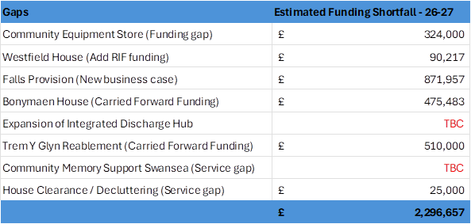
Within the Communities and Older People Programme, work is underway to review the totality of current investment to understand whether there are opportunities to disinvest and reinvest in areas that deliver greater impact. A series of workshops have taken place with partners to test priorities, processes and outcomes, with further workshops due to be scheduled after Easter to continue this work and support informed decision making.
Mental Health and Learning Disabilities:
The Integrated Autism and dementia monies (ANP posts) sit with Mental Health and Learning Disabilities (MHLD). The December 2025 financial allocation letter confirmed that the dementia element for 2026/27 is within Health Board baseline funding. The International Standard on Auditing (ISA) is ringfenced RIF funds and are Health Board pay related. The ISA funding is critical to the Health Board, supporting the backlog for Neurodevelopment (ND) services and assessments.
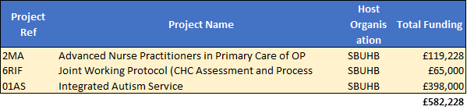
- RECOMMENDATIONS

Members are asked to:
- RECIEVE the West Glamorgan RPB report and be assured of the governance arrangements in place to review projects funded though the Regional Integration Fund.
- BE ASSURED that internal governance arrangements are place with Senior Health Board leadership embedded across the WGRPB governance and the internal Strategic Partnerships Group in place with a standing agenda item on the RIF.
- CONSIDER the financial risks outlined in section 4 of the report and continued discussions /pending decisions.

Governance and Assurance

Link to Enabling Objectives  (please choose) | Supporting better health and wellbeing by actively promoting and empowering people to live well in resilient communities
Link to Enabling Objectives  (please choose) | Partnerships for Improving Health and Wellbeing |  | ☒
Link to Enabling Objectives  (please choose) | Co-Production and Health Literacy |  | ☒
Link to Enabling Objectives  (please choose) | Digitally Enabled Health and Wellbeing |  | ☒
Link to Enabling Objectives  (please choose) | Deliver better care through excellent health and care services achieving the outcomes that matter most to people
Link to Enabling Objectives  (please choose) | Best Value Outcomes and High-Quality Care |  | ☒
Link to Enabling Objectives  (please choose) | Partnerships for Care |  | ☒
Link to Enabling Objectives  (please choose) | Excellent Staff |  | ☒
Link to Enabling Objectives  (please choose) | Digitally Enabled Care |  | ☒
Link to Enabling Objectives  (please choose) | Outstanding Research, Innovation, Education and Learning |  | ☒
Health and Care Standards
(please choose) | Staying Healthy |  | ☒
(please choose) | Safe Care |  | ☒
(please choose) | Effective Care |  | ☒
(please choose) | Dignified Care |  | ☒
(please choose) | Timely Care |  | ☒
(please choose) | Individual Care |  | ☒
(please choose) | Staff and Resources |  | ☒
Quality, Safety and Patient Experience
There are no implications in relation to Quality, Safety and Patient Experience to report.

Financial Implications
Known financial risks are outlined in section 4.

Legal Implications (including equality and diversity assessment)
There are no known legal implications to the Health Board.

Staffing Implications
Over and above the financial risks that are outlined in section 4, there are no known staffing implications to the Health Board.

Long Term Implications (including the impact of the Well-being of Future Generations (Wales) Act 2015)
The delivery of the RPB Area Plan and priorities is a critical part of public service organisations delivering against their statutory duties.
Report History |  | This is the second RIF Report that will be presented to the Performance & Finance Committee on 28th April 2026. This report was also discussed at Formal Executive Team on 22 April 2026.
Appendices |  | Appendix 1 Wales Audit Office Report – March 2026  Appendix 2 SBUHB RIF Schemes  Appendix 3 SPG Slide Deck  Appendix 4: WGRPB RIF Evaluation

