Meeting Date | 28 April 2026 |  | Agenda Item |  |  | 6.1
Name of Meeting | Performance and Finance In-Committee
Report Title | Recovery and Sustainability Board Highlight Report
Report Author | Deborah Longman – Head of Recovery and Sustainability
Report Sponsor | Claire Osmundsen-Little – Interim Executive Director of Finance
Presented by | Claire Osmundsen-Little – Interim Executive Director of Finance
Freedom of Information | Open
Purpose of the Report | The report is provided to update the committee on the current actions and work in progress of the Recovery & Sustainability (R&S) Board.
Key Issues | The report invites the Performance & Finance Committee to note the work undertaken by the Recovery & Sustainability programme, overseen by the Recovery & Sustainability Board.  The report includes an overview of the key actions arising from the latest Recovery & Sustainability Boards as well as an update on the thematic programmes.
Specific Action Required  (please choose one only) | Information | Discussion |  | Assurance | Approval
Specific Action Required  (please choose one only) | ☐ | ☐ |  | ☒ | ☐
Recommendations | Members are asked to:  - RECEIVE the report for assurance.

Recovery and Sustainability Board Highlight Report

- INTRODUCTION
The paper provides the monthly formal update to the committee regarding the actions and progress within the Recovery and Sustainability programme.

- BACKGROUND
The Recovery and Sustainability Board meets on a twice monthly basis to manage the financial recovery programmes for the health board. The board is chaired by the Chief Executive and the thematic programmes that comprise the programme are executive led. There are eleven themes, each with a delivery lead and underpinned by project plan on a page and depending on the maturity a detailed project initiation document and quality impact assessment. The anticipated financial benefit for 2026/27, as set out in the 2026/27 Financial Plan has been initially assessed and the proposed apportionment will be included in the budget setting process.

- R&S PROGRAMME UPDATE

  - R&S Board 25 March 2026
The focus of the board was looking forward at the schemes which will form the 2026/2027 financial recovery programme.

Schemes totalling £65m have been identified and are in differing stages of maturity as highlighted above. The tables below provide a summary of the key areas.
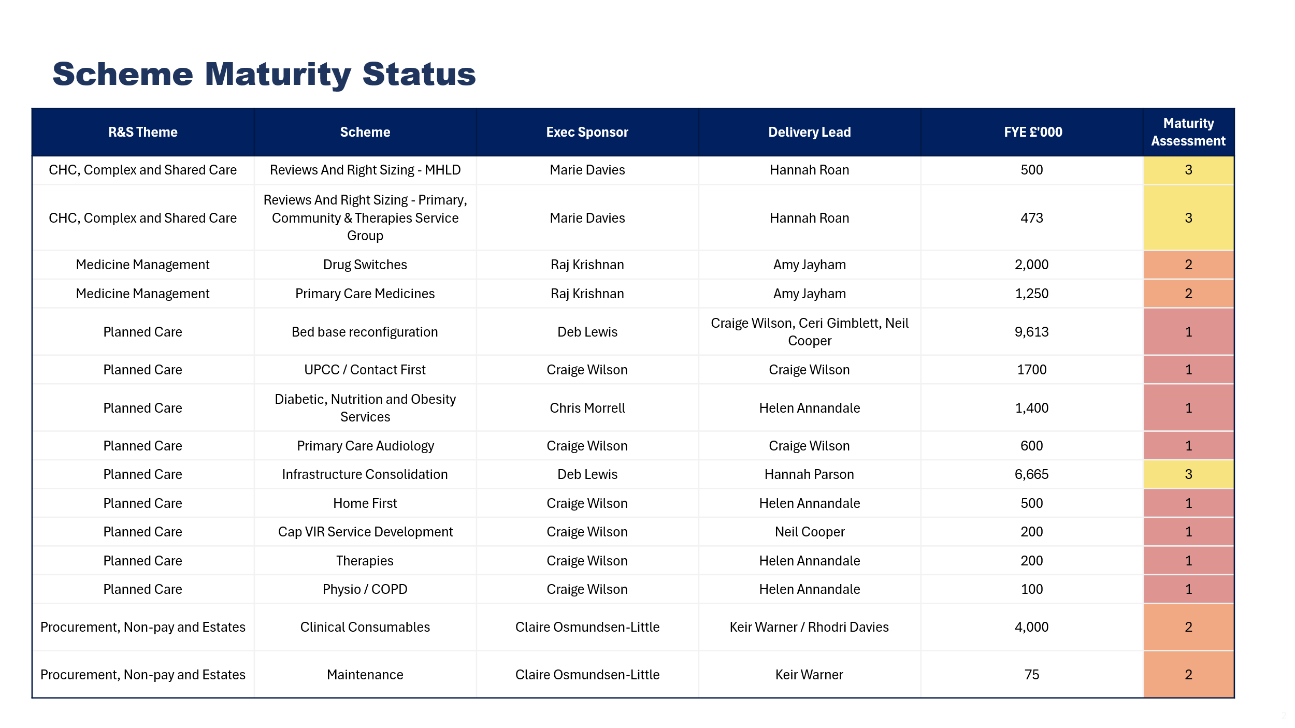
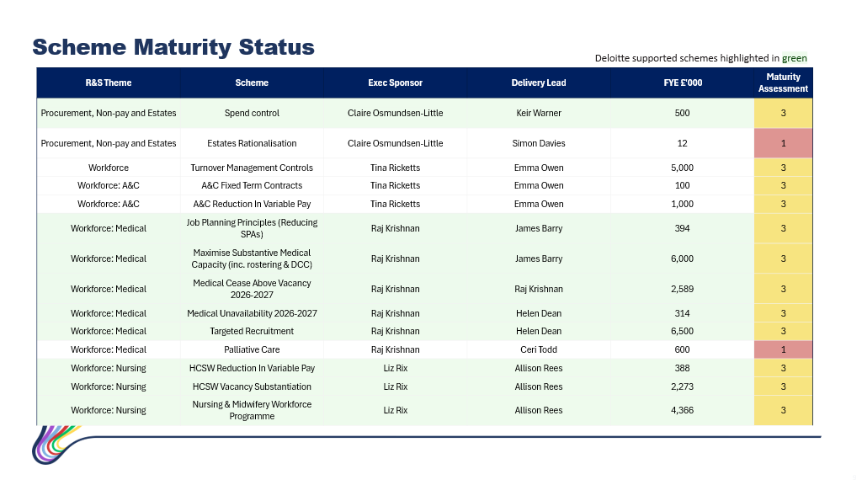
Given these are full year effect figures, additional pipeline opportunities are being explored to cover any shortfalls.

  - R&S Board 8 April 2026
The main focus was on the 2026/27 readiness activities. The identified projects which make up the £65m financial recovery programme are now undertaking impacts assessments to assess to risks to service delivery and patient care. There is a detailed spreadsheet highlighting figures and proposed phasing of financial delivery.

It was agreed that in future R&S boards there is a need to be more forward looking and that each programme would show their forecast, milestones and financial delivery.

In relation to impact assessments, those with a low impact score can proceed. Those with a higher impact score will be reviewed at the next R&S board at the end of April.

- GOVERNANCE AND RISK ISSUES

The work summarised in section 3 provides the Heath Board with a line of sight to £65m savings required, which addresses the plan submitted on 31 March 2026. The plan is predicated on a Full Year Effect of the savings, and so delivery is dependent on seeing immediate results. As it is appreciated that some financial recovery projects will take longer to see traction, the pipeline opportunities are being explored to help mitigate those risks.

- FINANCIAL IMPLICATIONS
The financial implications of this report are set out within it.

- RECOMMENDATION
Members are asked to:
- RECEIVE the report for assurance.

Governance and Assurance
Link to Enabling Objectives  (please choose) | Supporting better health and wellbeing by actively promoting and empowering people to live well in resilient communities
Link to Enabling Objectives  (please choose) | Partnerships for Improving Health and Wellbeing |  | ☐
Link to Enabling Objectives  (please choose) | Co-Production and Health Literacy |  | ☐
Link to Enabling Objectives  (please choose) | Digitally Enabled Health and Wellbeing |  | ☐
Link to Enabling Objectives  (please choose) | Deliver better care through excellent health and care services achieving the outcomes that matter most to people
Link to Enabling Objectives  (please choose) | Best Value Outcomes and High-Quality Care |  | ☒
Link to Enabling Objectives  (please choose) | Partnerships for Care |  | ☐
Link to Enabling Objectives  (please choose) | Excellent Staff |  | ☐
Link to Enabling Objectives  (please choose) | Digitally Enabled Care |  | ☐
Link to Enabling Objectives  (please choose) | Outstanding Research, Innovation, Education and Learning |  | ☐
Health and Care Standards
(please choose) | Staying Healthy |  | ☐
(please choose) | Safe Care |  | ☒
(please choose) | Effective Care |  | ☒
(please choose) | Dignified Care |  | ☐
(please choose) | Timely Care |  | ☒
(please choose) | Individual Care |  | ☒
(please choose) | Staff and Resources |  | ☒
Quality, Safety and Patient Experience
No implications

Financial Implications
No implications
Legal Implications (including equality and diversity assessment)
No implications
Staffing Implications
No direct implications
Long Term Implications (including the impact of the Well-being of Future Generations (Wales) Act 2015)
No implications
Report History |  | Routine report to Performance and Finance Committee
Appendices |  | Nil.

