Meeting Date | 23 June 2026 | Agenda Item | 2.2
Name of Meeting | Finance and Performance Committee
Report Title | Financial Report – Month 02 2026/27
Report Author | Samantha Moss, Deputy Director of Finance  Gemma Pearson, Finance Business Partner  Crystal Davies, Principal Finance Manager
Report Sponsor | Executive Director of Finance
Presented by | Samantha Moss, Deputy Director of Finance
Freedom of Information | Open
FoI Closed detail | If closed, choose detail
Impact Assessment Summary Outcome |  | IA Completion date
N/A |  | Click or tap to enter a date.
Purpose of the Report | For Assurance
Report Summary; detailing any action required
The report advises the Performance & Finance Committee of the Health Board on the financial position for Month 02 2026/27 (May 2026) and risks regarding the current forecast revenue year end outturn.

Key Issues
The report invites the Performance & Finance Committee to note the detailed analysis of the financial position for Month 02 2026/27 (May 2026).

The report and the appendices, includes a summary of the key drivers of the position either at Service level or by expenditure type (i.e. Non-Pay/Pay). It also provides information of the current position with regards to Health Board reserves to ensure transparency in the overall Health Board position.

Risk will have been considered on the basis of the information provided within the report and the score updated where necessary.

Whilst the key messages are provided within the main body of the report, further information is provided within the accompanying Annex.

Decision / Action required | No
Recommendations
Members are asked to: -
- CONSIDER the 2026/27 Financial Plan, and the Health Board’s and Welsh Government’s inability to approve it given the planned deficit of £76.6m.
- CONSIDER the actions in place with regards to Welsh Government’s expectation that the Health Board delivers the £65m savings to support the delivery of the 2026/27 Financial Plan.
- CONSIDER and comment upon the Health Board’s financial performance for Month 02 2026/27 and the Year to Date (YTD) position.
- CONSIDER the risks to the position at Month 02.
- SUPPORT the position with regards to Health Board reserves.

FINANCIAL REPORT – MONTH 02 2026/27

- INTRODUCTION
The draft Annual Plan submitted to the Welsh Government on 31 March 2026 for assessment and scrutiny included a financial assessment, as summarised in the table below:
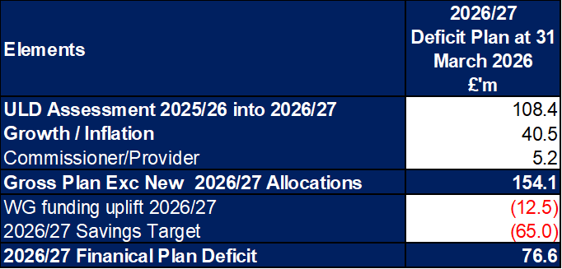

The Health Board accepts that this financial assessment is not acceptable or supportable for Welsh Government and does not meet the statutory duties of the Health Board. A strengthened reiteration was submitted to Welsh Government on 29th May, with a further iteration being drafted for submission following Board scrutiny on 25 June.

The Health Board acknowledges the Welsh Government expectation that the Health Board’s Planned Deficit for 2026/27 should not exceed the 2025/26 outturn. The Health Board is working to finalise the detailed delivery plan in respect of the £65.0m savings target set out in the draft plan submitted in March. Work is underway at pace to develop the required Plan resubmission ahead of the June 2026 deadline, taking account of the feedback provided by Welsh Government and the requirements of the Board on actions to support the required level of assurance.

The Health Board’s actual performance against the Planned Deficit and last year’s outturn position is provided in the table below. This table shows that at the end of Month 2 the reported deficit is £7.7m, which is £1.3m above the planned deficit and £3.3m against last year’s outturn. The table provides the reconciliation to £7.7m Month 2 variance, based on a 12th of the £76.6m Deficit Plan compared to a 12th of a £53.2m outturn from 2025/26. The key difference for the purposes of this illustration is the level of non-delivery of savings, as the assumption made for this letter is that for the plan to move from £76.6m to £53.2m additional recurrent savings would be required.
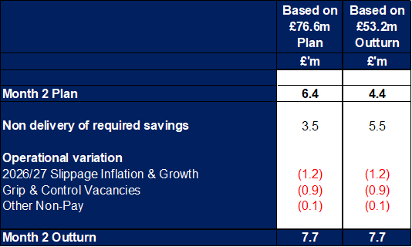

The Health Board has made progress during May in improving the level of assurance on savings and has now validated £16.7m. Work will focus on translating the next £18.9m to Amber. A Task and Finish group scheduled for 17 June will translate the work on the bed reconfiguration and planned care plans and this will dictate further £29.4m savings assessment. Further details are provided in Annex 1 regarding the progress to date.

Cumulatively the Health Board is over plan by £3.4m at the end of Month 2 or £7.4m based on the further stretched target of 2025/26 outturn. This will need to be recovered through delivery of additional savings or reducing expenditure below plan in future months.

Given the financial position, actions to mitigate growth and generate further stretched savings are being undertaken. The Board will further scrutinise the reiterated plan on the 25 June 2026 where the options to address the gap will be discussed. Progress on these plans are part of the Recovery & Sustainability Board and work that the Delivery Unit is driving through weekly ‘Confirm and Challenge’ meetings for each thematic workstream.

- BACKGROUND – Financial Performance

KEY PERFORMANCE INDICATORS
TARGET | ACTUAL PERFORMANCE
Cash Balance Bank < £6.0m | £7.256m
In Month Performance Revenue Resource Limit ≤ 2/ 12th £76.6m | £7.656m
YTD Performance Revenue Resource Limit ≤ £ 2/12th £76.6m x YTD Months | £16.174m
YTD Performance Capital Resource Limit ≤ £0m | £0
YTD Performance Public Sector Payment Policy > 95% | 97.1%

FINANCIAL REPORT REVENUE – MONTH 02

At Month 2 there was an In-Month overspend of £7.7m, which is £1.3m worse than the planned deficit of £6.4m (£76.6m/12).

With regards to the overall financial performance, Graph 1 below reflects the actual financial performance in each month, with the orange bars reflecting the performance required to achieve the original plan of £76.6m. Graph 2 outlines the savings delivered to date as the blue bars against the monthly target set (red line), and the orange bars reflect the level of savings required in future months to achieve the £65m target aligned to the £76.6m plan.
Graph 1: Performance Graph 2: Savings
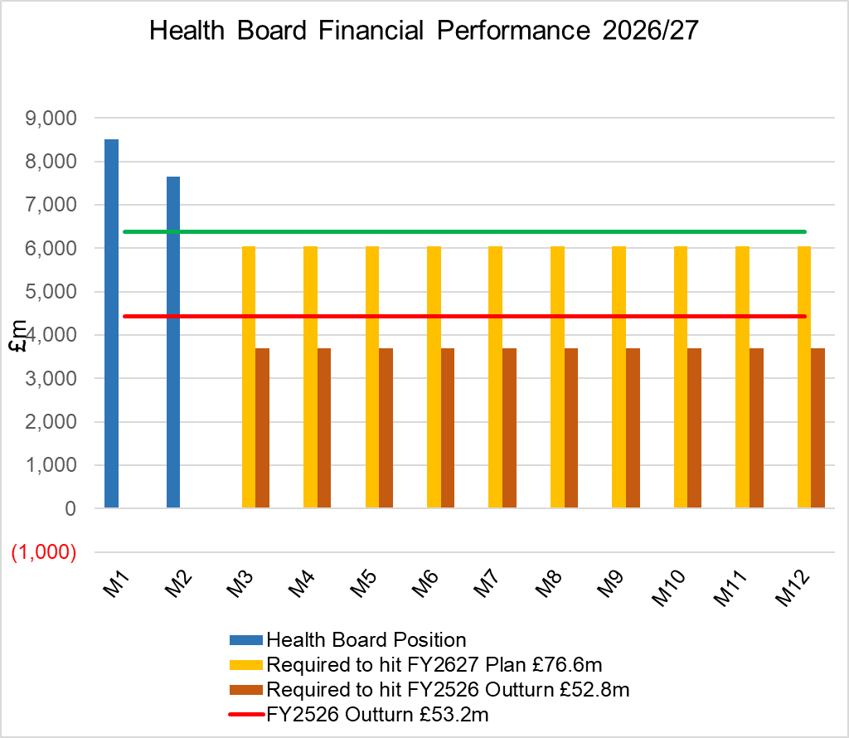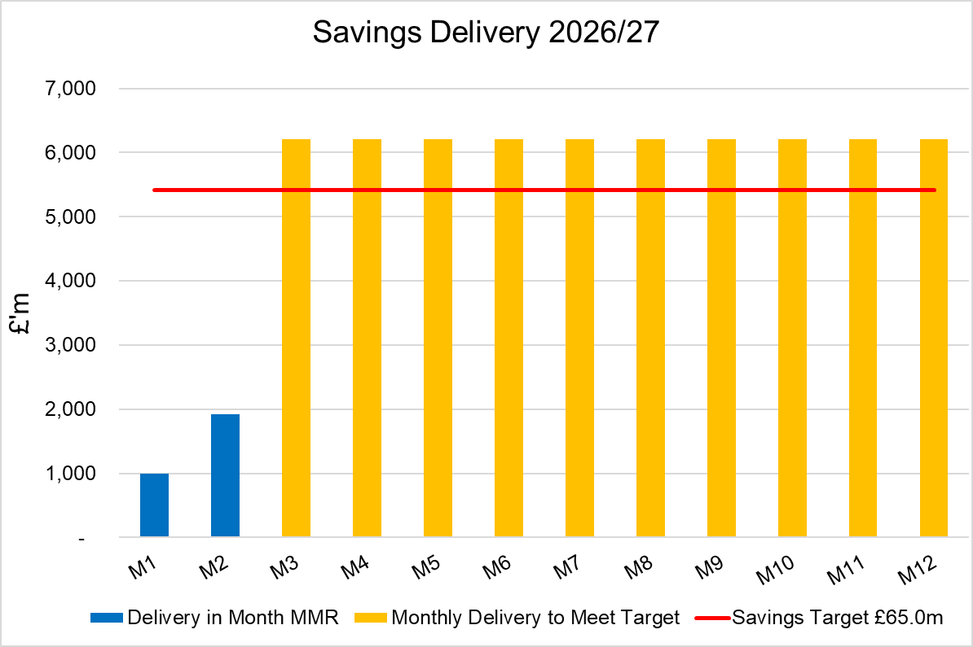

KEY DRIVERS OF THE IN-MONTH POSITION
The key movement from plan of the Month 2 position are summarised in second table reported in Section 1 above. Further detail at a Health Board level of expenditure on Income, Pay and Non-Pay, is provided within Annex 1.

SAVINGS
Full details on savings are provided Annex 1, but in summary the in-month delivery in Month 2, was £1.9m against a target of £5.4m and remains the key driver of the Health Board overspend. YTD delivery is £2.9m against a target of £10.8m.
Part C Actions
- Part C1: Savings Trackers Red & Corporate Stretch @ 4 September 2025
- Part C2: Savings Trackers Pipeline @ 4 September 2025
- Part C3: In-year impact of the thematic Scheme Summaries (adjusted to avoid double count)
Further Actions
- Additional interventions to close the gap to the original savings plan
  - Exec oversight of variable pay
  - Additional capacity reduction
  - Non pay bans / restrictions

BUDGET SETTING PROCESS
In May budget letters were issued to all 67 identified Senior Leaders along with invites to attend a budget holder training session with additional procurement training. The return of the signed letters and Budget Holder access to the Qliksense finance dashboard is being tracked and reported within Annex 1, Appendix 2-3.

YEAR END PROCESS
The final year end accounts continue to undergo Audit Wales scrutiny, with ISA260 and final version of the Accounts to be reported via the Audit Committee and then to Board on 25 June, prior to submission to WG and the Auditor General for Wales at the end of June.

- GOVERNANCE AND RISK ISSUES

Two Board level financial risks:

- Achieving financial plan (HBR92) with the key elements as follows: -

- Risk of delivery of savings quantum
- Risk of operational overspend being in excess of funding available agreed via the Financial Plan
- Risk of commitment of reserves (e.g. NICE) being above reserves available.
- Risk of achieving the actions and options outlined in the 2025/26 Financial Recovery & Sustainability Assessment.

Given the improvement needed to the monthly performance and the YTD delivery of savings to achieve the deficit plan of £76.6m, it is recommended that the Health Board Corporate Risk Register continues to reflect a risk score of 25.

- Availability of capital (HBR93). This risk was re-opened in 2022/23 given the reduction in discretionary capital allocation. Due to the additional capital funding provided during 2024/25 the risk score was reduced to 12. The score was increased in June 2025 to reflect risks regarding Emergency Department and Adult Acute Mental Health. However, following further assessment at start Quarter 4 2025/26 and based on funding received the risk score reduced to 12, which is the recommendation post Month 1.

For Month 2 the key risks to the delivery of the Deficit Plan reported to WG in the MMR, linked to HBR92 are summarised below:
- Delivery of savings: as seen in the actual Month 2 performance. The Health Board has identified £16.7m of Green and Amber savings (with Red/Pipeline schemes totalling a further £48.3m) and whilst it continues to scrutinise delivery of these via the Recovery & Sustainability Team and Board (chaired by the CEO), the role of the Delivery Unit is to quickly translate these plans to deliverable savings in year. Therefore, at this stage in the year, it is assumed that risk and the value of this, remains as per the MDS submission but this is being reviewed as part of the updating of our plan.
- Non-Delivery Actions to Mitigate Growth/Inflation: growth pressures above plan level are expected to be mitigated by the identification of mitigating actions outside of (in addition to) the planned savings delivery. The Health Board acknowledges that this is challenging in the context of the savings position described above. We are working alongside P&I finance team to validate our working assumptions and ensure we are not an outlier. These have been reduced in Month 2 to reflect there remains only 10 months of the financial year remain.
- Energy Risk provided by NWSSP: not all the energy requirements for 2026/27 have been purchased in advance. The assessment provided by NWSSP on 09/06/26 highlighted a risk of £0.539m, which is 117% increase from previous value. This will be updated based on the data from NWSSP.
- Resident Dr Contract Changes: the contractual changes will be phased from August 2026 to August 2028. Initial assessment by the Health Board suggested there is a risk of between £2m - £2.5m. A report is being prepared to assess the implications and look at risks and mitigations.

- OPEN AUDIT RECOMMENDATIONS
Core Audit recommendations at Month 2 relate to the Internal Audit Budget Setting Audit Report 2025/26. Key actions and updates summarised below:

- RECOMMENDATION
Members are asked to:
- CONSIDER the 2026/27 Financial Plan, and the Health Board’s and Welsh Government’s inability to approve it given the planned deficit of £76.6m.
- CONSIDER the actions in place with regards to Welsh Government’s expectation that the Health Board delivers the £65m savings to support the delivery of the 2026/27 Financial Plan.
- CONSIDER and comment upon the Health Board’s financial performance for Month 02 2026/27 and the Year to Date (YTD) position.
- CONSIDER the risks to the position at Month 02.
- SUPPORT the position with regards to Health Board reserves.

Governance and Assurance
Strategic Objectives
Strategic Objectives  (please choose which is impacted) | People of Swansea Bay live healthier, fairer and more prosperous lives | ☐
Strategic Objectives  (please choose which is impacted) | Care is high quality, safe, efficient and delivers the best possible outcomes for people in partnerships | ☐
Strategic Objectives  (please choose which is impacted) | Care is delivered in partnership with our communities in safe and appropriate setting, supported by innovation | ☐
Strategic Objectives  (please choose which is impacted) | The health board is a great place to work where staff feel valued and work together towards a common goal | ☐
Strategic Objectives  (please choose which is impacted) | The health board is a resilient, sustainable and responsible organisation | ☒
Health and Care Standards
Standards (please choose which applies) | Safe Care | ☐
Standards (please choose which applies) | Timely Care | ☐
Standards (please choose which applies) | Effective Care | ☐
Standards (please choose which applies) | Efficient Care | ☒
Standards (please choose which applies) | Equitable care | ☐
Standards (please choose which applies) | Person-centred Care | ☐
Standards (please choose which applies) | Staff and Resources | ☐
Enablers (please choose which applies) | Whole Systems Approach | ☒
Enablers (please choose which applies) | Leadership | ☐
Enablers (please choose which applies) | Workforce | ☐
Enablers (please choose which applies) | Culture | ☐
Enablers (please choose which applies) | Information | ☐
Enablers (please choose which applies) | Learning, Improvement and Research | ☐
Quality, Safety and Patient Experience
Financial Governance supports quality, safety, and patient experience.

Financial Implications
The Board is reporting a forecast year-end deficit financial outturn.

Legal Implications (including equality and diversity assessment)
No implications

Staffing Implications
No implications

Long Term Implications (including the impact of the Well-being of Future Generations (Wales) Act 2015)
No implications

Report History
Updates on the financial position are provided at every meeting.

Appendices
Annex 1 – Detail on Financial Position @ Mth 2

