Meeting Date | 23 June 2026 | Agenda Item | 2.3
Name of Meeting | Finance and Performance Committee
Report Title | Recovery and Sustainability Board Update
Report Author | Deborah Longman – Head of Recovery and Sustainability
Report Sponsor | Executive Director of Finance
Presented by | Callum Allen-Ridge, Head of PMO
Freedom of Information | Open
FoI Closed detail | If closed, choose detail
Impact Assessment Summary Outcome |  | IA Completion date
n/a |  | Click or tap to enter a date.
Purpose of the Report | For Assurance
Report Summary; detailing any action required
The report is provided to update the committee on the current actions and work in progress of the Recovery & Sustainability (R&S) Board.

Key Issues
The report invites the Performance & Finance Committee to note the work undertaken by the Recovery & Sustainability programme, overseen by the Recovery & Sustainability Board.

The report includes an overview of the key actions arising from the latest Recovery & Sustainability Boards.

It presents the current and future pipeline position and the forecast position for quarter 1.

Decision / Action required | No
Recommendations
Members are asked to:
- Receive for Assurance
RECOVERY AND SUSTAINABILITY BOARD UPDATE

- INTRODUCTION
The paper provides the monthly formal update to the committee regarding the actions and progress within the Recovery and Sustainability programme and the status of the savings pipeline

- BACKGROUND
The Recovery and Sustainability Board meets on a twice monthly basis to manage the financial recovery programmes for the health board. The board is chaired by the Chief Executive and the thematic programmes that comprise the programme are executive led.

A formal project management approach has been established, around executive led themes. The R&S team also hold the RAID logs (Risks, Actions, Issues and Decisions) to further scrutinise the governance. The governance has been further enhanced by the development of the Delivery Unit, bringing together resources into a central Programme Management Office, allowing for a more agile approach to respond to project management needs across the organisation.

It should be noted that support from our strategic external partner has now come to an end now that the Delivery Unit now has oversight and responsibility for managing the pipeline into delivery but it also working to create an incubator for new ideas and initiatives.

As part of the delivery assurance a ‘Check and Challenge’ meetings with delivery teams to progress schemes across the Welsh Government tracker process continue. These meetings review actions, milestones and financial assumptions to provide assurance on the quality of the project plans and delivery, and to move themes through the tracker status. The aim is to get the schemes from ideas to delivery from red to green.

- R&S PROGRAMME UPDATE

  - R&S Board 27th May 2026
This board was chaired by Jon Scott, Director of Delivery. The main focus of the board was agreeing processes to move forward Welsh Government ratings, assessing the PID progressions since the last meeting and to review proposals relating to the development of the delivery unit.

The RAG progression assessment and review process is highlighted below, showing the synergy between PMO and Finance:

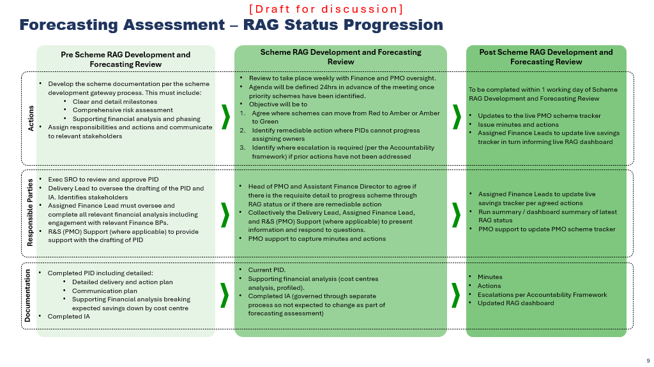
The maturity of the schemes were presented and delivery leads were tasked to get 40% amber/green position by the end of Month 2. Key areas of focus included Workforce PIDs relating to Admin and Clerical, Medical with focus on medicine management and procurement.

  - R&S Board 10th June 2026
The main focus of the meeting to review the 26% outturn position and set an accelerated improved position for the end of Quarter 1. Focus was to discuss the check points which needed to be met to move schemes from pipeline > red > amber > green, as highlighted below:
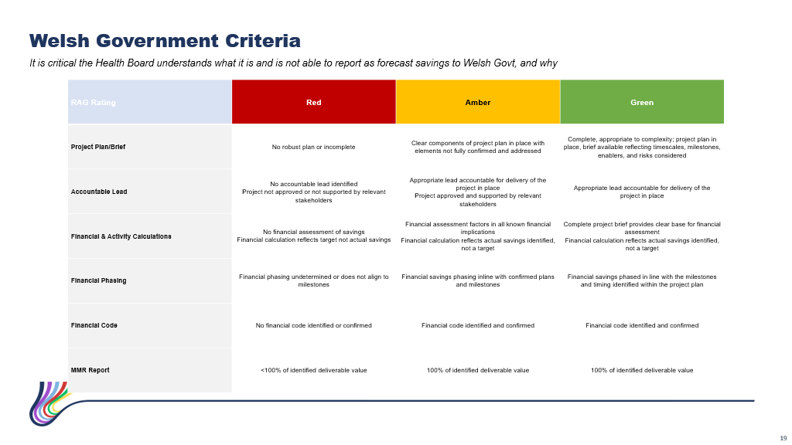 Colleagues have been working closely with finance colleagues so that schemes can be moved into Green and Amber for Welsh Government tracking purposes.
Month two financial reporting showed an improved position to 26% £16.654m, but 14% lower than planned. The team agreed to target a 48% £31.137 position at the end of quarter 1.

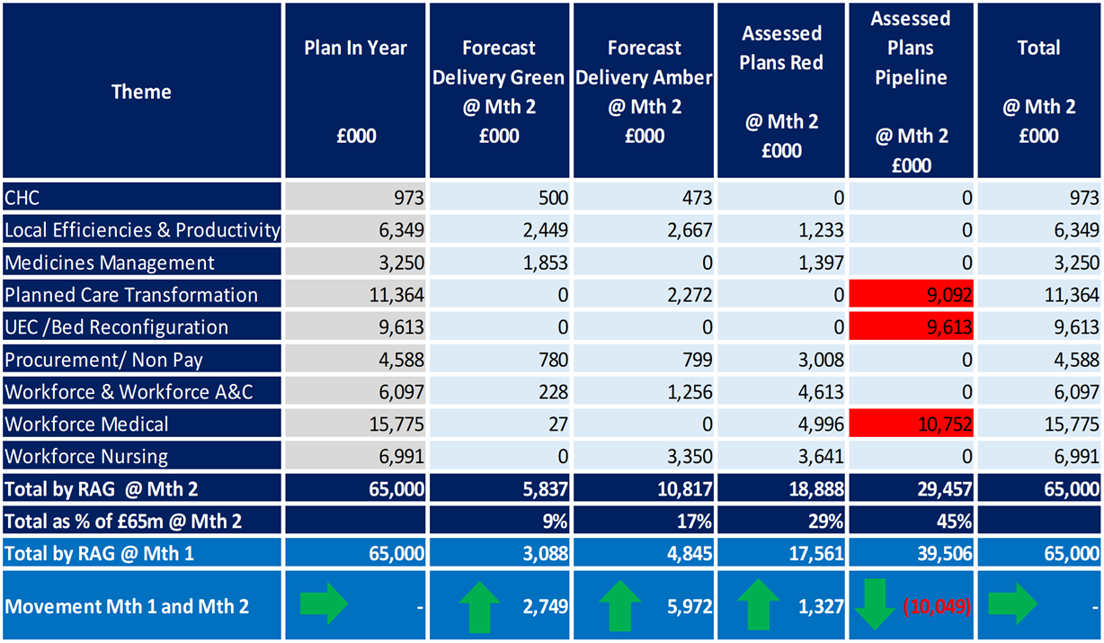

Schemes which are currently showing red and pipeline were subjected to additional scrutiny with some key deliverables in the following areas:

- Workforce A&C completion of 5 outstanding PIDs to finalise the £3.5m target
- Medicine Management – consideration of the £1.3m balance and further opportunities
- Procurement - New PIDS - AHPS/Digital /LTA actions to be updated and included in the pipeline

The ‘check and challenge’ meeting outputs so far were reviewed to provide assurance on the progression. Escalation in the week for the medicine and medical management team to finalise the PID positions.

- GOVERNANCE AND RISK ISSUES
The established governance processes within the R&S programme and board are clear and robust.

- FINANCIAL IMPLICATIONS
The financial implications of this report are set out within it.

- RECOMMENDATION
Members are asked to:
- Receive the report for assurance and note the progress to translate the pipeline to Green and Amber to get the pipeline to 48% at the end of the quarter.

Governance and Assurance
Strategic Objectives
Strategic Objectives  (please choose which is impacted) | People of Swansea Bay live healthier, fairer and more prosperous lives | ☐
Strategic Objectives  (please choose which is impacted) | Care is high quality, safe, efficient and delivers the best possible outcomes for people in partnerships | ☐
Strategic Objectives  (please choose which is impacted) | Care is delivered in partnership with our communities in safe and appropriate setting, supported by innovation | ☐
Strategic Objectives  (please choose which is impacted) | The health board is a great place to work where staff feel valued and work together towards a common goal | ☐
Strategic Objectives  (please choose which is impacted) | The health board is a resilient, sustainable and responsible organisation | ☒
Health and Care Standards
Standards (please choose which applies) | Safe Care | ☐
Standards (please choose which applies) | Timely Care | ☐
Standards (please choose which applies) | Effective Care | ☒
Standards (please choose which applies) | Efficient Care | ☒
Standards (please choose which applies) | Equitable care | ☐
Standards (please choose which applies) | Person-centred Care | ☐
Standards (please choose which applies) | Staff and Resources | ☒
Enablers (please choose which applies) | Whole Systems Approach | ☒
Enablers (please choose which applies) | Leadership | ☒
Enablers (please choose which applies) | Workforce | ☐
Enablers (please choose which applies) | Culture | ☐
Enablers (please choose which applies) | Information | ☐
Enablers (please choose which applies) | Learning, Improvement and Research | ☐
Quality, Safety and Patient Experience
Recovery & Sustainability programme, whilst addressing the need for a sustainable financial position, is focused on undertaking through delivery of good quality, safety, and patient experience.

Financial Implications
No direct financial implications
Legal Implications (including equality and diversity assessment)
No implications
Staffing Implications
No direct implications
No implications
No implications
Report History
n/a

Appendices
N/A.

