Meeting Date | 23 June 2026 | Agenda Item | 3.4
Name of Meeting | Finance and Performance Committee
Report Title | Theatre Utilisation and Efficiency
Report Author | Rhodri Davies, Associate Service Group Director Surgery  Jonathan Gates, Head of Nursing Surgery
Report Sponsor | Chief Operating Officer
Presented by | Rhodri Davies, Associate Service Group Director, Surgery
Freedom of Information | Open
FoI Closed detail | If closed, choose detail
Impact Assessment Summary Outcome |  | IA Completion date
N/A |  | Click or tap to enter a date.
Purpose of the Report | For Assurance
Report Summary; detailing any action required
To highlight to the committee the next steps taken in improving utilisation and efficiency across SBUHB Theatres
Key Issues
1. Theatre Utilisation Performance
2. Efficiency Improvement Progress
3. Elective Surgery Toolkit Implementation
4. MDT-Based List Scrutiny and Planning
5. Targeted Specialty Improvement – Ophthalmology
6. LOCSSIP Local Safety Standard for Invasive Procedures (Internal Audit)
Decision / Action required | No
Recommendations
Members are asked to:
- Receive for ASSURANCE the Theatres efficiency update and the actions being taken to improve the overall performance in a sustainable and consistent manner.

Theatre Utilisation and Efficiency

- INTRODUCTION
This report provides an update to the Performance and Finance Committee on progress made in improving theatre utilisation and operational efficiency across Swansea Bay University Health Board (SBUHB). It outlines the actions being implemented to maximise productivity, reduce unwarranted variation, and optimise the use of existing theatre capacity to support elective recovery and long-term sustainability.

- BACKGROUND
Improving theatre utilisation remains a critical corporate priority, with a Welsh Government expectation of achieving and sustaining 85% utilisation across all theatre capacity.

Performance across the Health Board continues to demonstrate variation between sites and specialties. While Morriston Hospital consistently achieves expected utilisation levels, Singleton Hospital and Neath Port Talbot Hospital (NPTH) continue to operate below the required benchmark, highlighting opportunities to release additional capacity. During the current reporting period, a structured programme of improvement has been implemented, including:

- Strengthened governance through the Theatres Board and operational delivery groups
- Deployment of the Elective Surgery Toolkit to standardise processes
- Expansion of multidisciplinary (MDT) list planning and scrutiny
- Targeted interventions within underperforming specialties

These actions have led to:

- Improved operational oversight and accountability
- Increased clinical engagement and ownership
- Better use of real-time data to drive performance improvement

While early gains are evident, variation persists across sites and specialties. Continued focus on consistent implementation and embedded practice will be essential to achieve sustained performance at or above the 85% utilisation target.

- Site-Level Performance Overview
The latest utilisation data demonstrates a clear and consistent performance differential across the three main sites. Morriston Hospital continues to deliver utilisation levels at or near the 85% target. Singleton Hospital and NPTH remain below target, though showing early signs of incremental improvement.
This variation reflects differing levels of operational maturity, pathway alignment, and consistency in theatre management practices across sites.

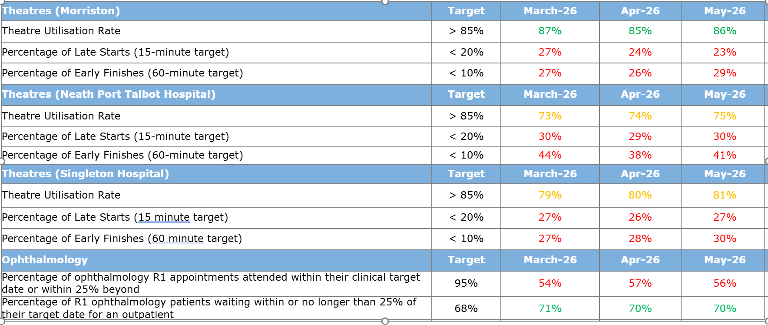

The graph above highlights the utilisation by hospital theatre complex. It highlights that overall theatre utilisation is improving in quarter1, with the average across the three hospital sites reaching 80% in May 2026. Morriston utilisation is near the Ministerial target consistently. However, NPTH and Singleton site whilst improving in areas are underperforming against the target.

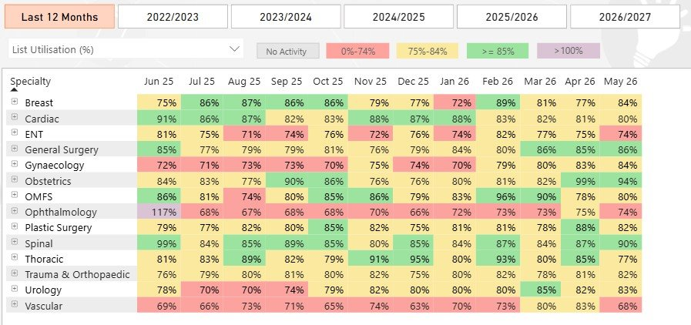

The table above highlights an important point where overall improvements in theatre utilisation performance is impacted by a small number of specialties that are under-performing.

  - Morriston
The Morriston Hospital position reflects a well-embedded and mature operating model, with effective alignment between clinical teams, theatre scheduling processes, and wider pathway capacity. The gap between Morriston and the other sites remains significant, highlighting additional / emergency capacity, 3 session lists and overrunning list influencing the upward utilisation trajectory.

  - Neath Port Talbot Hospital (NPTH)
The table below highlights the performance in percentages per surgical specialty. There has been significant work conducted in Trauma, Orthopaedics and Spinal surgery to implement a weekly scheduling approach. The updated graphs illustrate ongoing variation between specialties who have now implemented elective operating toolkit actions.
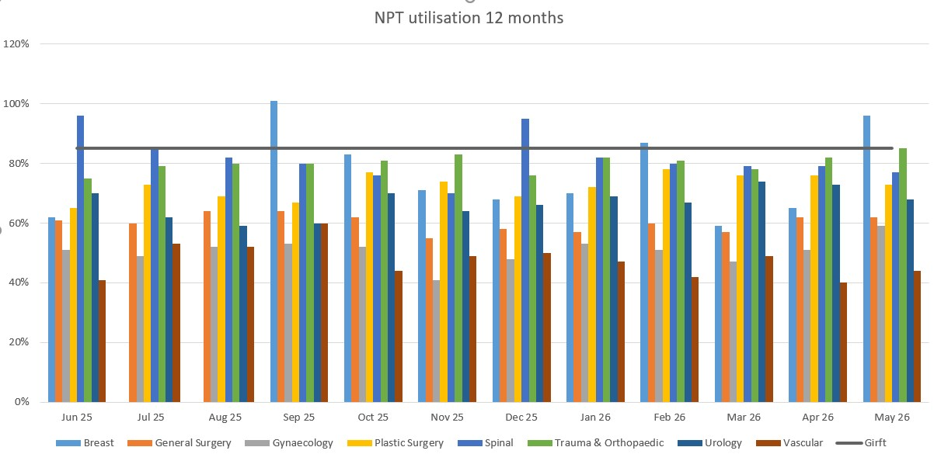

High-performing specialties (e.g., Trauma and Orthopaedics, Spinal surgery) are now consistently approaching the 85% target, particularly where structured MDT planning and weekly list scrutiny have been embedded. Those specialties that have yet to implement the elective toolkit actions (e.g. Vascular) continue to see utilisation performance below the standard.

Specialties continue to demonstrate under-filled lists, variability in case throughput and lost capacity due to early finishes and delayed starts. Neath Port Talbot Hospital continues to perform below the expected utilisation benchmark, with a more pronounced gap when compared to Morriston. This position is of particular concern given that NPTH operates with significantly less exposure to emergencies and unscheduled care pressures, which would typically be expected to support higher levels of planned care productivity.

The current performance therefore indicates that inefficiencies are primarily driven by internal operational factors, including variation in list planning, inconsistent application of scheduling practices, and suboptimal use of available session time. Whilst there are pockets of robust performance, particularly within Trauma, Orthopaedics and Spinal services where MDT scheduling processes have been implemented, this has not yet been consistently replicated across all specialties. The data suggests that there is opportunity at NPTH to improve utilisation through expansion of proven improvement approaches across underperforming services which is being explored in each individual specialty performance review.

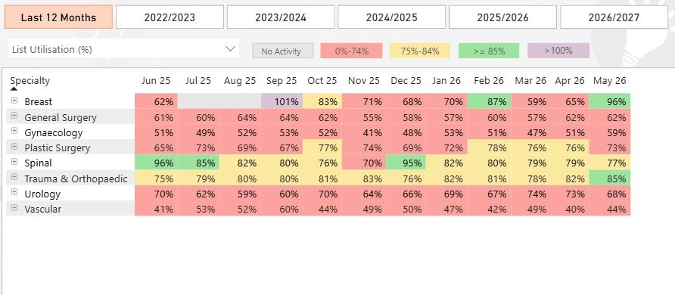

  - Singleton
Singleton Hospital continues to demonstrate an improving but variable utilisation profile, remaining below the 85% target overall but showing evidence of incremental gains in specific specialties.

The data indicates that performance variability is largely driven by inconsistencies at specialty level, with services performing closer to expected standards while others continue to under-utilise available capacity. Focused improvement work, particularly within Ophthalmology, has begun to strengthen clinical engagement and operational oversight, leading to a clearer understanding of the drivers of inefficiency, including late starts, early finishes, and suboptimal list composition. This has supported a sustained increase in utilisation / efficiency. It is also important to point out that Getting It Right First Time (GIRFT) and Healthcare Systems Engineering guidance states that it is not always possible to achieve 85% utilisation in Ophthalmology due to the turnaround times required for complex eye operations. The Health Board is therefore measuring Ophthalmology against an 80% utilisation target.

While these interventions are beginning to positively influence performance, utilisation remains dependent on sustained implementation of the Elective Surgery Toolkit, continued MDT-led list scrutiny, and improved alignment across the surgical pathway.

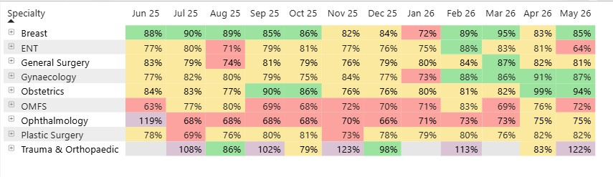
- GOVERNANCE AND RISK ISSUES
The current position reflects variation in operational maturity and consistency across sites and specialties. Key risks include:

- Failure to achieve the 85% utilisation target
- Continued inefficiencies resulting in lost elective capacity
- Inability to maximise productivity within existing resources

Mitigating actions include:

- Increased performance scrutiny at specialty and site level
- Standardisation of processes across the Health Board
- Continued implementation of the elective surgery toolkit

Reducing unwarranted variation through consistent implementation of best practice remains the critical success factor for sustained improvement.

At the Theatre Operational Group in May 2026, the Associate Medical Director for Surgery presented a detailed assessment of missed opportunities across Theatre activity in NPTH. This was the first time surgical specialties have been challenged at surgeon name level granularity. This highlighted that there were 5 consultants driving 50% of the late starts and early finishes on site. These surgical specialties were challenged to address this within the next three months.

4.1 LOCSSIP Internal Audit Actions
The recent internal audit review has identified several interconnected governance and patient safety risks within the National Safety Standard for Invasive Procedures (NatSSIPs)/ Local Safety Standard for Invasive Procedures (LocSSIPs) framework. Variability in the quality and clarity of LocSSIP documentation creates a risk of inconsistent application of safety controls across services, limiting full alignment with NatSSIPs2 and increasing the potential for procedural error.

This is compounded by the absence of a formalised, mandatory, and consistently monitored training framework in SBUHB, which reduces assurance that all staff maintain the required competencies and apply procedures in a standardised manner. The SBUHB e learning module below has been developed in response to this specific risk. It has been approved in NPTSSG Quality, Safety & Risk (QSR) forum and will require review in MSG QSR as the scope covers clinicians in two Service Groups and three division across the Health Board.

This credentialing tool is an essential element of theatre safety and efficiency and when progressed to the Health Board Quality and Safety Group meeting, we seek assurance that it will become a tier two mandatory requirement for all Surgical, Anaesthetic and Theatre staff in SBUHB.

https://360.articulate.com/review/content/6d20c546-39b4-49ab-a7eb-2a2b66ef9c41/review

In addition, while audit processes are in place, inconsistent coverage and limited resource for thematic analysis restrict the organisation’s ability to identify systemic risks and use intelligence effectively to drive improvement. The lack of consistent accessibility to key safety-critical documentation, including Never Event guidance, further heightens the risk that staff are not fully aware of, or able to apply, required protocols. Finally, although incidents are investigated and learning is identified, inconsistent implementation, monitoring, and formal closure of resulting actions limit assurance that learning is embedded and that risks are sustainably reduced.

Collectively, these issues present a risk to the reliability of safety systems and the organisation’s ability to demonstrate continuous improvement.

- OPEN AUDIT RECOMMENDATIONS
There are actions open again theatre utilisation internal audit from September 2025. An update will be provided to next Audit Committee.

- FINANCIAL IMPLICATIONS
The Neath Port Talbot Service Group has been given a very challenging financial envelope for the period 2026-27, which will require a reduction in theatre sessions across all theatre sites in the Health Board. The reduction in theatre slots will be undertaken in line with the Deloitte assessment of demand and capacity plans across all surgical specialties.

- RECOMMENDATION
The Performance and Finance Committee is asked to:

- Receive for ASSURANCE the Theatres efficiency update and the actions being taken to improve the overall performance in a sustainable and consistent manner.

Governance and Assurance
Strategic Objectives
Strategic Objectives  (please choose which is impacted) | People of Swansea Bay live healthier, fairer and more prosperous lives | ☐
Strategic Objectives  (please choose which is impacted) | Care is high quality, safe, efficient and delivers the best possible outcomes for people in partnerships | ☒
Strategic Objectives  (please choose which is impacted) | Care is delivered in partnership with our communities in safe and appropriate setting, supported by innovation | ☐
Strategic Objectives  (please choose which is impacted) | The health board is a great place to work where staff feel valued and work together towards a common goal | ☐
Strategic Objectives  (please choose which is impacted) | The health board is a resilient, sustainable and responsible organisation | ☐
Health and Care Standards
Standards (please choose which applies) | Safe Care | ☒
Standards (please choose which applies) | Timely Care | ☒
Standards (please choose which applies) | Effective Care | ☒
Standards (please choose which applies) | Efficient Care | ☐
Standards (please choose which applies) | Equitable care | ☐
Standards (please choose which applies) | Person-centred Care | ☐
Standards (please choose which applies) | Staff and Resources | ☐
Enablers (please choose which applies) | Whole Systems Approach | ☐
Enablers (please choose which applies) | Leadership | ☐
Enablers (please choose which applies) | Workforce | ☐
Enablers (please choose which applies) | Culture | ☐
Enablers (please choose which applies) | Information | ☐
Enablers (please choose which applies) | Learning, Improvement and Research | ☐
Quality, Safety and Patient Experience
Improved theatre utilisation will directly enhance patient outcomes and experience by:

- Increasing the number of procedures undertaken
- Reducing waiting times for surgery
- Improving pathway reliability

All improvement activity continues to align with:
- Safe care principles
- Effective and timely treatment delivery
Maintenance of clinical quality standards.

Financial Implications
The additional financial implications have been identified as part of this report.
Legal Implications (including equality and diversity assessment)
There are no legal implications to consider.

Staffing Implications
Briefly identify the known and/or potential staffing implications of this proposal/paper.

Long Term Implications (including the impact of the Well-being of Future Generations (Wales) Act 2015)
Efficient theatre utilisation is dependent on the availability and coordination of skilled theatre practitioners, Surgical and anaesthetic workforce and staff involved in the pre-operative and post-operative pathway staff

This includes ensuring alignment across outpatient services, pre-assessment, bed capacity and patient flow. Workforce engagement remains a key enabler of sustainable improvement in the NPTSSG Surgical Division.
Report History
January 2026 – PFC report

Appendices
N/A

