Bwrdd Iechyd Prifysgol Bae Abertawe
Swansea Bay University Health Board
Un Porthfa Talbot | One Talbot Gateway
Parc Ynni, Baglan | Baglan Energy Park
Port Talbot SA12 7BR
Ffôn Phone: 01639 683 334

Abigail.Harris7@wales.nhs.uk

Dyddiad/Date: 18 May 2026
Ein Cyf/Our Ref: AL00X

Dear [INSERT colleague name],

Delivery of the Annual Plan 2026/27 and Financial Delegated Budget

I am writing to you as the Budget Holder for the [INSERT Service Delivery Group/Corporate Directorate/ Service Area] to set out at the start of the 2026/27 Financial Year the following:

- Expectation for delivering your contribution to the Health Board’s Strategic ‘Breakthrough Objectives’;
- Specific delivery actions, milestones and outcomes for your Service areas;
- Principles of the plan for 2026/27;
- Funding allocated to your Service Area;
- Delegated Budget Savings Targets for 2026/27;
- Budgetary Management principles;

In line with our strategy, a Healthier Swansea Bay, the Health Board has set an ambition to become a high quality, sustainable organisation and our Annual Plan 2026/27 sets out what we need to do to increase productivity and efficiency, do more with less, and continuously improve and transform how we deliver our services to our patients so that we get to a sustainable position over the next three years.

In line with our strategy, we have committed to deliver on a number of ‘Breakthrough Objectives’ that will be critical to assessing if we are on the right path to sustainability and improving both performance and quality and safety.

As a Budget Holder and Service lead you will be accountable for delivering your contribution to the objectives outlined below and detailed in Annex 1:

- Flu vaccine uptake improved in most deprived areas by 1%
- Bowel screening rates up 10%
- 0 >45 min ambulance handovers by Sept 2026.
- 0 patients waiting more than 104 weeks referral to treatment.
- Reduce the number of adults placed out of area for mental health inpatient treatment by 50%
- 30% reduction in avoidable pressure ulcers
- Deliver 70% waiting for first definitive treatment from point of suspicion of cancer, 62 Days by end of Q2 and 76% by end of Q4
- Clinically Optimised patients reduced to <100 at any one time
- Increase in the take up of the NHS App by 25% (from a March 2026 baseline)
- Improvement in staff engagement score by 5%
- Improvement in staff health & wellbeing by 1%
- Deliver recurrent savings plan of £65m

Attached is the current Operational Delivery plan that you will be accountable for delivering along with your colleagues. This contains specific delivery actions, milestones and outcomes for your Service areas that contribute directly to overall delivery of the Health Board’s ambitions for 2026/27.

Work will be ongoing in next 10 days to finalise the Operational Delivery Plan which will be re-issued on 1 June 2026.

For clarity, the detailed appendices to this letter set out the following:
- Annex 1 – Planning Objectives
- Annex 2 – Summary of the opening rollover budget 2026/27
- Annex 3 – Delegated Budget Savings Targets for 2026/27
- Annex 4 – Summary total opening 2026/27 budget
- Annex 5 – Budgetary Management Framework 2026/27
- Annex 6 – Responsibilities as Accountable Officer / Budget Holder
- Annex 7 – The Delegation & Budget Authority
- Annex 8 – Approval Pro Forma

Principles of the financial plan & savings for 2026/27
On 31st March 2026 SBUHB submitted planned deficit to WG for 2026/27of £76.6m. This is against Welsh Government (WG) expectation of £17m target control total deficit. The summarised plan, as included in the IMTP submission, is provided below and you will note that to achieve the planned deficit of £76.6m, we need the organisation to deliver £65.0m of recurrent savings and retain growth and inflation more than planned value. The failure to deliver recurrent savings year after year has in part contributed to the challenging underlying deficit. The reported planned deficit of £76.6m, is unsupportable and unacceptable to WG as this is a £17.9m deterioration from the 2025/26 Deficit Plan on £58.7m.

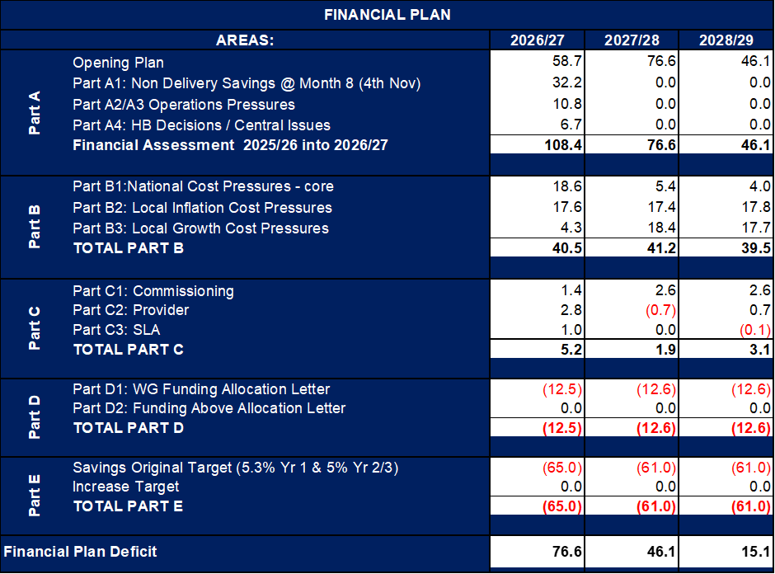

The 2026/27 deficit plan has been arrived at based on extensive engagement with, and scrutiny from, the Board. The development of the plan has been one focused on sustainability and not new investment. Its aim is to deliver a Health Board plan over 3 years that delivers as a minimum the target control total of £17m.

From 2026/27, a centrally held deficit value will not be permissible, with budgets allocated to service areas limited to the available financial envelope of the Health Board; this is in line with best practice recommendations from WG and our external strategic partner. Therefore, budgets previously allocated above the Health Boards funding have been removed and the methodology for this reduction will be based on the amount of Underlying Deficit funding that was issued as part of the 2025/26 Plan. Also, further actions to mitigate the deficit further may result in further budget adjustment and if so will be confirmed and agreed formally when applicable.

All savings should be budget releasing and driven at Service Group/Service Area level and pan-Health Board supported by the Recovery & Sustainability Programme. The target for each area is outlined in Annex 3. The basis of this approach is provided in Annex 5 (Budget Management Framework 2026/27).

The overarching key principles for 2026/27:
- Health Board cannot issue budgets above its allocated funding;
- All Budget Holders are expected to deliver as a minimum a balanced position against their delegated budgetary allocation;
- All Budget Holders are expected to deliver recurrently the 2026/27 savings target, supported by the Delivery Unit and the Executive Lead Thematic Workstreams.

Annex 4 provides the detail breakdown of your total budget for 2026/27. As per the Health Board Standing Financial Instructions Point 5.2.2 neither the Chief Executive, Director of Finance or delegated Budget Holders can exceed the budgetary total allocated. Therefore, all elements of the Health Board are required to ensure that a balanced financial position is delivered in 2026/27.

To support both the Service Group/Corporate Directorates to maximise the opportunities I will be asking the new Delivery Unit to work closely with the Service Groups/Corporate Directorates to provide support and identification of areas of focus.

Governance & Oversight
Good governance is about how we achieve our objectives as set out in our Annual Plan. To support this we must have in place appropriate and proportionate internal controls so I can assure myself that we are managing all resources effectively. Our Scheme of Delegation and Standing Financial Instructions remain our key governance documents.

As part of your own governance arrangements, I would expect that, as a minimum, you are holding monthly business performance meetings that review your financial performance, and ensure that you and your team, are using the reports available to provide assurance that:
- Financial balance is maintained and take appropriate recovery actions where required. In particular, the reasons for variation from budget is understood and explained, using non-financial information, (such as activity, sickness etc.) as appropriate, to enable early intervention to be taken where deficits are identified;
- Unbudgeted cost pressures are addressed with mitigating actions;
- Forecasts are checked and challenged to provide assurance for delivery over the year;
- Under no circumstances are any unbudgeted in-year decisions to be made. There will be no further allocations to in-year budget unless additional funding is provided by WG.
- Opportunities are being translated into realistic and robust saving plans;
- Savings plans are being delivered in a timely manner with a minimum expectation that you recurrently deliver your proportion of the savings target during 2026/27.

As a Health Board recognised delegated Budget Holder you are accountable for the effective management of the resources within your service area. Within your service area there will be a number of individuals who under the scheme of delegation have the authority to commit expenditure for which you are the accountable office. As such you will need to oversee and ensure their compliance with the Standing Orders, Standing Financial Instructions and Grip and Control Frameworks implemented across the organisation, as well as ensuring they have the relevant support.

Given the challenging financial position there will continue to be a requirement for a more focused oversight of the financial positions. This will be managed via:

- Recovery & Sustainability Board – programme of work will continue into 2026/27, with meetings held bi-weekly.

- Financial Performance Meetings – for Service Groups Directors these will be monthly, for other Budget Holders these will be monthly with Finance Team and for Corporate Directorates this be held on a quarterly basis. Regularity of meetings may be escalated dependent on the financial performance. The purpose of these meetings above the Recovery & Sustainability Board is to provide a higher level of assurance and detail on:

  - In Month, Year to Date, and Forecast Position
  - Delivery of savings
  - Drivers of the position and impact recurrently
  - Actions being taken to manage the positions
  - Outcomes from Actions agreed at the last meeting

- Monthly Performance Reviews – these meetings will also discuss the financial performance in the context of the overall delivery and will be aligned to the revised Performance Management Framework for 2026/27, which will include escalation criteria for non-delivery of performance.

- PFC Oversight – we will continue with the rolling programme for each Service Group to present to PFC 5 times within a 12-month period, with two Service Groups presenting per meeting. The order and months, will be as follows (subject to change post Organising for Success):

Month (Financial Period) | Service Group
June (P02) | MH/LD & PCT
July (P03) | NPTS & Morriston
Aug (P04) | MH/LD & PCT
Sept (P05) | NPTS & Morriston
Oct (P06) | MH/LD & PCT
Nov (P07) | NPTS & Morriston
Jan (P09) | MH/LD & PCT
Feb (P10) | NPTS & Morriston
March (P11) | MH/LD & PCT
April (P12 / Savings 2027/28) | NPTS & Morriston

Overarching Financial Control Principles
You are required to manage your delegated budget without exceeding the financial sum, including the achievement of delegated savings targets. Any unforeseen or new expenditure commitments arising within the year must be managed. At no point are you able to commit funding ‘at risk’ above your delegated budgets. You have the authority to move budgets/funding between your Budget Holders where you consider this appropriate to support quality, safety and performance issues.

You should plan to spend the delegated budget in line with the monthly profile submitted at the start of the financial year, ensuring accuracy of the profile in your budget setting discussions with your Finance Business Partner for all known fluctuations that might occur.

You should, at all times, adhere to the principles of economy, efficiency and effectiveness in the application of resources.

In respect of Pay expenditure, the following are to be strictly observed:
- Timely completion and approval of the Payroll procedures for Staff Changes Form, to ensure ESR reporting and associated Staff in Post is correct;
- Approval authorisation vacancies must comply with Grip and Control Framework;
- Approval authorisation procedures for the control of variable pay must comply with Grip and Control Framework;
- Procedures for the management of staff absence is undertaken timely.

Information on Payroll processes is provided via the Swansea Bay Intranet site by Payroll and the link is below:
Useful Documents for Swansea Bay Payroll

In respect of non-pay expenditure, the following are to be strictly observed:
- The Health Board’s “No PO (Purchase Order) No Pay” procedure;
- The appropriate and prompt receipting of goods;
- The prompt authorisation of invoices for payment where not covered by receipted purchase orders, in accordance with delegated limits.

Support on procurement can be accessed via the Swansea Bay local procurement team and again contact details are available via the Swansea Bay Intranet Site using the link below:
SBUHB Frontline Procurement Team Contact Details

As part of the delegation of duties, I would request that you and your operational team, with the support the Finance Business Partnering team formally review at the start of the financial year the procurement hierarchy to ensure it is fit for purpose and aligned to the delegated budgets.

Delegations and Responsibilities
Annex 6 provides a summary of the main responsibilities associated with your Accountable Officer role and Annex 7 describes your budget authority.

A summary of the budgets allocated to you in 2026/27 is shown in Annex 4, with the Budgetary Management process summarised in Annex 5. From time to time during the year these figures are likely to change to take account of additional allocations, transfers and savings plans, but this letter will remain in force as the covering delegations for any revisions.

To support you in your responsibilities, the Heath Board requires all Budget Holders to attend a face-to-face training session which will take you through the requirements of being Budget Holder as well as providing further training on how to access and use the Finance Dashboard (Qliksense). Details on these events and how to book on will be issued separately by email.

Confirmation
Please would you acknowledge your understanding and acceptance of these delegations by signing and returning to the Director of Finance, the pro forma attached to this letter at Annex 8, within 2 weeks of the issue of the letter. Where a reply is not submitted within the deadline set out this will be escalated up to line managers and ultimately the Board. Updates on replies will be provided monthly to Performance & Finance Committee and the Board.

Yours sincerely

ABIGAIL HARRIS
CHIEF EXECUTIVE OFFICER

Annex 1
Planning Objectives

Annex 2
Summary of the Total Opening Rollover Budget 2026/27

This table provides a summary of the overall budget, your Finance Business Partners will have full access to the detail behind these values, should you require further information.

Annex 3
Delegated Budget Savings Targets for 2026/27

Annex 4
Summary Total Opening Budget 2026/27

Annex 5
Budgetary Management Framework

Annex 6
Responsibilities as an Accountable Officer

As a Unit Accountable Officer, your responsibilities are:

- You must ensure that there is proper keeping of accounting records; prudent and economical administration; the avoidance of waste and extravagance; the efficient and effective use of all resources and that new commitments are affordable.

- You should ensure that appropriate advice is given to the SBUHB Board on all matters of financial propriety and regularity, and more broadly on all considerations of prudent and economical administration, efficiency and effectiveness.

- You should comply with the requirements laid out in the Health Board’s Standing Orders and Standing Financial Instructions which are available on the Health Board intranet page.

- You must clearly allocate the budgets where appropriate to those within the Service Area, ensuring that their responsibilities as a Budget Holder are clear and aligned to the requirements set out in this letter.

- I depend on you to manage the allocated budget in an effective and efficient manner, in particular emerging overspends and underspends must be identified and reported as soon as possible so they can be managed properly in the context of the overall SBUHB budget as well as in accordance with my responsibilities contained within my Accountable Officer role.

- You should maintain a sound system of internal control within your Service Area, utilising the financial and governance structures in place to ensure corporate alignment as well as ensuring that activities support the achievement of Health Board’s priorities, aims and objectives; ensures statutory compliance and compliance with policies, procedures and contracts; safeguards Health Board assets and interests, and protects the reliability and integrity of financial and operational information.

- Your risk tolerance should be clearly articulated and appropriate risk management practices put in place so that significant and relevant risks are identified and assessed in accordance with the SBUHB Risk Strategy and communicated in a timely manner.

- You must ensure that sensitive information and data is protected in accordance with data security rules and your staff utilise good records management practice.

- You should ensure that your staff have the necessary training or access to persons who will support them in discharging their financial and governance roles effectively.

- You will remain accountable for your budgets, even where you have delegated responsibility to others.

- You will ensure your Service Area co-operates with and provide timely information to the SBUHB’s Finance Team which co-ordinates and reports definitive financial and governance information for the whole of SBUHB.

Annex 7
The Delegation & Budget Authority

Within your delegation, you may:
- Commit and incur expenditure.
- Make transfers of funding between categories within your budget, providing you do not increase your total delegated budget. All movement must be in line with your financial forecast to support your delivery plan and advice from your Finance Business Partner must be secured in advance.

You should not:
- Incur expenditure where you do not hold sufficient budget;
- Charge expenditure to a budget which you are not directly responsible for;
- Commit recurrent expenditure against a non-recurrent budget;
- Recruit over your funded establishment and allow the appointment of posts at risk;
- Incur temporary staffing costs (bank, overtime, agency) over your total available budget;
- Fail to ensure forecasts are checked and challenged to provide assurance for delivery over the year;
- Fail to ensure appropriate monitoring and scrutiny of investments are conducted to ensure clear benefit realisations for delivery within a stated timeframe;
- Hold local reserves, as this would not align to the Health Board’s Budgetary Management Policy, as all budgets should be phased in 12th.

As overall Budget Holder for your Service Area, you have the authority and responsibility to:
- Ensure that financial limits are set as appropriate to the grade and responsibility of the officer delegated a financial authority;
- Ensure that all financial authorities within your Service Area are regularly reviewed and communicated within your team; and
- You may not delegate financial decision making and spend authority to contractors, contingent labour support or other off payroll staff.

Annex 8
Approval Pro Forma

APPOINTMENT AS ACCOUNTABLE OFFICER

I acknowledge receipt of your letter appointing me as the Accountable Officer for [INSERT AREA] and confirm I have read the annexes enclosed with your letter and accept the responsibilities placed upon me as an Accountable Officer for the budgets delegated.

Signed: ……………………………………….. Date: …………………..

Please return completed form to:

Director of Finance & Performance

Copying in:
Director of Corporate Governance
Finance Business Partner

