Meeting Date | 23 June 2026 | Agenda Item | 4.2
Name of Meeting | Finance and Performance Committee
Report Title | Continuing NHS Healthcare (CHC) Performance Report- 2025/26 Quarter 4
Report Author | Hannah Roan, Assistant Director of Planning & Partnerships (Commissioning & Sustainability)  Amanda Davies, Deputy Head of Nursing for Long  Term Care  Colin Jones, CHC & Commissioning Manager MHLD  Janet Millward, Deputy Head of Nursing for  Children’s Services
Report Sponsor | Executive Director of Planning and Partnership
Presented by | Executive Director of Planning and Partnerships
Freedom of Information | Open
FoI Closed detail | If closed, choose detail
Impact Assessment Summary Outcome |  | IA Completion date
N/A |  | Click or tap to enter a date.
Purpose of the Report | For Assurance
Report Summary; detailing any action required
This report provides an update on the quarter 4 2025/26 activity and highlight areas of relevance to Executive Board relating to Continuing Health Care (CHC), Complex Care and Children and Young People’s Continuing Care.
Key Issues
Mental Health & Learning Disabilities (MHLD)
Demand for packages of care continues to rise sharply, with significant pressures across adult MH services, complex care commissioning, and routine reviews identifying many individuals requiring reassessment of CHC eligibility, made more challenging by Local Authority capacity constraints to support the review process. Financial pressures remain significant, driven by new cases, rising additional observation costs and unfunded growth.

Long Term Care
Demand for CHC, joint packages and Section 117 has stabilised however, costs are increasing. Review backlogs and pressures within the care home market remain key operational challenges. Social worker allocation continues to be the biggest barriers for reviews and stepping down patients that are no longer eligible for CHC into a more suitable commissioned package of care. This issue is being addressed through collaborative working via the Regional Partnership Board Transforming Complex Care Programme Board chaired by the Executive Director of Planning & Partnerships.

As at the end of quarter 4 25/26, the financial position was a small underspend driven by review-related adjustments, ongoing inflationary pressures, high-cost placements and a shift toward higher rate packages present a continuing financial risk.

Children and Young People
The Children’s Continuing Care service delivered 15 active packages of care in Q4, but persistent staffing shortages, particularly within the unregistered workforce, led to a rising number of missed care episodes and increased pressure on families.

Although finances show a modest underspend, workforce deficits remain the key risk, with mitigation efforts focused on recruitment, bank utilisation and strengthened rota oversight to stabilise service delivery.

Decision / Action required | No
Recommendations
Members are asked to:
- Consider the content of this report

Continuing NHS Healthcare (CHC) Performance Report- 2025/26 Quarter 4

- INTRODUCTION
This report provides an update on the Quarter 4 2025/26 activity and highlights areas of relevance to the Health Board (HB) relating to NHS Continuing Health Care (CHC) as well as Complex Care and children and young people Continuing Care (CC).

- BACKGROUND
The revised National Framework for CHC was implemented on 1st April
2022.

As part of the CHC Performance Framework required by Welsh Government, HBs are required to receive a quarterly report on CHC, and this paper fulfils that requirement. Its intention is to inform the Committee of developments and current issues relevant to CHC, both nationally and locally.

Commissioning of CHC including complex care and Continuing Care (CYP), sits across three Service Groups in the HB:
- Mental Health and Learning Disabilities (MH&LD)
- Long Term Care (LTC)
- Children and Young People (CYP) (Provider and Commissioner)

- 2025/26 PERFORMANCE Overview
Swansea Bay University Health Board (SBUHB) has a transformation programme in place to strengthen the commissioning arrangements for CHC and Complex Care. A key deliverable of the programme is the creation of a central commissioning function for CHC within the Corporate Commissioning Team that would aid in providing a HB view of CHC commissioning across the organisation. The central function will aid in:
- Standardising decision-making and commissioning approaches across the Health Board footprint
- Reducing variation in care packages, rates, and provider engagement
- Creating a central oversight of CHC spend enables better cost benchmarking and challenge
- Enhancing grip on high-cost packages and outliers
- Providing clear, consistent standards for care packages and review processes
- Better alignment between commissioning decisions and patient outcomes
- Shifting from reactive, case-by-case purchasing to proactive, planned commissioning
- Providing a single, coordinated interface with providers
- Better intelligence on capacity, pricing trends, and market risks
- Improving ability to respond more effectively to provider failure or instability

A summary report for the Health Board for quarter 4 2025/26 is included in Appendix 1, with the following sections providing a detailed analysis of activity trends, key challenges, and financial performance at the Service Group level. Figure 1 provides a visual overview of performance for 2025/26 with comparison to the same reporting period in 2024/25.

Reporting for CHC has developed over 2025/26 however, it will continue to evolve over 2026/27 with the development of key performance indicators associated with the key workstreams of the CHC/ Complex Care Programme Board. This will aid in analysing the full picture for individual patient funding and not focusing purely on the financial savings targets. From 2026/27 the Health Board will also commence reporting against the newly developed national Direct Payments measures and the national CHC and Funded Nursing Care Performance Reporting measures that are being developed by Welsh Government.
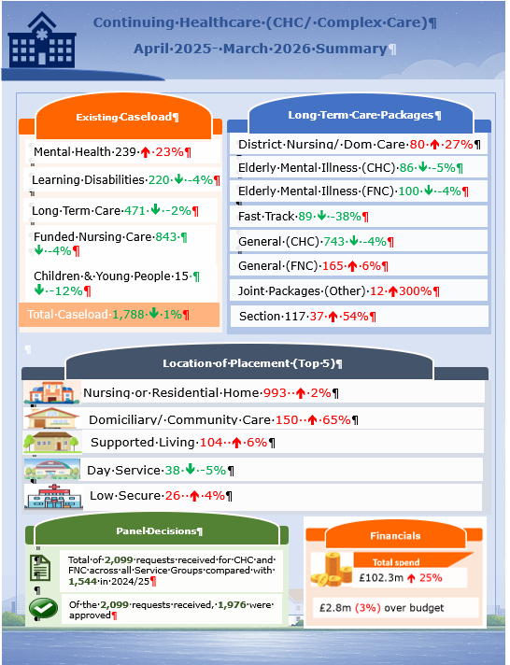
Figure 1: CHC, Complex Care and FNC Overview

  - Mental Health and Learning Disabilities (LD) Quarter 4 2025/26 Overview
Figure 2 provides an overview of performance for key measures as at Q4 25/26. The percentage variance has been calculated by comparing Q4 25/26 with Q4 24/25.
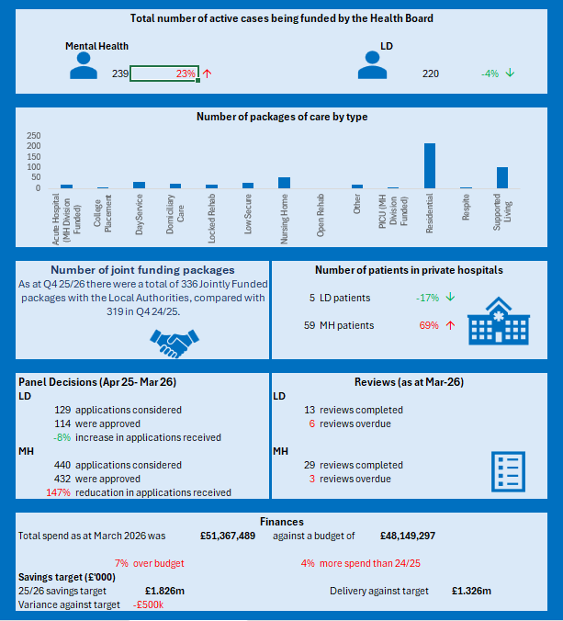
Figure 2: MH& LD Performance Summary- Q4 25/26

    - Key highlights for Q4 25/26
- Demand for Mental Health (MH) packages has increased by 30% whereas Learning Disabilities (LD) packages have decreased by 4%.
- Residential placements account for the largest proportion of commissioned care (41%), and these packages also saw the largest increased compared with 24/25 with 24 more cases at the end of Q4 25/26.
- 93% of in year MH reviews were completed as at end of March 2026.
- 89% of in year LD reviews were completed as at end of March 2026

    - Key drivers/ issues
- Several drivers contribute to the level of demand, primarily a continuation of pressure within adult mental health services and unscheduled care which appears to be overflowing into complex care commissioning.
- Routine reviews are increasingly identifying a significant number of individuals who require a reassessment of their NHS Continuing Healthcare (CHC) status. Where this applies, Decision Support Tools (DSTs) are being scheduled jointly with the relevant Local Authority. However, this process has become protracted due to resource constraints within the Local Authorities, particularly a shortage of Social Workers to support timely completion. The prioritisation of DSTs is currently being progressed through the Joint Working Arrangements workstream of the Transformation Complex Care Programme Board.
- There are increasing requests for additional observations by both our own clinical teams and independent sector providers on existing packages. This issue will be closely monitored by the Service Group via Scrutiny Panel and Complex Case Panel.

    - Actions planned for Q1 26/27
- Discussions are ongoing with Neath Port Talbot (NPT) LA to look at the existing Brokerage process to see where changes can be made to streamline the process to increase efficiencies and provide education and resources to the Care Co-ordinators.
- Ongoing meetings with both Local Authorities to establish a joint funding and dispute agreement.
- Ongoing meetings with both Local Authorities to establish a Joint Funding Matrix for cases where a DST has been completed (No PHN found), but Health needs exist and a degree of Health Board funding is required.

  - Long Term Care Quarter 4 2025/26 Overview
Figure 3 provides an overview of performance for key measures as at Q4 25/26. The percentage variance has been calculated by comparing Q4 25/26 with Q4 24/25.
Figure 3: Long Term Care Performance Summary- Q4 25/26

    - Key highlights for Q4 25/26
- Demand for joint packages and Section 117 have increased compared with 2024/25. Nursing home packages account for the largest proportion of commissioned care for CHC, with an increase of 6%.
- Fastrack referrals have increased by 11% when compared with data from 2024/25. Community Fastrack referrals for end-of-life care at home from District Nursing (DN) and domiciliary care packages account for this increase. Nursing Home packages for Palliative (Fastrack) CHC have decreased by 61% when compared with 2024/25.
- 365 statutory care home reviews were completed in Q4, with 24 outstanding reviews on 1st April 2026. Outstanding reviews are due to hospital admissions, care homes in incident status and if patient is acutely unwell. Outstanding reviews are being prioritised in quarter 1 month.
- 12 community reviews were completed for Q4. 55 out of compliance.

    - Key drivers/ issues
- Backlog of reviews
  - An independent Community Review is being undertaken
  - Majority of outstanding community reviews have fast track eligibility. Due to DN capacity, the data cleansing of the review list is resource intensive, and not all deaths are being reported in a timely manner. A new process has been implemented to mitigate this risk.
  - A weekly scrutiny panel meeting with Director PCTSG has been implemented in November 2025 to monitor performance of all reviews and timescales to complete.
  - Outstanding reviews are to be prioritised in Q1.
- Care Homes- The overall occupancy in the independent sector for Swansea 90.47% & Neath Port Talbot Locality is 90.17%.
- Escalating Concerns – There are no care homes in escalating concerns within the Swansea Bay footprint.

    - Actions planned for Q1 26/27
- Continue to progress with Direct Payment implementation date of 1st April 2026.
- Finalise CIP delivery actions for 26-27
- Prioritise outstanding reviews

  - Children and Young People Continuing Care Q3 2025/26 Overview
Figure 4 provides an overview of performance for key measures as at Q4 25/26. The percentage variance has been calculated by comparing Q4 25/26 with Q4 24/25.

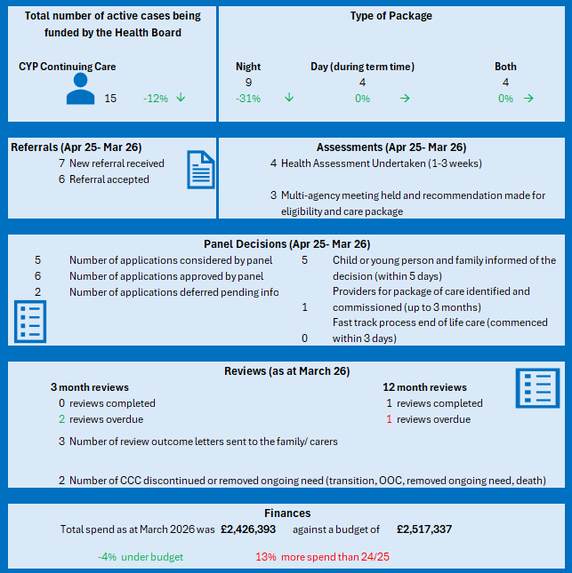
Figure 4: Children and Young People Performance Summary Q4 25/26

    - Key Highlights Quarter 4 CYP
- At the end of Q4, a total of 15 active Packages of Care (POC) were in place across Children’s Services. These packages collectively delivered 1,076.5 hours of care per week, which included:
- 112.5 hours of term-time day care
- 859 hours of night support
- 105 hours of daytime support at home
- The end-of-Q4 POC position includes the hours associated with the successful transition from children’s services to adult CHC by the end of March. Close partnership working with CHC adult service provided a hand over period of CYP HCSW staff, enabling a skilled and safe transition of care. Following close discussions with family and presentation at Panel a POC was cancelled at the family’s request in January. The above figures exclude a new eligible POC presented at Panel during March, which is in the process of being implemented.
- All POC are staffed by Health Care Support Workers (HCSWs) at Band 3 and Band 4, aligned to the level of dependency and complexity of each child’s care needs. The distribution of support levels is as follows:
- 8 POC provide 1:1 support delivered by Band 4 HCSWs
- 4 POC provide 1:1 support delivered by Band 3 HCSWs
- 1 POC requires 2:1 support delivered by Band 3 HCSWs
- 2 POC require 2:1 support delivered jointly by Band 3 and Band 4 HCSWs

Missed Care Episodes – Q4 Overview (Jan - March)
There has been a continued pattern of missed care episodes across the quarter, primarily associated with staffing shortages within unregistered roles. In all cases, care responsibilities reverted back to parents, creating potential pressures on families and impacting the continuity of planned care packages.
- January 2026: 20 episodes of missed care recorded:
  - 14 episodes of care
  - 6 partial episode where only one member of staff was available for a planned 2:1 package
  - All unavailable episodes resulted in care reverting back to parents. The increase in January is consistent with ongoing workforce challenges and seasonal pressures.
- February 2026: 5 episodes of missed care:
  - 3 episodes of care
  - 2 partial episodes where only one member of staff was available for a planned 2:1 package
  - Care reverted back to parents in all instances.
- March: 9 episodes of missed care:
  - 4 episodes of care
  - 5 partial episodes where only one member of staff was available for a planned 2:1 package
  - Care again reverted back to parents throughout.

CYP Review Activity (Jan 26- Mar 26)
- January Reviews
  - 1 CYP had their 12-month reviews completed and all continue to meet the eligibility criteria for Continuing Care (CC).
  - 1 new referral was reviewed and assessed not eligible for CC.
- February Reviews
  - 1 CYP had a 12-month review completed and continues to be eligible for their current Package of Care (POC). CYP is due to transition to adult services this year.
  - 1 new referral received and for assessment

- March Reviews
  - 1 CYP had a 12-month review completed, maintaining eligibility for their POC.
  - 1 new referral eligible for a POC

    - Key Drivers/Issues
- The workforce risk remains on the register with a current score of 16, against a target score of 12. Ongoing unavailability within the unregistered workforce continues to create staffing deficits, impacting the ability to deliver care packages and resulting in continued reliance on bank staff to maintain service provision.
Enhanced weekly scrutiny of rota management is in place to ensure appropriate oversight and efficient allocation of the available workforce. To support service continuity, one package of care has commenced with a commissioned external care agency as of November, helping to reduce immediate pressures.
- Recruitment activity is progressing positively, with several new starters now undergoing training needs analysis, mandatory training, and scheduled shadow shifts. This is expected to improve the staffing position once they are fully onboarded.
- Due to the Recruitment freeze there were delays in Recruitment following staff leaving post during this time. At time of report (April ) these posts are now being approved on TRAC and will be advertised shortly.

Mitigation measures remain active, including backfilling with bank staff and increasing the number of bank-only contracts to strengthen workforce resilience. Datix reporting continues to be utilised to monitor incidents, capture themes, and support ongoing audit and governance.

- GOVERNANCE AND RISK ISSUES
The CHC programme is overseen by the monthly CHC Programme Board, chaired by the Executive Director of Planning & Partnerships, with issues escalated to Management Board as appropriate. Monthly updates on delivery against the savings plan is also presented to Recovery & Sustainability Board.

Risk: Direct Payments
The introduction of Direct Payments for CHC in April 2026 remains a significant risk for the Health Board. To mitigate the risk SBUHB is actively engaged in all of the national workstreams which have been established to prepare Health Boards. SBUHB has also established its own internal sub group with a detailed project plan which remains on tack for delivery.

Risk: Delayed reviews and disputes
The Health Board continues to hold a significant cohort of individuals who require review, many of whom are no longer eligible for CHC but cannot be progressed until a Social Worker is allocated—an ongoing consequence of limited capacity within Social Services. Alongside this, a number of cases remain in dispute where the joint funding split between health and social care cannot be agreed. To help resolve this, partners have agreed to design a joint funding matrix, which, if adopted, will streamline decision‑making and significantly reduce administrative burden. In parallel, the Health Board has had positive discussion with Local Authority colleagues regarding clearing the backlog of LD disputes. This work is being taken forward through the Transforming Complex Care Programme Board, where partners are making strong progress in improving processes and strengthening strategic commissioning—an essential enabler for delivering the Health Board’s 2026/27 savings plan.

- OPEN AUDIT RECOMMENDATIONS
There are no open audit actions in relation to the CHC/ Complex Care Transformation Programme.

- FINANCIAL IMPLICATIONS
As at Quarter 4 of 2025/26, the Health Board has incurred expenditure of £102.3 million against a budget of £99 million, resulting in an overspend of £2.8 million.
Table 1 sets out a breakdown of expenditure by Service Group. It should be noted that the costs associated with private mental health out-of-area placements have been excluded from these figures.

Table 1: Summary of expenditure against budget (Q4 25/26)
 | MHLD | Long Term Care | CYP | HB Total
Spend (Apr-Mar 26) | £51,367,489 | £48,461,283 | £2,426,393 | £102,255,165
Budget (Apr-Mar 26) | £48,149,297 | £48,749,473 | £2,517,337 | £99,416,107
Variance | £3,218,192 | -£288,190 | -£90,944 | £2,839,058

  - MHLD Financial Analysis
The MHLD financial position for March 2026 is a reported overspend against budget of £0.450m, this is a reduction of £(0.144)m compared with the previous month’s overspend of £0.594m.

New cases in the month totalled £0.780m which was a increase of £0.198m compared to the previous month following the recognition of new packages particularly in Mental Health commencing in month some of which had retrospective impact.

One off reductions totalling £(0.211)m were recognised in month to reflect a number of one of gains due to a review of Supported living placements in readiness for the IPA alignment with CCoS, retrospective recognition of CCAPS rates following the mid-year NCCU review and a small release following a review of the 2023/24 balance sheet.

Further funding in respect of growth was not issued as part of the annual plan and as such, any further growth in demand must be managed within the current budget. Unfunded net growth in the month totalled £0.686m which was a deterioration of £0.169m compared to prior month primarily due to the retrospective costs recognised last month. YTD growth totals £4.517m at the end of Month 12.

  - Long Term Care Financial Analysis
The financial position for the Long Term Care Team to the end of Q4 was an underspend of £288k. Unlike MHLD, all inflation growth has been funded; therefore, the underspend is driven by patient numbers. The majority of the underspend has been derived from reviews of patients and the packages they have, as opposed to a reduction in demand. This has led to the identification of anomalies which have led to a net financial benefit.

Expenditure has plateaued over the last 12 months versus the period up to 24/25. External factors driving changes in expenditure are:
- Pay inflation and general inflation linked to CPI
- Changes in availability base rate packages versus higher rate packages
- Changes in demand and capacity

The split between base rate and non-base rate placements continues to move towards a higher proportion of the later. This shift is not expected to change and is expected to be accompanied with an increase in the unit cost of base rate packages in 26/27. This will create a financial risk for SBUHB and calculations have been provided for a range of scenarios.

Legal Challenge- The Health Board is an active partner with Swansea Local Authority (LA) in the process of considering the costs of providing care and accommodation for care home providers. Care home fees have significantly increased since 1st October 2021 in recognition of the increased costs of food, fuel and inflation. Concerns have been raised from Care Home Providers on the increase in employers’ contribution to National Insurance (NI) and Real Living Wage for 2025/26. A Finance Subgroup Meeting has been undertaken with Health, LA, Care Forum Wales and providers to discuss 2025/26 rates. Both LA’s have approved 6.1% uplift for 2025/26. Swansea care home providers are challenging this rate. Swansea LA received a legal challenge on 7th May 2025 relating to the fees set for 2025/26. At time of reporting, the health board have been made aware that the JR has been upheld and Swansea LA have 21 days to appeal this decision. The outcome of the decision will impact the Health Board due to the alliance with Local Authority partners on the fee setting process. The Health Board is still in the process of formally agreeing the 2026/27 rates.

  - Children and Young People (CYP) Financial Analysis
As at the end of Quarter 4 2025/26, CYP Group were reporting a cumulative spend of £2,426,393 against a budget of £2,517,337 resulting in a year to date underspend of £90,944.

  - High-cost cases
Since the high cost case panel was established in June 2026, a total of 20 cases were subject to scrutiny by the Executive Panel due to their annual costs expected to exceed £150k. The total annual cost for the 20 packages was in excess of £5.2m. Following approval by the oversight panel, the packages would be subject to regular review and monitoring of the high cost panel decisions is presented to the CHC/ Complex Care Programme Board in order to identify themes and possible opportunities.

Table 2: Summary of high costs cases approved by Executive Panel (June 25- March- 26)
Category | Type of Package | Total number of packages | Total annual cost
CYP | Residential | 1 | £230,554.717
LD | Supported living | 3 | £792,201.97
MH | Locked Rehab | 2 | £1,034,218.88
MH | Low Secure | 3 | £834,736.76
MH | Residential | 2 | £339,710.4288
MH | Supported living | 1 | £191,877.38
PCT | Domiciliary Care | 2 | £628,574.41
PCT | Nursing Homes | 5 | £1,021,208.74
PCT & LD (50/50) | Nursing Home | 1 | £165,336.06
Total |  | 20 | £5,238,419.346

- RECOMMENDATION
Members are asked to:
- Consider the content of this report
Governance and Assurance
Strategic Objectives
Strategic Objectives  (please choose which is impacted) | People of Swansea Bay live healthier, fairer and more prosperous lives | ☒
Strategic Objectives  (please choose which is impacted) | Care is high quality, safe, efficient and delivers the best possible outcomes for people in partnerships | ☒
Strategic Objectives  (please choose which is impacted) | Care is delivered in partnership with our communities in safe and appropriate setting, supported by innovation | ☒
Strategic Objectives  (please choose which is impacted) | The health board is a great place to work where staff feel valued and work together towards a common goal | ☐
Strategic Objectives  (please choose which is impacted) | The health board is a resilient, sustainable and responsible organisation | ☒
Health and Care Standards
Standards (please choose which applies) | Safe Care | ☒
Standards (please choose which applies) | Timely Care | ☒
Standards (please choose which applies) | Effective Care | ☒
Standards (please choose which applies) | Efficient Care | ☒
Standards (please choose which applies) | Equitable care | ☒
Standards (please choose which applies) | Person-centred Care | ☒
Standards (please choose which applies) | Staff and Resources | ☒
Enablers (please choose which applies) | Whole Systems Approach | ☒
Enablers (please choose which applies) | Leadership | ☒
Enablers (please choose which applies) | Workforce | ☒
Enablers (please choose which applies) | Culture | ☒
Enablers (please choose which applies) | Information | ☒
Enablers (please choose which applies) | Learning, Improvement and Research | ☐
Quality, Safety and Patient Experience
The Health Board has a responsibility to ensure that its duty of care extends to NHS provision. Standardisation of policies and strengthening commissioning processes are centred around quality of care.
Financial Implications
MH&LD and PCS Service Groups have identified financial risks and have
implemented improvement plans for 26/27.
Strengthening of the commissioning arrangements will create efficiencies.
Delivery of financial savings is being managed by the CHC/ Complex Care Programme Board
Legal Implications (including equality and diversity assessment)
The Health Board is required to provide NHS funded care in line with
agreed procedures. The sustainability of the independent sector, quality
and governance concerns and the pre–Judicial Review from the Caron
Group challenging the methodology of setting the CHC rates for the
Health Board have been identified as potential risk. This has now been
resolved.
Staffing Implications
There are staffing issues in the private care sector which require a
revised approach to ensure the sector remains positive and suitable for
continued commissioning of NHS funded care.
Long Term Implications (including the impact of the Well-being of Future Generations (Wales) Act 2015)
- Long Term – centralised commissioning function ensures a balance of short-term needs with the need to safeguard the ability to meet the longer-term commissioning needs.
- Prevention – strengthening the commissioning function is acting to prevent further problems occurring and current problems getting worse to help the Health Board meet our objectives
Report History
Q1 25/26 Performance Report- August 2025
Q2 25/26 Performance Report- September 2025
Q3 25/26 Performance Report- February 2026
Q4 25/26 Performance Report- May 2026

Appendices
Appendix 1- CHC Dashboard

Appendix 1: CHC Dashboard

