Meeting Date | 26 May 2026 | Agenda Item | 2.3
Name of Meeting | Finance and Performance Committee
Report Title | Recovery and Sustainability Board Highlight Report
Report Author | Deborah Longman – Head of Recovery and Sustainability
Report Sponsor | Executive Director of Finance
Presented by | Claire Osmundsen-Little – Interim Executive Director of Finance
Freedom of Information | Open
FoI Closed detail | If closed, choose detail
Impact Assessment Summary Outcome |  | IA Completion date
N/A |  | Click or tap to enter a date.
Purpose of the Report | For Assurance
Report Summary; detailing any action required
The report is provided to update the committee on the current actions and work in progress of the Recovery & Sustainability (R&S) Board.

Key Issues
The report invites the Performance & Finance Committee to note the work undertaken by the Recovery & Sustainability programme, overseen by the Recovery & Sustainability Board.

The report includes an overview of the key actions arising from the latest Recovery & Sustainability Boards.

Decision / Action required | No
Recommendations
Members are asked to:
- RECIEVE for assurance.

Recovery and Sustainability Board Highlight Report

- INTRODUCTION
The paper provides the monthly formal update to the committee regarding the actions and progress within the Recovery and Sustainability programme.

- BACKGROUND
The Recovery and Sustainability Board meets on a twice monthly basis to manage the financial recovery programmes for the health board. The board is chaired by the Chief Executive and the thematic programmes that comprise the programme are executive led.

There are eleven themes, each with a delivery lead and underpinned by project plan on a page and depending on the maturity a detailed project initiation document and quality impact assessment. The anticipated financial benefit for 2026/27, as set out in the 2026/27 Financial Plan has been initially assessed and the proposed apportionment will be included in the budget setting process.

A formal project management approach has been established, around executive led themes. The R&S team also hold the RAID logs (Risks, Actions, Issues and Decisions) to further scrutinise the governance.

R&S Board continues to meet face-to-face and is currently supported by our strategic external partner to provide additional challenge and scrutiny.

A gateway process was established and follows a set process from idea to live scheme:

- Plan on a Page documenting of idea
- Full Project Initiation Document ensuring there are robust financial assumptions underpinning the delivery actions
- Scheme Impact Assessment to rate the risk of delivery to the organisation

In addition, ‘Check and Challenge’ meetings with delivery teams have commenced to provide scrutiny against project milestones and financial assumptions to provide assurance on the quality of the project plans and delivery.

- R&S PROGRAMME UPDATE

  - R&S Board 22 April 2026
The focus of the board was assessing the Programme Initiation Document (PID) developments of schemes which were less defined, a review of the Gower Ward pilot and how a roll out plan can be established giving the delivery leads an opportunity to raise blockers for their individual schemes.

A maturity assessment on the route to the £65m can be seen below:

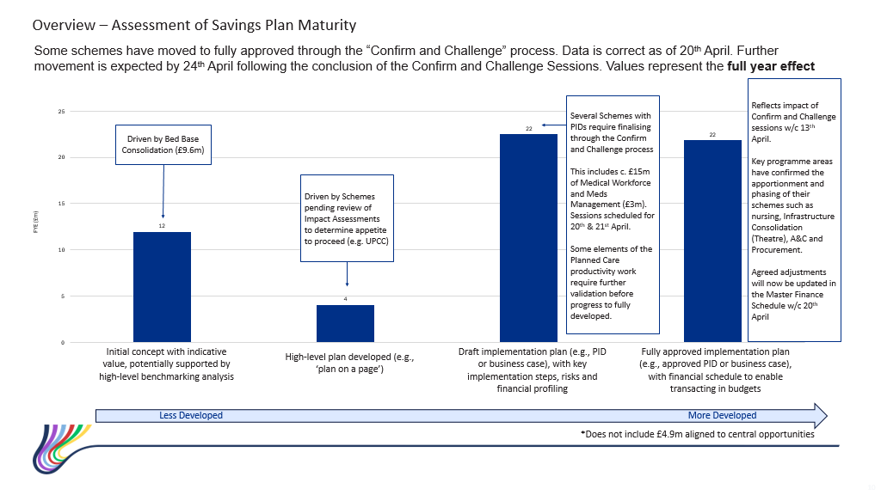

The Gower Ward pilot feedback was received positively, with evidence that the approach was providing positive staff and patient experiences. Reductions in staff absence, including sickness absence have been realised, and patients are needing a shorter length of stay impacting positively on patient wellbeing.

Figures can be seen below:

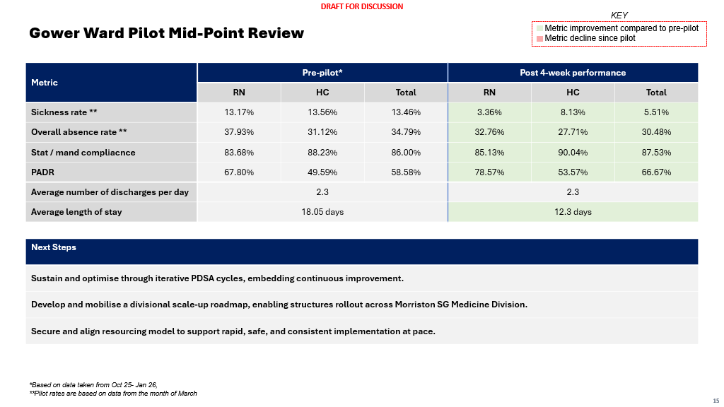

The board agreed that roll out should commence at pace, with a request for an ambitious roll out plan to be produced.

  - R&S Board 13 May 2026
This board was chaired by the Director of Delivery Unit. The attendance comprised of delivery leads, as most executive directors were not in attendance due to a conflicting commitment with NHS Performance and Improvement.

The main focus of the meeting was to discuss the development between the PID detail and the financial phasing assumptions to translate onto the Welsh Government tracker. Colleagues have been asked to work closely with finance colleagues so that schemes can be moved into Green and Amber for the Welsh Government tracking purposes.
All project initiation documents are to be reviewed urgently to progress at pace.

Discussions were also held regarding the exit planning process, and skills transfer from the external partners as they prepare to conclude their support in the organisation.

Discussions also took place around the movement towards the creation of the delivery unit, with the director highlighting the importance of the financial recovery programme and moving resources to align with the most pressing health board priorities. The director confirmed that an appointment had been made to the Head of Project Management Office (PMO) role secondment to facilitate the re-alignment of resources at pace.

- GOVERNANCE AND RISK ISSUES
The established governance processes within the R&S programme and board are clear and robust.

As we have entered 2026/27 the lack of identified recurrent savings within the delegated budgets represents a significant risk to the deficit of the Health Board, however the work outlined in earlier sections of this report will help mitigate some of this risk.

- FINANCIAL IMPLICATIONS
The financial implications of this report are set out within it.

- RECOMMENDATION
Members are asked to:
- RECIEVE the report for assurance.

Governance and Assurance
Strategic Objectives
Strategic Objectives  (please choose which is impacted) | People of Swansea Bay live healthier, fairer and more prosperous lives | ☐
Strategic Objectives  (please choose which is impacted) | Care is high quality, safe, efficient and delivers the best possible outcomes for people in partnerships | ☐
Strategic Objectives  (please choose which is impacted) | Care is delivered in partnership with our communities in safe and appropriate setting, supported by innovation | ☐
Strategic Objectives  (please choose which is impacted) | The health board is a great place to work where staff feel valued and work together towards a common goal | ☐
Strategic Objectives  (please choose which is impacted) | The health board is a resilient, sustainable and responsible organisation | ☒
Health and Care Standards
Standards (please choose which applies) | Safe Care | ☐
Standards (please choose which applies) | Timely Care | ☐
Standards (please choose which applies) | Effective Care | ☒
Standards (please choose which applies) | Efficient Care | ☒
Standards (please choose which applies) | Equitable care | ☐
Standards (please choose which applies) | Person-centred Care | ☐
Standards (please choose which applies) | Staff and Resources | ☒
Enablers (please choose which applies) | Whole Systems Approach | ☒
Enablers (please choose which applies) | Leadership | ☒
Enablers (please choose which applies) | Workforce | ☐
Enablers (please choose which applies) | Culture | ☐
Enablers (please choose which applies) | Information | ☐
Enablers (please choose which applies) | Learning, Improvement and Research | ☐
Quality, Safety and Patient Experience
Recovery & Sustainability programme, whilst addressing the need for a sustainable financial position, is focused on undertaking through delivery of good quality, safety, and patient experience.

Financial Implications
No direct financial implications
Legal Implications (including equality and diversity assessment)
No implications
Staffing Implications
No direct implications
No implications
No implications
Report History
n/a

Appendices
n/a

