Swansea Bay University Health Board
Performance & Accountability Framework

Contents
1. Purpose 2
2. Scope 2
3. Guiding Principles 4
4. Performance Principles 6
4.2 Quality and Safety Safeguards 6
5. Operating Context and Model 7
5.1. Welsh Government Oversight and Accountability 8
5.2. Health Board Management and Monitoring 10
5.2.2 Assurance Ratings 14
5.2.3 Cross-Committee Assurance and Escalation 15
6.1 Metric Ownership and Reporting Standard 15
6.1.1. Board Scrutiny 19
6.1.2. Monthly Service Group Oversight and Accountability 20
6.1.3. Quarterly Cross System Performance and Planning Reviews 20
6.1.4. Corporate Assurance & Accountability - Recovery & Sustainability Board 21
6.1.5. Service Group/Corporate Directorate Performance Arrangements 21
6.1.6. Performance Reports 22
6.1.7 Data Quality and Validation 22
7. Escalation 23
8. Roles & Responsibilities 31
9. Review and Implementation 35

- Purpose
  - This Performance and Accountability Framework sets out how Swansea Bay University Health Board will maintain clear lines of accountability from Board to team level and align internal performance, assurance and escalation arrangements with the Welsh Government and NHS Wales accountability interface, the Annual Plan, and the Recovery & Sustainability programme.

  - It establishes the arrangements through which the Health Board will identify emerging variance, secure timely corrective action, support delivery of the Annual Plan, Recovery & Sustainability priorities and agreed improvement trajectories, and provide confidence to Board, committees and external partners that there is effective organisational grip, control and assurance.

  - The framework will drive improvement, support delivery of operational and financial targets, provide proportionate assurance on recovery and sustainability delivery, and support the appropriate management and escalation of matters of concern within the organisation.

  - The Framework is firmly based on the Health Board’s values and behaviour framework of: -
- working together
- always improving; and
- caring for each other

- Scope
  - The PAF will act as the overarching mechanism for performance management across the Health Board and will form part of the assurance to the Board in regard to achieving the strategic objectives as detailed in the Board Accountability Framework (BAF).

  - The Framework applies to all Service Groups, corporate directorates, enabling functions, Delivery Unit arrangements, strategic improvement programmes, Recovery & Sustainability workstreams and relevant committee, group and Board reporting routes.

  - It sits alongside, and does not replace, statutory governance requirements, committee terms of reference, scheme of delegation, risk management arrangements, financial control procedures, quality governance processes or workforce policies.

  - The PAF describes the systems and activities that will be required to be in place to ensure that there is effective performance management across the Health Board and the roles and responsibilities of all individuals are clear.

  - The Governance arrangements for performance review meetings are described, setting out frequency, attendance and the governance process for recording and managing the actions from these meetings.

  - The content of the performance reports, in terms of core data sets will be determined corporately to reflect the delivery of the extant Health Board plan. Service groups and Corporate Directorates may wish to add supplementary measures reflecting their assessment of priorities in addition to these core data sets.

  - The levels of escalation within the Health Board will be guided by the compliance against the targets set out by Welsh Government in nationally published frameworks along with any locally agreed targets for delivery within the Health Board.

  - Clarity on the roles of individuals and teams and how they relate to the overall performance system is included in this document.

  - How this Framework will be used
This Framework will be used as the Health Board’s core operating mechanism for reviewing delivery, identifying variance, securing corrective action and providing assurance to the Board. It will be applied through the monthly and quarterly performance review cycle, routine Executive Team oversight, Board committee scrutiny and Board reporting.
The Framework will be used to:
• confirm the objectives, measures and trajectories against which delivery will be assessed;
• identify variation from plan, including deterioration, sustained underperformance or emerging risk;
• ensure that each area of concern has a named accountable lead, clear corrective actions, delivery milestones and timescales for improvement;
• determine whether issues can be resolved through routine management arrangements or require escalation;
• ensure that quality, safety, workforce, finance, performance, population health and strategic delivery are considered together rather than in isolation;
• provide a consistent basis for reporting assurance, risk and recovery progress to the Executive Team, Board committees and Board; and
• support a culture of improvement, transparency, early action and proportionate accountability.
The Framework is not intended to duplicate existing governance arrangements. It is intended to connect those arrangements so that the Health Board can demonstrate grip, control, improvement and assurance in relation to delivery of its Annual Plan, statutory duties, Welsh Government expectations and Board-approved priorities.
- Guiding Principles
  - The Performance and Accountability Framework supports the triangulation of the long-term approach to delivering the strategic vision of the organisation. As seen below, the Framework works in conjunction with the three pillars which looks to develop the Health Board plan, assess the risk to delivery and deliver on the performance.

  - The Performance and Accountability Framework (PAF) supports the delivery of the organisation’s long-term strategic vision, providing a clear line of sight between strategy, planning, delivery and assurance.

  - A high-performing organisation holds itself to account for the delivery of agreed quality, performance, activity, workforce and financial commitments. Where performance does not meet required standards, concerns are escalated appropriately and transparently.

  - The Health Board promotes a culture of mutual support between Service Groups and Corporate Directorates, recognising that performance is optimised through collective ownership and system working.
  - Service Groups and Corporate Directorates are resourced to deliver the agreed plan, including budgets, activity, savings and performance trajectories, and are accountable for delivery within the parameters set out in the annual plan.

  - The PAF aims to ensure that duplication of reporting is avoided and that the Board receive appropriate oversight and assurance for all areas requiring support or intervention.

  - Board assurance will be focussed on detailed information from the SBUHB Breakthrough objectives and the Welsh Government areas of escalation. All performance metrics will be assigned to a lead committee for scrutiny and assurance, with all other performance objectives being reporting for noting, unless escalated by the Board following key risk assessments.

  - The Framework incorporates a graduated escalation model, based on earned autonomy, which incentivises good performance and provides proportionate support and intervention where delivery falls short.

  - Performance management is underpinned by robust intelligence and foresight, including variance analysis, prospective forecasting (at least two periods ahead), demand and capacity modelling, and analytical insight to understand system behaviour and support evidence-based decision-making.

  - Through this PAF, the Health Board will adopt an approach which: -

- Set out the quality, performance, activity, workforce and financial expectations of Service Groups and Corporate Directorates as required in the Health Board plan.
- Embed systems and processes in Service Groups in particular to ensure that activity levels are managed, monitoring of variances is undertaken sufficiently to improve quality, capacity and performance.
- Ensures that corrective actions are taken to manage variances from plan
- Includes prospective forecasting of planned delivery at least two time periods in advance as a standard approach
- Is based on clear earned autonomy and levels of escalation
- Supports the resolution of issues outside of the direct control of the Service Group
- Uses demand and capacity modelling, analytical capability and business intelligence to understand system behaviours and which establishes the key facts to support solutions.

3.10 Population Health, Inequalities and Patient Experience
The Health Board will use this Framework to support improvement in population health, reduce unwarranted variation and ensure that performance is understood through the experience of patients, communities and staff.
Where relevant and available, performance information should be analysed by population group, geography, deprivation, protected characteristic, service area or pathway to identify variation in access, experience, outcomes and delivery. This will support the Health Board to understand whether improvement is being achieved equitably and whether particular groups are experiencing poorer access, outcomes or experience.
Performance reporting should also draw on patient experience, complaints, concerns, compliments, engagement feedback, staff feedback and other qualitative intelligence where this provides important context to reported performance. This is particularly important where quantitative performance appears stable but patient, public or staff feedback indicates emerging risk, poor experience or deterioration in service quality.
Where material inequalities, access variation or patient experience concerns are identified, these should be reflected in the relevant delivery or recovery plan and escalated through the appropriate Executive, committee or Board route.
- Performance Principles
  - The PAF is designed to support a culture of continuous performance improvement for the benefit of patients. This is done by a standard approach to performance management supported by tools and a central Performance Management Team. In particular, the approach provides.

- Clear objectives: The Health Board Plan Deliverables are highlighted throughout the PAF ensuring monitoring and focus on these key deliverables at all levels of the Board. Services will be performance managed against outcomes set out as part of the extant plan of the Health Board at the time.

- Accountability: Performance management arrangements ensure that everyone is clear who the Executive and Management leads are for any area of performance in the Health Board. A breakdown of Executive roles and responsibilities can be found within the document.

- Transparency: The tools to measure performance and the evidence used to assess performance is clear and staff across the Health Board understand what is required and will be held accountable through a clear approach which makes clear what is expected when performance drops below an acceptable level. This will be through the Service Groups and Corporate Directorates of the Health Board. Wherever possible the Health Board Performance team will ensure that tools and information are available to services enabling them to query and analyse the data on which they are being performance managed.
- Improvement focussed: The Performance management approach of the Health Board will be supportive and focussed on improvements. Services which are identified as underperforming will be offered the tools and resources to improve performance and the responsible individuals will be supported to make improvements, as outlined in the escalation framework. A failure to achieve the required performance may lead to formal action in line with the Health Boards relevant Workforce/HR policies.

- Empowerment and delegation: Areas of the Health Board which are performing strongly will experience lighter levels of performance management, rewarding and encouraging innovative ways of working. Conversely areas of the Health Board which are underperforming in key areas will be required to attend more regular formal performance meetings and will be offered greater support in making improvements through an agreed escalation process (set out later in this document).

4.2 Quality and Safety Safeguards
Performance improvement, financial recovery and delivery of operational targets must be achieved in a way that protects patient safety, clinical quality, patient experience and staff wellbeing. The Health Board will not regard a recovery action as sufficiently assured where it improves activity, productivity or financial performance but creates unmanaged risk to quality, safety or patient outcomes.
Where a performance issue, savings scheme, productivity improvement or recovery action has potential quality or safety implications, the relevant Executive lead, Service Group or Corporate Directorate must ensure that these implications are identified, assessed and mitigated. This should include, where appropriate:
• clinical leadership review;
• assessment of patient safety, experience and outcome implications;
• consideration of staffing, capacity and workforce sustainability;
• review of infection prevention and control implications;
• consideration of health inequalities and access impacts;
• assessment of any impact on statutory or regulatory duties; and
• escalation to the Quality and Safety Committee where assurance is required.
The Performance and Finance Committee and the Quality and Safety Committee will work together where performance recovery, financial delivery or productivity improvement has material quality or safety implications. Where there is a potential conflict between delivery of a target and maintenance of safe care, this must be escalated to the Executive Team and, where material, to the Board.

- Operating Context and Model

Board assurance criteria supporting the Annual Plan
The following assurance criteria will sit alongside the Annual Plan and be used to test whether the Health Board has sufficient grip over financial recovery, operational improvement and organisational sustainability:

Criteria | Source-based assurance expectation
Effective programme governance | Programme governance arrangements will strengthen organisational oversight, delivery discipline and assurance, with clear reporting into Weekly Executive Meetings, the Recovery & Sustainability Board, the Performance & Finance Committee and Board.
Understanding the underlying deficit | Finance colleagues, in collaboration with relevant Executives, will provide a clear and consistent understanding of the recurrent and non-recurrent drivers of the deficit and the barriers to short-term cost reduction.
A single, coherent savings programme | A consolidated savings programme will replace fragmented arrangements and become a single version of the truth, supported by standardised PIDs and delivery plans.
Worst-case mitigation | A high-level assessment of worst-case mitigation options will support organisational preparedness, transparency with Welsh Government and informed decision-making should delivery risks materialise.
Grip and control on key cost drivers | The organisation will demonstrate sustained improvement in control measures such as sickness absence, variable pay, vacancy control, budget setting assumptions and financial discipline.
Delivery capacity | The Delivery Unit brings together PMO, Transformation, Improvement, Recovery & Sustainability and Value Based Healthcare functions, working alongside Finance, Business Intelligence & Performance, Quality Improvement Nursing, Workforce and operational teams.
Ownership and accountability | Executive Directors, Service Groups and budget holders retain accountability for delivery, supported by clear SROs, delivery leads, consistent reporting, transparent trajectories and escalation arrangements.

The overview of the accountability mechanisms in place is set out below. The updated governance map shows the tiered reporting and monitoring route from Board and Board committees through Executive arrangements, Service Group performance review, Recovery & Sustainability, improvement programme groups and local Service Delivery Groups.
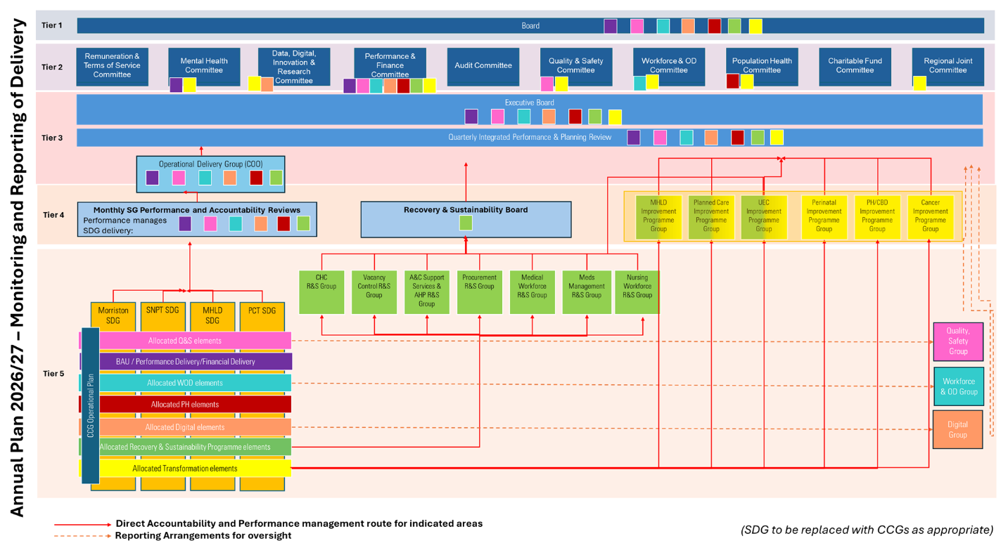
Governance map for Annual Plan 2026/27 monitoring and reporting of delivery

  - Welsh Government Oversight and Accountability

The March 2026 NHS Wales accountability approach seeks to modernise, simplify and sharpen system oversight, assurance and escalation. It removes the previous IQPD and JET style arrangements and replaces them with a more standardised, risk-based interface aligned to escalation level, supported through NHS Performance & Improvement as the single operational assurance interface.
In line with the 16 March 2026 letter from Nick Wood, Boards and Chairs remain accountable to Welsh Ministers, Chief Executives remain accountable to their Boards through the Chair, and existing Board governance arrangements are not altered by the revised national interface.
Within Swansea Bay, this Framework aligns to the HB’s governance arrangements for monitoring and reporting delivery of or annual plan, the continued use of monthly Service Group performance reviews and quarterly planning/performance reviews, and the Delivery Unit as a core component of the internal accountability model.

  - Health Board Management and Monitoring
    - Reporting and Monitoring

The following table updates and replaces the previous reporting and monitoring table, using the Performance Assurance Fora source document. It identifies the purpose, role in performance assurance and frequency of each forum.
Forum | Purpose | Role in Performance Assurance | Frequency
UHB Board | The Board sets the organisation’s strategic direction, establishes and upholds the governance and accountability framework, and receives assurance on delivery of the Health Board’s aims and objectives. | It is the apex forum for performance assurance. It receives integrated performance and quarterly outcomes reporting, challenges delivery against plan, and gains assurance via reports escalated through its committees and wider governance structure. | Bi-monthly
Audit Committee | To advise and assure the Board and Accountable Officer that effective assurance arrangements, governance, risk management and internal control are in place, and to advise where those arrangements need strengthening. | It provides assurance on the adequacy of the control environment underpinning performance delivery, including governance, risk, internal audit, external audit and internal controls. It does not performance manage services directly, but assures that the systems for doing so are robust. | Bi-monthly
Population Health Committee | To oversee population health priorities and activity, with a focus on prevention, inequalities, partnership working and improvement in the health and wellbeing of the population. | It provides assurance that population health objectives, public health priorities and partnership-led work are being progressed and that population-level risks, mitigations and delivery issues are visible within the Board’s assurance framework. | Quarterly
Performance and Finance Committee | To scrutinise in detail financial planning and monitoring, delivery of savings programmes, activity and productivity, operational efficiency and effectiveness, workforce metrics, and delivery against national performance measures. | This is the principal Board committee for formal scrutiny of operational and financial performance. It receives escalation updates, scrutinises recovery plans and improvement plans, and is the key route through which challenged performance is monitored and assured on behalf of the Board. | Monthly
Quality and Safety Committee | To focus on all aspects relating to the quality and safety of healthcare, including clinical governance. | It provides assurance that performance improvement is being delivered in a way that is safe and of the required quality. It scrutinises quality, safety and clinical governance risks and acts as a key escalation route where performance issues have quality or safety implications. | Bi-monthly
Workforce and OD Committee | To focus on all aspects of workforce as a resource, ensuring the strategic and operational workforce agenda enables delivery of Health Board objectives and supports quality, safety and employment practice. | It provides assurance on the workforce enablers of performance, including workforce capacity, capability, culture, staff development and key workforce indicators. It assures that workforce risks impacting service delivery are identified and managed. | Bi-monthly
Remuneration and Terms of Service Committee | To oversee remuneration and terms of service matters and ensure appropriate governance, compliance and proper decision-making in relation to senior workforce terms and conditions. | For performance assurance purposes, it provides assurance that remuneration and terms of service arrangements are governed appropriately and do not create unmanaged workforce, financial or governance risk. | Quarterly / as required
Mental Health Legislation Committee | To consider and monitor the Health Board’s use of the Mental Health Act 1983, Mental Capacity Act 2005, Deprivation of Liberty Safeguards and the Mental Health (Wales) Measure 2010. | It provides assurance on statutory compliance and performance in mental health legislative duties, and gives the Board assurance that legal, quality and operational obligations in mental health services are being discharged appropriately. | Quarterly
Data, Digital, Innovation and Research Committee | To oversee digital innovation within the Health Board and the strategic use of data, intelligence, innovation and research to support organisational objectives. | It provides assurance that digital, data and innovation capability supports performance management, including dashboarding, intelligence, prioritisation and monitoring. It is an enabling assurance forum, ensuring the information architecture needed for effective performance oversight is in place. | Bi-monthly
Charitable Fund Committee | To make and monitor arrangements for the control and management of the Health Board’s charitable funds. | Its role in performance assurance is indirect. It assures the Board that charitable funds are governed properly and used in a controlled way to support agreed priorities, rather than providing assurance on core operational performance. | Quarterly
Regional Joint Committee | To focus on strategic planning and the regional health economy, reflecting cross-organisational partnership and regional delivery arrangements. | It provides assurance where delivery depends on regional partnership rather than Swansea Bay acting alone. It is a route for oversight of shared regional priorities, dependencies and system risks that affect the Health Board’s ability to deliver its plan. | Regular scheduled cycle
Executive Board / Executive Team | To provide a forum for the Executive Team to discuss matters of key strategic or operational significance, receive routine performance reports and resolve issues not resolved locally. | It is the central executive assurance forum. It reviews performance by exception, determines whether deviation is minor or material for escalation purposes, and commissions or monitors executive action ahead of onward escalation to Executive Board, committees or Board. | Weekly
Operational Delivery Group | To review key operational priorities and coordinate operational delivery across Service Groups and corporate functions. | It provides a system-wide operational assurance route, particularly where issues are cross-cutting and cannot be resolved within one service area. It determines actions to manage areas outside expected performance and supports escalation in line with the framework. | Monthly
IPPR (Integrated Performance and Planning Review) | • The IPPR is the forum through which quarterly financial, strategic and planning performance is reviewed at system level through delivery of the strategic priorities set out in the Annual Plan.  • It requires system leads to provide an overview of the previous quarter’s performance, together with a forward look into the next quarter and any areas of exception against plan delivery. | • It provides the formal quarterly route for integrated review of performance and plan delivery across System programme plans.  • It enables Chief Executive-led scrutiny of delivery against Annual Plan priorities and ensures cross-system dependencies, risks and issues are identified and jointly actioned.  • It provides a route for escalation of strategic risks, exceptions and delivery issues that cannot be resolved through routine monthly performance review arrangements.  • It supports formal action logs and summary reporting to Executive Board and the Performance and Finance Committee, with progress informing quarterly Board and Welsh Government reporting. | Quarterly
Morriston Performance SDG | To review monthly operational, quality, workforce and financial performance for Morriston and its divisions by exception, using the monthly performance pack and local intelligence. | It is the principal local forum for holding Morriston services to account for delivery against trajectories, agreeing corrective actions and escalating unresolved issues into the Executive Team and Performance and Finance Committee route. | Monthly
Singleton and Neath Port Talbot SDG | To review monthly operational, quality, workforce and financial performance for the Service Group by exception and oversee delivery against agreed trajectories. | It provides local operational assurance on performance delivery, recovery actions and risk management, and acts as the first formal escalation point before matters move into executive or committee governance. | Monthly
Mental Health and Learning Disabilities SDG | To review monthly operational, quality, workforce and financial performance across MH&LD services, including progress against key trajectories and recovery actions. | It provides assurance that MH&LD services are delivering against expected performance, that underperformance is addressed through agreed actions, and that significant risks are escalated appropriately. | Monthly
Primary and Community Care SDG | To review monthly operational, quality, workforce and financial performance across primary and community services, with a particular focus on locally agreed and national measures. | It provides local assurance on delivery of primary and community care priorities and acts as the forum through which recovery actions, escalations and cross-system dependencies are identified and managed. | Monthly
Recovery and Sustainability Board | The Health Board-wide Recovery and Sustainability Programme is responsible for oversight of the financial recovery programme development and delivery. It oversees projects that contribute to reducing the Health Board’s expenditure and supports delivery of the Health Board’s target financial position. It does not look at day-to-day financial position or performance in the round. | It is the route through which financial recovery thematic and Service Group programmes of work are governed and progression against plan delivery is monitored. It enables Executive and Service Group Director level reporting of progress on thematic and Service Group programmes of work, provides a route for escalation of critical risks and issues that could impact financial benefits realisation, and provides a mechanism for ensuring the programme is coordinated and interdependencies are managed. | Twice monthly (2nd and 4th week of the month)
Mental Health and Learning Disability Improvement Programme Group | To oversee the development and delivery of the MH&LD improvement programme, including actions, milestones and risks associated with agreed improvement priorities. | It provides programme-level assurance that improvement actions are being delivered, risks and barriers are identified early, and issues requiring executive intervention are escalated through the established governance route. | Monthly
Planned Improvement Programme Group | To oversee the planned care improvement programme, including delivery of actions relating to waiting times, productivity, pathways and recovery trajectories. | It provides focused assurance on planned care improvement delivery, acting as the forum that tracks progress, challenges slippage, manages dependencies and escalates risks affecting delivery of national and local planned care measures. | Monthly
Urgent and Emergency Care Improvement Programme Group | To oversee improvement actions for urgent and emergency care, including pathway flow, escalation risks, operational resilience and delivery against urgent care measures. | It provides focused assurance on urgent and emergency care recovery and improvement, ensuring performance risks are actively managed and that cross-system actions are progressed and escalated where required. | Monthly
Perinatal Improvement Programme Group | To oversee the perinatal improvement programme and monitor delivery of agreed quality, safety and performance actions within maternity and perinatal services. | It provides assurance that required improvements are being delivered, that actions are monitored to completion, and that quality and performance concerns are escalated through the appropriate committee route. | Monthly
Public Health Improvement Programme Group | To oversee improvement work relating to public health and community-based models of care, including prevention, redesign and community delivery priorities. | It provides assurance that programme actions contributing to prevention, population health and community service redesign are being progressed, coordinated and escalated where delivery risk arises. | Monthly
Cancer Improvement Programme Group | To oversee the cancer improvement programme and delivery of recovery and improvement actions against cancer pathway performance and associated service changes. | It provides a dedicated route for monitoring cancer improvement delivery, reviewing risks and mitigations, and escalating barriers impacting achievement of cancer standards and trajectories. | Monthly

5.2.2 Assurance Ratings
To support consistent Board and committee scrutiny, reports produced under this Framework should include a clear assessment of the level of assurance available. The assurance rating should reflect not only current performance, but also the strength of the plan, the credibility of actions, the quality of evidence, the level of risk and whether delivery is improving.
• Substantial assurance: performance is on track or within agreed tolerance; risks are understood; controls are effective; delivery is supported by reliable evidence.
• Reasonable assurance: performance may be challenged in some areas, but there is a credible plan, clear accountability, active management of risk and evidence that actions are progressing.
• Limited assurance: performance is off track, risks are material, recovery actions are incomplete or not yet having sufficient impact, or there are gaps in evidence, ownership or delivery confidence.
• No assurance: there is significant underperformance, limited evidence of grip or recovery, unclear accountability, unmanaged risk, or failure to deliver agreed corrective actions.
Where limited or no assurance is reported, the relevant report must set out the reason for the assurance rating, the corrective action required, the accountable lead, the timescale for improvement and whether escalation is required under this Framework.

5.2.3 Cross-Committee Assurance and Escalation
Some performance issues will require scrutiny by more than one Board committee. Where an issue has implications across operational performance, finance, quality, safety, workforce, digital, population health or governance, the Executive Team will identify the lead committee for assurance purposes and any supporting committee routes.
The lead committee will be responsible for maintaining oversight of the overall delivery or recovery position. Supporting committees will provide scrutiny and assurance on the elements within their remit. For example, the Performance and Finance Committee may lead on operational recovery and financial delivery, while the Quality and Safety Committee provides assurance on quality and safety impacts, and the Workforce and OD Committee provides assurance on workforce risks and mitigations.
Committee reports should make clear:
• whether the committee is the lead assurance committee or a supporting committee;
• what specific assurance the committee is being asked to provide;
• whether any issue needs to be referred to another committee;
• whether there are unresolved risks or gaps in assurance; and
• whether escalation to the Board is required.
This approach is intended to avoid duplication while ensuring that complex issues are considered in the round.

- Performance indicators and Management Oversight Arrangements

6.1 Metric Ownership and Reporting Standard
Each measure reported through this Framework must have a clear definition, identified data source, named accountable lead and agreed reporting frequency. This is necessary to ensure that performance is assessed consistently and that accountability for delivery is clear.
As a minimum, each core performance measure should identify:
• the metric definition;
• the data source;
• the reporting frequency;
• the Executive lead;
• the operational, corporate or programme lead responsible for delivery;
• the relevant Board committee for assurance;
• the target, standard or agreed trajectory;
• the tolerance threshold for acceptable variation;
• the escalation trigger where performance deteriorates or remains off track;
• whether the measure should be analysed by Service Group, site, specialty, locality or population group; and
• any known data quality limitations.
Where a measure is reported as off track, the report should describe the reason for the variance, the corrective action being taken, the expected date of recovery and the confidence level that recovery will be achieved.

The table below sets out the metrics that the organisation is using to monitor delivery of its key objectives for the year and the committees leading and receiving assurance on them.

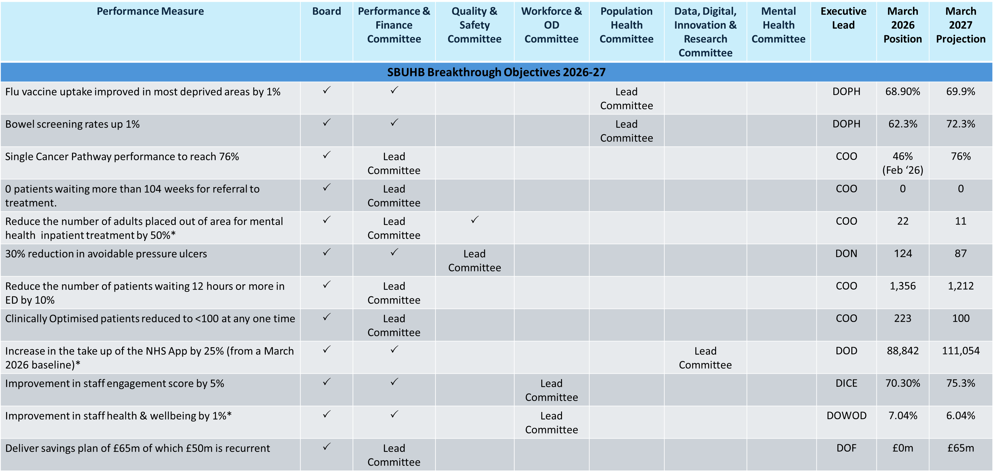

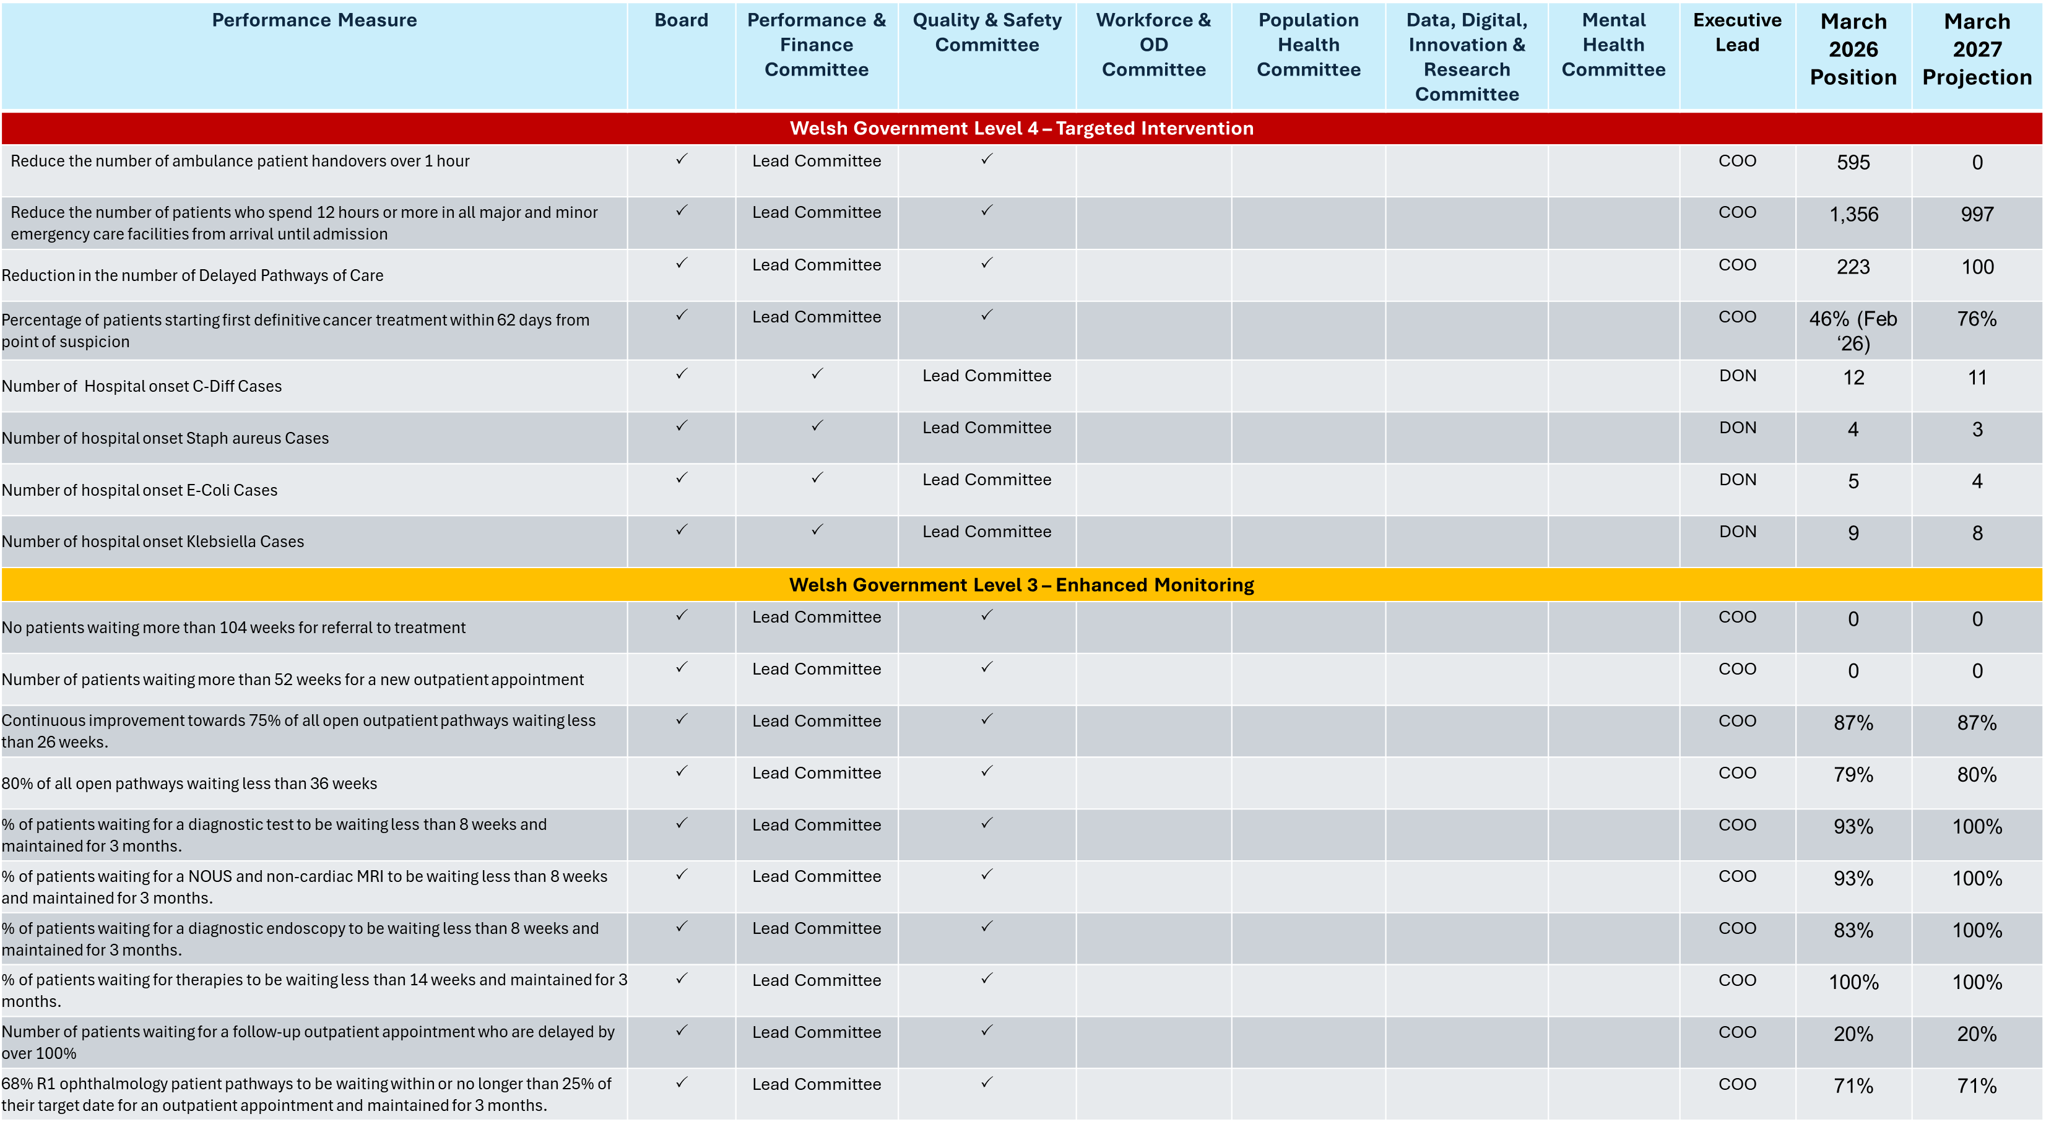

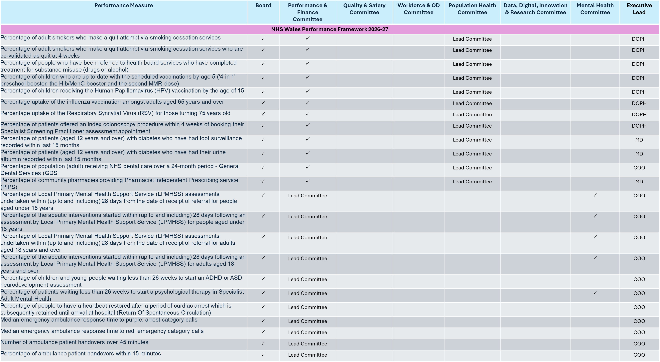

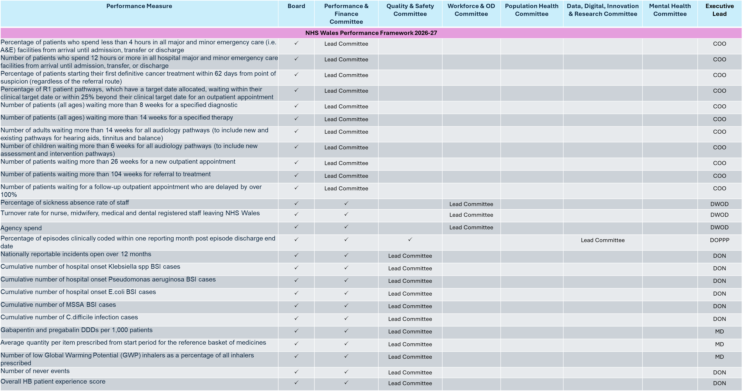

    - Board Scrutiny

Appropriate updates against the delivery of key performance targets will be given to the Board through the Governance structures outlined previously.

Detailed performance updates and progress against the delivery of the Health Board Strategic Objectives will be provided on a Bi-monthly basis.

Each Corporate directorate will partake in a quarterly Integrated Planning and Performance Review (IPPR) meeting, which will be chaired by the CEO, facilitated by the Executive Director of Planning, Partnerships and Performance

The meetings will focus on key objective delivery and the financial performance, all of which will be supported by agreed action notes.

    - Monthly Service Group Oversight and Accountability
Monthly Service Group level Performance reviews will take place, where the following principles of operation will apply: -

- The meetings will run for two hours
- Chaired by the Chief Operating Officer
- The deputy Chair will be the Executive Director of Planning and Partnerships
- The Service Group Triumvirate will be required to attend, along with the Finance Business Partner, Workforce Business Partner and any required divisional managers
- Other members may be requested to attend based on the agenda

The monthly performance meetings will focus on operational delivery and delivery against national performance measures. A subset of key performance and financial metrics will be reviewed and discussed, with appropriate actions developed as a result.

There is a clear expectation that the reviews will build on historical reporting to look ahead on a rolling quarterly basis and define the critical actions to ensure performance is delivered and where relevant recovered from any position of variance.

The review will consider the content of the Divisions’ Performance report/ performance dashboard and will be supported by agreed action notes for each session.

    - Quarterly Cross System Performance and Planning Reviews
The quarterly performance and planning review meetings will take place four times a year and will cover a broader agenda involving the whole Executive team. The meeting will be chaired by the Chief Executive and will seek to review the delivery of the strategic objectives outlined in the Annual Plan.

These meetings will also ensure that performance delivery which is predicated on cross system working rather than the accountabilities within each delegated area is clearly set out and joint objectives/actions agreed as required.

The meetings will be two hours long in total. Where necessary, deep dives into key areas of challenged quality, performance and finance will be requested in advance and considered within the meeting agenda. This meeting will also consider Service Group progress against its specific actions set out in the Health Board plan and will be subject to the requirement for an additional return (slide deck), reflecting this, on a quarterly basis.

The review will consider the key performance indicators (working towards a standard performance dashboard by Service Group) and will be supported by agreed action notes and a formal letter from the Chief Executive.

The progress reported against the annual plan will be summarised into an update paper, which will service as the quarterly update against the plan which will be submitted to Board and Welsh Government.

    - Corporate Assurance & Accountability - Recovery & Sustainability Board

The Recovery & Sustainability Board provides Health Board-wide oversight of the financial recovery programme development and delivery. It holds Service Groups and programmes to account for identifying, developing and delivering savings targets and planned KPI targets. It alternates twice monthly between thematic programme focus and Service Group focus and reports to Executive Board monthly and Performance & Finance Committee bi-monthly.
The review of the accountability delegated to the Executive Director of Planning and Partnerships will be undertaken by the Chief Executive Officer.

    - Service Group/Corporate Directorate Performance Arrangements

It is the responsibility of each Service Group Directorate and Corporate Directorate to implement their own local performance reporting and management systems. The precise timing and nature of these discussions will be at the discretion of the individual Director, but it is expected that these arrangements will include, as a minimum, the following areas of discussion on a minimum of a monthly basis: -

- Performance meeting to include reporting on KPI’s, projections and agreed local action
- Quality and safety meeting through which risk, clinical governance, patient experience, health & safety etc. is discussed
- Monthly financial position review (key drivers of the financial position to be discussed in detail; this will vary by Group and Directorate)
- Monthly savings review to assure in-year plans and build a pipeline of future savings opportunities
- Clinical Business meeting where all of the above is brought together to correlate activities

    - Performance Reports
To support the performance review process, routine reporting will be produced through the Performance and Business Intelligence function, with input from Finance, Workforce, Quality, operational teams and the Delivery Unit where relevant.

Additionally, the Performance team will also support production of any Welsh Government Oversight and Escalation assurance updates as required.

The monthly Integrated Performance Report will include detailed updates on the priority metrics outlined above, with the view to ensure committee members are assured of the progress against the annual plan, escalation requirements and strategic objectives. The remaining performance objectives will be included in the IPR in a ‘for noting’ capacity. The performance reports will include updates against:
- How we are tracking against our new plan.
- Escalation requirements.
- Strategic objectives: where are we off track, and is the issue improving, deteriorating, or stable?
- Is there a credible recovery plan with named ownership and milestones?
- What level of assurance is available: substantial, reasonable, limited, or none?
- What wider risks arise, and how are these being mitigated?
- How do we compare with the rest of Wales?

In response to the Ministerial Advisory Group recommendations, Wales will move towards reporting performance in a standardises approach, ensuring that data is presented in a Statistical Processing Chart format, meaningful comparison across Wales is included, along with key assessments against escalation criteria. These standardised changes will be made to the organisations IPR when available.

The Service Group monthly performance reviews will be supported by the production of a monthly performance pack. The Performance pack will feature key domains and the content will be agreed to reflect the key deliverables within each Service Group.

During 2026/27 an internal digital Integrated Performance Report dashboard will be developed to support the performance review process. This will strengthen the information architecture for performance oversight, dashboarding, intelligence, prioritisation and monitoring.

The reporting for the IPPR quarterly system reviews will be based on priority areas and by exception. The PowerPoint pack will go beyond what is discussed by exception in the monthly review meetings and will seek to provide a full quarter overview aligned with priorities set out as part of the annual plan.

Reporting to Board, Board level Committees and Executive Board has been outlined previously and will include a monthly Integrated Performance Report and a monthly Oversight and Escalation update.

6.1.7 Data Quality and Validation
The effectiveness of this Framework depends on timely, accurate and reliable information. The Health Board will therefore ensure that performance reporting is supported by clear data ownership, agreed definitions, validation processes and transparent identification of known limitations.
The Performance and Business Intelligence function will coordinate the production of routine performance reporting, working with Finance, Workforce, Quality, Digital, operational teams and the Delivery Unit as appropriate. Service Groups, Corporate Directorates and Executive leads remain responsible for understanding and acting on the performance information relevant to their areas.
Performance reports should identify any material data quality limitations that affect interpretation of performance. Where data is provisional, incomplete, subject to validation or materially different from previous reporting, this should be clearly stated. Where there is a dispute about data accuracy, the relevant Service Group or Corporate Directorate must work with the Performance and Business Intelligence function to resolve the issue promptly. Data quality concerns should not prevent immediate management action where there is evidence of material risk, deterioration or harm.
The Health Board will continue to strengthen its data quality, dashboarding and analytical capability during 2026/27 as part of the development of the internal digital Integrated Performance Report.

- Escalation

7.1 SBUHB Escalation Arrangements

The PAF will operate on the principle that, wherever possible, issues should be resolved at Service Group or Corporate Directorate level. Service Groups and Corporate Directorates are expected to work collaboratively and to be mutually supportive, in line with the Health Board’s values.

Escalation should therefore be the exception. Where escalation is necessary, it must be proportionate, timely and focused on providing appropriate support and intervention at the earliest opportunity to ensure performance remains on track to deliver the Health Board’s objectives, agreed plan and statutory duties.

The SBUHB escalation arrangements will run in parallel with the Welsh Government NHS Wales Oversight and Escalation Framework.

The Health Board’s internal escalation levels are aligned to the five-level Welsh Government escalation language. However, the internal monitoring, reporting, support and intervention arrangements will be determined by the Health Board, taking account of the level of risk, delivery confidence, assurance available and the extent to which agreed recovery actions remain on track.
The escalation arrangements are supported by the March 2026 domain threshold source material in Appendix 4 and will be applied using a combination of objective performance evidence, agreed trajectories, risk assessment and Executive judgement.

7.1.1 Escalation levels

Escalation level | Meaning / trigger | Action and monitoring
Level 1 – Routine Arrangements | Performance is within expected arrangements, agreed trajectory, or tolerable variation. | Routine monitoring through established performance and assurance routes. Delivery plans remain in place and are reviewed through normal management and committee arrangements.
Level 2 – Area of Concern | Noticeable pressure, emerging risk, or early evidence of deterioration that may affect delivery if not addressed. | Corrective action agreed through monthly performance review arrangements, with early support and action tracking. Reporting remains proportionate to risk and delivery confidence.
Level 3 – Enhanced Monitoring | Thresholds or trajectories are not being met, or Welsh Government has placed the Health Board, a domain, or a service area into Level 3 escalation. Recovery arrangements are required and must be capable of being established. | Recovery plan, trajectory, accountable leads and milestones confirmed. Reporting frequency, Executive oversight and committee scrutiny increased proportionately. Any area placed into Level 3 by Welsh Government will be reported to the Board and the relevant lead committee, with enhanced information and deep-dive provision as required. Delivery Unit support will be considered and deployed where this would add pace, grip or assurance.
Level 4 – Targeted Intervention | Material or sustained failure against agreed deliverables, trajectories, statutory requirements or domain thresholds, or Welsh Government has placed the Health Board, a domain, or a service area into Level 4 escalation. | Formal recovery plan required, with targeted Executive intervention, increased review frequency and clear arrangements for assurance. Any area placed into Level 4 by Welsh Government will be reported to the Board and the relevant lead committee, with deep-dive reporting, enhanced information on risks and mitigations, and clear evidence of progress against recovery trajectories. Delivery Unit intervention will be expected unless the Executive Team agrees an alternative support arrangement.
Level 5 – Special Measures | Significant and sustained failure, limited or no assurance of recovery, inability to deliver safe and sustainable performance, or Welsh Government has placed the Health Board, a domain, or a service area into Level 5 escalation. | Chief Executive-led intervention, formal Executive Team oversight and direct reporting to the relevant lead committee and Board. Separate Board papers may be required in addition to the Integrated Performance Report where the level of risk, public interest, statutory concern or delivery failure requires specific Board scrutiny. Delivery Unit intervention will be expected, with additional internal or external support considered as required.

The precise nature, frequency and content of reporting will be agreed for each specific area, taking account of the level of escalation, the level of assurance available, the risk to delivery, and the extent to which the agreed recovery plan is on track.
Appendix 1 provides illustrations of how the escalation levels will work in terms of meeting frequency and reporting/oversight. These illustrations are intended to guide proportionate application and do not remove the need for Executive judgement.

7.1.2 Core principles

The escalation arrangements are based on the following principles:

a. Subsidiarity and local ownership: issues should be owned and resolved as close as possible to the point of delivery by the relevant Service Group or Corporate Directorate.
b. No surprises: risks, delivery issues and deteriorating performance should be identified and escalated early through the established performance review, Executive and committee routes.
c. Proportionality: the level of scrutiny, reporting frequency and intervention should reflect the scale of risk, the level of assurance available, and whether delivery remains on track.
d. Support before intervention: early support should be provided where it can prevent deterioration, strengthen delivery or avoid formal escalation.
e. Clear accountability: every area requiring improvement must have a delivery plan or recovery plan, named accountable leads, milestones, trajectories and agreed reporting arrangements.
f. Evidence-based assurance: committees should receive sufficient information to determine their level of assurance on delivery, including whether the plan is credible, whether actions are progressing, and whether risks and mitigations are understood.
g. Alignment with Welsh Government escalation: any area placed by Welsh Government into Level 3, Level 4 or Level 5 escalation will automatically trigger internal escalation reporting to the Board and the relevant lead committee.

7.1.3 Delivery plans, recovery plans and committee assurance

All Service Groups and Corporate Directorates are required to maintain clear plans for delivery against relevant Health Board objectives, annual plan commitments, performance requirements, quality and safety standards, financial duties, workforce priorities and statutory obligations.

Where delivery remains on track and risk is within tolerance, scrutiny will be through routine performance and assurance routes. Where delivery is off track, or where the risk to delivery increases, the level of scrutiny will increase proportionately.

Lead committees will receive detailed information on the relevant delivery or recovery plan and will determine their level of assurance based on the information provided. This should include, as appropriate:
- the nature and cause of the delivery issue;
- current performance against agreed thresholds, trajectories and milestones;
- the quality and credibility of the recovery plan;
- named Executive, Service Group or Corporate Directorate accountabilities;
- key risks to delivery;
- mitigating actions;
- support requirements;
- expected timescales for improvement;
- evidence that actions are having the intended impact; and
- any decision required from the committee, Executive Team or Board.

The committee’s assessment of assurance should inform the level of reporting required. Where assurance is limited, reporting frequency, detail and Executive oversight should increase. Where assurance improves and delivery is demonstrably on track, reporting may return to a lighter-touch arrangement.

7.1.3.1 Minimum Recovery Plan Standard
Where a recovery plan is required under this Framework, it must be proportionate to the level of risk and escalation but should include, as a minimum:
• a clear description of the issue, including the scale of variance from plan, target or trajectory;
• a brief assessment of the root cause of the underperformance;
• the named Executive lead and operational, corporate or programme lead responsible for delivery;
• the actions required to recover performance;
• measurable milestones and timescales;
• the expected recovery trajectory;
• the support required from corporate teams, the Delivery Unit or Executive Team;
• the key risks and dependencies that may affect delivery;
• the quality, safety, workforce, finance and equality impacts of the proposed actions;
• the evidence that will be used to demonstrate improvement; and
• the date by which the plan will be reviewed.
Recovery plans should be action-focused and concise. They should distinguish between actions already completed, actions in progress, actions at risk and actions requiring Executive or Board decision. Where recovery is not on track, the accountable lead must set out the reason for slippage, the further action required and whether escalation should be increased.

7.1.4 Welsh Government escalation triggers

Where Welsh Government places the Health Board, a domain, service area or specific programme into Level 3, Level 4 or Level 5 escalation, this will automatically trigger internal escalation within the Health Board.

As a minimum, this will require:
a. reporting to the relevant lead committee;
b. reporting to the Board, normally through the Integrated Performance Report unless a separate paper is required;
c. a clear delivery or recovery plan with named accountable leads;
d. agreed trajectories, milestones and measures of improvement;
e. enhanced information on risks, mitigations and delivery confidence;
f. deep-dive reporting to the relevant committee where required;
g. explicit consideration of whether additional Board-level scrutiny is required; and
h. consideration of Delivery Unit support or intervention.

For areas at Level 4 or Level 5, separate Board papers should be considered where the level of risk, complexity, public interest, statutory concern or delivery failure requires focused Board scrutiny beyond the routine Integrated Performance Report.

7.1.5 Internal escalation by Executive Team or Chief Executive

Escalation may also be initiated internally by the Executive Team or Chief Executive where there is evidence of material or sustained risk to delivery, quality, safety, finance, workforce, performance, governance or statutory compliance.

The Executive Team may determine that an area should be placed into internal Level 2, Level 3, Level 4 or Level 5 escalation even where Welsh Government has not placed that area into formal escalation. This may be necessary where the Health Board identifies risk earlier than Welsh Government, or where the issue is primarily internal but has the potential to affect delivery of the Health Board’s objectives.

The final decision on the internal escalation status of a Service Group, Corporate Directorate, domain or programme will rest with the Director of Planning, Partnerships and Performance for Level 3 and 4 escalations, informed by advice from the relevant Executive lead and with the Chief Executive for escalation to Level 5.

7.1.6 Delivery Unit support and intervention

The Delivery Unit will provide support to areas requiring improvement, with the nature of support determined by the level of escalation, the level of risk and the assurance available.

At Level 3, Delivery Unit support should be actively considered and deployed where it would strengthen grip, pace, coordination or assurance.

At Level 4 and Level 5, Delivery Unit intervention will normally be expected unless the Executive Team agrees that alternative arrangements are more appropriate. This may include direct support to recovery planning, enhanced performance oversight, improvement methodology, milestone tracking, evidence review, risk management and preparation of assurance reports for Executive Team, committees and Board.
The purpose of Delivery Unit involvement is to support sustainable improvement and strengthen delivery confidence. It does not remove accountability from the relevant Service Group, Corporate Directorate or Executive lead.

7.1.7 Trajectories, thresholds and objective review

Service Groups and Corporate Directorates will be required to agree trajectories for relevant measures. Delivery of trajectories will be reviewed through the digital balanced scorecard, agreed plan milestones and the domain threshold framework.

Where a source threshold is not specified, escalation decisions will be based on Executive judgement using the evidence available, including performance trends, risk, delivery confidence, quality and safety indicators, financial impact, workforce constraints and external scrutiny.

Trajectory / threshold position | Action
In line with trajectory or Level 1 threshold | Routine monitoring.
Off trajectory or emerging Level 2 concern | Corrective action confirmed through the performance review route.
Persistent off-trajectory or Level 3 threshold reached | Recovery plan, named owners, milestones and reporting trajectory required.
Material non-delivery or Level 4/5 threshold reached | Formal escalation, Executive-led intervention and committee/Board reporting as appropriate.

7.1.8 Escalation review and reporting

Escalation status for Service Groups, Corporate Directorates, domains and specific programmes will be reviewed monthly, based on month-end reporting against key deliverables in the Health Board plan and any relevant recovery trajectories.

The Executive Board will receive a monthly overview report to support determination of escalation status and to ensure a consistent approach across the organisation. This report will draw on relevant information including, but not limited to:
- quality and safety matters, including HIW inspections, never events and serious incidents;
- external reviews;
- infection prevention and control;
- patient experience;
- public health matters;
- performance against plan deliverables;
- financial performance;
- unscheduled care delivery;
- planned care delivery, including outpatients, inpatient/day case, diagnostics and therapies;
- activity measures;
- workforce matters, including training, PADRs and revalidation;
- cancer access;
- primary care access;
- immunisation and vaccination; and
- any other material issue affecting delivery, assurance or risk.

Reporting of escalation levels and associated actions to recover performance will be made to Executive Board and to the relevant lead committee. This may include the Performance and Finance Committee, Quality and Safety Committee, Audit Committee, Workforce and OD Committee, or any other committee with responsibility for the relevant area.

The Board will receive escalation updates through the Integrated Performance Report. Where the level of escalation, risk or assurance gap requires additional scrutiny, separate Board papers may be provided.

7.1.9 Failure to deliver recovery trajectories

Where performance does not improve, the relevant Executive lead, in discussion with the Director of Strategy and Partnerships, will agree with the Chief Executive the support or intervention options available.

Formal written notice will be provided to the Chief Executive where a Service Group or Corporate Directorate fails to deliver agreed monthly recovery trajectories for three consecutive months. The appropriate escalation level will then be determined, taking account of the scale of variance, the reasons for non-delivery, the level of risk, the quality of the recovery plan and the assurance available.

The Performance and Finance Committee, Quality and Safety Committee or other relevant lead committee, and the Board, will be advised accordingly.

7.1.10 Rapid escalation and critical incidents

These arrangements assume that there are no surprises and that material changes in performance, quality, safety, finance or delivery risk will be identified through routine reporting and review arrangements.

Where rapid deterioration occurs, or where there is a critical incident, serious quality or safety concern, significant financial risk, reputational risk or other material event, the Chief Operating Officer or relevant Lead Executive will escalate to the Chief Executive for a decision on handling.

In these circumstances, escalation may take place outside the monthly review cycle.

7.1.11 Earned autonomy

The intention will be to maintain all Service Groups and Corporate Directorates as low down the escalation framework as possible. As the PAF develops, consideration will be given to increasing the benefits of earned autonomy for areas that demonstrate sustained delivery, strong assurance and effective risk management.

This could include, for example, fewer performance meetings, lighter-touch reporting, changes in financial delegations, or lighter-touch vacancy and non-pay control measures. Any such arrangements will be developed as part of the ongoing implementation of the PAF.

7.1.12 Current Welsh Government escalation position

Following assessment under the NHS Wales Oversight and Escalation Framework in July 2025, Swansea Bay University Health Board was placed in the following escalation positions:
- Level 4 for finance, strategy and planning, performance and outcomes related to urgent and emergency care, cancer, and quality of care related to HCAIs and maternity and neonatal services.
- Level 3 for performance and outcomes related to planned care and CAMHS.

Level 4, targeted intervention, is the second highest level of escalation within the NHS Wales Oversight and Escalation Framework. It is applied where organisations have serious problems and where there are concerns that they cannot make the necessary improvements without external support. Welsh Government will take and coordinate action and direct intervention to support the Health Board to strengthen capability and capacity in order to drive improvement. Interventions will normally be undertaken by NHS Wales Performance and Improvement, directed by Welsh Government. External support may also be agreed with the organisation where appropriate.

Level 3, enhanced monitoring, occurs when Welsh Government has identified serious concerns relating to the NHS organisation. Monitoring will be more frequent than under routine arrangements and may include regular interactions, meetings, written progress updates, submission of evidence, updated action plans, and qualitative and quantitative data. The organisation must demonstrate that it is taking a proactive response to the escalation and has effective processes in place to address the issues and drive improvement. Welsh Government will coordinate activity to closely monitor, challenge and review progress.

- Roles & Responsibilities

  - This section of the PAF sets out the high level roles and responsibilities of groups and individuals in respect of performance improvement.

  - All Staff
As stated in Section 3, it is the responsibility of every Health Board employee to promote a culture of delivering high performance in any way they can. The discharge of professional responsibilities by clinically qualified staff will to a large extent be determined by their respective professional bodies. Key elements are: -

  - Agreement of job plans (consultants and SAS doctors)
  - Appraisal
  - Revalidation (medically/dentally qualified staff)

  - The Board
The Board role is to “add value to the organisation through the exercise of strong leadership and control, including: -

- Setting the organisation’s strategic direction (i.e. via approved plans)
- Establishing and upholding the organisation’s governance and accountability framework, including its values and standards of behaviour
- Ensuring delivery of the organisation’s aims and objectives through effective challenge and scrutiny of the LHB’s performance across all areas (i.e. by receiving reports on performance and from its sub- committees).”

  - Chief Executive
The Chief Executive has ultimate responsibility for performance accountability in line with responsibilities set out in the Accountable Officer Memorandum in particular s/he has responsibility for performance managing individual Executive Directors. The Chief Executive will have the final say on escalation and de-escalation levels within this PAF.

  - Executive Board
The Executive Board, chaired by the Chief Executive, provides a forum for the Executive Team and Service Groups (represent as triumvirates/quadrumvirates) to discuss key matters affecting Health Board service delivery and in particular matters of cross Health Board importance. The Executive Board will receive a monthly Health Board level performance report and will determine actions to be undertaken to manage areas which are outside of performance expectations in line with the Escalation Framework discussed above. Reporting on these actions will also be carried out in line with the Escalation Framework.

  - Chief Operating Officer
The Chief Operating Officer holds Service Groups to account in terms of discharging their respective roles and responsibilities. S/he is the person to whom Service Group related issues should be directed in the first instance prior to consideration via relevant committees. The Chief Operating Officer is the designated Chair of the monthly performance reviews.

  - Director of Finance
The Director of Finance is responsible for ensuring that a financial framework is in place across the organisation. The Director of Finance also chair’s the quarterly Corporate Directorate reviews.

  - Director of Workforce and OD
The Director of Workforce and OD is responsible for ensuring that robust arrangements are in place for reviewing the performance of all staff on an individual basis. S/he works closely with the Medical Director, Director of Nursing and Patient Experience and the Director of Therapy and Health Science who have individual responsibilities for ensuring clinically qualified staff have appraisals which deliver their professional standards.

  - Director of Partnerships, Planning and Performance
Director of Partnerships, Planning and Performance is responsible for the strategic planning process within the Health Board and with other health organisations and will oversee the implementation of the Health Board plan. The Director of PPP will provide quarterly updates to the Executive Team and Performance and Finance Committee on progress in implementing the plan. The quarterly Service Group Performance Review meetings will also receive Service Group updates on plan implementation.

  - Director of Public Health
The Director of Public Health is responsible for ensuring that robust plans are in to place to secure improvement in population health and well-being and to protect the health of the local community. A model for ensuring the most appropriate performance management arrangements for the Director of Public Health given the unique way that resource is structured to support the Director will be developed in the first quarter of the deployment of the PAF. This document will update accordingly to account for this.

  - Medical Director
The Medical Director ensures that the required levels of medical performance are in place through the PAF.

  - Director of Nursing and Patient Experience
The Director of Nursing and Patient Experience ensures that the required levels of nursing performance are in place through the PAF.

  - Director of Therapy and Health Science
The Director of Therapy and Health Science ensures that the required levels of therapy and health science performance are in place through the PAF.

  - Director of Corporate Governance/Board Secretary
The Director of Corporate Governance/Board Secretary is responsible for advising on the process and system of reporting/escalation to the Committees and the Board in line with the PAF.

  - Director of Insight, Communication and Engagement
The Director of Insight, Communication and Engagement will advise on any communication and engagement issues arising from performance delivery.

  - Director of Digital
The Director of Digital is responsible for ensuring that the delivery of digital performance is managed in line with the principles of the PAF

  - Director of Performance and Business Intelligence
The Director of Performance and Business Intelligence will lead the development of analysis, dashboards and intelligence required to identify opportunities, monitor delivery, inform decision-making and support the Delivery Unit and Executive oversight arrangements.
  - Director of Delivery Unit
The Director of the Delivery Unit will bring together PMO, Transformation, Improvement, Recovery & Sustainability and Value Based Healthcare functions and will coordinate programme governance, reporting, delivery support, challenge and escalation for recovery and improvement priorities.

  - Service Groups
Service Groups are charged with planning and delivering services in accordance with their terms of reference as delegated by the Board. The Service Group structure can be summarised as follows: -

- Service Groups are accountable to the Chief Operating Officer via the Service Group Director
- Service Groups are expected to maximise the autonomy that the Board is prepared to grant them, subject to evidencing adequate organisational maturity, in terms of planning and delivering services as per their terms of reference in accordance with relevant targets set out in the Health Board plan
- The Service Group triumvirate comprises the Service Group Director, Service Group Medical Director and Service Group Nurse Director. In the Primary Care and Community Service Group this is a quadrumvirate to include the Group Dental Director also.
- The Business Partners for Finance and Workforce are not members of the Service Group triumvirates/quadrumvirates but are expected to be key individuals involved in all performance meetings and discussions.
- Service Groups are expected to have internal performance management arrangements with their Divisions/Departments in place. These will reflect individual operational and financial plans. Divisions/Directorates will then have performance management arrangements in place with individual wards and teams, again linked to Division/Directorate objectives. This will enable the Board to have assurance that there is a culture and process for managing performance against operational and financial plans throughout the organisation. These will link into personal objectives for staff via the PADR process.
- Each Service Group is supported by two Executive Directors (clinical and non-clinical) who are expected to support Service Groups on a general basis but also to support on issues of performance and accountability to ensure that decisions are considered from an organisational-wide perspective that maximise the opportunities presented by an integrated health organisation.

  - The Executive Board or Operational Delivery Group, where delegated to act on behalf of the Executive Board, will act as the primary operational forum to discuss matters where performance improvement and/or recovery is cross system and requires a system wide response and action plan to resolve.

  - Executive Team
All Executive Team members have responsibility for a Corporate Department. These provide services centrally where it would not be appropriate to provide them at Service Group level primarily for reasons of efficiency, economy and/or scarcity of expertise.

As with Service Groups, each Corporate Department will agree an Operational and Financial Plan to support the delivery of Health Board corporate objectives. Executive Directors, supported by Assistant Directors are responsible for delivery of these targets.

The following Corporate Departments will be subject to quarterly performance reviews: -

- Chief Operating Officer – hotel services and transformation
- Director of Insight Communication and Engagement
- Digital – health records and digital
- Director of Corporate Governance – corporate services (including corporate governance, Welsh language and risk management), Regulation (legal services, NHS re-dress)
- Director of Therapies and Health Science – professional matters
- Director of Finance – finance, local counter fraud services, procurement, capital, estates, health and safety (to be undertaken by CEO)
- Medical – R & D, revalidation, medical training
- Nursing – quality and safety, revalidation, health and safety
- Public Health – population health
- Director of Planning, Partnerships and performance – strategy, planning, performance, partnerships, voluntary sector
- Director of Workforce & OD – HR, occupational health, training and development

9. Review and Implementation
This Framework will be implemented during 2026/27 and will be reviewed periodically to ensure that it remains aligned with the Health Board’s Annual Plan, Board Accountability Framework, Welsh Government oversight arrangements and internal governance model.
The Director of Planning, Partnerships and Performance, working with the Director of Corporate Governance, Director of Performance and Business Intelligence, Director of the Delivery Unit and relevant Executive Directors, will keep the operation of the Framework under review. Any material changes to escalation arrangements, Board reporting, committee assurance routes or performance review arrangements will be reported through the appropriate governance route.
A formal review of the Framework will be undertaken at least annually. Earlier review may be required if there are material changes to Welsh Government oversight arrangements, the Health Board’s escalation status, organisational structure, committee arrangements or the internal performance reporting model.

Appendix 1 – Terms of Reference for Monthly Performance Review meetings

Purpose:
To review the monthly financial and operational performance of the service group by exception. Areas of review will be dictated by the areas highlighted as a priority for the organisation which will be produced by the Corporate Performance Team

Objectives:
- Review the areas of performance by exception which will be pulled from the monthly performance pack collaboratively produced between the Corporate Performance team and the Service Groups.
- Ensure performance against key measures are in line with approved Service Group trajectories
- Routine action logs and meeting summaries to be produced by the Performance team for circulation each month
- Service Group leads will provide updates and actions where required regarding performance published within the Performance pack

Governance:
The Action log and meeting summaries will feed directly into the monthly Executive Team meeting with escalation requirements reported directly to the Performance and Finance Committee.

Attendees:
- Chief Operating Officer (Chair)
- Executive Director of Planning, Partnerships and Performance (Deputy Chair)
- Director of Finance
- Executive Director of Nursing and Patient Experience
- Director of Workforce & OD
- Executive Medical Director
- Director of Digital
- Director of Insight, Communication and Engagement
- Director of Therapies and Health Science
- Director of Performance and Business Intelligence
- Service Group Director
- Service Group Medical Director
- Service Group Nurse Director
- Finance Business Partner
- Workforce Business Partner
- Head of Performance
- Any additional members from the Service Group as required

Each meeting must have one co-chair, and all member of the service group triumvirate in attendance as a minimum to proceed.

Meeting Frequency/focus:
The meetings will be two hours in duration and will be action focussed. The meetings will continue to run in this format in such a way until the Performance Management Framework dictates otherwise.

Appendix 3 – Terms of Reference for Quarterly Performance and Planning Review meeting

Purpose:
To review the quarterly financial and strategic performance of the service group through delivery of the strategic priorities as defined within the Annual Plan.

Objectives:
- Service Groups will be required to provide an overview of their previous quarter’s performance, with a look forward into the next quarter performance delivery (in a presentation format).
- Areas of exception will be highlighted with regards to any strategic objectives which cannot be delivered as outlined in the Annual plan
- The planning team will be responsible for the administrative function of the quarterly meetings and will manage the action log.
- Service Group leads will be responsible for to carrying out actions created as a result of the Performance and Planning Reviews.

Governance:
The Action log and meeting summaries will be shared with Service Group leads following each meeting for joint approval of the actions agreed. Once approved, a summary of the Quarterly performance review and key areas discussed will be shared at the subsequent Executive Board and Performance and Finance Committee.

Attendees:
- Chief Executive Officer (Co-Chair)
- Executive Director of Planning, Partnerships and Performance (Co-Chair)
- Executive Medical Director
- Director of Finance
- Chief Operating Officer
- Director of Workforce and OD
- Director of Digital Intelligence
- Director of Public Health
- Director of Therapies and Health Science
- Director of Performance and Business Intelligence
- Director of Insight, Communication and Engagement
- Service Group Director
- Service Group Medical Director
- Service Group Nurse Director
- Finance Business Partner
- Workforce Business Partner
- Head of Performance
- Any additional members from the Service Group as required

Meeting Frequency/focus:
Quarterly performance meetings will occur at the end of each Quarter. The meetings will be two hours in duration and will require a 15-minute Service Group led

presentation, following focus areas as dictated by the agenda. The meetings will continue to run in this format in such a way until the Performance Management Framework dictates otherwise.

Appendix 4 – Recovery & Sustainability Board Terms of Reference
• Responsible for oversight of the financial recovery programme development and delivery. It oversees projects that contribute to reducing the Health Board’s expenditure and supports delivery of the Health Board’s target financial position. It generally does not look at day-to-day financial position or performance in the round.
• Hold Service Groups and Programmes to account for identification, development and delivery of savings targets.
• Holds Service Groups and Programmes to account for delivery of planned KPI target
Frequency and duration
• Twice a month – alternating focus between Thematic Programmes and Service Groups
Objectives
Health Board Position (every meeting):
• Briefly present the overall financial position of the Health Board to ensure magnitude of savings required is reviewed
• Review progress against savings identification and development, with comparison to previous reporting period.
• Review progress against savings delivery, provide challenge on savings YTD delivery vs planned and savings M12 forecast, vs target, with comparison to previous reporting period. Programmes Focus (2nd week of the month):
• Review and challenge progress against savings development, with comparison to previous reporting period.
• Review and challenge progress against savings delivery, provide challenge on savings YTD delivery vs planned and savings M12 forecast vs target, with comparison to previous reporting period
• Agree recovery plans and noting any further mitigating actions identified to address under-delivery
• Evaluate escalations, risks and provide support in unblocking where possible
• Final approval of project documentation to move a project from development into delivery and subject it to delivery monitoring Service Group Focus (4th week of the month):
• Review and challenge progress against savings identification and development, with comparison to previous reporting period.
• Review and challenge progress against savings delivery, provide challenge on savings YTD delivery vs planned and savings M12 forecast, vs target, with comparison to previous reporting period.
• Agree recovery plans and noting any further mitigating actions identified to address under-delivery
• Evaluate escalations, risks and provide support in unblocking where possible
• Final approval of project documentation to move a project from development into delivery and subject it to delivery monitoring
Attendees
• Chief Executive Officer (Chair) • Director of Finance
• Chief Operating Officer • Executive Medical Director
• Executive Director of Nursing • Executive Director of Allied Health Professions and Health Science
• Executive Director of Workforce & OD • Executive Director of Planning & Partnerships
• Executive Director of Corporate Governance • Director of Insight, Communications and Engagement
• Director of Digital • Director of Delivery Unit
• Director of Performance and Intelligence • Service Group Director
• Deputy Director of Finance • Head of Recovery & Sustainability
Quorum: 2 x Exec Directors, Programme SRO’s from each Programme (for Programme focused Boards), Service Group Director for each Service Group
Deputies can be nominated to attend but the frequency of this must be kept to a minimum.
Nominated deputies are expected to be suitably prepared to present to the Board and have authority required to make any decisions required.
Scope
• Health Board, Service Group and Programme savings scheme delivery and risks against financial recovery plan
Reporting Lines
• Reports to Executive Board Monthly
Reports to Performance & Finance Committee bi-monthly
Inputs
Action Log • Dashboard from savings tracker (including pipeline ideas) • Highlight report from Programme Steering Groups and Service Group Financial Recovery & Sustainability Group
Outputs
Actions and decision log (communicated within 48 hours of the R&S Board) •Minutes (following the R&S Board

